Fine mapping and gene silencing pinpoint Capana10g002229 as a strong candidate gene regulating the deciduous character of ripe pepper fruit (Capsicum spp.)
Fang Hu^{1,2}, Jichi Dong¹, Shaobin Zhang², Zhao Song³, Wendong Guan¹, Fanchong Yuan¹, Jian Zhong¹, Jia Liu¹, Kailin Hu^{1*}, Jiaowen Cheng^{1*}
¹College of Horticulture, South China Agricultural University/Key Laboratory of Biology and Genetic Improvement of Horticultural Crops (South China), Ministry of Agriculture and Rural Affairs/Guangdong Vegetables Engineering Research Center, Guangzhou 510642, China.
²Guangdong Provincial Key Laboratory of Utilization and Conservation of Food and Medicinal Resources in Northern Region, Henry Fok School of Biology and Agricultural, Shaoguan University, Shaoguan 512023, Guangdong, China.
³Vegetable Research Institute, Guangdong Academy of Agricultural Sciences, Guangzhou 510640, China.
*Corresponding authors: Kailin Hu, E-mail: hukailin@scau.edu.cn, and Jiaowen Cheng, jiaolong1015@126.com

Supplementary Information Legends

Supplementary Table S1 Primer sequences used for candidate gene cloning

Supplementary Table S2 Primer sequences used for qRT-PCR analysis

Supplementary Table S3 Primer pairs used for VIGS experiment

Supplementary Table S4 Information of SNPs in the high-confidence candidate interval of S locus

Supplementary Table S5 Primer pairs used for linkage analysis

Supplementary Table S6 Primer pairs used for fine mapping

Supplementary Table S7 DNA sequences variable sites of Capana10g002229

Supplementary Figure S1 Genotyping results of the 13 recombinants using the markers FD-33 and FD-640
D and ND represent the deciduous and non-deciduous fruit phenotypes, respectively.

Supplementary Figure S2 Alignment of protein sequences between Capana10g002229 and tomato PG2
The red box represents the protein sequence difference due to the SNP (SNP_1689:304) and the 7-bp InDel in cDNA sequences, respectively.

Supplementary Figure S3 Alignment of cDNA sequences of Capana10g002230

Supplementary Figure S4 Alignment of cDNA sequences of Capana10g002232

Supplementary Figure S5 Alignment of cDNA sequences of Capana10g002231

Supplementary Figure S6 Alignment of protein sequences of Capana10g002231

Supplementary Figure S7 Alignment of cDNA sequences of Capana10g002229
The first red boxes represent the SNP (SNP_1689:304), the second red boxes represent a 7-bp InDel.
The red and green lines represent two conserved regions (106-906 bp and 912-1082 bp) of Capana10g002229 for BB3. The sequence indicated by two black arrows represent the conserved region (912-1089 bp) of Capana10g002229 for Chiltepin.

Supplementary Figure S8 Last intron and exon junction sequences of Capana10g002229
Exons and introns are indicated as boxes and lines, respectively. The frameshift mutation site is marked with an arrow. The red labeled font indicates the premature termination codon (PTC).

Supplementary Figure S9 Expression of Capana10g002229 in different tissues of BB3 and Chiltepin based on qPCR
The fruit from the red ripe stage was used as a control. * Represents significance at the level of 0.05 (Student’s t test).

Supplementary Figure S10 Blank TRV-mediated VIGS of the PDS in pepper fruit
a Mature green fruit of control. b Red fruit of control (no infiltration). c Mature green fruit of infection with TRV:PDS. d Ripe fruit of infection with TRV:PDS.

Supplementary Tables

Supplementary Table S1 Primer sequences used for candidate gene cloning
Gene | Forward primer sequence (5’ to 3’) | Reverse primer sequence (5’ to 3’) | Length (bp)
Capana10g002229-DNA-segment 1 | AGCTTACCCTTCTTATTTGGA | CTTGCCATGCTTGCTTAAAT | 1008
Capana10g002229-DNA-segment 2 | TTGCTAGTGTTGCTTATCGT | GGGGATGTTTCTCTATTTAATGAG | 1293
Capana10g002229-DNA-segment 3 | CTCTGACTTACTCGATACGT | TCATCGTTCCATCCTAAATCA | 831
Capana10g002229-DNA-segment 4 | ACACAAGATGCACACAAAAG | CCAGATCCTAAGCTTCCAAT | 1435
Capana10g002229-DNA-segment 5 | CAACAATTGAGATGTGTGCT | CAACCATAGATTATTTTGCATGT | 1877
Capana10g002229-cDNA | GGCCATGACTGTCAAGCTTAC | ACACCTAGTATACAAATCCCC | 1254
Capana10g0022230-cDNA | ATGGGTACACCAGAATTCC | CTATGCCTTTGAAGTTCCTT | 822
Capana10g0022231-cDNA | TGTTGTTGTGTTGGTCTTTG | AGTGTATTCCGACAAAGTGG | 1311
Capana10g0022232-cDNA-segment 1 | ATGGCGAGCTTGATATCACAG | CTGCCGACTAGAGGACCTACT | 1016
Capana10g0022232-cDNA-segment 2 | AAGGCATCTTTCTTACCCAA | CATGCCTTTGAACTCACATT | 765

Supplementary Table S2 Primer sequences used for qRT-PCR analysis
Gene | Forward primer sequence (5’ to 3’) | Reverse primer sequence (5’ to 3’) | Length (bp)
Capana10g002229 | TGATATGGAAGGAGTGGAGA | TTAATTGCCACATCTGTTGC | 150
Capana10g002230 | GCAGATTGATTTCTTGCCAT | TCATCAGGAATAAGGCGTAC | 162
Capana10g002231 | AACATTGGATCTGGCTACTG | TAGTCAACTCCTGCAATACG | 153
Capana10g002232 | TCGTAAAAGTGGAGAAGGTG | AGTGCCTGGATTGAGTTTAG | 185
Ca-Actin (GenBank: GQ339766) | CCCAGATTATGTTTGAGACC | GCAAAGCATAACCCTCATAG | 154

Supplementary Table S3 Primer pairs used for VIGS experiment
Primer name | Forward primer sequence (5’ to 3’) | Reverse primer sequence (5’ to 3’) | Length (bp)
TRV2:PDS | cgggatccAGGTCTTCTTTGGGAACTGATAGTC | cggaattcAGACAAACCACCCAAACCTGCA | 300
TRV2:Capana10g002229 | cgggatccGGGGAACTATCAATGGAAATG | cggaattcATTTGGGCTATTTTCTGGAGA | 245
RNA2-AF406991 | TGAGGGAAAAGTAGAGAACG | CCTATGGTAAGACAATGAGT | 381
Lower case letters in the primer represents the restriction site and the protective base.

Supplementary Table S4 Information of SNPs in the high-confidence candidate interval of S locus
SNP nameª | Chromosome | Coordinate | K* | LOD
scaffold1125.777179 | Chr10 | 197778758 | 45.466 | 16.76
scaffold1125.777210 | Chr10 | 197778789 | 32.157 | 16.97
scaffold6733.20832 | Chr10 | 198868136 | 54.49 | 20.57
scaffold6733.73549 | Chr10 | 198920853 | 42.375 | 13.44
scaffold13129.27234 | Chr10 | 199216713 | 54.49 | 20.57
scaffold13129.6885 | Chr10 | 199237062 | 42.375 | 13.44
scaffold1520.236430 | Chr10 | 199251491 | 54.49 | 20.57
scaffold1520.134618 | Chr10 | 199353303 | 43.781 | 14.13
scaffold9868.63865 | Chr10 | 199552785 | 54.531 | 20.6
scaffold9868.65254* | Chr10 | 199554174 | 54.588 | 20.65
scaffold1582.57725 | Chr10 | 200045297 | 42.56 | 13.53
scaffold1582.582 | Chr10 | 200102440 | 54.471 | 20.56
scaffold4068.1716 | Chr10 | 200212830 | 41.183 | 12.88
scaffold2582.365818 | Chr10 | 200607477 | 41.111 | 12.35
scaffold2582.428815 | Chr10 | 200670474 | 34.911 | 12.35
scaffold5784.299312 | Chr10 | 200857043 | 40.856 | 12.73
scaffold1947.23766 | Chr10 | 200728698 | 42.56 | 13.53
scaffold5784.39418 | Chr10 | 201116937 | 41.792 | 13.16
scaffold2056.1308003 | Chr10 | 201236817 | 35.591 | 10.45
scaffold3161.11684 | Chr10 | 202567964 | 44.579 | 14.54
scaffold3161.202 | Chr10 | 202579446 | 38.704 | 14.54
scaffold11313.7402 | Chr10 | 202588049 | 44.394 | 14.44
scaffold13384.698 | Chr10 | 202673565 | 36.362 | 10.77
scaffold2838.10857 | Chr10 | 202708948 | 37.266 | 11.14
scaffold20383.65648 | Chr10 | 202836153 | 45.508 | 15.02
ªThe Marker with peak value of K* and LOD was labeled with an asterisk.

Supplementary Table S5 Primer pairs used for linkage analysis
Primer name | Forward primer sequence (5’ to 3’) | Reverse primer sequence (5’ to 3’) | Product Length (bp) | Start position (bp)
FD-13 | GAGAGTCCAAGCATTATAGGT | ACAATGTTGGGCAGAAAGAT | 150 | 200241705
FD-27 | TTTACGTCCCATGATCTGTG | GGGGTCTGGAGAGGATAAAA | 165 | 200850867
FD-177 | CCATCACAAAATACGAAGGC | TAGGAAGCAAAATCGTGTCA | 185 | 200937956
FD-244 | ATATTTTGGGCCTCTCATGG | GTGTGTACAATTTAGGCATACA | 147 | 200999914
FD-33 | TGATTAAGTGGATAAGCTAAGC | AGTTAAACTACGCTCTGAGG | 162 | 201033682
FD-280 | TGGCCCGACGATTATTAAAA | CCATGTTATCCGGATCAACT | 142 | 201070109
FD-188 | GGTAGTGAGACAAATGAGGG | GGACAAGAAACTAGTGTGGA | 185 | 201078642
FD-113 | CCAATAAGTAGATGAAGGGCA | AAGGAAAGCTTCAACATGGA | 200 | 201162652

Supplementary Table S6 Primer pairs used for fine mapping
Primer name | Forward primer sequence (5’ to 3’) | Reverse primer sequence (5’ to 3’) | Product Length (bp) | Start position (bp)
FD-405 | TTTTAAACCCATAGAGCTAACG | AGTGCGCTTTCAGGGTTTTA | 150 | 200944927
FD-431 | ACTTTGATCGAGAGTTTAAGTT | TGTTCTCGAGTTGCCTTTT | 200 | 200979632
FD-564 | GGTCACGTAACGAAGAAGTA | ATATCAGACCGACAAGTACG | 176 | 201018466
FD-640 | AGCCTTGTTTGTTATTTGGT | ACACTGAATGCACCTAATGT | 182 | 201039071
FD-634 | ATATTTCCCGTCACACACTC | GGGAAAGCAAACAATCAGAC | 191 | 201056666
FD-608 | ACCCGCTATAGTGTAATTTGT | GGAGACAAGTTCAGGGGAA | 200 | 201061729
FD-624 | TTCATTTTAACATGCGGTCC | GTTTGACGCTGCATTACTG | 170 | 201065574
FD-328 | ACTGTTATCAATAGAAACGCTT | TCGATCTTGCAAATCCTTTC | 160 | 201129391
FD-448 | GTTTCATCAGATTGAGCAAGT | TTCCCATGATTGTAATGCTTT | 100 | 201130958

Supplementary Table S7 DNA sequences variable sites of Capana10g002229
Variable site | 1039 | 1084 | 1118 | 1154 | 1196 | 1271 | 1317 | 1394-1395 | 1578
Chiltepin | A | T | / | C | T | T | T | T | T
BB3 | T | A | CAATA | T | / | C | C | AA | G
Variable site | 1689 | 1874 | 1956-1957 | 2022-2031 | 2073 | 3533 | 3577 | 3743 | 3745
Chiltepin | T | T | / | / | T | T | A | T | T
BB3 | G | / | TT | CATACATATA | / | C | C | C | A
Variable site | 3749 | 3764 | 3820 | 3893 | 3934 | 4025 | 4026 | 4285
Chiltepin | T | T | T | G | A | T | T | A
BB3 | C | A | A | T | C | A | A | T
Variable site | 4380 | 4701-4724 | 4940-4958 | 4959 | 4968 | 5280-5282 | 5284 | 5288
Chiltepin | T | / | / | G | A | / | C | G
BB3 | / | CCAATGGCTTATCAATTGTACAT | TTCTTTTTCACCCAAATTC | A | G | TTT | T | A
The green labeled site represents the non-synonymous SNP (SNP_1689:304), the yellow labeled site represents the SNP in the intron Ⅷ 3' splice acceptor site.

Supplementary Figures

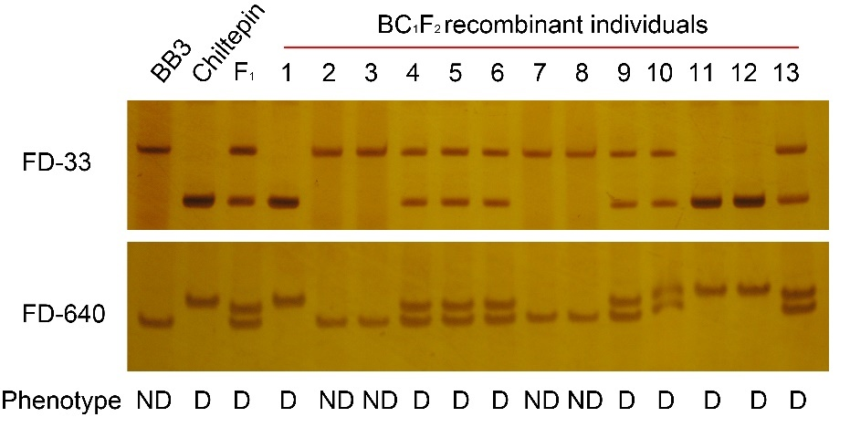

Supplementary Figure S1 Genotyping results of the 13 recombinants using the markers FD-33 and FD-640
D and ND represent the deciduous and non-deciduous fruit phenotypes, respectively.

Supplementary Figure S2. Alignment of protein sequences between Capana10g002229 and tomato PG2
The red box represents the protein sequence difference due to the SNP (SNP_1689:304) and the 7-bp InDel in cDNA sequences, respectively.

Supplementary Figure S3 Alignment of cDNA sequences of Capana10g002230

Supplementary Figure S4 Alignment of cDNA sequences of Capana10g002232

Supplementary Figure S5 Alignment of cDNA sequences of Capana10g002231

Supplementary Figure S6 Alignment of protein sequences of Capana10g002231

Supplementary Figure S7 Alignment of cDNA sequences of Capana10g002229
The first red boxes represent the SNP (SNP_1689:304), the second red boxes represent a 7-bp InDel.
The red and green lines represent two conserved regions (106-906 bp and 912-1082 bp) of Capana10g002229 for BB3. The sequence indicated by two black arrows represent the conserved region (912-1089 bp) of Capana10g002229 for Chiltepin.

Supplementary Figure S8 Last intron and exon junction sequences of Capana10g002229
Exons and introns are indicated as boxes and lines, respectively. The frameshift mutation site is marked with an arrow. The red labeled font indicates the premature termination codon (PTC).

Supplementary Figure S9 Expression of Capana10g002229 in different tissues of BB3 and Chiltepin based on qPCR
The fruit from the red ripe stage was used as a control. * Represents significance at the level of 0.05 (Student’s t test).

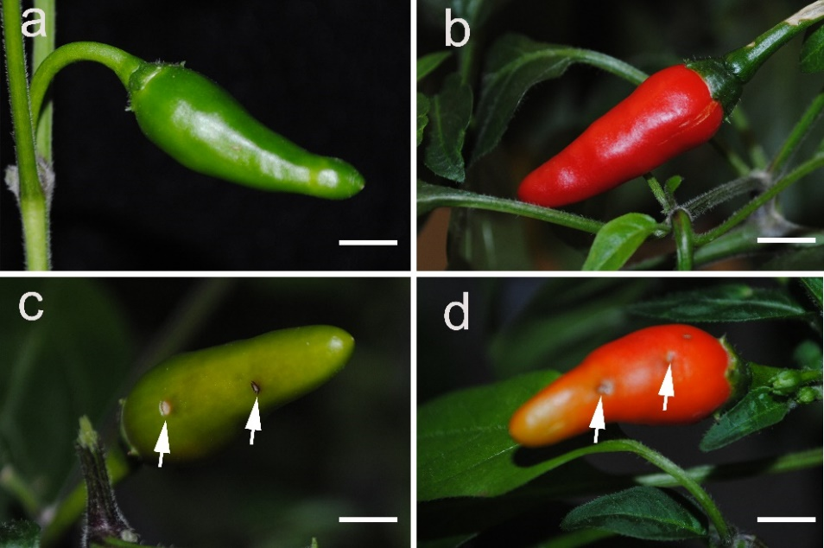

Supplementary Figure S10 Blank TRV-mediated VIGS of the PDS in pepper fruit
a Mature green fruit of control. b Red fruit of control (no infiltration). c Mature green fruit of infection with TRV:PDS. d Ripe fruit of infection with TRV:PDS.

