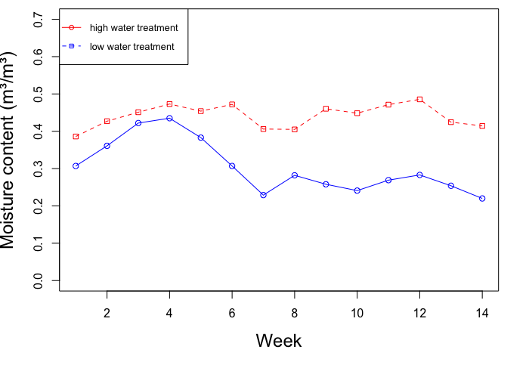

Fig S1 Soil moisture content between low and well-watered plants (significance level; p = 2.79e-06). There are fourteen weeks because there were no taken for two weeks in the middle of the experiment

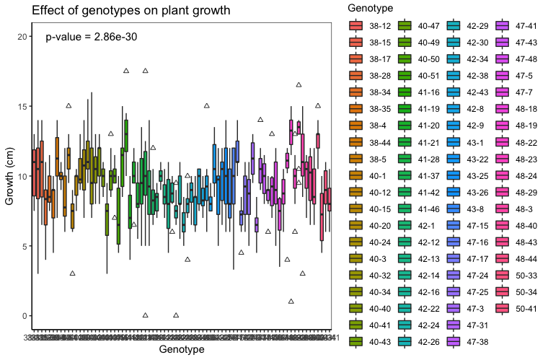
Fig S2 Effects of Norway spruce genotypes on plant growth

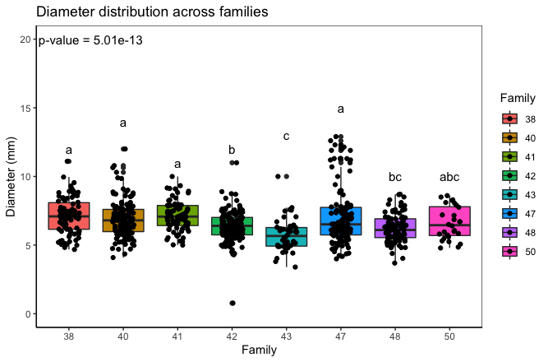
Fig S3 Diameter distribution among families (median diameter for each family. Different letters above plots denote significantly different groups after posthoc test)

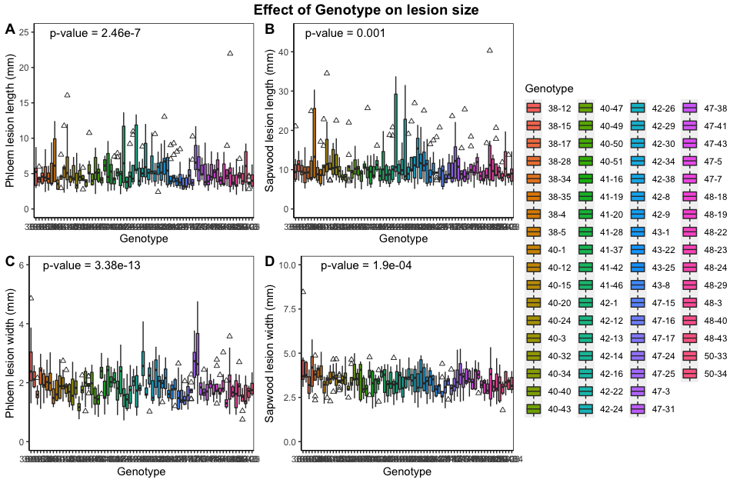
Fig S4 Genotype effect on lesion size. a) lesion length in phloem b) lesion length in sapwood c) lesion width in phloem d) lesion width in sapwood

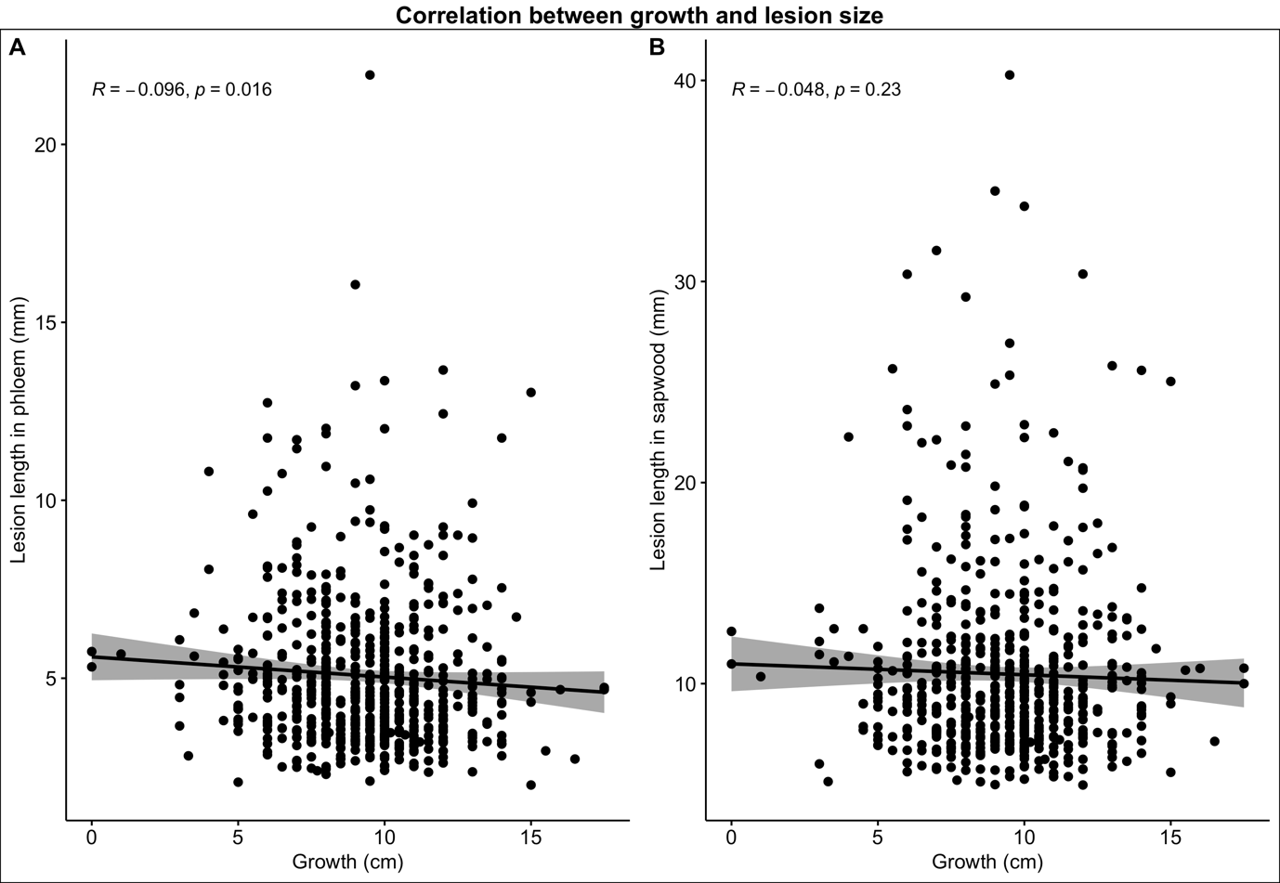

Fig S5 Correlation analysis between growth and lesion length in a) phloem, b) sapwood

