Supplement 1: STROBE Statement—Checklist of items included in reports of cohort studies

 | Item No | Recommendation | Page No
Title and abstract | 1 | (a) Indicate the study’s design with a commonly used term in the title or the abstract  Effects of transfusing older red blood cells on patient outcomes in critical illness: a retrospective cohort study
Title and abstract | 1 | (b) Provide in the abstract an informative and balanced summary of what was done and what was found  What was done  A retrospective observational analysis was conducted of data obtained from 7-years of medical records (2007–2013). This data was obtained from all public and licensed private hospitals in the state of Queensland with intensive care units. Included in this study were 10,350 critically ill adult (>12 years) patients transfused ≥1 unit of non-irradiated pRBCs (64,594 pRBCs units transfused). Main outcome measures were in hospital mortality, hospital length of stay and rate of discharge home was compared between patients transfused with pRBCs of different ages. Rates of comorbid sepsis, thrombotic events, cardiac ischaemia and delirium were also compared.  What was found  Receiving at least 1-unit pRBCs ≥35 days old was associated with increased mortality (OR 1.21 [95% CI 1.06–1.38]; p=0.005), decreased discharge to usual residence (OR 0.81 [95% CI 0.73–0.89]; p<0.0001) and increased hospital LOS (Estimate 2.55 [95% CI 1.57–3.77]; p<0.0001). There was also association with increased sepsis (OR 1.27 [95% CI 1.13–1.42]; p<0.0001) and delirium (OR 1.25 [95% CI 1.06–1.49]; p=0.01). Transfusion of ≥1-unit pRBCs ≥35 days old was associated with evidence of increased mortality and morbidity in critically ill patients. Further prospective studies are required to validate findings and overcome limitations of retrospective analysis.
Introduction
Background/ rationale | 2 | Explain the scientific background and rationale for the investigation being reported  The shelf-life of packed red blood cells (pRBCs) for transfusion is limited to between 21-49 days. During storage, numerous metabolic and structural changes, referred to as “storage lesions”, occur within pRBCs. A 2018 meta-analysis by Rygard and colleagues concluded that patient morbidity and mortality were unaffected by pRBC storage duration across 7 randomised controlled trials (RCTs). However, each of these RCTs only compared “fresher” pRBC to either “standard-issue pRBC”, “oldest available pRBC”, or to pRBC stored for longer than 15-20 days, without specific consideration for pRBCs at the extreme end of their shelf life. It remains unclear whether these patients might be harmed by receiving pRBCs nearing expiry.
Objectives | 3 | State specific objectives, including any prespecified hypotheses  Hypothesis: transfusion with any RBCs older than 35 days may predispose to transfusion-related morbidity.  Objectives: the aim of this study was to investigate the effects of transfusing pRBCs ≥35 days old on clinical outcomes in critical illness, and whether reducing pRBC shelf-life to <35 days would improve transfusion safety.
Methods
Study design | 4 | Present key elements of study design early in the paper  A retrospective observational cohort study
Setting | 5 | Describe the setting, locations, and relevant dates, including periods of recruitment, exposure, follow-up, and data collection  Records of all blood products transfused in public and licensed private hospitals in QLD from 2007–2013 were accessed from the Queensland Hospital Admitted Patient Data Collection (QHAPDC), AUSLAB and International Classification of Diseases (ICD) Code databases. Data analysis occurred from June 2021 to May 2022.
Participants | 6 | (a) Give the eligibility criteria, and the sources and methods of selection of participants. Describe methods of follow-up  There were 10,350 patients >12 years of age who received ≥1 transfusion of any product either (a) in ICU or (b) under the care of ICU. There was no follow-up data available for these patients.
Participants | 6 | (b) For matched studies, give matching criteria and number of exposed and unexposed  N/A
Variables | 7 | Clearly define all outcomes, exposures, predictors, potential confounders, and effect modifiers. Give diagnostic criteria, if applicable  In-hospital mortality was a key outcome investigated, determined by the mode of separation. The QHAPDC database did not link patients who were transferred between hospitals or to other care facilities, which could lead to under-reporting of mortality. Thus, rate of discharge home was also investigated as a marker of a positive patient outcome, as was hospital length of stay. Comorbid outcomes of sepsis, thrombotic events, cardiac ischaemia and delirium were investigated. These comorbidities were chosen based on the findings of a 2019 review by Yoshida, which proposed possible clinical implications of storage lesions, specifically highlighting increased infection, hypercoagulability, impaired tissue oxygenation as consequences of transfusing RBCs with storage lesions (6). Comorbidity data was sourced from the ICD code database and linked to patient identifiers on the QHAPDC database. Categorisation of ICD codes is listed in Supplement 2.
Data sources/ measurement | 8* | For each variable of interest, give sources of data and details of methods of assessment (measurement). Describe comparability of assessment methods if there is more than one group  All data was sourced from the Queensland Hospital Admitted Patient Data Collection (QHAPDC), AUSLAB and International Classification of Diseases (ICD) Code databases.
Bias | 9 | Describe any efforts to address potential sources of bias  Selection bias was addressed by designing strict inclusion and exclusion criteria prior to database manipulation and statistical analyses. Information bias was minimalised as there was limited missing data. The only data missing in some instances was the AUSLAB date, as the date when the blood product was released from the laboratory. Where the AUSLAB date was missing (n=36,433; 5.0%), the date the transfusion was marked as administered by the ward was used instead, which is largely consistent with the AUSLAB date in patients who had both recorded.
Study size | 10 | Explain how the study size was arrived at  There was no formal size calculation done. The study size utilised the maximum number of eligible patients from the QHAPDC database.
Quantitative variables | 11 | Explain how quantitative variables were handled in the analyses. If applicable, describe which groupings were chosen and why  Patients were grouped into those who received exclusively pRBCs <35 days old, and those who received at least 1 unit ≥35 days old. For quantitative variables, the median (interquartile range, IQR) was reported for non-parametric data, and the count (% of total) was reported for frequencies.
Statistical methods | 12 | (a) Describe all statistical methods, including those used to control for confounding
Statistical methods | 12 | (b) Describe any methods used to examine subgroups and interactions
Statistical methods | 12 | (c) Explain how missing data were addressed
Statistical methods | 12 | (d) If applicable, explain how loss to follow-up was addressed
Statistical methods | 12 | (e) Describe any sensitivity analyses  For each outcome, univariate analysis was conducted. Independent variables included in univariate analysis were: exclusively pRBCs <35 days old, age, sex, year of transfusion, hospital length of stay, number of pRBCs transfused, number of plasma products transfused, number of platelet products transfused, number of cryoprecipitate units transfused, sepsis, thrombotic events, cardiac ischaemia and delirium. In-hospital mortality and rate of discharge home were also included as independent variables for hospital length of stay. All variables that were included in univariate analysis were also included in multivariate analysis, irrespective of whether these variables displayed statistical significance. Logistic regression models were used for all outcomes, with the exception of hospital length of stay, for which a linear regression model was used. Statistical analysis was conducted using STATA SE 17.0. Results were reported using odds ratios (OR) or regression coefficients with 95 % confidence intervals (CI). Statistical significance was defined with an alpha level of 0.05.  The age of pRBC units was calculated as the difference between the date of blood donation and the date on which the product was released from the laboratory, as recorded on AUSLAB. Where the AUSLAB date was missing (n=36,433; 5.0%), the date the transfusion was marked as administered by the ward was used instead.
Results
Participants | 13* | (a) Report numbers of individuals at each stage of study—e.g., numbers potentially eligible, examined for eligibility, confirmed eligible, included in the study, completing follow-up, and analysed  (b) Give reasons for non-participation at each stage  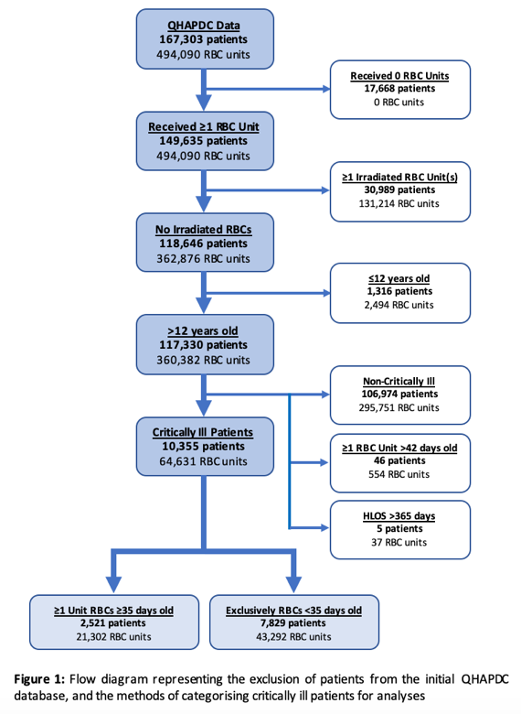  (c) Consider use of a flow diagram
Descriptive data | 14* | (a) Give characteristics of study participants (e.g., demographic, clinical, social) and information on exposures and potential confounders  (b) Indicate number of participants with missing data for each variable of interest  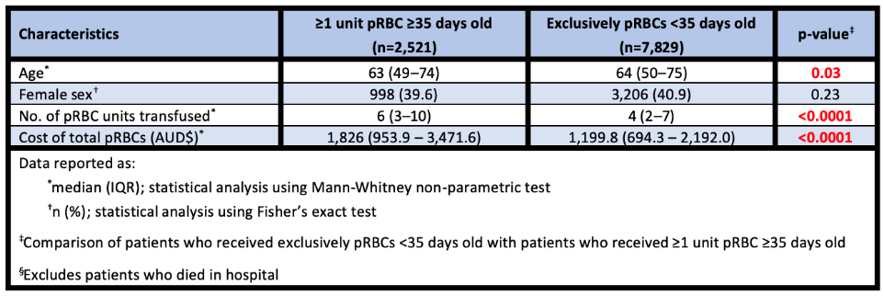  (c) Summarise follow-up time (e.g., average and total amount)
Outcome data | 15* | 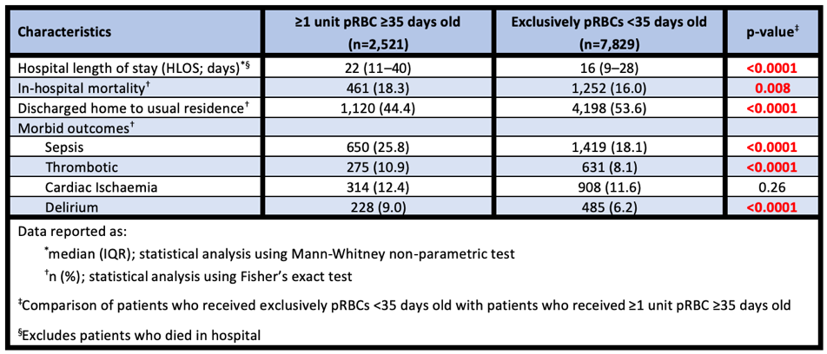  Report numbers of outcome events or summary measures over time
Main results | 16 | (a) Give unadjusted estimates and, if applicable, confounder-adjusted estimates and their precision (e.g., 95% confidence interval). Make clear which confounders were adjusted for and why they were included  (b) Report category boundaries when continuous variables were categorized  (c) If relevant, consider translating estimates of relative risk into absolute risk for a meaningful time period  For each dependent outcome, multivariate modelling included all independent variables that were statistically significant in univariate models (Appendix 1). In a multivariate model containing all patients, receiving ≥1 unit of pRBC that was ≥35 days old was found to be associated with increased mortality (OR 0.83 [95% CI 0.73 – 0.94]; p=0.005) (Table 2). Receiving blood no older than 35 days old was also associated with decreased discharge to a patient’s usual residence (OR 1.24 [95% CI 1.12 – 1.36]; p<0.0001) and for increased hospital length of stay (Estimate 2.55 [95% CI 1.60 – 3.49]; p<0.0001). Multivariate analysis of comorbid outcomes found receiving ≥1 unit of pRBC that was ≥35 days old was associated with decreased rates of sepsis (OR 1.27 [95% CI 1.13 – 1.42]; p<0.0001) and delirium (OR 01.25 [95% CI 1.06 – 1.49]; p=0.01).
Other analyses | 17 | Report other analyses done—e.g., analyses of subgroups and interactions, and sensitivity analyses  N/A
Discussion
Key results | 18 | Summarise key results with reference to study objectives  Our study utilises methods most reflective of a clinical setting by comparing patients who received pRBCs exclusively <35 days old to those transfused at least 1-unit pRBCs ≥35 days old. These results indicated patients receiving pRBCs nearing expiry experienced increased rates of in-hospital mortality and lengths of hospital stay, were less frequently discharged to their usual residence and experienced increased rates of comorbid outcomes. This suggests that the outcomes of critically ill patients could be improved if the expiry date of pRBCs was reduced to 35 days for this cohort.
Limitations | 19 | Discuss limitations of the study, taking into account sources of potential bias or imprecision. Discuss both direction and magnitude of any potential bias  Some of the limitations of this study were; the retrospective design which limited our ability to define a clear cause and effect between older pRBCs and poorer patient outcomes. A lack of longitudinal follow-up of patients and no sequential information about the timing of comorbid events during the course of admission further restrict our results to recognising association only. The database identified patients with codes unique to a single admission only, preventing us from identifying patients who required additional transfusion in future admissions, hence readmissions were considered as a new patient entry. Additional information to define the extent of critical illness, such as a patient’s APACHE II score, were also not recorded in the database.
Interpretation | 20 | Give a cautious overall interpretation of results considering objectives, limitations, multiplicity of analyses, results from similar studies, and other relevant evidence  This retrospective analysis showed an association between the transfusion of pRBCs close to the end of shelf-life with adverse clinical outcomes in critically ill patients. This association was present regardless of whether the patient received exclusively older pRBCs or only a single unit of older pRBCs. Therefore, critically ill patients may have better clinical outcomes if transfusions are restricted to pRBC units <35 days old.
Generalisability | 21 | Discuss the generalisability (external validity) of the study results  Prospective clinical studies could further explore this association and elucidate its implications on clinical outcomes.
Other Information
Funding | 22 | Give the source of funding and the role of the funders for the present study and, if applicable, for the original study on which the present article is based  Australian Governments fund Australian Red Cross Lifeblood for the provision of blood, blood products and services to the Australian Community.

Supplement 2: Definitions of comorbidity by ICD code
Sepsis
A40.0 Sepsis due to streptococcus, group A
A40.2 Sepsis due to streptococcus, group D and enterococcus
A40.3 Sepsis due to Streptococcus pneumoniae
A40.8 Other streptococcal sepsis
A40.9 Streptococcal sepsis, unspecified
A41.0 Sepsis due to Staphylococcus aureus
A41.1 Sepsis due to other specified staphylococcus
A41.2 Sepsis due to unspecified staphylococcus
A41.4 Sepsis due to anaerobes
A41.50 Sepsis due to unspecified Gram-negative organisms
A41.51 Sepsis due to Escherichia coli [E. Coli]
A41.52 Sepsis due to Pseudomonas
A41.58 Sepsis due to other Gram-negative organisms
A41.8 Other specified sepsis
A41.9 Sepsis, unspecified
B37.7 Candidal sepsis
A02.1 Salmonella sepsis
A32.7 Listerial sepsis
A40.1 Sepsis due to streptococcus, group B
A41.3 Sepsis due to Haemophilus influenzae
O85 Puerperal sepsis
Thrombotic
D65 Disseminated intravascular coagulation [defibrination syndrome]
G08 Intracranial and intraspinal phlebitis and thrombophlebitis
I24.0 Coronary thrombosis not resulting in myocardial infarction
I26.0 Pulmonary embolism with mention of acute cor pulmonale
I26.9 Pulmonary embolism without mention of acute cor pulmonale
I63.0 Cerebral infarction due to thrombosis of precerebral arteries
I63.1 Cerebral infarction due to embolism of precerebral arteries
I63.3 Cerebral infarction due to thrombosis of cerebral arteries
I63.4 Cerebral infarction due to embolism of cerebral arteries
I74.0 Embolism and thrombosis of abdominal aorta
I74.1 Embolism and thrombosis of other and unspecified parts of aorta
I74.2 Embolism and thrombosis of arteries of upper extremities
I74.3 Embolism and thrombosis of arteries of lower extremities
I74.4 Embolism and thrombosis of arteries of extremities, unspecified
I74.5 Embolism and thrombosis of iliac artery
I74.8 Embolism and thrombosis of other arteries
I74.9 Embolism and thrombosis of unspecified artery
I80.0 Phlebitis and thrombophlebitis of superficial vessels of lower extremities
I80.1 Phlebitis and thrombophlebitis of femoral vein
I80.2 Phlebitis and thrombophlebitis of other deep vessels of lower extremities
I80.3 Phlebitis and thrombophlebitis of lower extremities, unspecified
I80.8 Phlebitis and thrombophlebitis of other sites
I80.9 Phlebitis and thrombophlebitis of unspecified site
I81 Portal vein thrombosis
I82.2 Embolism and thrombosis of vena cava
I82.8 Embolism and thrombosis of other specified veins
I82.9 Embolism and thrombosis of unspecified vein
M31.1 Thrombotic microangiopathy
O22.3 Deep phlebothrombosis in pregnancy
O87.0 Superficial thrombophlebitis in the puerperium
O87.1 Deep phlebothrombosis in the puerperium
O88.2 Obstetric blood clot embolism

Cardiac Ischaemia
I21.0 Acute transmural myocardial infarction of anterior wall
I21.1 Acute transmural myocardial infarction of inferior wall
I21.2 Acute transmural myocardial infarction of other sites
I21.3 Acute transmural myocardial infarction of unspecified site
I21.4 Acute subendocardial myocardial infarction
I21.9 Acute myocardial infarction, unspecified
I22.0 Subsequent myocardial infarction of anterior wall
I22.1 Subsequent myocardial infarction of inferior wall
I22.8 Subsequent myocardial infarction of other sites
I22.9 Subsequent myocardial infarction of unspecified site
I24.8 Other forms of acute ischaemic heart disease
I24.9 Acute ischaemic heart disease, unspecified
I25.5 Ischaemic cardiomyopathy
I46.0 Cardiac arrest with successful resuscitation
I46.9 Cardiac arrest, unspecified
Delirium
F05.0 Delirium not superimposed on dementia, so described
F05.1 Delirium superimposed on dementia
F05.8 Other delirium
F05.9 Delirium, unspecified

Supplement 3:

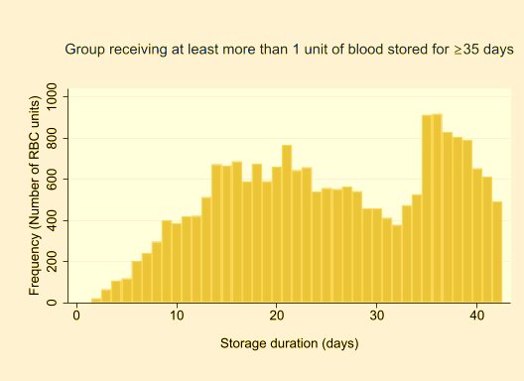
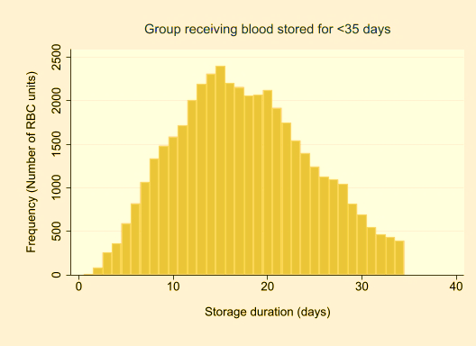

Figure 1: Frequency distribution of pRBC age for (a) patients who received ≥1-unit pRBC ≥35 days old and (b) patients who exclusively received pRBCs <35 days old

Supplement 4: Multivariate and univariate analyses for outcomes of mortality and morbidity

Table 1: Results of in-hospital mortality in critically ill patients using univariate and multivariate logistic regression models

 | Univariate Analysis |  |  | Multivariate Analysis
 | Odds Ratio | 95% CI | p-value | Odds Ratio | 95% CI | p-value
Receiving ≥1-unit pRBC ≥35 days old | 1.17 | 1.04 – 1.32 | 0.008 | 1.21 | 1.06 – 1.38 | 0.005
Age | 1.02 | 1.01 – 1.02 | <0.0001 | 1.02 | 1.01 – 1.02 | <0.0001
Sex (Female) | 1.10 | 0.99 – 1.23 | 0.06 | 1.21 | 1.08 – 1.36 | 0.001
Year | 0.96 | 0.93 – 0.99 | 0.003 | 0.94 | 0.91 – 0.97 | <0.0001
Number of products transfused
Packed red blood cells | 1.02 | 1.02 – 1.03 | <0.0001 | 1.04 | 1.03 – 1.05 | <0.0001
Plasma products | 1.02 | 1.02 – 1.03 | <0.0001 | 1.01 | 1.00 – 1.02 | 0.02
Platelet products | 1.08 | 1.05 – 1.10 | <0.0001 | 1.03 | 1.00 – 1.06 | 0.02
Cryoprecipitate | 1.04 | 1.03 – 1.05 | <0.0001 | 1.02 | 1.01 – 1.04 | 0.003
Hospital length of stay (HLOS; days) | 0.97 | 0.97 – 0.98 | <0.0001 | 0.95 | 0.94 – 0.95 | <0.0001
Morbid Outcomes
Sepsis | 2.35 | 2.10 – 2.64 | <0.0001 | 3.90 | 3.40 – 4.46 | <0.0001
Thrombotic | 1.30 | 1.10 – 1.55 | 0.002 | 1.62 | 1.33 – 1.98 | <0.0001
Cardiac Ischaemia | 2.82 | 2.47 – 3.22 | <0.0001 | 2.74 | 2.36 – 3.17 | <0.0001
Delirium | 0.89 | 0.72 – 1.11 | 0.30 | 1.09 | 0.86 – 1.38 | 0.47

Table 2: Results of discharge of critically ill patients to their usual residence using univariate and multivariate logistic regression models

 | Univariate Analysis |  |  | Multivariate Analysis
 | Odds Ratio | 95% CI | p-value | Odds Ratio | 95% CI | p-value
Receiving ≥1-unit pRBC ≥35 days old | 0.69 | 0.63 – 0.76 | <0.0001 | 0.81 | 0.73 – 0.89 | <0.0001
Age | 0.99 | 0.99 – 1.00 | <0.0001 | 0.99 | 0.99 – 0.99 | <0.0001
Sex (Female) | 0.90 | 0.83 – 0.97 | 0.006 | 0.85 | 0.78 – 0.92 | <0.0001
Year | 0.96 | 0.94 – 0.98 | <0.0001 | 0.96 | 0.94 – 0.99 | 0.001
Number of products transfused
Packed red blood cells | 0.96 | 0.95 – 0.97 | <0.0001 | 0.97 | 0.96 – 0.98 | <0.0001
Plasma products | 0.98 | 0.97 – 0.99 | <0.0001 | 1.00 | 0.99 – 1.00 | 0.26
Platelet products | 0.98 | 0.96 – 1.00 | 0.07 | 1.03 | 1.00 – 1.05 | 0.03
Cryoprecipitate | 0.99 | 0.98 – 1.00 | 0.01 | 1.00 | 0.99 – 1.01 | 0.95
Hospital length of stay (HLOS; days) | 0.99 | 0.99 – 0.99 | <0.0001 | 1.00 | 1.00 – 1.00 | 0.10
Morbid Outcomes
Sepsis | 0.36 | 0.33 – 0.40 | <0.0001 | 0.42 | 0.38 – 0.47 | <0.0001
Thrombotic | 0.46 | 0.40 – 0.54 | <0.0001 | 0.56 | 0.48 – 0.66 | <0.0001
Cardiac Ischaemia | 0.42 | 0.37 – 0.47 | <0.0001 | 0.47 | 0.42 – 0.54 | <0.0001
Delirium | 0.44 | 0.38 – 0.52 | <0.0001 | 0.57 | 0.48 – 0.68 | <0.0001

Table 3: Results of hospital length of stay of critically ill patients using univariate and multivariate linear regression models

 | Univariate Analysis |  |  | Multivariate Analysis
 | Odds Ratio | 95% CI | p-value | Odds Ratio | 95% CI | p-value
Receiving ≥1-unit pRBC ≥35 days old | 6.87 | 5.81 – 7.93 | <0.0001 | 2.55 | 1.60 – 3.49 | <0.0001
Age | -0.12 | -0.15 – -0.09 | <0.0001 | -0.06 | -0.08 – -0.03 | <0.0001
Sex (Female) | -0.16 | -1.09 – 0.78 | 0.74 | 0.54 | -0.27 – 1.36 | 0.19
Year | -0.41 | -0.66 – -0.17 | 0.001 | -0.54 | -0.76 – -0.33 | <0.0001
Number of products transfused
Packed red blood cells | 1.13 | 1.07 – 1.19 | <0.0001 | 1.08 | 1.01 – 1.15 | <0.0001
Plasma products | 0.23 | 0.18 – 0.29 | <0.0001 | -0.10 | -0.16 – -0.05 | <0.0001
Platelet products | 0.61 | 0.39 – 0.83 | <0.0001 | -0.41 | -0.62 – -0.19 | <0.0001
Cryoprecipitate | 0.08 | -0.04 – 0.21 | 0.18 | -0.43 | -0.55 – -0.32 | <0.0001
Morbid Outcomes
Sepsis | 16.48 | 15.37 – 17.58 | <0.0001 | 12.83 | 11.79 – 13.86 | <0.0001
Thrombotic | 14.97 | 13.37 – 16.56 | <0.0001 | 9.40 | 7.97 – 10.83 | <0.0001
Cardiac Ischaemia | 2.55 | 1.13 – 3.98 | <0.0001 | 1.61 | 0.35 – 2.87 | 0.01
Delirium | 13.68 | 11.89 – 15.47 | <0.0001 | 8.48 | 6.88 – 10.08 | <0.0001
In-hospital mortality | -8.92 | -10.15 – -7.70 | <0.0001 | -15.62 | -16.85 – -14.40 | <0.0001
Discharged to usual residence | -5.37 | -6.29 – -4.46 | <0.0001 | -5.86 | -6.78 – -4.94 | <0.0001

Table 4: Results of comorbid sepsis in critically ill patients using univariate and multivariate logistic regression models

 | Univariate Analysis |  |  | Multivariate Analysis
 | Odds Ratio | 95% CI | p-value | Odds Ratio | 95% CI | p-value
Receiving ≥1-unit pRBC ≥35 days old | 1.56 | 1.41 – 1.74 | <0.0001 | 1.27 | 1.13 – 1.42 | <0.0001
Age | 1.00 | 0.99 – 1.00 | <0.0001 | 1.00 | 1.00 – 1.00 | 0.60
Sex (Female) | 1.01 | 0.92 – 1.12 | 0.79 | 1.04 | 0.93 – 1.14 | 0.50
Year | 0.96 | 0.94 – 0.99 | 0.006 | 0.98 | 0.95 – 1.00 | 0.08
Number of products transfused
Packed red blood cells | 1.05 | 1.04 – 1.06 | <0.0001 | 1.02 | 1.01 – 1.03 | <0.0001
Plasma products | 1.02 | 1.01 – 1.03 | <0.0001 | 1.01 | 1.00 – 1.01 | 0.05
Platelet products | 1.04 | 1.02 – 1.06 | <0.0001 | 1.00 | 0.98 – 1.03 | 0.73
Cryoprecipitate | 1.00 | 0.99 – 1.01 | 0.90 | 0.98 | 0.96 – 0.99 | 0.004
Hospital length of stay (HLOS; days) | 1.03 | 1.02 – 1.03 | <0.0001 | 1.02 | 1.02 – 1.02 | <0.0001

Table 5: Results of comorbid thrombotic events in critically ill patients using univariate and multivariate logistic regression models

 | Univariate Analysis |  |  | Multivariate Analysis
 | Odds Ratio | 95% CI | p-value | Odds Ratio | 95% CI | p-value
Receiving ≥1-unit pRBC ≥35 days old | 1.39 | 1.20 – 1.62 | <0.0001 | 1.12 | 0.95 – 1.31 | 0.17
Age | 0.99 | 0.98 – 0.99 | <0.0001 | 0.99 | 0.99 – 0.99 | <0.0001
Sex (Female) | 0.98 | 0.85 – 1.12 | 0.75 | 0.97 | 0.84 – 1.12 | 0.67
Year | 1.05 | 1.02 – 1.09 | 0.005 | 1.06 | 1.02 – 1.10 | 0.004
Number of products transfused
Packed red blood cells | 1.04 | 1.04 – 1.05 | <0.0001 | 1.02 | 1.01 – 1.03 | <0.0001
Plasma products | 1.02 | 1.01 – 1.02 | <0.0001 | 1.00 | 0.99 – 1.01 | 0.74
Platelet products | 1.05 | 1.03 – 1.08 | <0.0001 | 1.00 | 0.98 – 1.03 | 0.74
Cryoprecipitate | 1.04 | 1.03 – 1.06 | <0.0001 | 1.02 | 1.01 – 1.04 | 0.005
Hospital length of stay (HLOS; days) | 1.02 | 1.02 – 1.02 | <0.0001 | 1.01 | 1.01 – 1.012 | <0.0001

Table 6: Results of comorbid cardiac ischaemia in critically ill patients using univariate and multivariate logistic regression models

 | Univariate Analysis |  |  | Multivariate Analysis
 | Odds Ratio | 95% CI | p-value | Odds Ratio | 95% CI | p-value
Receiving ≥1-unit pRBC ≥35 days old | 1.08 | 0.95 – 1.24 | 0.25 | 1.01 | 0.88 – 1.16 | 0.91
Age | 1.03 | 1.02 – 1.03 | <0.0001 | 1.03 | 1.02 – 1.03 | <0.0001
Sex (Female) | 0.93 | 0.83 – 1.05 | 0.26 | 0.99 | 0.87 – 1.12 | 0.82
Year | 0.99 | 0.96 – 1.02 | 0.63 | 0.99 | 0.96 – 1.03 | 0.74
Number of products transfused
Packed red blood cells | 1.02 | 1.01 – 1.03 | <0.0001 | 1.03 | 1.02 – 1.04 | <0.0001
Plasma products | 1.00 | 1.00 – 1.01 | 0.26 | 1.00 | 0.99 – 1.01 | 0.92
Platelet products | 1.01 | 0.99 – 1.04 | 0.38 | 0.99 | 0.95 – 1.02 | 0.45
Cryoprecipitate | 1.00 | 0.99 – 1.02 | 0.72 | 1.00 | 0.98 – 1.02 | 0.90
Hospital length of stay (HLOS; days) | 1.00 | 1.00 – 1.01 | <0.0001 | 1.00 | 1.00 – 1.00 | 0.009

Table 7: Results of comorbid delirium in critically ill patients using univariate and multivariate logistic regression models

 | Univariate Analysis |  |  | Multivariate Analysis
 | Odds Ratio | 95% CI | p-value | Odds Ratio | 95% CI | p-value
Receiving ≥1-unit pRBC ≥35 days old | 1.51 | 1.28 – 1.77 | <0.0001 | 1.25 | 1.06 – 1.49 | 0.01
Age | 1.02 | 1.01 – 1.02 | <0.0001 | 1.02 | 1.02 – 1.03 | <0.0001
Sex (Female) | 0.74 | 0.63 – 0.86 | <0.0001 | 0.73 | 0.62 – 0.86 | <0.0001
Year | 1.22 | 1.17 – 1.27 | <0.0001 | 1.24 | 1.19 – 1.30 | <0.0001
Number of products transfused
Packed red blood cells | 1.03 | 1.02 – 1.03 | <0.0001 | 1.02 | 1.01 – 1.03 | <0.0001
Plasma products | 1.00 | 0.99 – 1.01 | 0.66 | 1.00 | 0.99 – 1.01 | 0.66
Platelet products | 0.97 | 0.93 – 1.02 | 0.27 | 0.93 | 0.88 – 0.99 | 0.03
Cryoprecipitate | 1.00 | 0.97 – 1.02 | 0.66 | 0.99 | 0.97 – 1.01 | 0.41
Hospital length of stay (HLOS; days) | 1.02 | 1.01 – 1.02 | <0.0001 | 1.02 | 1.01 – 1.02 | <0.0001

