Supplementary Information

Discovery of a pyrano[2,3-b]pyridine derivative YX-2102 as a cannabinoid receptor 2 agonist for alleviating lung fibrosis

This file includes:
Supplementary Video Legends
Supplementary Figures 1-5
Supplementary Tables 1-4

Supplementary Video Legends

Supplementary Video 1.
A Representative 3-dimensional (3D) structure and morphology of rat lung in the sham group at day 21 after drug administration.

Supplementary Video 2.
A Representative 3D structure and morphology of rat lung in the YX-2102 group at day 21 after drug administration.

Supplementary Video 3.
A Representative 3D structure and morphology of rat lung in the BLM group at day 21 after drug administration.

Supplementary Video 4.
A Representative 3D structure and morphology of rat lung in the BLM+YX-2102 group at day 21 after drug administration.

A | B
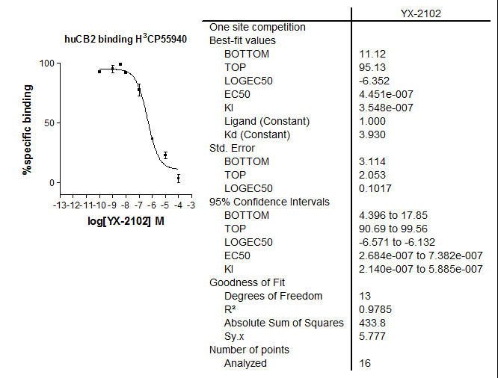 | 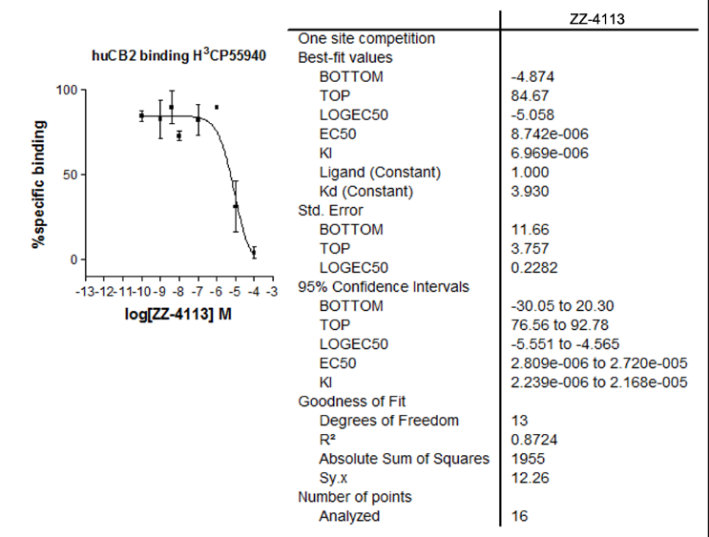
C | D
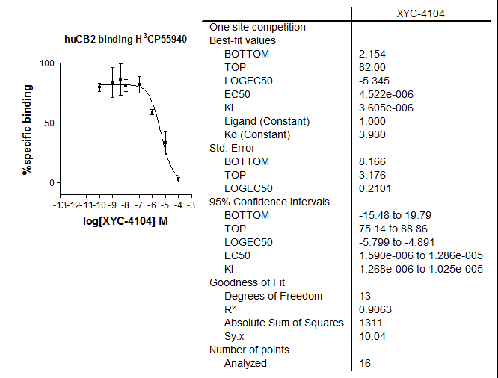 | 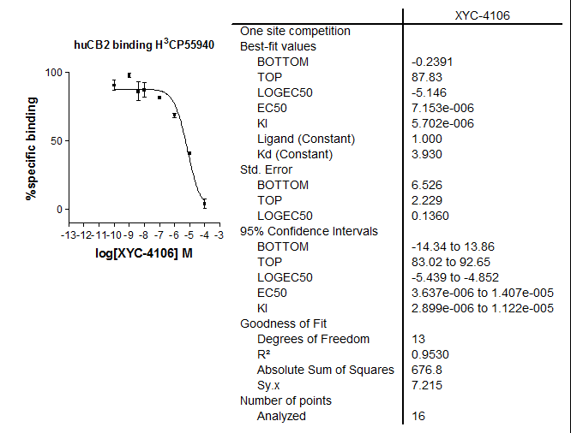

Supplementary Figure 1. Binding affinities of compounds YX-2102 (A), ZZ-4113 (B), XYC-4104 (C) and XYC-4106 (D)
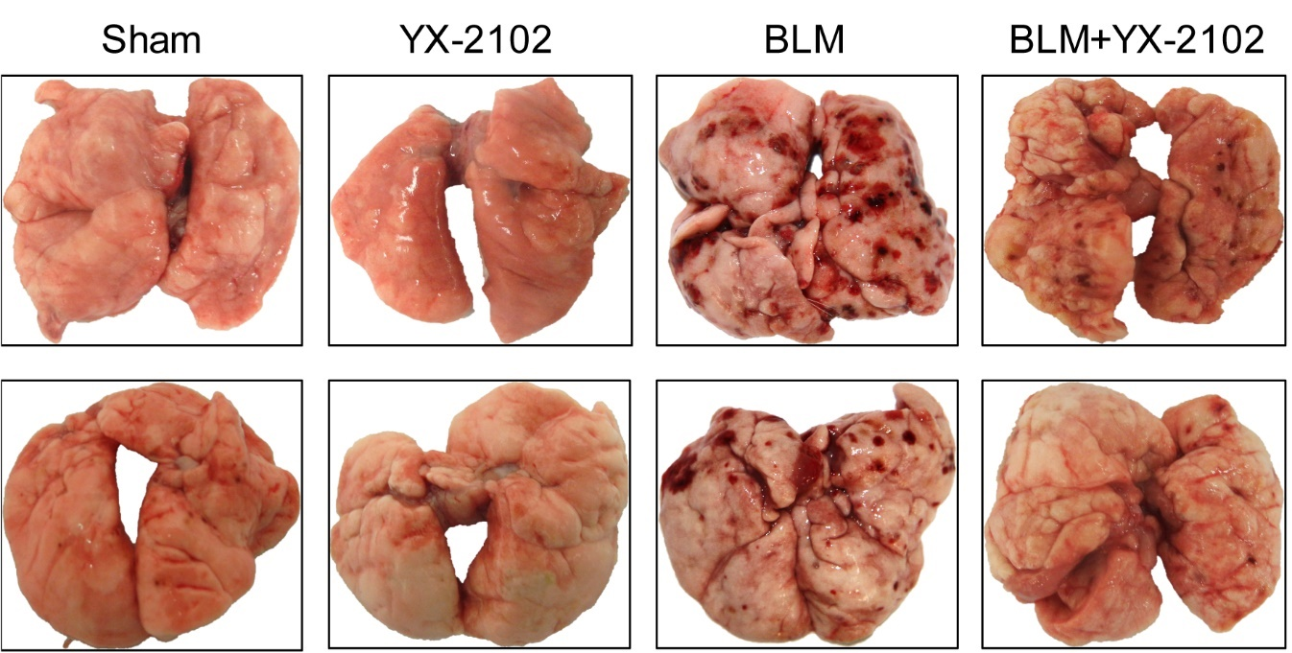

Supplementary Figure 2. The representative gross-morphological images of rat lung from each group at day 21.

Supplementary Figure 3. The changes in body weight for each experimental group; Data are expressed as mean ± SEM. n = 5 rats per group. **P < 0.001 versus BLM group.

Supplementary Figure 4. YX-2102 improved the oxidative stress in rats with BLM-induced pulmonary fibrosis. Oxidative stress was assessed by measuring the activity of tissue superoxide dismutase (SOD) and the contents of malondialdehyde (MDA) and glutathione (GSH). The measurement was repeated three times and the data were represented as mean ± SD; ****P < 0.0001 versus sham group, #P < 0.05, ###P < 0.001 versus BLM group.
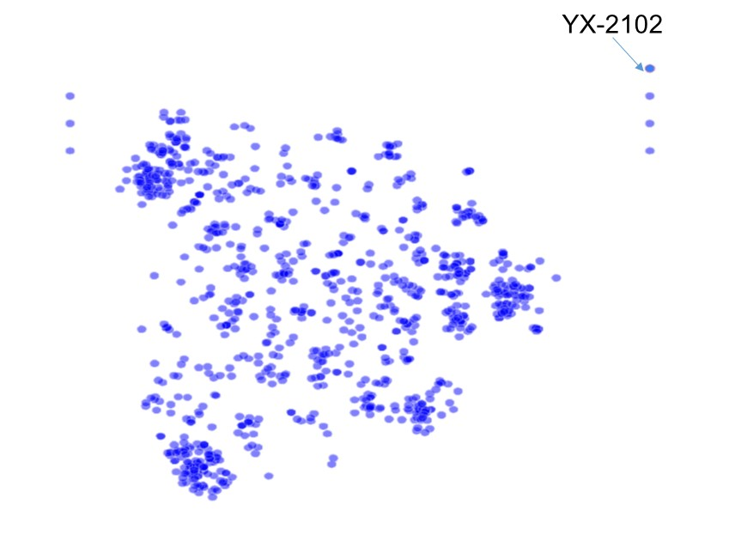
Supplementary Figure 5. Structure similarity map of CB2 ligand. 1000 CB2 ligand were collected from CHEMBL (https://www.ebi.ac.uk/chembl/) whose binding affinity was lower than 10 nM. The shorter distance means to the more obvious similarity. The structures are outlierss if similarity to other structure is less than 50%, meaning the similarity of YX-2102 to other structure is less than 50%.

Supplementary Table 1. Purchase, dilution and storage conditions of primary and second antibodies.

Antibody | Cat.NO | Corporation | Dilution |  | Storage
Antibody | Cat.NO | Corporation | WB | IF/IHC | Storage
TGF-β1 | ab92486 | Abcam | 1:500 | 1:400 | -20 ºC
α-SMA | ab5694 | Abcam | 1:300 | 1:400 | -20 ºC
E-cadherin | sc-8426 | Santa Cruz | 1:200 | 1:100 | 4 ºC
Fibronectin | sc-8422 | Santa Cruz | 1:200 | 1:100 | 4 ºC
CB2R | ab3561 | Abcam | 1:500 | 1:200 | -20 ºC
CD206 | GB13438 | Servicebio | - | 1:200 | -20 ºC
CD68 | ab31630 | Abcam | - | 1:200 | -20 ºC
MPO | ab65871 | Abcam | - | 1:200 | -20 ºC
iNOS | PA1-036 | Invitrogen | - | 1:200 | -20 ºC
pSmad2 | ab188334 | Abcam | 1:1000 | - | -20 ºC
pSmad3 | 9520 | CST |  |  | -20 ºC
Smad2/3 | sc-398844 | Santa Cruz |  |  | 4 ºC
Smad7 | 42-0400 | Invitrogen | 1:1000 | 1:500 | -20 ºC
Nrf2 | ab89443 | Abcam | 1:1000 | 1:500 | -20 ºC
GAPDH | sc25778 | Santa Cruz | 1:500 |  | 4 ºC
HRP-linked Antibody | sc2357 | Santa Cruz | 1:1000 | - | 4 ºC

Supplementary Table 2. Structural information and sources of the active molecules used in the manuscript.
Compound | Structure | Source
JWH-133 |  | Purchased from Sigma-Aldrich
XL-002 |  | Synthesized according to ACS Med. Chem. Lett. 2013, 4, 387.
ZZ-4113 |  | Synthesized according to Org. Lett. 2014, 16, 2370
XYC-4102 |  | Synthesized according to Org. Lett. 2014, 16, 3208
XYC-4104 |  | Synthesized according to Org. Lett. 2014, 16, 3208
XYC-4106 |  | Synthesized according to Org. Lett. 2014, 16, 3208
YX-2102 |  | Synthesized according to Chin. J. Chem. 2012, 30, 2669

Supplementary Table 3. Primers used for real-time qPCR (h and r indicate human and rat species, respectively).
Gene | Forward (5' to 3') | Reverse (5' to 3')
Fibronectin (r) | TCGCCATCAGTAGAAGGTAGCA | TGTTATACTGAACACCAGGTTGCA
E-cadherin (h) | TGCACCAACCCTCATGAGTG | GTCAGTATCAGCCGCTTTCAG
E-cadherin (r) | GGGTTGTCTCAGCCAATGTT | CACCAACACACCCAGCATAG
α-SMA (h) | GACCGAATGCAGAAGGAGAT | CCACCGATCCAGACAGAGTA
α-SMA (r) | AGCCAGTCGCCATCAGGAAC | GGGAGCATCATCACCAGCAAAG
Slug (h) | GAGCATTTGCAGACAGGTCA | ACAGCAGCCAGATTCCTCAT
Snail1 (h) | GACTACCGCTGCTCCATTCCA | TCCTCTTCATCACTAATGGGGCTTT
Twist (h) | GGCCGGAGACCTAGATGTCATT | CCACGCCCTGTTTCTTTGAAT
ZEB1 (h) | GAAAATGAGCAAAACCATGATCCTA | CAGGTGCCTCAGGAAAAATGA
ZEB2 (h) | TTCCATTGCTGTGGGCCTT | TTGTGGGAGGGTTACTGTTGG
TGF-β1 (r) | AAGAAGTCACCCGCGTGCTA | TGTGTGATGTCTTTGGTTTTGTCA
CB2 (h) | TGGCAGCGTGACTATGAC | AAAGAGGAAGGCGATGAA
CB2 (r) | ACTGCCTGCTGCGGACATC | GCTGATTGGTCTTCTCACTGAACAC
Smad7 (h, r) | CCGCAGCAGTTACCCCATCT | CGAAAGCCTTGATGGAGAAACC
IL-1β (r) | CACCTCTCAAGCAGAGCACAG | GGGTTCCATGGTGAAGTCAAC
TNF-α (r) | CCAGGTTCTCTTCAAGGGACAA | CTCCTGGTATGAAATGGCAAATC
IL-6 (r) | GCCCTTCAGGAACAGCTATG | GCAGTGGCTGTCAACAACA
IL-4 (r) | CGTGATGTACCTCCGTGCTT | GTGAGTTCAGACCGCTGACA
MCP-1 (r) | CAGGTCTCTGTCACGCTTCTGG | AATGAGTAGCAGCAGGTGAGTGG
IL-10(r) | CACTGCTATGTTGCCTGCTCTTAC | GGGTCTGGCTGACTGGGAAG
iNOS (r) | GAGTGAGGAGCAGGTTGAGG | CCAAGGTGTTGCCCTTTTT
CD86 (r) | GACACCCACGGGATCAATTA | GCCTCCTCTATTTCAGGTTCAC
Ym-1 (r) | GATCACCACCCCTATGACCCT | GGGACCAGTTGGTGTAGTAGC
CD206 (r) | ACTGCGTGGTGATGAAAGG | TAACCCAGTGGTTGCTCACA
Arginase-1 (r) | TTGATGTTGATGGACTGGAC | TCTCTGGCTTATGATTACCTTC
GAPDH (h,r) | CATCCTGCACCACCAACTGCTTAG | GCCTGCTTCACCACCTTCTTGATG

Supplementary Table 4. Components of the binding free energy (kcal/mol) calculated by MM/GBSA approach.*
Evdw | Eele | Ggb | Gnp | ΔGcal
-76.45 ± 3.07 | -9.99 ± 4.40 | 25.93 ± 4.27 | -9.45 ± 0.23 | -69.96 ± 4.15
*The statistical error was estimated based on stabilized 100 ns MD simulation trajectory. 1000 snapshots evenly extracted from the 40-140 ns MD trajectory of complex were used for MM/GBSA calculations.

