Supplementary text for
“System-level analysis of flux regulation of yeast show that glycolytic flux is controlled by allosteric regulation and enzyme phosphorylation”
Min Chen¹, Tingting Xie¹, Huan Li¹, Yingping Zhuang¹, Jianye Xia*^{1,2},Jens Nielsen*^{3,4}

1. State Key Laboratory of Bioreactor Engineering, East China University of Science and Technology, Shanghai 200237, China
2. Key Laboratory of Systems Microbial Biotechnology, Tianjin Institute of Industrial Biotechnology, Chinese Academy of Sciences, Tianjin, 300308, China
3. Department of Biology and Biological Engineering, Chalmers University of Technology, Gothenburg, SE41296, Sweden
4. BioInnovation Institute, Ole Maaløes Vej 3, DK2200 Copenhagen N, Denmark
*Correspondence: xiajy@tib.cas.cn; nielsenj@chalmers.se

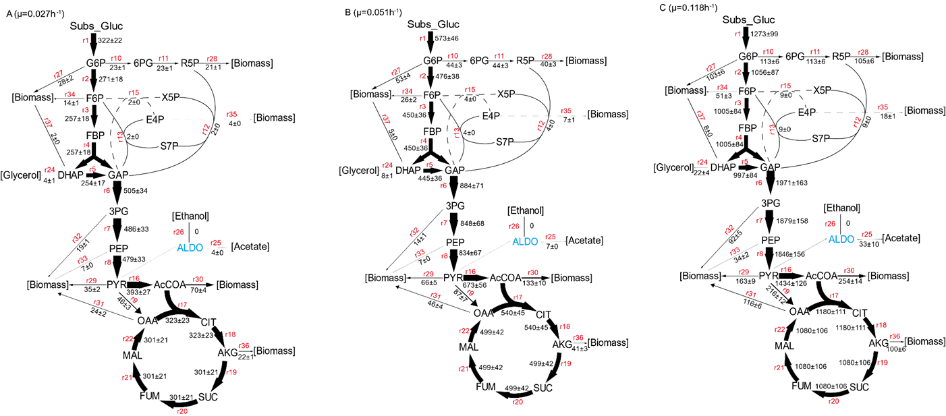
Supplemetary figure 1.

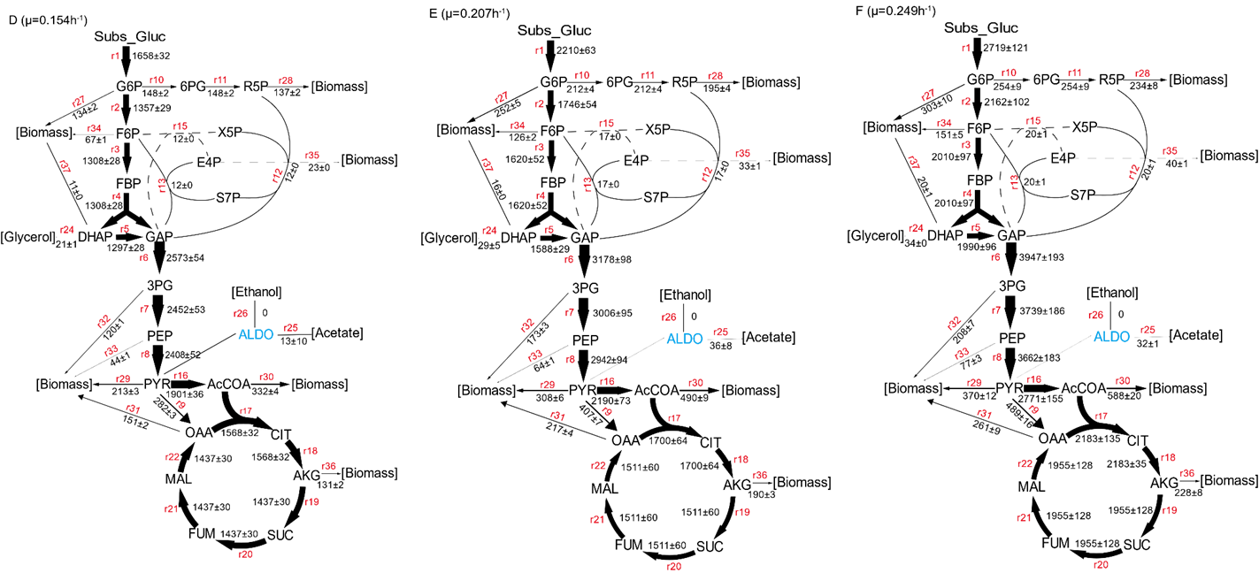
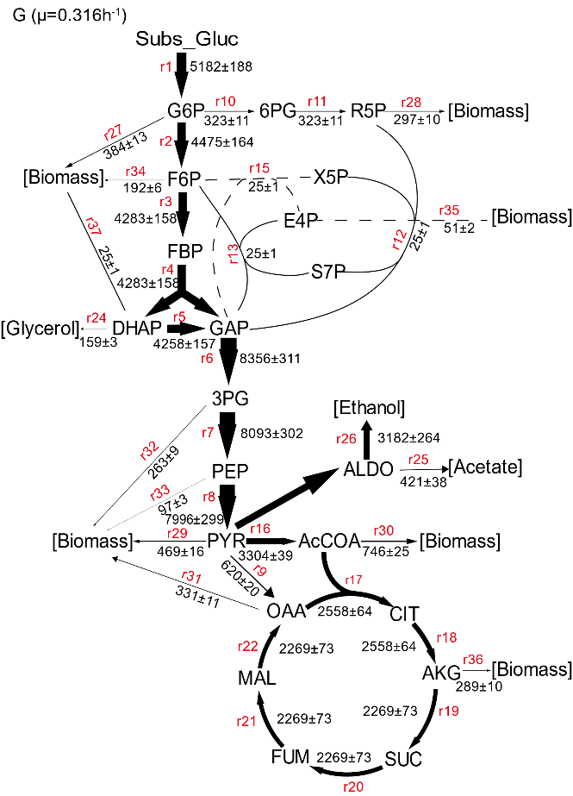
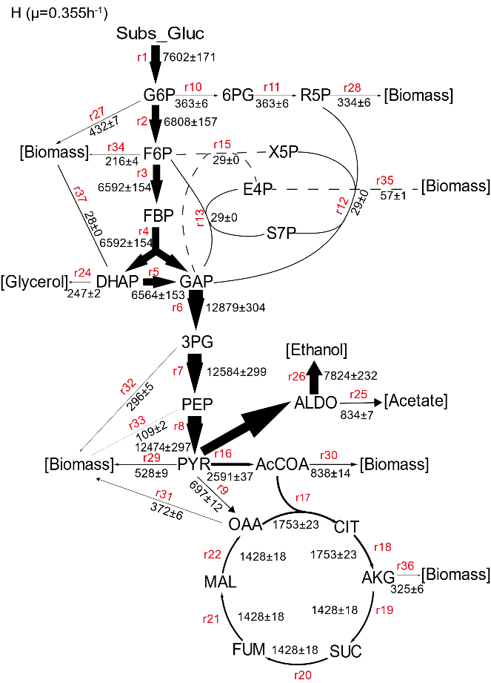
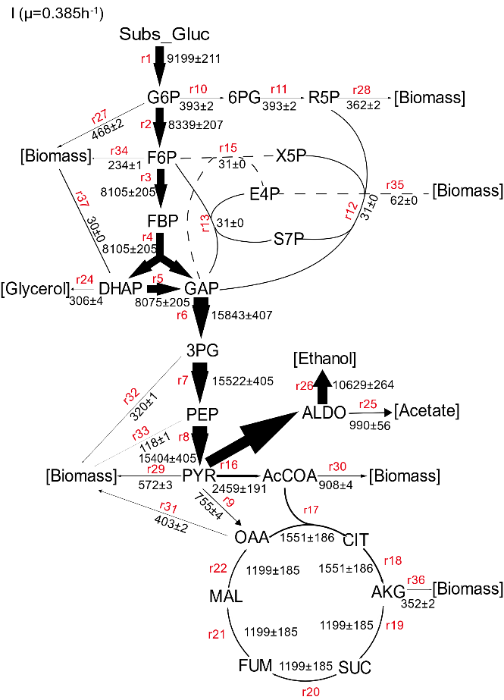

Supplemetary figure 1. Flux distribution across the nine dilution rates ((μ=0.027h⁻¹, 0.051h⁻¹, 0.118h⁻¹, 0.154h⁻¹, 0.207h⁻¹, 0.249h⁻¹, 0.316h⁻¹, 0.355h⁻¹, 0.385h⁻¹). The unit of the flux values were given in μmol/g_{DW}⁻¹h⁻¹. The reaction arrow thickness scales linear with the flux value with a maximal thickness of 10 pt.

Supplementary figure 2.
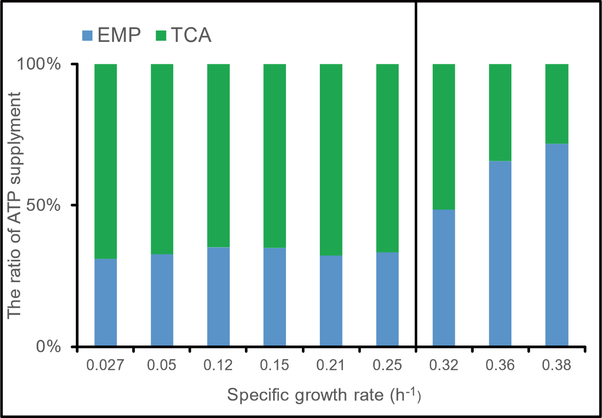

Supplementary figure 2. Percentage bar graph of ATP supply sources under different specific growth rates. Green bar showed that ATP was derived from oxidative phosphorylation (calculated from P/O=1.2 of budding yeast), while blue bar showed that ATP was derived from the glycolysis (calculated from metabolic flux). The black line indicated the critical specific growth rate, with respiration conditions on the left and respiro-fermentation conditions on the right.

Supplementary Table 1-5.
Supplementary table 1-5：Reaction network including the atom transitions

Flux ID | Yeast-7.6 ID | Reaction name | Abbreviation | Pathway | Reactions | Carbon transitions
r1 | r_0534 | Hexokinase (D-glucose:ATP) | HXK | EMP | Subs_GLC --> G6P | ABCDEF --> ABCDEF
r2 | r_0467 | Glucose-6-phosphate isomerase | GPI | EMP | G6P --> F6P | ABCDEF --> ABCDEF
r3 | r_0886 | Phosphofructokinase | PFK | EMP | F6P --> FBP | ABCDEF --> ABCDEF
r4 | r_0450 | Fructose-bisphosphate aldolase | FBA | EMP | FBP --> DHAP + GAP | ABCDEF --> CBA + DEF
r5 | r_1054 | Triose-phosphate isomerase | TPI | EMP | DHAP --> GAP | ABC --> ABC
r6 | r_0486+r_0892 | glyceraldehyde-3-phosphate dehydrogenase+ phosphoglycerate kinase | GAPDH+ PGK | EMP | GAP --> 3PG | ABC --> ABC
r7 | r_0893+r_0366 | phosphoglycerate mutase + enolase | GPM + ENO | EMP | 3PG --> PEP | ABC --> ABC
r8 | r_0962 | Pyruvate kinase | PYK | EMP | PEP -->PYR | ABC --> ABC
r9 | r_0958 | Pyruvate carboxylase | PYC | TCA | PYR + Ind_CO2 --> OAA | ABC + D --> ABCD
r10 | r_0466+r_0091 | Glucose 6-phosphate dehydrogenase+6-phosphogluconolactonase | ZWF + SOL | PPP | G6P --> 6PG | ABCDEF --> ABCDEF
r11 | r_0889+r_0982 | phosphogluconate dehydrogenase + ribose-5-phosphate isomerase | GND + RRE | PPP | 6PG --> Ind_CO2 + R5P | ABCDEF --> A + BCDEF
r12 | r_1049 | Transketolase 1 | TKL1 | PPP | X5P + R5P --> S7P + GAP | ABCDE + FGHIJ --> ABFGHIJ + CDE
r13 | r_1048 | Transaldolase1 | TAL | PPP | GAP + S7P --> E4P + F6P | ABC + DEFGHIJ --> GHIJ + DEFABC
r14 | r_1050 | Transketolase 2 | TKL2 | PPP | GAP + F6P --> X5P + E4P | CDE + ABFGHI --> ABCDE + FGHI
r15* | r_1050 | Transketolase 2 | TKL2 |  | X5P + E4P --> GAP + F6P | ABCDE + FGHI --> CDE + ABFGHI
r16 | r_0961 | Pyruvate dehydrogenase | PDH | TCA | PYR --> ACCOA + Ind_CO2 | ABC --> BC + A
r17 | r_0300 | Citrate synthase | CIT Synth | TCA | ACCOA + OAA --> CIT | AB + CDEF --> FEDCBA
r18 | r_0302+r_0280+r_0658 | citrate to cis-aconitate (3-) + cis-aconitate (3-) to isocitrate+ isocitrate dehydrogenase (NAD+) | ACO + IDH | TCA | CIT --> AKG + Ind_CO2 | ABCDEF --> ABCDE + F
r19 | r_0831+r_1022 | oxoglutarate dehydrogenase (dihydrolipoamide S-succinyltransferase) + succinate-CoA ligase (ADP-forming) | KGD + LSC | TCA | AKG --> Sym_SUC + Ind_CO2 | ABCDE --> BCDE + A
r20 | r_1021 | succinate dehydrogenase (ubiquinone-6) | SDH | TCA | Sym_SUC --> Sym_FUM | ABCD --> ABCD
r21 | r_0451 | Fumarase | FUM | TCA | Sym_FUM --> MAL | ABCD --> ABCD
r22 | r_0713 | Malate dehydrogenase | MDH | TCA | MAL --> OAA | ABCD --> ABCD
r23 |  |  |  |  | G6P --> TRE | ABCDEF --> ABCDEF
r24 |  | Pyruvate decarboxylase | PDC | EMP | GAP --> [GLY] | ABC --> ABC
r25 |  | Pyruvate decarboxylase | PDC | EMP | PYR--> [ACE] + Ind_CO2 | ABC --> AB + C
r26 |  |  |  |  | PYR--> [ETH] + Ind_CO2 | ABC --> AB + C
r27 |  |  |  |  | G6P --> [Biomass]
r28 |  |  |  |  | R5P --> [Biomass]
r29 |  |  |  |  | PYR --> [Biomass]
r30 |  |  |  |  | ACCOA --> [Biomass]
r31 |  |  |  |  | OAA --> [Biomass]
r32 |  |  |  |  | 3PG --> [Biomass]
r33 |  |  |  |  | PEP --> [Biomass]
r34 |  |  |  |  | F6P --> [Biomass]
r35 |  |  |  |  | E4P --> [Biomass]
r36 |  |  |  |  | AKG --> [Biomass]
r37 |  |  |  |  | DHAP --> [Biomass]
Note: Yeast-7.6 ID line was the reaction ID which were corresponding to the reaction name of the genomic metabolic network model of the yeast7.6.
Subs_ was prefix for carbon sources such as glucose and Sym_ wans prefix for metabolites with symmetric structure such as succinate and fumarate.
[ ] was metabolic identifiers in square brackets were considered to be outside the metabolic systems.
22 reactions belong to EMP, PPP, and TCA cycle (Pathway line) were used for the following work.
For details can be looked up in ¹.

Supplementary Table 1-6.
Supplementary table 1-6：Precursor requirements for biomass formation

Precursor metabolite | Dilution Rate
Precursor metabolite | 0.027h⁻¹ | 0.051h⁻¹ | 0.118h⁻¹ | 0.154h⁻¹ | 0.207h⁻¹ | 0.249h⁻¹ | 0.316h⁻¹ | 0.355h⁻¹ | 0.385h⁻¹
ALA | -422 | -422 | -466 | -466 | -480 | -480 | -480 | -480 | -480
GLU | -805 | -805 | -850 | -850 | -915 | -915 | -915 | -915 | -915
ASP | -826 | -826 | -873 | -873 | -939 | -939 | -939 | -939 | -939
VAL | -241 | -241 | -255 | -255 | -274 | -274 | -274 | -274 | -274
PYR | -643 | -643 | -680 | -680 | -732 | -732 | -732 | -732 | -732
3PG | -716 | -716 | -780 | -780 | -833 | -833 | -833 | -833 | -833
R5P | -792 | -792 | -889 | -889 | -941 | -941 | -941 | -941 | -941
ACCOA | -2616 | -2616 | -2185 | -2185 | -2316 | -2316 | -2316 | -2316 | -2316
PEP | -271 | -271 | -286 | -286 | -308 | -308 | -308 | -308 | -308
E4P | -142 | -142 | -150 | -150 | -161 | -161 | -161 | -161 | -161
OAA | -76 | -76 | -109 | -109 | -109 | -109 | -109 | -109 | -109
DHAP | -92 | -92 | -72 | -72 | -79 | -79 | -79 | -79 | -79
G6P | -1037 | -1037 | -872 | -872 | -1216 | -1216 | -1216 | -1216 | -1216
F6P | -519 | -519 | -436 | -436 | -608 | -608 | -608 | -608 | -608
CO2 | 864 | 864 | 936 | 936 | 1001 | 1001 | 1001 | 1001 | 1001
NADH | 1240 | 1240 | 1338 | 1338 | 1432 | 1432 | 1432 | 1432 | 1432
NADPH | -10548 | -10548 | -10098 | -10098 | -10914 | -10914 | -10914 | -10914 | -10914
The data was calculated based on the biomass composition which has been reported. However, no measurements available for 0.027h⁻¹, 0.154h⁻¹, 0.249h⁻¹, 0.316h⁻¹, 0.355h⁻¹, and 0.385h⁻¹. The assumptions were made that the biomass composition was same to the 0.051h⁻¹ for the 0.027h⁻¹, 0.154h⁻¹ same to the 0.118h⁻¹, and 0.2491h⁻¹, 0.316h⁻¹, 0.355h⁻¹, 0.385h⁻¹ same to the 0.207h⁻¹. The negative coefficients indicate consumption of the respective metabolite, while positive indicate production. Unite for all precursor metabolite was μ mol/g_{DW}.
Supplementary Table 3-1.
Supplementary table 3-1：Consistency between measured flux and basic kinetic expression model (without allosteric modulators) fits.

Yeast-7.6 ID | Reaction name | Abbreviation | R² | RMSE
r_0300 | Citrate synthase | CIT Synth | 0.25 | 1.19
r_0302+r_0280+r_0658 | citrate to cis-aconitate (3-) + cis-aconitate (3-) to isocitrate+ isocitrate dehydrogenase (NAD+) | ACO + IDH | 0 | 0.56
r_0450 | Fructose-bisphosphate aldolase | FBA | 0.09 | 2.82
r_0451 | Fumarase | FUM | 0.12 | 0.56
r_0466+r_0091 | Glucose 6-phosphate dehydrogenase+6-phosphogluconolactonase | ZWF + SOL | 0.58 | 2.09
r_0467 | Glucose-6-phosphate isomerase | GPI | 0.24 | 2.15
r_0486+r_0892 | glyceraldehyde-3-phosphate dehydrogenase+ phosphoglycerate kinase | GAPDH+ PGK | 0 | 1.83
r_0534 | Hexokinase (D-glucose:ATP) | HXK | 0 | 1.31
r_0713 | Malate dehydrogenase | MDH | 0 | 1.12
r_0831+r_1022 | oxoglutarate dehydrogenase (dihydrolipoamide S-succinyltransferase) + succinate-CoA ligase (ADP-forming) | KGD + LSC | 0.19 | 1.43
r_0886 | Phosphofructokinase | PFK | 0.14 | 2.97
r_0889+r_0982 | phosphogluconate dehydrogenase + ribose-5-phosphate isomerase | GND + RRE | 0.34 | 2.27
r_0893+r_0366 | phosphoglycerate mutase + enolase | GPM + ENO | 0.41 | -8.27
r_0958 | Pyruvate carboxylase | PYC | 0 | 1.11
r_0959 | Pyruvate decarboxylase | PDC | 0.11 | 1.64
r_0961 | Pyruvate dehydrogenase | PDH | 0 | 6.10
r_0962 | Pyruvate kinase | PYK | 0.07 | 3.48
r_1021 | succinate dehydrogenase (ubiquinone-6) | SDH | 0.15 | 2.15
r_1048 | Transaldolase1 | TAL | 0.61 | 1.43
r_1049 | Transketolase 1 | TKL1 | 0.39 | 1.65
r_1050 | Transketolase 2 | TKL2 | 0.26 | 4.00
r_1054 | Triose-phosphate isomerase | TPI | 0.22 | 1.51
Note: R² was calculated by the linear fitting between the output of the basic kinetic expression and the measured flux across the 9 dilution rates. RMSE was the root of the mean squared error that was the mean of the square of the difference between the output of the basic kinetic expression and the measured flux across the 9 dilution rates. “+” indicated that the reaction was composite reaction.

Supplementary Table 3-2.
Supplementary table 3-2： Pseudo-allosteric regulators for Bayes-model.

Yeast-7.6 ID | Reaction Name | Regulators | Regulators Function
r_0300 | CIT Synth | None | None
r_0302+r_0280+r_0658 | ACO + IDH | None | None
r_0450 | FBA | AMP  ADP | Inhibitor  Inhibitor
r_0451 | FUM | CIT | Inhibitor
r_0466+r_0091 | ZWF + SOL | AMP  PEP  NADPH | Inhibitor  Inhibitor  Inhibitor
r_0467 | GPI | 6PG  E4P  M6P  RL5P  X5P  R5P  S7P | Inhibitor  Inhibitor  Inhibitor  Inhibitor  Inhibitor  Inhibitor  Inhibitor
r_0486+r_0892 | GAPDH+ PGK | 3PG  AMP  CIT  SUC  NAD  ADP | Inhibitor  Inhibitor  Activator  Inhibitor & Activator  Inhibitor  Inhibitor
r_0534 | HXK | 3PG  AMP  CIT  G6P  UDPG  COA  ATP  ADP | Activator  Inhibitor  Inhibitor  Activator  Inhibitor  Inhibitor  Inhibitor  Inhibitor
r_0713 | MDH | PEP | Activator
r_0831+r_1022 | KGD + LSC | CYS  NADH  ADP | Activator  Inhibitor  Activator
r_0886 | PFK | AMP  CIT  FBP  ATP  ADP | Inhibitor & Activator  Inhibitor  Activator  Inhibitor  Activator
r_0889+r_0982 | GND + RRE | ASP | Activator
r_0893+r_0366 | GPM + ENO | 3PG | Inhibitor
r_0958 | PYC | AKG  ASP | Inhibitor  Inhibitor & Activator
r_0959 | PDC | PYR | Inhibitor & Activator
r_0961 | PDH | FBP  PYR  NADH | Inhibitor  Inhibitor  Inhibitor
r_0962 | PYK | AMP  CIT  FBP  R5P  DHAP | Inhibitor  Inhibitor  Inhibitor & Activator  Activator  Activator
r_1021 | SDH | None | None
r_1048 | TAL | None | None
r_1049 | TKL1 | PEP  R5P | Inhibitor  Inhibitor
r_1050 | TKL2 | PEP  R5P | Inhibitor  Inhibitor
r_1054 | TPI | None | None
Note：None indicated no allosteric regulators for the enzymes. & implied that metabolite may be inhibitor or activator for the enzymes, which were reported on the Breda database and literature.

Supplementary Table 3-3.
Supplementary table 3-3： Best-supported predictions of physiological regulators of yeast CCM metabolism

Yeast-7.6 ID | R² | RMSE | Best allosteric modulators | A_R² | A_RMSE
r_0300 | 0.25 | 1.19 | None | None | None
r_0302 | 0 | 0.56 | None | None | None
r_0450 | 0.09 | 2.82 | None | None | None
r_0451 | 0 | 0.56 | None | None | None
r_0466 | 0.58 | 2.09 | PEP (-) | 0.86 | 0.91
r_0467 | 0.24 | 2.15 | 6PG (-) | 0.27 | 0.98
r_0486 | 0 | 1.83 | None | None | None
r_0534 | 0 | 1.31 | ATP (-) | 0.06 | 0.78
r_0713 | 0 | 1.12 | None | None | None
r_0831 | 0 | 1.43 | None | None | None
r_0886 | 0.14 | 2.97 | ATP (-) ADP (+) | 0.79 | 0.83
r_0889 | 0.34 | 2.27 | ASP (+) | 0.65 | 0.84
r_0893 | 0 |  | 3PG (-) | 0.41 | 1.27
r_0958 | 0 | 1.11 | None | None | None
r_0959 | 0.11 | 1.64 | None | None | None
r_0961 | 0 | 6.10 | None | None | None
r_0962 | 0 | 3.48 | FBP (+) | 0.35 | 0.76
r_1021 | 0.15 | 2.15 | None | None | None
r_1048 | 0.61 | 1.43 | None | None | None
r_1049 | 0 | 1.65 | PEP (-) | 0.81 | 1.44
r_1050 | 0.26 | 4.00 | R5P (-) | 0.54 | 1.35
r_1054 | 0.22 | 0.73 | None | None | None
Note: None means no best allosteric modulators for the enzymes. R² was determined by linear fitting of the measured flux with the output of the kinetic equation across the 9 experimental conditions. RMSE was mean squared error which was obtained by calculating the average sum of squares of the difference between the flux predicted by kinetic equation and observed flux. A_R² was calculated by linear fitting of the measured flux with the output of the kinetic equation with plausible allosteric modulators across the 9 experimental conditions. A_RMSE was mean squared error which was obtained by calculating the average sum of squares of the difference between the flux predicted by kinetic equation with plausible allosteric modulators and observed flux. (+) implies that the metabolite accelerates the reaction rate, while (-) suggests that the metabolite is allosteric inhibitors.

Supplementary Table 5-1.
Supplementary table 5-1： Metabolic enzymes for which the phosphorylation sites have been detected of CCM in this work.

Reaction ID | YORF | Enzyme name | Phosphorylation site | Phosphorylation function in the literature | Phosphorylation function in this work
r_0300 | YNR001C | CIT1 | Y356
r_0486+r_0892 | YJL052W | TDH1 | S201
r_0486+r_0892 | YJL052W | TDH1 | S146 |  | Inhibits the enzyme activity
r_0486+r_0892 | YJL052W | TDH1 | S149
r_0486+r_0892 | YJL052W | TDH1 | T151*
r_0486+r_0892 | YJL052W | TDH1 | Y253*
r_0486+r_0892 | YJR009C | TDH2 | T252
r_0486+r_0892 | YJR009C | TDH2 | Y253 |  | Inhibits the enzyme activity
r_0486+r_0892 | YJR009C | TDH2 | Y316*
r_0486+r_0892 | YJR009C | TDH2 | Y54*
r_0486+r_0892 | YCR012W | PGK1 | S76 |  | Inhibits the enzyme activity
r_0486+r_0892 | YCR012W | PGK1 | Y123
r_0486+r_0892 | YCR012W | PGK1 | Y75
r_0486+r_0892 | YCR012W | PGK1 | Y49
r_0534 | YCL040W | GLK1 | S2
r_0534 | YFR053C | HXK1 | S15
r_0534 | YFR053C | HXK1 | S293 |  | Inhibits the enzyme activity
r_0534 | YFR053C | HXK1 | T104*
r_0534 | YFR053C | HXK1 | Y439*
r_0534 | YFR053C | HXK1 | Y285*
r_0534 | YFR053C | HXK1 | Y112*
r_0893+r_0366 | YKL152C | GPM1 | T55
r_0893+r_0366 | YKL152C | GPM1 | Y90
r_0893+r_0366 | YKL152C | GPM1 | Y49
r_0893+r_0366 | YKL152C | GPM1 | S12*
r_0893+r_0366 | YKL152C | GPM1 | Y54*
r_0893+r_0366 | YGR254W | ENO1 | S188 |  | Inhibits the enzyme activity
r_0893+r_0366 | YGR254W | ENO1 | Y259 |  | Inhibits the enzyme activity
r_0893+r_0366 | YGR254W | ENO1 | Y191 |  | Increases the enzyme activity
r_0893+r_0366 | YGR254W | ENO1 | S205*
r_0893+r_0366 | YGR254W | ENO1 | Y202*
r_0893+r_0366 | YHR174W | ENO2 | S138*
r_0893+r_0366 | YHR174W | ENO2 | Y426*
r_0893+r_0366 | YHR174W | ENO2 | Y259 |  | Inhibits the enzyme activity
r_0893+r_0366 | YHR174W | ENO2 | Y131
r_0962 | YAL038W | CDC19 | Y59 |  | Inhibits the enzyme activity
r_0962 | YAL038W | CDC19 | S53*
r_0962 | YAL038W | CDC19 | Y74*
r_1054 | YDR050C | TPI1 | S71 |  | Increases the enzyme activity
r_1054 | YDR050C | TPI1 | S100
r_1054 | YDR050C | TPI1 | S215*
r_1054 | YDR050C | TPI1 | Y101*
r_1054 | YDR050C | TPI1 | Y67 |  | Increases the enzyme activity
r_0889+r_0982 | YHR183W | GND1 | S462*
r_1048 | YLR354C | TAL1 | Y290*
r_1049 | YPR074C | TKL1 | T2*
r_0450 | YKL060C | FBA1 | S313 | Increases the in vivo activity ² | Increases the enzyme activity
r_0450 | YKL060C | FBA1 | S76 |  | Increases the enzyme activity
r_0450 | YKL060C | FBA1 | S96*
r_0450 | YKL060C | FBA1 | Y310*
r_0450 | YKL060C | FBA1 | Y25*
r_0450 | YKL060C | FBA1 | Y247*
r_0450 | YKL060C | FBA1 | S83 |  | Increases the enzyme activity
r_0450 | YKL060C | FBA1 | Y93 |  | Inhibits the enzyme activity
r_0450 | YKL060C | FBA1 | Y101 |  | Inhibits the enzyme activity
r_0467 | YBR196C | PGI1 | S2
r_0467 | YBR196C | PGI1 | S5
r_0831+r_1022 | YGR244C | LSC2 | S263
r_0959 | YLR044C | PDC1 | S223 | Increases the in vivo activity ³
r_0959 | YLR044C | PDC1 | Y344 |  | Increases the enzyme activity
r_0959 | YLR044C | PDC1 | Y38*
r_0959 | YLR044C | PDC1 | Y259*
r_0959 | YLR044C | PDC1 | Y263 |  | Inhibits the enzyme activity
r_0886 | YGR240C | PFK1 | S188 |  | Inhibits the enzyme activity
r_0886 | YGR240C | PFK1 | S189 |  | Inhibits the enzyme activity
r_0886 | YGR240C | PFK1 | S192 |  | Inhibits the enzyme activity
r_0886 | YGR240C | PFK1 | S179 |  | Inhibits the enzyme activity
r_0886 | YGR240C | PFK1 | S185 |  | Inhibits the enzyme activity
r_0886 | YGR240C | PFK1 | T178
r_0886 | YMR205C | PFK2 | S160 |  | Increases the enzyme activity
r_0886 | YMR205C | PFK2 | S163 | Inhibits in vitro activity ⁴ | Inhibits the enzyme activity
r_0886 | YMR205C | PFK2 | S166 | Increases the in vivo activity ² | Inhibits the enzyme activity
r_0886 | YMR205C | PFK2 | S167 |  | Inhibits the enzyme activity
r_0886 | YMR205C | PFK2 | S171 | Increases the in vivo activity ² | Increases the enzyme activity
r_0886 | YMR205C | PFK2 | T152 |  | Inhibits the enzyme activity
r_0886 | YMR205C | PFK2 | T148*
r_0886 | YMR205C | PFK2 | T173*
r_0961 | YER178W | PDA1 | S313 | Inhibits in vitro activity ⁵ | Inhibits the enzyme activity
Note: For “Phosphorylation site” column, the S means serine, Y is tyrosine, and T is threonine. For “Phosphorylation function in this work” column, the methods for exploring the function phosphorylation events has been expounded in Materials and methods. * means phosphorylation data exists under only one condition.

Reference：

1. Kajihata S, Furusawa C, Matsuda F, Shimizu H. OpenMebius: an open source software for isotopically nonstationary 13C-based metabolic flux analysis. BioMed research international 2014, (2014).

2. Chen Y, Wang Y, Nielsen J. Systematic inference of functional phosphorylation events in yeast metabolism. Bioinformatics 33, 1995-2001 (2017).

3. de Assis LJ, Zingali RB, Masuda CA, Rodrigues SP, Montero-Lomeli M. Pyruvate decarboxylase activity is regulated by the Ser/Thr protein phosphatase Sit4p in the yeast Saccharomyces cerevisiae. FEMS Yeast Res 13, 518-528 (2013).

4. Chen Y, Nielsen J. Flux Control through Protein Phosphorylation in Yeast. Fems Yeast Research 16, fow096 (2016).

5. Oliveira AP, Ludwig C, Picotti P, Kogadeeva M, Aebersold R, Sauer U. Regulation of yeast central metabolism by enzyme phosphorylation. Molecular Systems Biology 8, 623 (2012).

