The anti-hypoxia protective effect of WYY026B by combining with red blood cells

Yuying Zhang^{1,2}, Pingping Zhang², Ye Liu²*

¹ Department of Maternal, Child and Adolescent Health, School of Public Health, Tianjin Medical University, No. 22 Qixiangtai Road, Tianjin 300070, China
² Beijing Honghui Meditech Co., Ltd, No. 50 Huatuo Road, CBP Daxing, Beijing 102600, China

*Corresponding author (Email, ye.liu@honghui-meditech.com)

HPLC spectra of WYY026B.

The interaction relationship between WYY026B with blood components.

Plasma-WYY026B
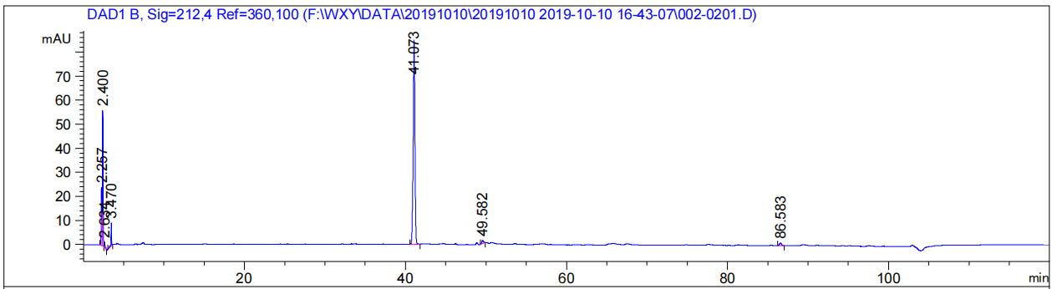
Peak RetTime Type Width Area Height Area
# [min] - [min] [mAU*s] [mAU] %
1 2.257 BV 0.1125 175.68054 24.26819 9.8461
2 2.400 VB 0.0636 249.96765 56.54729 14.0095
3 2.634 BB 0.0940 14.13024 2.16825 0.7919
4 3.470 BB 0.0570 36.95824 9.57759 2.0713
5 41.073 BB 0.2235 1270.10400 84.43288 71.1833
6 49.582 BB 0.2123 18.54734 1.33297 1.0395
7 86.583 BB 0.2728 18.88366 1.03543 1.0583
Totals: 1784.27168 179.36261

Plasma-Control 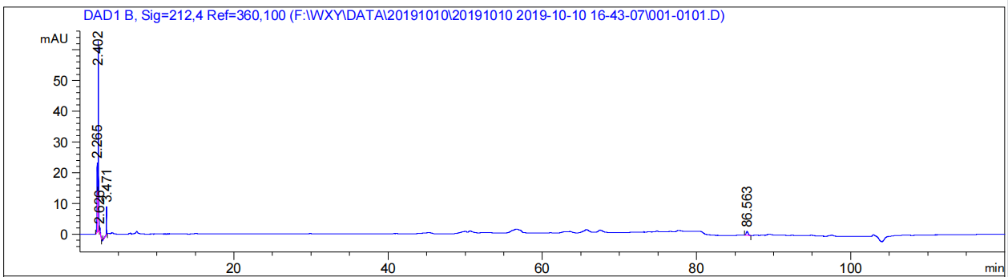
Peak RetTime Type Width Area Height Area
# [min] - [min] [mAU*s] [mAU] %
1 2.265 BV 0.1117 163.05774 22.74004 32.0980
2 2.402 VB 0.0652 284.03394 62.27346 55.9123
3 2.626 BB 0.0864 7.87488 1.34376 1.5502
4 3.471 BB 0.0503 30.60238 9.32404 6.0241
5 86.563 BB 0.2848 22.43034 1.26554 4.4154
Totals: 507.99927 96.94684

RBC-WYY026B 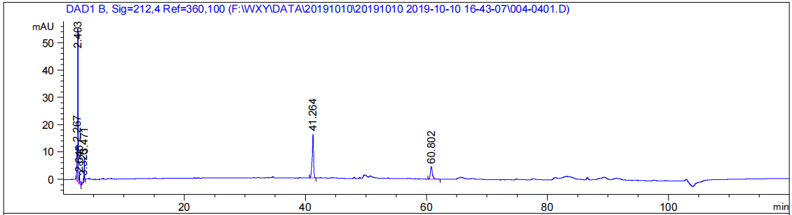
Peak RetTime Type Width Area Height Area
# [min] - [min] [mAU*s] [mAU] %
1 2.267 BV 0.0939 86.10897 13.23029 10.9597
2 2.403 VV 0.0685 271.61786 56.11665 34.5707
3 2.645 VB 0.1196 27.48797 3.21927 3.4986
4 3.326 BV 0.0834 7.18121 1.24348 0.9140
5 3.471 VB 0.0526 28.71968 8.67602 3.6554
6 41.264 BB 0.2316 258.44254 16.07115 32.8938
7 60.802 BB 0.3490 106.12959 4.56934 13.5079
Totals: 785.68782 103.12620

RBC-Control 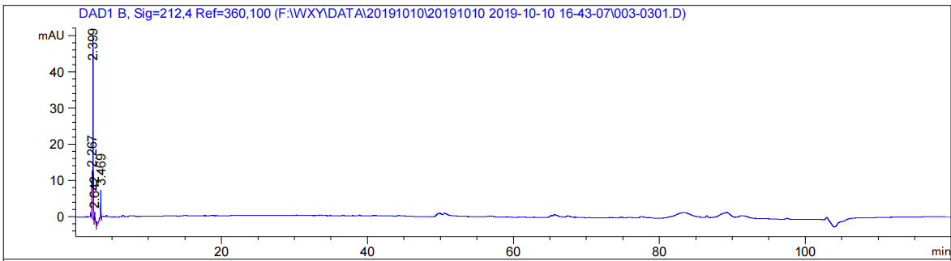
Peak RetTime Type Width Area Height Area
# [min] - [min] [mAU*s] [mAU] %
1 2.267 BV 0.0900 78.86114 13.13986 21.9580
2 2.399 VB 0.0673 230.75621 50.55383 64.2515
3 2.642 BB 0.1018 16.98748 2.48218 4.7300
4 3.469 BB 0.0603 32.54068 7.86289 9.0606
Totals: 359.14551 74.03876

Whole blood-WYY026B
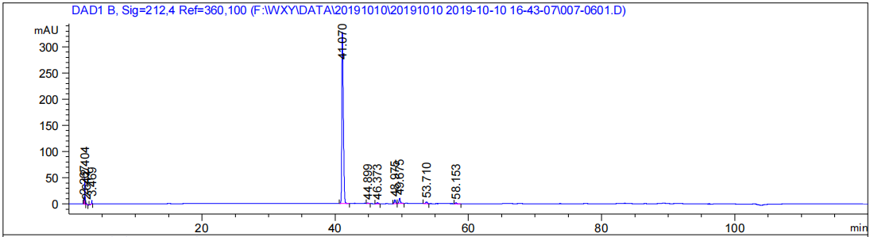
Peak RetTime Type Width Area Height Area
# [min] - [min] [mAU*s] [mAU] %
1 2.267 BV 0.0811 63.92680 11.81028 1.0717
2 2.404 VB 0.0702 231.59978 48.10410 3.8828
3 2.641 BB 0.1027 16.92236 2.33088 0.2837
4 3.469 BB 0.0555 29.97754 8.03413 0.5026
5 41.070 BB 0.2495 5262.45117 327.52191 88.2248
6 44.899 BB 0.1975 15.13468 1.19673 0.2537
7 46.373 BB 0.2087 23.10174 1.69806 0.3873
8 48.975 BB 0.2014 97.80739 7.53914 1.6397
9 49.675 BB 0.2269 145.78290 9.61624 2.4440
10 53.710 BB 0.2566 56.65978 3.50511 0.9499
11 58.153 BB 0.1996 21.45876 1.65135 0.3598
Totals: 5964.82290 423.00793

Whole blood-Control
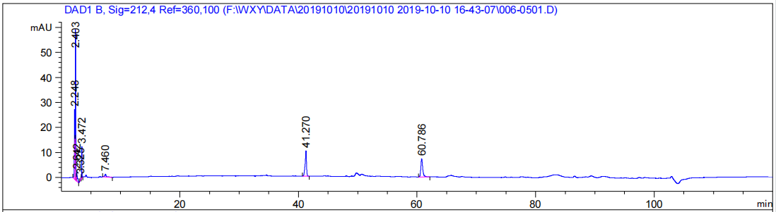
Peak RetTime Type Width Area Height Area
# [min] - [min] [mAU*s] [mAU] %
1 2.248 BV 0.1160 215.07550 27.88358 22.9484
2 2.403 VV 0.0689 294.43533 60.40036 31.4160
3 2.642 VB 0.1241 32.28872 3.61854 3.4452
4 3.325 BV 0.0792 5.33354 1.01722 0.5691
5 3.472 VB 0.0493 40.67118 12.71267 4.3396
6 7.460 BB 0.2605 19.96733 1.08621 2.1305
7 41.270 BB 0.2308 164.59105 10.27901 17.5617
8 60.786 BB 0.3405 164.85109 7.27190 17.5895
Totals: 937.21374 124.26949
The interaction relationship between WYY026B and RBC.
RBC-WYY026B-10 min-1
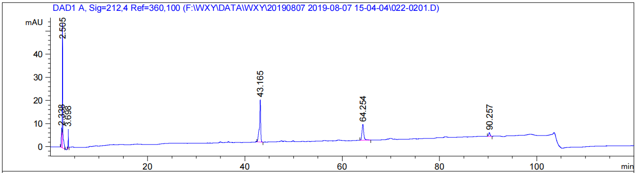
Peak RetTime Type Width Area Height Area
# [min] - [min] [mAU*s] [mAU] %
1 2.338 BV 0.1232 77.00433 8.53891 7.8979
2 2.505 VV 0.0873 339.10394 53.95482 34.7800
3 3.698 BB 0.0620 35.17643 8.20869 3.6079
4 43.165 BB 0.2435 318.09430 18.41626 32.6252
5 64.254 BB 0.3857 176.15674 6.90367 18.0674
6 90.257 BB 0.2944 29.46029 1.55942 3.0216
Totals: 974.99603 97.58177

RBC-WYY026B-10 min-2
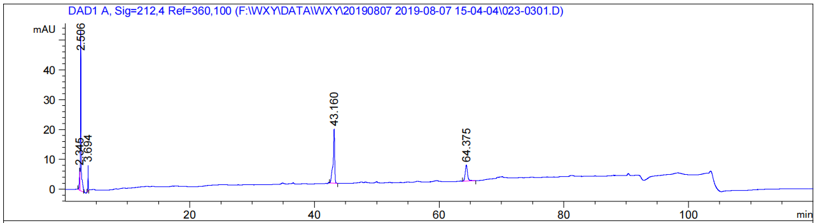
Peak RetTime Type Width Area Height Area
# [min] - [min] [mAU*s] [mAU] %
1 2.345 BV 0.1087 55.26474 7.27274 6.1815
2 2.506 VV 0.0869 345.48587 53.82037 38.6435
3 3.694 BB 0.0577 33.74322 8.61222 3.7743
4 43.160 BB 0.2504 321.28574 18.15952 35.9366
5 64.375 BB 0.3853 138.25429 5.35386 15.4641
Totals: 894.03386 93.21869

RBC-WYY026B-10 min-3
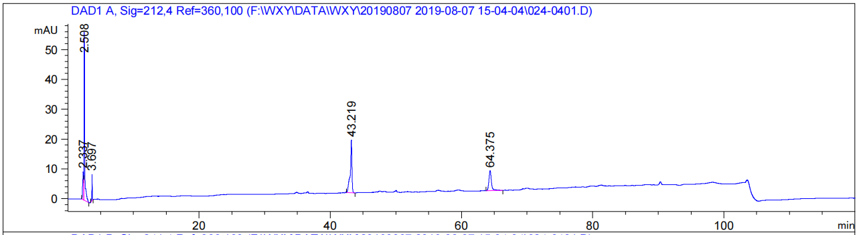
Peak RetTime Type Width Area Height Area
# [min] - [min] [mAU*s] [mAU] %
1 2.337 BV 0.1240 83.53018 9.37477 8.5077
2 2.508 VB 0.0898 366.29947 56.34456 37.3082
3 3.697 BB 0.0608 37.21120 8.89434 3.7900
4 43.219 BB 0.2530 317.64371 17.73385 32.3525
5 64.375 BB 0.3979 177.13516 6.66781 18.0415
Totals: 981.81972 99.01534

RBC-WYY026B-30 min-1
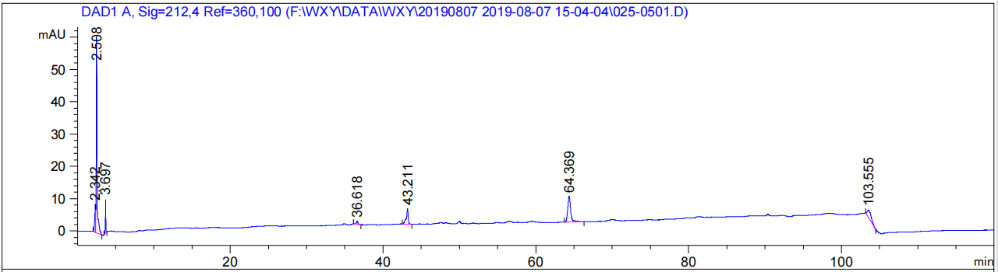
Peak RetTime Type Width Area Height Area
# [min] - [min] [mAU*s] [mAU] %
1 2.342 BV 0.1143 71.13890 8.62286 7.8491
2 2.508 VB 0.0895 393.65820 60.84459 43.4343
3 3.697 BB 0.0565 39.51823 10.37158 4.3602
4 36.618 BB 0.2124 14.46229 1.01388 1.5957
5 43.211 BB 0.2531 87.57143 4.83921 9.6622
6 64.369 BB 0.3969 209.13817 7.95023 23.0753
7 103.555 BB 0.5937 90.84332 2.38890 10.0232
Totals: 906.33054 96.03125

RBC-WYY026B-30 min-2
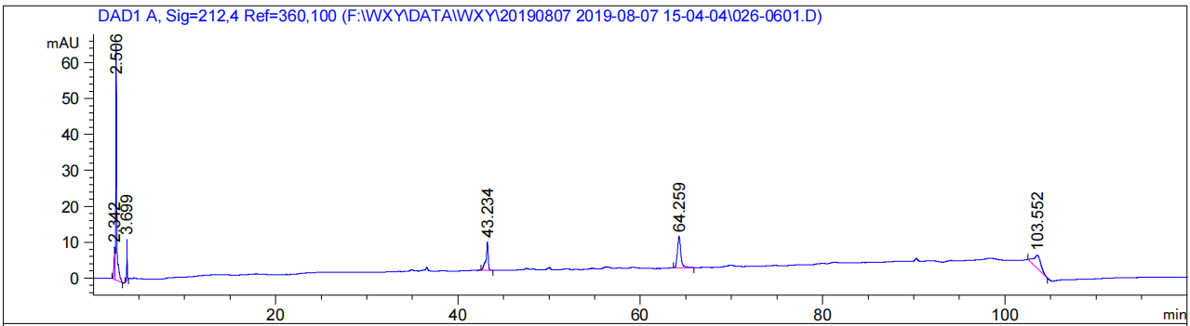
Peak RetTime Type Width Area Height Area
# [min] - [min] [mAU*s] [mAU] %
1 2.342 BV 0.1111 72.27544 9.05996 6.5728
2 2.506 VB 0.0894 421.74414 65.26703 38.3540
3 3.699 BB 0.0552 41.92844 11.32483 3.8130
4 43.234 BB 0.2494 140.63057 7.91002 12.7892
5 64.259 BB 0.3909 226.64854 8.72900 20.6118
6 103.552 BB 0.7789 196.38081 3.65490 17.8592
Totals: 1099.60796 105.94574

RBC-WYY026B-30 min-3
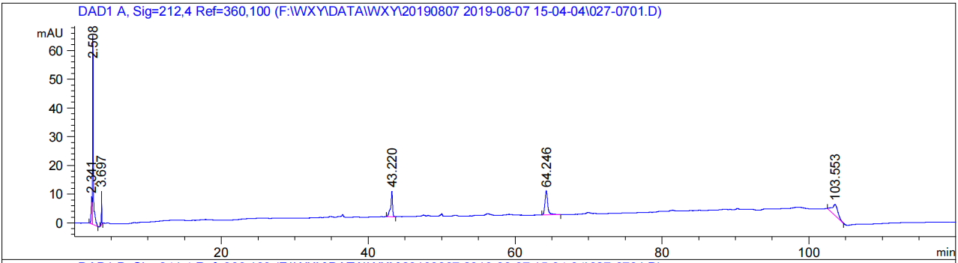
Peak RetTime Type Width Area Height Area
# [min] - [min] [mAU*s] [mAU] %
1 2.341 BV 0.1160 78.23196 9.51094 6.8758
2 2.508 VB 0.0908 433.12149 65.82428 38.0669
3 3.697 BB 0.0551 42.88240 11.61663 3.7689
4 43.220 BB 0.2502 157.20810 8.89530 13.8170
5 64.246 BB 0.3881 217.22046 8.33297 19.0914
6 103.553 BB 0.7875 209.12599 3.81528 18.3800
Totals: 1137.79040 107.99540

RBC-WYY026B-60 min-1
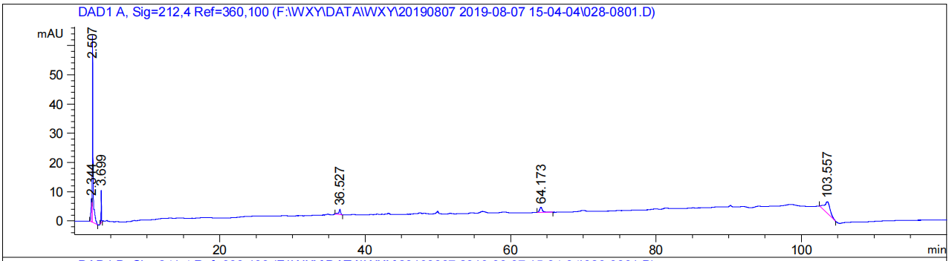
Peak RetTime Type Width Area Height Area
# [min] - [min] [mAU*s] [mAU] %
1 2.344 BV 0.1176 65.81568 7.86438 7.9507
2 2.507 VB 0.0884 418.07056 63.85777 50.5040
3 3.699 BB 0.0550 41.15170 11.16660 4.9712
4 36.527 BB 0.2457 30.41441 1.77712 3.6741
5 64.173 BB 0.4091 49.97013 1.75025 6.0365
6 103.557 BB 0.7769 222.37402 4.02288 26.8634
Totals: 827.79650 90.43900

RBC-WYY026B-60 min-2
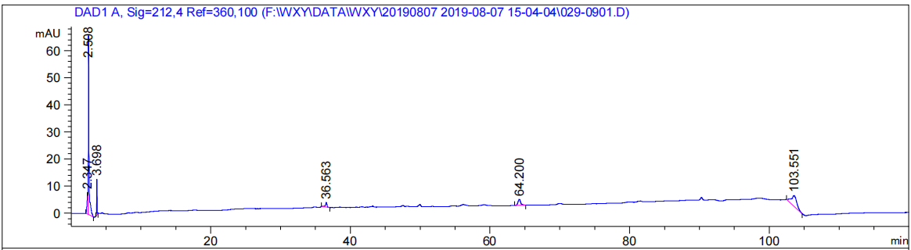
Peak RetTime Type Width Area Height Area
# [min] - [min] [mAU*s] [mAU] %
1 2.347 BV 0.1166 68.15390 8.06204 7.9763
2 2.508 VB 0.0880 433.71625 66.61253 50.7592
3 3.698 BB 0.0539 47.22454 13.13780 5.5268
4 36.563 BB 0.2432 30.20371 1.80481 3.5348
5 64.200 BB 0.3860 57.66507 2.24248 6.7487
6 103.551 BB 0.7884 217.49503 3.96229 25.4541
Totals: 854.45850 95.82195

RBC-WYY026B-60 min-3
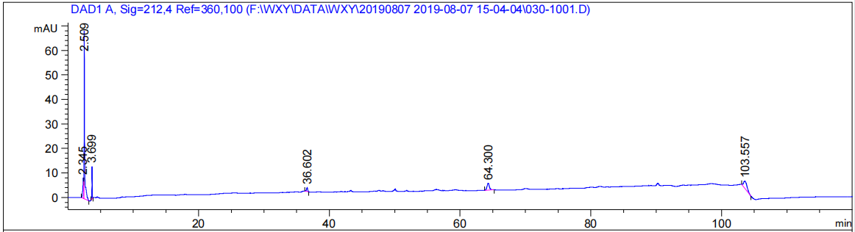
Peak RetTime Type Width Area Height Area
# [min] - [min] [mAU*s] [mAU] %
1 2.345 BV 0.1159 68.96851 8.21608 9.0114
2 2.509 VB 0.0870 442.57626 68.87100 57.8269
3 3.699 BB 0.0542 47.89835 13.25746 6.2584
4 36.602 BB 0.1949 19.88651 1.55827 2.5984
5 64.300 BB 0.3724 70.48425 2.81251 9.2095
6 103.557 BB 0.5940 115.53310 2.96890 15.0955
Totals: 765.34700 97.68423

RBC-WYY026B reference compound
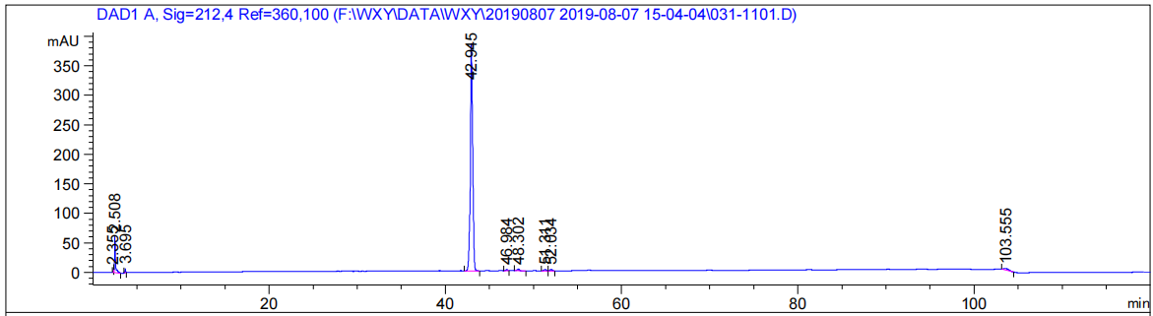
Peak RetTime Type Width Area Height Area
# [min] - [min] [mAU*s] [mAU] %
1 2.355 BV 0.0888 32.62230 5.70163 0.4176
2 2.508 VB 0.0927 410.60025 60.88055 5.2559
3 3.695 BB 0.0600 31.59076 7.67335 0.4044
4 42.945 BB 0.2751 7093.03125 384.80093 90.7939
5 46.984 BB 0.2121 23.61585 1.63883 0.3023
6 48.302 BB 0.2387 42.19490 2.50328 0.5401
7 51.311 BB 0.2282 31.28978 2.09596 0.4005
8 52.034 BB 0.2389 37.76220 2.43571 0.4834
9 103.555 BB 0.5831 109.52850 2.90991 1.4020
Totals: 7812.23579 470.64014

RBC-Control
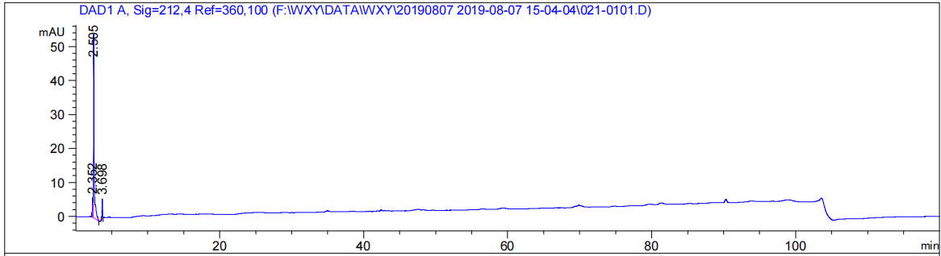
Peak RetTime Type Width Area Height Area
# [min] - [min] [mAU*s] [mAU] %
1 2.352 BV 0.0903 32.90015 5.62270 8.0463
2 2.505 VB 0.0874 349.23007 54.05188 85.4106
3 3.698 BB 0.0634 26.75377 6.06801 6.5431
Totals: 408.88399 65.74260

The effect of drug dosage on the interaction of WYY026B to RBC.
RBC-WYY026B-10 min-20 μg/mL
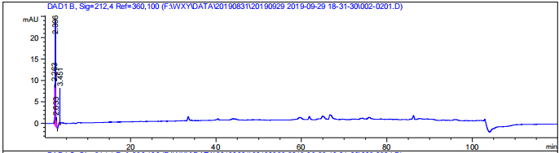
Peak RetTime Type Width Area Height Area
# [min] - [min] [mAU*s] [mAU] %
1 2.263 BV 0.0848 55.10115 9.61981 18.8151
2 2.396 VV 0.1049 191.46429 24.57223 65.3783
3 2.633 VB 0.1258 18.92448 2.16826 6.4620
4 3.451 BB 0.0507 27.36609 8.26045 9.3446
Totals: 292.85602 44.62074

RBC-WYY026B-10 min-50 μg/mL
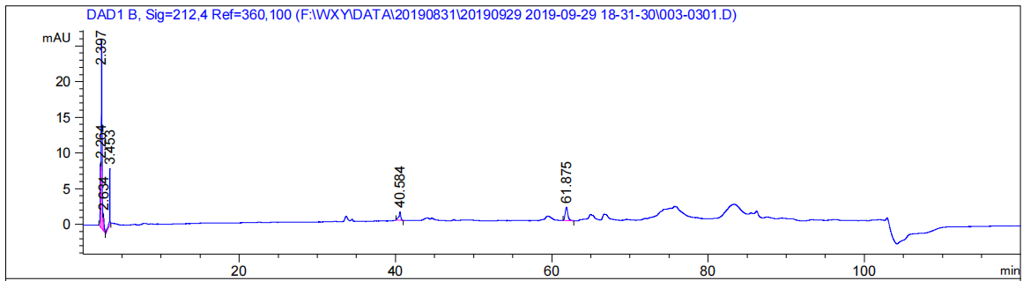
Peak RetTime Type Width Area Height Area
# [min] - [min] [mAU*s] [mAU] %
1 2.264 BV 0.0810 50.32898 9.03886 13.3959
2 2.397 VV 0.1072 211.28955 26.44491 56.2381
3 2.634 VB 0.1263 20.45853 2.33335 5.4454
4 3.453 BB 0.0561 30.01314 7.94649 7.9885
5 40.584 BB 0.2510 20.54961 1.15806 5.4696
6 61.875 BB 0.3539 43.06524 1.87511 11.4625
Totals: 375.70505 48.79678

RBC-WYY026B-10 min-100 μg/mL
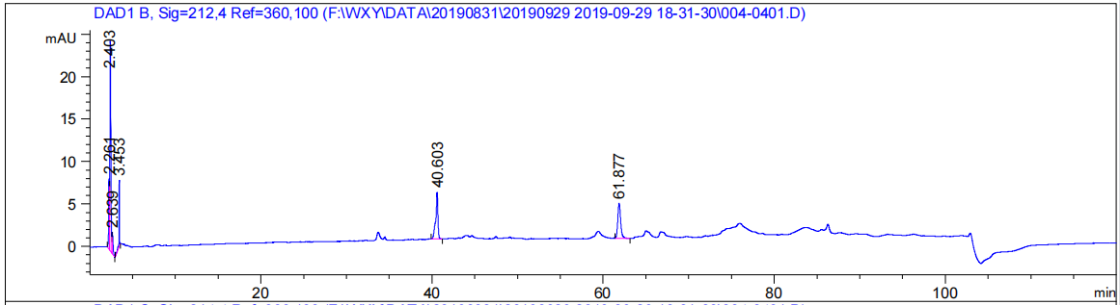
Peak RetTime Type Width Area Height Area
# [min] - [min] [mAU*s] [mAU] %
1 2.261 BV 0.0858 48.62573 8.36975 9.8593
2 2.403 VV 0.1114 202.59203 24.76740 41.0772
3 2.639 VB 0.1335 22.95550 2.53820 4.6544
4 3.453 BB 0.0526 27.21632 7.81856 5.5183
5 40.603 BB 0.2448 96.05373 5.52578 19.4757
6 61.877 BB 0.3506 95.75509 4.12768 19.4151
Totals: 493.19840 53.14737

RBC-WYY026B-10 min-200 μg/mL
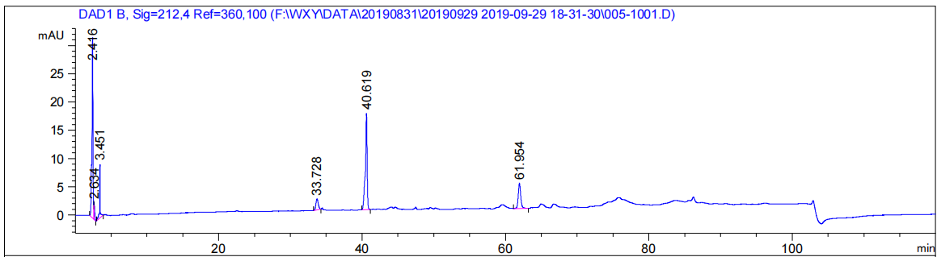
Peak RetTime Type Width Area Height Area
# [min] - [min] [mAU*s] [mAU] %
1 2.416 BV 0.1526 324.84885 31.95170 38.6807
2 2.634 VB 0.1297 25.85955 2.96560 3.0792
3 3.451 BB 0.0701 47.43039 9.51622 5.6477
4 33.728 BB 0.3656 44.65203 1.93256 5.3168
5 40.619 BB 0.2381 289.84082 17.07001 34.5122
6 61.954 BB 0.3673 107.18959 4.44548 12.7634
Totals: 839.82123 67.88156

RBC-WYY026B-10 min-250 μg/mL
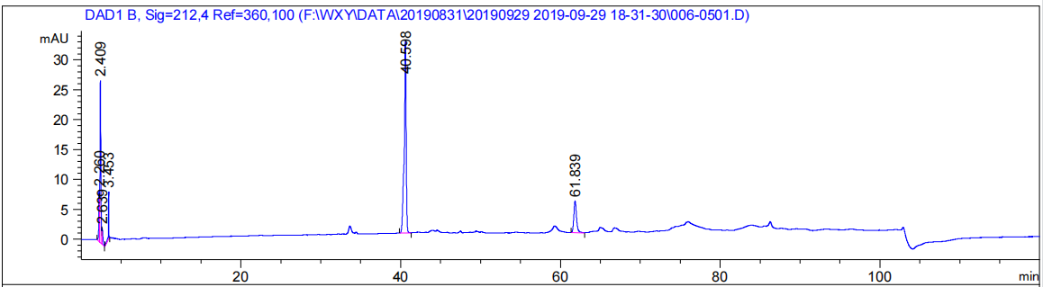
Peak RetTime Type Width Area Height Area
# [min] - [min] [mAU*s] [mAU] %
1 2.260 BV 0.0914 54.42013 8.64846 5.4899
2 2.409 VV 0.1265 215.07376 27.13049 21.6967
3 2.639 VB 0.1357 24.61586 2.71781 2.4833
4 3.453 BB 0.0560 30.46959 8.07286 3.0738
5 40.598 BB 0.2411 542.94086 32.14155 54.7721
6 61.839 BB 0.3568 123.75173 5.29227 12.4841
Totals: 991.27193 84.00344

RBC-WYY026B-10 min-260 μg/mL
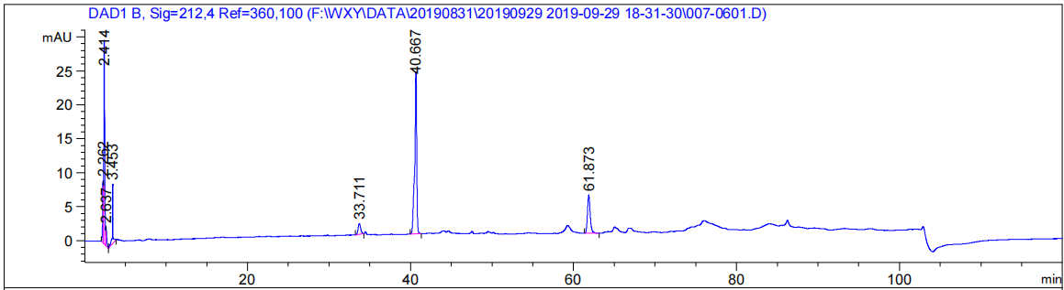
Peak RetTime Type Width Area Height Area
# [min] - [min] [mAU*s] [mAU] %
1 2.262 BV 0.0914 57.76990 9.17891 6.1121
2 2.414 VV 0.1282 242.63110 30.06057 25.6706
3 2.637 VB 0.1367 24.63972 2.74431 2.6069
4 3.453 BB 0.0728 45.83461 8.79690 4.8494
5 33.711 BB 0.3487 35.57430 1.60460 3.7638
6 40.667 BB 0.2416 408.12637 23.85822 43.1802
7 61.873 BB 0.3533 130.59399 5.61661 13.8170
Totals: 945.17000 81.86011

RBC-WYY026B-10 min-270 μg/mL
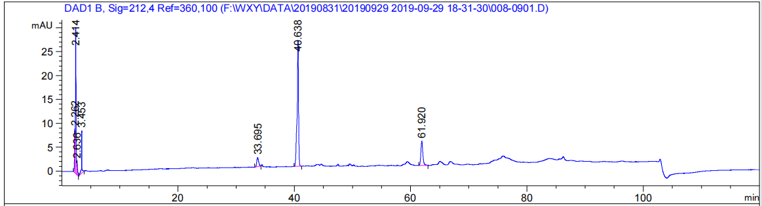
Peak RetTime Type Width Area Height Area
# [min] - [min] [mAU*s] [mAU] %
1 2.262 BV 0.0961 60.17924 9.22761 6.1591
2 2.414 VV 0.1236 240.73602 30.66089 24.6383
3 2.636 VB 0.1327 25.12034 2.85502 2.5710
4 3.453 BB 0.0719 45.94766 8.95198 4.7026
5 33.695 BB 0.3538 42.91749 1.89821 4.3924
6 40.638 BB 0.2381 443.18176 26.37253 45.3578
7 61.920 BB 0.3560 118.99630 5.06634 12.1788
Totals: 977.07881 85.03259

RBC-WYY026B-10 min-280 μg/mL
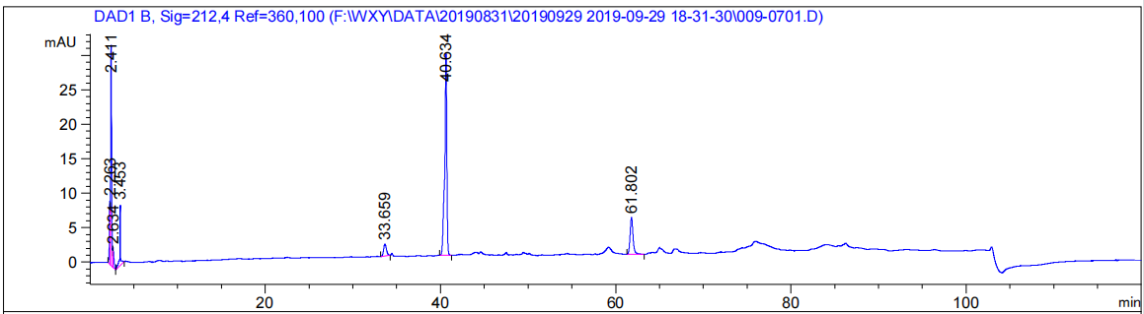
Peak RetTime Type Width Area Height Area
# [min] - [min] [mAU*s] [mAU] %
1 2.263 BV 0.0941 58.86876 9.27381 5.6949
2 2.411 VV 0.1231 250.27255 32.05717 24.2109
3 2.634 VB 0.1188 25.40152 2.82883 2.4573
4 3.453 BB 0.0730 45.94969 8.78843 4.4451
5 33.659 BB 0.3594 39.22337 1.72425 3.7944
6 40.634 BB 0.2373 490.57767 29.30765 47.4577
7 61.802 BB 0.3530 123.42308 5.31408 11.9397
Totals: 1033.71664 89.29422

WYY026B reference compound
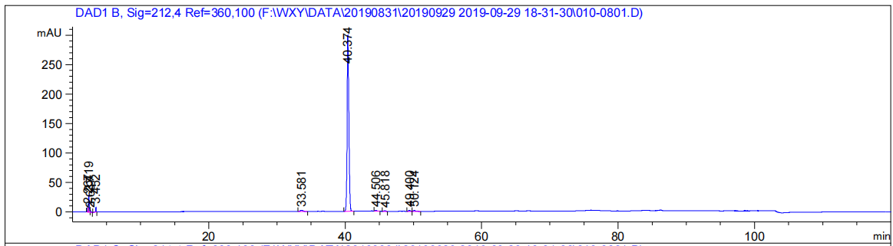
Peak RetTime Type Width Area Height Area
# [min] - [min] [mAU*s] [mAU] %
1 2.267 BV 0.0897 47.54037 8.19310 0.8291
2 2.419 VV 0.1238 233.76488 29.69436 4.0771
3 2.637 VB 0.1362 24.85557 2.78216 0.4335
4 3.452 BB 0.0595 31.35201 7.69702 0.5468
5 33.581 BB 0.3726 48.26945 2.02141 0.8419
6 40.374 BB 0.2674 5258.64258 298.66483 91.7155
7 44.506 BB 0.2185 21.13449 1.46319 0.3686
8 45.818 BB 0.2121 16.19338 1.09782 0.2824
9 49.400 BB 0.2254 23.13173 1.57460 0.4034
10 50.124 BB 0.2472 28.76265 1.75485 0.5016
Totals: 5733.64709 354.94335

Control
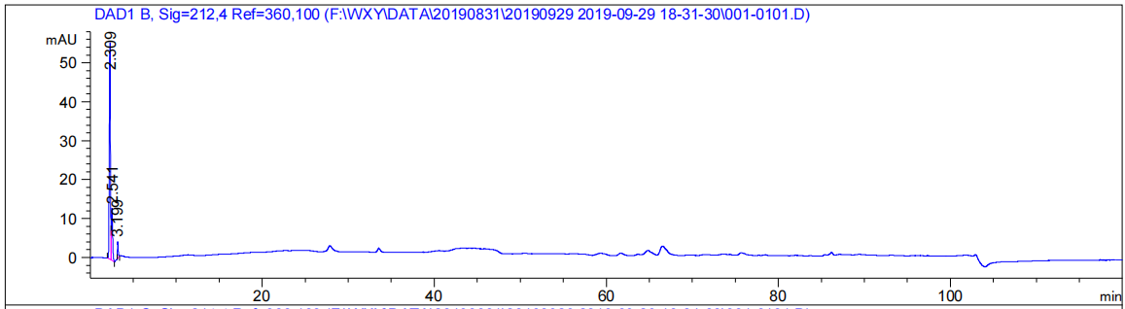
Peak RetTime Type Width Area Height Area
# [min] - [min] [mAU*s] [mAU] %
1 2.309 BV 0.1112 473.18100 55.64029 76.8396
2 2.541 VB 0.1175 116.48409 13.39382 18.9158
3 3.199 BB 0.0832 26.13818 4.28277 4.2446
Totals: 615.80326 73.31688

