Supplementary files

(A) DENV
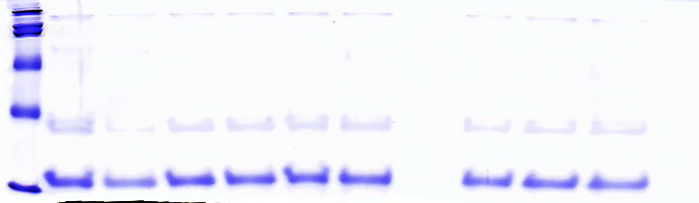

(B) JEV
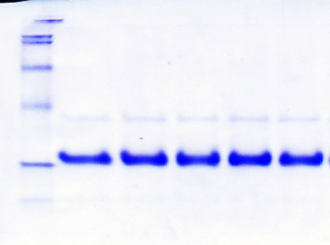

(C) ZIKV
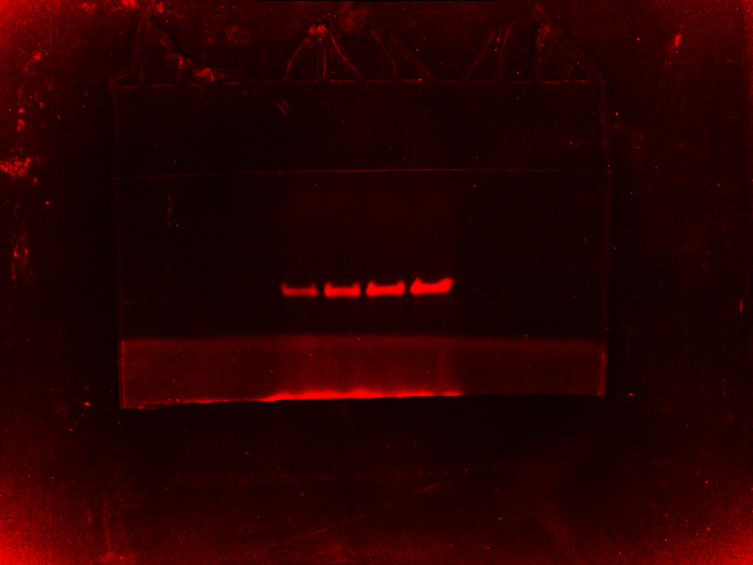

Supplementary Figure S1
The gel-based assay of GTase activity of each enzyme (A) DENV, (B) JEV and (C) ZIKV. The same gel was then stained with Coomassie blue R250 for loading control verification.

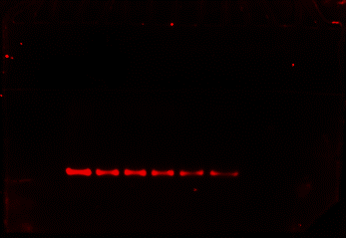
(A) DENV

GTase activity

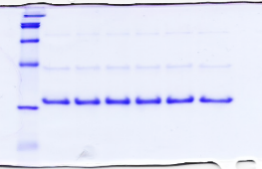
(1) (2) (3)
Coomassie
stain

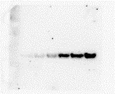

Western Blot

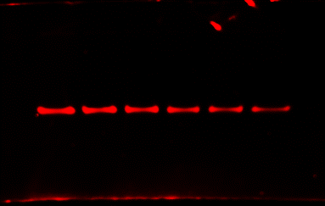
(B) JEV

GTase
Activity

(1) (2)
Coomassie
stain

Western Blot

(C) ZIKV
GTase
Activity

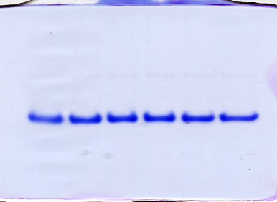
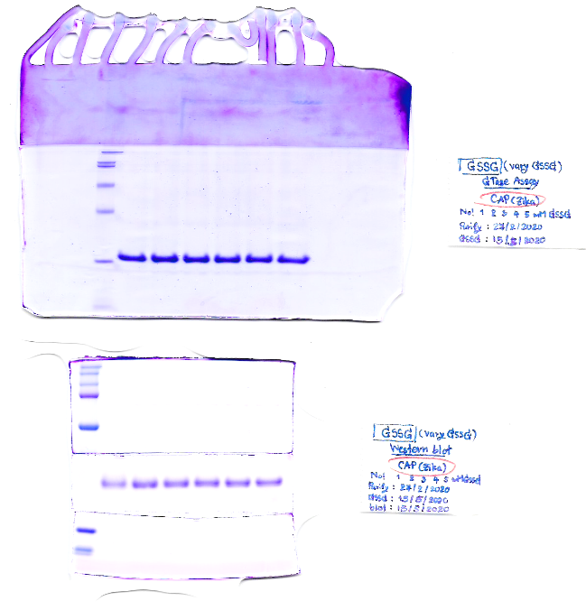
(1) (2)

Coomassie
stain

Western Blot

Supplementary Figure S2
The gel-based assay of GTase activity after glutathionylation of each enzyme (A) DENV (n=3), (B) JEV (n=2) and (C) ZIKV (n=2). The same gel was then stained with Coomassie blue R250 for loading control verification. The same samples were also used for western blot analysis detected with anti-GSH antibody.

