APPENDIX A. SUPPLEMENTARY DATA

Role of periosteum in alveolar bone regeneration comparing with collagen membrane in beagle dogs

Zhigui Ma^{1*} Ph.D., Ke Guo^{2*} M.S., Lu Chen¹ M.S., Xinwei Chen¹ Ph.D., Duohong Zou^{1#} Ph.D., Chi Yang^{1#} Ph.D.

Supplemental Figures
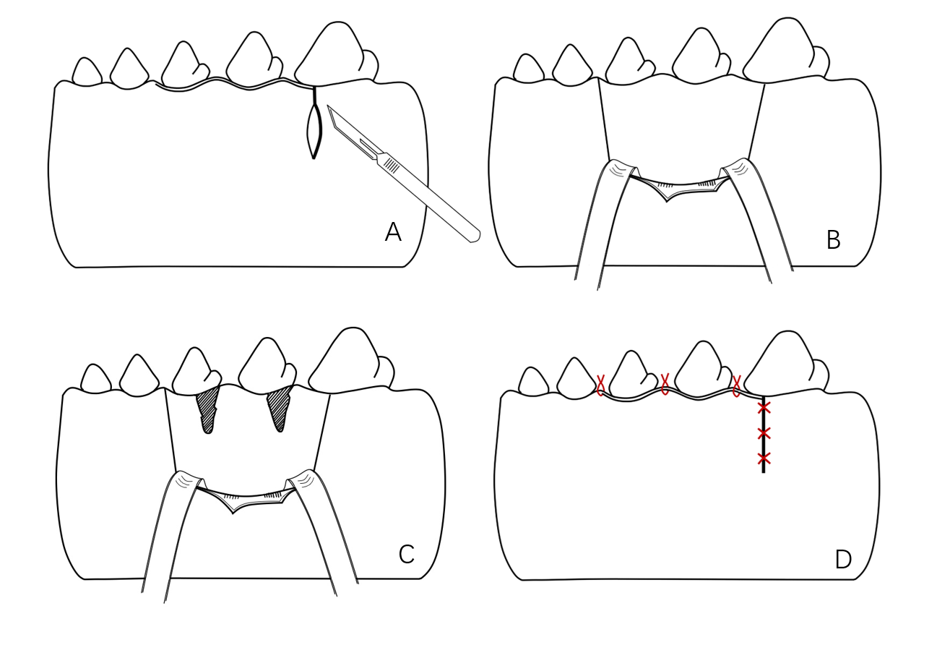
Fig.S1 Procedure for creation of buccal dehiscence defect. (A) A full thickness mucoperiosteal incision from the gingival sulcus. (B) Reflecting the mucoperiosteal ﬂap. (C) Creation of standardized dehiscence-type defects. (D) Repositioning the flap and closing the wound.

Fig.S2 Verification of buccal dehiscence defect model. (A) CBCT scans were performed at initial dehiscence creation and 1 month later for 3 groups. (B) No significant difference in vertical alveolar bone level (VABL, from CEJ to the base of the defect in the largest bucco-lingual section) was found between these three groups or within groups at the initial and 1 month later. Significant differences were observed among 3 groups (*P<0.05, ** P<0.01).

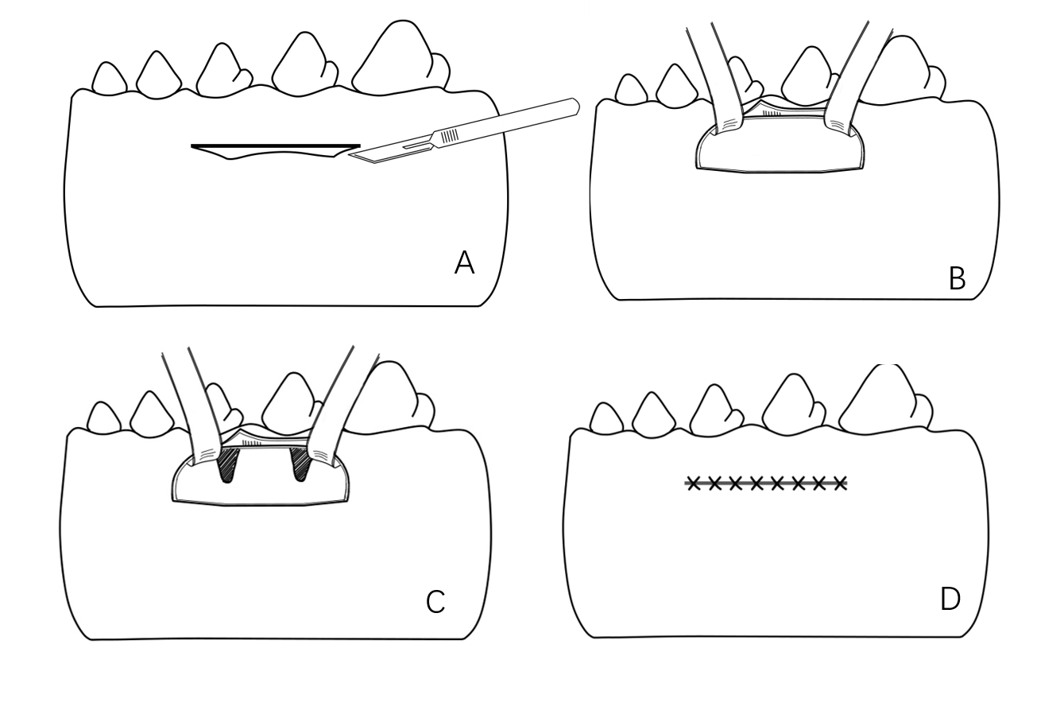
Fig. S3 Procedure for negative control group 1-month after creation of dehiscence-type defects. (A) A full thickness mucoperiosteal incision at the mucogingival junction (M1). (B) Coronal reflecting the mucoperiosteal ﬂap. (C) Blood clot in the defect area. D, repositioning the flap and closing the wound.

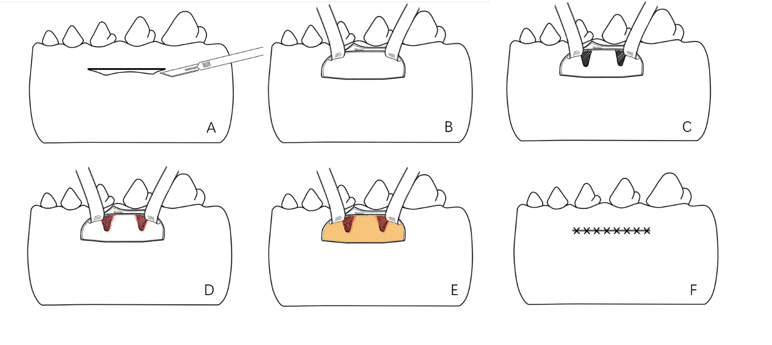
Fig.S4 Procedure for Bio-Gide membrane covered group. (A-C) The operative approach was the same as negative control group. (D)The defect was filled with DBBM. (E) Bio-Gide membrane were placed over the defect to ensure the stability of the grafted materials. (F) Repositioning the flap and closing the wound.

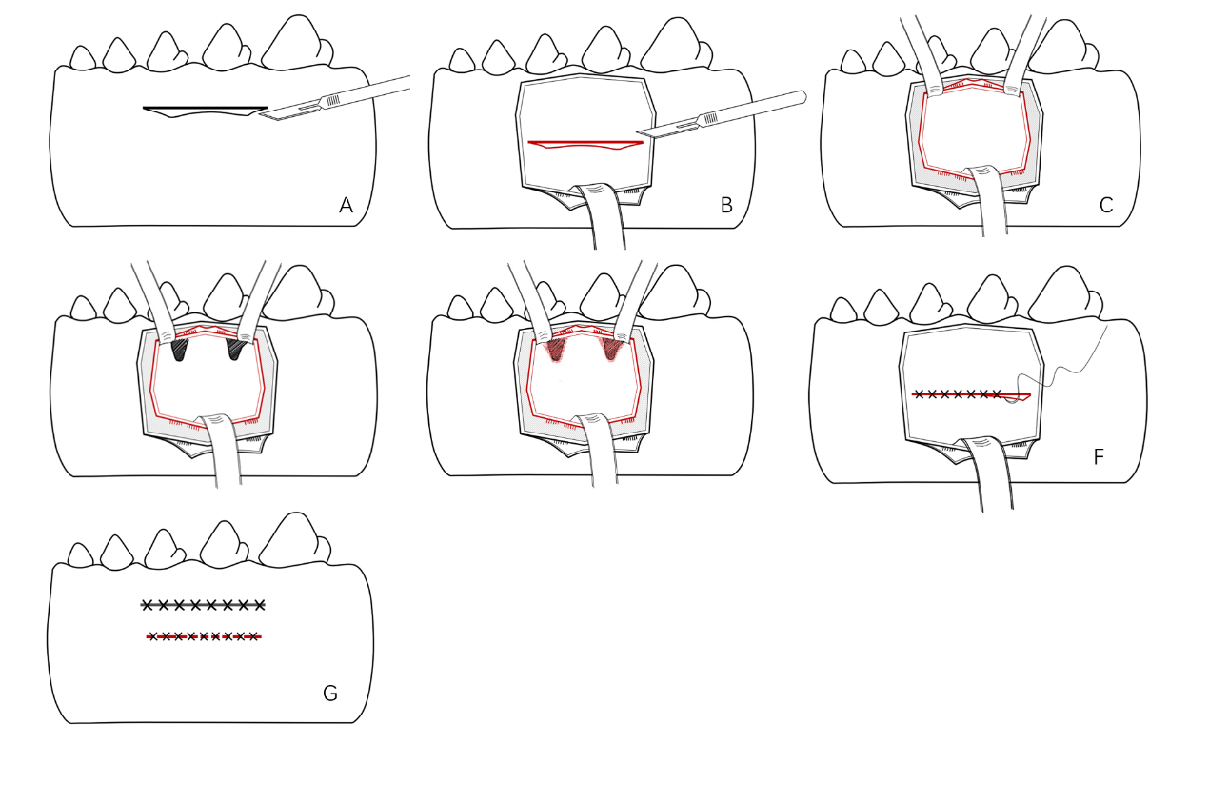
Fig. S5 Procedure for periosteum covered group. (A) A horizontal incision at the mucogingival junction was first made from mesial P3 to distal P4 without vertical releasing incisions. (B) A partial full-thickness flap was reflected apically by sharp dissection to ensure the operation remaining on the periosteal surface. (C)The periosteum was incised 5mm below the initial incision and reflected coronally so that the periosteum dimension was similar to that of the collagen membrane. (D)Exposure of the defect area. (E) Bone grafting with DBBM over the defect area. (F) The periosteum was repositioned and sutured. (G) Repositioning the flap and closing the wound.

