Subset of the periodontal ligament expressed leptin receptor contributes to part of hard tissue forming cells

Hirotsugu Oka ¹, Shinichirou Ito ², Mana Kawakami³, Hodaka Sasaki ¹, Shinichi Abe ^{4,5}, Satoru Matsunaga ^{4,5}, Sumiharu Morita ⁴, Taku Noguchi ⁴, Norio Kasahara ⁶, Akihide Tokuyama ², Masataka Kasahara ², Akira Katakura ^{3,5}, Yasutomo Yajima ^{1,7}, Toshihide Mizoguchi ^{5*}

¹Department of Oral and Maxillofacial Implantology, Tokyo Dental College, Tokyo, Japan
²Department of Pharmacology, Tokyo Dental College, Tokyo, Japan
³Department of Oral Pathobiological Science and Surgery, Tokyo Dental College, Tokyo, Japan
⁴Department of Anatomy, Tokyo Dental College, Tokyo, Japan
⁵Oral Health Science Center, Tokyo Dental College, Tokyo, Japan
⁶Department of Histology and Developmental Biology, Tokyo Dental College, Tokyo, Japan
⁷Matsumoto Dental University, MDU hospital, Implant Center, Nagano, Japan

Supplementary Information

Supplementary Figure S1
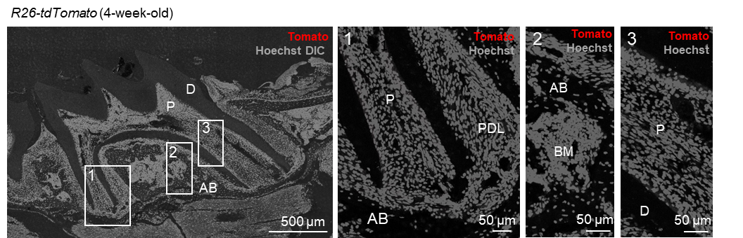

Supplementary Figure S1. Image of maxillary first molar from negative control mouse
Representative confocal images (Z stack) of thick maxillary first molar sections from R26-tdTomato control mice. n = 3. Scale bar = 500 μm. Numbered panels represent the magnified views of the boxed areas. Scale bar = 50 μm. P, pulp; D, dentin; AB, alveolar bone; PDL, periodontal ligament; BM, bone marrow; DIC, differential interference contrast. The nuclei were visualized using Hoechst staining.

Supplementary Figure S2

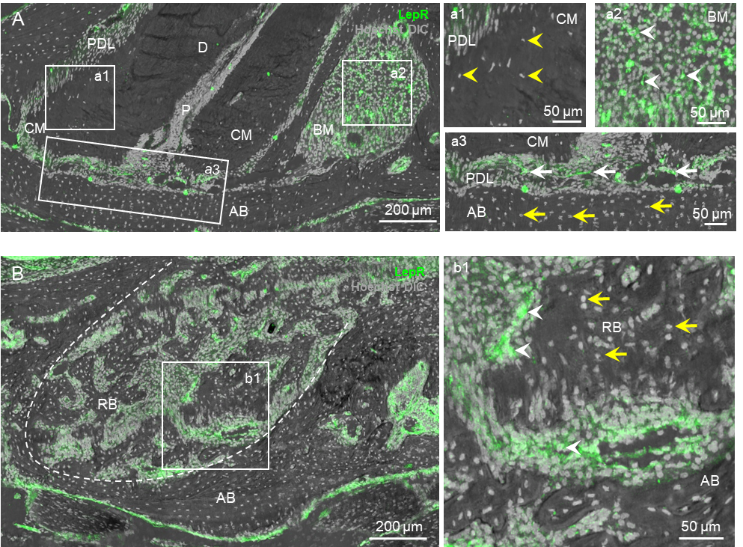

Supplementary Figure S2. Osteocytes and cementocytes are negative for LepR.
A and B. Representative Z-stack confocal images stained with anti-LepR antibody in thick maxillary first molars of 10-month-old mice (A) and in regenerated bone tissue of maxillary first molars after 2 weeks post tooth extraction in 4-week-old mice (B). n = 3. Scale bar = 200 μm. Numbered panels represent the magnified views of the boxed areas. Scale bar = 50 μm. White arrows: LepR⁺ PDL, white arrowheads: LepR⁺ BM stroma, yellow arrows: LepR⁻osteocytes, yellow arrowheads: LepR– cementocytes. The nuclei were visualized using Hoechst staining.

Supplementary Figure S3

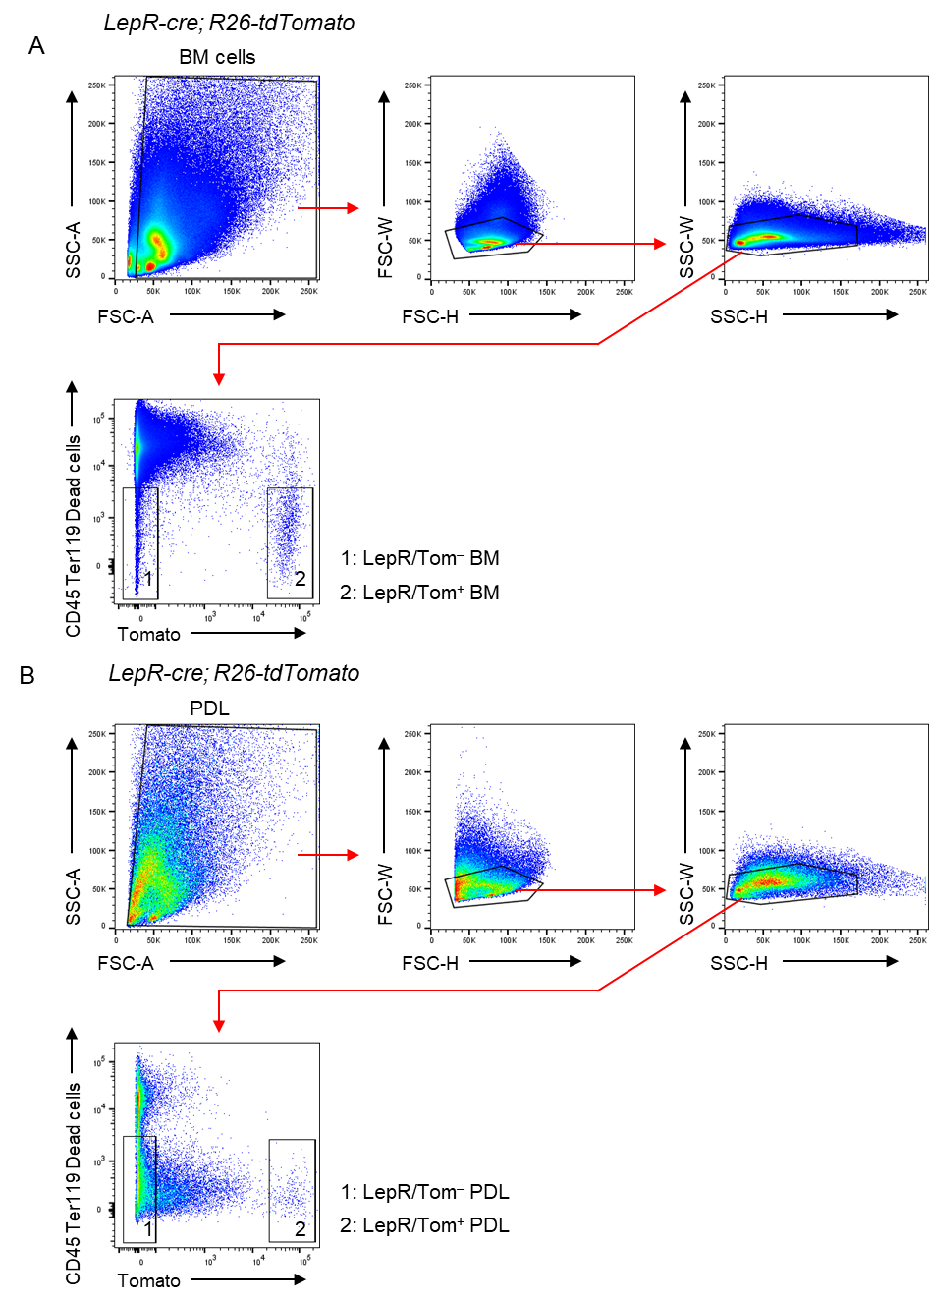

Supplementary Figure S3. Gating strategy using for spheroid formation assay
A and B. Representative FACS plots showing the gating strategy of flow cytometry for bone marrow (BM) (A) and periodontal ligament (PDL) (B)-derived LepR/Tom⁺ and LepR/Tom– cells.

