Supplementary Table 1: Amount (ng/ul) of RNA extracted from leaf samples of cultivated diploid Solanum goniocalix, purity indicators by spectrophotometry through the absorbance coefficients A260/A280 and A260/A230, and RNA integrity number (RIN) stressed with Phytophthora infestans according to experimental design
N° | Sample code | Concentration (ng/μl) | Volume (μL) | A260/A280 | A260/A230 | RIN
1 | R48A | 468.01 | 70 | 2.15 | 2.26 | 7.7
2 | R48B | 284.83 | 69 | 2.14 | 2.12 | 8.4
3 | R48C | 384.39 | 70 | 2.12 | 2.37 | 8.2
4 | R0D | 198.62 | 69 | 2.13 | 2.23 | 8
5 | R0E | 189.24 | 71 | 2.18 | 2.13 | 8
6 | R0F | 281.37 | 71 | 2.14 | 2.36 | 8
7 | S48G | 320.84 | 68 | 2.14 | 2.00 | 8.4
8 | S48H | 454.08 | 70 | 2.15 | 2.14 | 7.8
9 | S48I | 93.13 | 71 | 2.11 | 2.29 | 8.4
10 | S0J | 355.16 | 70 | 2.14 | 2.00 | 8.1
11 | S0K | 293.59 | 69 | 2.15 | 2.36 | 8.6
12 | S0L | 248.38 | 68 | 2.13 | 2.23 | 8
Average |  | 297.63 | 69.66 | 2.14 | 2.24 | 7.7

Supplementary Table 2: Illumina Hiseq 2500 sequencing performance, considering poor reads (PQ) (code_1 and code _2)
N° | Library code | Total sequence | Poor Q | N° | Library code | Total sequence | Poor Q
1 | R0D_1_fastqc | 22426271 | 0 | 13 | SOJ_1_fastqc | 22214831 | 0
2 | R0D_2_fastqc | 22426271 | 0 | 14 | SOJ_2_fastqc | 22214831 | 0
3 | R0E_1_fastqc | 26603758 | 0 | 15 | SOK_1_fastqc | 26865248 | 0
4 | R0E_2_fastqc | 26603758 | 0 | 16 | SOK_2_fastqc | 26865248 | 0
5 | R0F_1_fastqc | 32315289 | 0 | 17 | SOL_1_fastqc | 29550226 | 0
6 | R0F_2_fastqc | 32315289 | 0 | 18 | SOL_2_fastqc | 29550226 | 0
7 | R48A_1_fastqc | 24450439 | 0 | 19 | S48G_1_ fastqc | 30339609 | 0
8 | R48A_2_fastqc | 24450439 | 0 | 20 | S48G_2_ fastqc | 30339609 | 0
9 | R48B_1_fastqc | 26292429 | 0 | 21 | S48H_1_ fastqc | 28334636 | 0
10 | R48B_2_fastqc | 26292429 | 0 | 22 | S48H_2_ fastqc | 28334636 | 0
11 | R48C_1_fastqc | 29745260 | 0 | 23 | S48H_1_ fastqc | 37080049 | 0
12 | R48C_2_fastqc | 29745260 | 0 | 24 | S48H_2_ fastqc | 37080049 | 0

Supplementary Table 3: Result of cleaning the reads of the 12 libraries of cultivated diploid Solanum goniocalix using the Trimomatric software
Library | Reads input | Reads output | Survival (%)
R48A | 24450439 | 22827755 | 93.36
R48B | 26292429 | 24745408 | 94.12
R48C | 29745260 | 279752586 | 94.05
R0D | 22426271 | 20398374 | 90.96
R0E | 26603758 | 24975298 | 93.88
R0F | 32315289 | 30386620 | 94.03
S48G | 30339609 | 28640618 | 94.40
S48H | 28334636 | 26478467 | 93.45
S48I | 37080049 | 34921050 | 94.18
S0J | 22214831 | 20582748 | 92.65
S0K | 26865248 | 25272790 | 94.07
S0L | 29550226 | 28038690 | 94.88
Total | 336218045 | 315243076
Average | 28018170.42 | 26270256.33 | 93.66

Supplementary Table 4: List of 303 differentially expressed genes in cultivated diploid Solanum goniocalix resistant accession CIP-704270, Wira Pasña, at 48 hpi that confer resistance against Phytophthora infestans POX-067, of which 136 genes are over expressed (35 +101 genes) and 167 genes are under expressed (42 + 125 genes) in the resistance process. Effect accessions + pathogen (A+P).

(A+T) Up | (A+T) Down | (A) Up y (A+T) Down | (A) Down y (A+T) Up
35 genes exclusively in "Up WP48/SP48": | 42 genes exclusively in "Dow WP48/SP48": | 125 common elements in "Up WP00/SP00" and "Down WP48/SP48": | 101 common elements in "Up WP48/SP48" and "Down WP00/SP00":
ENSRNA049458286 | PGSC0003DMG400007547 | PGSC0003DMG400031156 | PGSC0003DMG400029752
PGSC0003DMG400001845 | PGSC0003DMG400022355 | PGSC0003DMG400002276 | PGSC0003DMG400029822
PGSC0003DMG400036825 | PGSC0003DMG400019506 | PGSC0003DMG400005471 | PGSC0003DMG400031547
PGSC0003DMG400040086 | PGSC0003DMG400025333 | PGSC0003DMG400003342 | PGSC0003DMG400000655
PGSC0003DMG400025444 | PGSC0003DMG400021270 | PGSC0003DMG401015009 | PGSC0003DMG400025547
PGSC0003DMG400030149 | PGSC0003DMG400016517 | PGSC0003DMG400033641 | PGSC0003DMG400023485
PGSC0003DMG401028834 | PGSC0003DMG400001681 | PGSC0003DMG400026863 | PGSC0003DMG400011670
PGSC0003DMG400024005 | PGSC0003DMG400009959 | PGSC0003DMG400024829 | PGSC0003DMG400027639
PGSC0003DMG400013171 | PGSC0003DMG400031822 | PGSC0003DMG400021289 | PGSC0003DMG400037701
PGSC0003DMG400013120 | PGSC0003DMG400006737 | PGSC0003DMG400020153 | PGSC0003DMG400038425
PGSC0003DMG400011989 | PGSC0003DMG400031521 | PGSC0003DMG401007871 | PGSC0003DMG400002886
PGSC0003DMG401031172 | PGSC0003DMG400003544 | PGSC0003DMG402022579 | PGSC0003DMG400028873
PGSC0003DMG400021882 | PGSC0003DMG400012174 | PGSC0003DMG400018462 | PGSC0003DMG400004979
PGSC0003DMG404008678 | PGSC0003DMG401014864 | PGSC0003DMG402017380 | PGSC0003DMG400031274
PGSC0003DMG400005060 | PGSC0003DMG400020139 | PGSC0003DMG400007271 | PGSC0003DMG400031277
PGSC0003DMG400014736 | PGSC0003DMG400024644 | PGSC0003DMG400000862 | PGSC0003DMG400021749
PGSC0003DMG401022140 | PGSC0003DMG400010427 | PGSC0003DMG400015707 | PGSC0003DMG400034093
PGSC0003DMG400010867 | PGSC0003DMG400002091 | PGSC0003DMG401032501 | PGSC0003DMG400036554
PGSC0003DMG400013346 | PGSC0003DMG400016518 | PGSC0003DMG400029504 | PGSC0003DMG400031279
PGSC0003DMG400006727 | PGSC0003DMG400043507 | PGSC0003DMG400013090 | PGSC0003DMG400034710
PGSC0003DMG400015872 | PGSC0003DMG400026872 | PGSC0003DMG400010738 | PGSC0003DMG400007755
PGSC0003DMG400014767 | PGSC0003DMG400031557 | PGSC0003DMG400027929 | PGSC0003DMG400026063
PGSC0003DMG401004946 | PGSC0003DMG400001915 | PGSC0003DMG400002408 | PGSC0003DMG400021397
PGSC0003DMG402015976 | PGSC0003DMG400029362 | PGSC0003DMG403029631 | PGSC0003DMG400025418
PGSC0003DMG401021681 | PGSC0003DMG400022083 | PGSC0003DMG402025828 | PGSC0003DMG400042297
PGSC0003DMG400003936 | PGSC0003DMG400026864 | PGSC0003DMG400022592 | PGSC0003DMG400019558
PGSC0003DMG400017330 | PGSC0003DMG400024377 | PGSC0003DMG400003446 | PGSC0003DMG400024277
PGSC0003DMG400005731 | PGSC0003DMG400030470 | PGSC0003DMG400020636 | PGSC0003DMG400027530
PGSC0003DMG400017508 | PGSC0003DMG400027614 | PGSC0003DMG401022708 | PGSC0003DMG400027638
PGSC0003DMG401017241 | PGSC0003DMG401019771 | PGSC0003DMG400006075 | PGSC0003DMG400031032
PGSC0003DMG400007066 | PGSC0003DMG400037627 | PGSC0003DMG400002221 | PGSC0003DMG400040013
PGSC0003DMG400021831 | PGSC0003DMG400031522 | PGSC0003DMG402024222 | PGSC0003DMG402028118
PGSC0003DMG400009326 | PGSC0003DMG400015307 | PGSC0003DMG400029128 | PGSC0003DMG400045937
PGSC0003DMG400026556 | PGSC0003DMG400021867 | PGSC0003DMG400018290 | PGSC0003DMG400011724
PGSC0003DMG400006933 | PGSC0003DMG400017277 | PGSC0003DMG400021728 | PGSC0003DMG400007664
 | PGSC0003DMG400042128 | PGSC0003DMG400018169 | PGSC0003DMG400004420
 | PGSC0003DMG400006296 | PGSC0003DMG400006722 | PGSC0003DMG400007666
 | PGSC0003DMG400016023 | PGSC0003DMG400007605 | PGSC0003DMG400002433
 | PGSC0003DMG400018000 | PGSC0003DMG401030815 | PGSC0003DMG400031267
 | PGSC0003DMG400033042 | PGSC0003DMG400022170 | PGSC0003DMG400013225
 | PGSC0003DMG400022961 | PGSC0003DMG400014299 | PGSC0003DMG400022069
 | PGSC0003DMG400010213 | PGSC0003DMG401032256 | PGSC0003DMG400015727
 |  | PGSC0003DMG400017240 | PGSC0003DMG403029613
 |  | PGSC0003DMG400002217 | PGSC0003DMG401013738
 |  | PGSC0003DMG400021247 | PGSC0003DMG400031278
 |  | PGSC0003DMG400021567 | PGSC0003DMG400004465
 |  | PGSC0003DMG400029132 | PGSC0003DMG400022859
 |  | PGSC0003DMG400007639 | PGSC0003DMG400031541
 |  | PGSC0003DMG400033348 | PGSC0003DMG400024364
 |  | PGSC0003DMG400007870 | PGSC0003DMG400002871
 |  | PGSC0003DMG400024432 | PGSC0003DMG400024980
 |  | PGSC0003DMG402017239 | PGSC0003DMG400024287
 |  | PGSC0003DMG400017185 | PGSC0003DMG400005590
 |  | PGSC0003DMG400018822 | PGSC0003DMG400008596
 |  | PGSC0003DMG400003811 | PGSC0003DMG400029750
 |  | PGSC0003DMG400002658 | PGSC0003DMG400031271
 |  | PGSC0003DMG400016904 | PGSC0003DMG400003345
 |  | PGSC0003DMG400028435 | PGSC0003DMG400017246
 |  | PGSC0003DMG400007925 | PGSC0003DMG400014468
 |  | PGSC0003DMG400029801 | PGSC0003DMG400023762
 |  | PGSC0003DMG400037235 | PGSC0003DMG401021841
 |  | PGSC0003DMG400022744 | PGSC0003DMG401029613
 |  | PGSC0003DMG400019080 | PGSC0003DMG400002847
 |  | PGSC0003DMG400029474 | PGSC0003DMG400033357
 |  | PGSC0003DMG400014588 | PGSC0003DMG400020377
 |  | PGSC0003DMG400006632 | PGSC0003DMG400013559
 |  | PGSC0003DMG401013613 | PGSC0003DMG400014589
 |  | PGSC0003DMG400005098 | PGSC0003DMG400012950
 |  | PGSC0003DMG400001172 | PGSC0003DMG400008593
 |  | PGSC0003DMG400017323 | PGSC0003DMG400024363
 |  | PGSC0003DMG401025785 | PGSC0003DMG400031303
 |  | PGSC0003DMG400037309 | PGSC0003DMG400018253
 |  | PGSC0003DMG400012074 | PGSC0003DMG400013109
 |  | PGSC0003DMG401030805 | PGSC0003DMG400025108
 |  | PGSC0003DMG400029129 | PGSC0003DMG400001269
 |  | PGSC0003DMG400037923 | PGSC0003DMG400021726
 |  | PGSC0003DMG400021956 | PGSC0003DMG400011517
 |  | PGSC0003DMG400023126 | PGSC0003DMG400040729
 |  | PGSC0003DMG400004730 | PGSC0003DMG400026566
 |  | PGSC0003DMG400032516 | PGSC0003DMG400025686
 |  | PGSC0003DMG400021822 | PGSC0003DMG400025772
 |  | PGSC0003DMG400000996 | PGSC0003DMG400003380
 |  | PGSC0003DMG400047102 | PGSC0003DMG401031520
 |  | PGSC0003DMG400034531 | PGSC0003DMG400040510
 |  | PGSC0003DMG400017452 | PGSC0003DMG400012083
 |  | PGSC0003DMG400013730 | PGSC0003DMG400023826
 |  | PGSC0003DMG400016067 | PGSC0003DMG402031520
 |  | PGSC0003DMG402007888 | PGSC0003DMG400013478
 |  | PGSC0003DMG400023479 | PGSC0003DMG400026876
 |  | PGSC0003DMG400016045 | PGSC0003DMG400017234
 |  | PGSC0003DMG402032256 | PGSC0003DMG400030581
 |  | PGSC0003DMG400022070 | PGSC0003DMG400002427
 |  | PGSC0003DMG400009169 | PGSC0003DMG400010320
 |  | PGSC0003DMG402023368 | PGSC0003DMG400022699
 |  | PGSC0003DMG400008628 | PGSC0003DMG402018777
 |  | PGSC0003DMG400019604 | PGSC0003DMG400000325
 |  | PGSC0003DMG400015071 | PGSC0003DMG400012466
 |  | PGSC0003DMG400004600 | PGSC0003DMG400026877
 |  | PGSC0003DMG400027455 | PGSC0003DMG400007469
 |  | PGSC0003DMG402012062 | PGSC0003DMG400005577
 |  | PGSC0003DMG400015480 | PGSC0003DMG400014369
 |  | PGSC0003DMG400021875
 |  | PGSC0003DMG400042461
 |  | PGSC0003DMG400016372
 |  | PGSC0003DMG400024134
 |  | PGSC0003DMG400035539
 |  | PGSC0003DMG400032496
 |  | PGSC0003DMG401012062
 |  | PGSC0003DMG400015040
 |  | PGSC0003DMG400021985
 |  | PGSC0003DMG400013210
 |  | PGSC0003DMG401023369
 |  | PGSC0003DMG402016602
 |  | PGSC0003DMG400014286
 |  | PGSC0003DMG400019774
 |  | PGSC0003DMG400029523
 |  | PGSC0003DMG400013161
 |  | PGSC0003DMG400004683
 |  | PGSC0003DMG401024222
 |  | PGSC0003DMG400028085
 |  | PGSC0003DMG400021874
 |  | PGSC0003DMG400031515
 |  | PGSC0003DMG400004599
 |  | PGSC0003DMG400022094
 |  | PGSC0003DMG400013036

Supplementary Table 5: Enrichment analysis of 167 under expressed differentially expressed genes (DEGs) in Solanum goniocalyx cultivar ‘Wira Pasña’ (CIP-704270), compared with the KEGG database g:Profiler was used with significance at P_{adj} < 0.05.

Term name | Term ID | P_{adj} | -log₁₀(P_{adj})  0 <16
KEGG root term | KEGG:00000 | 4.941x10⁻³²⁴ | 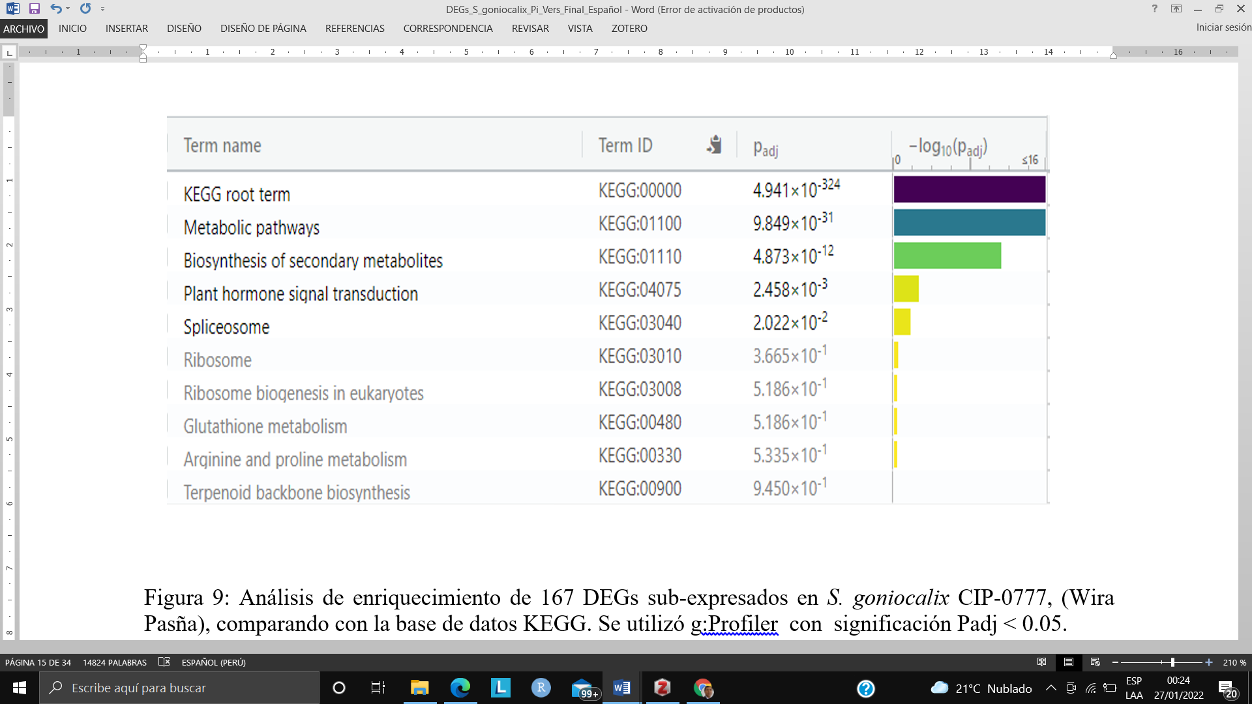
Metabolic pathways | KEGG:01100 | 9.849x10⁻³¹
Biosynthesis of secondary metabolites | KEGG:01110 | 4.873x10⁻¹²
Plant hormone signal transduction | KEGG:04075 | 2.458x10⁻³
Spliceosome | KEGG:03040 | 2.022x10⁻²
Ribosome | KEGG:03010 | 3.665x10⁻¹
Ribosome biogenesis in eukaryotes | KEGG:03008 | 5.186x10⁻¹
Glutathione metabolism | KEGG:00480 | 5.186x10⁻¹
Arquine and proline metabolism | KEGG:00330 | 5.335x10⁻¹
Terpenoid backbone biosynthesis | KEGG:00900 | 9.450x10⁻¹

Supplementary Table 6: Enrichment analysis of 136 over expressed differentially expressed genes (DEGs) in Solanum goniocalyx cultivar Wira Pasña (CIP-704270), compared with the KEGG database g:Profiler was used with significance at P_{adj} < 0.05.

Term name | Term ID | P_{adj} | -log₁₀(P_{adj})  0 <16
KEGG root term | KEGG:00000 | 4.941×10⁻³²⁴ | 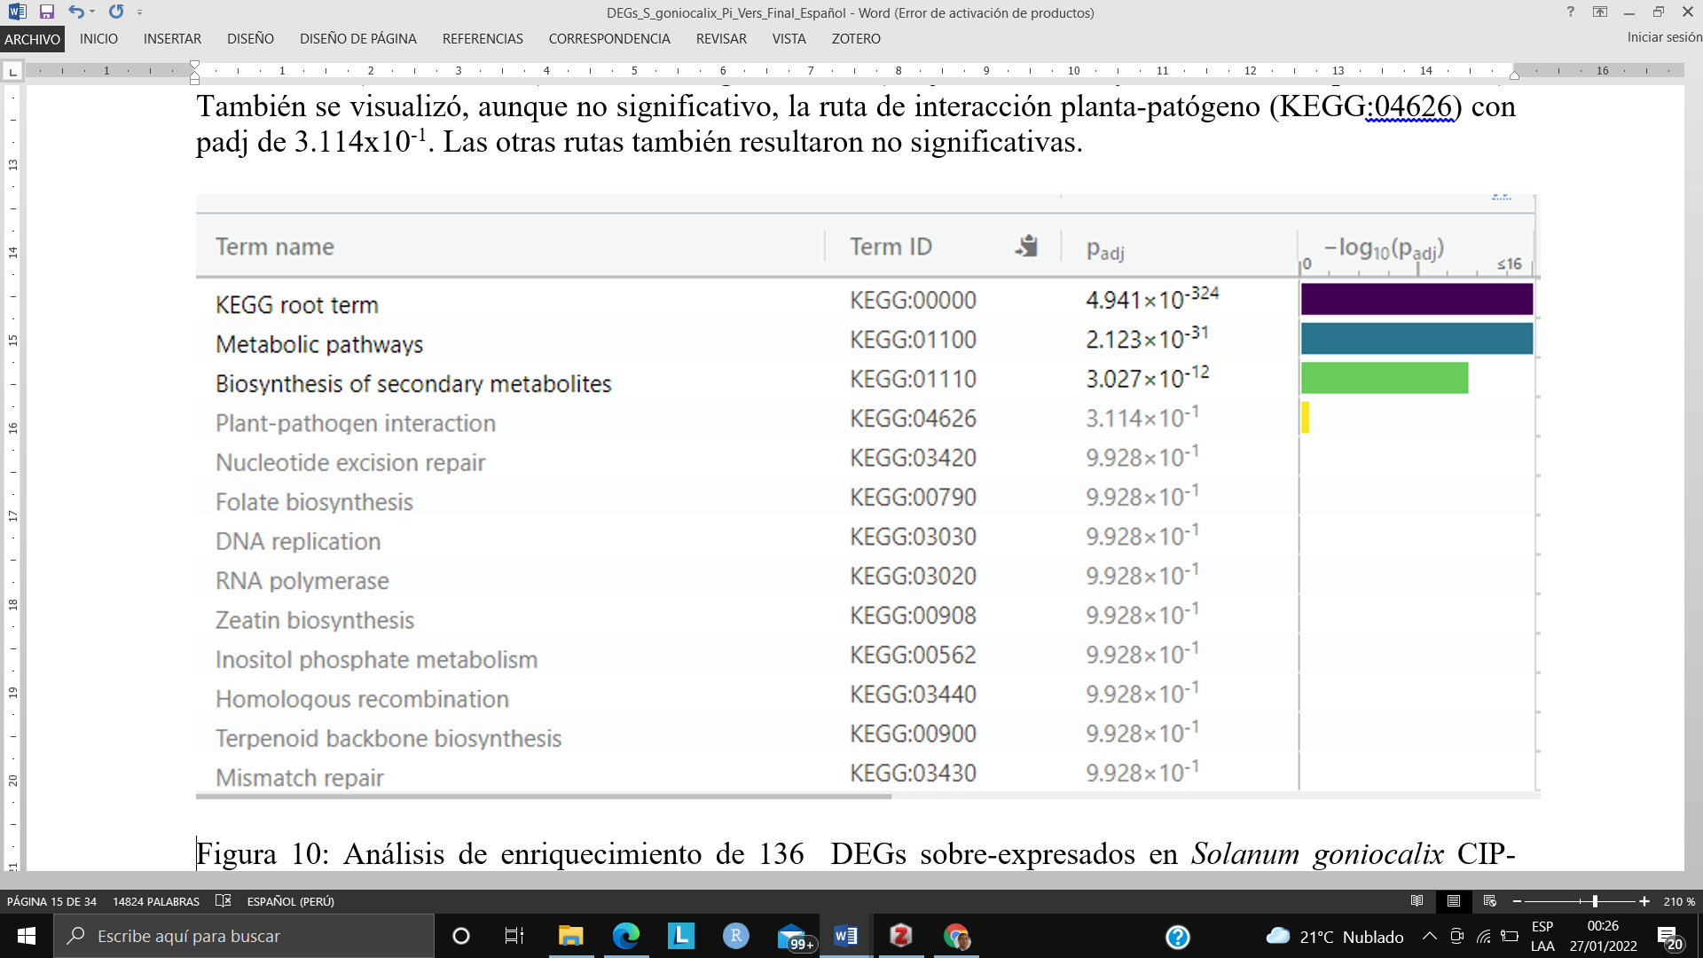
Metabolic pathways | KEGG:01100 | 2.123×10⁻³¹
Biosynthesis of secondary metabolites | KEGG:01110 | 3.027×10⁻¹²
Plant–pathogen interaction | KEGG:04626 | 3.114×10⁻¹
Nucleotide excision repair | KEGG:03420 | 9.928×10⁻¹
Folate biosynthesis | KEGG:00790 | 9.928×10⁻¹
DNA replication | KEGG:03030 | 9.928×10⁻¹
RNA polymerase | KEGG:03020 | 9.928×10⁻¹
Zeatin biosynthesis | KEGG:00908 | 9.928×10⁻¹
Inositol phosphate metabolism | KEGG:00562 | 9.928×10⁻¹
Homoloqous recombination | KEGG:03440 | 9.928×10⁻¹
Terpenoid backbone biosynthesis | KEGG:00900 | 9.928×10⁻¹
Mismatch repair | KEGG:03430 | 9.928×10⁻¹

