Nelson Pacheco Rocha is Full Professor of the University of Aveiro. He received his BSc degree in Electronics and Telecommunications Engineering in 1983 and his PhD in Electronics Engineering in 1992, from the University of Aveiro. He was the Head of Health Sciences School (2001-2011), the Head of the Health Sciences Department of the University of Aveiro (2001-2014) and Pro-Rector of the University of Aveiro (2005-2010). His current research interests include the application of information and communications technologies to healthcare and social services, the secondary use of electronic health records, and the interconnection of human functionality and ambient assisted living services. He has been involved in various European and national funded research projects, has supervised several PhD and MSc students and has a patent and more than two hundred research publications distributed by books, book chapters, international journals and proceedings of international conferences.


Vítor Tedim Cruz was born in Porto, Portugal. He is graduated in Medicine from the ICBAS-HGSA of the University of Porto (1998) and specialized in Neurology. He completed a postgraduate degree in Management of Health Services at the University of Porto Business School and completed his PhD in Health Sciences and Technologies at the University of Aveiro in 2014. He is an integrated member of Epidemiological Research Unit of the Institute of Public Health of the University of Porto (since 2015). His main research interests are neurorehabilitation, neurology of cognition and behavior and cerebrovascular diseases. He was the principal investigator and co-investigator of publicly funded scientific projects by competition and was co-author of three patents. Moreover, he has 36 full papers in international scientific journals indexed in Pubmed and 15 books and book chapters. He taught in the field of Neurosciences as a inivted professor at the University of Aveiro (2006-2014). As a Senior Neurologist (2006-2014) he was responsible for the memory consultation and for the structuring of care for patients with stroke in the Neurology Service of Centro Hospitalar de Entre o Douro e Vouga, Santa Maria da Feira, Portugal. Since 2016, he is the director of the Neurology Service at Hospital Pedro Hispano, Unidade Local de Saúde de Matosinhos. In 2011 he co-founded Neuroinova, a company dedicated to the research and development of technologies in the area of ​​cognitive rehabilitation and commercialization of COGWEB®, Brain on Track® and CACAO® systems. In 2013 he co-founded the SWORD Health with the mission of disseminating access to motor rehabilitation through the clinical incorporation of technological solutions. He is a member of the Board of the Portuguese Society of Cerebral Vascular Accidents (since 2011) and Member of the Board of the College of Neurology of the Portuguese Ordem dos Médicos (since 2012).
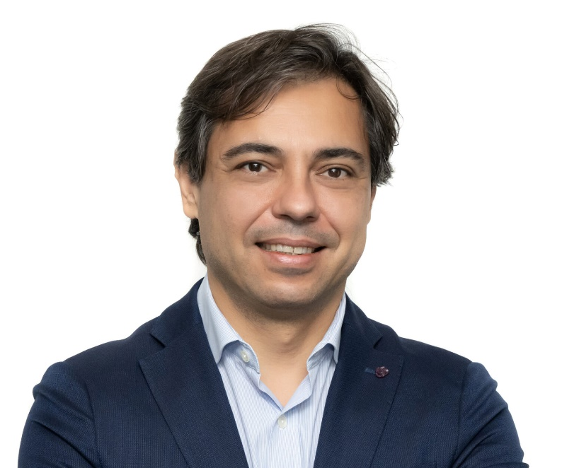
Joana Pais was born in Espinho, Portugal. She is graduated in Psychology from the Faculty of Psychology and Educational Sciences of the University of Porto in 1999. In 2010 she completed her PhD in Psychology with the theme “Cognitive plasticity in normal and pathological aging”. She was a researcher in several scientific projects focused on diagnosis and intervention with people with brain injury (dementia, traumatic brain injury, multiple sclerosis, among other pathologies). She is member of the Epidemiological Research Unit of the Institute of Public Health of the University of Porto (since 2015). She is co-author of books in the area of ​​cognitive training and of several articles published in national and international journals. She was responsible for the Neuropsychology Laboratory of the Neurology Service of Centro Hospitalar de Entre o Douro e Vouga, Santa Maria da Feira, Portugal, between 2000 and 2014. In 2011 she co-founded Neuroinova, a company dedicated to the research and development of technologies in the area of cognitive rehabilitation and commercialization of COGWEB®, Brain on Track® and CACAO® systems. She is currently responsible for the Neuropsychology Innovation Unit at Neuroinova and coordinates the Neuropsychology Department at COGWEB CLINIC.
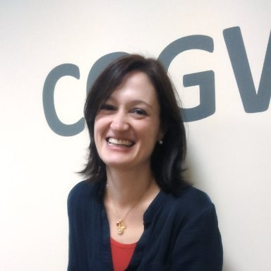
Rui L. Aguiar (born 1967) received his Ph.D. degree in electrical engineering in 2001 from the University of Aveiro, where he is currently a Full Professor. He has supervised more than than 30 PhD and 100 Master students. He was the founder of the ATNOG research group, an advanced telecommunication research group at the Universidade de Aveiro and is currently co-coordinating a research line in Instituto de Telecomunicações, on the area of Networks and Services. He has been an advisory for the portuguese Secretaria de Estado das Comunicações, associated with Carnegie Mellon University and with Universidade Federal de Uberlandia. He is a Chartered Engineer, a Senior Member of IEEE, and a member of ACM. He is serving as the Steering Board Chair of Networld Europe, the European ETP representing the telecommunications community, engaged in the discussions of the future European R&D workprogrames for telecommunications, and is working with Jesus College, Cambridge University. As further community engagement, he has served as Technical and General (co)Chair of several conferences (ICNS, ICT, ISCC, Mobiarch, Monami, NTMS, etc). He is a regular keynote speaker in the future of mobile communications and digital society, with dozens of talks across the whole world. He is an associated editor of Wiley’s Emerging Telecommunication Technologies and Springers’ Wireless Networks. He has more than 500 papers published.


