Effective Remediation of Pb²⁺ Polluted Environment by Adsorption onto Recyclable Hydroxyl Bearing Covalent Organic Framework

Ahmed M. Elewa,^{a,b} Ahmed F. M. EL-Mahdy,^{c,}* and Ho-Hsiu Chou ^{a,}*

ªDepartment of Chemical Engineering, National Tsing Hua University, Hsinchu 300044, Taiwan
^{b}Nuclear Chemistry Department, Hot Laboratories Center, Atomic Energy Authority, P.O. Box 13759, Inshas, Cairo, Egypt
^{c}Department of Materials and Optoelectronic Science, National Sun Yat-Sen University, Kaohsiung, 80424, Taiwan

E-mail: hhchou@mx.nthu.edu.tw

S1. Materials
Lead (II) nitrate (Pb(NO₃)₂) and p-Formylbenzeneboronic acid were purchased from Sigma-Aldrich. 2,5-Dihydroxyterephthalic acid, Tetrakis(triphenylphosphine) palladium(0), and 1,3,5-tribromobenzene were purchased from Acros. Hydrazine hydrate (98%), mesitylene, and potassium carbonate were obtained from Alfa Aesar. Analytical grade methanol, ethanol, 1,4-dioxane, glacial acetic acid, and acetone were obtained and utilized without purification.
S2. Characterization
Siemens D5000 and monochromated Cu/K (= 0.1542 nm) were used for determining the COFs' powder X-ray diffraction (PXRD) pattern. On an XRD sample holder's square recess, the sample was dispersed thinly. The FTIR spectra were acquired using the KBr plate approach on a Bruker Tensor 27 FTIR spectrophotometer; 32 scans were made at a resolution of 4 cm^{–1}. The surface area and porosity of the prepared samples (ca. 20–100 mg) were measured using a Micromeritics ASAP 2020 Surface Area and Porosity analyzer. Nitrogen gas isotherm was created by gradually exposing a liquid N₂ (77 K) bath to ultrahigh-purity N₂ (up to 1 atm). Under a flowing N₂ environment, TGA was conducted with a TA Q-50 analyzer. The material was packed in a Pt cell and heated at a rate of 20 °C min^{–1} under N₂ at a flow rate of 50 mL min^{–1} from 40 to 800 °C. A JEOL-2100 scanning electron microscope with a 200 kV accelerating voltage was used for transmission electron microscopy (TEM). A JEOL JSM-7610F scanning electron microscope was used to perform field-emission scanning electron microscopy (FE-SEM); the COF sample was sputtered with Pt for 100 seconds prior to imaging. A SUNTEX SP-2100 pH meter was used to take all of the readings.

S3. Synthetic Procedures
S3.1. Synthesis of 2,3-dihydroxybenzene-1,4-dicarbohydrazide (DHTP). Hydrazine monohydrate (5mL) and diethyl 2,5-dihydroxyterephthalate (1.00 g, 3.93 mmol) and 40 mL ethanol were charged into a 200 mL round-bottom flask, then heated the mixture under reflux for 24 h at 90 °C. The pale-yellow precipitate was filtered and washed several times with ethanol. After recrystallizations of the crude solid from ethanol, DHTP (0.75 g, 86%) was produced.

Scheme S1 Synthesis of 2,5-dihydroxyterephthalohydrazide (DHTP)

S3.2. Synthesis of 1,3,5-tris (4'-aldehyde phenyl) benzene (TPB–3CHO). 1,3,5-tribromobenzene (0.75 g, 2.38 mmol), 4-(Dihydroxyboryl)benzaldehyde (2.145 g, 14.32 mmol), tetrakis(triphenylphosphine) palladium(0) (138 mg, 0.12 mmol), and potassium carbonate (1.98 g, 14.32 mmol) were charged into a 100 mL round-bottom flask, then evacuated under pressure for 15 min and then a mixture of 30 mL of 1,4-dioxane and 5.5 mL of water was added slowly under N₂. The resultant mixture was heated for 40 h at 110 °C before cooling to room temperature. A white precipitate formed when the mixture was put into 200 mL of ice water. The crude material was washed with water and MeOH multiple times after vacuum filtering. TPB–3CHO was obtained as a white solid after purification using a flash chromatographic column (SiO₂; EA/n-hexane, 1: 9) (743 mg, 80%).

Scheme S2 Synthesis of 1,3,5-tris(4-formylphenyl)benzene (TPB-3CHO)

S3.3. Preparation of DHTP–TPB COF. TPB–3CHO (75 mg, 0.192 mmol) and DHTP (65.2 mg, 0.288 mmol) are charged into a Pyrex tube together with mesitylene and 1,4-dioxane (3: 1, 4 mL) and an aqueous solution of acetic acid (6 M, 0.4 mL). To achieve a uniform dispersion, this mixture was sonicated for 15 minutes. After many freeze/pump/thaw cycles, the tube was capped and degassed before being heated at 120 °C for 72 hours. After cooling to ambient temperature, the yellow-brownish solid was filtered and washed with THF, MeOH, and acetone. After drying under vacuum at 120 °C for 24 hours, the DHTP–TPB COF solid (90 % yield) was produced.

S4. Spectral Profiles of monomers
Fig. S1 FT-IR spectrum of 2,5-dihydroxyterephthalohydrazide (DHTP)
Fig. S2 ¹H NMR spectrum of 2,5-dihydroxyterephthalohydrazide (DHTP)
Fig. S3 ¹³C NMR spectrum of 2,5-dihydroxyterephthalohydrazide (DHTP)
Fig. S4 FT-IR spectrum of 1,3,5-tris(4-formylphenyl)benzene (TPB-3CHO)
Fig. S5 ¹H NMR spectrum of 1,3,5-tris(4-formylphenyl)benzene (TPB-3CHO)
Fig. S6 ¹³C NMR spectrum of 1,3,5-tris(4-formylphenyl)benzene (TPB-3CHO)

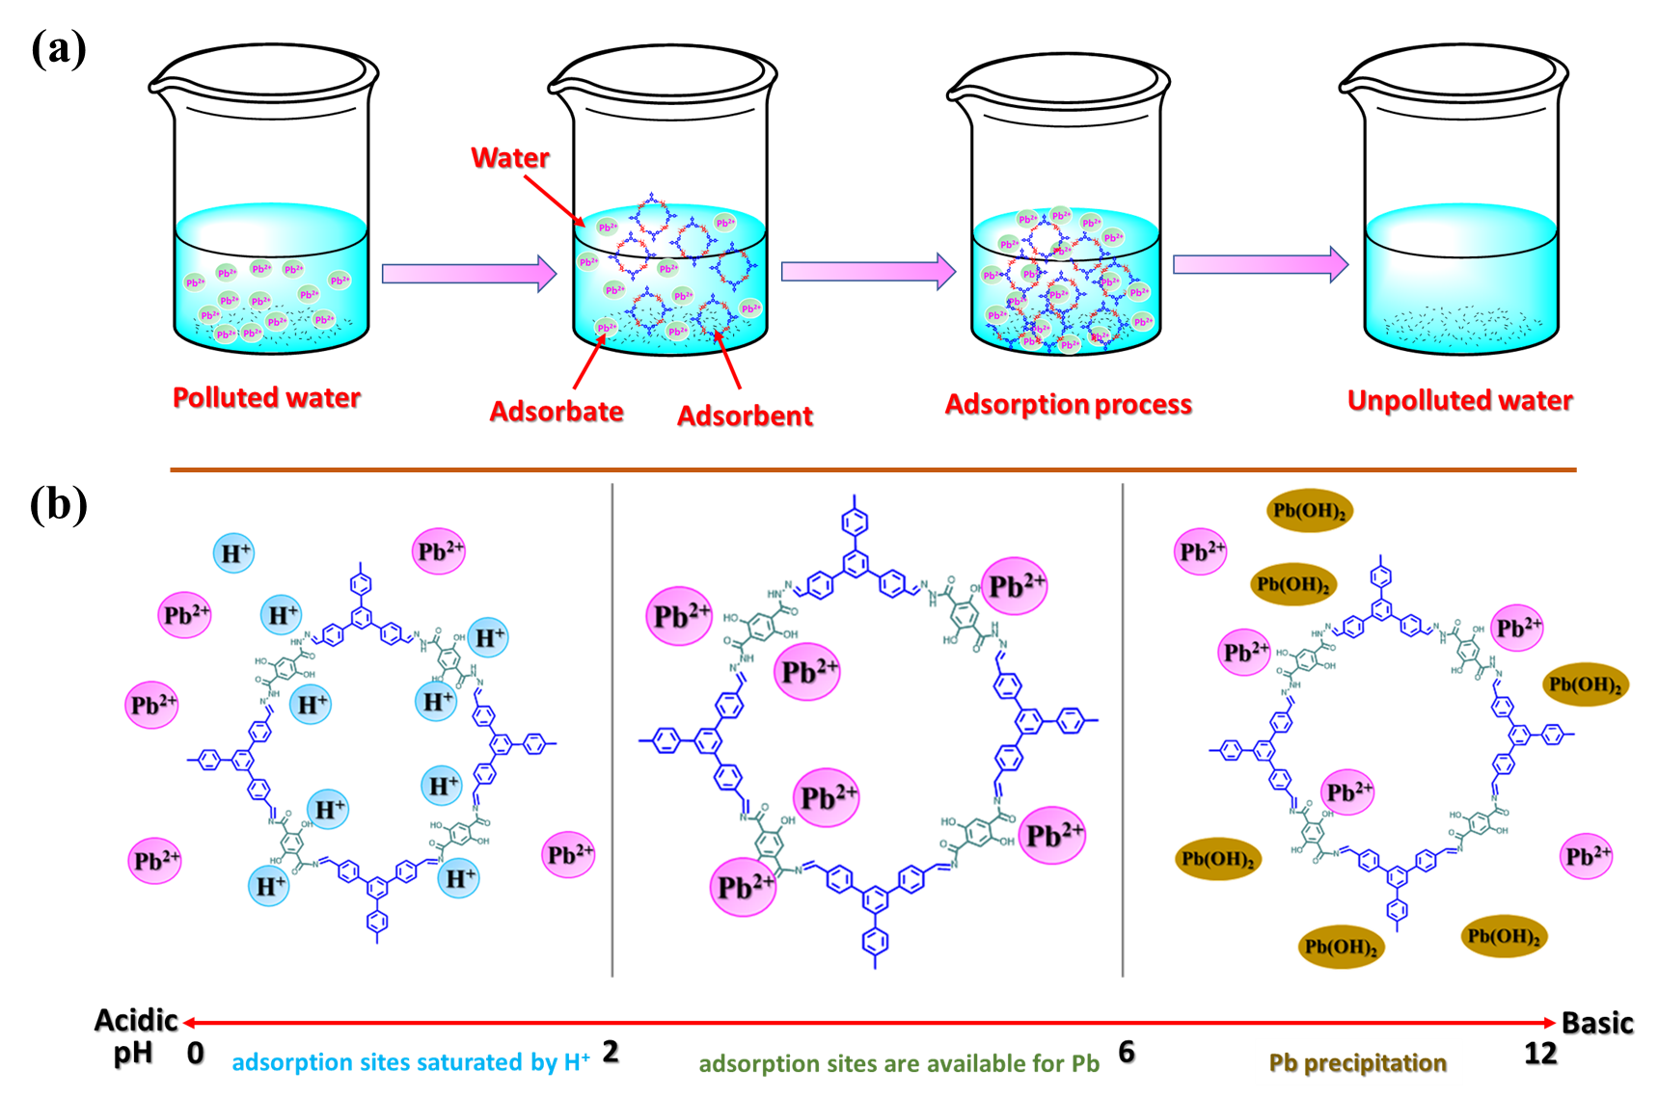
Fig. S7 (a) Pictorial representation for batch adsorption of Pb²⁺ onto DHTP–TPB COF, (b) the best condition for Pb²⁺ adsorption onto DHTP–TPB COF.

S5. PXRD data and BET parameters

Table S1. PXRD and BET parameters of the synthesized COF
COF | S_{BET}  (m² g⁻¹) | d₁₀₀  (nm) | Pore size  (nm) | Pore volume  (cm³ g⁻¹) | Interlayer  Distance (Å)
DHTP–TPB | 360 | 4.01 | 3.77 | 0.58 | 3.45

S6. Structural Modeling and Fractional Atomic Coordinates for COF Structure
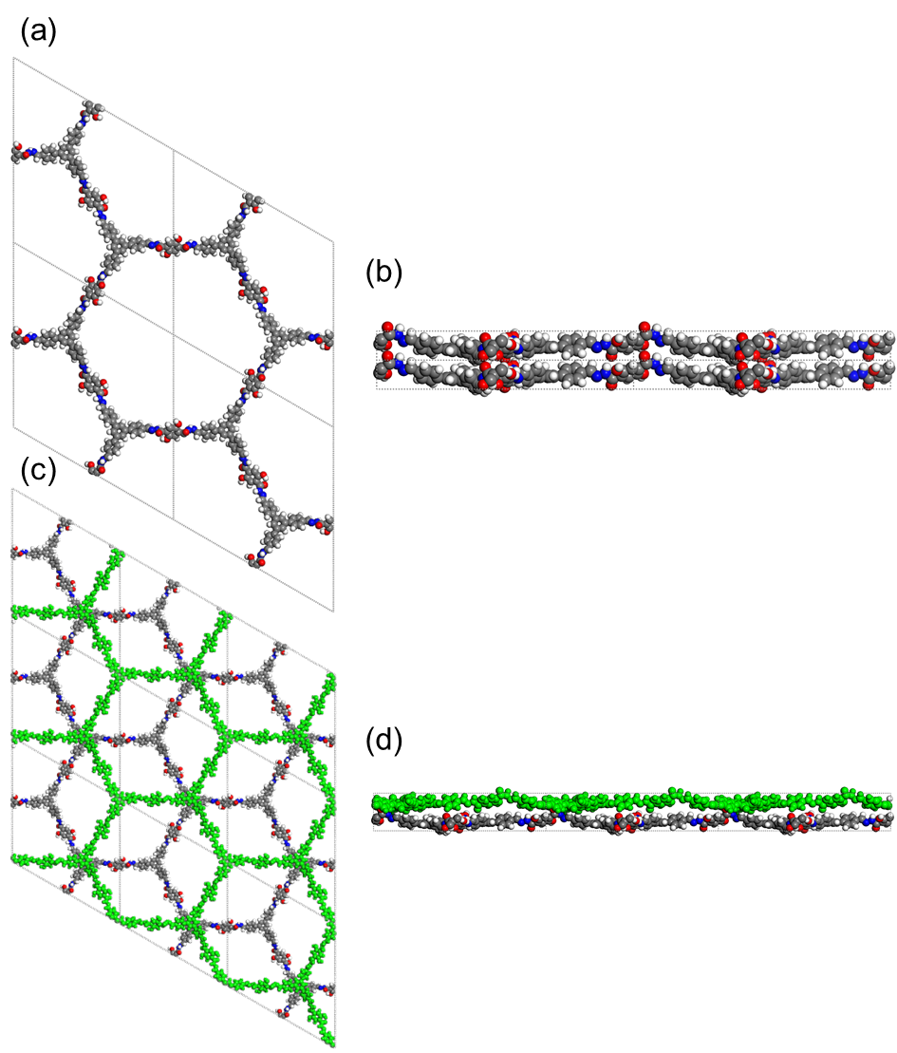
Fig. S8 Crystalline structure for the DHTP–TPB COF (a, b) completely eclipsed AA-stacking models and (c, d) staggered AB-stacking successions models

Table S2. Fractional atomic coordinates for the unit cell of the DHTP–TPB COF with eclipsed AA-stacking model

Sample Name: DHTP–TPB COF
Space Group: P 1
a = 46.23100 , b = 46.23100, c = 4.07851 α = β = 90°, γ = 120°
R_{wp}= 4.91% R_{p}= 3.72%
Atom | x/a | y/b | z/c | Atom | x/a | y/b | z/c
C1 | 0.60426 | 0.16673 | 0.5738 | C30 | 0.46226 | 0.45959 | 0.25054
C2 | 0.63673 | 0.19111 | 0.65973 | C31 | 0.48424 | 0.44661 | 0.26022
C3 | 0.65015 | 0.22492 | 0.58724 | C32 | 0.51808 | 0.46671 | 0.34016
C4 | 0.63177 | 0.23618 | 0.42363 | C33 | 0.52917 | 0.50025 | 0.42553
C5 | 0.59947 | 0.21165 | 0.32712 | C34 | 0.50722 | 0.51309 | 0.4148
C6 | 0.58584 | 0.17733 | 0.40141 | C35 | 0.3656 | 0.59073 | 0.29195
C7 | 0.64626 | 0.27342 | 0.37002 | C36 | 0.3855 | 0.57542 | 0.31643
C8 | 0.68111 | 0.29453 | 0.33079 | C37 | 0.41322 | 0.58845 | 0.50815
C9 | 0.69591 | 0.32958 | 0.30566 | C38 | 0.42057 | 0.61732 | 0.67092
C10 | 0.67483 | 0.34363 | 0.31535 | C39 | 0.40109 | 0.63278 | 0.6441
C11 | 0.63981 | 0.32357 | 0.35304 | C40 | 0.37315 | 0.6198 | 0.45534
C12 | 0.62599 | 0.2884 | 0.37741 | C41 | 0.39172 | 0.74692 | 0.30685
C13 | 0.73343 | 0.35151 | 0.27487 | C42 | 0.40689 | 0.782 | 0.34308
C14 | 0.75573 | 0.34509 | 0.4376 | C43 | 0.39395 | 0.79577 | 0.54594
C15 | 0.7907 | 0.36565 | 0.4086 | C44 | 0.36507 | 0.77355 | 0.70481
C16 | 0.80453 | 0.39298 | 0.21231 | C45 | 0.34959 | 0.73876 | 0.66409
C17 | 0.78231 | 0.39921 | 0.04827 | C46 | 0.36282 | 0.72468 | 0.46771
C18 | 0.74743 | 0.37907 | 0.08071 | C47 | 0.31649 | 0.61655 | 0.4326
C19 | 0.61798 | 0.33947 | 0.38123 | C48 | 0.35178 | 0.63618 | 0.43683
C20 | 0.62477 | 0.36861 | 0.22251 | C49 | 0.36648 | 0.67142 | 0.43972
C21 | 0.60444 | 0.38338 | 0.2541 | C50 | 0.34683 | 0.68705 | 0.44126
C22 | 0.57668 | 0.36946 | 0.44562 | C51 | 0.31162 | 0.66652 | 0.43353
C23 | 0.57005 | 0.34051 | 0.60386 | C52 | 0.29576 | 0.63115 | 0.43066
C24 | 0.59028 | 0.3259 | 0.57316 | C53 | 0.2065 | 0.55569 | 0.34482
C25 | 0.43456 | 0.5726 | 0.55288 | C54 | 0.24137 | 0.5767 | 0.31905
C26 | 0.55389 | 0.38371 | 0.48768 | C55 | 0.25777 | 0.60946 | 0.43623
C27 | 0.54222 | 0.45405 | 0.30016 | C56 | 0.2373 | 0.62071 | 0.56695
C28 | 0.45136 | 0.50836 | 0.27167 | C57 | 0.20225 | 0.59995 | 0.58412
C29 | 0.4737 | 0.49345 | 0.32085 | C58 | 0.18643 | 0.56694 | 0.47801

Continuous (Table S2)
Atom | x/a | y/b | z/c | Atom | x/a | y/b | z/c
C59 | 0.15043 | 0.54272 | 0.54611 | O94 | 0.55116 | 0.04217 | 1.12888
C60 | 0.06628 | 0.50066 | 0.51526 | O95 | 0.03054 | 0.53167 | 0.8047
C61 | 0.01017 | 0.45985 | 0.31285 | O96 | 0.42899 | 0.43868 | 0.171
C62 | 0.02951 | 0.48861 | 0.48527 | O97 | 0.5616 | 0.52172 | 0.52563
C63 | 0.01257 | 0.50192 | 0.64602 | O98 | 0.48433 | 0.03746 | 0.53628
C64 | 0.58939 | 0.13348 | 0.72852 | O99 | 0.43866 | 0.91378 | 0.14689
C65 | 0.54364 | 0.04903 | 0.89174 | O100 | 0.51578 | 0.93492 | 0.64883
C66 | 0.52993 | -0.00736 | 0.71674 | H101 | 0.90904 | 0.42221 | 0.75111
C67 | 0.52255 | 0.01895 | 0.7001 | H102 | 0.9588 | 0.41405 | 0.14448
C68 | 0.49296 | 0.01246 | 0.55459 | H103 | 0.65146 | 0.18419 | 0.79835
C69 | 0.41183 | 0.83225 | 0.62778 | H104 | 0.67461 | 0.24256 | 0.67369
C70 | 0.45369 | 0.91791 | 0.37901 | H105 | 0.58451 | 0.21903 | 0.19805
C71 | 0.47773 | 0.9531 | 0.48059 | H106 | 0.56043 | 0.15948 | 0.33756
C72 | 0.5079 | 0.96027 | 0.61426 | H107 | 0.69703 | 0.28362 | 0.31656
C73 | 0.47116 | 0.97982 | 0.4405 | H108 | 0.68601 | 0.37053 | 0.30609
C74 | 0.84161 | 0.41458 | 0.16635 | H109 | 0.59939 | 0.27263 | 0.4097
C75 | 0.92055 | 0.43616 | 0.51981 | H110 | 0.74614 | 0.32445 | 0.59198
C76 | 0.95789 | 0.45566 | 0.48071 | H111 | 0.80705 | 0.36 | 0.53742
C77 | 0.9751 | 0.44328 | 0.3108 | H112 | 0.792 | 0.4197 | -0.10777
C78 | 0.97717 | 0.48524 | 0.64455 | H113 | 0.73131 | 0.38453 | -0.05292
N79 | 0.4328 | 0.54845 | 0.3887 | H114 | 0.64543 | 0.37968 | 0.06852
N80 | 0.45352 | 0.53428 | 0.44079 | H115 | 0.61017 | 0.40549 | 0.12673
N81 | 0.55825 | 0.41109 | 0.36125 | H116 | 0.5492 | 0.32924 | 0.75627
N82 | 0.5358 | 0.42335 | 0.40717 | H117 | 0.58452 | 0.30425 | 0.70698
N83 | 0.1262 | 0.55042 | 0.52049 | H118 | 0.45268 | 0.58221 | 0.73097
N84 | 0.0927 | 0.52953 | 0.6487 | H119 | 0.53272 | 0.37037 | 0.63409
N85 | 0.56254 | 0.10523 | 0.65474 | H120 | 0.46983 | 0.54245 | 0.6207
N86 | 0.54717 | 0.08052 | 0.87915 | H121 | 0.5142 | 0.40946 | 0.53338
N87 | 0.42914 | 0.85674 | 0.44291 | H122 | 0.47512 | 0.42105 | 0.19282
N88 | 0.44784 | 0.89038 | 0.54431 | H123 | 0.51697 | 0.53908 | 0.47151
N89 | 0.86352 | 0.41531 | 0.35348 | H124 | 0.34458 | 0.5801 | 0.14152
N90 | 0.89872 | 0.43529 | 0.31457 | H125 | 0.37926 | 0.55335 | 0.18661
N91 | 0.43148 | 0.49789 | 0.06753 | H126 | 0.44147 | 0.62788 | 0.82297
O92 | 0.56789 | 0.47115 | 0.16181 | H127 | 0.40742 | 0.65453 | 0.7785
O93 | 0.07811 | 0.51141 | 0.76167 | H128 | 0.40253 | 0.73711 | 0.1519

Continuous (Table S2)
Atom | x/a | y/b | z/c | Atom | x/a | y/b | z/c
H129 | 0.42937 | 0.79829 | 0.22056 | H143 | 0.5549 | 0.09004 | 1.09248
H130 | 0.35479 | 0.78315 | 0.86767 | H144 | 0.55265 | -0.00281 | 0.82681
H131 | 0.32789 | 0.72271 | 0.79647 | H145 | 0.01616 | 0.53844 | 0.92055
H132 | 0.30524 | 0.5897 | 0.44415 | H146 | 0.42304 | 0.41522 | 0.11419
H133 | 0.39339 | 0.68685 | 0.4464 | H147 | 0.57586 | 0.51118 | 0.5624
H134 | 0.29659 | 0.67843 | 0.42586 | H148 | 0.46269 | 0.0298 | 0.42389
H135 | 0.19516 | 0.53031 | 0.26262 | H149 | 0.40929 | 0.83837 | 0.85458
H136 | 0.25547 | 0.56697 | 0.20857 | H150 | 0.45842 | 0.89514 | 0.75488
H137 | 0.24835 | 0.64516 | 0.6676 | H151 | 0.44842 | 0.97464 | 0.32881
H138 | 0.18766 | 0.60907 | 0.69633 | H152 | 0.53849 | 0.94318 | 0.74377
H139 | 0.14444 | 0.51884 | 0.64124 | H153 | 0.8503 | 0.43044 | -0.02783
H140 | 0.10755 | 0.55107 | 0.50868 | H154 | 0.90968 | 0.44937 | 0.12957
H141 | 0.02228 | 0.44895 | 0.18691 | H155 | 0.96457 | 0.49485 | 0.77931
H142 | 0.60098 | 0.13456 | 0.93938 | H156 | 0.93344 | 0.40241 | 0.14459

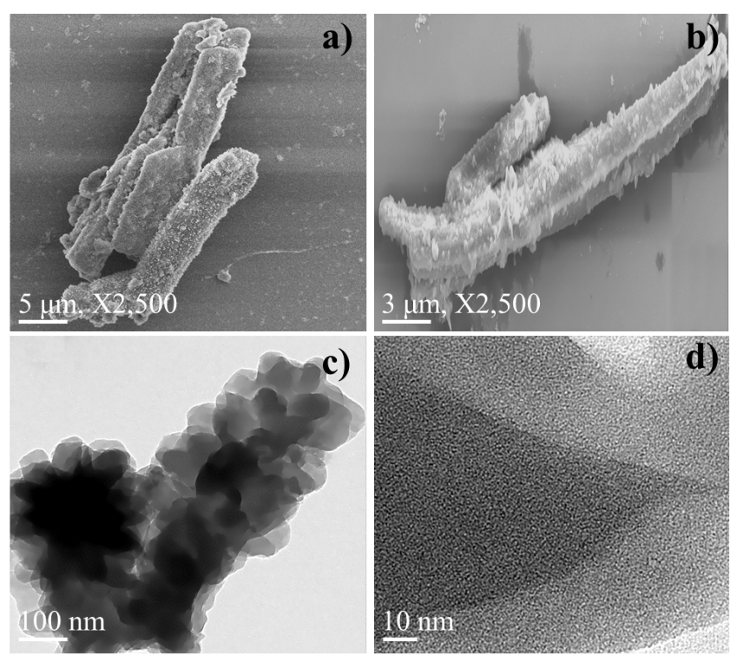

Fig. S9. SEM images (a, b) and TEM images (c, d) of DHTP–TPB COF.

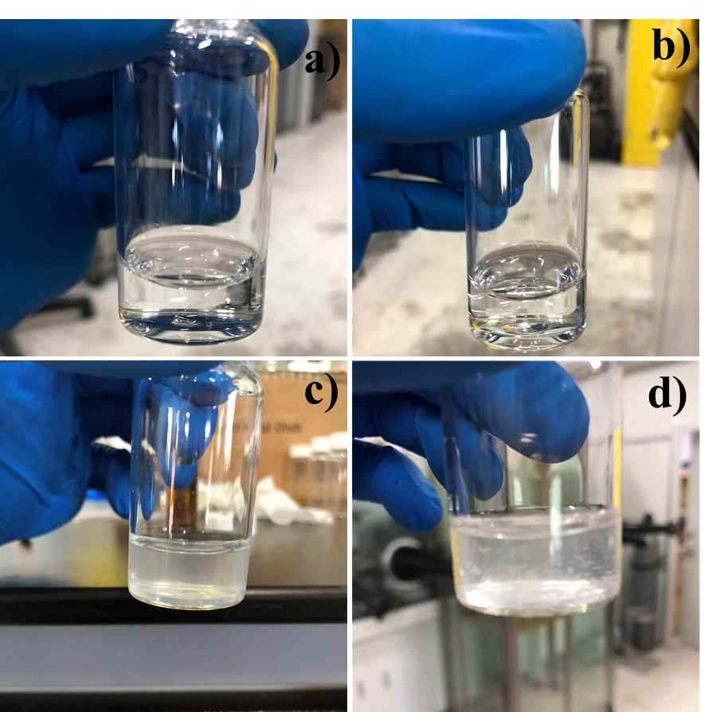

Fig. S10. Photograph images of Pb²⁺ solution with a) C_{i}=250 ppm and b) C_{i}=500 ppm at pH 4.0, and c) C_{i}=250 ppm and d) C_{i}=500 ppm at pH 6.0.

Fig. S11. Langmuir isotherm model.

Fig. S12. Freundlich isotherm model.

Fig. S13. Pseudo-first order model.
Fig. S14. Pseudo-second order model.

Fig. S15. Plot of lnK_{d} versus 1/T for adsorption of Pb²⁺ onto DHTP–TPB COF

Figure S16. XPS spectra of DHTP–TPB COF before and after Pb²⁺ adsorption.

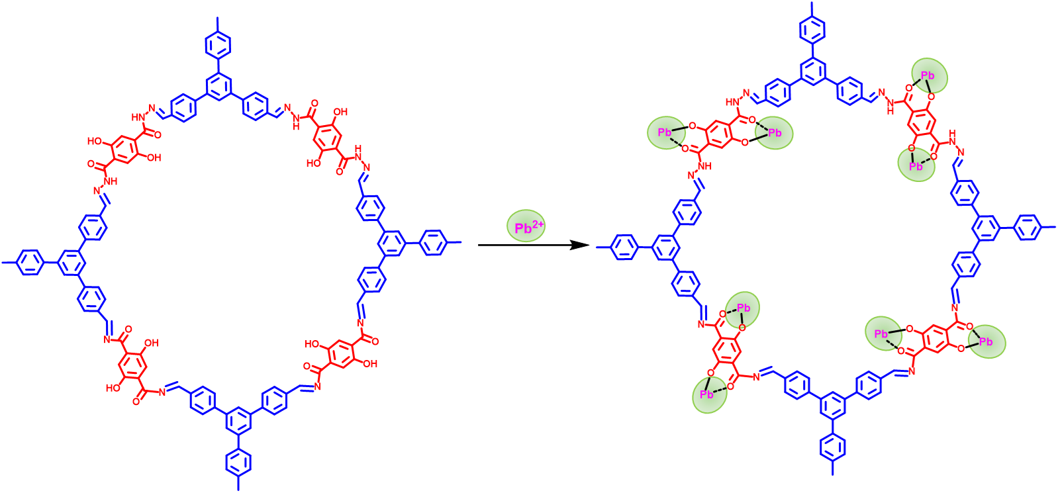

Figure S17. Coordination of Pb²⁺ with the hydroxyl groups in COFs structure.

Table S3. The adsorption capacity of different adsorbents for Pb²⁺.

Materials | pH | Capacity (mg/g) | References
DHTP–TPB COF | 4.0 ± 0.1  6.0 | 154.3  419.6 | This work
COF-TP  COF-TE | 6.5  6.5 | 140.0  185.7 | Chem. Eng. J. 2019, 370, 822–830
COF-SH | 5.0-6.0 | 239.0 | Colloids and Surfaces A 2020, 600, 125004
COOH@COF | 6.0 | 123.9 | Ind. Eng. Chem. Res. 2019, 58, 17660−17667
Co-Fe2O3  Ni-Fe₂O₃  Fe₂O₃ | 5.0 | 136.0  97.5  93.9 | J. Cleaner Production 2019, 211 1250-1258
MIL-101  Fe-MIL-101 | 6.0 | 57.96  86.20 | J. Environ. Chem. Eng. 2018, 6 4093–4102
FFO@Sil@Chi-DTPA | 6.0 | 111.7 | J. Hazard. Mater. 2022 422, 126856
Co_{0.6}Fe_{2.4}O₄ | 6.0 | 80.32 | Colloids and Surfaces A 2015, 469, 211–223
Mg₂Al LDH | 5.7 | 57.51 | Chem. Eng. J. 2011,171, 167–174
ES-PAN/AHCNs | 6.0 | 192 | Colloids Surfaces A 2021, 627, 127177
UiO-66-1:1-120  UiO-66-1:2-50 | 6.0 | 125.1  149.8 | Langmuir 2021, 37, 13602−13609
MIL-101(Fe)/GO | 6.0 | 128.6 | New J. Chem. 2019, 43, 1032--1037

