Supplementary Information

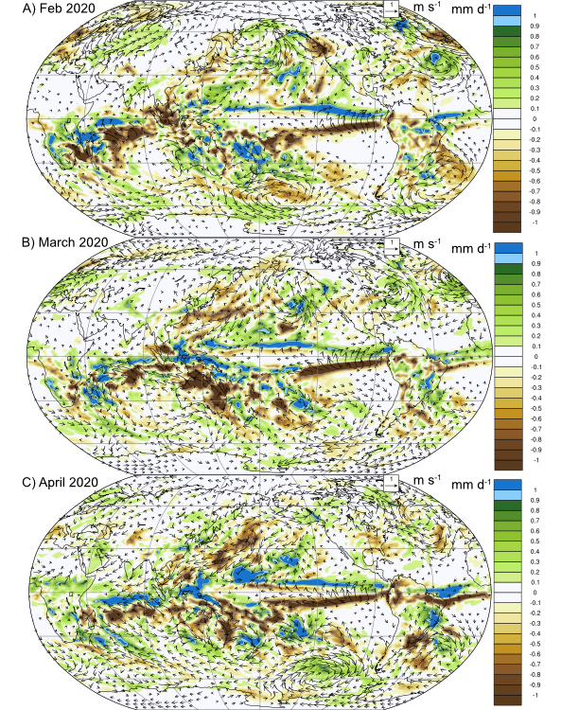
Fig. S1 | Northward Migration of the ITCZ. Responses to wildfire emission in total precipitation for February (a), March (b), and Apr (c) 2020. Also shown are the low-level wind field responses (vectors).
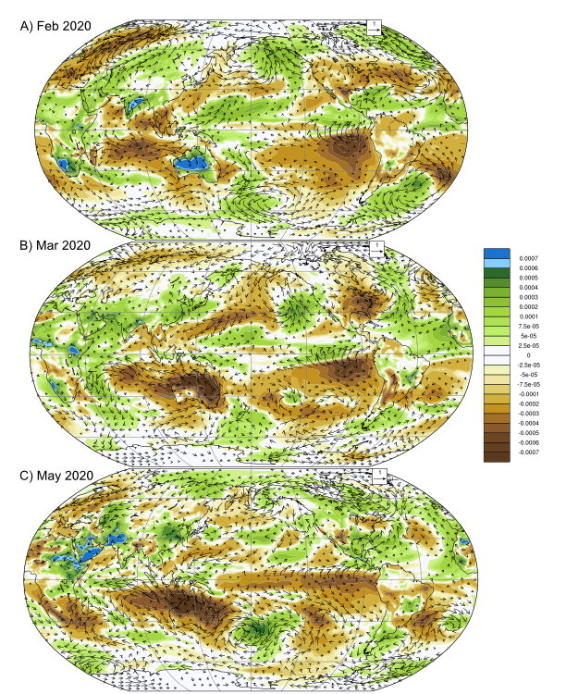
Fig. S2 | Tropical Intrusion of Low Specific Humidity. Responses to wildfire emission in 2-m specific humidity for February (a), March (b), and Apr (c) 2020. Also shown are the low-level wind field anomalies (vectors).
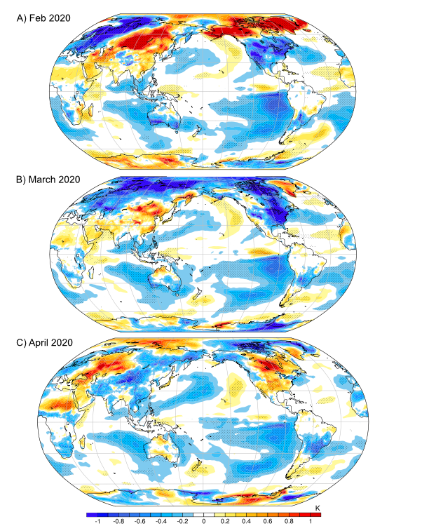
Fig. S3 | Surface Temperature Responses. Responses to wildfire emission in surface temperature for February (a), March (b), and Apr (c) 2020. Responses that exceed twice the ensemble standard error are also shown (stippling).

