Supplementary Material

“Human displacements from tropical cyclone Idai attributable to climate change”

Benedikt Mester ¹ ² *, Thomas Vogt ¹, Seth Bryant ² ³, Christian Otto ¹, Katja Frieler ¹, and Jacob Schewe ¹

¹ Potsdam Institute for Climate Impact Research, Potsdam, Germany
² Institute of Environmental Science and Geography, Potsdam University, Potsdam, Germany
³ GFZ German Research Centre for Geosciences, Potsdam, Germany
* To whom correspondence should be addressed. Email: benedikt.mester@pik-potsdam.de

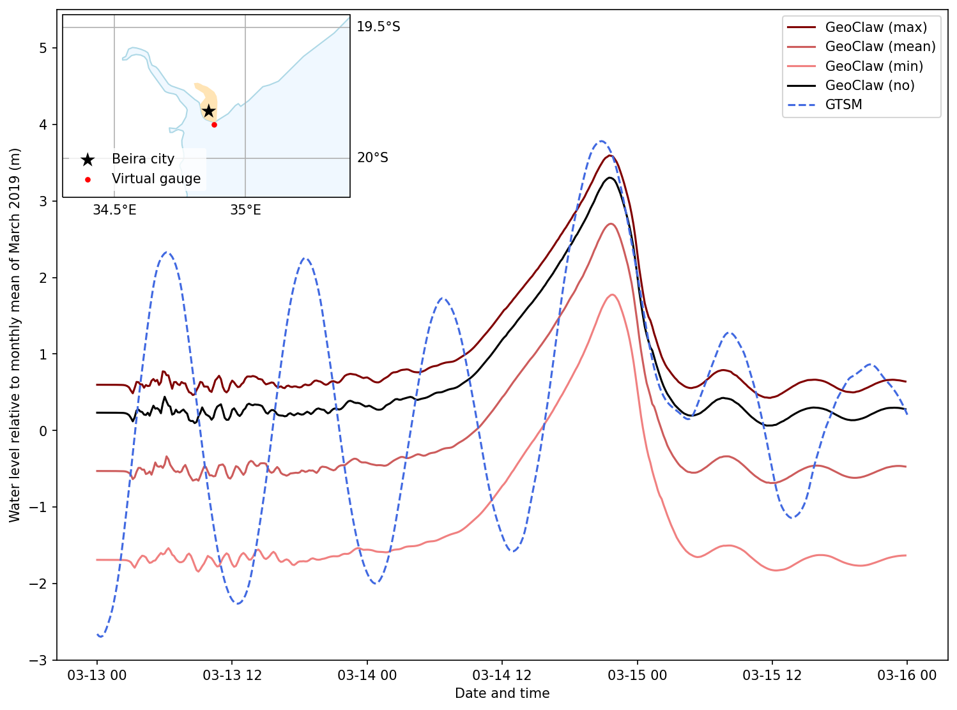 Figure S1: Water levels at a virtual tide gauge station off the coast of Beira, Mozambique, according to simulations. Several runs of GeoClaw are compared to GTSM: The GeoClaw runs are initialized with different base sea levels corresponding to assumptions of low (min), average (mean), and high (max) astronomical tides at landfall. Another run of GeoClaw is initialized with the monthly mean sea level from satellite altimetry (no). GTSM is driven by astronomical tidal forcing, and ERA5 meteorological forcing overlayed by a parametric TC wind field. While GeoClaw does not incorporate tidal dynamics, the maximum surge heights agree well with GTSM.

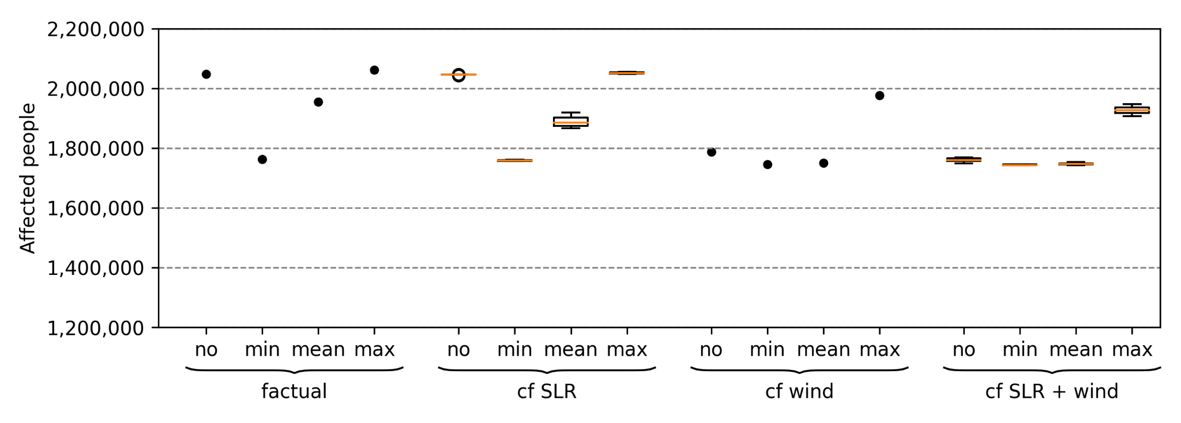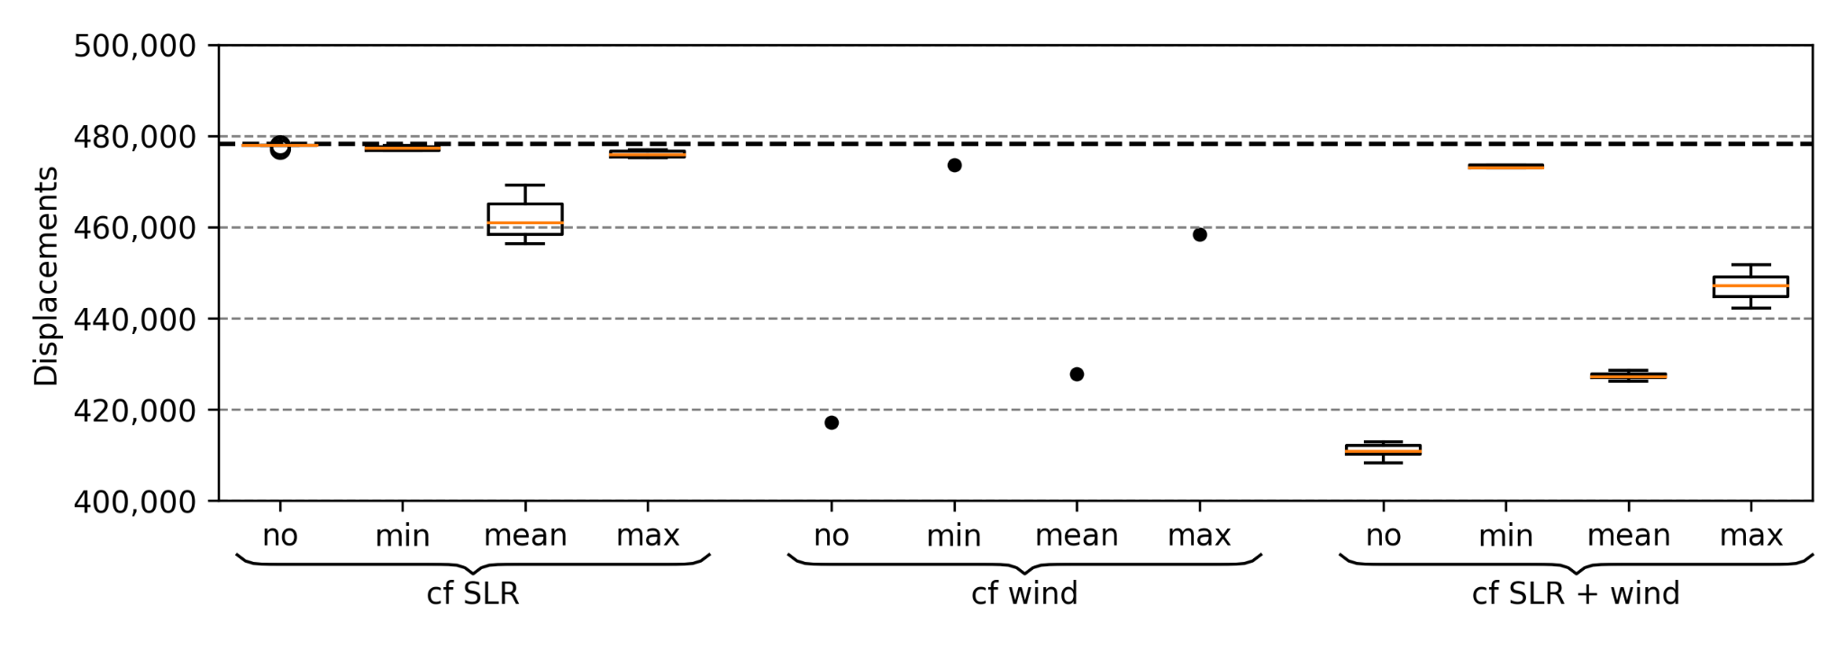
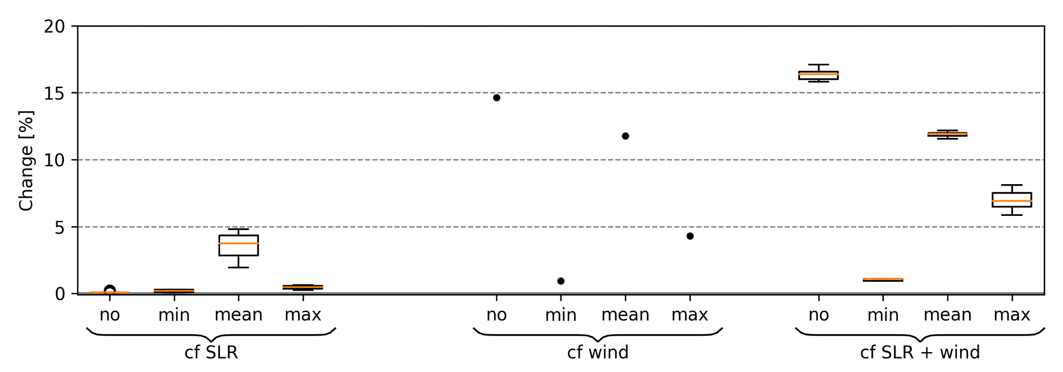

Figure S2: Simulated affected people, displacements and percentile change by flooding (10 cm impact threshold). Three counterfactual scenarios are shown: lower sea level (“cf SLR”)), de-intensification (“cf wind”), and a combination of both (“cf SLR + wind”). Additionally, a variety of counterfactual sea levels as well as a set of astronomical tides is presented, covering minimum (“min”), mean (“mean”), and maximum (“max”) as well as monthly mean sea level from satellite altimetry (“no”). Bold dashed line in the middle panel shows the number of observed displacements. Percentile changes in affected people and displacements are the same.

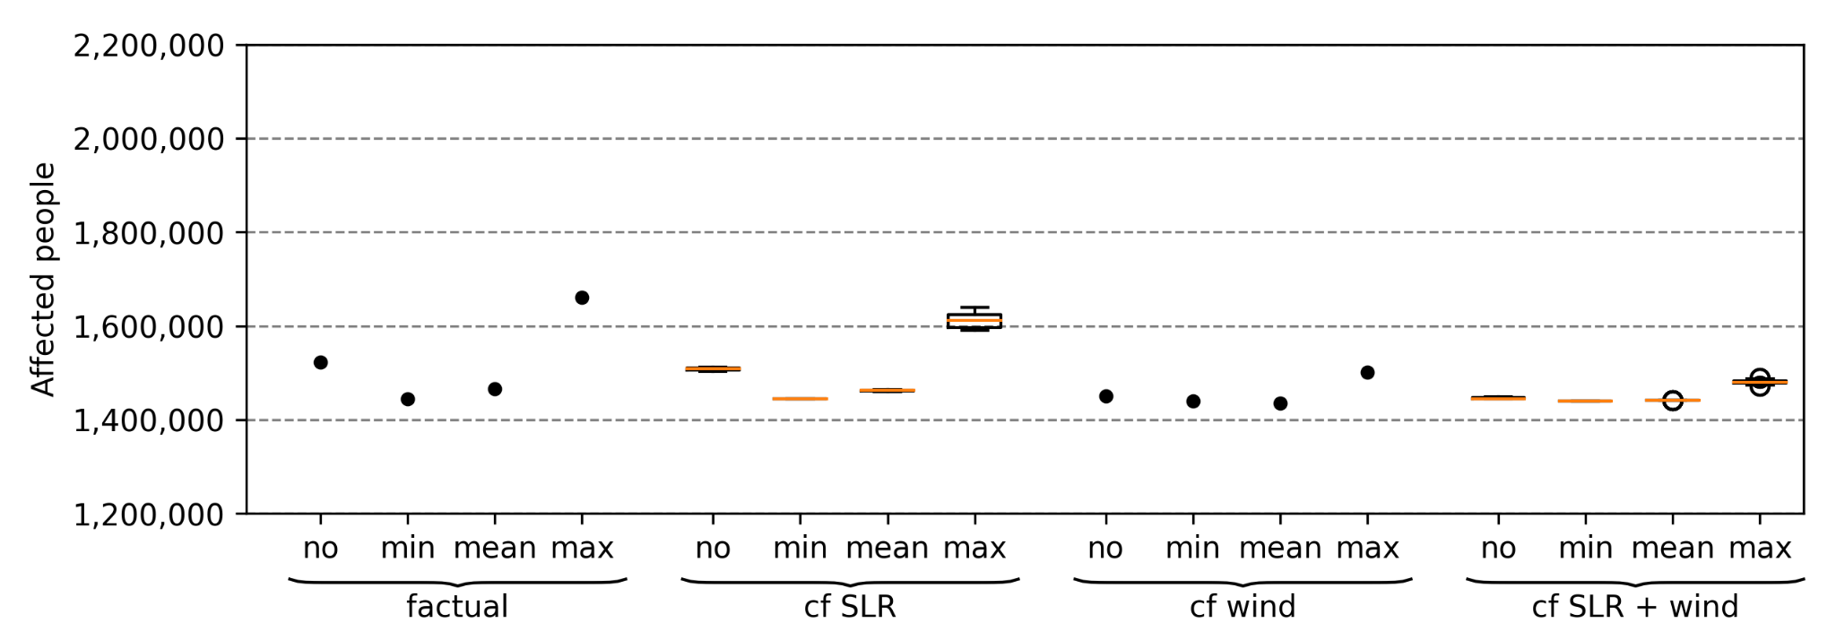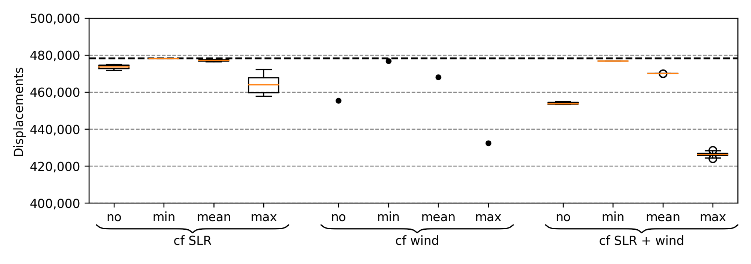
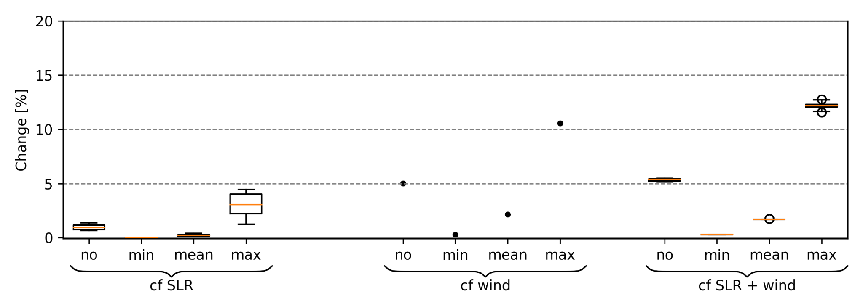

Figure S3: Simulated affected people, displacements and percentile change by flooding (50 cm impact threshold). Three counterfactual scenarios are shown: lower sea level (“cf SLR”)), de-intensification (“cf wind”), and a combination of both (“cf SLR + wind”). Additionally, a variety of counterfactual sea levels as well as a set of astronomical tides is presented, covering minimum (“min”), mean (“mean”), and maximum (“max”) as well as monthly mean sea level from satellite altimetry (“no”). Bold dashed line in the middle panel shows the number of observed displacements. Percentile changes in affected people and displacements are the same.

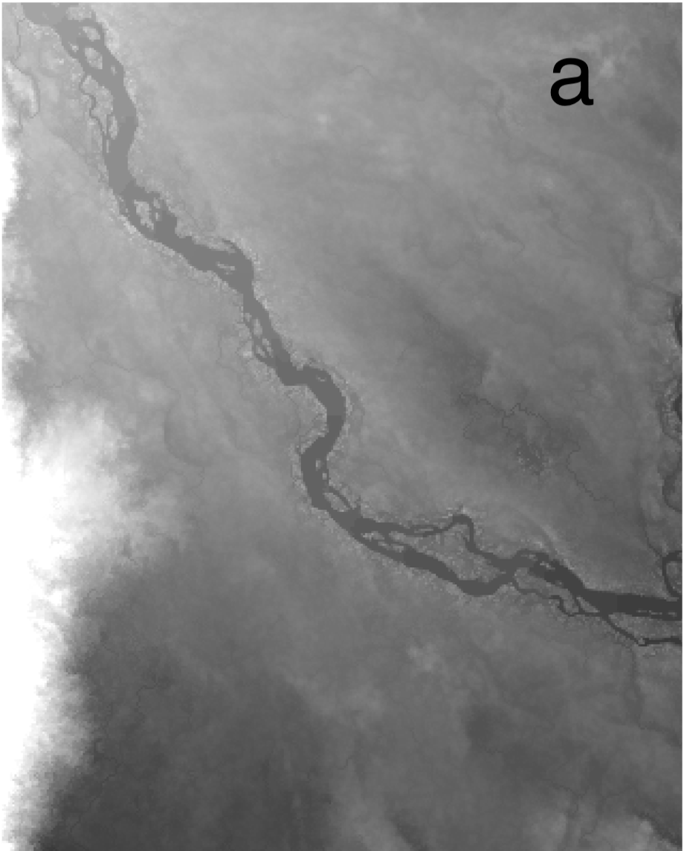 | 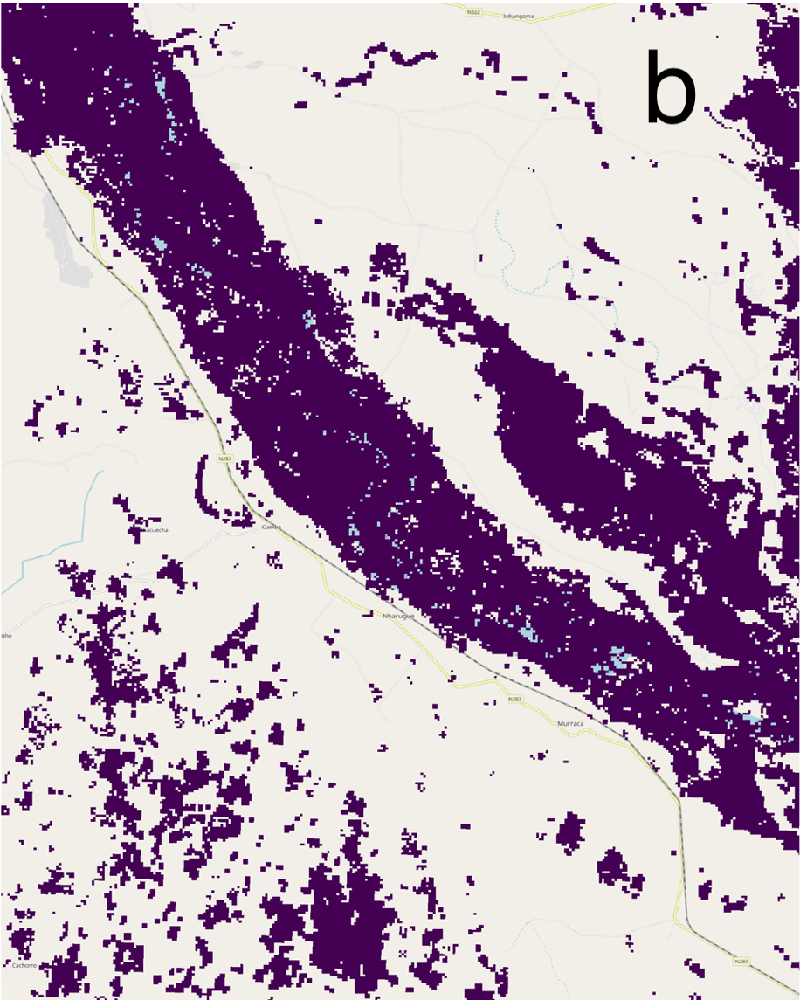 | 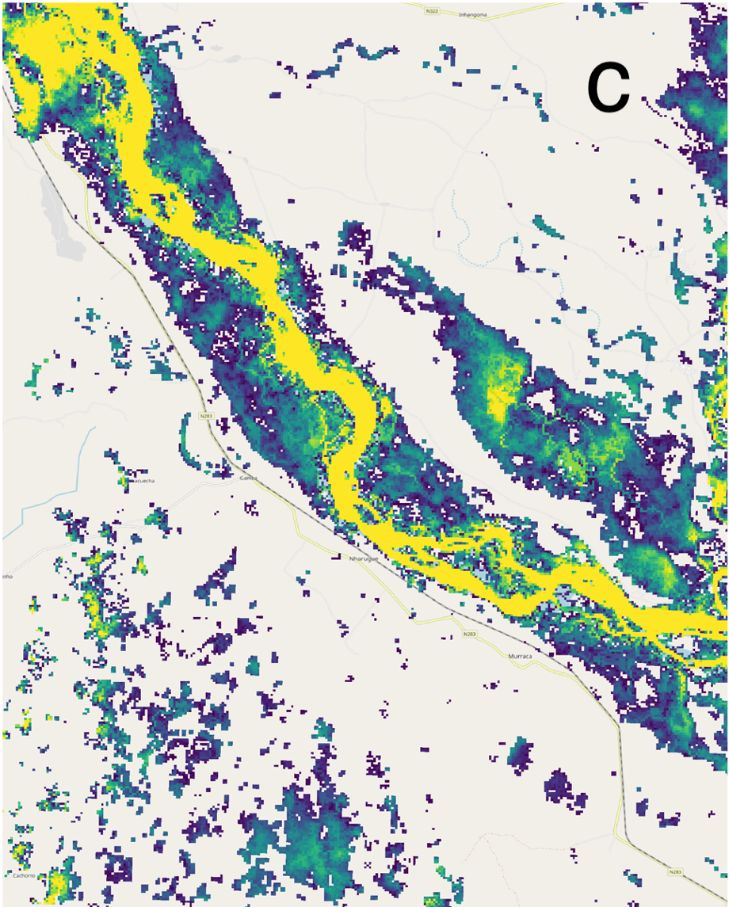
 |  | 0.1 m 3 m

Figure S4: Extract of a) MERIT DEM (Yamazaki et al., 2019), b) flood extents obtained from FloodScan (Atmospheric and Environmental Research & African Risk Capacity 2022), and c) corresponding gridded-depths computed with the RICorDE algorithm. AFED-detected non-persistent water (2019/03/01 - 2019/03/31). Includes copyrighted material of Atmospheric and Environmental Research, Inc. with its permission.

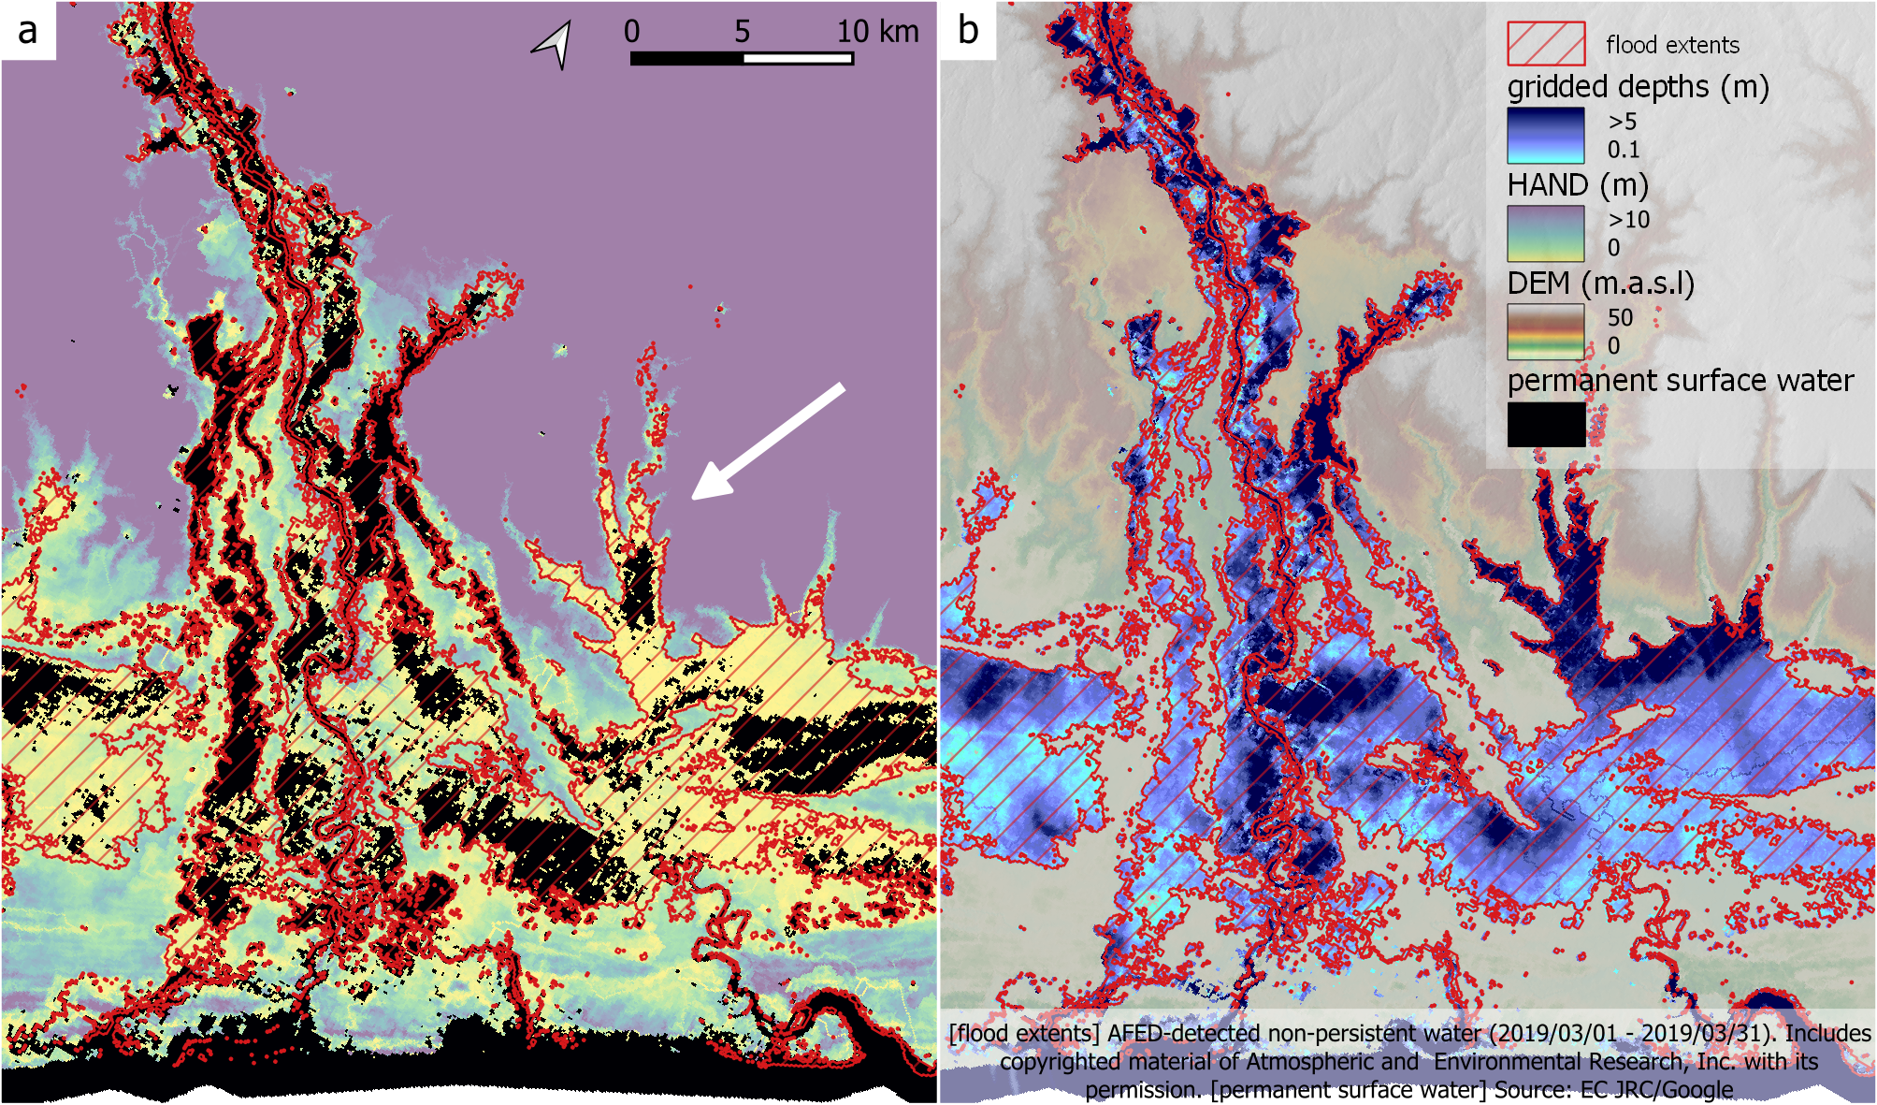
Figure S5: Example of RICorDE performance against flood extents obtained from FloodScan (Atmospheric and Environmental Research & African Risk Capacity 2022) showing a) permanent surface water (Pekel et al., 2016) and resulting HAND values; and b) MERIT DEM (Yamazaki et al., 2019) and resulting depths values.

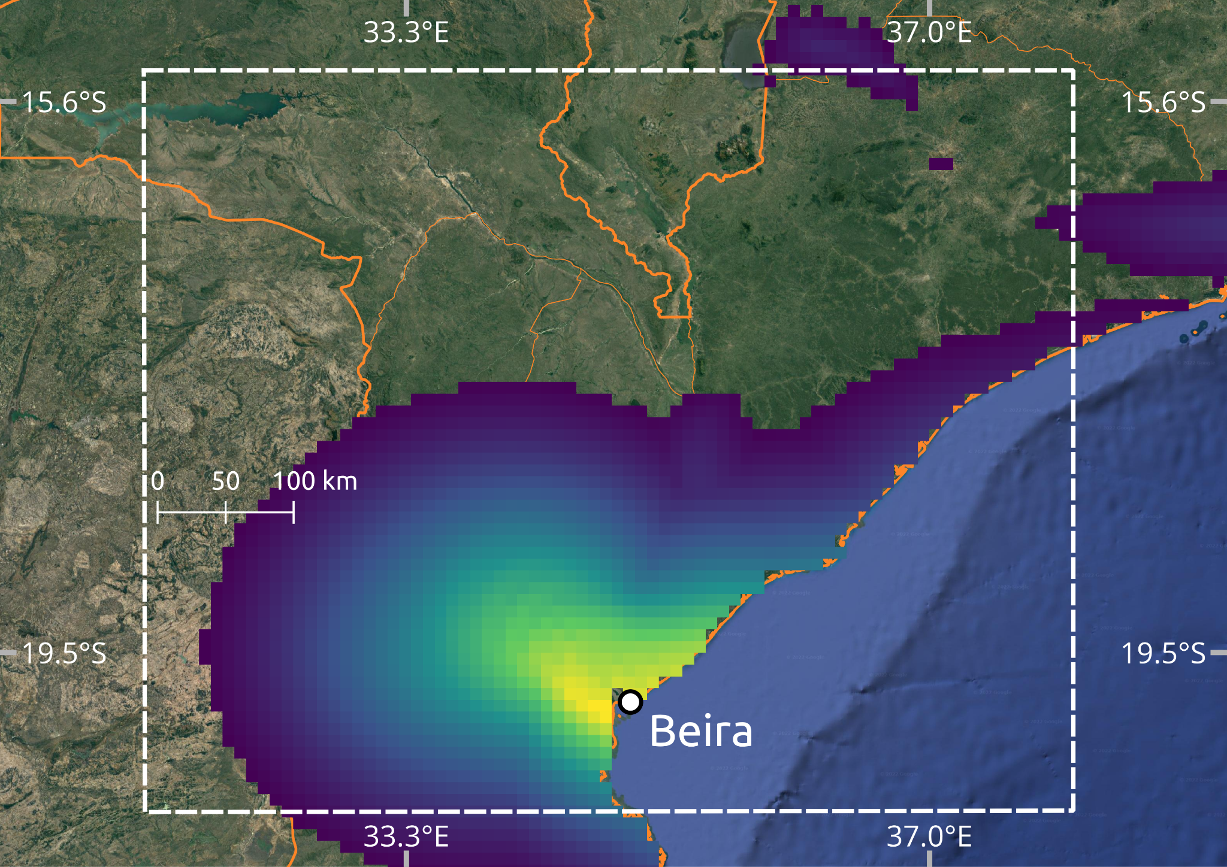 | 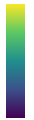 | 51.5 m/s  17.5 m/s
Figure S6: Maximum wind speeds of TC Idai, which made landfall in Mozambique in 2019. White dashed box shows the area of interest in which high wind speed exposure is computed.

