Supplementary Material

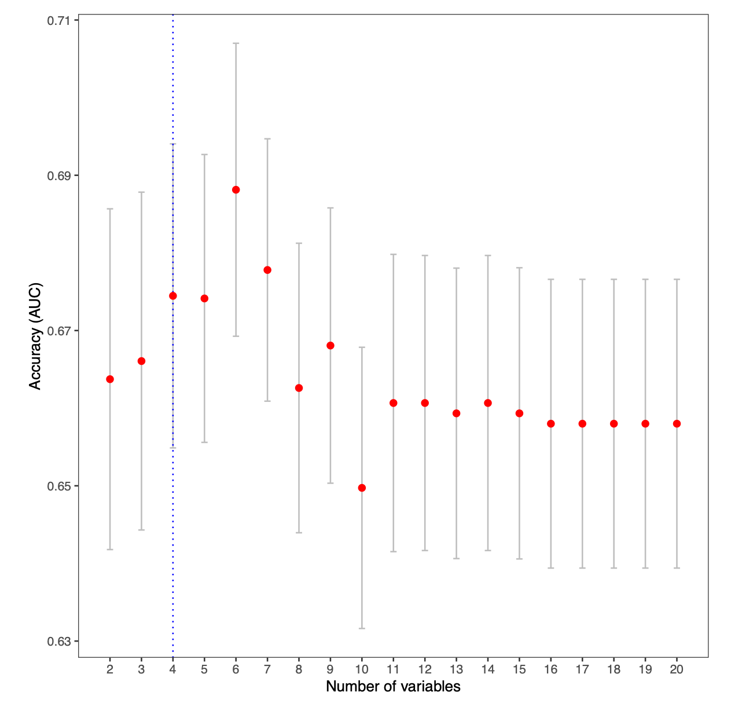

Supplementary Figure 1. Optimization of a biomarker for mortality
Mean area under the ROC curve (AUC) as a function of the number of discrete taxa included in candidate biomarkers for 28-day mortality generated during cross-validation. The optimal number of components according to the “1se rule” is highlighted with a vertical dashed line. The 1se rule is to take the least complex model from the set of models with a mean performance within one standard error of the best performing model. Models included Age and APACHE II score as covariates.

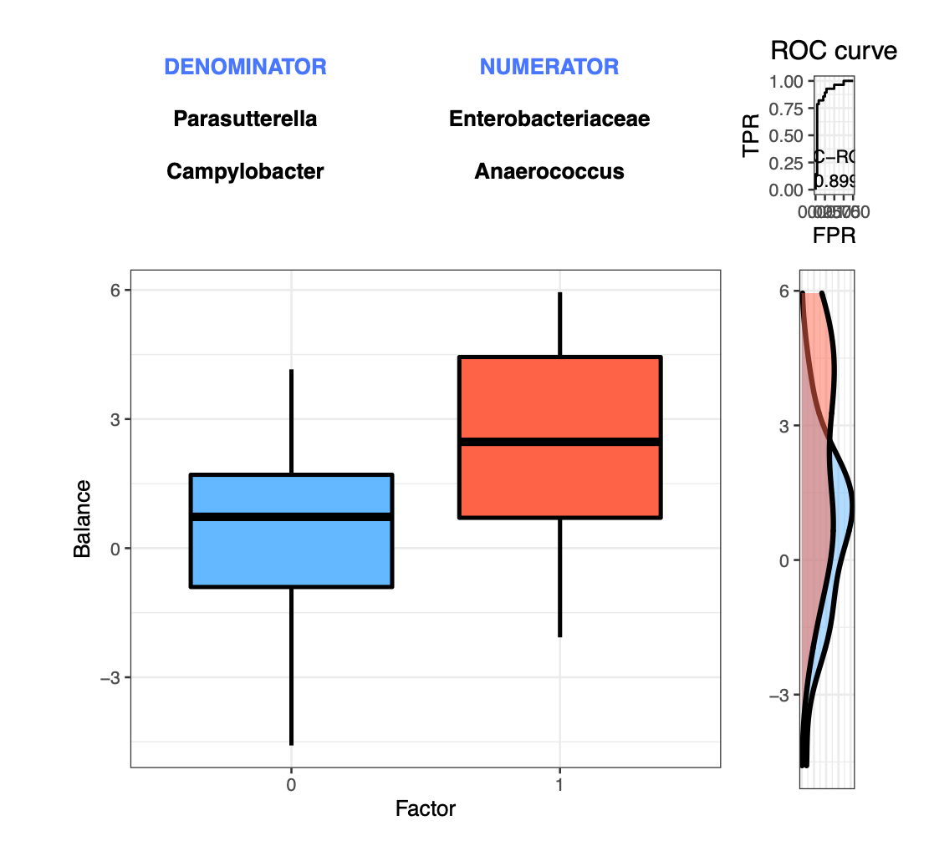

Supplementary Figure 2. Summary of output from selbal analysis
Profile of the final biomarker for 28-day mortality in critically ill patients determined by forward selection of taxa (up to four) from the global dataset of 52 samples. The balance (log contrast of two sets of taxa) specified at the top of the plot comprises the Microbial Mortality Index (MMI). The box plot represents the distribution of MMI values for patients who were dead by 28-days following hospitalization vs. those who were still alive. The rightmost portion of the figure depicts the ROC curve with its AUC value (0.90) and the density curve for each cohort.

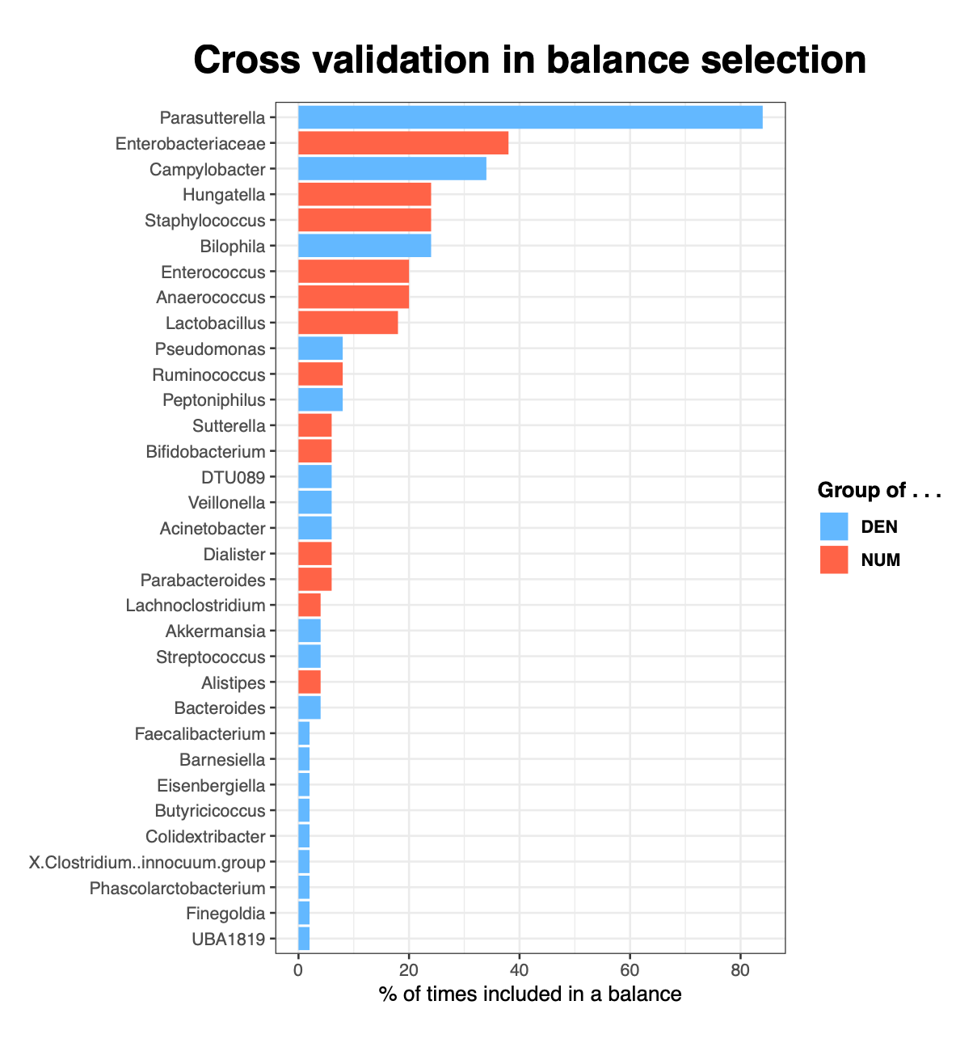
Supplementary Figure 3. Robustness of selected taxa during repeated K-fold cross-validation
Frequency bar plot of taxa selected during cross-validation compared to the global balance obtained with the whole dataset. Colors indicate whether the component was in the numerator (red) or the denominator (blue). 5-fold CV was repeated 10 times for a total of 50 models.
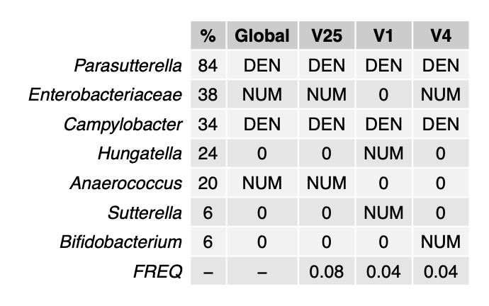
Supplementary Figure 4. Robustness of selected models during repeated K-fold cross-validation
The frequency of different CV balances and the frequency of selection of each taxon. Rows represent the most frequent taxa, with their percentage of selection given in the first column. The second column represents the global balance, that is, the balance obtained using all the samples. The last three columns represent the three most frequent balances selected in the CV procedure. The last row indicates the proportion of times each balance has been selected as optimal in the CV procedure. The third column shows that the taxa from the global model were selected by the CV procedure as optimal 8% of the time, which is highest among selected models.

