Supplementary materials
Table S1. Sepsis-induced coagulopathy criteria

 | Score | Range
Platelet count (10³/μL) | 2 | < 100
 | 1 | ≥ 100, <150
INR | 2 | > 1.4
 | 1 | >1.2, ≤1.4
SOFA score | 2 | ≥ 2
 | 1 | 1
Total score for SIC |  | ≥ 4
Abbreviations: SIC, sepsis-induced coagulopathy; INR, international normalized ratio; SOFA, sequential organ failure assessment.

Table S2. Missing number (%) for included variables in the dataset

Variables | Missing (%)
Age | 0 (0)
Gender | 0 (0)
WBC | 0 (0)
Hemoglobin | 1 (0)
Minimum platelet | 0 (0)
Maximum INR | 0 (0)
APTT | 33 (0.5%)
PT | 0 (0)
SpO₂ | 1 (0)
Temperature | 500 (7.7%)
MAP | 0(0)
Heart rate | 0 (0)
Respiratory rate | 2 (0)
Hypertension | 0 (0)
Diabetes | 0 (0)
Chronic heart disease | 0 (0)
Chronic pulmonary disease | 0 (0)
Vasopressor | 0 (0)
Mechanical ventilation | 0 (0)
RRT | 0 (0)
SOFA | 0 (0)
SAPS II | 0 (0)
Urine output | 124(1.9%)
AKI stage | 39(0.6%)
SIC score | 0 (0)
ICU mortality | 0 (0)
Hospital mortality | 0 (0)
Length of ICU stay | 0 (0)
Length of hospital stay | 0 (0)
Abbreviations: WBC, white blood cell; INR, international normalized ratio; PT, prothrombin time; APTT, activated partial thromboplastin time; MAP, mean arterial pressure; AKI, acute kidney injury; RRT, renal replacement therapy; SIC, sepsis-induced coagulopathy; SOFA, sequential organ failure assessment; SAPS II, simplified acute physiology score II .

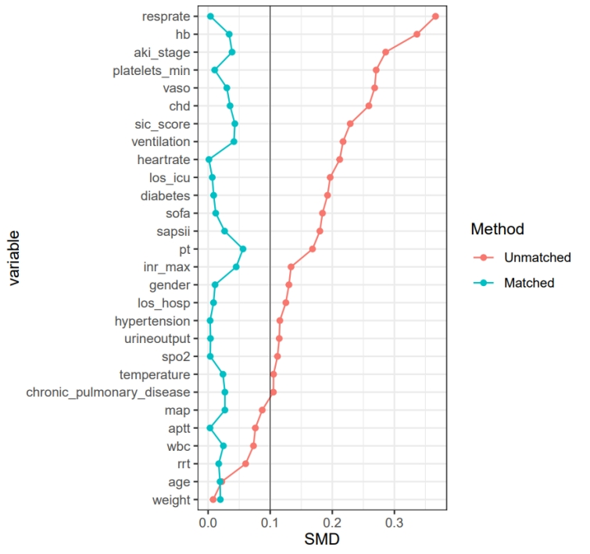
Figure S1. Standardized mean difference (SMD) of variables before and after propensity score matching.
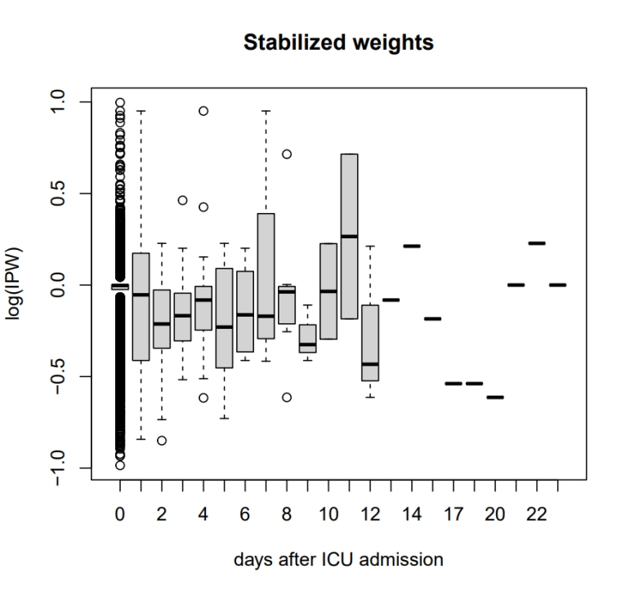
Figure S2. Weight distribution plots for the inverse probability weights that were used to adjust for confounding.

Marginal structural Cox model
Marginal structural Cox models (MSCM) provide the marginal causal relation between a time-varying exposure (heparin treatment) and a survival outcome (e.g. time to death), controlling for time-varying confounders (platelets, INR) without conditioning on those variables. Since the treatment with heparin might change during the follow up period, this was considered as a time-dependent variable. Potential . such as age, gender, use of mechanical ventilation, RRT, vasopressor, urine output, SOFA and SAPSII were obtained on day 1 after ICU admission.
Platelets and INR were included in the model as time-varying confounding factors because 1)Platelets and INR were affected by the previous heparin treatment; and 2) Platelets and INR values could influence subsequent heparin treatment ¹. The parameters of MSCM could be estimated using inverse probability weighting (IPW) to correct both for confounding and for forms of selection bias such as informative censoring ². By weighting each patient by IPW, two pseudo-populations are created, similar with regards to baseline and time-dependent confounding factors, and different in heparin exposure. Details of IPW will be introduced in the statistical analysis section.
The MSCM model allows the comparison of hazard functions for patients who never used heparin with those who used heparin ¹. The partial likelihood function of Cox model was modified such that the contribution of patient to the risk set was weighted by the stabilized inverse probability of treatment and censoring (IPTC) weight, , to account for potential confounding effects induced by baseline (i.e. variables obtained on day 1 including age, gender, use of mechanical ventilation, RRT, vasopressor, urine output, SOFA and SAPSII) and time-varying confounders (i.e. Platelets and INR). The stabilized inverse probability of treatment (IPT) for patient at day t can be obtained by
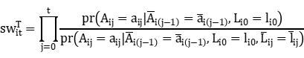
Where represents the treatment with heparin for patient i in day j. and are the baseline and time-varying variables, respectively, for patient i. 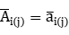 and 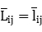 are observed treatment and time-varying confounder history, respectively, from baseline to time j. Since the time-varying confounders appeared only in the denominator of the weights, the stabilized weights were inversely related to a function of the time-varying confounder cumulative relapse. The weights down-weighted the person-day contributions when cumulative time-varying confounders were a strong predictor of treatment status in the subsequent time periods, after controlling for the baseline covariates. The weights created a pseudopopulation in which Platelets and INR no longer predicted subsequent heparin treatment status. The estimates of the effect of heparin treatment in this pseudopopulation would be an unbiased estimate for the target population. Similarly, the inverse probability of censoring can be estimated in the same way:
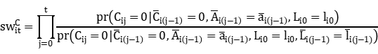
Then the overall stabilized IPTW weights were obtained by the product of 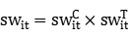. Finally, a MSCM was fit using robust variance estimator, and time-varying treatment assignment was included in the model ³.

References
1. Karim, M. E. et al. Marginal structural Cox models for estimating the association between β-interferon exposure and disease progression in a multiple sclerosis cohort. Am. J. Epidemiol. 2014, 180: 160-171.
2. Robins, J. M., Hernán, M. Á. & Brumback, B. Marginal structural models and causal inference in epidemiology. Epidemiology 2000, 11: 550-560.
3. Hernán, M. A., Brumback, B. & Robins, J. M. Marginal structural models to estimate the causal effect of zidovudine on the survival of HIV-positive men. Epidemiology 2000, 11: 561-570.

