Genomewide association testing in malaria studies in the presence of overdominance.
- Additional file Table S1: Genotype distributions of the 17 SNPs selected from the GWAS, Age-related macular degeneration (AMD) [1], Prostate Cancer (PC) [2], Breast cancer (BC) [3] and Hypertension (HP) [4]
Cases and Controls
SNP ID Casesdd CasesdD CasesDD Controldd ControldD ControlDD
Rs380390(AMD) 50 35 11 6 25 19
Rs1329428(AMD) 2 24 68 5 29 14
Rs1447295(PC) 25 283 864 10 218 929
Rs698267(PC) 223 598 351 301 579 277
Rs7837688(PC) 27 283 861 11 206 939
Rs10510126(PC) 10 180 955 14 272 854
Rs12505080(BC) 50 477 608 99 408 628
Rs17157903(BC) 18 316 777 26 220 862
Rs1219648(BC) 250 543 352 170 538 433
Rs7696175(BC) 187 605 353 249 496 396
Rs2420946(BC) 242 546 357 165 537 440
Rs2820037(HP) 40 587 1,325 72 684 2,180
Rs6997709(HP) 118 716 1,116 237 1,201 1,500
Rs7961152(HP) 416 963 570 492 1,448 992
Rs11110912(HP) 67 647 1,237 83 804 2,049
Rs1937506(HP) 113 742 1,097 244 1,205 1,484
Rs2398162(HP) 111 624 1,205 194 1,121 1,608

- Additional file 2 Table S2: Chi-square tests and the MAX test results of the 17 SNPs selected from the GWAS, Age-related macular degeneration (AMD) [1], Prostate Cancer (PC) [2], Breast cancer (BC) [3] and Hypertension (HP) [4]. The chi-square test was performed under dominant(DOM), recessive(REC), additive(ADD) and heterotic (HET) models. The genotype test was also performed.
rsid | MODEL | MAX_pval | DOM_pval | REC_pval | ADD_pval | HET_pval | Genotype_pv
rs380390 | Additive | 8.56E-07 | 6.17E-06 | 0.000418 | 8.56E-07 | 0.216247 | 1.80E-06
rs1329428 | Recessive | 2.21E-06 | 0.066268 | 2.21E-06 | 2.30E-06 | 0.000121 | 3.60E-06
rs1447295 | Additive | 0.000109 | 0.026024 | 0.000391 | 0.000109 | 0.004222 | 1.90E-04
rs6983267 | Additive | 2.16E-05 | 0.000143 | 0.002698 | 2.16E-05 | 0.865484 | 3.50E-05
rs7837688 | Additive | 6.66E-06 | 0.022018 | 2.24E-05 | 6.66E-06 | 0.00041 | 1.60E-05
rs10510126 | Recessive | 1.41E-06 | 0.650767 | 1.41E-06 | 3.37E-06 | 2.54E-06 | 3.70E-06
rs12505080 | Dominant | 8.46E-05 | 8.46E-05 | 0.639791 | 0.544965 | 0.007032 | 1.80E-05
rs17157903 | Heterosis | 5.76E-06 | 0.397101 | 6.17E-05 | 0.001492 | 5.76E-06 | 9.90E-06
rs1219648 | Additive | 4.99E-06 | 4.97E-05 | 0.000726 | 4.99E-06 | 0.988946 | 7.50E-06
rs7696175 | Heterosis | 2.01E-05 | 0.002069 | 0.100329 | 0.824674 | 2.01E-05 | 1.60E-05
rs2420946 | Additive | 5.34E-06 | 7.72E-05 | 0.000577 | 5.34E-06 | 0.936387 | 8.80E-06
rs2820037 | Heterosis | 3.17E-07 | 0.588908 | 3.23E-06 | 0.000141 | 3.17E-07 | 7.70E-07
rs6997709 | Additive | 2.07E-05 | 0.017889 | 5.83E-05 | 2.07E-05 | 0.008284 | 4.40E-05
rs7961152 | Additive | 2.01E-05 | 0.000158 | 0.00191 | 2.01E-05 | 0.999826 | 3.00E-05
rs11110912 | Recessive | 8.15E-06 | 0.409801 | 8.15E-06 | 2.32E-05 | 3.75E-05 | 1.90E-05
rs1937506 | Additive | 2.43E-05 | 0.002133 | 0.00031 | 2.43E-05 | 0.067814 | 4.50E-05
rs2398162 | Recessive | 2.42E-06 | 0.359548 | 2.42E-06 | 2.05E-05 | 2.77E-05 | 5.70E-06

- R codes for MAX TEST AND ALLELIC TESTS ( MAX EXTENDED TO HETEROTIC GENETIC MODEL) for Kenyan datasets

Both Kenyan and Gambian datasets from malariaGEN were pre-processed using SNP test V 2.4.1 then organized into 2 by 3 case-control tables before applying the MAX and the allelic tests in Rassoc package [5] [6]

setwd("D:/tests - 904")
data=read.csv("ch11New.csv")

#install.packages("readxl")

#library("readxl")

#data <- read_excel("ch1filtered.xlsx")
names(data)[5]='cases_AA'
names(data)[6]='cases_AB'
names(data)[7]='cases_BB'
names(data)[8]='controls_AA'
names(data)[9]='controls_AB'
names(data)[10]='controls_BB'
data
MAX3 <-
function(data,method="asy",m=1){
DNAME=deparse(substitute(data))
## Check if data is a 2 by 3 contingency table. ##
if(any(is.na(data)==TRUE)||any(abs(data)>10^9))
stop("data must be a 2 by 3 table without infinite and missing values.")
if(any(data<0))
stop("all entries of data must be non-negative.")
if((dim(data)[1]!=2)||(dim(data)[2]!=3))
stop("data must be a 2 by 3 table.")
if((data[1,1]<0.5)||(data[1,2]<0.5)||(data[1,3]<0.5)||(data[2,1]<0.5)||(data[2,2]<0.5)||(data[2,3]<0.5)){
warning("At least one cell of the table is zero.")
data=data+matrix(rep(0.5,6),nrow=2)
}
## Check if m is integer. ##
if ((trunc(m)-m)<0)
stop("m MUST be integer")
## Calculate the correlations. ##
p=apply(data,2,sum)/sum(data)
p0=p[1]
p1=p[2]
p2=p[3]
rho005=p2*(p1+2*p0)/(sqrt(p2*(1-p2))*sqrt((p1+2*p2)*p0+(p1+2*p0)*p2))
rho105=p0*(p1+2*p2)/(sqrt(p0*(1-p0))*sqrt((p1+2*p2)*p0+(p1+2*p0)*p2))
rho01=sqrt((p0*p2)/((1-p0)*(1-p2)))
w0=(rho005-rho01*rho105)/(1-rho01^2)
w1=(rho105-rho01*rho005)/(1-rho01^2)
r=sum(data[1,])
s=sum(data[2,])
## Define CATT. ##
CATT=function(tab,score){
nr=apply(tab,2,sum)
n=sum(nr)
Rbar=sum(nr*score)/n
s2=sum(nr*(score-Rbar)^2)
phi=sum(tab[1,])/n
catt_v=sum(tab[1,]*(score-Rbar))/sqrt(phi*(1-phi)*s2)
## Report the statistic of CATT. ##
return(catt_v)
}
## Report the statistic of MAX3. ##
dom=abs(CATT(data,c(0,1,1)))
rec=abs(CATT(data,c(0,0,1)))
add=abs(CATT(data,c(0,0.5,1)))
het=abs(CATT(data,c(0,1,0)))
maxr=max(dom,rec,add,het)
if((method!="boot")&&(method!="bvn")&&(method!="asy"))
stop("method must be boot, bvn or asy.")
## Use "boot" to caculate the p-value of MAX3. ##
if(method=="boot"){
CATTN=function(data,score){
tab=matrix(data,nrow=2,byrow=TRUE)
nr=apply(tab,2,sum)
n=sum(nr)
Rbar=sum(nr*score)/n
s2=sum(nr*(score-Rbar)^2)
phi=sum(tab[1,])/n
catt_v=sum(tab[1,]*(score-Rbar))/sqrt(phi*(1-phi)*s2)
return(catt_v)
}
ca=rmultinom(m,r,p)
co=rmultinom(m,s,p)
caco=rbind(ca,co)
caco0=apply(caco,2,CATTN,score=c(0,0,1))
caco05=apply(caco,2,CATTN,score=c(0,0.5,1))
caco1=apply(caco,2,CATTN,score=c(0,1,1))
cacos=rbind(abs(caco0),abs(caco05),abs(caco1))
max1=apply(cacos,2,max)
## Report empirical p-value using "boot" method. ##
pv=length(max1[max1>=maxr])/m
pvdom=length(max1[max1>=dom])/m
pvrec=length(max1[max1>=rec])/m
pvadd=length(max1[max1>=add])/m
pvhet=length(max1[max1>=het])/m
md="The MAX3 test using the boot method"

}
## Use "bvn" to caculate the p-value of MAX3. ##
if(method=="bvn"){
BV05=function(x,a1,a2){
return(a1*x[1]+a2*x[2])
}
bv01=rmvnorm(m,mean=c(0,0),sigma=matrix(c(1,rho01,rho01,1),nrow=2))
bv05=apply(bv01,1,BV05,a1=w0,a2=w1)
bv=cbind(abs(bv01),abs(bv05))
max2=apply(bv,1,max)
## Report empirical p-value using "bvn" method. ##
pv=length(max2[max2>=maxr])/m
pvdom=length(max2[max2>=dom])/m
pvrec=length(max2[max2>=rec])/m
pvadd=length(max2[max2>=add])/m
pvhet=length(max2[max2>=het])/m
md="The MAX3 test using the bvn method"

}
## Use "asy" to caculate the p-value of MAX3. ##
if(method=="asy"){
fun1=function(t,z){
return(pnorm((t-rho01*z)/sqrt(1-rho01^2))*dnorm(z))
}
fun2=function(t,z){
return(pnorm(((t-w0*z)/w1-rho01*z)/sqrt(1-rho01^2))*dnorm(z))
}
fun3=function(t,z){
return(pnorm((-t-rho01*z)/sqrt(1-rho01^2))*dnorm(z))
}
asy=function(t){
z1=2*integrate(function(z){fun1(t,z)},lower=0,upper=t*(1-w1)/w0,subdivisions=1000)$value
z2=2*integrate(function(z){fun2(t,z)},lower=t*(1-w1)/w0,upper=t,subdivisions=1000)$value
z3=-2*integrate(function(z){fun3(t,z)},lower=0,upper=t,subdivisions=500)$value
return(z1+z2+z3)
}
## Report asymptotic p-value using "asy" method. ##
pv=1-asy(maxr)
pvdom=1-asy(dom)
pvrec=1-asy(rec)
pvadd=1-asy(add)
pvhet=1-asy(het)

md="The MAX3 test using the asy method"

}
## print the output. ##
if(max(dom,rec,add,het)==dom)
mdl="Dominant"
if(max(dom,rec,add,het)==rec)
mdl="Recessive"
if(max(dom,rec,add,het)==add)
mdl="Additive"
if(max(dom,rec,add,het)==het)
mdl="Heterosis"

names(mdl)="model"
names(maxr)="statistic"
names(pv)="p-value"

cat(paste('model=',mdl,'statistic=',maxr,'p-value=',pv,'\n'))
result=c(mdl,maxr,pv)
#result=c(mdl,maxr,pv,dom,pvdom,rec,pvrec,add,pvadd,het,pvhet)
#return(result)

##if you want original output (including method, etc), print below
##print(structure(list(statistic=maxr,p.value=pv,method=md,data.name=DNAME),class="htest"))

##if you want the values for all models, print below
#print(c('Dom=',dom,'Rec=',rec,'Add=',add,'Het=',het))
#print(c('P_Dom=',pvdom,'P_Rec=',pvrec,'P_Add=',pvadd,'P_Het=',pvhet))
}

result=matrix(data=NA,nrow=nrow(data),ncol=3)
for (i in (1:nrow(data))){
ca=c(data[i,5],data[i,6],data[i,7])
co=c(data[i,8],data[i,9],data[i,10])
a=rbind(ca,co)
cat(paste('\n','ID=',data[i,2],'\n'))
test=MAX3(a,"asy",1)
result[i,]=test
}

data=data.frame(data,result)
names(data)[12]='model'
names(data)[13]='statistic'
names(data)[14]='p-value'
data

ABT <-
function(data){
if((data[1,1]<0.5)||(data[1,2]<0.5)||(data[1,3]<0.5)||(data[2,1]<0.5)||(data[2,2]<0.5)||(data[2,3]<0.5)){
data=data+matrix(rep(0.5,6),nrow=2)
}
rr=data[1,]
ss=data[2,]
nn=apply(data,2,sum)
r=sum(rr)
s=sum(ss)
n=sum(nn)
pd=(2*rr[3]+rr[2])/(2*r)
ph=(2*ss[3]+ss[2])/(2*s)
p=(2*nn[3]+nn[2])/(2*n)
u=pd-ph
v=p*(1-p)*(1/(2*r)+1/(2*s))
re1=u/sqrt(v)
re2=1-pchisq(re1^2,df=1)
if(re2>=0.05){
re3="null hypothesis: association doesn't exist under significant level 0.05"
}
if(re2<0.05){
re3="alternative hypothesis: association exists under significant level 0.05"
}
names(re1)="statistic"
names(re2)="p-value"

cat(paste('allele_stat=',re1,'allele_p=',re2,'conclu=',re3,'\n'))
result=c(re1,re2,re3)
return(result)

}

result=matrix(data=NA,nrow=nrow(data),ncol=3)
for (i in (1:nrow(data))){
ca=c(data[i,3],data[i,4],data[i,5])
co=c(data[i,6],data[i,7],data[i,8])
a=rbind(ca,co)
cat(paste('\n','rsid=',data[i,2],'\n'))
test=ABT(a)
result[i,]=test
}

data=data.frame(data,result)
names(data)[15]='allele_stat'
names(data)[16]='allele_p'

write.table(data,file="D:/tests - 904/data_ch11max.csv",row.names=FALSE,na="",col.names=TRUE,sep=",")

- Manhattan and quantile-quantile plots for selected chromosomes for Kenyan datasets

Manhattan and the quantile-quantile plots for selected chromosomes was conducted for the Kenyan datasets using the qqman package [7]

setwd("D:/tests - 904")

Data1=read.csv("data_ch1max.csv")
Data2=read.csv("data_ch2max.csv")
Data3=read.csv("data_ch3max.csv")
Data4=read.csv("data_ch4max.csv")
Data5=read.csv("data_ch5max.csv")
Data6=read.csv("data_ch6max.csv")
Data7=read.csv("data_ch7max.csv")
Data8=read.csv("data_ch8max.csv")
Data9=read.csv("data_ch9max.csv")
Data10=read.csv("data_ch10max.csv")
Data11=read.csv("data_ch11max.csv")
Data12=read.csv("data_ch12max.csv")
Data13=read.csv("data_ch13max.csv")
Data14=read.csv("data_ch14max.csv")
Data15=read.csv("data_ch15max.csv")
Data16=read.csv("data_ch16max.csv")
Data17=read.csv("data_ch17max.csv")
Data18=read.csv("data_ch18max.csv")
Data19=read.csv("data_ch19max.csv")
Data20=read.csv("data_ch20max.csv")

library(qqman)
par(mfrow=c(3,3))
manhattan(subset(Data1, CHR == 1), highlight = snpsOfInterest, xlim = c(0, 50000000), ,ylim=c(0,20), main = "Chr 1")

manhattan(subset(Data2, CHR == 2), highlight = snpsOfInterest, xlim = c(0, 50000000), ,ylim=c(0,20), main = "Chr 2")

manhattan(subset(Data3, CHR == 3), highlight = snpsOfInterest, xlim = c(0, 50000000), ,ylim=c(0,20), main = "Chr 3")

manhattan(subset(Data4, CHR == 4), highlight = snpsOfInterest, xlim = c(0, 50000000), ,ylim=c(0,20), main = "Chr 4")

manhattan(subset(Data5, CHR == 5), highlight = snpsOfInterest, xlim = c(0, 50000000), ,ylim=c(0,20), main = "Chr 5")

manhattan(subset(Data6, CHR == 6), highlight = snpsOfInterest, xlim = c(0, 50000000), ,ylim=c(0,20), main = "Chr 6")

manhattan(subset(Data7, CHR == 7), highlight = snpsOfInterest, xlim = c(0, 50000000), ,ylim=c(0,20), main = "Chr 7")

manhattan(subset(Data8, CHR == 8), highlight = snpsOfInterest, xlim = c(0, 50000000), ,ylim=c(0,20), main = "Chr 8")

manhattan(subset(Data9, CHR == 9), highlight = snpsOfInterest, xlim = c(0, 50000000), ,ylim=c(0,20), main = "Chr 9")

manhattan(subset(Data10, CHR == 10), highlight = snpsOfInterest, xlim = c(0, 50000000), ,ylim=c(0,20), main = "Chr 10")

manhattan(subset(Data11, CHR == 11), highlight = snpsOfInterest, xlim = c(0, 50000000), ,ylim=c(0,20), main = "Chr 11")

manhattan(subset(Data12, CHR == 12), highlight = snpsOfInterest, xlim = c(0, 50000000), ,ylim=c(0,20), main = "Chr 12")

manhattan(subset(Data13, CHR == 13), highlight = snpsOfInterest, xlim = c(0, 50000000), ,ylim=c(0,20), main = "Chr 13")

manhattan(subset(Data14, CHR == 14), highlight = snpsOfInterest, xlim = c(0, 50000000), ,ylim=c(0,20), main = "Chr 14")

manhattan(subset(Data15, CHR == 15), highlight = snpsOfInterest, xlim = c(0, 50000000), ,ylim=c(0,20), main = "Chr 15")

manhattan(subset(Data16, CHR == 16), highlight = snpsOfInterest, xlim = c(0, 50000000), ,ylim=c(0,20), main = "Chr 16")

manhattan(subset(Data17, CHR == 17), highlight = snpsOfInterest, xlim = c(0, 50000000), ,ylim=c(0,20), main = "Chr 17")

manhattan(subset(Data18, CHR == 18), highlight = snpsOfInterest, xlim = c(0, 50000000), ,ylim=c(0,20), main = "Chr 18")

manhattan(subset(Data19, CHR == 19), highlight = snpsOfInterest, xlim = c(0, 50000000), ,ylim=c(0,20), main = "Chr 19")

manhattan(subset(Data20, CHR == 20), highlight = snpsOfInterest, xlim = c(0, 50000000), ,ylim=c(0,20), main = "Chr 20")

par(mfrow=c(3,3))

qq(Data1$P, main = "Chr 1")

qq(Data2$P, main = "Chr 2")
qq(Data3$P, main = "Chr 3")
qq(Data4$P, main = "Chr 4")
qq(Data5$P, main = "Chr 5")
qq(Data6$P, main = "Chr 6")
qq(Data7$P, main = "Chr 7")
qq(Data8$P, main = "Chr 8")
qq(Data9$P, main = "Chr 9")

qq(Data10$P, main = "Chr 10")

qq(Data11$P, main = "Chr 11")
qq(Data12$P, main = "Chr 12")
qq(Data13$P, main = "Chr 13")
qq(Data14$P, main = "Chr 14")
qq(Data15$P, main = "Chr 15")
qq(Data16$P, main = "Chr 16")
qq(Data17$P, main = "Chr 17")
qq(Data18$P, main = "Chr 18")

- SIMULATION CODES

#Note: we have to transpose the vectors to have data in the correct 2 by 3 table format
#different number of cases and controls for each SNP (total to be 200-5000)
#10 snps at a time, same format as MalariaGEN data
prob=c(0.25,0.5,0.25)
data=matrix(data=NA,nrow=10,ncol=6)
for(i in (1:nrow(data))){
n=sample(200:5000)
n1=sample(200:n)
n2=n-n1
cases=t(rmultinom(1,n1,prob))
controls=t(rmultinom(1,n2,prob))
data[i,]=cbind(cases,controls)
}
data=data.frame(SNP=c(1:nrow(data)),data)
data

#Renaming columns to match MalariaGEN data
names(data)[2]='cases_AA'
names(data)[3]='cases_AB'
names(data)[4]='cases_BB'
names(data)[5]='controls_AA'
names(data)[6]='controls_AB'
names(data)[7]='controls_BB'
data
## Install and load package mvtnorm first ##
## This function conducts the MAX3 to a given case-control table. ##
## MAX3 takes the maximum of the absolute values of the three CATTs respectively optimal for the REC, ADD and DOM models. ##
## The MAX3 calculates the statistic and associated p-value as well as reporting the conclusion of the hypothesis test. ##
## data is a 2 by 3 contingency table for analysis. ##
## The rows of the data represent disease status and the columns represent genotypes. ##
## method is the method for calculating the p-values of MAX3. ##
## "boot" represents the parametric bootstrap method. ##
## "bvn" represents the simulation from the bivariate normal distribution. ##
## "asy" represents the asymptotic null distribution method. ##
## m is the number of replicates for "boot" and "bvn". ##
## m can be any positive integer for "asy". ##
## m MUST be positive intefer ##

library(mvtnorm)
MAX3 <-
function(data,method="asy",m=1){
DNAME=deparse(substitute(data))
## Check if data is a 2 by 3 contingency table. ##
if(any(is.na(data)==TRUE)||any(abs(data)>10^9))
stop("data must be a 2 by 3 table without infinite and missing values.")
if(any(data<0))
stop("all entries of data must be non-negative.")
if((dim(data)[1]!=2)||(dim(data)[2]!=3))
stop("data must be a 2 by 3 table.")
if((data[1,1]<0.5)||(data[1,2]<0.5)||(data[1,3]<0.5)||(data[2,1]<0.5)||(data[2,2]<0.5)||(data[2,3]<0.5)){
warning("At least one cell of the table is zero.")
data=data+matrix(rep(0.5,6),nrow=2)
}
## Check if m is integer. ##
if ((trunc(m)-m)<0)
stop("m MUST be integer")
## Calculate the correlations. ##
p=apply(data,2,sum)/sum(data)
p0=p[1]
p1=p[2]
p2=p[3]
rho005=p2*(p1+2*p0)/(sqrt(p2*(1-p2))*sqrt((p1+2*p2)*p0+(p1+2*p0)*p2))
rho105=p0*(p1+2*p2)/(sqrt(p0*(1-p0))*sqrt((p1+2*p2)*p0+(p1+2*p0)*p2))
rho01=sqrt((p0*p2)/((1-p0)*(1-p2)))
w0=(rho005-rho01*rho105)/(1-rho01^2)
w1=(rho105-rho01*rho005)/(1-rho01No table of figures entries found.^2)
r=sum(data[1,])
s=sum(data[2,])
## Define CATT. ##
CATT=function(tab,score){
nr=apply(tab,2,sum)
n=sum(nr)
Rbar=sum(nr*score)/n
s2=sum(nr*(score-Rbar)^2)
phi=sum(tab[1,])/n
catt_v=sum(tab[1,]*(score-Rbar))/sqrt(phi*(1-phi)*s2)
## Report the statistic of CATT. ##
return(catt_v)
}
## Report the statistic of MAX3. ##
dom=abs(CATT(data,c(0,1,1)))
rec=abs(CATT(data,c(0,0,1)))
add=abs(CATT(data,c(0,0.5,1)))
het=abs(CATT(data,c(0,1,0)))
maxr=max(dom,rec,add,het)
if((method!="boot")&&(method!="bvn")&&(method!="asy"))
stop("method must be boot, bvn or asy.")
## Use "boot" to caculate the p-value of MAX3. ##
if(method=="boot"){
CATTN=function(data,score){
tab=matrix(data,nrow=2,byrow=TRUE)
nr=apply(tab,2,sum)
n=sum(nr)
Rbar=sum(nr*score)/n
s2=sum(nr*(score-Rbar)^2)
phi=sum(tab[1,])/n
catt_v=sum(tab[1,]*(score-Rbar))/sqrt(phi*(1-phi)*s2)
return(catt_v)
}
ca=rmultinom(m,r,p)
co=rmultinom(m,s,p)
caco=rbind(ca,co)
caco0=apply(caco,2,CATTN,score=c(0,0,1))
caco05=apply(caco,2,CATTN,score=c(0,0.5,1))
caco1=apply(caco,2,CATTN,score=c(0,1,1))
cacos=rbind(abs(caco0),abs(caco05),abs(caco1))
max1=apply(cacos,2,max)
## Report empirical p-value using "boot" method. ##
pv=length(max1[max1>=maxr])/m
pvdom=length(max1[max1>=dom])/m
pvrec=length(max1[max1>=rec])/m
pvadd=length(max1[max1>=add])/m
pvhet=length(max1[max1>=het])/m
md="The MAX3 test using the boot method"

}
## Use "bvn" to caculate the p-value of MAX3. ##
if(method=="bvn"){
BV05=function(x,a1,a2){
return(a1*x[1]+a2*x[2])
}
bv01=rmvnorm(m,mean=c(0,0),sigma=matrix(c(1,rho01,rho01,1),nrow=2))
bv05=apply(bv01,1,BV05,a1=w0,a2=w1)
bv=cbind(abs(bv01),abs(bv05))
max2=apply(bv,1,max)
## Report empirical p-value using "bvn" method. ##
pv=length(max2[max2>=maxr])/m
pvdom=length(max2[max2>=dom])/m
pvrec=length(max2[max2>=rec])/m
pvadd=length(max2[max2>=add])/m
pvhet=length(max2[max2>=het])/m
md="The MAX3 test using the bvn method"

}
## Use "asy" to caculate the p-value of MAX3. ##
if(method=="asy"){
fun1=function(t,z){
return(pnorm((t-rho01*z)/sqrt(1-rho01^2))*dnorm(z))
}
fun2=function(t,z){
return(pnorm(((t-w0*z)/w1-rho01*z)/sqrt(1-rho01^2))*dnorm(z))
}
fun3=function(t,z){
return(pnorm((-t-rho01*z)/sqrt(1-rho01^2))*dnorm(z))
}
asy=function(t){
z1=2*integrate(function(z){fun1(t,z)},lower=0,upper=t*(1-w1)/w0,subdivisions=1000)$value
z2=2*integrate(function(z){fun2(t,z)},lower=t*(1-w1)/w0,upper=t,subdivisions=1000)$value
z3=-2*integrate(function(z){fun3(t,z)},lower=0,upper=t,subdivisions=500)$value
return(z1+z2+z3)
}
## Report asymptotic p-value using "asy" method. ##
pv=1-asy(maxr)
pvdom=1-asy(dom)
pvrec=1-asy(rec)
pvadd=1-asy(add)
pvhet=1-asy(het)

md="The MAX3 test using the asy method"

}
## print the output. ##
if(max(dom,rec,add,het)==dom)
mdl="Dominant"
if(max(dom,rec,add,het)==rec)
mdl="Recessive"
if(max(dom,rec,add,het)==add)
mdl="Additive"
if(max(dom,rec,add,het)==het)
mdl="Heterosis"

names(mdl)="model"
names(maxr)="statistic"
names(pv)="p-value"

cat(paste('model=',mdl,'statistic=',maxr,'p-value=',pv,'\n'))
result=c(mdl,maxr,pv)
#result=c(mdl,maxr,pv,dom,pvdom,rec,pvrec,add,pvadd,het,pvhet)
#return(result)

##if you want original output (including method, etc), print below
##print(structure(list(statistic=maxr,p.value=pv,method=md,data.name=DNAME),class="htest"))

##if you want the values for all models, print below
#print(c('Dom=',dom,'Rec=',rec,'Add=',add,'Het=',het))
#print(c('P_Dom=',pvdom,'P_Rec=',pvrec,'P_Add=',pvadd,'P_Het=',pvhet))
}

#Run the MAX test on simulated data. Make sure to run code from file 'MAXtest_DHAR.R' first.
result=matrix(data=NA,nrow=nrow(data),ncol=3)
for (i in (1:nrow(data))){
ca=c(data[i,2],data[i,3],data[i,4])
co=c(data[i,5],data[i,6],data[i,7])
a=rbind(ca,co)
cat(paste('\n','rsid=',data[i,1],'\n'))
test=MAX3(a,"asy",1)
result[i,]=test
}

#Add MAX test results and change column names
data=data.frame(data,result)
names(data)[8]='model'
names(data)[9]='statistic'
names(data)[10]='p-value'
data
getwd()
setwd("C:/Users/George/Desktop/data")
write.table(data,file="C:/Users/George/Desktop/data/data_simulation.csv",row.names=FALSE,na="",col.names=TRUE,sep=",")

#Save results in Excel file
write.table(data, data)
write.table(data,file="C:/Users/bomolo/Documents/bomolo/documents/SIMS/MorineAkoth/GeneticAssocCC/data_simulation.csv",row.names=FALSE,na="",col.names=TRUE,sep=",")

- Additional file 3 Figure S1: Manhattan plots for additive, dominant, recessive and overdominant models for selected chromosomes. MAX test performs model selection using the P-value approach for Kenyan datasets.
The blue line indicates the threshold used in our study (5*10^-5) while the red line indicates the global threshold(5*10^-8).
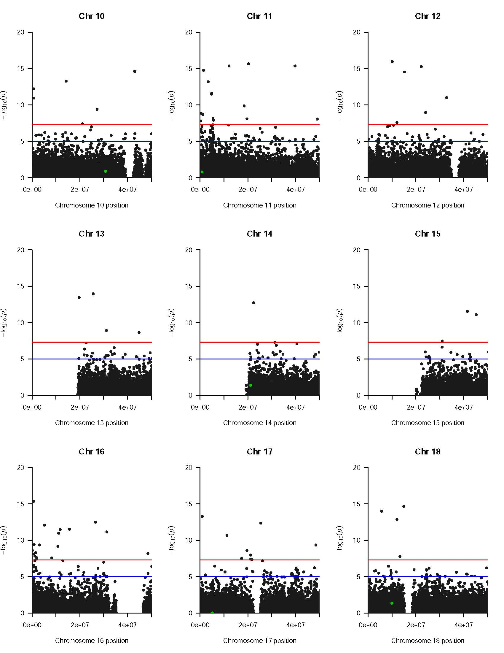
- Additional file 4 Figure S2: Quantile-quantile plots for additive, dominant , recessive and overdominant models for selected chromosomes. The MAX test performs model selection using the P-value approach for Kenyan datasets.
The deviation from the red line, the expected frequency, is an indication of the genetic association of malaria with SNPs in the genotyped regions.
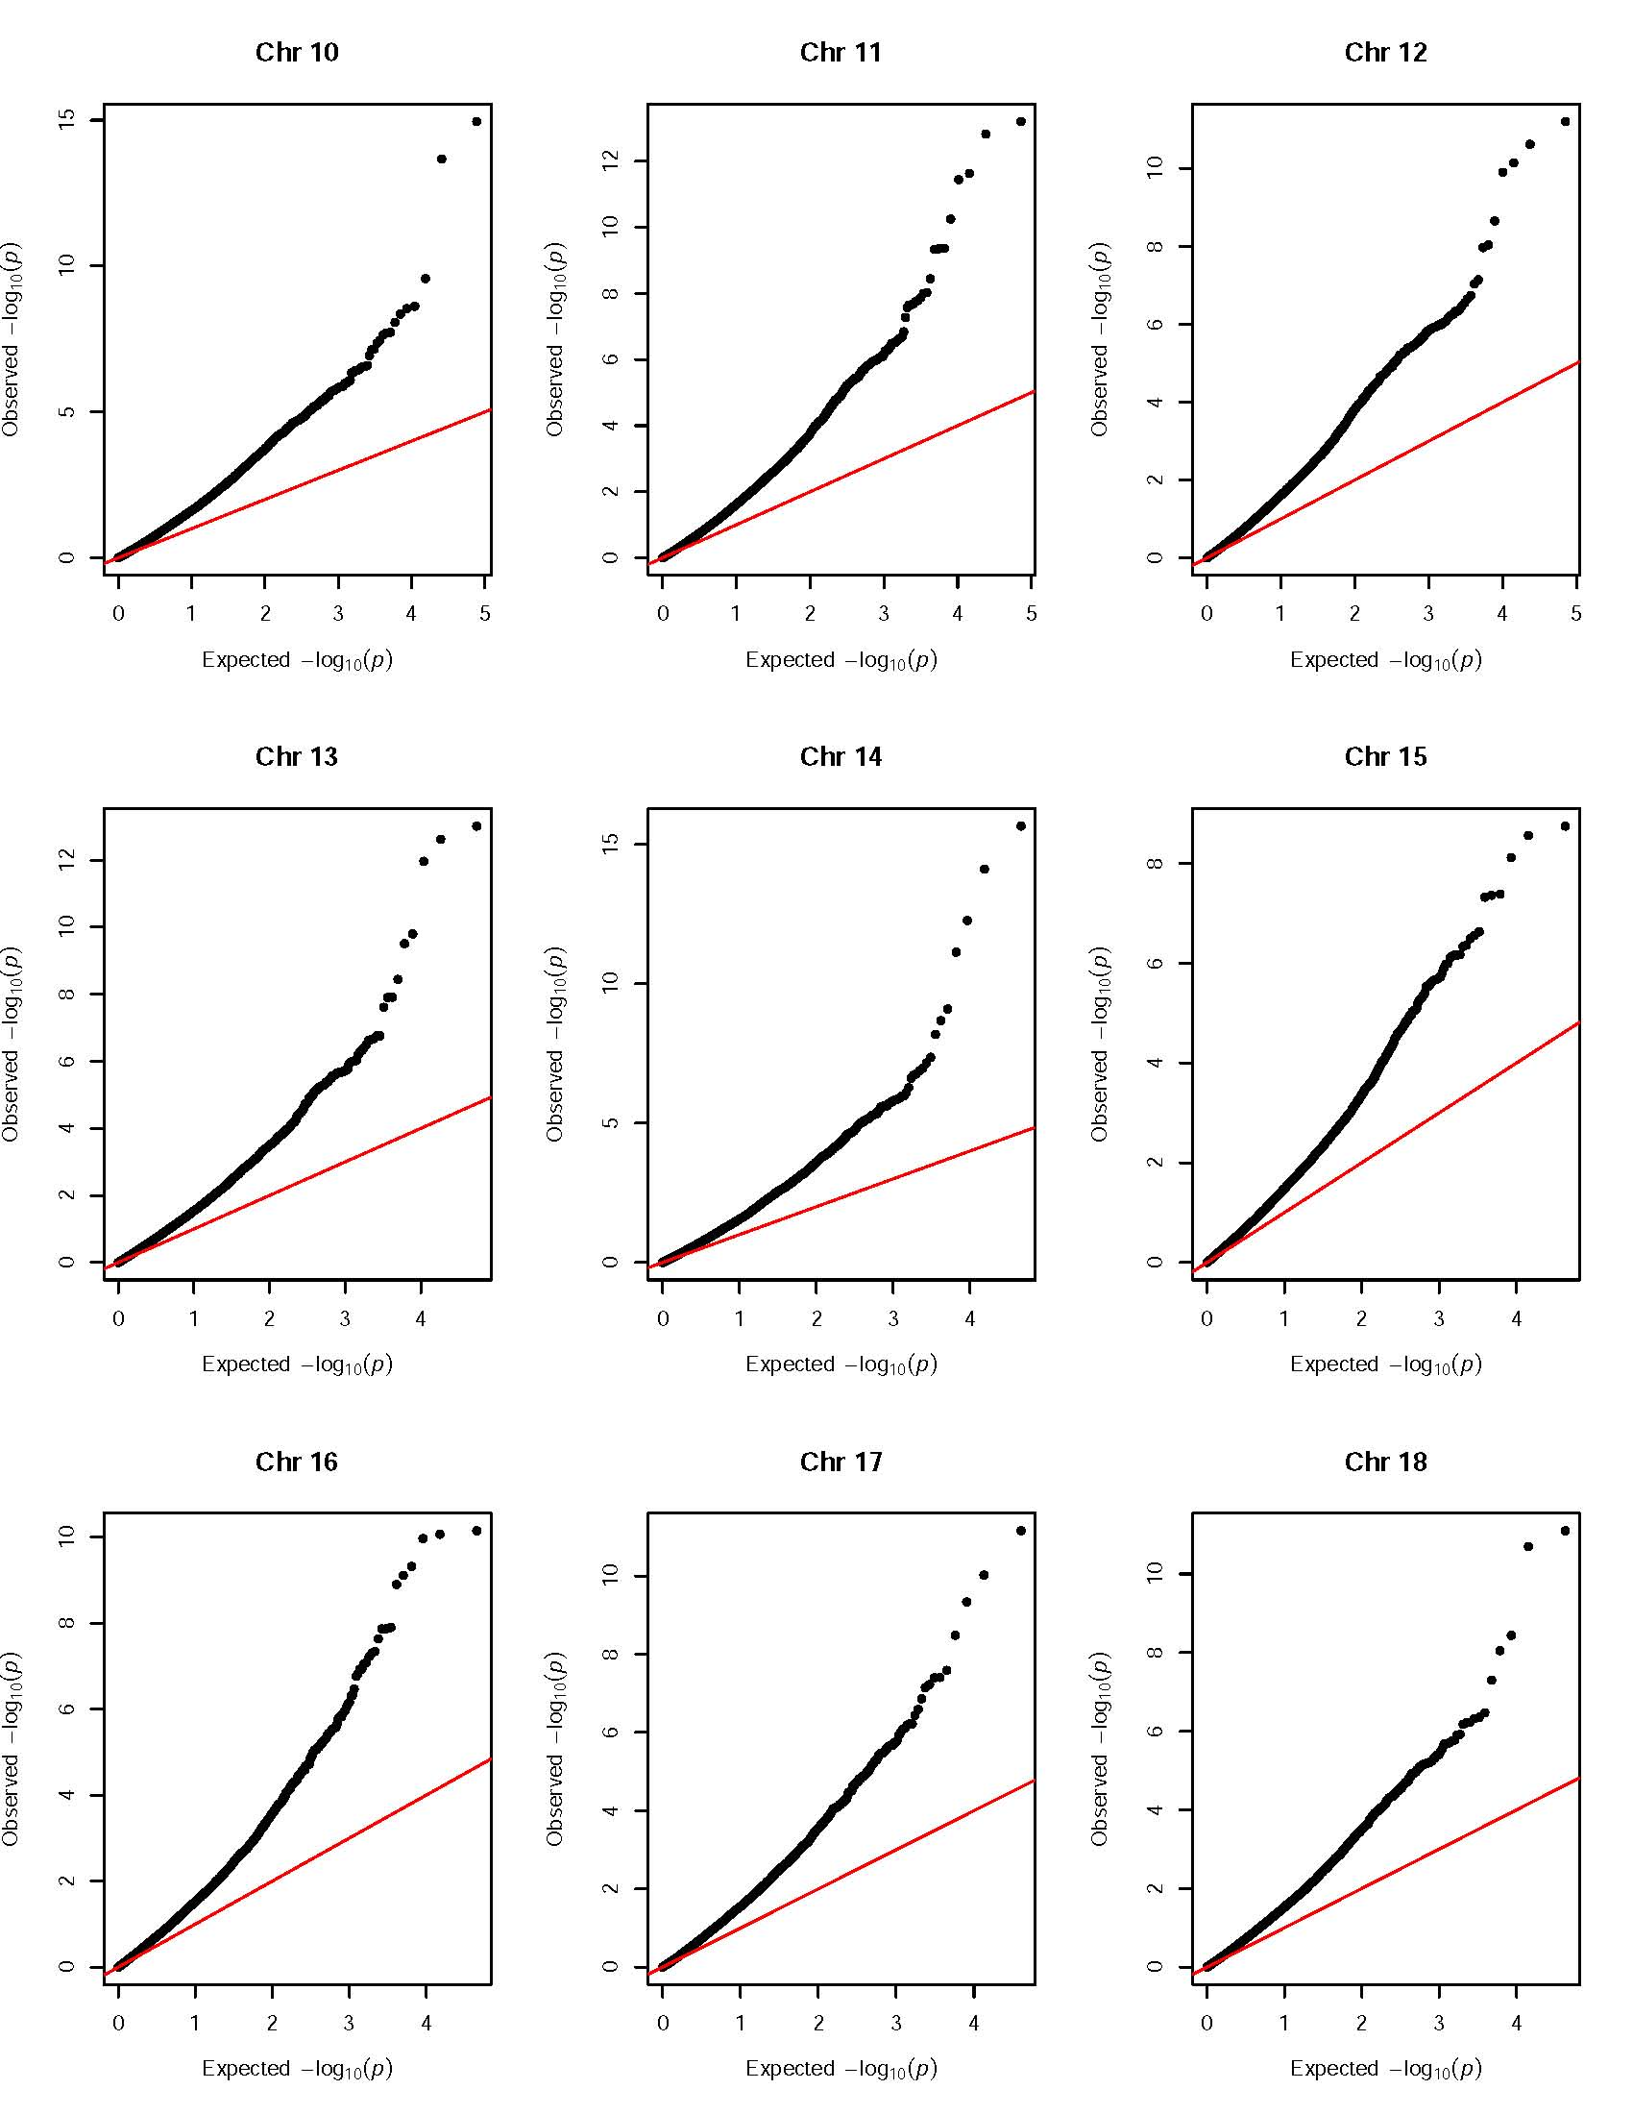
Reference

[1].Klein, R.J., Zeiss, C., Chew, E.Y., Tsai, J.-Y., Sackler, R.S., Haynes, C., Henning, A.K., SanGiovanni, J.P., Mane, S.M., Mayne, S.T., et al.: Complement factor h polymorphism in age-related macular degeneration. Science 308(5720), 385–389 (2005)
[2].Klein, R.J., Zeiss, C., Chew, E.Y., Tsai, J.-Y., Sackler, R.S., Haynes, C., Henning, A.K., SanGiovanni, J.P., Mane, S.M., Mayne, S.T., et al.: Complement factor h polymorphism in age-related macular degeneration. Science 308(5720), 385–389 (2005)
[3].Hunter, D.J., Kraft, P., Jacobs, K.B., Cox, D.G., Yeager, M., Hankinson, S.E., Wacholder, S., Wang, Z., Welch, R., Hutchinson, A., et al.: A genome-wide association study identifies alleles in fgfr2 associated with risk of sporadic postmenopausal breast cancer. Nature genetics 39(7), 870–874 (2007) 17.
[4].Consortium, W.T.C.C., et al.: Genome-wide association study of 14,000 cases of seven common diseases and 3,000 shared controls. Nature 447(7145), 661 (2007)
[5].R Core Team: R: A Language and Environment for Statistical Computing. R Foundation for Statistical Computing, Vienna, Austria (2021). R Foundation for Statistical Computing. https://www.R-project.org/
[6].Zang, Y., Fung, W. K., & Zheng, G. (2010). Simple algorithms to calculate asymptotic null distributions of robust tests in case-control genetic association studies in R. Journal of Statistical software, 33, 1-24.
[7].Turner, S. D. (2014). qqman: an R package for visualizing GWAS results using QQ and manhattan plots. Biorxiv, 005165.

