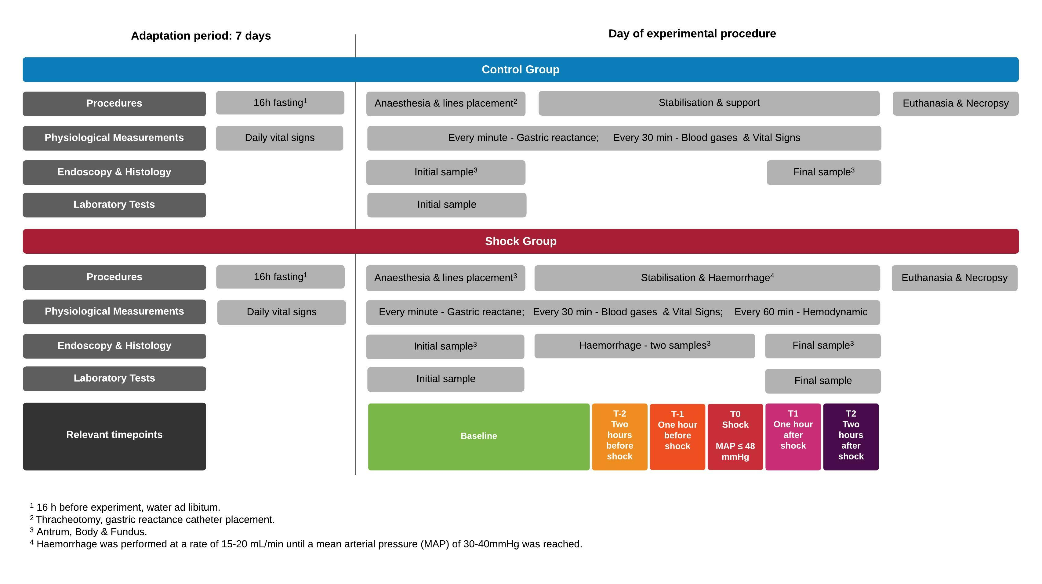
Fig. S1 Study flow. The study flow displaying the steps and procedure for each group.

