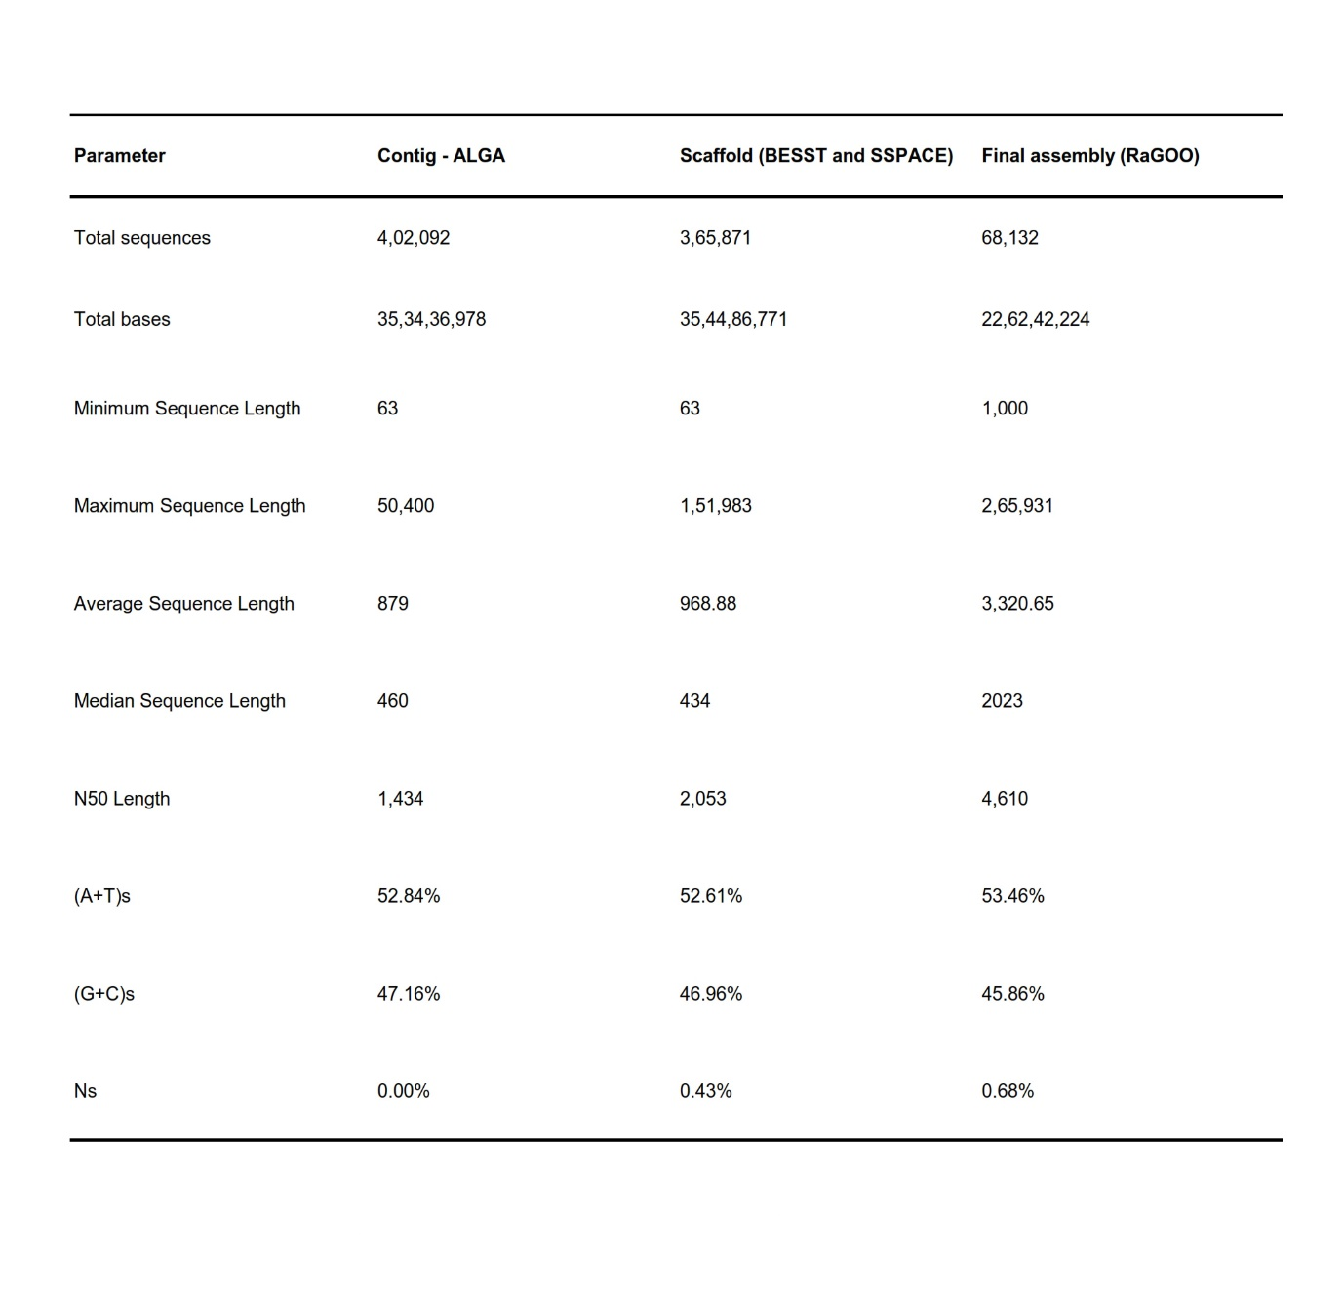
Extended Data Table 1: Genome assembly statistics of P. onkodes draft genome. Genome assembly statistics of P. onkodes showing the values of different assembly parameters for contigs, scaffolds and final assembly
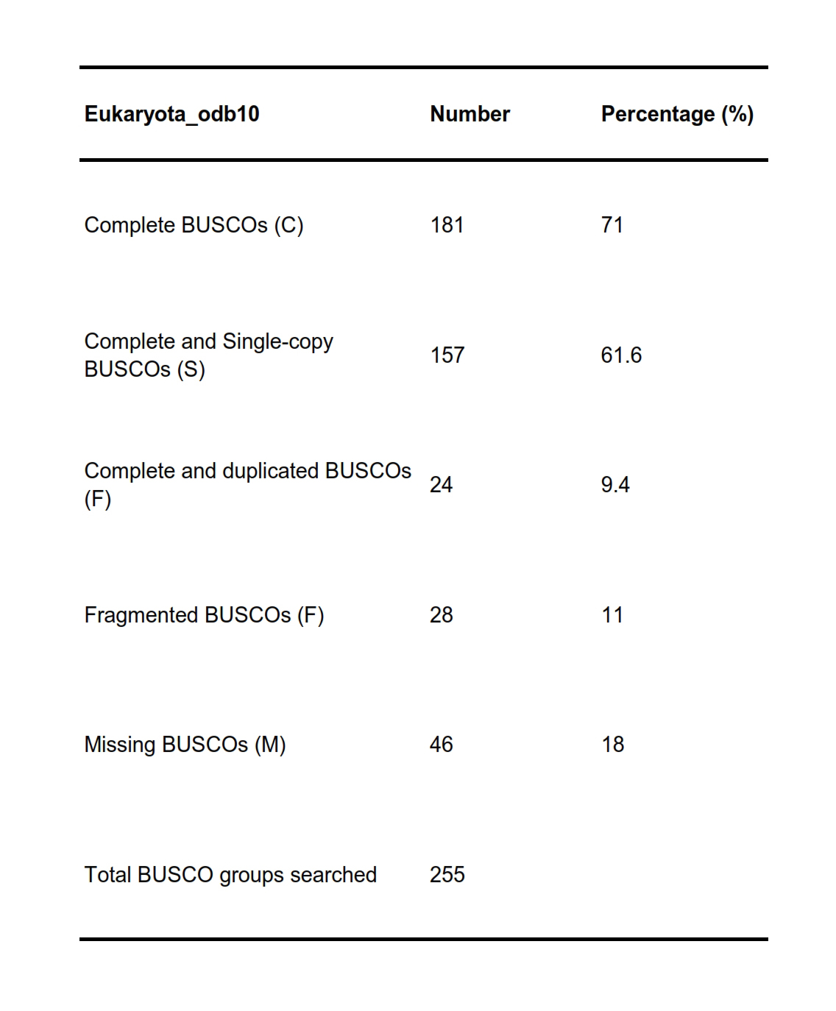
Extended Data Table 2: Result summary of genome assembly completeness analysis using BUSCO. Genome completeness analysis using BUSCO representing complete BUSCOs, complete and single-copy BUSCOs, complete and duplicated BUSCOs, fragmented BUSCOs and missing BUSCOs
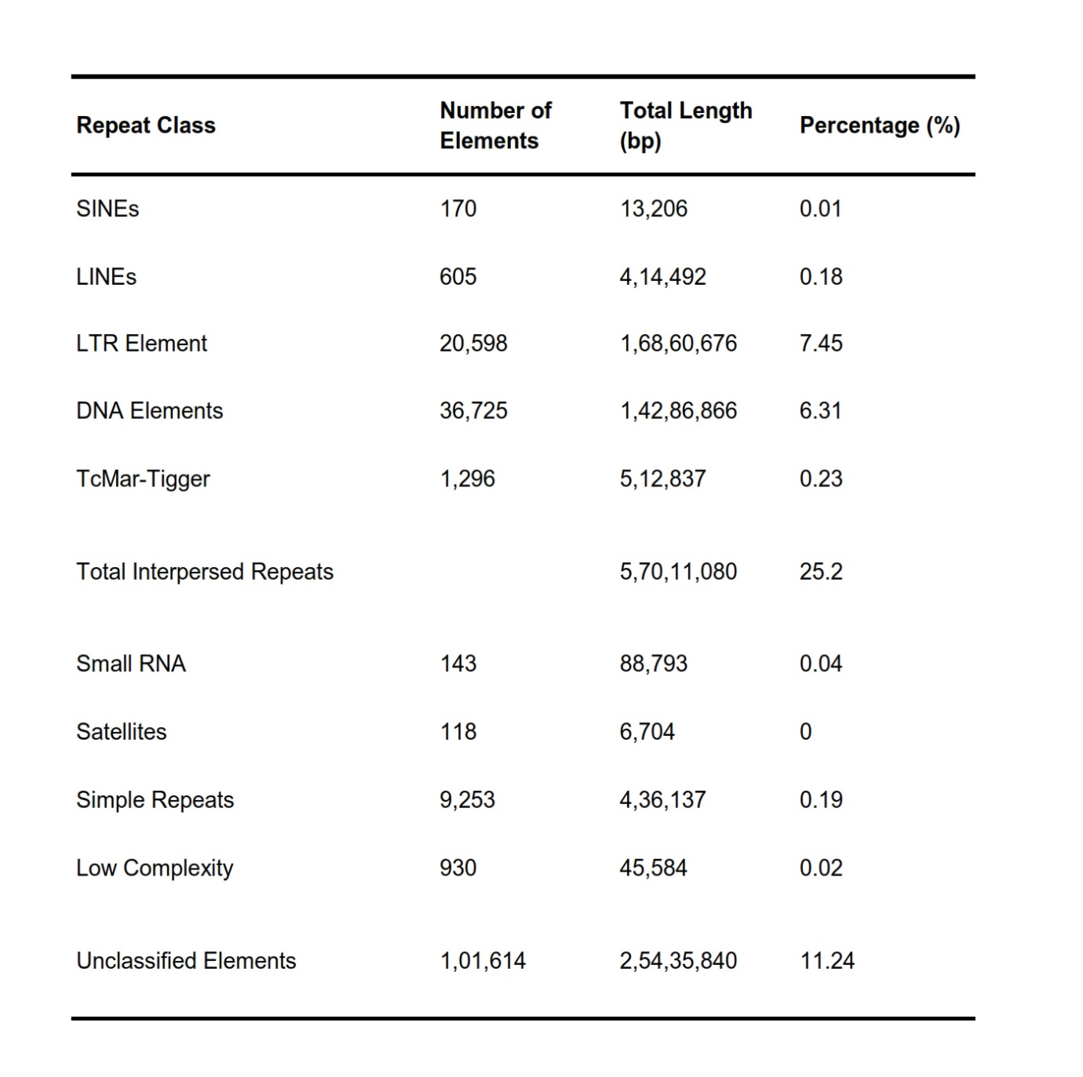
Extended Data Table 3: Repeat Elements identified from the draft genome of P. onkodes. The different categories of repeat elements identified from the draft genome of P. onkodes

