Supplemental Material Search Strategy
Searching strategy (As of April 9, 2022 )
PUBMED
((((occult hepatitis B infection[Title/Abstract]) OR (occult hepatitis B virus infection[Title/Abstract])) OR (occult HBV infection[Title/Abstract])) OR (OBI[Title/Abstract])) AND (((hepatitis B core antibody) OR (HBcAb)) OR (anti-HBc))

Web of science
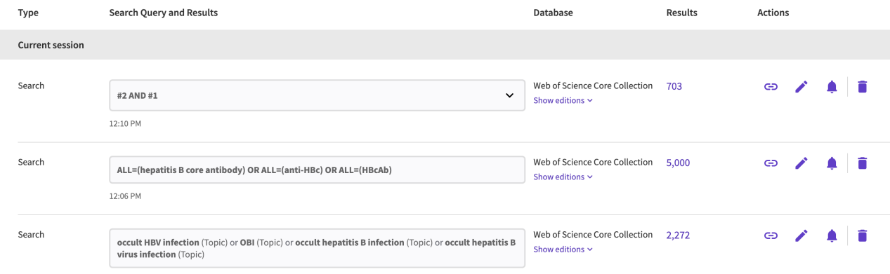

Embase
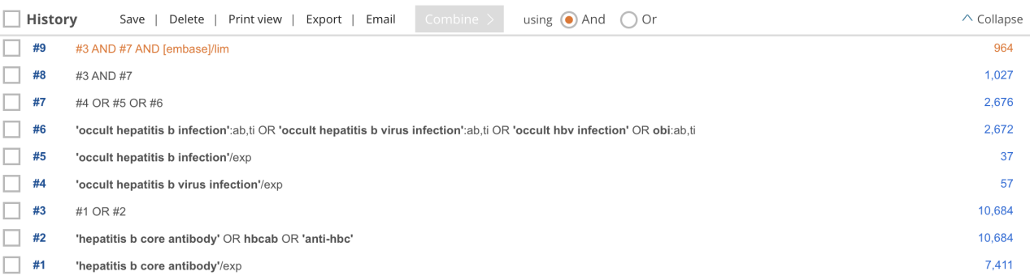

Cochrane
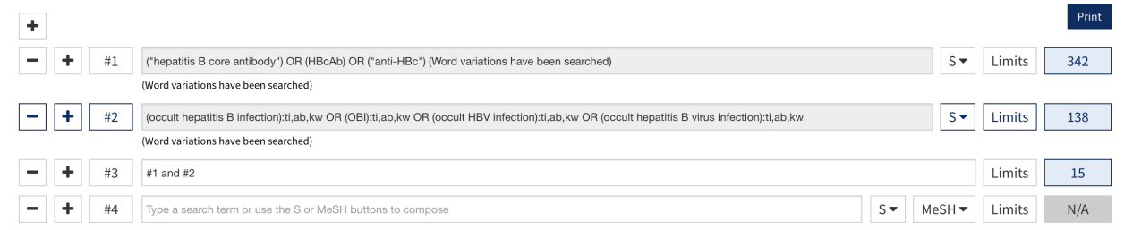

Supplementary Figures
Supplementary Figure 1.
(A) Funnel plot estimating the prevalence of OBI in HBcAb-positive with blood sample detection. Publication bias, p<0.05, tested by the Egger test.

(B) Funnel plot estimating the prevalence of OBI in HBcAb-negative with blood sample detection. Publication bias, p>0.05, tested by the Egger test.

Supplementary Figure 2. Subgroup analyses on the rates of OBI in HBcAb-positive population.

(A) Pooled rates of OBI stratified by HBsAg prevalence.

- Pooled rates of OBI stratified by HBcAb-positive rates.

(C) Pooled rates of OBI stratified by detection method.
(D) Pooled rates of OBI stratified by HBsAb status.

(E) Pooled rates of OBI stratified by year of research publication.

(F) Pooled rates of OBI stratified by research group.

Supplementary Figure 3. Subgroup analyses on the rates of OBI in HBcAb-negative population.

(A) Pooled rates of OBI stratified by HBsAg prevalence.

(B) Pooled rates of OBI stratified by HBcAb-positive rates

(C) Pooled rates of OBI stratified by detection method.

(D) Pooled rates of OBI stratified by year of research publication.

(E) Pooled rates of OBI stratified by HBsAb status.

(F) Pooled rates of OBI stratified by research group.

Supplementary Figure 4. Sensitivity analysis of the included studies to estimate the pooled rate of OBI among HBcAb-positive (A) and HBcAb-negative (B) general population.
(A)

(B)
Table S1. Quality assessment of studies included in OBI meta-analyses
Included  Studies | Was the sample frame appropriate to address the target population? | Were study participants sampled in an appropriate way? | Was the planned sample size adequate? | Were the study subjects and the setting described in detail? | Was the data analysis conducted with sufficient coverage of the identified sample? | Were valid methods used for the identification of the condition? | Was the condition measured in a standard, reliable way for all participants? | Was there appropriate statistical analysis? | Was the response rate adequate, and if not, was the low response rate managed appropriately? | Total  Score | Quality
Zervou et al. | 1 | 0 | 0 | 2 | 0 | 1 | 0 | 1 | 1 | 6 | Low
Hui et al. | 2 | 0 | 0 | 1 | 2 | 2 | 2 | 2 | 1 | 12 | High
Banerjee et al. | 2 | 0 | 0 | 1 | 2 | 2 | 1 | 2 | 1 | 11 | High
Chevrier et al. | 2 | 0 | 0 | 1 | 1 | 2 | 1 | 1 | 1 | 9 | Medium
Kim et al. | 2 | 0 | 0 | 2 | 2 | 1 | 1 | 2 | 1 | 11 | High
Manzini et al. | 1 | 0 | 0 | 1 | 1 | 2 | 1 | 1 | 1 | 8 | Medium
Kupski et al. | 2 | 0 | 0 | 1 | 1 | 2 | 1 | 1 | 0 | 8 | Medium
Seo et al. | 1 | 0 | 0 | 1 | 2 | 2 | 1 | 2 | 1 | 10 | High
Fang et al. | 1 | 0 | 0 | 2 | 1 | 1 | 1 | 2 | 1 | 9 | Medium
Song et al. | 1 | 0 | 0 | 1 | 1 | 2 | 2 | 2 | 1 | 10 | High
Arababadi et al. | 1 | 0 | 0 | 1 | 1 | 1 | 0 | 1 | 1 | 6 | Low
Ie et al. | 2 | 0 | 0 | 1 | 2 | 1 | 1 | 2 | 1 | 10 | High
Panigrahi et al. | 2 | 0 | 0 | 2 | 1 | 2 | 1 | 1 | 1 | 10 | High
Shim et al. | 2 | 0 | 0 | 1 | 2 | 2 | 2 | 2 | 0 | 11 | High
Maheswari et al. | 1 | 0 | 0 | 2 | 1 | 1 | 1 | 2 | 1 | 9 | Medium
Su et al. | 2 | 0 | 0 | 2 | 1 | 2 | 1 | 1 | 0 | 9 | Medium
Mahmoud et al. | 1 | 0 | 1 | 1 | 2 | 1 | 1 | 1 | 1 | 9 | Medium
Romano et al. | 1 | 1 | 1 | 2 | 2 | 2 | 1 | 2 | 1 | 13 | High
Said et al. | 2 | 0 | 0 | 1 | 2 | 2 | 1 | 2 | 1 | 11 | High
Moresco et al. | 1 | 0 | 0 | 2 | 1 | 2 | 1 | 1 | 1 | 9 | Medium
Muselmani et al. | 2 | 0 | 0 | 2 | 0 | 2 | 2 | 0 | 1 | 9 | Medium
Rios-Ocampo et al. | 1 | 0 | 0 | 1 | 1 | 2 | 1 | 2 | 1 | 9 | Medium
Tandoi et al. | 1 | 0 | 0 | 2 | 2 | 2 | 2 | 2 | 1 | 12 | High
Borzooy et al. | 1 | 0 | 0 | 2 | 0 | 2 | 1 | 2 | 1 | 9 | Medium
Darmawan et al. | 1 | 0 | 0 | 2 | 2 | 2 | 1 | 1 | 1 | 10 | High
Hashemi et al. | 1 | 0 | 0 | 1 | 0 | 1 | 1 | 1 | 1 | 6 | Low
Kishk et al. | 1 | 1 | 0 | 1 | 2 | 2 | 1 | 2 | 1 | 11 | High
Zheng et al. | 2 | 1 | 0 | 2 | 2 | 2 | 2 | 2 | 2 | 15 | High
Alshayea et al. | 1 | 0 | 0 | 2 | 1 | 2 | 1 | 1 | 1 | 9 | Medium
Hudu et al. | 2 | 1 | 0 | 1 | 1 | 1 | 1 | 2 | 1 | 10 | High
Karimi et al. | 2 | 1 | 2 | 1 | 1 | 2 | 2 | 1 | 0 | 12 | High
Sosa-Jurado et al. | 1 | 1 | 0 | 2 | 0 | 1 | 1 | 2 | 1 | 9 | Medium
Jaramillo et al. | 1 | 1 | 1 | 2 | 1 | 2 | 2 | 2 | 1 | 13 | High
Ye et al. | 2 | 1 | 0 | 2 | 2 | 2 | 2 | 2 | 2 | 15 | High
Athira et al. | 1 | 0 | 0 | 1 | 1 | 2 | 1 | 2 | 1 | 9 | Medium
Fopa et al. | 1 | 0 | 0 | 2 | 1 | 2 | 1 | 2 | 1 | 10 | High
Jacinto et al. | 2 | 1 | 0 | 1 | 2 | 2 | 2 | 2 | 2 | 14 | High
Ky/Ba et al. | 2 | 1 | 0 | 1 | 1 | 2 | 1 | 2 | 1 | 11 | High
Ye et al. | 2 | 0 | 0 | 2 | 2 | 2 | 2 | 2 | 2 | 14 | High
Cheung et al. | 2 | 0 | 0 | 2 | 2 | 2 | 1 | 2 | 1 | 12 | High
Caviglia et al. | 2 | 0 | 0 | 2 | 2 | 2 | 2 | 2 | 2 | 14 | High
Tandoi et al. | 2 | 0 | 0 | 2 | 2 | 2 | 2 | 2 | 1 | 13 | High
Rao et al. | 2 | 0 | 0 | 2 | 2 | 2 | 2 | 2 | 1 | 13 | High

Table S2. Results of meta-regression analysis in HBcAb-positive general population.

Characteristic | R² | Estimate | Se | Zval | P
HBsAg prevalence | 7.6% | 0 | 0.2513 | 0 | 0.1125
HBcAb-positive rate | 9.7% | 0.1587 | 0.0731 | 2.1710 | 0.0583
Detection method | 0.25% | 0.1947 | 0.0679 | 2.8691 | 0.3411
Publication of year | 0 | 0.3097 | 0.0724 | 4.2797 | 0.8793
HBsAb status | 0 | 0.0374 | 0.0987 | 0.3788 | 0.7048
Research population | 0 | 0.2797 | 0.0505 | 5.5349 | 0.9314

Table S3. Results of meta-regression analysis in HBcAb-negative general population.

Characteristic | R² | Estimate | Se | Zval | P
HBsAg prevalence | 0 | 0.1592 | 0.0594 | 2.6787 | 0.7227
HBcAb-positive rate | 0% | 0.000 | 0.1308 | 0.000 | 0.4085
Detection method | 30.21% | 0.0754 | 0.0481 | 1.5678 | 0.1169
Publication of year | 0.57% | 0.0689 | 0.0777 | 0.8869 | 0.3049
HBsAb status | 0 | 0.1547 | 0.0523 | 2.9566 | 0.8436
Research population | 0.57% | 0.0689 | 0.0777 | 0.8869 | 0.3049

