Supplementary Information
Supplementary figure S1: PERFORM Phenotyping Algorithm (Nijman et al. 2021)
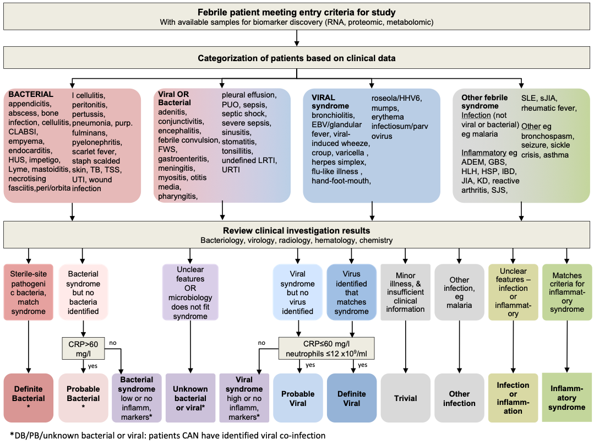

Supplementary Table S1: Detailed underlying diagnoses by episode
Underlying diagnosis | All (N=599) | Proven/presumed bacterial (N=174) | Proven/presumed viral (N=127)
Any malignancy | 354 | 98 | 68
Haematological malignancy | 227 | 61 | 45
ALL | 155 | 38 | 39
AML | 24 | 11 | 1
Lymphoma | 10 | 2 | 1
Non-Hodgkin lymphoma | 8 | 3 | 1
Langerhans cell histiocytosis | 7 | 1 | 1
Aplastic anaemia | 5 | 1 | 0
Burkitt lymphoma | 5 | 0 | 1
Hodgkin lymphoma | 3 | 0 | 0
JMML | 2 | 1 | 1
Blastic Plasmacytoid Dendritic Cell Neoplasm | 1 | 1 | 0
Fanconi anaemia | 1 | 1 | 0
Histiocytosis | 1 | 0 | 0
Leukaemia | 1 | 0 | 0
Leukaemia-like | 1 | 1 | 0
Myelodysplastic syndrome | 1 | 0 | 0
Myeloblastoma | 1 | 1 | 0
Schwachman-Diamond syndrome | 1 | 0 | 1
Solid malignancy | 90 | 27 | 14
Osteosarcoma | 21 | 11 | 3
Ewing sarcoma | 20 | 4 | 2
Neuroblastoma | 17 | 3 | 4
Wilms tumour | 8 | 2 | 1
Rhabdomyosarcoma | 7 | 2 | 1
PNET | 4 | 2 | 0
Rhabdoid tumour | 3 | 1 | 1
Sarcoma | 2 | 0 | 1
Synovial sarcoma | 2 | 0 | 0
Germ cell tumour | 1 | 0 | 1
Hepatoblastoma | 1 | 1 | 0
Myeloid sarcoma | 1 | 0 | 0
Nephroblastoma | 1 | 0 | 0
Peripheral Nerve Sheath Tumour | 1 | 1 | 0
Small blue round cell tumour | 1 | 0 | 0
Brain/CNS malignancy | 37 | 10 | 9
Medulloblastoma | 10 | 3 | 4
Glioma | 8 | 2 | 3
Ependymoma | 7 | 3 | 0
Atypical Teratoid Rhabdoid Tumour | 3 | 1 | 0
Retinoblastoma | 3 | 0 | 1
Astrocytoma | 1 | 1 | 0
Choroid plexus tumour | 1 | 0 | 0
Endodermic sinus tumour | 1 | 0 | 0
Glioblastoma | 1 | 0 | 0
Pineoblastoma | 1 | 0 | 1
Posterior fossa tumour | 1 | 0 | 0
Haematological disease | 79 | 21 | 19
Sickle cell disease | 44 | 13 | 7
Autoimmune neutropenia | 8 | 1 | 2
Beta thalassaemia | 6 | 0 | 2
Asplenia | 3 | 1 | 1
Hereditary spherocytosis | 3 | 1 | 1
Haemolytic anaemia | 2 | 0 | 1
Neutropenia e.c.i | 2 | 1 | 1
Autoimmune granulocytopenia | 1 | 0 | 1
Autoimmune haemolytic anaemia | 1 | 0 | 1
Chronic neutropenia | 1 | 0 | 0
Congenital neutropenia | 1 | 0 | 1
Cyclic neutropenia | 1 | 1 | 0
Diamond-Blackfan anaemia | 1 | 0 | 0
Henoch-Schonlein purpura | 1 | 1 | 0
RALD-Ras associated autoimmuno leukoproliferative disease | 1 | 1 | 0
Spherocytosis | 1 | 0 | 1
Thrombocytopenia e.c.i. | 1 | 0 | 0
Thrombotic thrombocytopenic purpura | 1 | 1 | 0
Inflammatory | 47 | 7 | 7
Crohn disease | 14 | 2 | 1
Ulcerative colitis | 8 | 2 | 2
sJIA | 7 | 0 | 1
JIA | 4 | 0 | 1
Granulomatosis with polyangiitis | 2 | 0 | 2
Haemophagocytic lymphohistiocytosis | 2 | 0 | 0
SLE | 2 | 0 | 0
Autoimmune enteropathy | 1 | 0 | 0
Autoimmune hepatitis | 1 | 0 | 1
Autoinflammatory syndrome e.c.i. | 1 | 1 | 0
Behcet disease | 1 | 0 | 0
Megacystis-microcolon-intestinal hypoperistalsis syndrome | 1 | 1 | 0
Optic neuritis | 1 | 1 | 0
Polyarteritis nodosum | 1 | 0 | 0
Polychondritis | 1 | 0 | 1
PID | 47 | 10 | 14
Severe combined immunodeficiency | 7 | 1 | 2
Chronic granulomatous disease | 4 | 1 | 1
STAT1-GOF | 4 | 0 | 2
CD40 Ligand Deficiency | 3 | 1 | 0
Combined immunodeficiency | 2 | 0 | 0
Hypogammaglobulinaemia | 2 | 1 | 1
IgA deficiency | 2 | 0 | 1
IKAROS/IKZF1 deficiency | 2 | 0 | 1
MHC-II deficiency | 2 | 0 | 0
Wiskott Aldrich syndrome | 2 | 0 | 1
Activated P13 Kinase Delta Syndrome | 1 | 0 | 0
Arteriovenous malformation with specific antibody synthesis defect | 1 | 1 | 0
Ataxia telangiectasia | 1 | 1 | 0
Complement c3 deficiency | 1 | 0 | 1
Chediak-Higashi syndrome | 1 | 0 | 0
GATA2 deficiency | 1 | 1 | 0
IgA/IgG subclass deficiency | 1 | 0 | 0
IPEX syndrome | 1 | 1 | 0
SPINK1 mutation | 1 | 0 | 0
Methyl-CpG Binding protein 2 Xq28 duplication syndrome | 1 | 1 | 0
Mowat-Wilson syndrome | 1 | 1 | 0
Omenn syndrome | 1 | 0 | 1
PAX2 mutation | 1 | 0 | 1
Protein C kinase delta immunodeficiency | 1 | 0 | 1
TRAC deficiency | 1 | 0 | 0
Undiagnosed immunodeficiency | 1 | 0 | 1
X-linked agammaglobulinaemia | 1 | 0 | 0
Solid organ transplant | 30 | 19 | 4
Kidney | 23 | 15 | 4
Liver | 4 | 3 | 0
Heart | 2 | 1 | 0
Kidney and liver | 1 | 0 | 0
HIV | 8 | 6 | 0
Nephrotic syndrome | 6 | 3 | 1
Cystic fibrosis | 5 | 2 | 1
Short bowel syndrome | 4 | 2 | 1
Other | 19 | 6 | 9
Medication induced | 5 | 3 | 2
Sarcoidosis | 2 | 0 | 1
Atypical Haemolytic Uraemic Syndrome | 1 | 0 | 1
Bronchopulmonary dysplasia | 1 | 0 | 0
c3 glomerulopathy | 1 | 0 | 1
Camptodactyly-Arthropathy-Coxa-Vara-Pericarditis syndrome | 1 | 0 | 1
Colitis e.c.i. | 1 | 1 | 0
Congenital adrenal hyperplasia | 1 | 0 | 1
Dyskeratosis congenita | 1 | 0 | 0
Hurler syndrome | 1 | 1 | 0
Lymphatic malformations | 1 | 1 | 0
Osteopetrosis | 1 | 0 | 0
Sclerodermia | 1 | 0 | 1
Tuburous sclerosis | 1 | 0 | 1
For the Gambian patients, 7 had sickle cell disease, and 1 HIV as underlying condition

Supplementary Table S2: Detailed empirical antimicrobials given and AwARe classification. Number exceeds total of episodes as multiple antimicrobials could have been started empirically, as well as multiple antibiotics from the same antibiotic class.
Antimicrobials by group | N= episodes | % | AWaRE
1st generation cephalosporins | 3 | 0.5
Cefalexin | 2 |  | Access
Cefazolin | 1 |  | Access
2nd generation cephalosporins | 15 | 2.5
Cefuroxime | 15 |  | Watch
3rd generation cephalosporins | 106 | 17.7
Ceftriaxone | 44 |  | Watch
Ceftazidime | 36 |  | Watch
Cefotaxime | 26 |  | Watch
4th generation cephalosporins | 71 | 11.9
Cefepim | 71 |  | Watch
Aminoglycosides | 109 | 18.2
Amikacin | 63 |  | Access
Gentamicin | 44 |  | Access
Tobramycin | 2 |  | Watch
Amphenicols | 2 | 0.3
Chloramphenicol | 2 |  | Access
Carbapenems | 41 | 6.8
Meropenem | 41 |  | Watch
DHFR inhibitors | 9 | 1.5
Trimethoprim/sulphamethoxazole | 6 |  | Access
Trimethoprim | 3 |  | Access
Fluroquinolones | 15 | 2.5
Ciprofloxacin | 15 |  | Watch
Glycopeptides | 138 | 23.0
Teicoplanin | 115 |  | Watch
Vancomycin | 26 |  | Watch
Imidazoles | 19 | 3.2
Metronidazole | 19 |  | Access
Lincosamides | 10 | 1.7
Clindamycin | 10 |  | Access
Macrolides | 29 | 4.8
Clarithromycin | 23 |  | Watch
Azithromycin | 8 |  | Watch
Oxazolidinones | 1 | 0.2
Linezolid | 1 |  | Reserve
Penicillins | 257 | 42.9
Piperacillin/tazobactam | 197 |  | Watch
Amoxicillin/clavulanic acid | 32 |  | Access
Amoxicillin | 18 |  | Access
Ampicillin | 6 |  | Access
Flucloxacillin | 6 |  | Access
Phenoxymethylpenicillin | 2 |  | Access
Cloxacillin | 1 |  | Access
Other antibiotics | 12 | 2.0
Antivirals | 37 | 6.2
Aciclovir | 22
Oseltamavir | 12
Foscarnet | 1
Ganciclovir | 1
Valaciclovir | 1
Antifungals | 23 | 3.8
Fluconazole | 10
Amphotericin | 7
Caspofungin | 4
Clotrimazole | 2
No antimicrobials | 77 | 12.9
For the Gambian patients: 4 episodes were started on amoxicillin, 2 on ampicillin and gentamicin, and 2 had no empirical antibiotics started

Supplementary Table S3: Detailed clinical syndromes by episode (n=599)
Clinical syndrome | N= Episodes
Undifferentiated fever | 144
Fever without source | 118
Fever unknown origin | 26
Upper respiratory tract infection | 93
URTI (non-specific) | 68
Stomatitis | 6
Tonsillitis | 6
Otitis media | 5
Pharyngitis | 5
Abscess | 1
Laryngitis subglottica | 1
Otitis externa | 1
Sepsis syndromes | 62
CLABSI | 40
Bacteraemia | 18
Septic shock | 2
Endocarditis | 1
Infected thrombus | 1
Lower respiratory tract infection | 53
Pneumonia | 30
Undefined LRTI | 17
Bronchiolitis | 3
CF exacerbation | 1
Pleural effusion | 1
Viral induced wheeze | 1
Viral pathogen syndromes | 44
Flu(-like) illness | 17
Herpes Simplex virus stomatitis | 4
Roseola | 4
Varicella | 4
Viral infection (unspecified) | 4
Adenoviraemia | 3
Epstein-Barr virus | 2
Herpes Simplex virus | 2
Parvovirus B19 | 2
Febrile neutropenia (only) | 42
Gastrointestinal infection | 25
Diarrhoea (moderate/severe) | 17
Gastroenteritis | 6
Colitis | 1
Enterocolitis | 1
Urinary tract infection | 24
UTI | 15
Pyelonephritis | 9
Soft tissue infection | 17
Cellulitis | 6
Wound infection | 5
Abscess (skin) | 3
Impetigo | 1
Lymphadenitis | 1
Periorbital cellulitis | 1
CNS infection | 6
Meningitis | 4
Cerebrospinal fistula | 1
Encephalitis | 1
Surgical infection | 5
Abscess (intra-abdominal) | 1
Appendicitis | 1
Cholangitis | 1
Mesenteric lymphadenitis | 1
Peritonitis | 1
Muskuloskeletal infection | 1
Myositis | 1
Other infections | 2
Conjunctivitis | 2
Other not infections | 81
Sickle crisis | 12
ALL | 11
sJIA | 6
Crohn exacerbation | 5
Abdominal pain e.c.i. | 4
Engrafting | 4
AML | 3
Drug induced fever | 3
Ulcerative colitis exacerbation | 3
Graft-versus-host disease | 2
Inflammatory syndrome e.c.i. | 2
Lymphoma | 2
Pancreatitis | 2
Seizures | 2
SLE | 2
Toxicodermy | 2
Arhtralgia | 1
Back pain e.c.i | 1
BCG-IRIS | 1
Behcet disease | 1
Cholelithiasis | 1
Chronic constipation | 1
Dermatitis | 1
Haematoma post-biopsy | 1
Hodgkin lymphoma | 1
Irritable bowel syndrome | 1
Immune reconstitution syndrome | 1
HLH | 1
JIA | 1
Leukaemia | 1
Myelodysplastic syndrome | 1
Non-Hodgkin lymphoma | 1
Rhabdomysarcoma | 1
For the Gambian patients: 4 had fever without source, 2 pneumonia,
1 bacteraemia, and 1 an UTI

