Supplementary material
Figure S1: Isolation and characterization of EVs.
Figure S2: Dynamic changes of EV-biomarkers during ICI-related therapy.
Figure S3: Expressional landscape of EV-derived lncRNA-GC1 in ICI-treated GC.
Figure S4: EV-derived lncRNA-GC1 dynamically monitored immunotherapeutic outcomes of patients receiving ICI-related therapy in retrospective validation cohort (cohort 2).
Figure S5: EV-derived lncRNA-GC1 dynamically monitored immunotherapeutic outcomes of patients receiving ICI-related therapy in retrospective validation cohort (cohort 3).
Figure S6: Low levels of circulating EV-derived lncRNA-GC1 are correlated with strong antitumor immunity.
Figure S7: The stability of circulating EV-derived lncRNA-GC1 in retrospective expanding cohort (cohort 5).

Figure S1
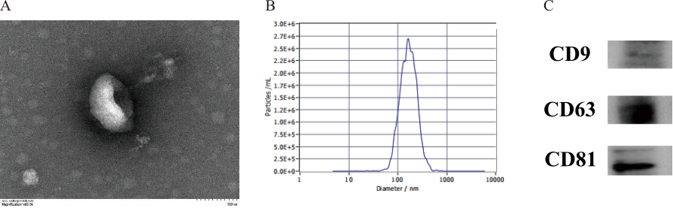
Figure S1: Isolation and characterization of EVs. (A) EVs were observed using electron microscopy, which revealed characteristic vesicular structures. Scale bar = 100 nm. (B) The size distributions of EVs were analyzed using NanoSight particle-tracking analysis, which revealed particle sizes ranging from 80 nm to 120 nm. (C) Western blot analysis detected the EVs’ markers CD9, CD63 and CD81.

Figure S2
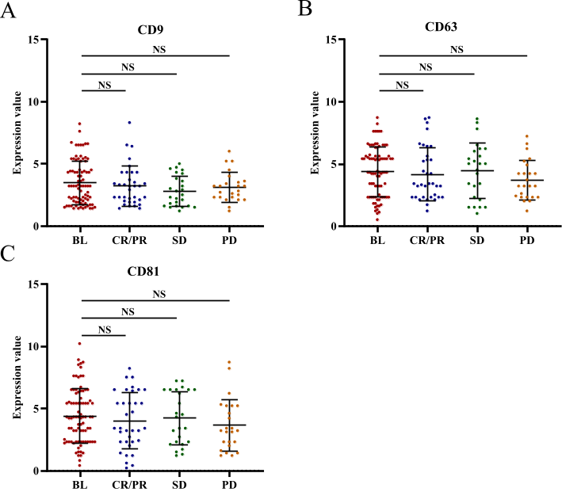
Figure S2: Dynamic changes of EV-biomarkers during ICI-related therapy. The EV-biomarkers CD9 (A), CD63 (B) and CD81 (C) remained stable at baseline and for all time points. NS, no significance.

Figure S3
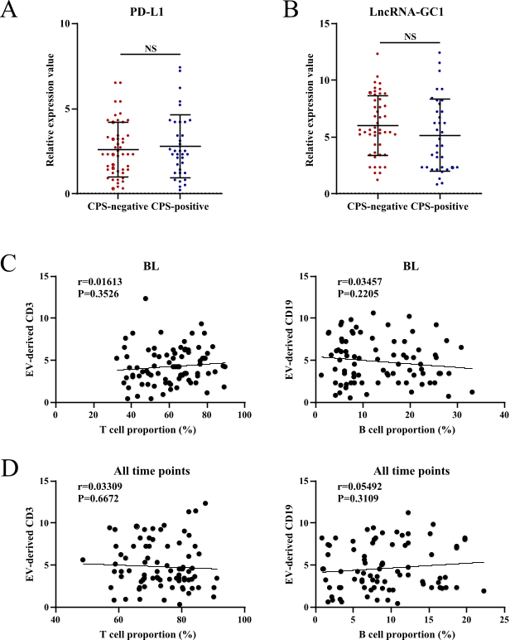
Figure S3: Expressional landscape of EV-derived lncRNA-GC1 in ICI-treated GC. (A) Levels of EV-derived PD-L1 in tissue CPS-negative and CPS-positive GC patients. (B) Levels of EV-derived lncRNA-GC1 in tissue CPS-negative and CPS-positive GC patients. (C) Correlation between circulating T (left panel) or B cells (right panel) and EV-derived T cell marker CD3 or B cell marker CD19 at baseline. (D) Correlation between circulating T (left panel) or B cells (right panel) and EV-derived T cell marker CD3 or B cell marker CD19 for all time points. CPS-negative, CPS=0. CPS-positive, CPS≥1. BL, baseline. NS, no significance.

Figure S4
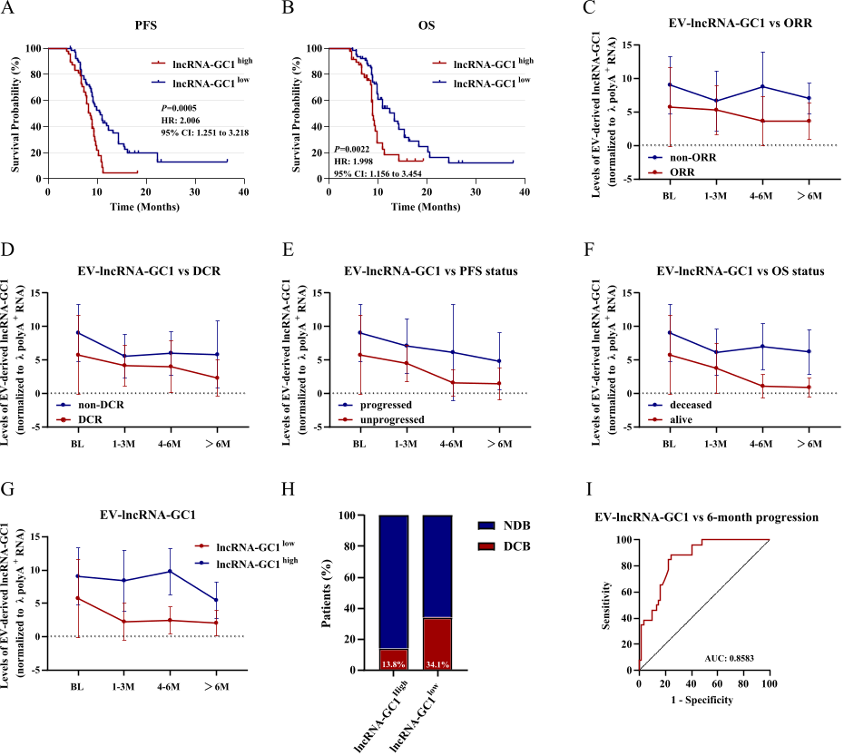
Figure S4: EV-derived lncRNA-GC1 dynamically monitored immunotherapeutic outcomes of patients receiving ICI-related therapy in retrospective validation cohort (cohort 2). (A) Kaplan-Meier curves of PFS according to levels of circulating EV-derived lncRNA-GC1. (B) Kaplan-Meier curves of OS according to levels of circulating EV-derived lncRNA-GC1. (C) Dynamic changes of circulating EV-derived lncRNA-GC1 along with the timeline of ICI-related therapy were compared between patients defined as EV-derived lncRNA-GC1^{high} or EV-derived lncRNA-GC1^{low}. (D-G) Dynamic changes of circulating EV-derived lncRNA-GC1 along with the timeline of ICI-related therapy were compared between patients with/without overall response (D), disease control (E), disease progression (F) and cancer death (G). (H) Proportion of patients who were DCB or NCB according to the levels of circulating EV-derived lncRNA-GC1 classified as high and low. (I) ROC curve was used to measure the specificity and sensitivity of circulating EV-derived lncRNA-GC1 in characterizing patients reached progression longer than 6 months. ORR, objective response rate. DCR, disease control rate. PFS, progression-free survival. OS, overall survival. ROC, receiver operator characteristic.
Figure S5
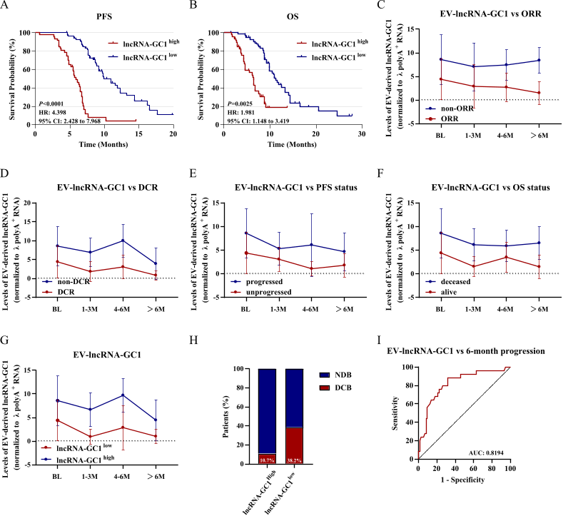
Figure S5: EV-derived lncRNA-GC1 dynamically monitored immunotherapeutic outcomes of patients receiving ICI-related therapy in retrospective validation cohort (cohort 3). (A) Kaplan-Meier curves of PFS according to levels of circulating EV-derived lncRNA-GC1. (B) Kaplan-Meier curves of OS according to levels of circulating EV-derived lncRNA-GC1. (C) Dynamic changes of circulating EV-derived lncRNA-GC1 along with the timeline of ICI-related therapy were compared between patients defined as EV-derived lncRNA-GC1^{high} or EV-derived lncRNA-GC1^{low}. (D-G) Dynamic changes of circulating EV-derived lncRNA-GC1 along with the timeline of ICI-related therapy were compared between patients with/without overall response (D), disease control (E), disease progression (F) and cancer death (G). (H) Proportion of patients who were DCB or NCB according to the levels of circulating EV-derived lncRNA-GC1 classified as high and low. (I) ROC curve was used to measure the specificity and sensitivity of circulating EV-derived lncRNA-GC1 in characterizing patients reached progression longer than 6 months. ORR, objective response rate. DCR, disease control rate. PFS, progression-free survival. OS, overall survival. ROC, receiver operator characteristic.

Figure S6
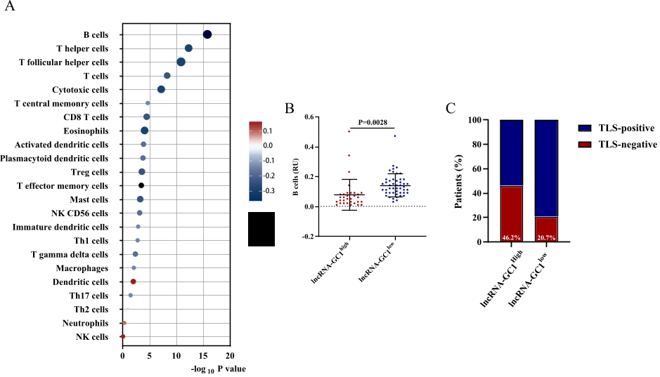
Figure S6: Low levels of circulating EV-derived lncRNA-GC1 are correlated with strong antitumor immunity. (A) Correlation of immune cell lineages and levels of circulating EV-derived lncRNA-GC1. Dot size depicts the correlation coefficient while the color is indicative of positive or negative correlation. (B) Histogram representation of B-cell score (in relative units, RU) according to baseline plasmatic level of LIF classified as high or low. (B) Histogram representation of B-cell score (in relative units, RU) according to baseline level of circulating EV-derived lncRNA-GC1 classified as high or low. (C) Proportion of patients with positive or negative of intratumoral TLS according to baseline levels of circulating EV-derived lncRNA-GC1. TLS, tertiary lymphoid structures.

Figure S7
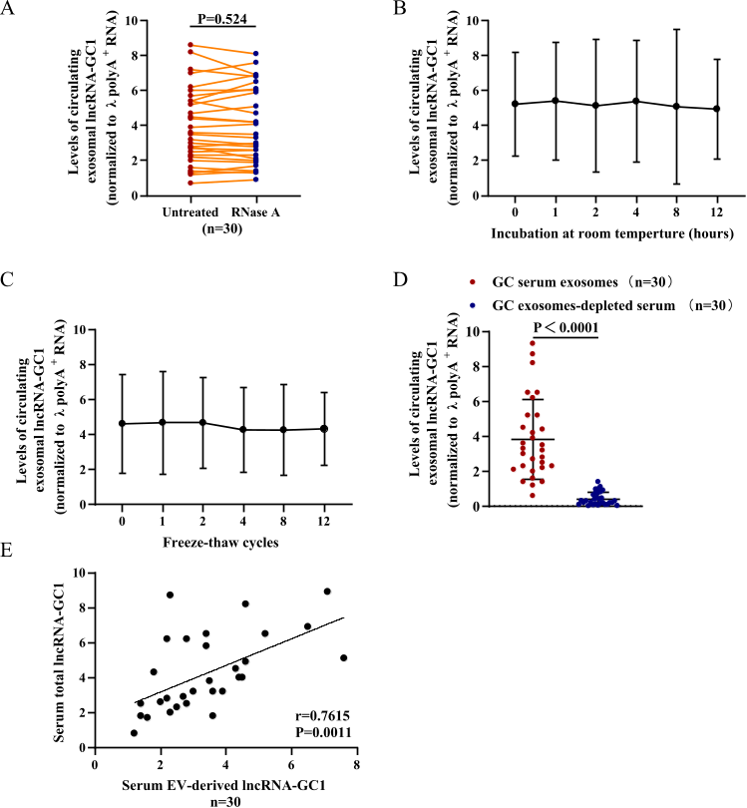
Figure S7: The stability of circulating EV-derived lncRNA-GC1 in retrospective expanding cohort (cohort 5). Levels of circulating EV-derived lncRNA-GC1 in patients with GC (n = 30) when EVs were (A) treated with or without RNase A (5 µg/ml) for 30 min, (B) subjected to prolonged incubation to room temperature and (C) subjected to with repeated freezing and thawing. (D) Levels of lncRNA-GC1 in EVs and EV-depleted sera of patients with GC (n = 30). (e) Positive correlations between levels of circulating EV-derived lncRNA-GC1 and levels of total circulating lncRNA-GC1 in patients with GC (n = 30). The results are presented as the mean ± SD.

