Features | SSHD | SSD | HDD
Mechanism | Magnetic + NAND Flash Memory | NAND NOR Flash Memory | Magnetic rotating platters
Capacity | Up to 2TB (notebooks) + upto 8  Up to 10TB (desktops) GB SSD | Up to 1TB (notebooks)  Up to 4TB (desktops) | Up to 2TB (notebooks)  Up to 10TB (desktops)
Durability | ---- | Shock-resistant | Fragile
Power consumption | Same as SSD | Average 2W | Average 10W
Endurance | ----- | MTBF > 2 million hours | MTBF < 700,000 Hours
Noise | ----- | None | Present
Operating System Boot-Time | Same as SSD | Average of 10–15 seconds | Average of 30–40 seconds
File Opening Speed | Faster Compare to HDD | 30% faster than HDD | Slower than SSD
Speed | Faster than HDD | >200 MB/s | 50–120 MB/s
Vibration | While HDD in use | No Vibration | Moving parts cause vibration
Affected by Magnetism | Sometime affected | No effect | Can erase data
Full Drive Encryption | Supported | Supported | Supported
Cost | Cheap compare to SSD | Costly | Cheap compare to SSD
Heating | Moderate | less | High
Size | Large | Compact | Large
Figure | 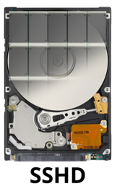 | 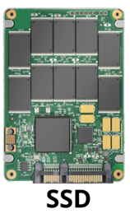 | 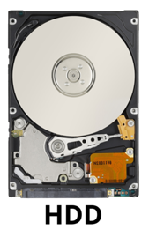
Table 1. SSHD Vs SSD Vs HDD [18]

