Supplementary Table 1. The list of used oligos
Oligo name | Primer sequence (5' to 3') | description
TpIRT1A-clone-F | ACCAAAAGTAAAGAGGAGAC | TpIRT1A cloning
TpIRT1A-clone-R | CAGAGATAGGAGAGATGCTA | TpIRT1A cloning
TpIRT1B-clone-F | TACTCACCATCATCAATCAA | TpIRT1B cloning
TpIRT1B-clone-R | TACACATCATAAAGCAAAGTT | TpIRT1B cloning
TpIRT1-qPCR-F | ATGTGCTTCCACCAGATGTT | expression level
TpIRT1-qPCR-R | CTGTTGTCCTTGTACACCTT | expression level
TpIRT1A-HindIII-F | CCCAAGCTTATGCCGTCGTCGCAAGCCCT | construct building
TpIRT1B-HindIII-F | CTAGTCTAGAATGCCGTCGTCGCAAGCCCT | construct building
TpIRT1A/B-XBaI-R | CTAGTCTAGATCACGCCCATTTGGCCATG | construct building

Supplementary Table 2. The list of plant materials and gene names
Latin name | Accessions | Genome | gene name
Triticum polonicum |  | AABB | TpIRT1A/B
Triticum dicoccoides | PI470947 | AABB | TdIRT1A/B
Triticum dicoccum | PI427274 | AABB | TdiIRT1A/B
Triticum durum | CItr1515 | AABB | TduIRT1A/B
Triticum turanicum | PI481582 | AABB | TtIRT1A/B
Triticum carthlicum | PI115816 | AABB | TcIRT1A/B
Triticum turgidum | PI94689 | AABB | TtuIRT1A/B
Triticum timopheevi | PI282933 | AAGG | TtiIRT1A/G
Triticum araraticum | PI427302 | AAGG | TarIRT1A/G
Triticum ispahanicum | PI572904 | AAGG | TiIRT1A/G
Aegilops speltoides | PI542245 | SS | AsIRT1
Triticum urartu | PI542274 | AA | TuIRT1

Supplementary Table 3. Characteristics of IRT1 genes from wheat and A. speltoides
Gene Name | ORF Length | GC % | Protein Length | TMs Number | Molecular Weight (kDa) | Nucleotide Sequence Identity % | Amino Acid Sequence%
TpIRT1A | 1113 | 46.1 | 370 | 8 | 38.99 | 100 | 100
TdIRT1A | 1113 | 46.2 | 370 | 8 | 39.01 | 99.91 | 99.73
TdiIRT1A | 1113 | 46.2 | 370 | 8 | 39.01 | 99.91 | 99.73
TduIRT1A | 1113 | 46.2 | 370 | 8 | 39.01 | 99.91 | 99.73
TtIRT1A | 1113 | 46.2 | 370 | 8 | 39.01 | 99.91 | 99.73
TcIRT1A | 1113 | 46.2 | 370 | 8 | 39.01 | 99.91 | 99.73
TtuIRT1A | 1113 | 46.2 | 370 | 8 | 39.01 | 99.91 | 99.73
TtiIRT1A | 1113 | 46.1 | 370 | 8 | 39.04 | 99.73 | 99.46
TarIRT1A | 1113 | 46.2 | 370 | 8 | 39.01 | 99.82 | 99.73
TiIRT1A | 1113 | 46.2 | 370 | 8 | 39.01 | 99.91 | 99.73
TuIRT1 | 1113 | 46.2 | 370 | 8 | 39.01 | 99.91 | 99.73
TpIRT1B | 1122 | 45.8 | 373 | 8 | 39.27 | 100 | 100
TdIRT1B | 1095 | 46.4 | 364 | 8 | 38.36 | 93.32 | 93.57
TdiIRT1B | 1122 | 46.0 | 373 | 9 | 39.33 | 99.82 | 99.46
TduIRT1B | 1095 | 46.4 | 364 | 8 | 38.36 | 93.32 | 93.57
TtIRT1B | 1095 | 46.4 | 364 | 8 | 38.36 | 93.32 | 93.57
TcIRT1B | 1104 | 46.3 | 367 | 8 | 38.67 | 93.94 | 94.10
TtuIRT1B | 1095 | 46.2 | 364 | 8 | 38.33 | 92.96 | 93.03
TtiIRT1G | 1104 | 46.3 | 367 | 8 | 38.67 | 93.94 | 94.10
TarIRT1G | 1095 | 46.4 | 364 | 8 | 38.36 | 93.32 | 93.57
TiIRT1G | 1095 | 46.4 | 364 | 8 | 38.39 | 92.96 | 92.76
AsIRT1 | 1095 | 46.4 | 364 | 8 | 38.36 | 93.32 | 93.57

*note: The homoeologs of the A genome group were compared to TpIRT1A, while the homoeologs from the B genome group were compared to TpIRT1B

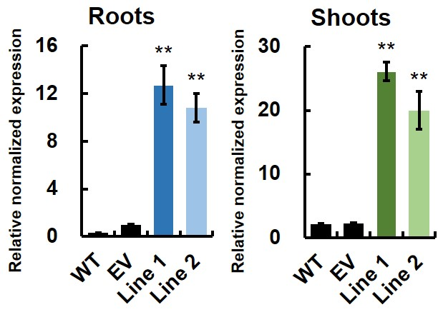
Supplemental Figure 1. The expression levels of TpIRT1 in transgenic lines at the seedling stage
The A. thaliana wild-type (WT), EV- and TpIRT1B-expressing lines (EV, Line 1 and Line 2, respectively) were grown hydroponically for two weeks. Roots and leaves were collected for qRT-PCR analysis. Asterisks indicate significant differences between WT and transgenic lines by Student’s t-test (p < 0.05). The value was mean ± standard deviation with three independent experiments.

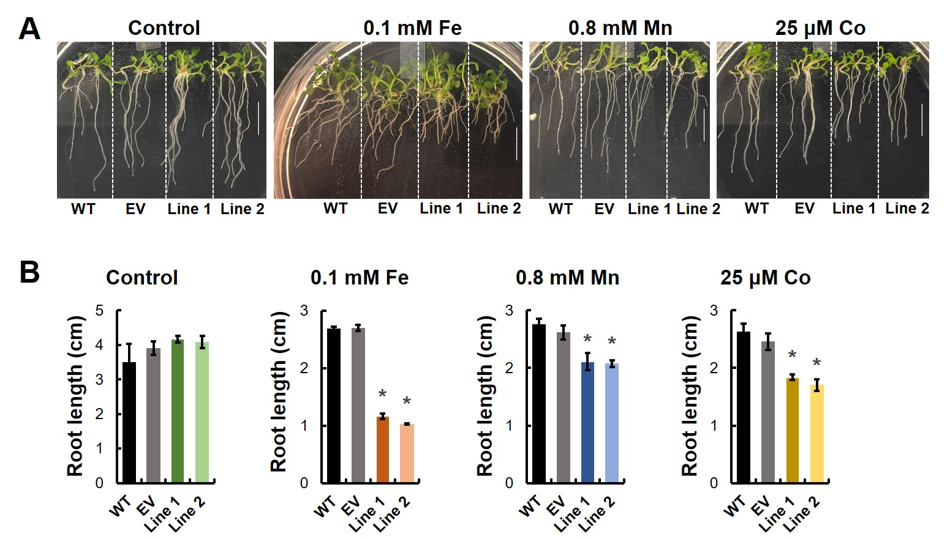
Supplemental Figure 2. The TpIRT1B-overexpressing lines were more sensitive to excess Fe, Mn, and Co than WT when grew on solid ½ MS medium
The WT, EV, and TpIRT1B-overexpressing lines (Line 1 and Line 2) were sowed and grown for seven days on solid ½ MS media without (control) or with 0 1 mM Fe, 0 8 mM Mn and 25 μM Co. (A) shows representative images from three independent experiments. The root lengths were averaged from eight plants per line (B). Asterisks indicate significant differences from WT by Student’s t-test (p < 0.05, n = 3 independent experiments). Scale bar = 1 cm.

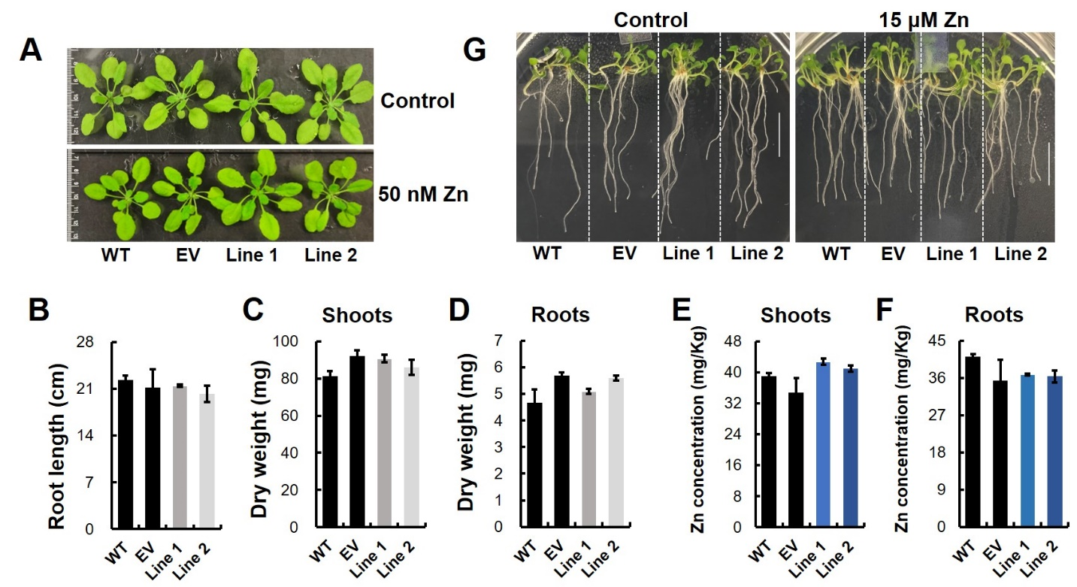
Supplemental Figure 3. The expression of TpIRT1B did not affect Arabidopsis growth under low or excess Zn and did not change Zn accumulation in roots and shoots compared to wild-type or empty vector expressing plants
Wild-type (WT), empty vector (EV), and two TpIRT1B-overexpressing lines (Line 1 and Line 2) were grown hydroponically for two weeks prior to transferring to a fresh medium with a reduced concentration of Zn (50 nM ZnCl₂, A to F). Images were collected (A) and roots lengths measured (B) after five days of treatment from a subset of plants. Biomass including dry weight of roots (C) and leaves (D) were measured after additional two weeks of growth under control of low Zn conditions. The root lengths and biomass were averaged from eight plants per genotype. For analysis of Zn concentration by ICP-MS, roots (E) and leaves (F) were collected from four-week-old hydroponically grown plants. (G) shows plants phenotype grown on ½ MS media with excess content of Zn (15 μM ZnCl₂) for seven days. Scale bar = 1 cm.

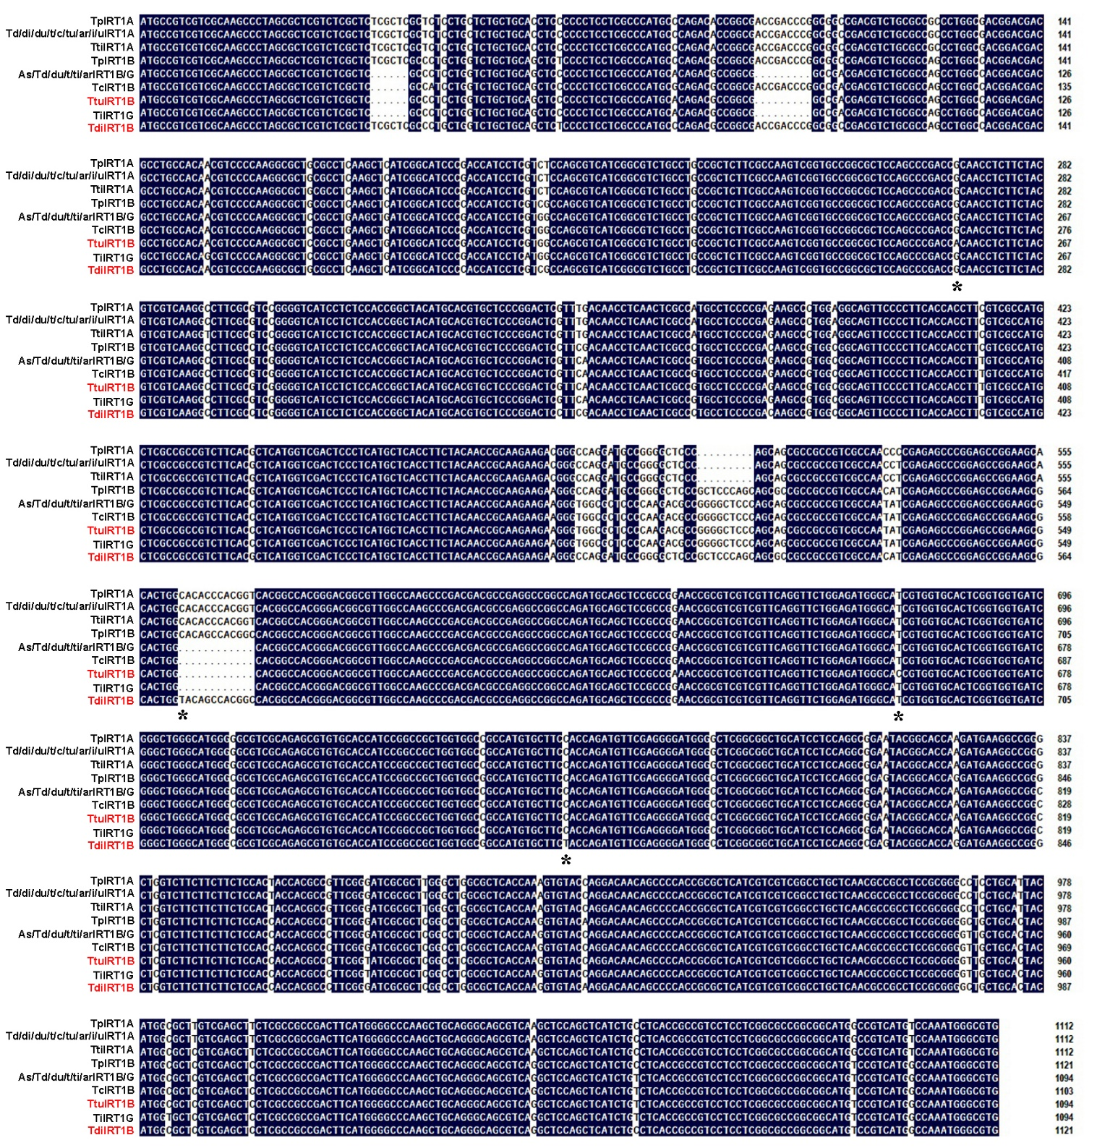
Supplemental Figure 4. Alignment of IRT1 ORF sequences by DNAMAN
Functional difference genes were marked in red. Asterisks show the pivotal substitution sites.

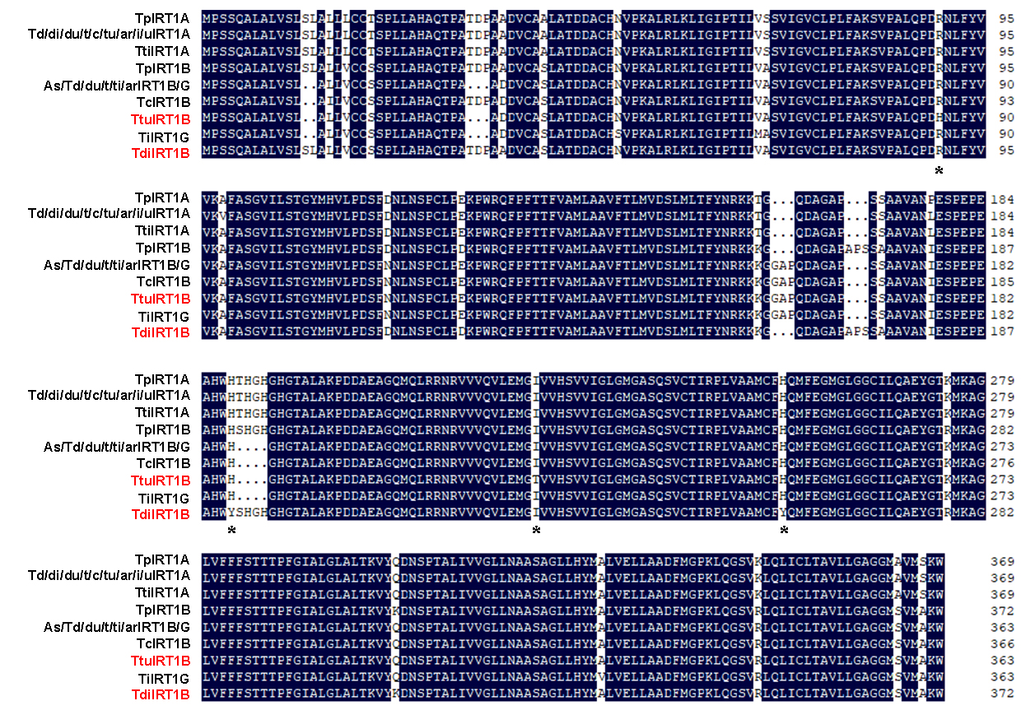
Supplemental Figure 5. Alignment of IRT1 amino acid sequences by DNAMAN
Functional difference genes were marked in red. Asterisks show the pivotal polymorphisms sites.

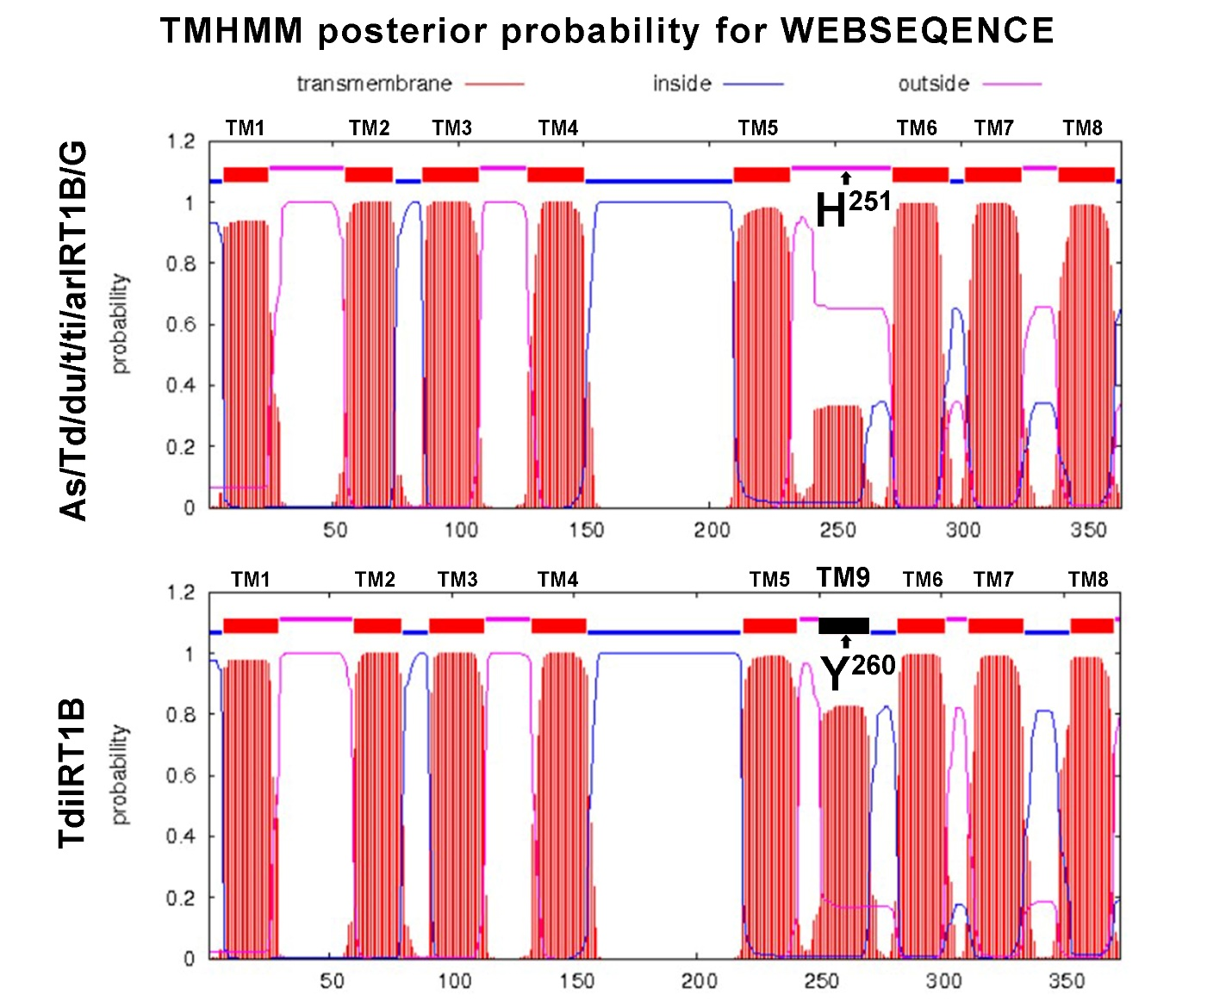
Supplemental Figure 6. TdiIRT1B is predicted to possess one more TM (TM9) compared to other IRT1B proteins
The TMs of proteins were predicted by TMHMM Server v2.0 (http://www cbs dtu dk/services/TMHMM/). The amino acid substitution sites and a putative additional TM (TM9) in TdiIRT1B are marked in black.

