Supplementary Materials
Strong and tough Mg-MAX phase composites with nacre-like lamellar and brick-and-mortar architectures
Yanyan Liu^{1,2,#}, Xi Xie^{2,#}, Zengqian Liu^{1,2,*}, Qin Yu³, Xuegang Wang², Qing Jia^{1,2}, Zhefeng Zhang^{1,2,*}, Rui Yang^{2,4,*}, Robert O. Ritchie³
¹School of Materials Science and Engineering, University of Science and Technology of China, Shenyang 110016, China
²Shi-Changxu Innovation Center for Advanced Materials, Institute of Metal Research, Chinese Academy of Sciences, Shenyang 110016, China
³Department of Materials Science and Engineering, University of California Berkeley, Berkeley, CA 94720, USA
⁴Center for Adaptive System Engineering, School of Creativity and Art, ShanghaiTech University, Shanghai 201210, China

____________
#These authors contributed equally to this work.
*Corresponding authors: Tel: +86-24-8397-0116, e-mail address: zengqianliu@imr.ac.cn (Z. Liu); Tel: +86-24-2397-1043, e-mail address: zhfzhang@imr.ac.cn (Z. Zhang); Tel: +86-21-2068-4099, e-mail address: yangrui@shanghaitech.edu.cn (R. Yang).
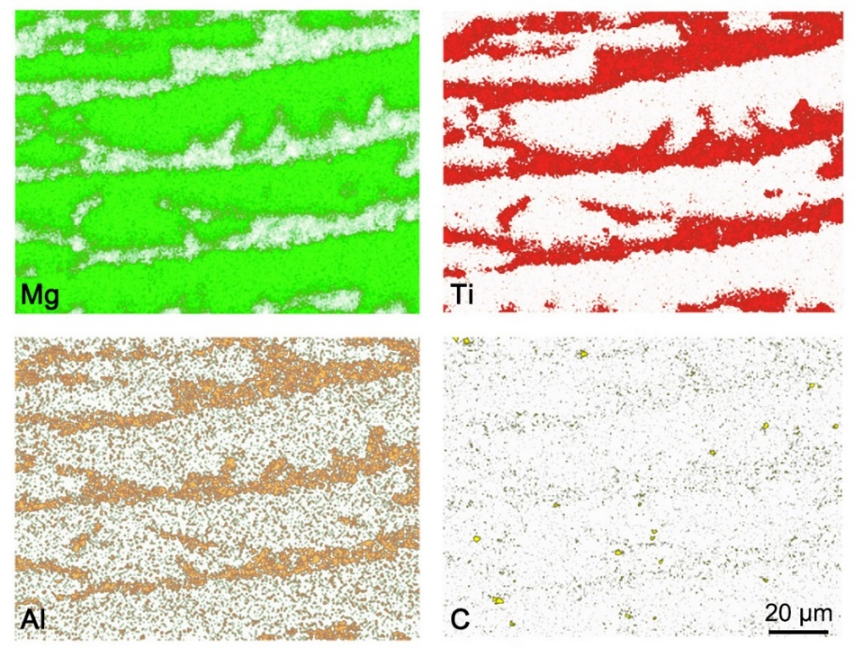
Figure S1. Distribution of elements measured by EDS in the pure Mg composite with lamellar architecture. The Mg element and the elemental Ti, Al and C were found to be principally concentrated in the metal and ceramic-rich constituents, respectively, which is similar with the case in the AZ91D composites.

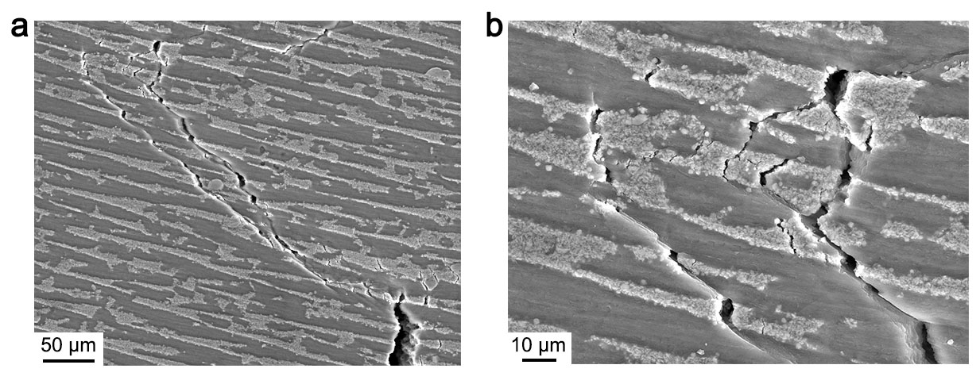
Figure S2. Crack bifurcation and deflection in the nacre-like Mg-MAX phase composites. Plastic deformation and microcracking occurred around the crack tip and played a role in promoting the crack bifurcation and deflection following the slip bands in the inter-lamellar regions or along the microcracks. The AZ91D alloy composite with lamellar architecture was taken as an example here.

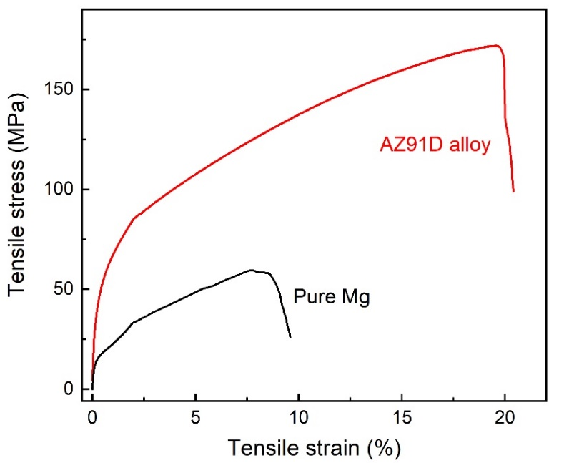
Figure S3. Representative room temperature tensile stress-strain curves of pure Mg and AZ91D alloy which were solidified following the same process as for the melt infiltration procedure of the Mg-MAX phase composites.

