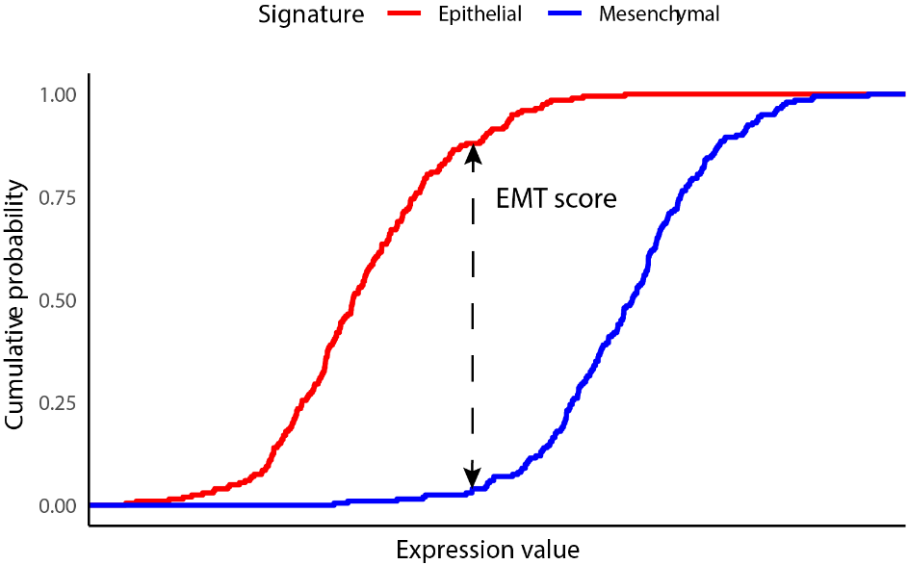
Supplementary figure 1 A diagram of the mechanism of the KS method, exhibiting a tumor tissue with a more mesenchymal phenotype. The lower ECDF curve represented the higher expression of mesenchymal gene signatures, thus the EMT score of the presented sample is positive.

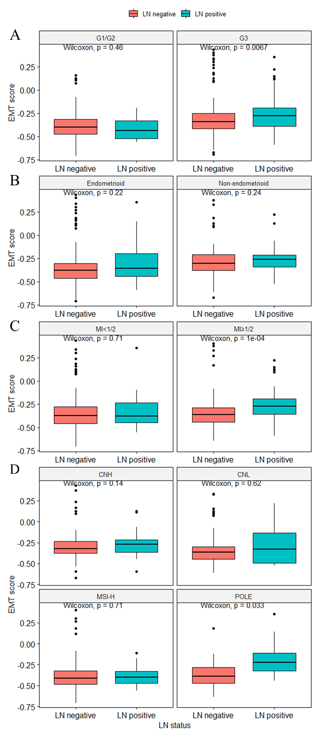
Supplementary figure 2 EMT scores were distributed unevenly when stratified by grade (A), histological subtype (B), MI (C) and molecular subtypes (D). LN: lymph node; MI: myometrial invasion; CNH: Copy-number high; CNL: copy-number low; MSI-H: microsatellite instability-high.

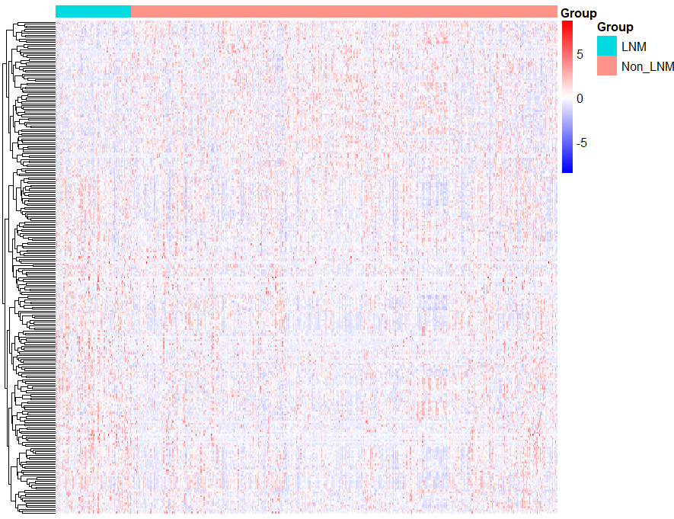
Supplementary figure 3 Heatmap for ERGs between tumor samples from LN positive and negative cases (normalized for exhibition). ERG: EMT-related gene; LN: lymph node.

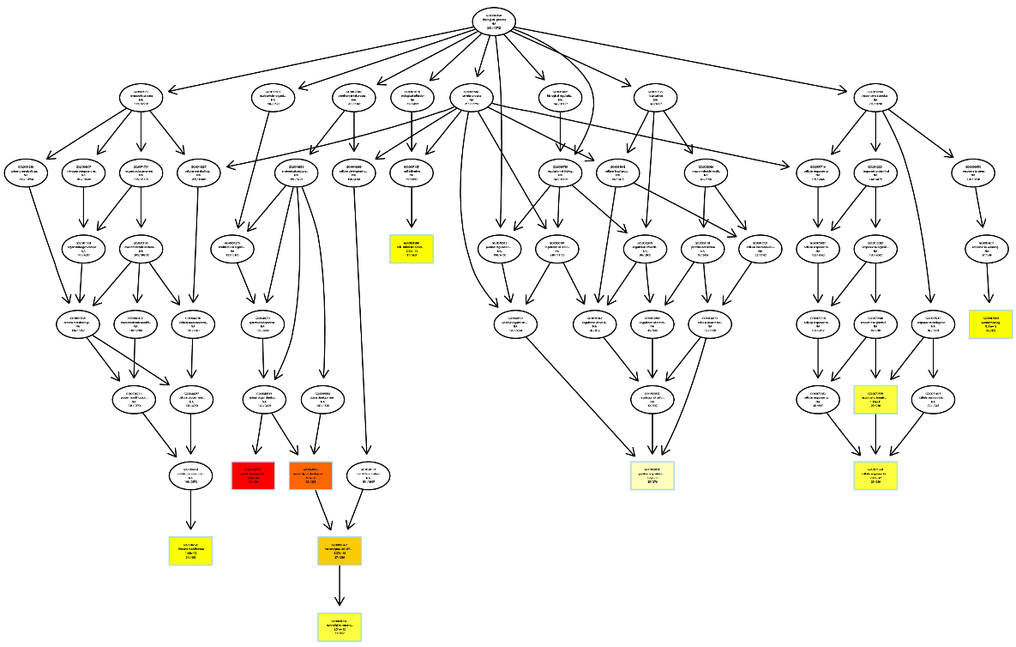
Supplementary figure 4 A DAG displaying the relationship between BPs from GO analysis. DAG: directed acyclic graph. BP: biological process; GO: Gene Ontology.

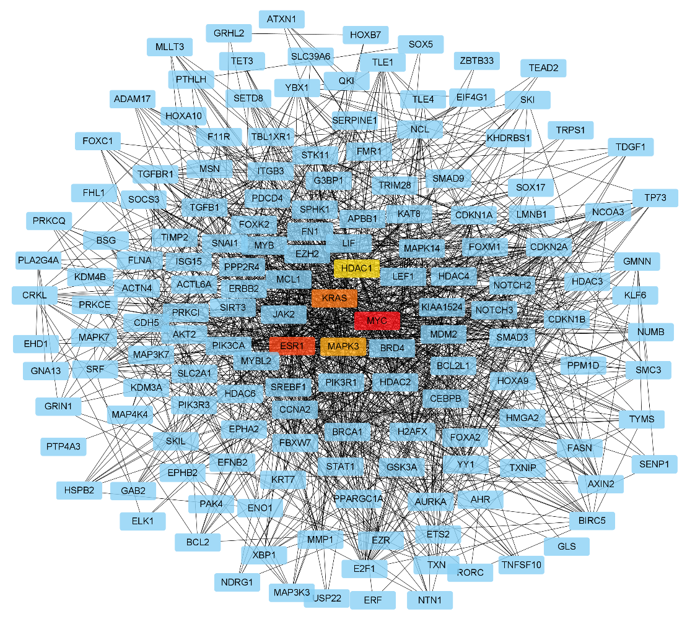
Supplementary figure 5 PPI network by Cytohubba, with top 5 hub genes highlighted by colors. PPI: protein–protein interaction.

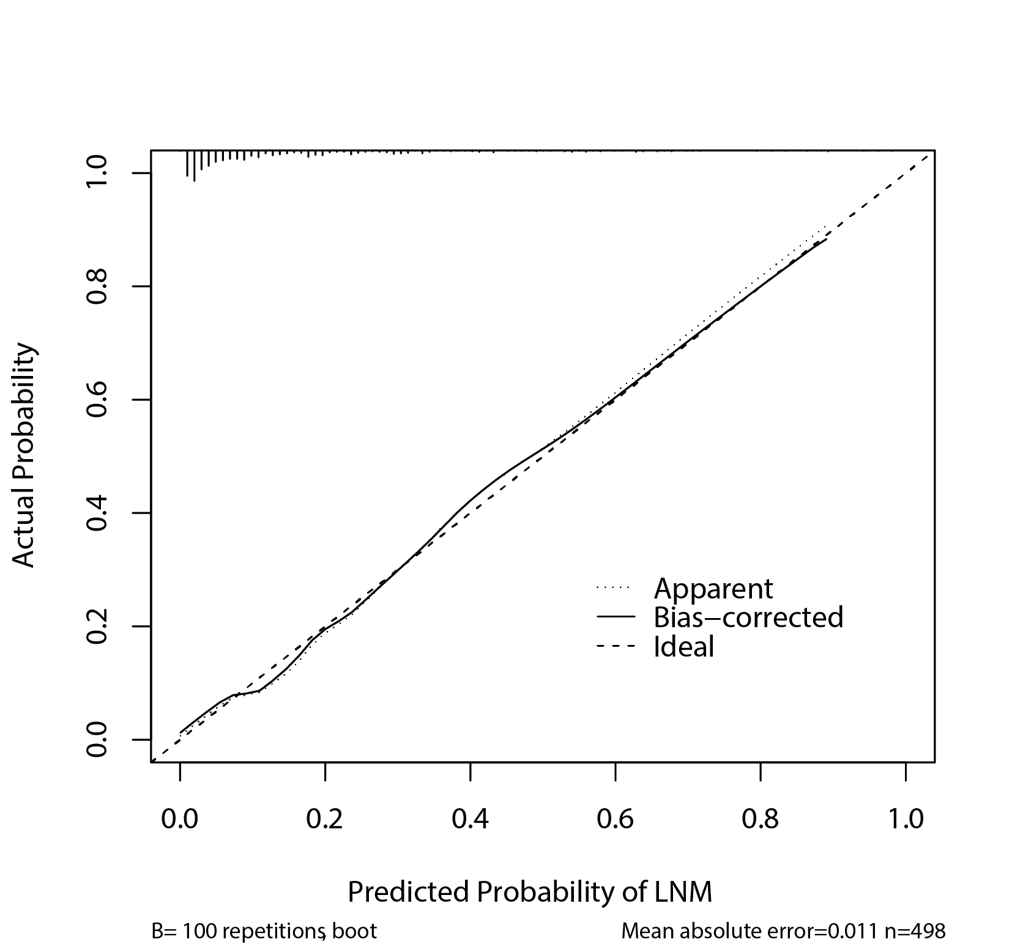
Supplementary figure 6 Calibration plot suggesting predicted probabilities of LNM corresponded closely to the actually observed proportions.

