Supplemental Material
Table S1. Number of samples per species included in the variant call format file used to call genotypes.
Species | samples
S. atrovirens | 242
S. chrysomelas | 113
S. goodei | 65
S. levis | 48
S. ovalis | 36
S. serranoides | 33
S. flavidus | 32
S. hopkinsi | 32
S. melanops | 32
S. paucispinis | 32
S. proriger | 31
S. caurinus | 30
S. carnatus | 29
S. diaconus | 26
S. emphaeus | 26
S. ensifer | 26
S. mystinus | 25
S. alutus | 24
S. miniatus | 23
S. crameri | 22
S. nebulosus | 22
S. melanostomus | 20
S. rosaceus | 20
S. umbrosus | 20
S. rubrivinctus | 19
S. semicinctus | 19
S. auriculatus | 16
S. aurora | 16
S. babcocki | 16
S. constellatus | 16
S. diploproa | 16
S. elongatus | 16
S. entomelas | 16
S. jordani | 16
S. maliger | 16
S. oculatus | 16
S. pinniger | 16
S. rastrelliger | 16
S. reedi | 16
S. saxicola | 16
S. wilsoni | 16
S. chlorostictus | 15
S. dalli | 15
S. zacentrus | 15
S. ruberrimus | 13
S. rufus | 12
S. moseri | 10
S. aleutianus | 9
S. helvomaculatus | 9
S. rufinanus | 9
S. borealis | 8
S. polyspinis | 8
S. serriceps | 8
S. melanostictus | 7
S. simulator | 7
S. nigrocinctus | 6
S. brevispinis | 1
S. rosenblatti | 1
Total | 1440
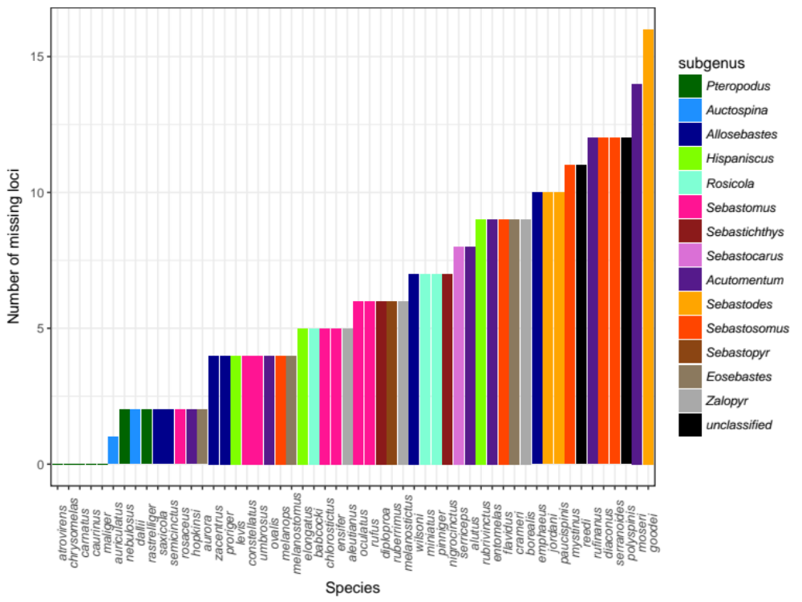
Fig. S1: Number of loci that do not amplify in all samples for a given species out of 96 total loci. Species are ranked from fewest-missing to most-missing loci. Color corresponds to subgenus. No loci are missing entirely from S. atrovirens, S. chrysomelas, S. carnatus, S. caurinus, or S. maliger.
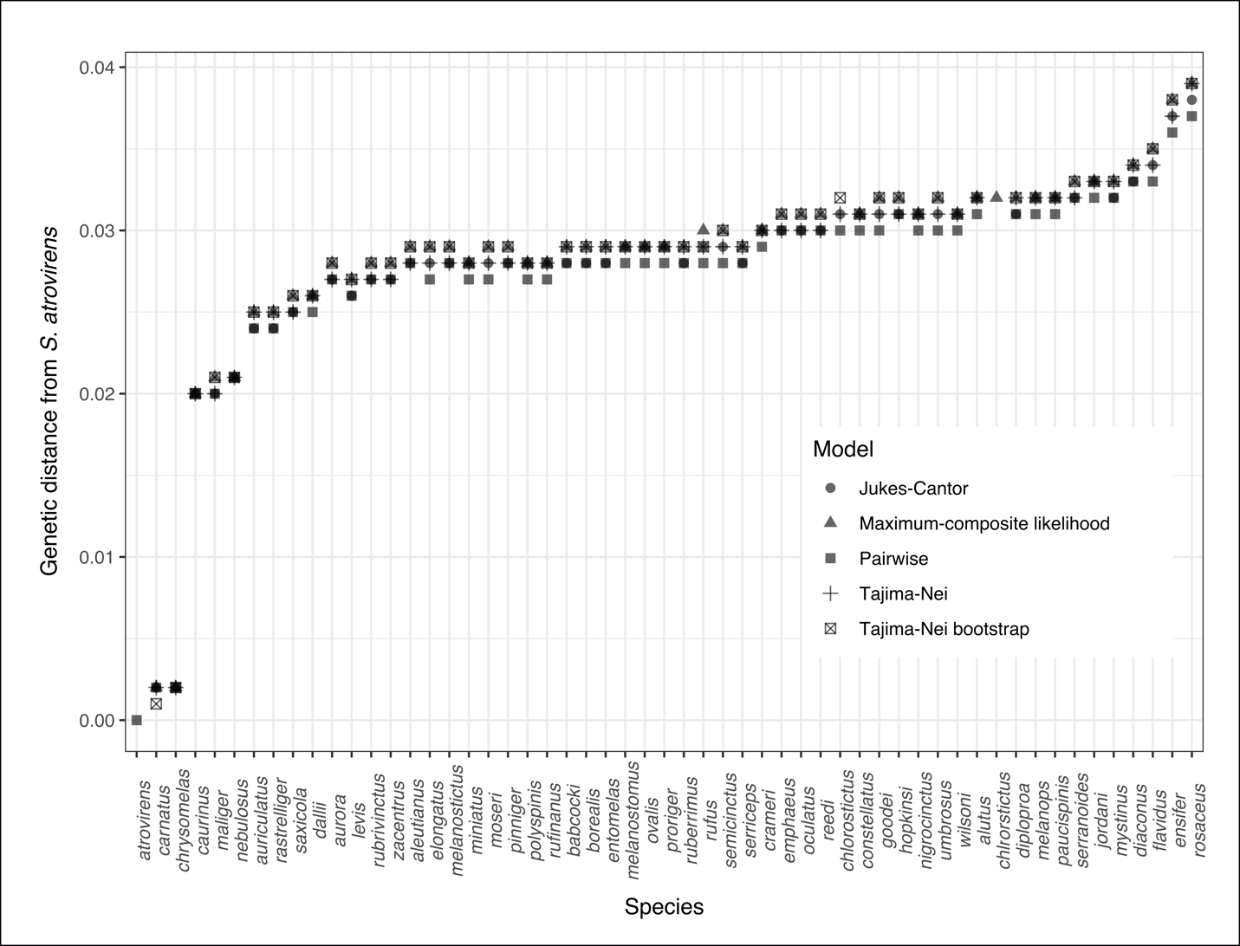
Fig. S2: Genetic distances are base substitutions per site between each species and S. atrovirens. Nucleotide substitution models are indicated by symbols. The Jukes-Cantor (Jukes and Cantor 1969), Tajima-Nei (Tajima and Nei 1984), and Kimura 2-parameter (Kimura 1980) models included uniform rates among sites. The maximum composite like- lihood model (Tamura, Nei, and Kumar 2004) and Tajima-Nei model with 1000 bootstraps included rate variation among sites modeled with a gamma distribution and differences in sequence composition (Tamura and Kumar 2002). The dataset included 10,695 sites, excluding gaps and missing data and analyses were conducted in MEGA v. 7.0.26.
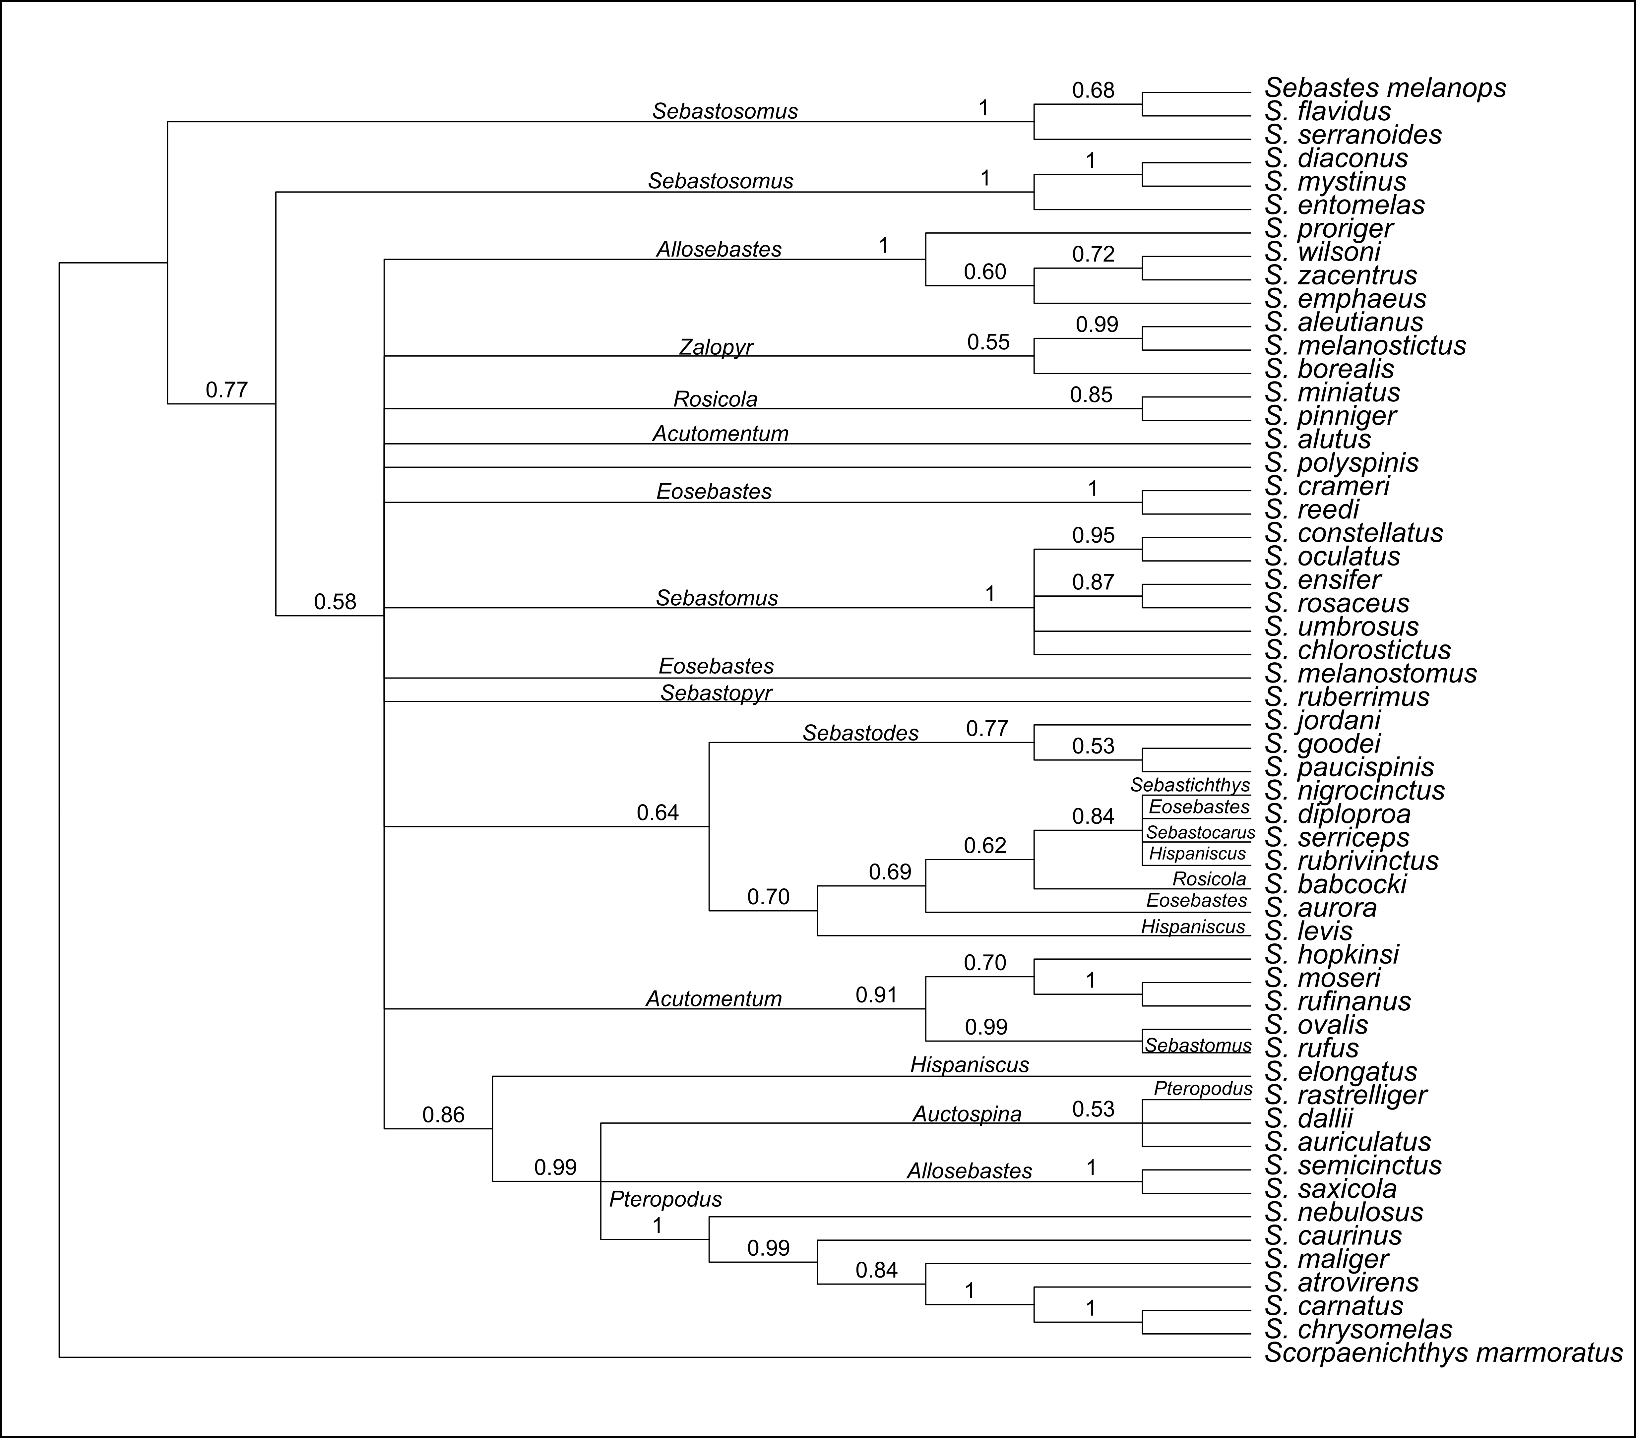
Fig. S3: Rooted maximum-likelihood tree estimated with the General Time Reversible model and 1000 bootstrap replicates. Bootstrap values above 50 are indicated above nodes on relevant branches. Analyses included 11,622 sites and retained gaps and missing data.
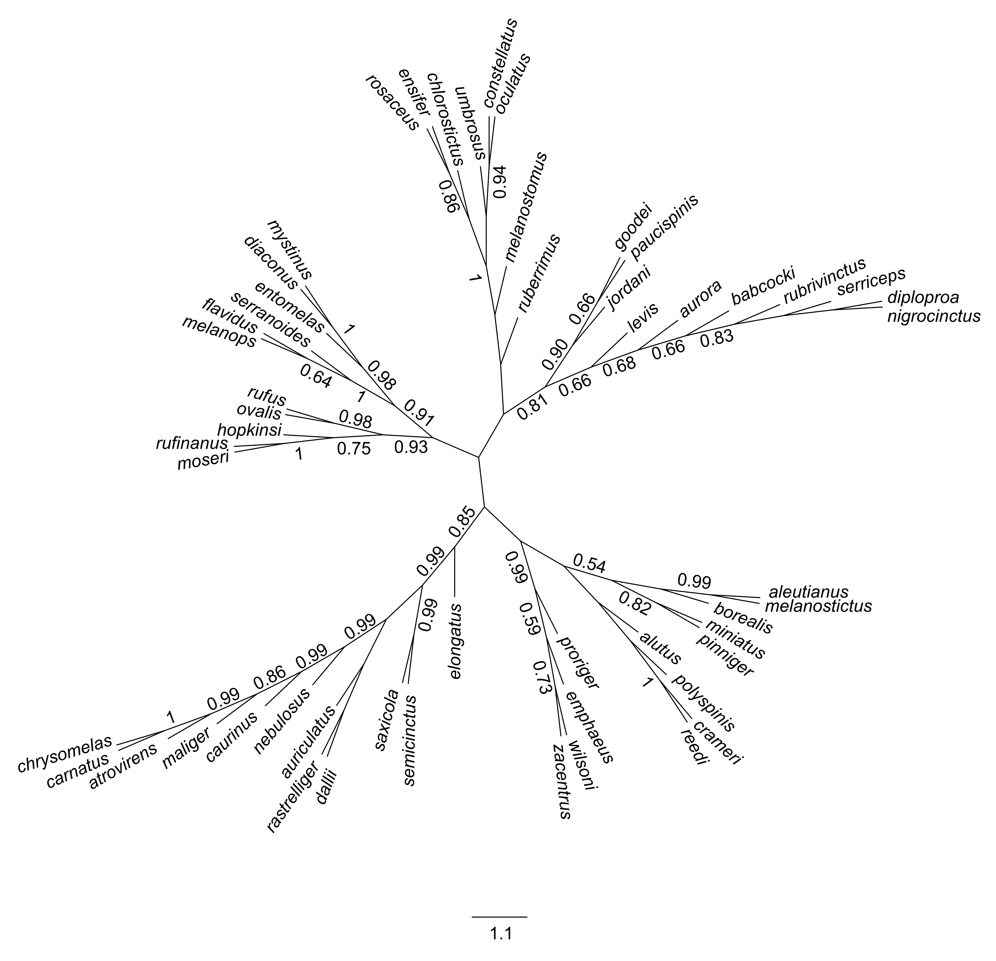
Fig. S4: Unrooted maximum-likelihood tree estimated using the General Time Reversible model with 1000 bootstrap replicates. Bootstrap support above 0.50 is shown on branches. The analysis included 11,622 sites and retained gaps and missing data.

