APPENDIX A: List of Tables

Table 1: Existence of Microplastic in Respective Sample Sites
SAMPLE SITES | INTESTINES | GIZZARDS
Market A | ✓ | ✓
Market B |  | ✓
Market C | ✓
Market D | ✓
Market E | ✓
Market F
Market G | ✓

Table 2: Micrograph of Examined Potential Microplastics in Intestines
SAMPLE SITES | SHEET | FILM | FIBER | FRAGMENT | PELLET | FOAM
Market A |  | 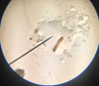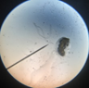
Market B |  | 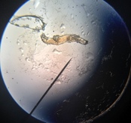
Market C |  | 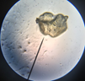
Market D |  | 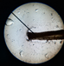
Market E |  | 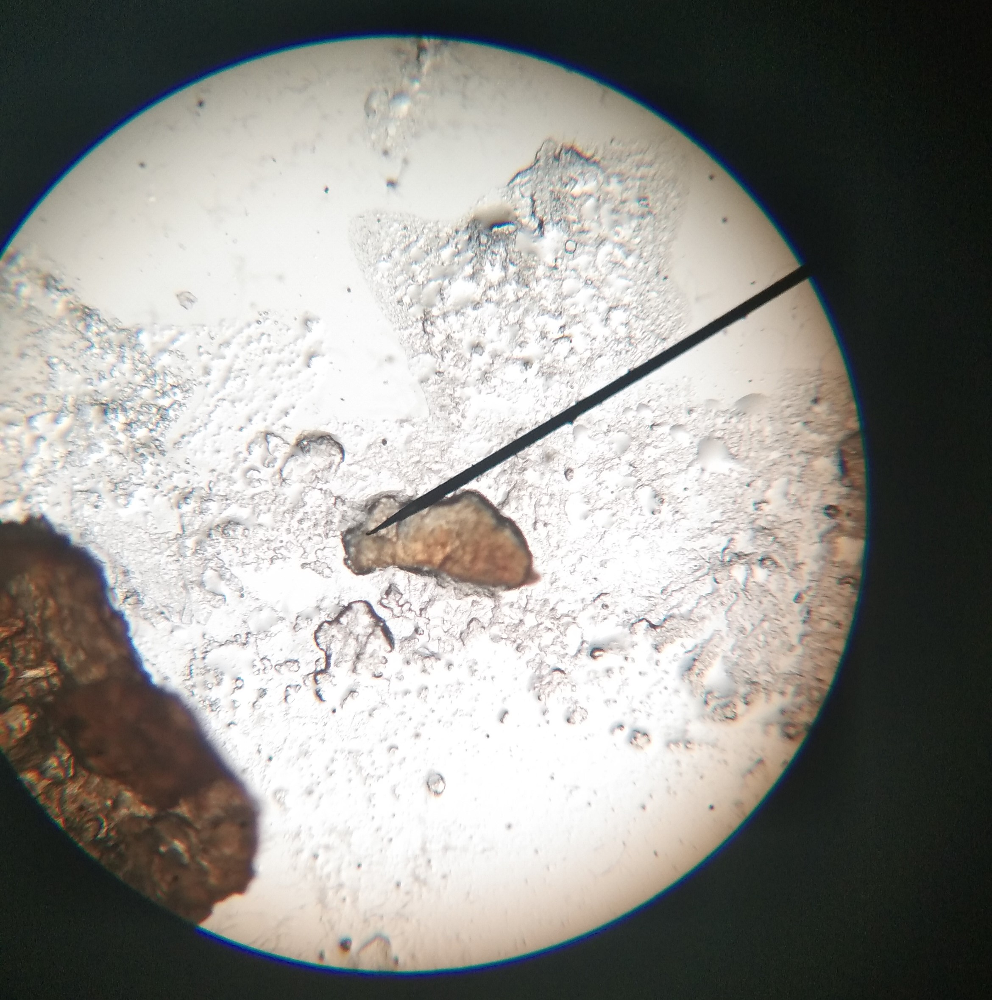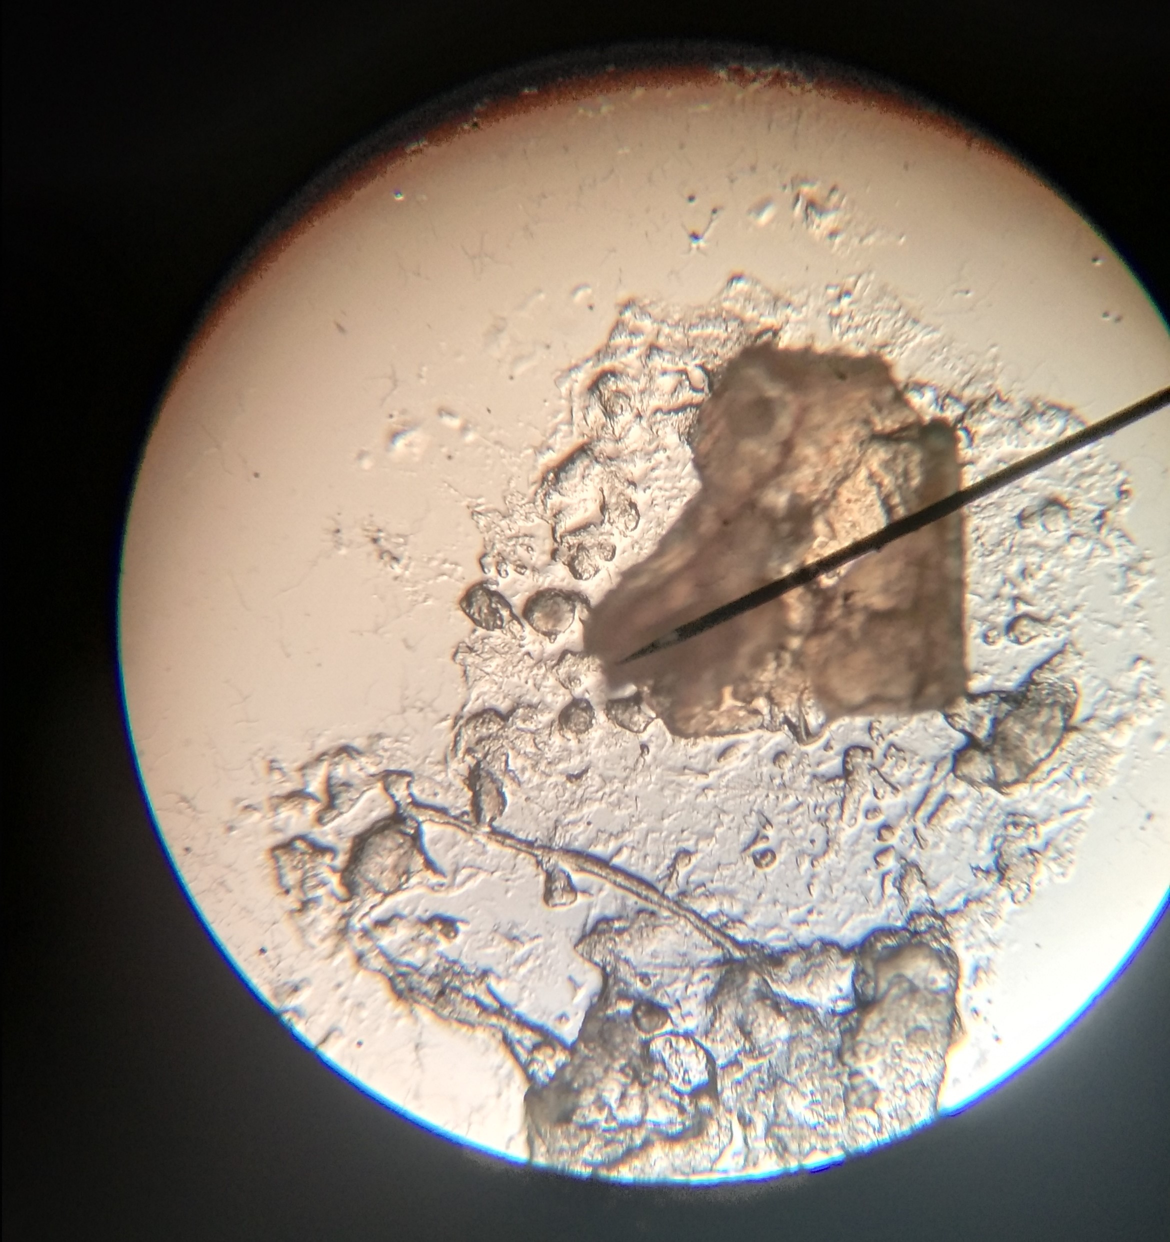

Table 3: Micrograph of Examined Potenial Microplastics in Gizzards
SAMPLE SITES | SHEET | FILM | FIBER | FRAGMENT | PELLET | FOAM
Market A |  |  |  | 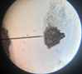
Market B |  |  |  |  | 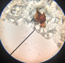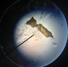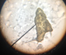

APPENDIX B: Documentation

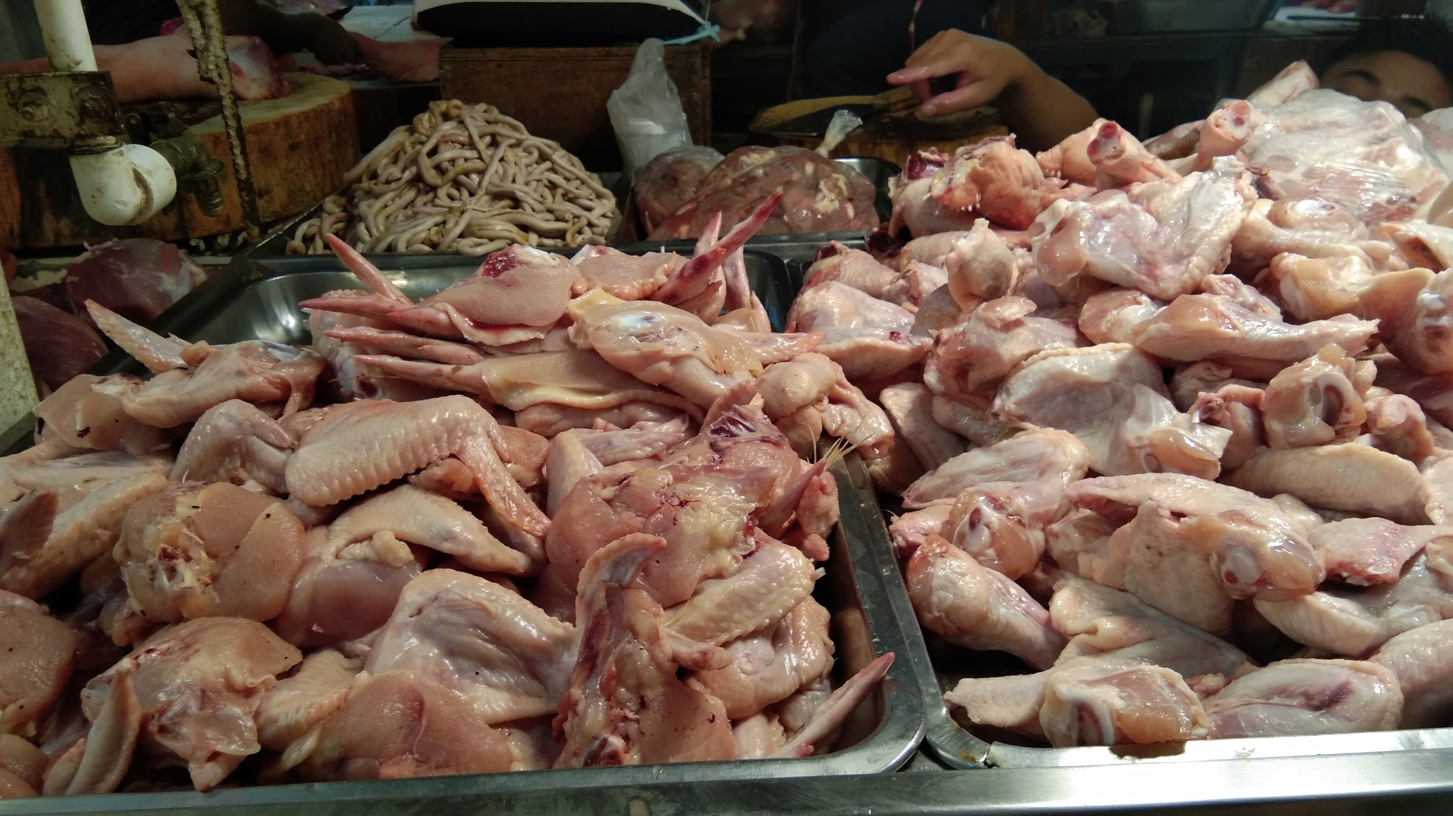
Samples were collected from markets in South Caloocan.

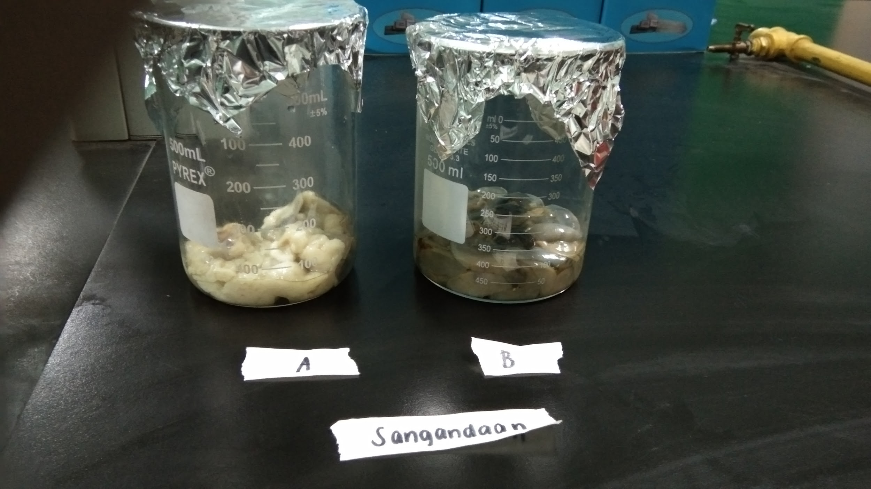
Samples were placed in individual beakers.
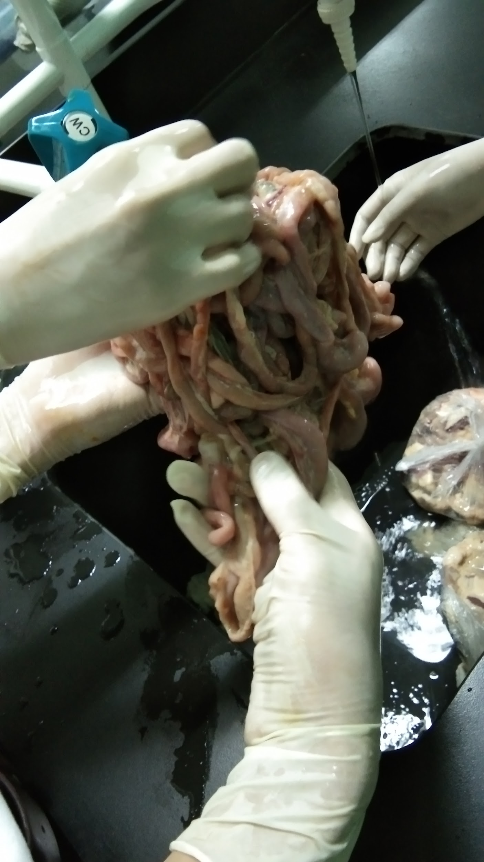
Poultry entrails were washed to remove extrinsic contaminants and to prepare for microplastic isolation.
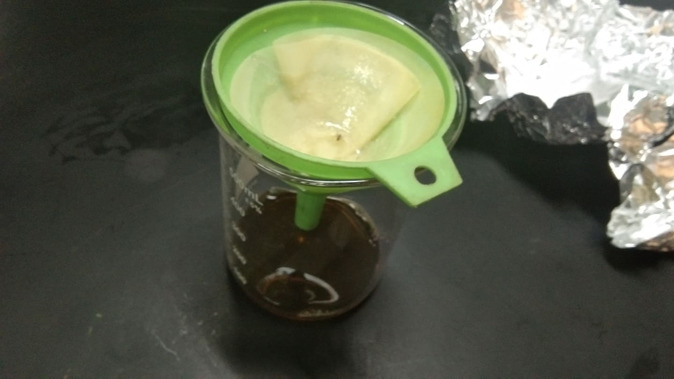
Unwanted materials were filtrated through a funnel with a microfiber filter.

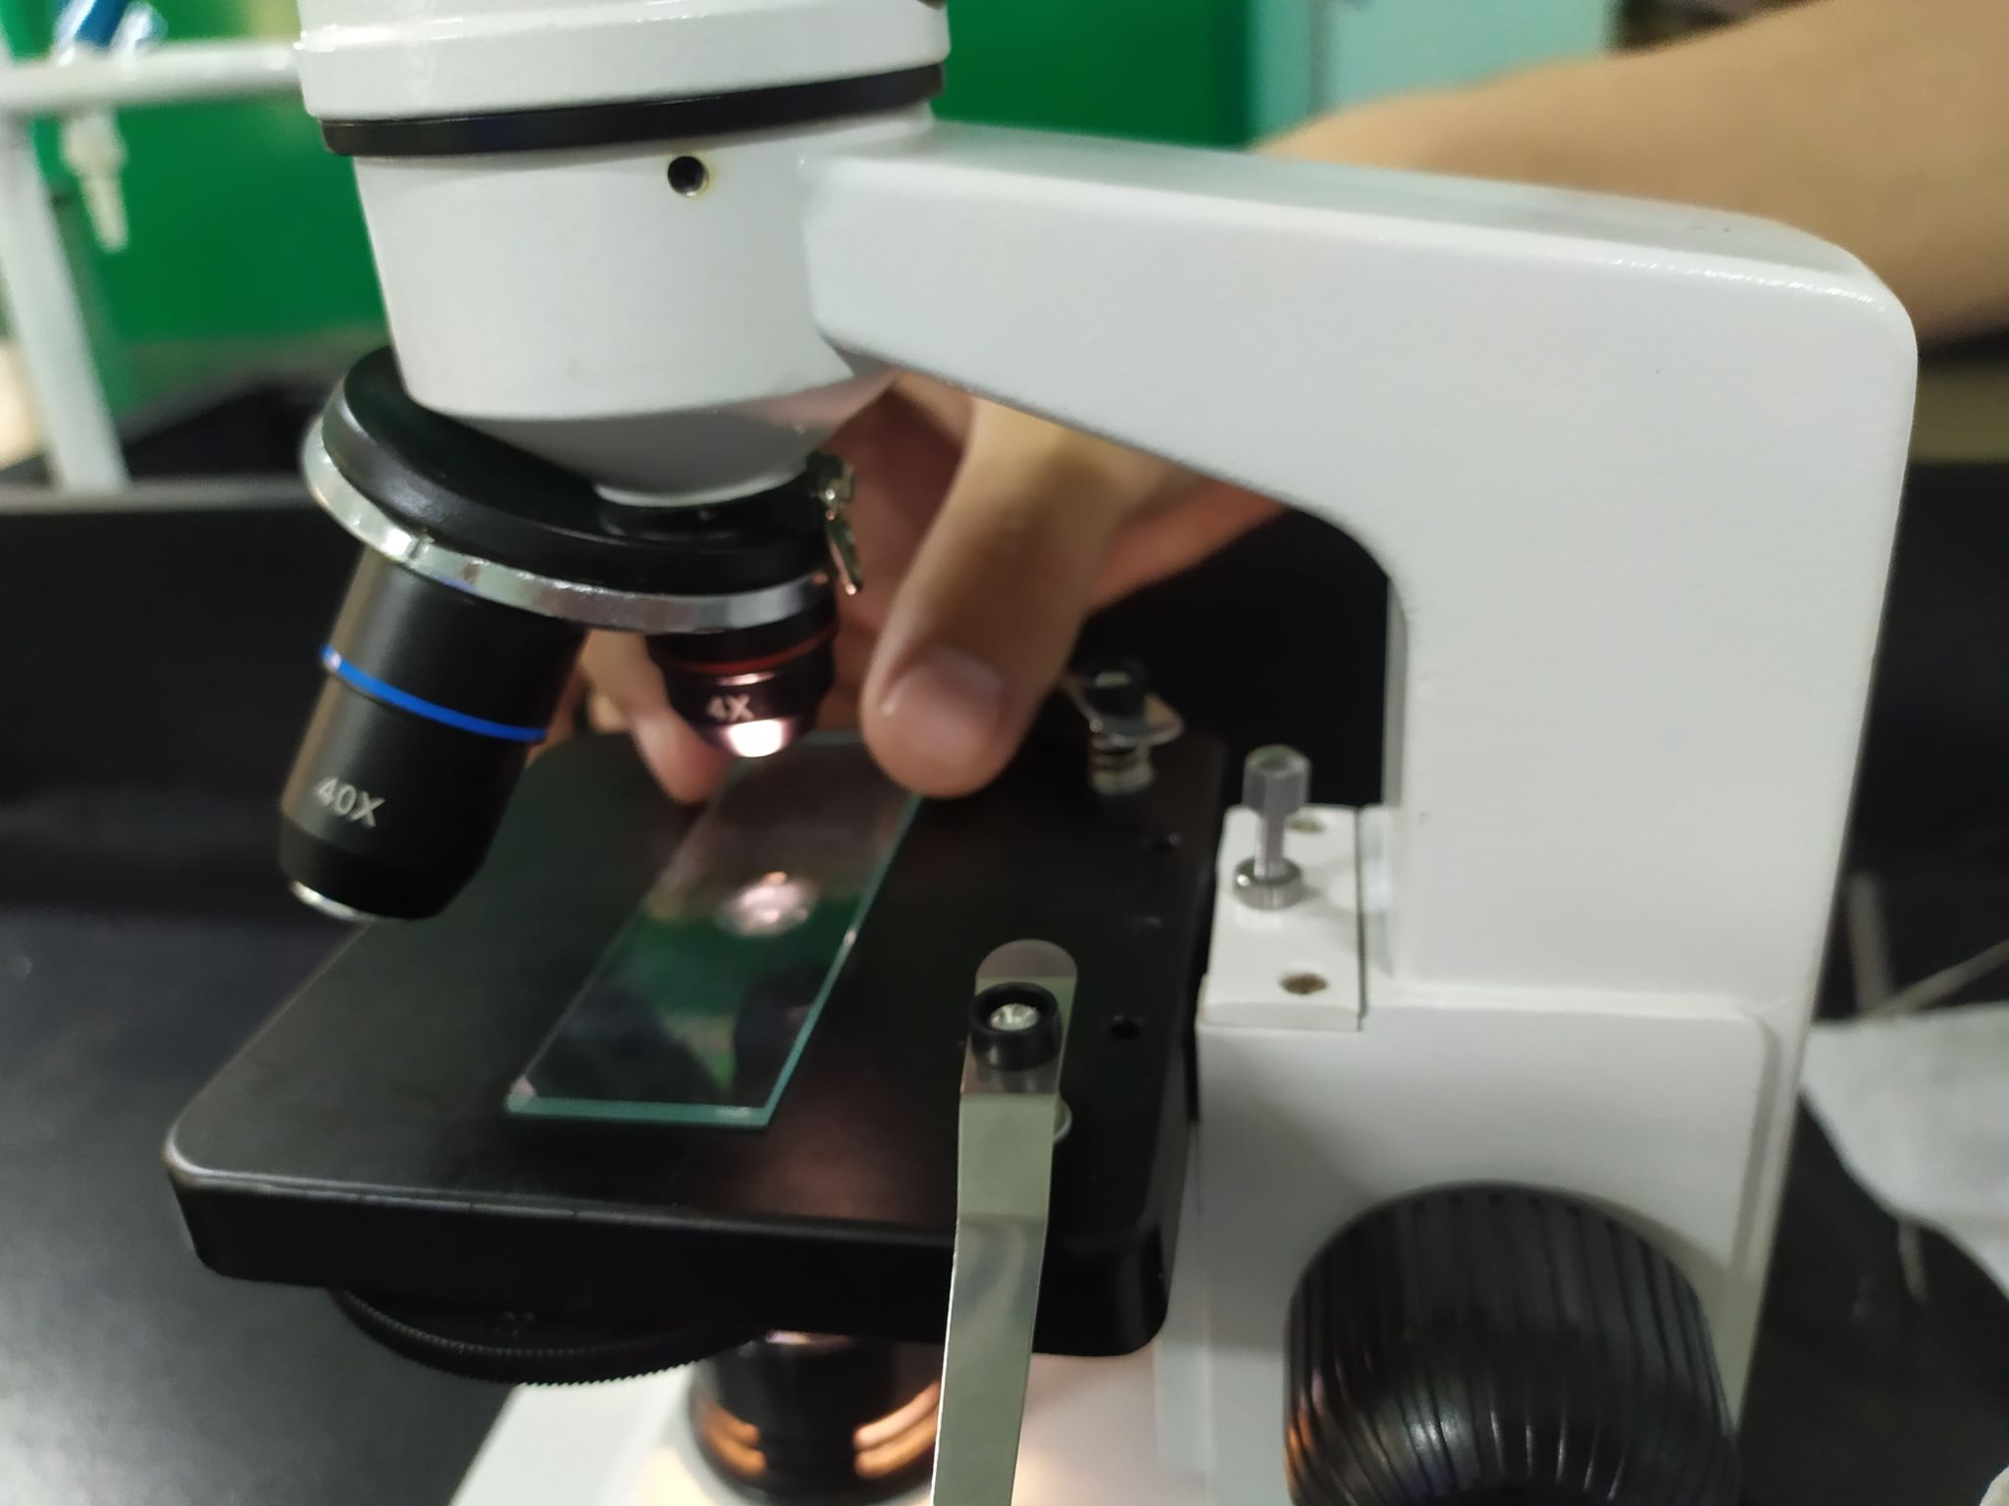
Potential microplastics were examined under a microscope

