Supplementary Materials
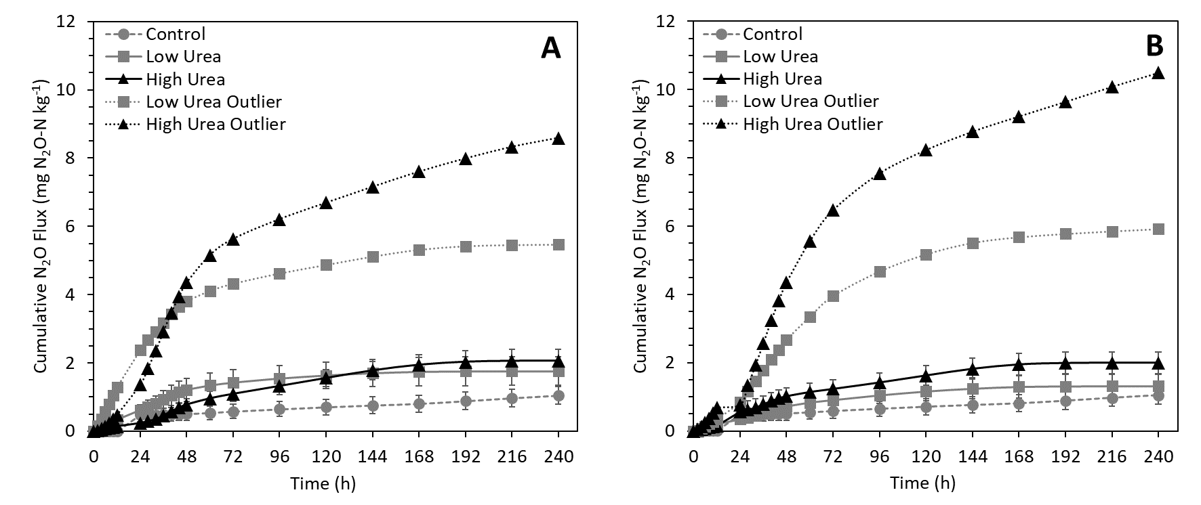
Figure S1: Outlier N₂O cumulative fluxes relative to treatment means for unlabeled urea (A) and ¹³C¹⁵N labeled urea (B) microcosms. Error bars represent SEM.

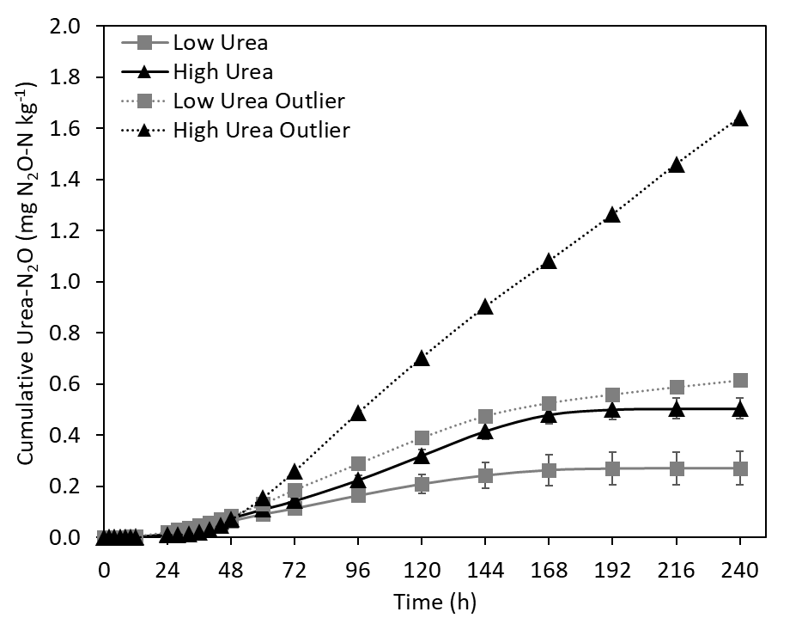
Figure S2: Outlier cumulative ¹⁵N₂O fluxes relative to treatment means. Error bars represent SEM.

Table S1: Outlier N₂O flux cumulative emission factors after 240 h expressed as a percentage of total urine-N or total urea-N (¹⁵N) added and emitted as N₂O-N.
Soil Treatment | Urine-N N₂O | ¹⁵N₂O (urea-N)
 | %
High Urea Outlier | 3.0 | 0.85
Low Urea Outlier | 3.9 | 0.65

Table S2: Average microcosm soil pH, ammonium, and nitrate content ± SEM.
Treatment | Time | pH | Soil NH₄⁺-N | Soil NO₃⁻-N
 | h |  | mg kg⁻¹ | mg kg⁻¹
Pre-Condition | 0 | 7.22 ± 0.03 | 6.3 ± 0.2 | 114 ± 3
3.5 g L⁻¹ | 8 | 7.44 ± 0.01 | 126 ± 3 | 161 ± 7
 | 36 | 7.47 ± 0.01 | 142 ± 3 | 129 ± 9
 | 168 | 7.17 ± 0.04 | 92.9 ± 22.9 | 145 ± 21
 | 240 | 7.13 ± 0.00 | 7.9 ± 0.2 | 219 ± 9
7.0 g L⁻¹ | 8 | 7.52 ± 0.02 | 281 ± 5 | 133 ± 11
 | 36 | 7.36 ± 0.01 | 263 ± 7 | 84.8 ± 3.9
 | 168 | 7.29 ± 0.05 | 218 ± 34 | 126 ± 36
 | 240 | 7.08 ± 0.01 | 8.1 ± 1.1 | 236 ± 3
Control | 240 | 7.18 ± 0.01 | 8.9 ± 0.3 | 134 ± 1
3.5 g L⁻¹ (¹⁵N¹³C) | 240 | 7.11 ± 0.02 | 9.1 ± 1.0 | 216 ± 6
7.0 g L⁻¹ (¹⁵N¹³C) | 240 | 7.06 ± 0.02 | 11.6 ± 2.5 | 246 ± 2

Table S3: qPCR target genes, master mixes, and primers used.
Gene | Primer | Sequence (5’ → 3’) | Product (bp)
Arch. amoA | Crenamo23F (Tourna et al., 2008)  Crenamo616r48x (Nicol et al., 2008) ª | ATGGTCTGGCTWAGACG  GCCATCCABCKRTANGTCCA | 629
Bact. amoA | amoA1F  amoA2R (Rotthauwe et al., 1997) | GGGGTTTCTACTGGTGGT  CCCCTCKGSAAAGCCTTCTTC | 491
nirK | nirKH1F  nirKH1R (Henry et al., 2004) | ATYGGCGGVAYGGCGA  GCCTCGATCAGRTTRTGGTT | 165
nirS | Cd3aF (Michotey et al., 2000)  R3cd (Throbäck et al., 2004) | GTSAACGTSAAGGARACSGG  GASTTCGGRTGSGTCTTGA | 410
nosZ clade I | nosZ2F  nosZ2R (Henry, Bru, Stres, Hallet, & Philippot, 2006) | CGCRACGGCAASAAGGTSMSSGT  CAKRTGCAKSGCRTGGCAGAA | 267
nosZ clade II | nosZ-II-F  nosZ-II-R (Jones et al., 2013) | CTIGGICCIYTKCAYAC  GCIGARCARAAITCBGTRC | 698
ª Crenamo616r degenerate primer

Table S4: Thermocycler conditions for qPCR. Cycles consisted of denaturation (D), annealing (A), extension (E), and measurement (M) to denature possible primer-dimers at measurement.
Gene | SYBR MM | Primer Conc. | Thermal Cycle ª | Efficiency | r²
 |  | uM |  | %
Arch. amoA | Platinum | 0.5 | D: 60s 95°C  A: 60s 55°C  E: 60s 72°C  M: 60s 80°C [45x] | 90.4 | 0.995
Bact. amoA | PowerUp | 0.9 | D: 45s 95°C  A: 45s 55°C  E: 45s 72°C  M: 60s 80°C [40x] | 90.8 | 0.999
nirK ^{b} | PowerUp | F: 0.6;  R: 0.8 | D: 15s 95°C  A: 30s 58°C  E: 30s 72°C  M: 15s 80°C [40x] | 101.3 | 0.995
nirS ^{b} | PowerUp | 1.0 | D: 15s 95°C  A: 30s 60°C  E: 30s 72°C  M: 15s 80°C [40x] | 95.0 | 0.998
nosZ clade I ^{b} | PowerUp | 1.0 | D: 15s 95°C  A: 30s 60°C  E: 30s 72°C  M: 15s 80°C [40x] | 96.6 | 0.998
nosZ clade II ^{b} | Platinum | 2.0 | D: 15s 95°C  A: 30s 58°C  E: 30s 72°C  M: 15s 80°C [45x] | 109.2 | 0.992
ª All methods started with 2 min 50 °C UDG activation and 2 min 95 °C DNA polymerase activation and initial denaturation.
^{b} Initial 6 cycles of touchdown qPCR using stated method denaturation, annealing, and extension cycles with an initial annealing temperature +5°C and decreasing -1°C with each cycle until reaching stated temperature.

Table S5: representative organisms and genes cloned for absolute qPCR.
Gene | Representative Organism
Arch. amoA | Synthesized from uncultivated crenarchaeota Fosmid 54d9 sequence (Treusch et al., 2005)
Bact. amoA | Nitrosomonas europa
nirK | Synthesized from Sinorhizobium meliloti nirK sequence
nirS | Pseudomonas stutzeri
nosZ clade I | Pseudomonas stutzeri
nosZ clade II | Equimolar mix of 10 cloned nosZ-II amplicons derived from environmental samples and confirmed by DNA sequencing.

Table S6: Gas flux and soil N model ANOVA results (Type III F-test).
Flux Model | Term | df | Res. df | F value | Pr ( > F)
Hourly N₂O | Treatment | 2 | 52.1 | 16.3 | < 0.0001 | ***
 | Time | 21 | 147 | 23.9 | < 0.0001 | ***
 | Treatment:Time | 42 | 147 | 28.5 | < 0.0001 | ***
Hourly CO₂ | Treatment | 2 | 88.8 | 201.3 | < 0.0001 | ***
 | Time | 21 | 189 | 251.8 | < 0.0001 | ***
 | Treatment:Time | 42 | 189 | 29.6 | < 0.0001 | ***
Cumulative N₂O | Treatment | 2 | 11.5 | 0.2 | 0.8252
 | Time | 21 | 147 | 46.2 | < 0.0001 | ***
 | Treatment:Time | 42 | 147 | 4.3 | < 0.0001 | ***
Cumulative CO₂ | Treatment | 2 | 11.7 | 36.7 | < 0.0001 | ***
 | Time | 21 | 189 | 2644 | < 0.0001 | ***
 | Treatment:Time | 42 | 189 | 73.4 | < 0.0001 | ***
Hourly Urea-N₂O | Treatment | 1 | 49.5 | 0.287 | 0.5948 | ***
 | Time | 21 | 84 | 21.0 | < 0.0001 | ***
 | Treatment:Time | 21 | 84 | 3.36 | < 0.0001 | ***
Hourly Urea-CO₂ | Treatment | 1 | 130.7 | 8.31 | 0.00462 | ***
 | Time | 21 | 125 | 413.6 | < 0.0001 | ***
 | Treatment:Time | 21 | 125 | 10.1 | < 0.0001 | ***
Cumulative Urea-N₂O | Treatment | 1 | 39.3 | 1.18 | .2840
 | Time | 21 | 84 | 202.5 | < 0.0001 | ***
 | Treatment:Time | 21 | 84 | 4.37 | < 0.0001 | ***
Cumulative Urea-CO₂ | Treatment | 1 | 8.4 | 5.76 | 0.0420 | *
 | Time | 21 | 125 | 379.4 | < 0.0001 | ***
 | Treatment:Time | 21 | 125 | 237.6 | < 0.0001 | ***

Table S7: Gene Abundance (DNA) ANOVA results (Type III F-test).
Gene | Term | df | F value | Pr ( > F)
Arch. amoA | Treatment | 2 | 1.10 | 0.3452
 | Time | 3 | 0.50 | 0.6838
 | Treatment:Time | 6 | 3.63 | 0.0066 | **
 | Residuals | 35
Bact. amoA | Treatment | 2 | 5.49 | 0.0083 | **
 | Time | 3 | 23.4 | < 0.0001 | ***
 | Treatment:Time | 6 | 18.3 | < 0.0001 | ***
 | Residuals | 36
nirK | Treatment | 2 | 0.70 | 0.5042
 | Time | 3 | 1.79 | 0.1656
 | Treatment:Time | 6 | 3.36 | 0.0098 | **
 | Residuals | 36
nirS | Treatment | 2 | 7.19 | 0.0024 | **
 | Time | 3 | 10.1 | < 0.0001 | ***
 | Treatment:Time | 6 | 9.25 | < 0.0001 | ***
 | Residuals | 36
nosZ Clade I | Treatment | 2 | 3.48 | 0.0417 | *
 | Time | 3 | 2.16 | 0.1097
 | Treatment:Time | 6 | 3.54 | 0.0074 | **
 | Residuals | 36
nosZ Clade II | Treatment | 2 | 5.14 | 0.0111 | *
 | Time | 3 | 6.82 | 0.0010 | ***
 | Treatment:Time | 6 | 13.1 | < 0.0001 | ***
 | Residuals | 35
Total nos:nir | Treatment | 2 | 1.88 | 0.1683
 | Time | 3 | 24.2 | < 0.0001 | ***
 | Treatment:Time | 6 | 15.8 | < 0.0001 | ***
 | Residuals | 35

Table S8: Gene Transcript Abundance (mRNA) ANOVA results (Type III F-test).
Gene | Term | df | F value | Pr ( > F)
Arch. amoA | Treatment | 2 | 1.28 | 0.2916
 | Time | 3 | 1.60 | 0.2080
 | Treatment:Time | 6 | 2.07 | 0.0845 | .
 | Residuals | 33
Bact. amoA | Treatment | 2 | 2.82 | 0.0743 | .
 | Time | 3 | 2.27 | 0.0991 | .
 | Treatment:Time | 6 | 3.59 | 0.0076 | **
 | Residuals | 33
nirK | Treatment | 2 | 47.6 | < 0.0001 | ***
 | Time | 3 | 14.0 | < 0.0001 | ***
 | Treatment:Time | 6 | 15.3 | < 0.0001 | ***
 | Residuals | 33
nirS | Treatment | 2 | 4.96 | 0.0131 | *
 | Time | 3 | 18.8 | < 0.0001 | ***
 | Treatment:Time | 6 | 10.5 | < 0.0001 | ***
 | Residuals | 33
nosZ Clade I | Treatment | 2 | 7.83 | 0.0016 | **
 | Time | 3 | 10.8 | < 0.0001 | ***
 | Treatment:Time | 6 | 14.2 | < 0.0001 | ***
 | Residuals | 33
nosZ Clade II | Treatment | 2 | 92.8 | < 0.0001 | ***
 | Time | 3 | 92.2 | < 0.0001 | ***
 | Treatment:Time | 6 | 34.4 | < 0.0001 | ***
 | Residuals | 32
Total nos:nir | Treatment | 2 | 16.0 | < 0.0001 | ***
 | Time | 3 | 0.19 | 0.9018
 | Treatment:Time | 6 | 6.84 | < 0.0001 | ***
 | Residuals | 32

Table S9: Soil N model ANOVA results (Type III F-test).
Model | Term | df | F value | Pr ( > F)
Urine Soil Ammonium | Treatment | 1 | 54.2 | < 0.0001 | ***
 | Time | 3 | 71.3 | < 0.0001 | ***
 | Treatment:Time | 3 | 10.6 | < 0.0001 | ***
 | Residuals | 24
Urine Soil Nitrate | Treatment | 1 | 1.53 | 0.2286
 | Time | 3 | 15.9 | < 0.0001 | ***
 | Treatment:Time | 3 | 1.28 | 0.3049
 | Residuals | 24
Ammonium 240 h | Treatment | 2 | 0.61 | 0.5656
 | Residuals | 9
Nitrate 240 h | Treatment | 2 | 99.1 | < 0.0001 | ***
 | Residuals | 9

