Comparative study of silicon and selenium to mitigate arsenic induced stress by modulating TCA cycle, GABA and polyamine synthesis in rice seedlings
Susmita Das, Barsha Majumder and Asok K. Biswas*
Plant Physiology and Biochemistry Laboratory, Centre of Advanced Studies, Department of Botany, University of Calcutta, 35 Ballygunge Circular Road, Kolkata – 700019, India. Email: *dr.asokbiswas25@gmail.com

Influence of arsenate with or without silicate and selenate on total arsenic, arsenite, silicate and selenate contents
In both root and shoot of As(V) treated 3 weeks old test seedlings, total As and As(III) contents were significantly increased compared to control with more accumulation in root than shoot under As(V) treated test seedlings. In presence of As(V)+Si and As(V)+Se, total As [Fig. a, b] and As(III) [Fig. c. d] accumulation were decreased in the test seedlings than in the seedlings treated with As(V) alone. Si and Se contents were detected only in the test seedlings that were treated jointly with As(V) + Si and As(V) + Se with more Si and Se accumulation in shoot than root in case of As(V) + Si and As(V) + Se respectively [Fig. e, f]. ANOVA analysis showed significant accumulation of total As and its conversion to As(III) as well as Si and Se accumulation in both root and shoot of the test seedlings at a significance level of p < 0.001.
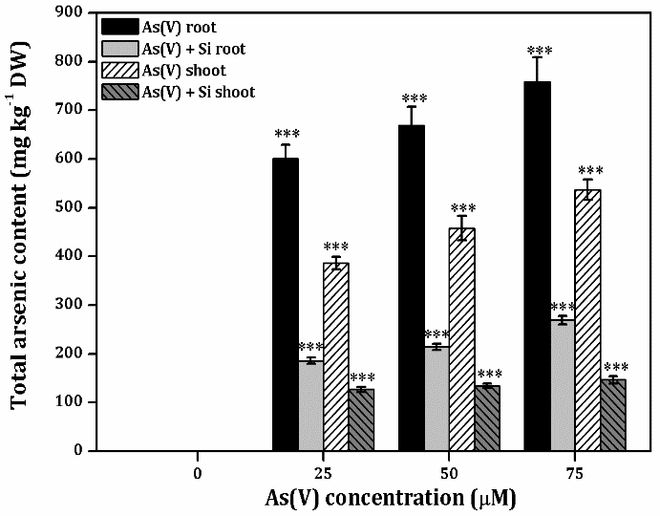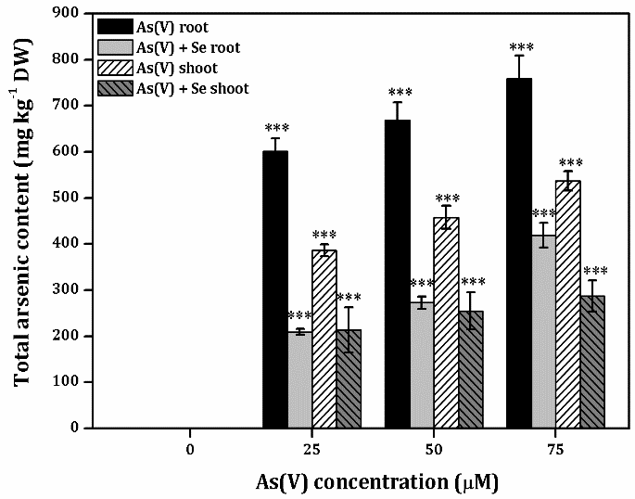
(b)
(a)
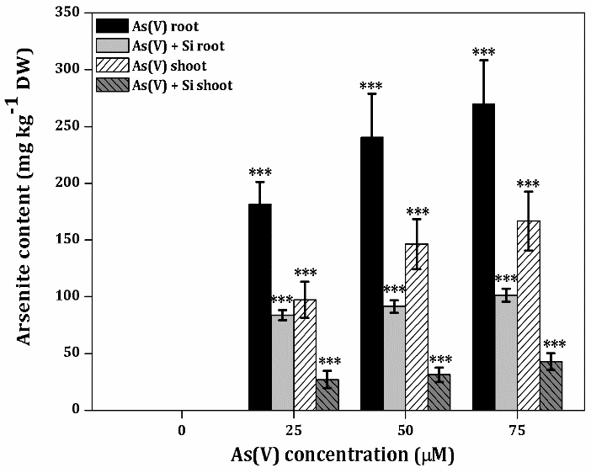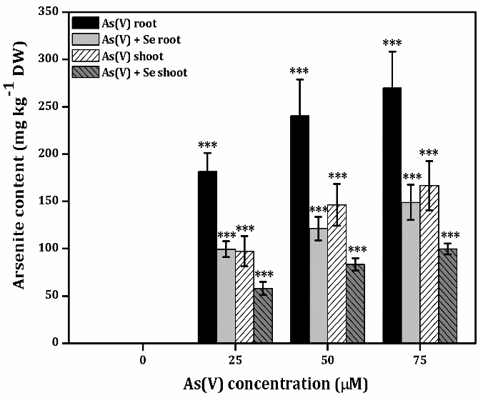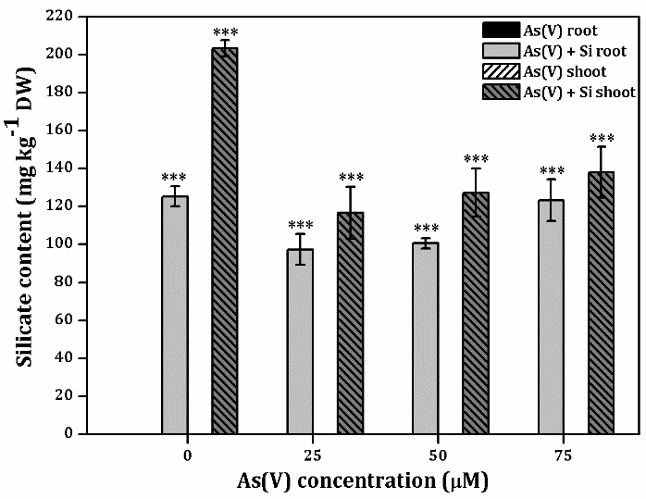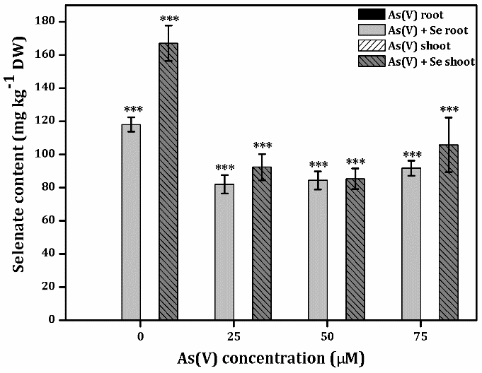
(f)
(e)
(d)
(c)
Figure: Influence of increasing concentrations of As(V) with or without Si and Se on total arsenic (a, b), arsenite (c, d), silicate (e) and selenate (f) contents in 3 weeks old rice seedlings. Multiple comparisons of the means ± S.E. (n = 6 i.e. three experiments with two replicates each) were conducted with the Tukey-Kramer HSD test. Bars labelled by *** are highly significant at level of p ≤ 0.001, in comparison to control.

3.4.2. Detection of polyamines by HPLC
The chromatograms of polyamines (PAs) content obtained from As(V) with or without Si and Se treated rice seedlings are presented in Fig. 15(b) & 15(c). All peaks were determined in less than 10 min. The chromatograms of individual standard PAs viz. Putrescine (Put), Spermidine (Spd), and Spermine (Spm) showed the retention times at 4.793 min, 5.287 min and 5.857 min respectively [Fig. 15(a)], used for identification of unknown peaks identification. In both root and shoot, the high intensity peaks of Put were detected under As(V) treatment. The intensity of peaks of Put were near 100 mV in root and 330 mV to 340 mV in shoot in non-treated (control) seedlings of the test cultivar. The intensity was increased near 200 mV to 250 mV in root and 350 mV to 375 mV in shoot under As(V) treatment. The peak intensity obtained from Put were enhanced in the test seedlings jointly treated with As(V) and Si that were by about 275 mV to 300 mV in root and 350 mV to 450 mV in shoot. During co-application of As(V) with Se, intensity of Put peaks were by about 225 mV to 275 mV in root and 375 mV to 400 mV in shoot. The intensity of peaks obtained from Spd and Spm were decreased in both root and shoot under As(V) treatments over control. The intensity of said peaks were increased under joint application of Si and As(V) in the test seedlings. It was also noticed that Put contents was higher than Spd and Spm contents in the test seedlings. The intensity levels of Spm were about 300 mV in root and 275 mV in shoot whereas the intensity levels were decreased by about 220 mV to 170 mV in root and 275 mV to 150 mV in shoot under only As(V) treatments. The peak intensity of Spd was gradually reduced during Si+As(V) that were by 350 mV to 240 mV in root and 325 mV to 300 mV in shoot. During Se+As(V) application, the peak intensity of Spd was also reduced that were by 250 mV to 200 mV in root and 300 mV to 275 mV in shoot. More or less similar incident was perceived on intensity level of peaks obtained against Spm contents that were by 200 mV in root and 280 mV in shoot of untreated seedlings. Whereas the intensities were decreased by 200 mV to 175 mV in root and 275 mV to 250 mV in shoot under only As(V) treatment. The peak intensity was high for Spm obtained from seedlings challenged with As(V)+Si or As(V)+Se than As(V) treatment alone. The intensity of peaks obtained from Spm were gradually reduced in test seedlings jointly treated with As(V) and Si that were about 250 mV to 230 mV in root and 325 mV to 300 mV in shoot. During co-application with As(V) and Se the intensity of Spm peaks obtained from the said test seedlings were also reduced that were about 275 mV to 200 mV in root and 300 mV to 275 mV in shoot.
Figure 15(a): HPLC chromatograms of standard polyamines viz. putrescine (Put), spermidine (Spd), and spermine (Spm) with retention time at 4.793 mins, 5.287 mins and 5.857 mins for Put, Spd and Spm, respectively.

Retention Time (minutes)
Intensity (mV)

Figure 15(b): HPLC chromatograms of polyamines (Retention time; Put - 4.793 mins, Spd - 5.287 mins and Spm - 5.857 mins) in root of 3 weeks old As(V), As(V)+Si, As(V)+Se treated rice seedlings.

Retention Time (minutes)
Intensity (mV)

Figure 15(c): HPLC chromatograms of polyamines (Retention time; Put - 4.793 mins, Spd - 5.287 mins and Spm - 5.857 mins) in shoot of 3 weeks old As(V), As(V)+Si, As(V)+Se treated rice seedlings.

The peak areas for chromatograms of polyamines obtained from As(V) along with or without Si and Se treated rice seedlings are presented in Fig. 16. The chromatograms of the individual Put, Spd and Spm standards were used for the peak identification. The high levels of polyamines were detected in shoot compared to root in the seedlings of test cultivar. The peak height and area of Put contents were more than the peak heights and areas of both Spd and Spm contents. In both root and shoot, peak heights and areas of Put were gradually increased under 25 μM, 50 μM and 75 μM As(V) treatments. The said parameters of both Spd and Spm were decreased by As(V) treatment in a dose dependent manner in the test seedlings. During co-application of As(V)+Si and As(V)+Se, the peak heights and areas of Put were increased more while the peak heights and areas of both Spd and Spm were decreased but less than the respective peak areas and heights of PAs obtained from only As(V) treated seedlings.
(d)
(c)
(b)
(a)
Figure 16: Peak areas of PAs in 3 weeks old root and shoot samples of As(V) with or without Si (a, c) and Se (b, d) treated rice seedlings.

