Supplementary Figure-1
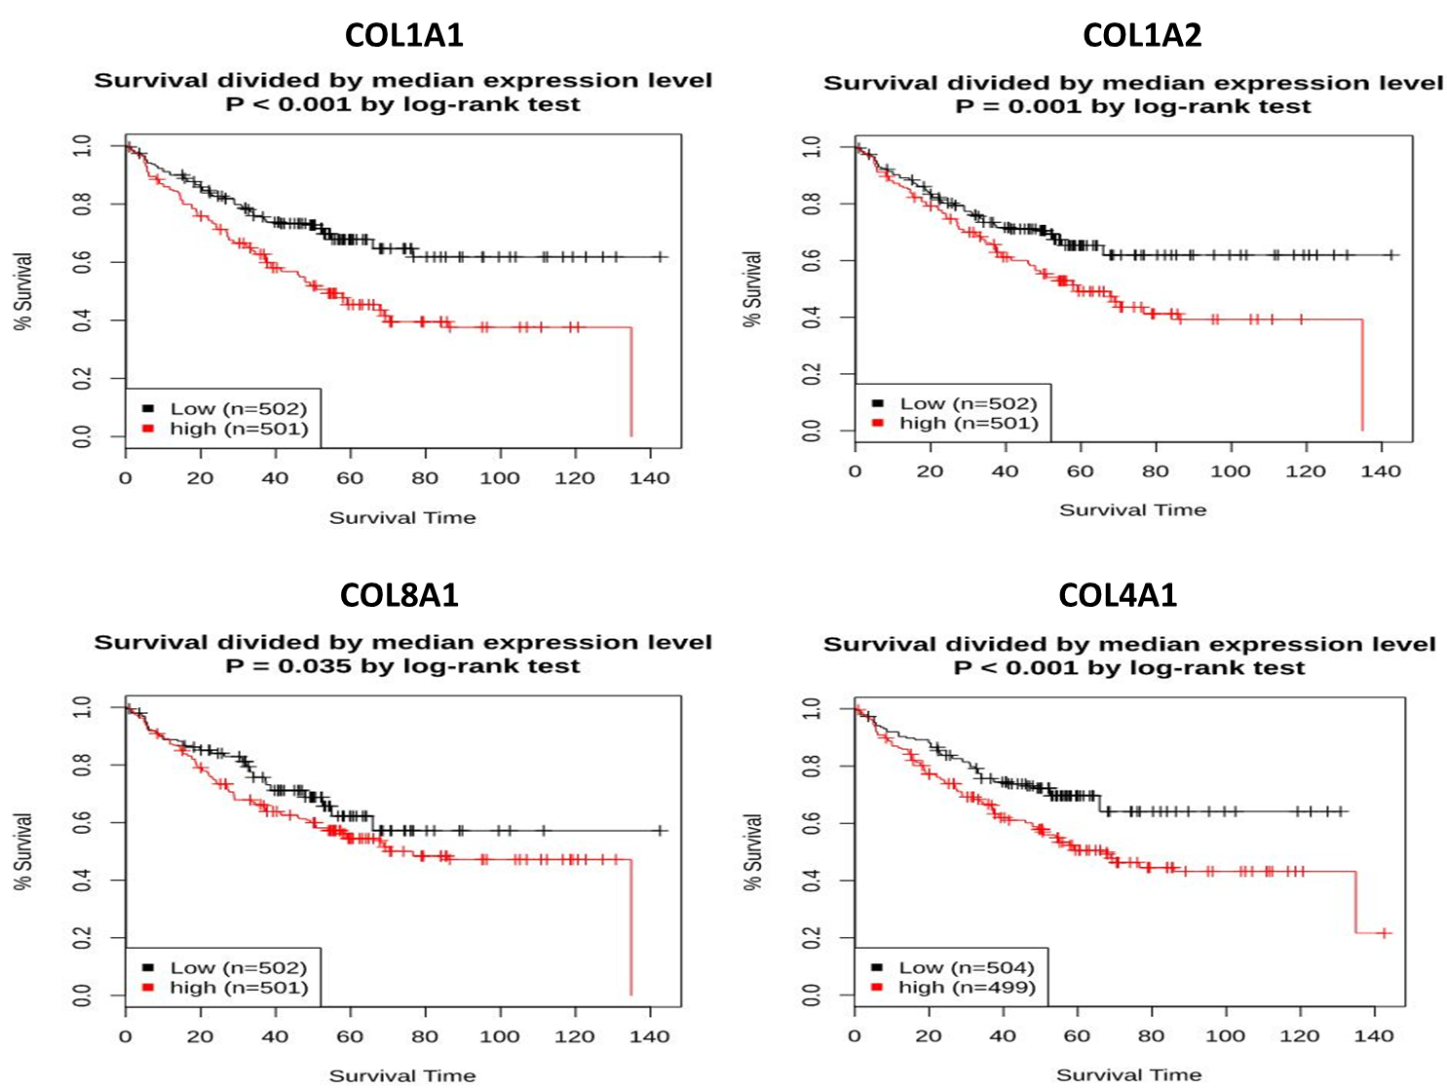
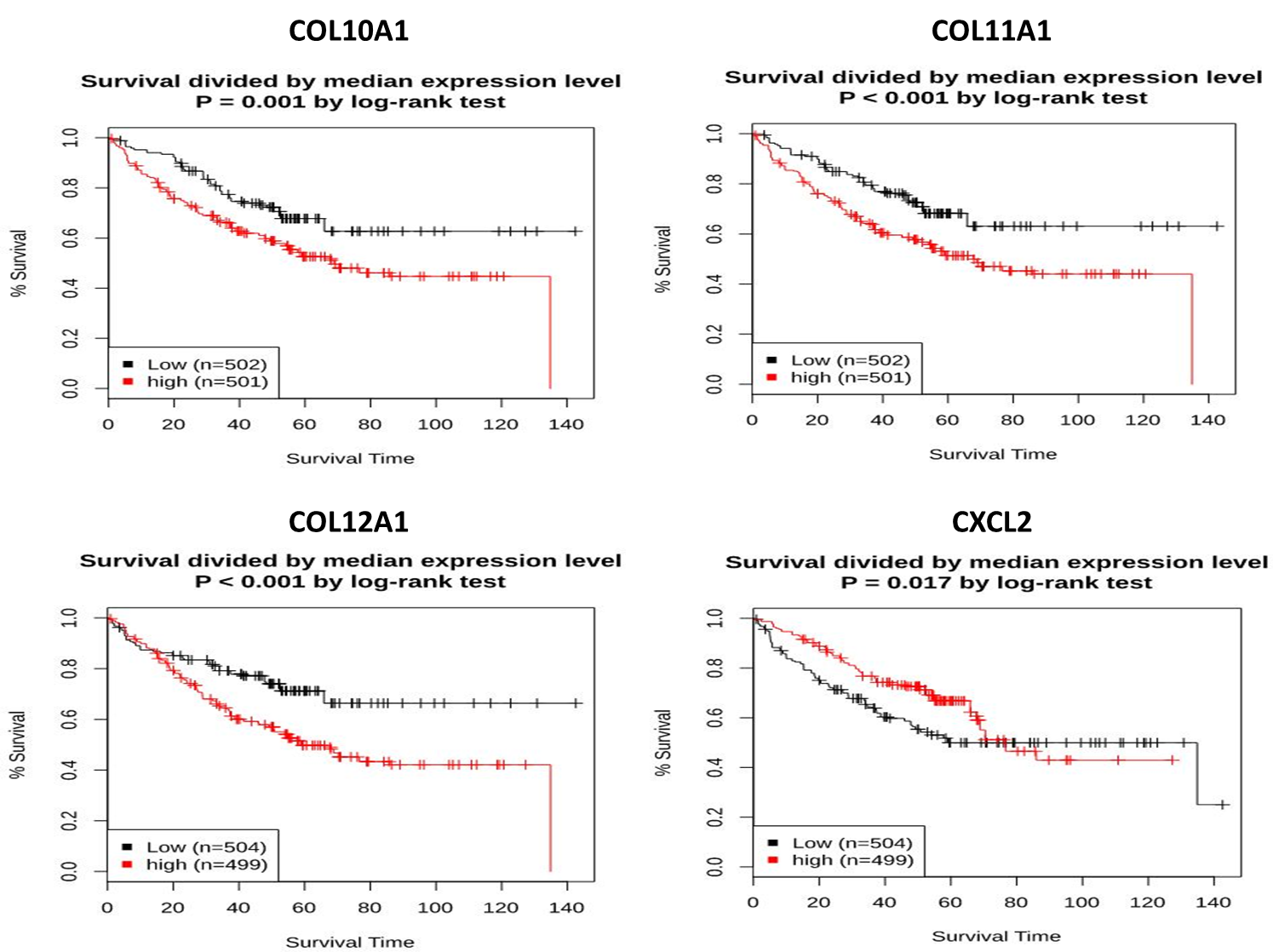
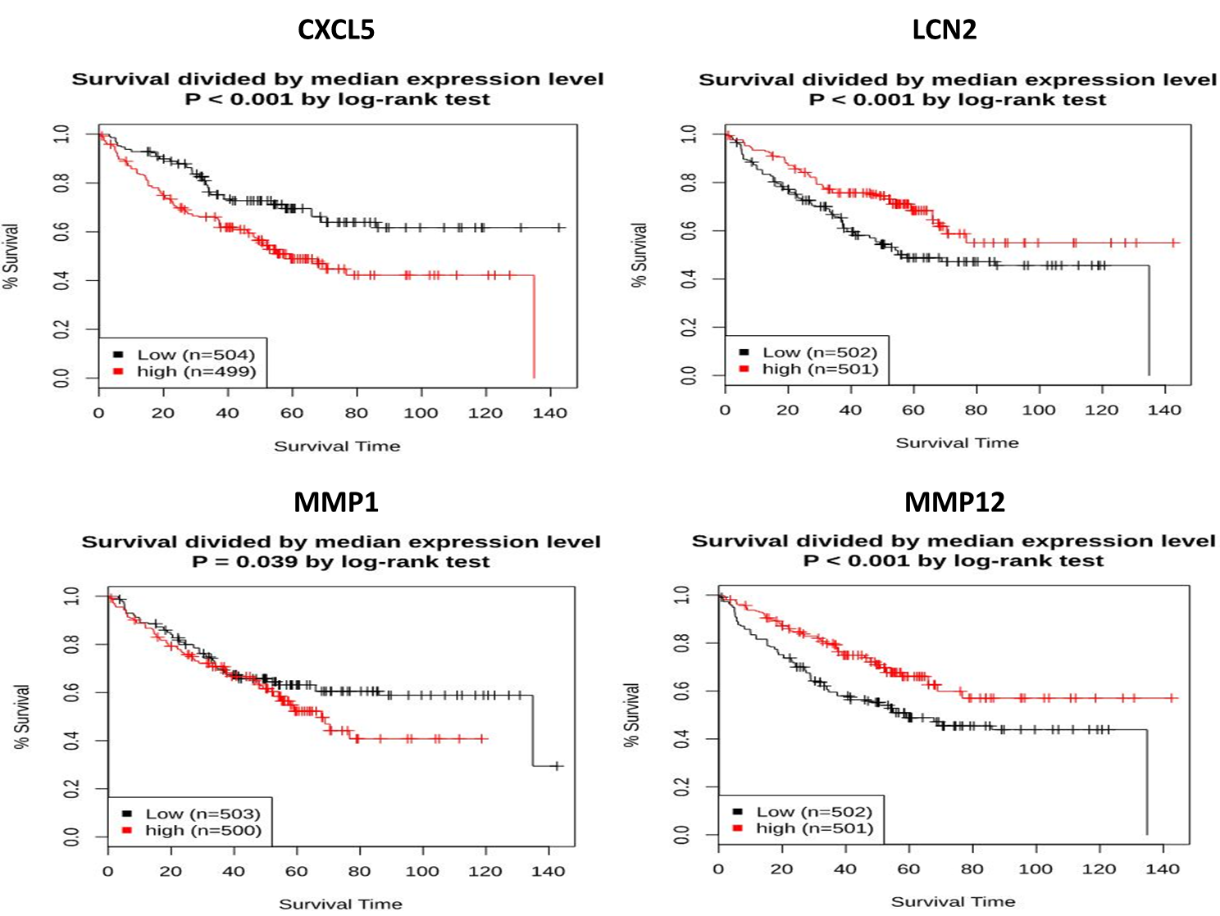
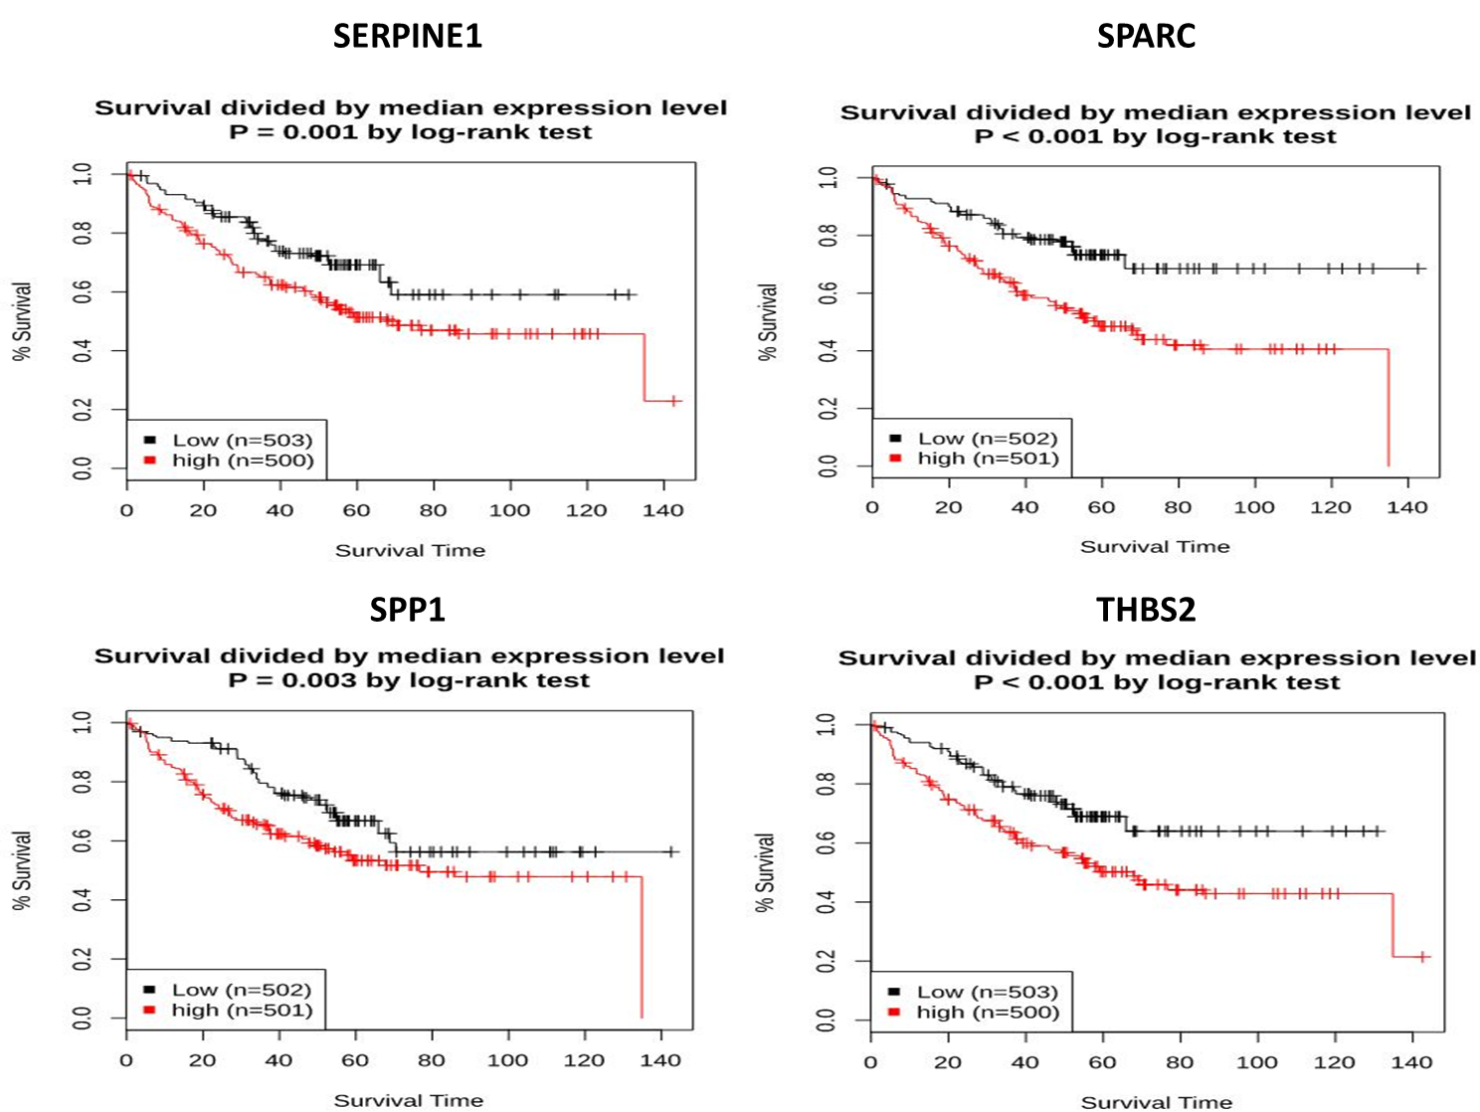
Supplementary Figure-2
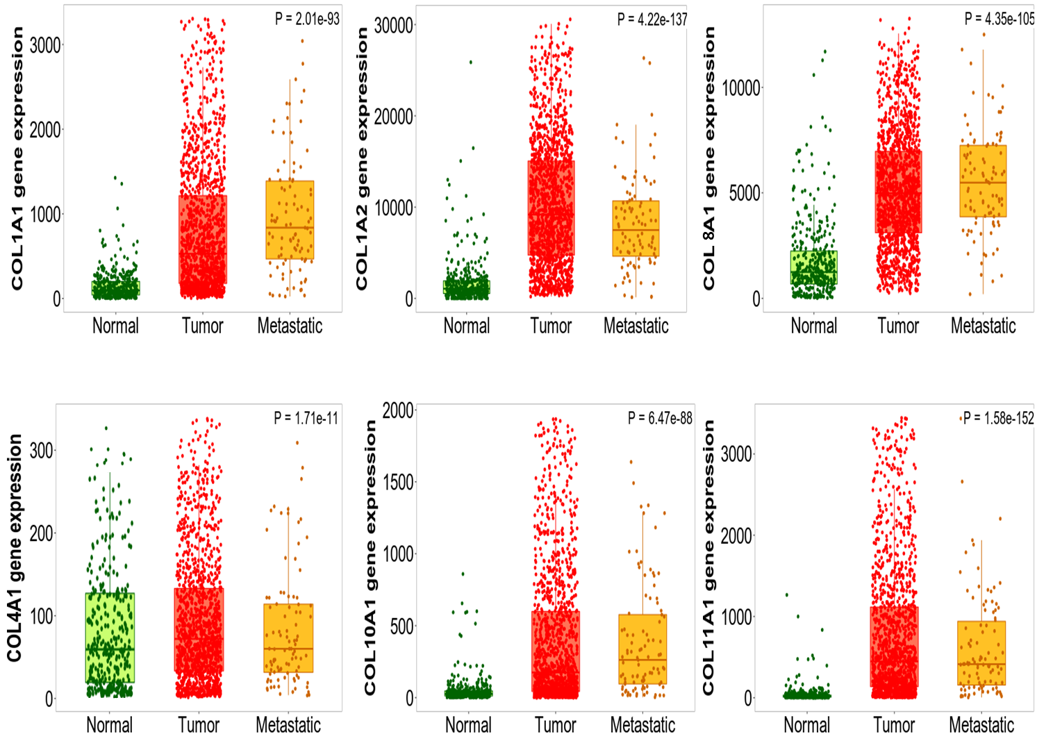
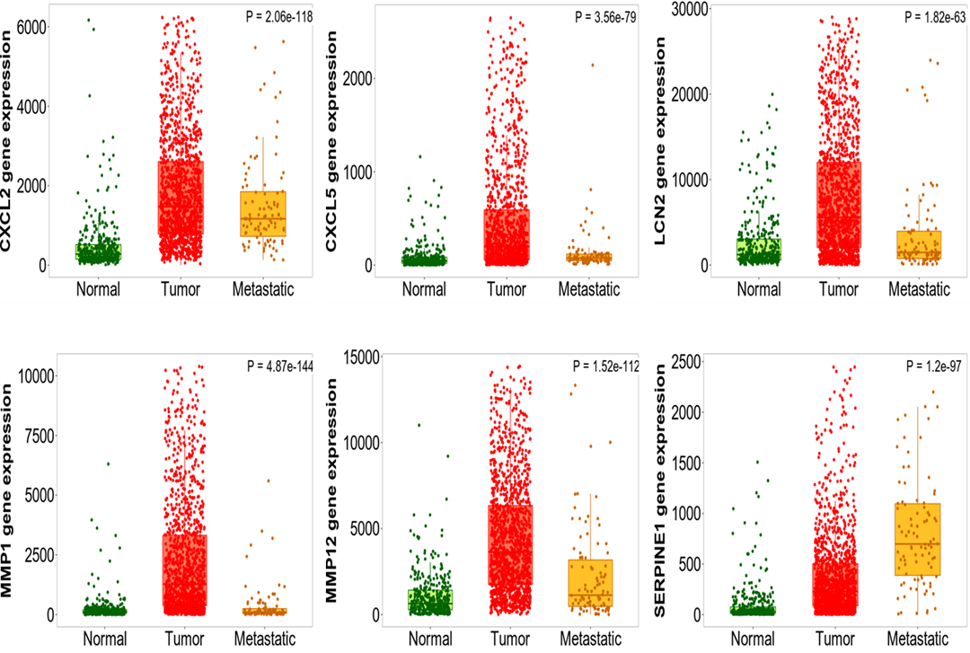

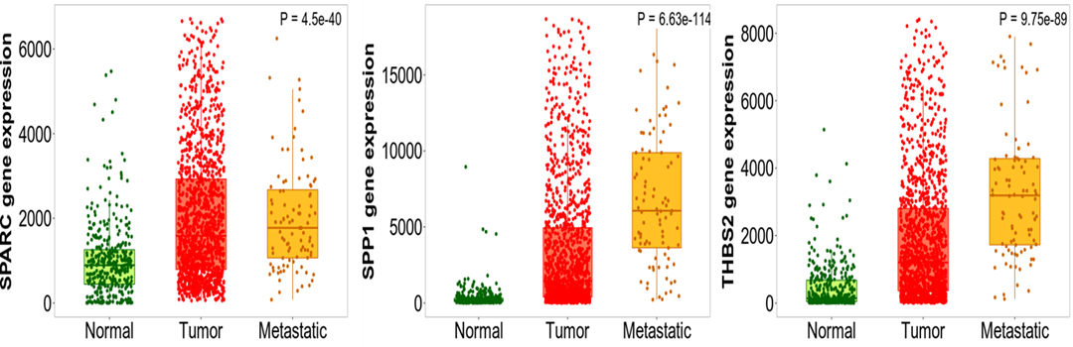

Supplementary Figure-3
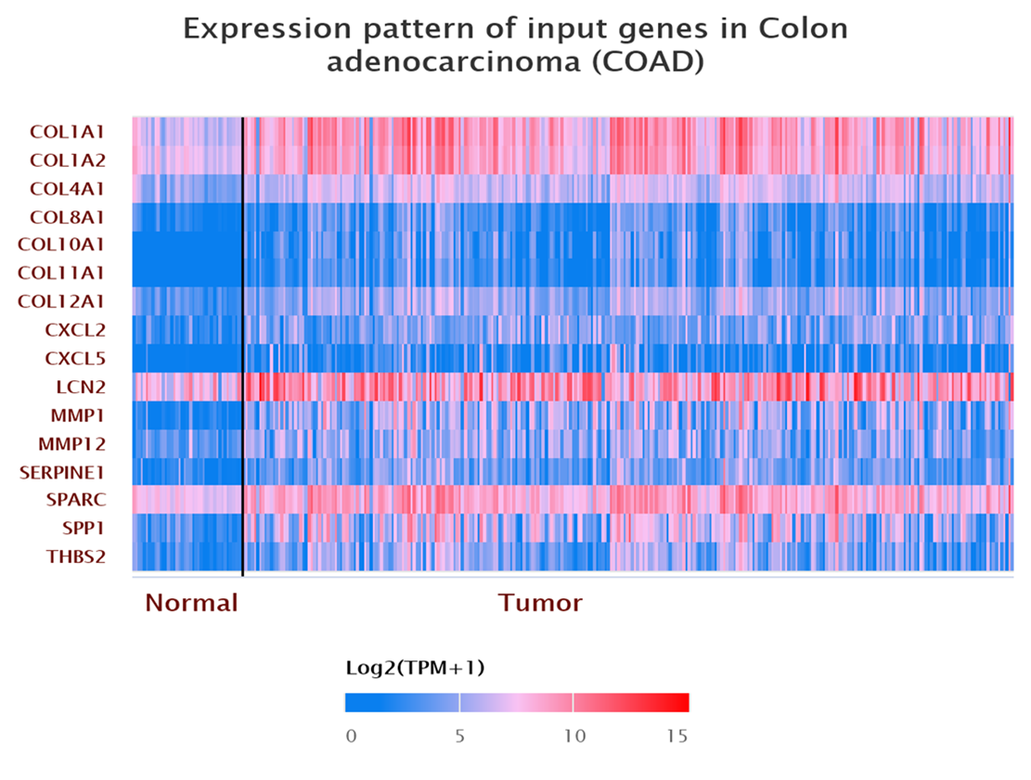
(Figure-3A)

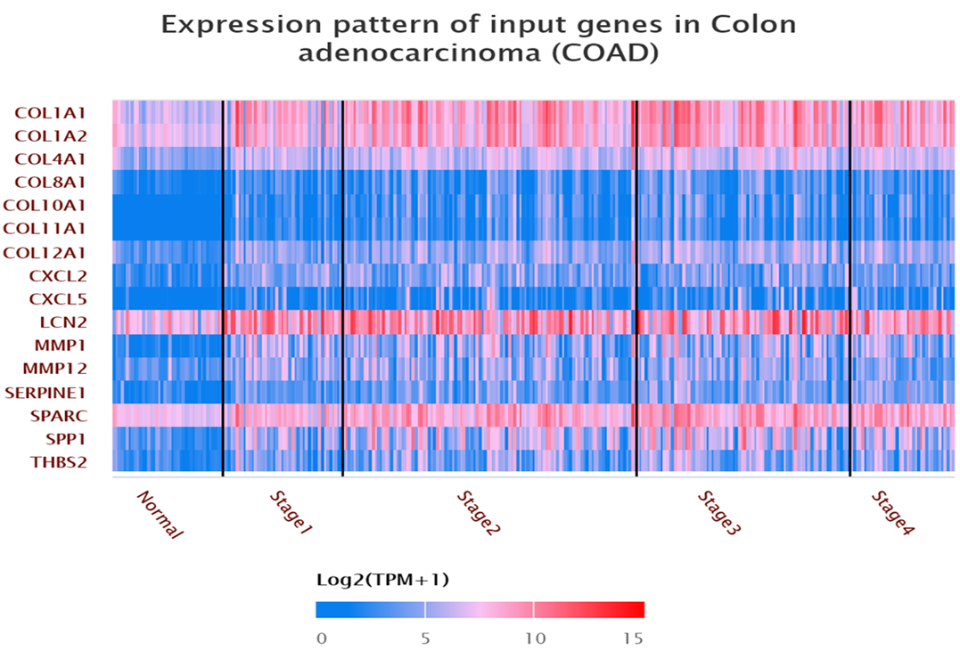
(Figure-3B)
Supplementary Figure-4

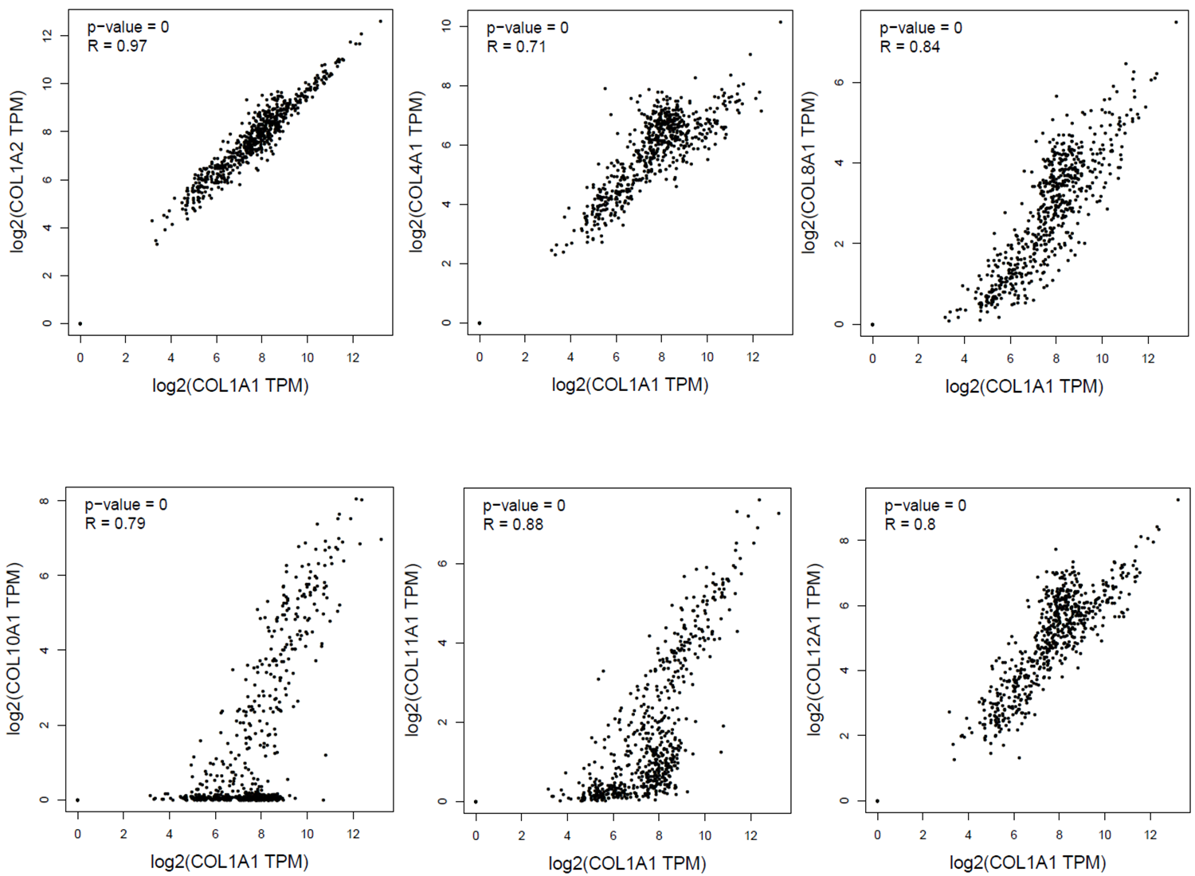
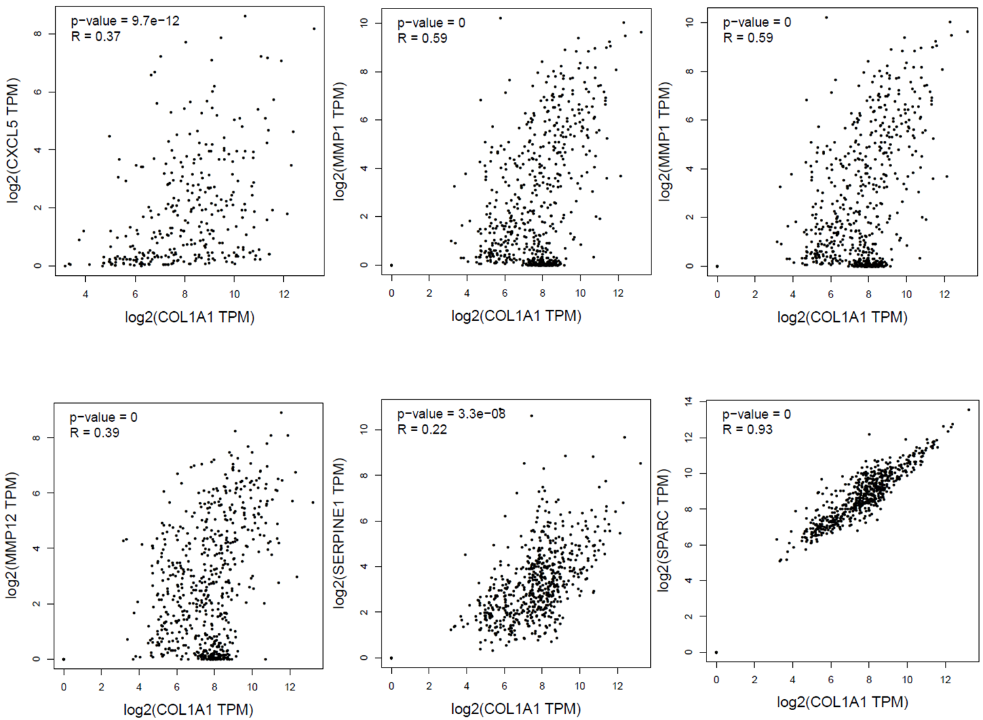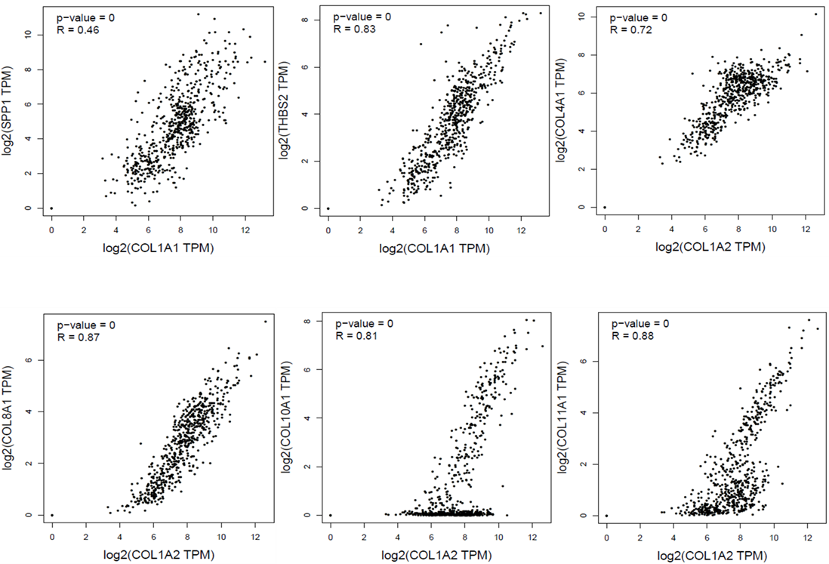
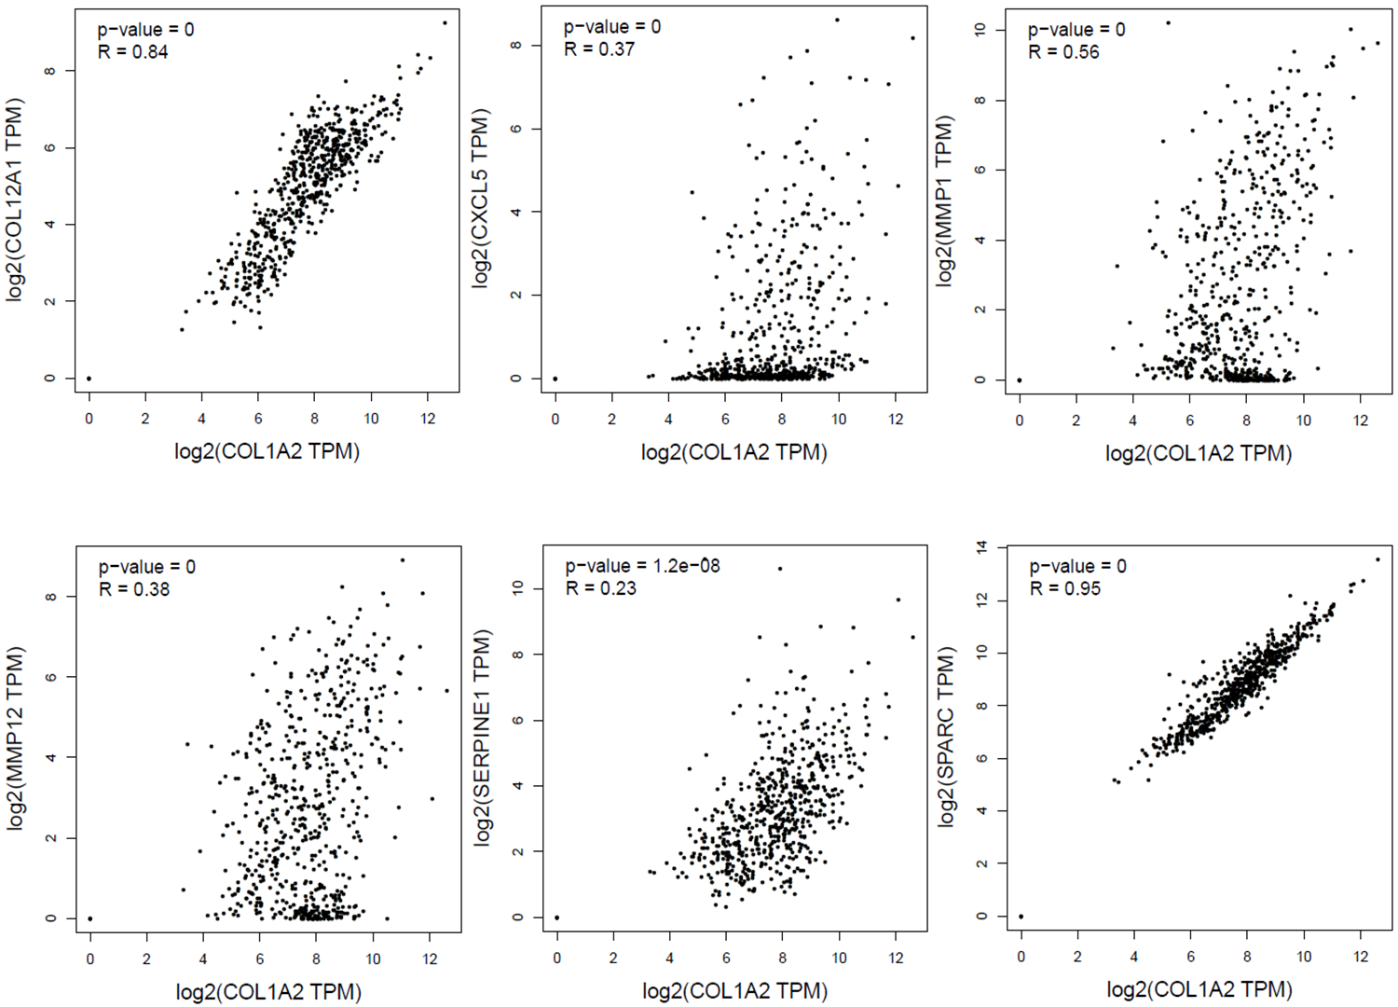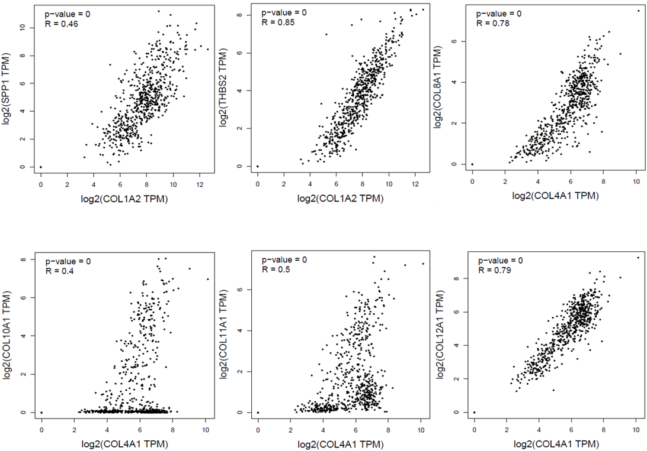
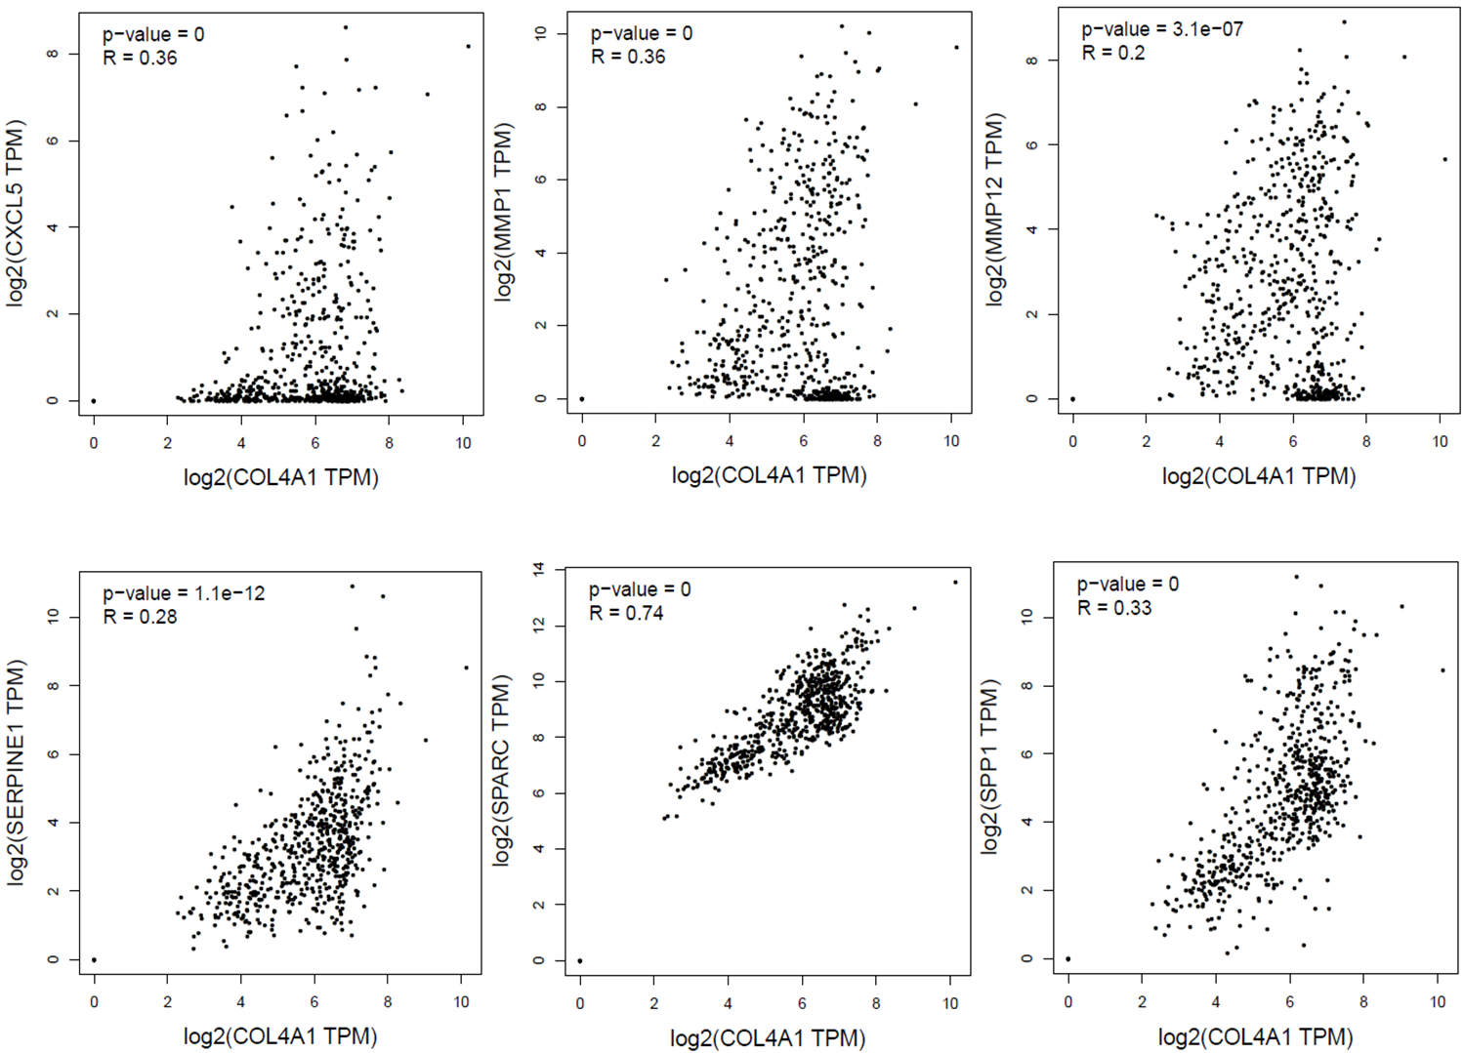
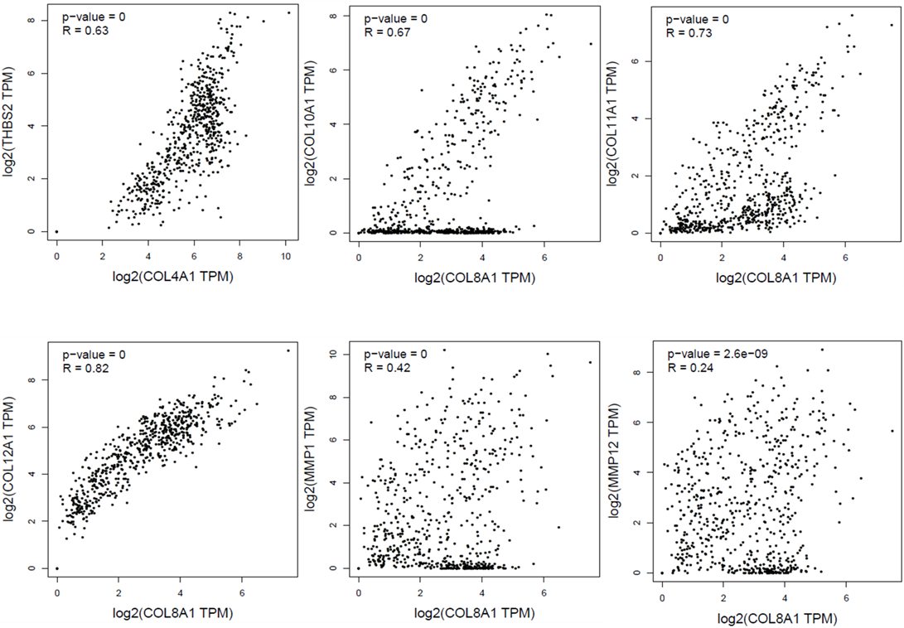
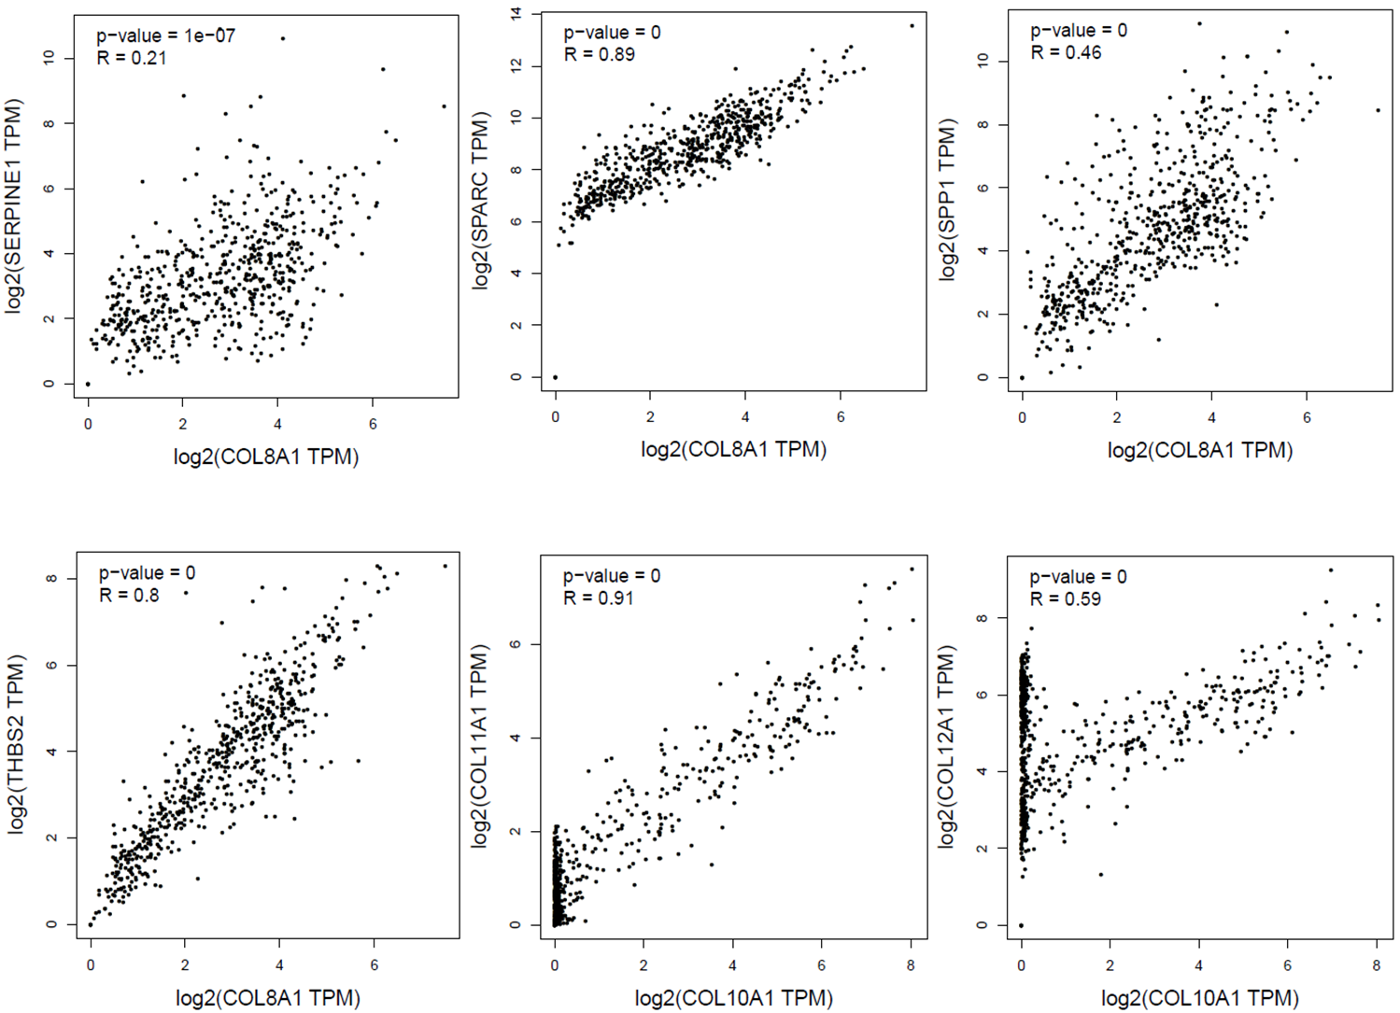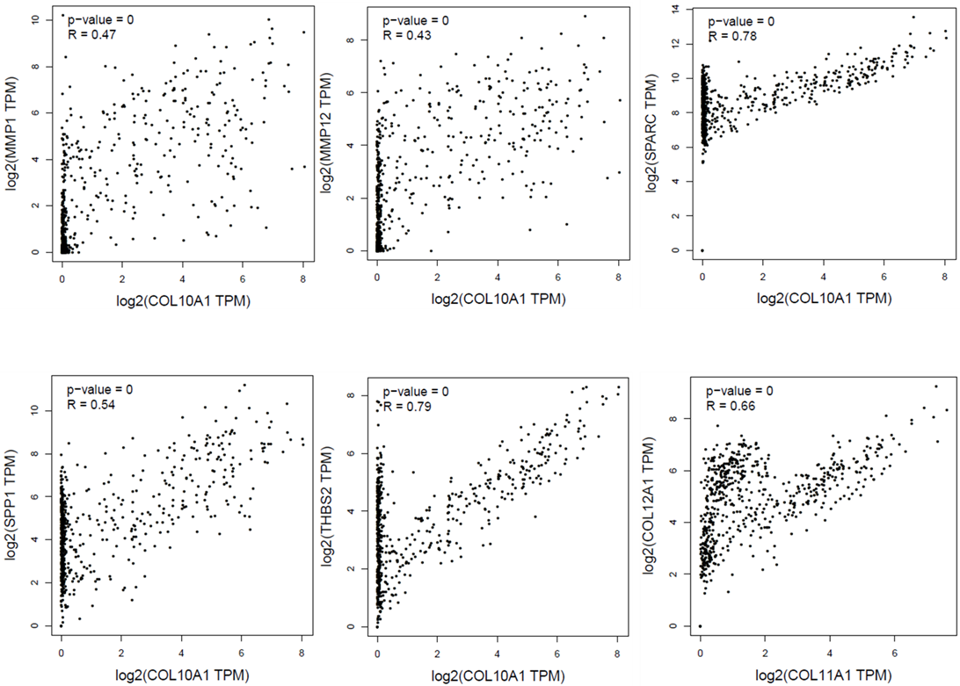
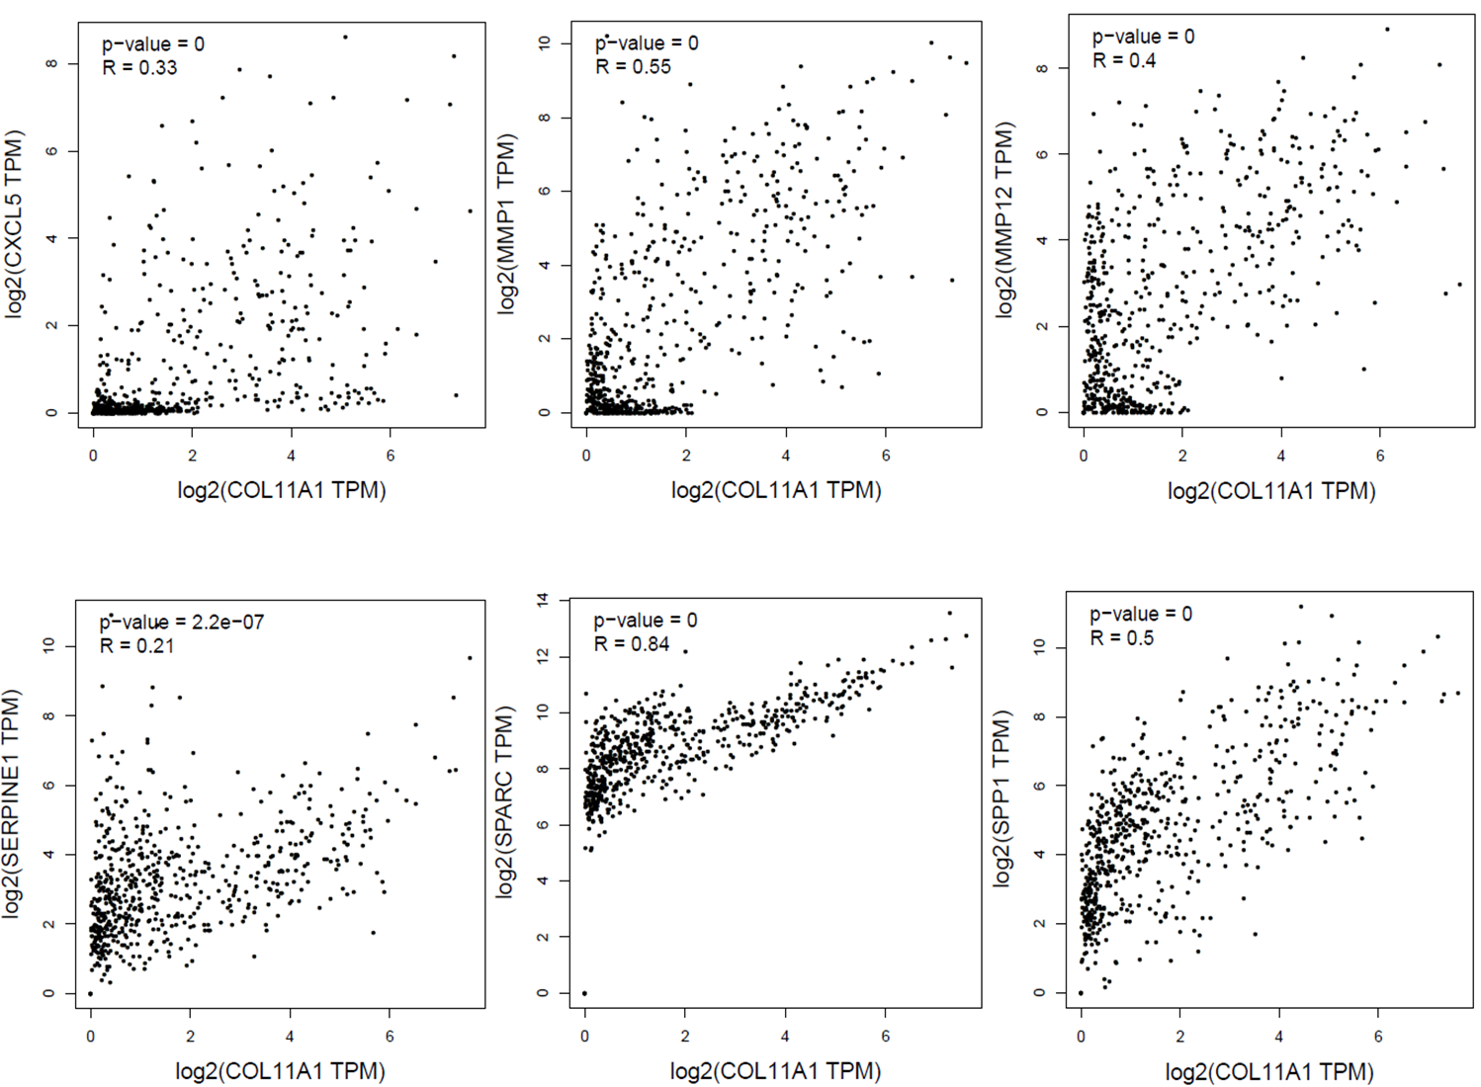
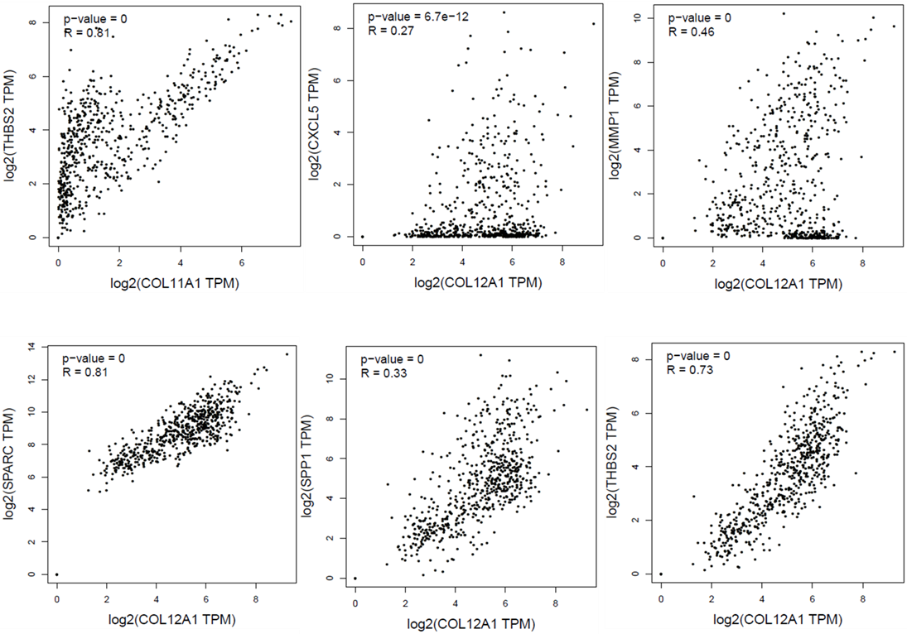
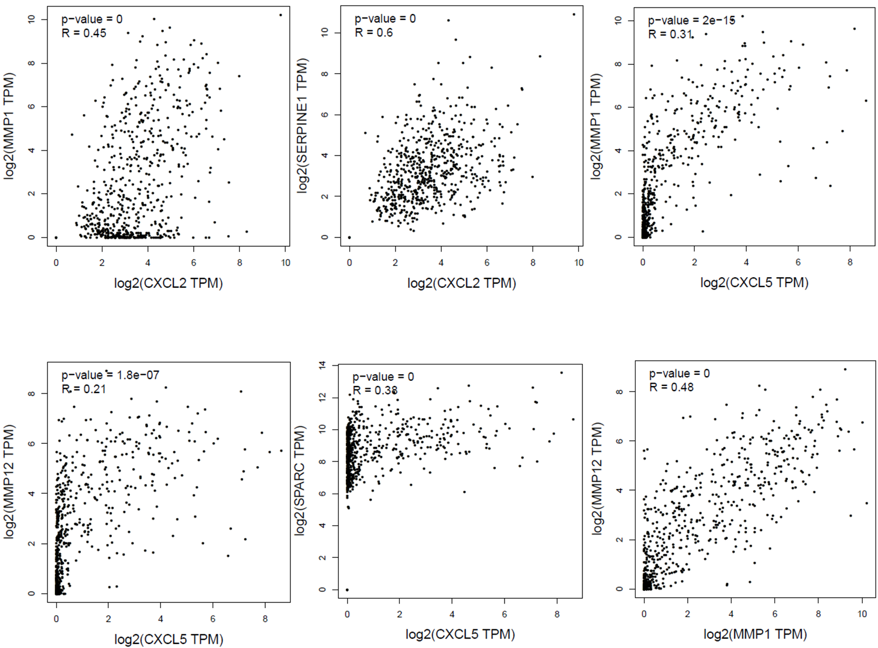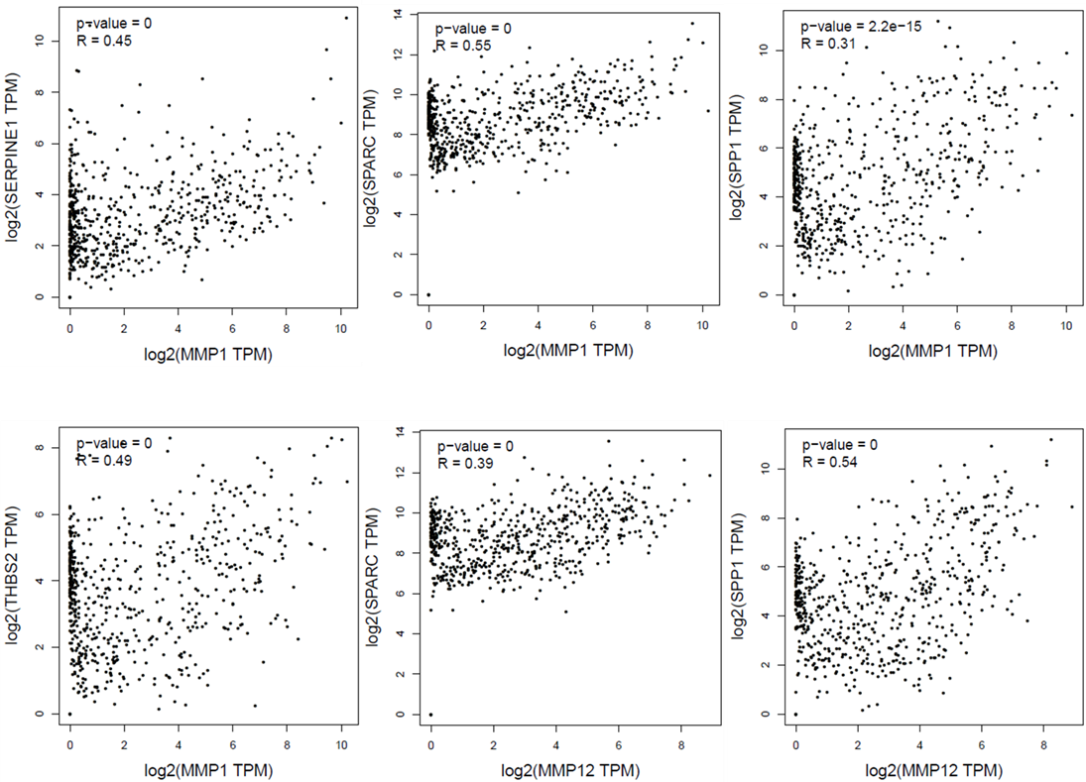
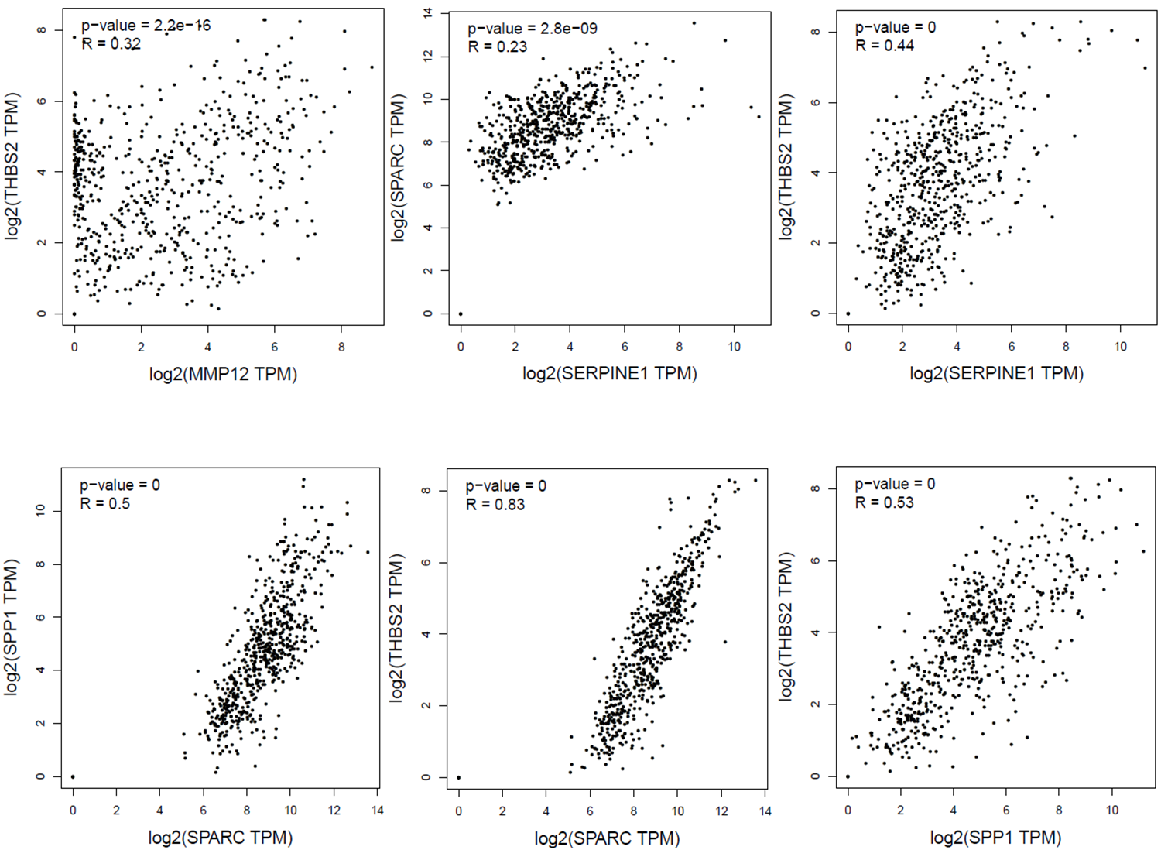
Supplementary Figure-5
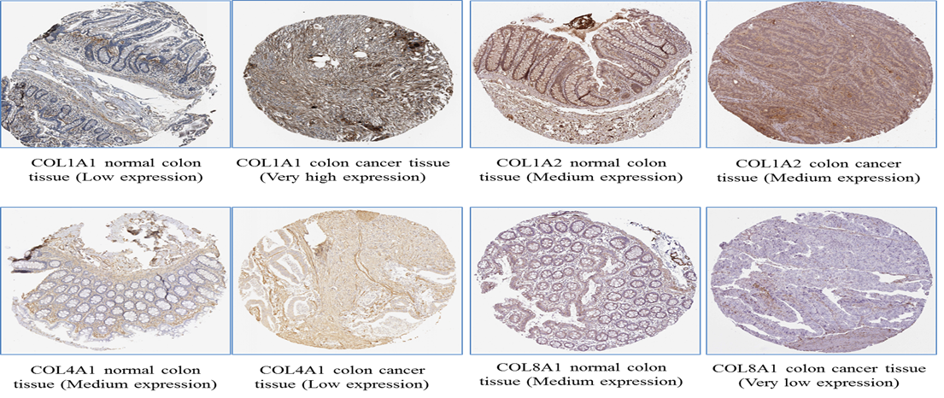
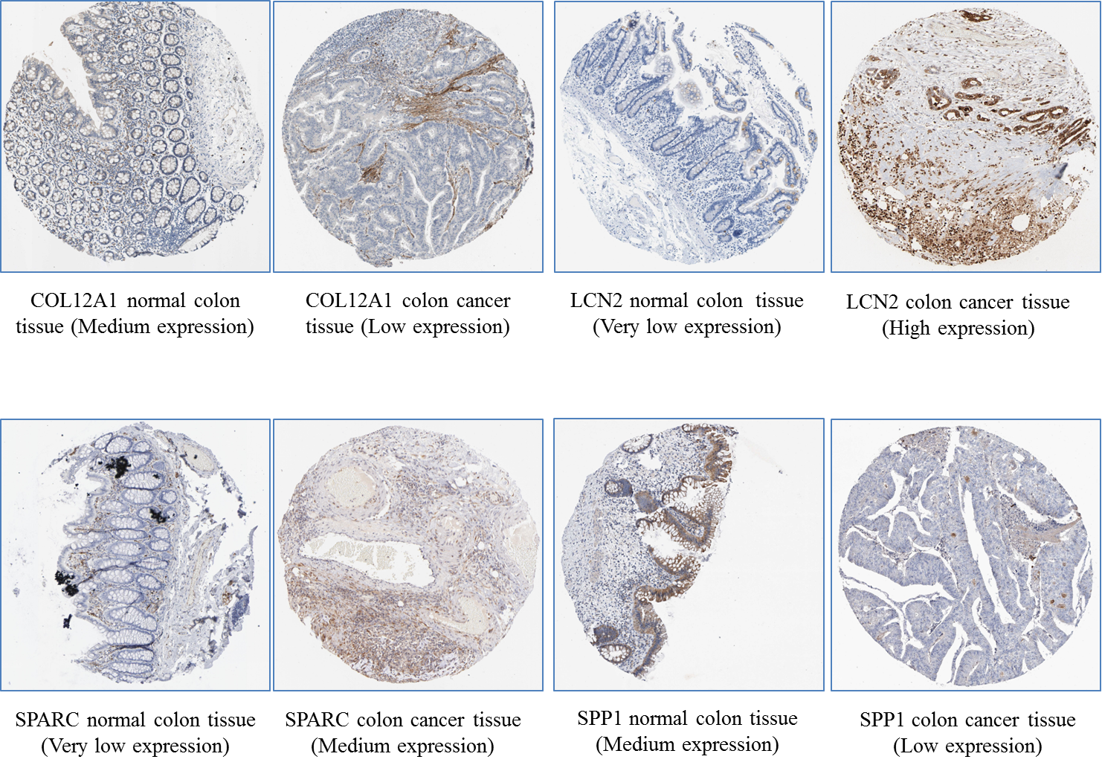

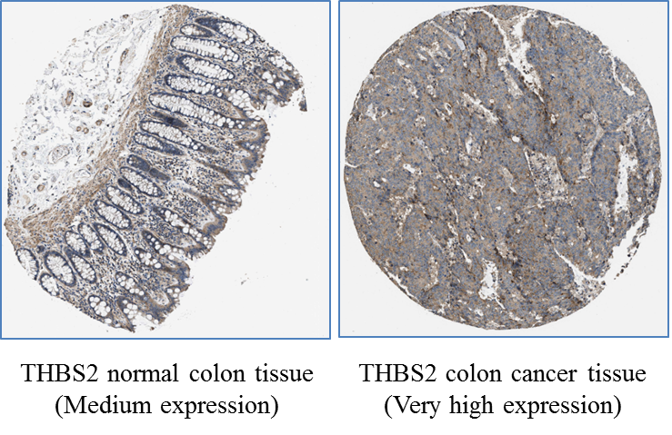

Supplementary Figure-6
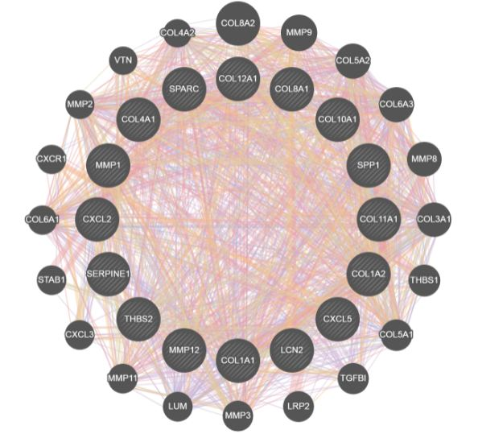
Figure-6A
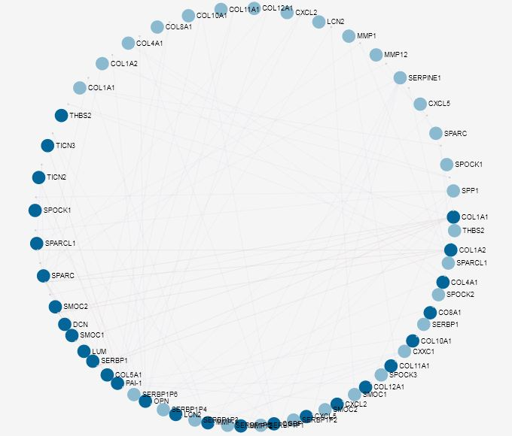
Figure-6B
Supplementary Figure-7
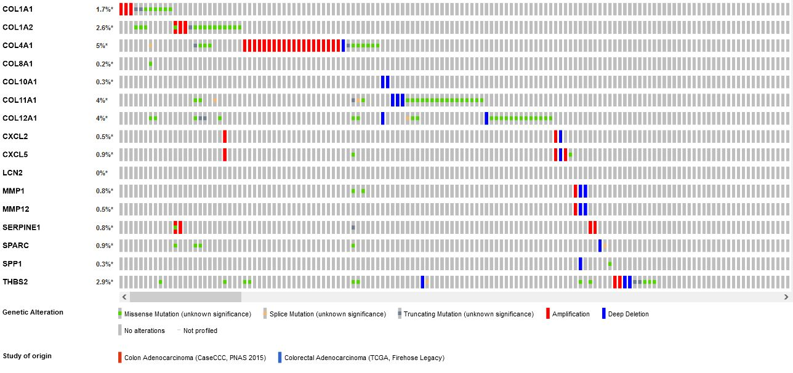

Supplementary Figure-8
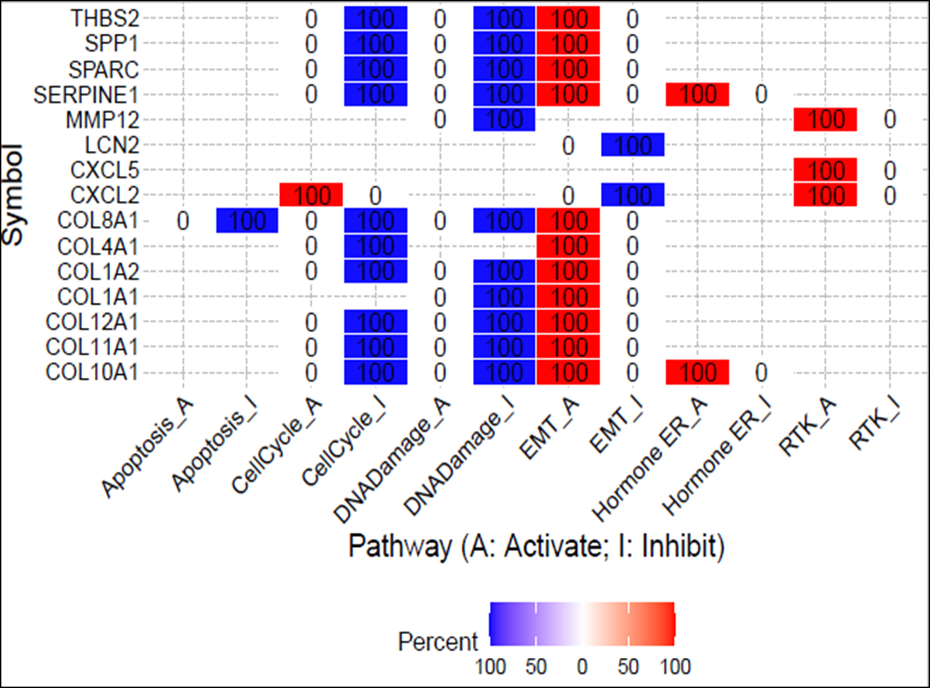
Supplementary Figure-9
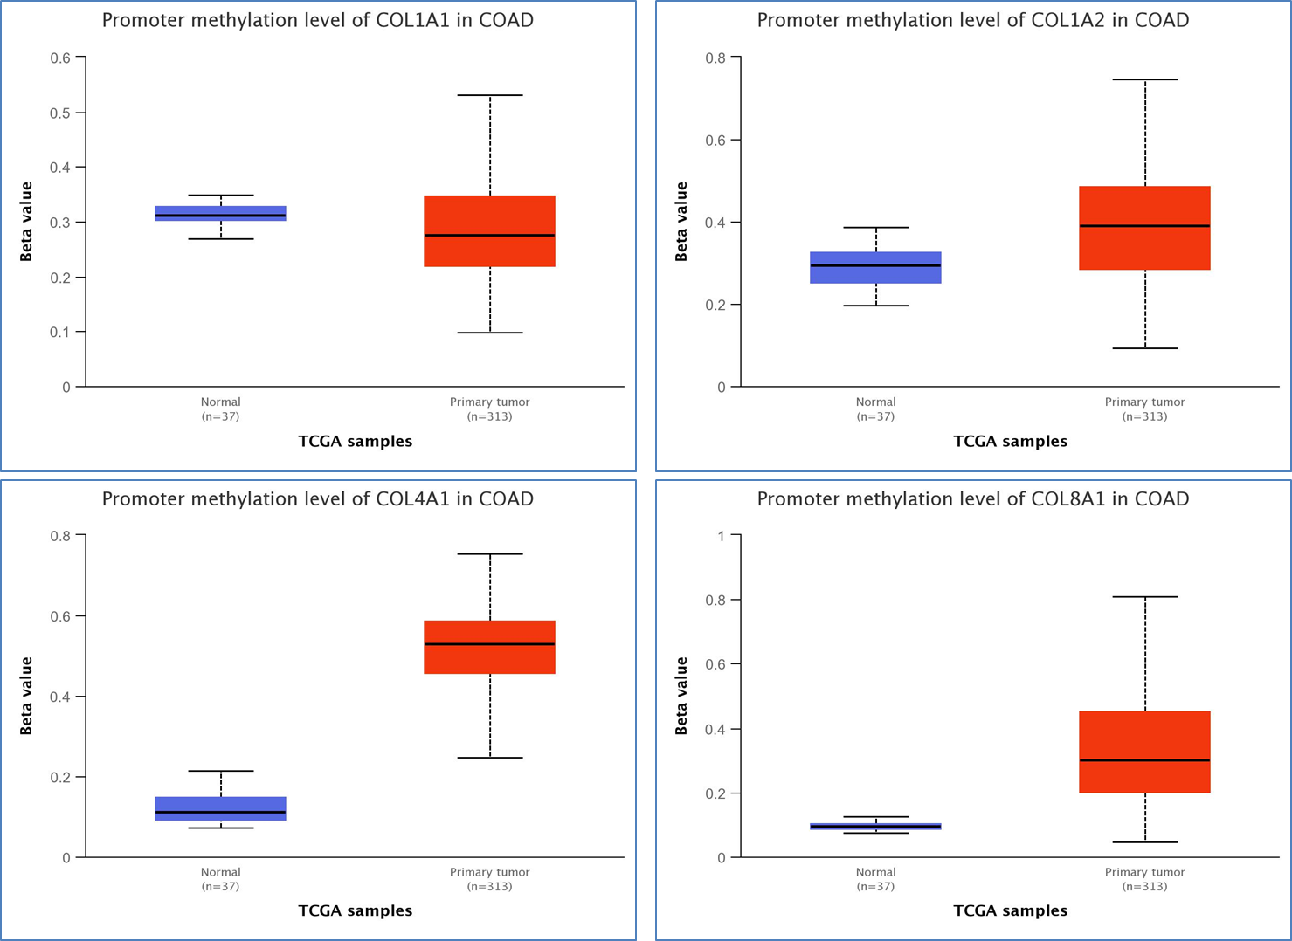
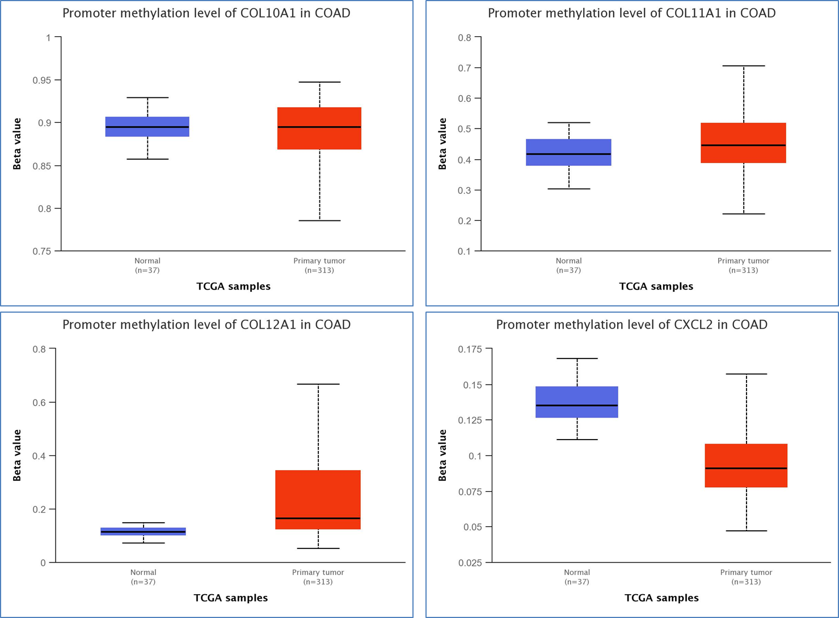

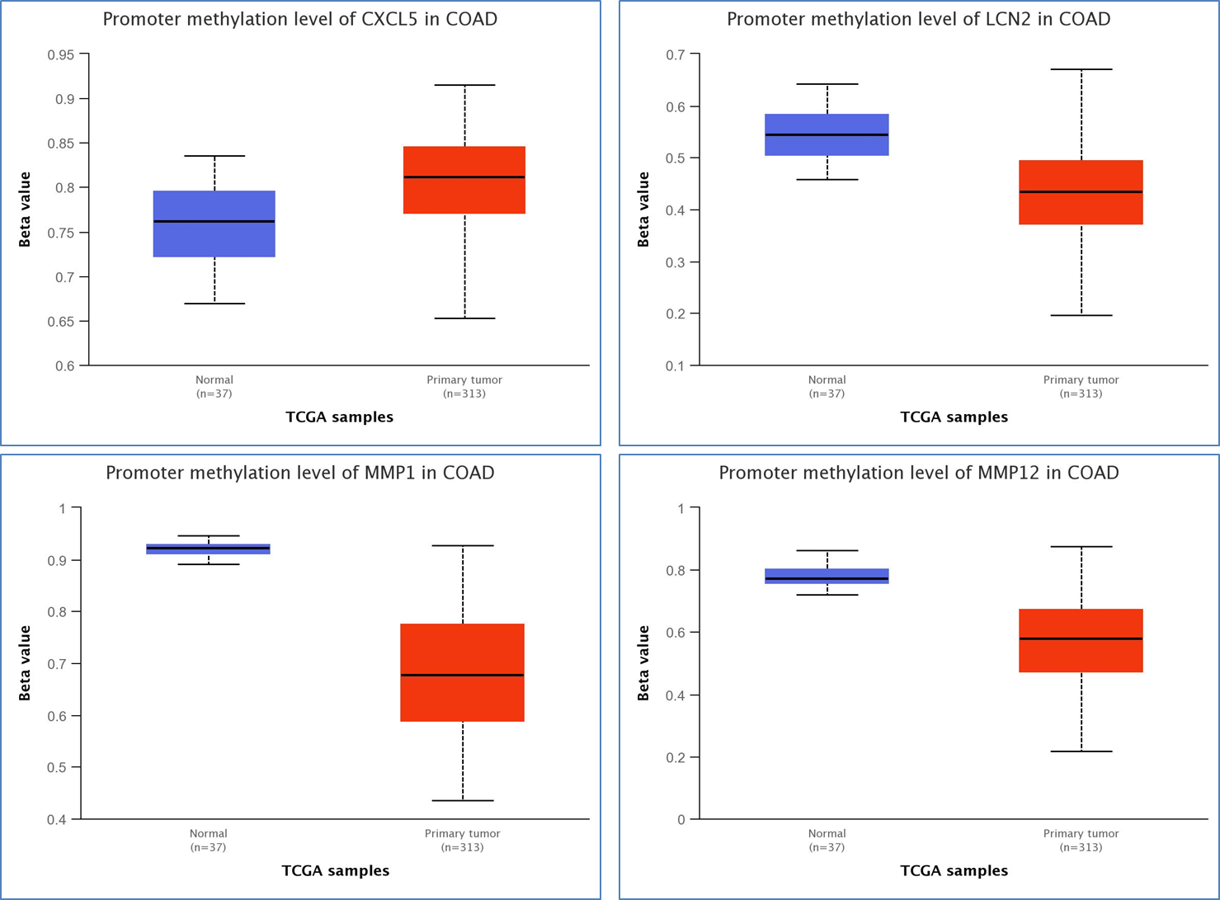
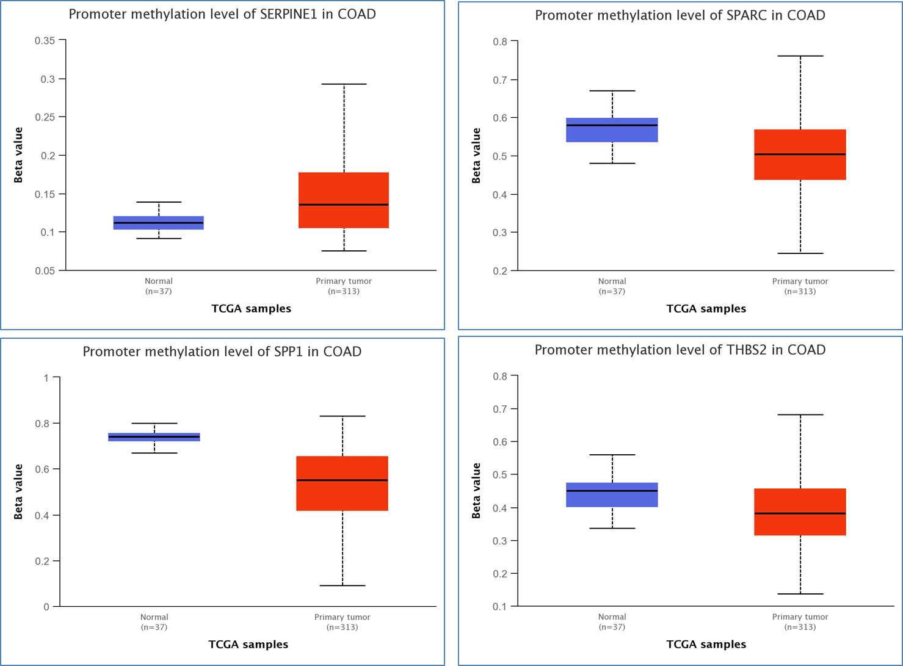
Supplementary Figure-10
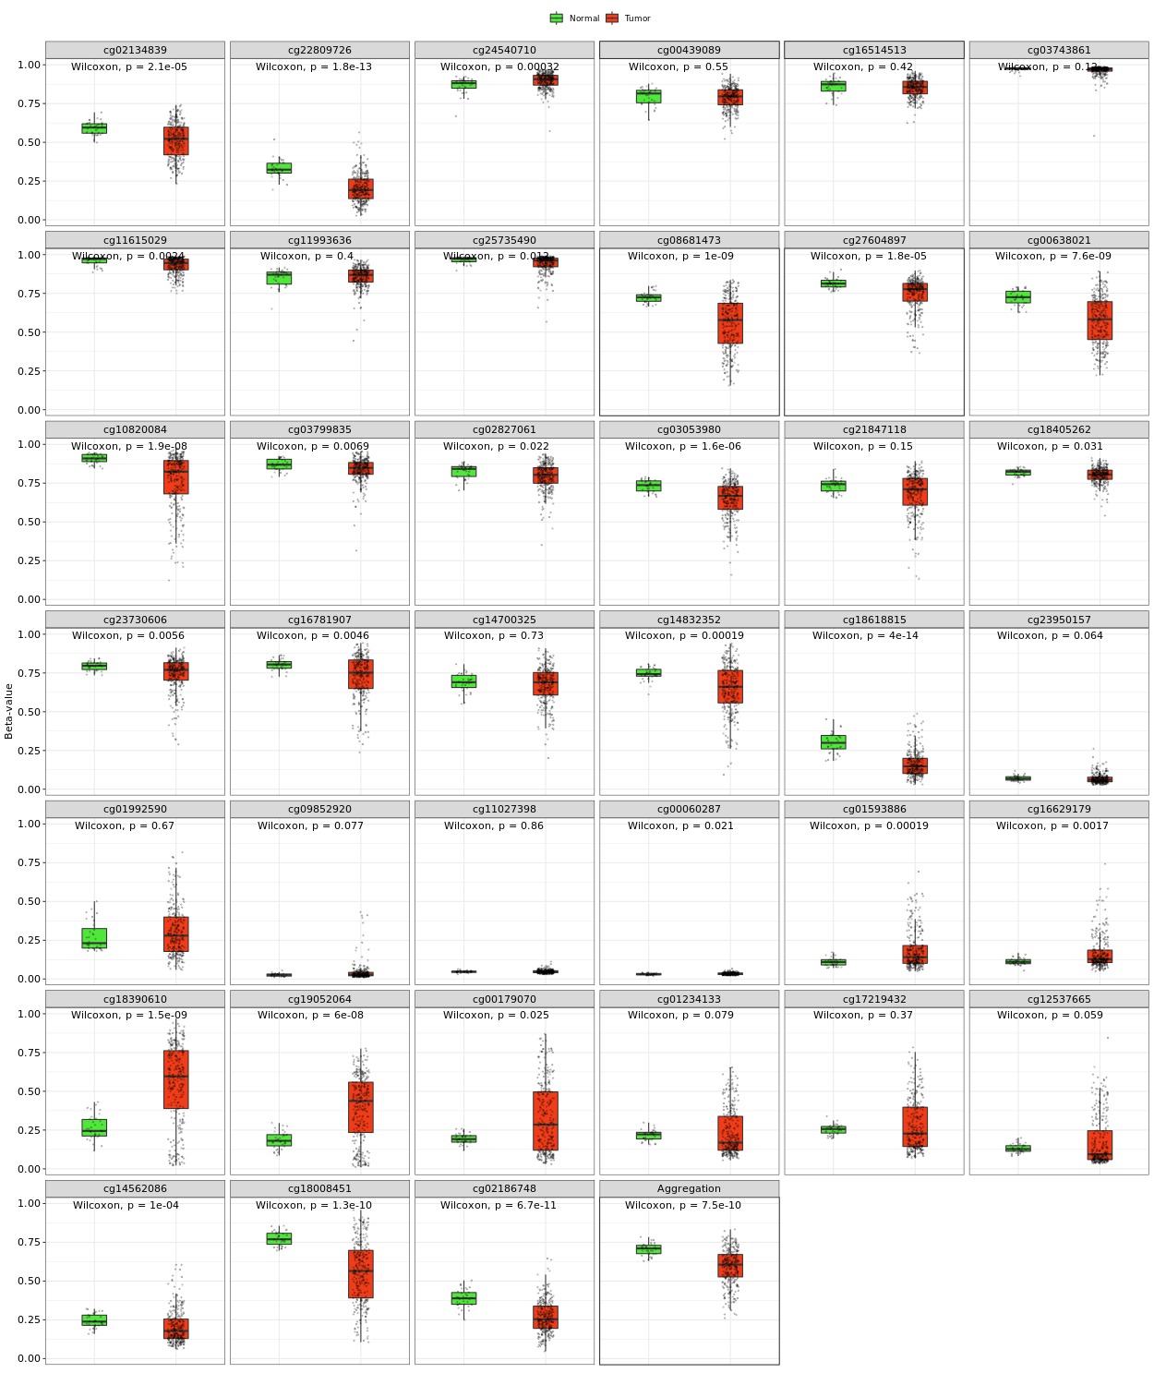
COL1A1
Beta value cut-off indicates hyper-methylation [beta value range: 0.7-0.5] or hypo-methylation [beta-value range: 0.3-0.25]
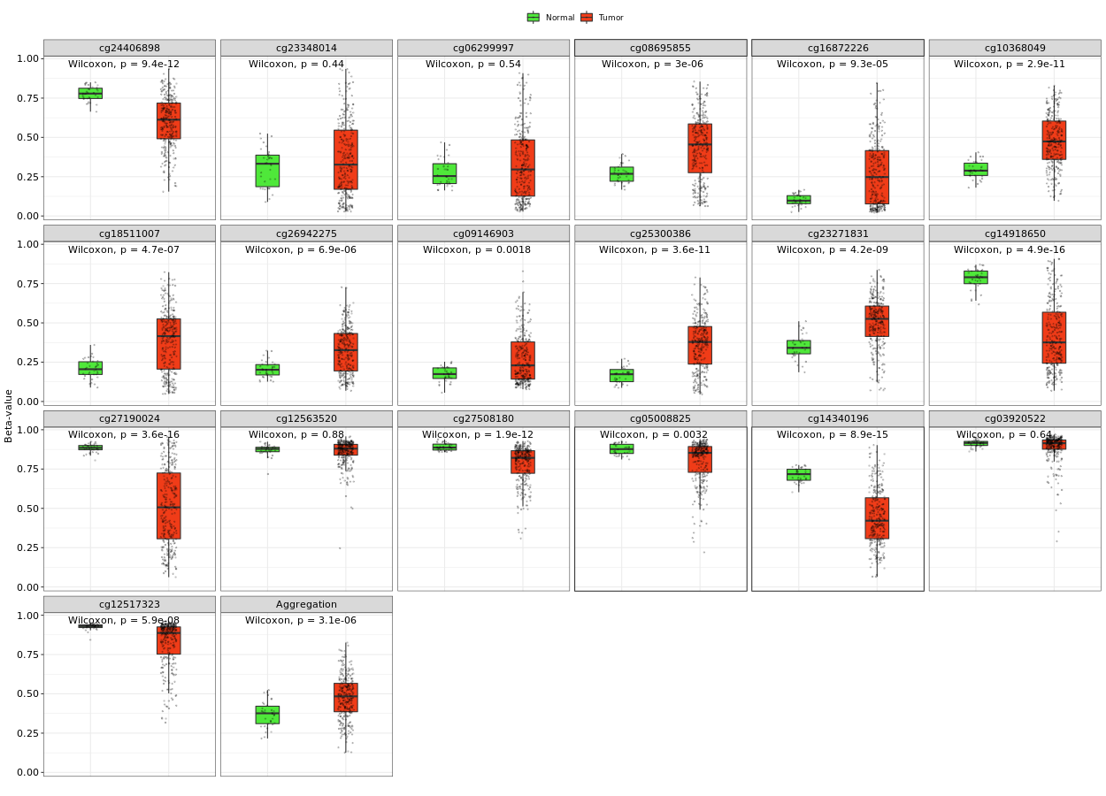
COL1A2
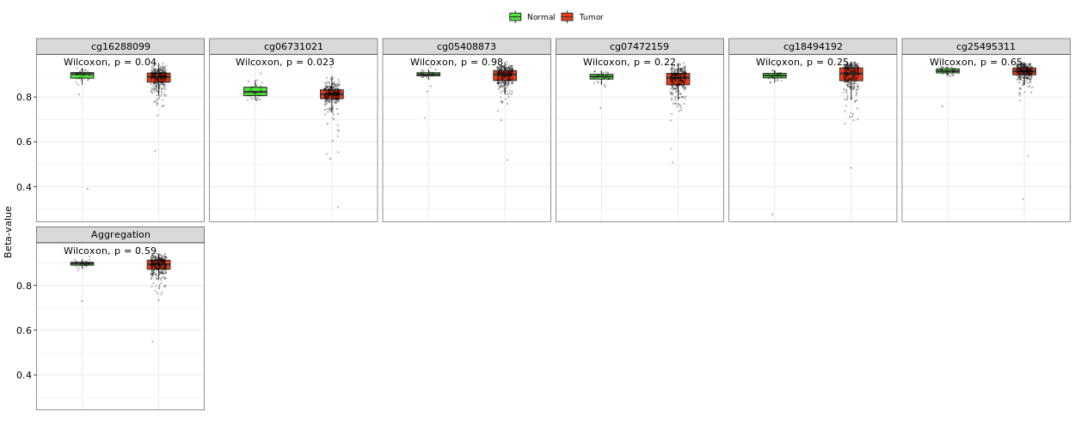
COL10A1
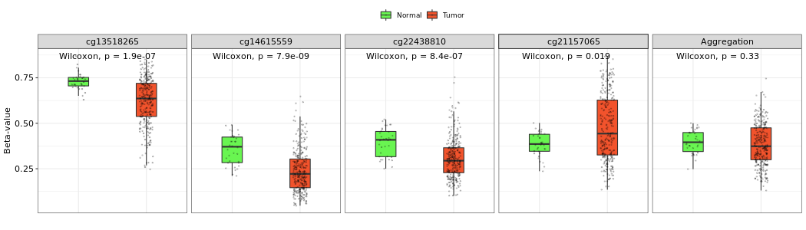
LCN2
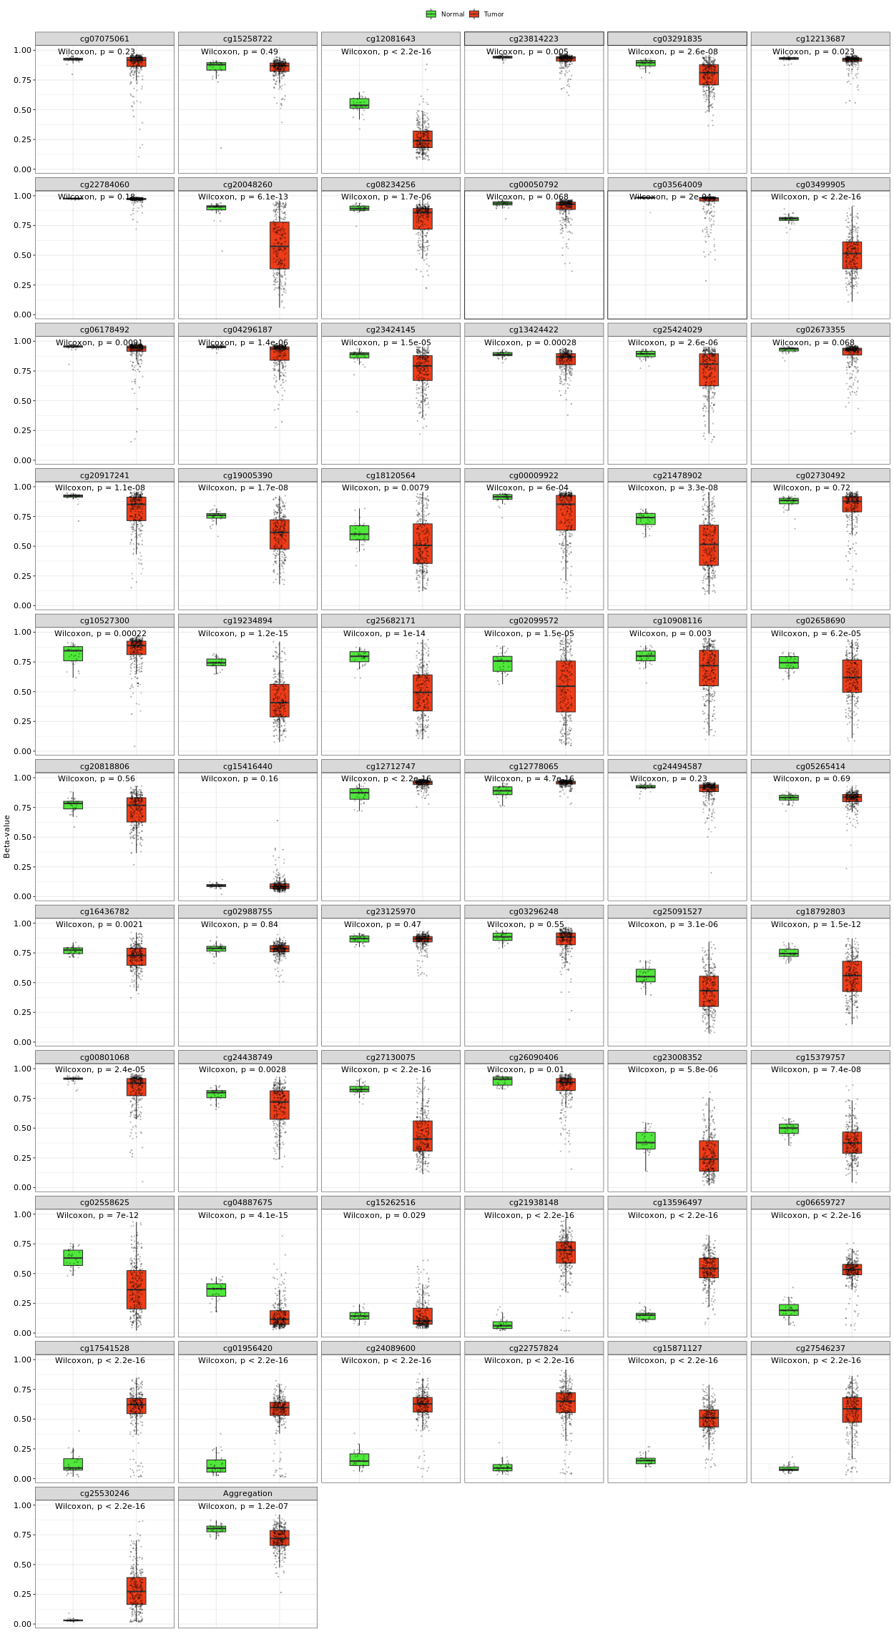
COL4A1
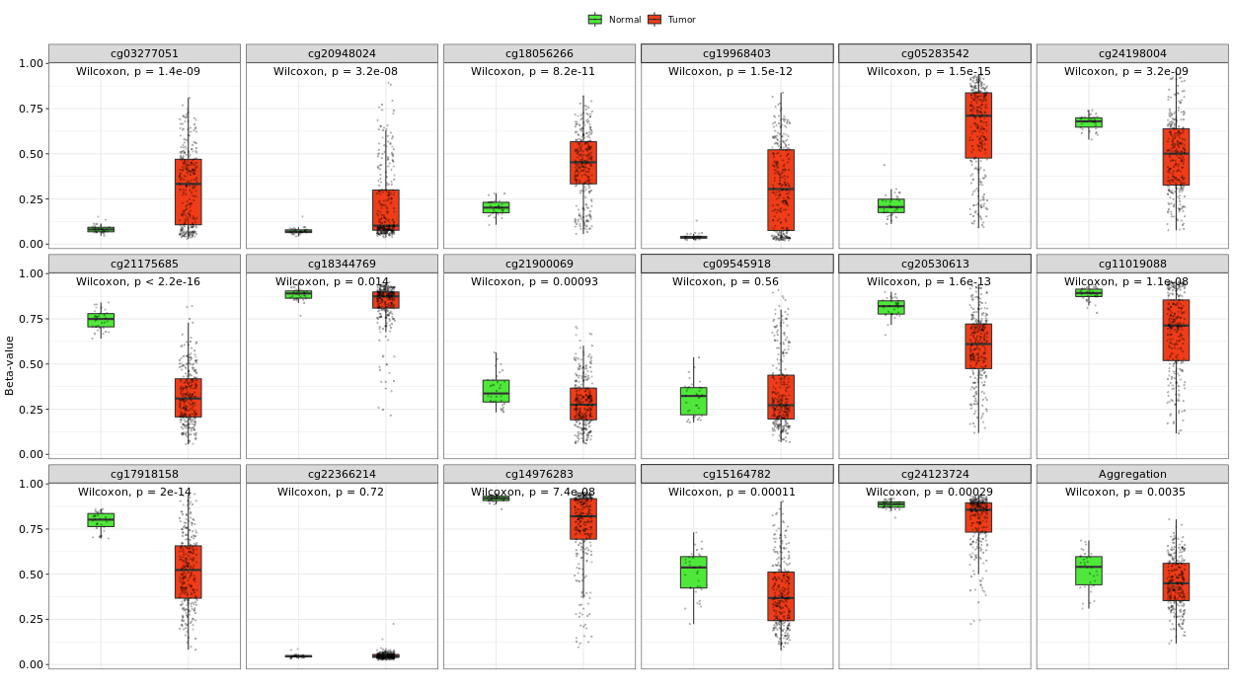
COL8A1
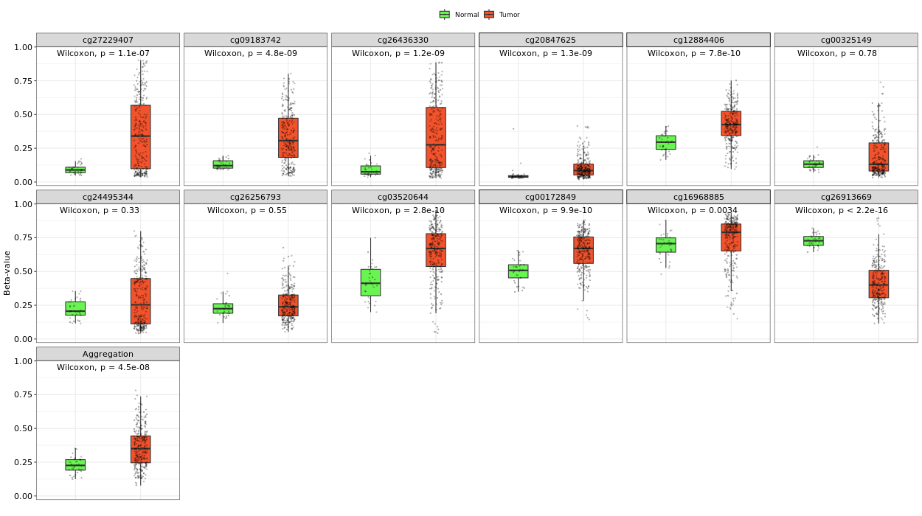
COL11A1
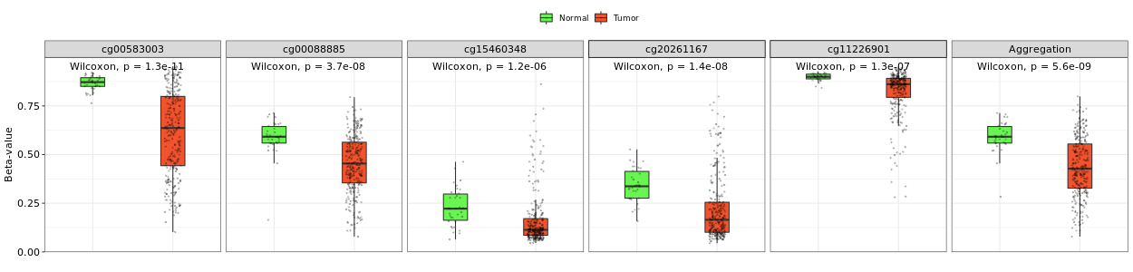
SPP1

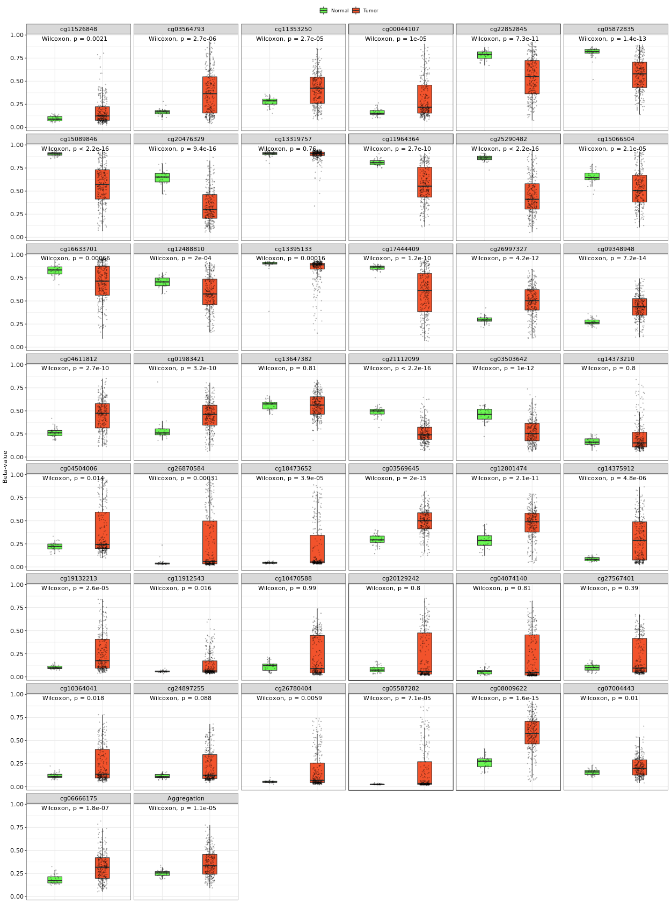
COL12A1
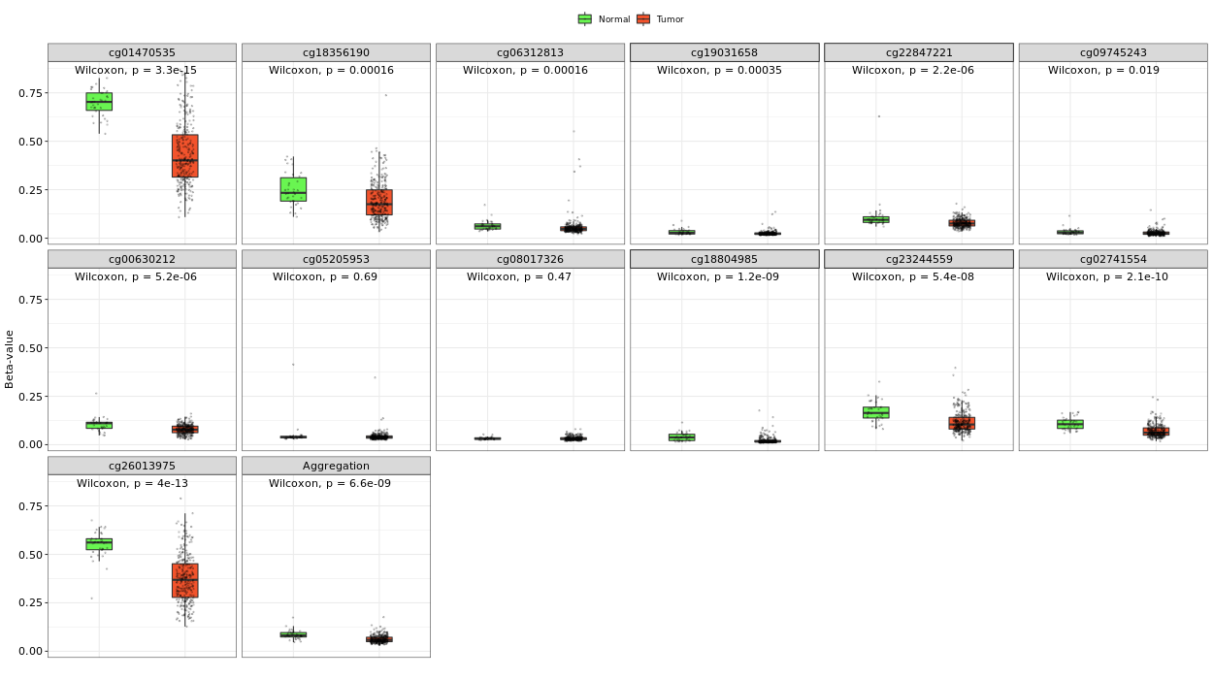
CXCL2
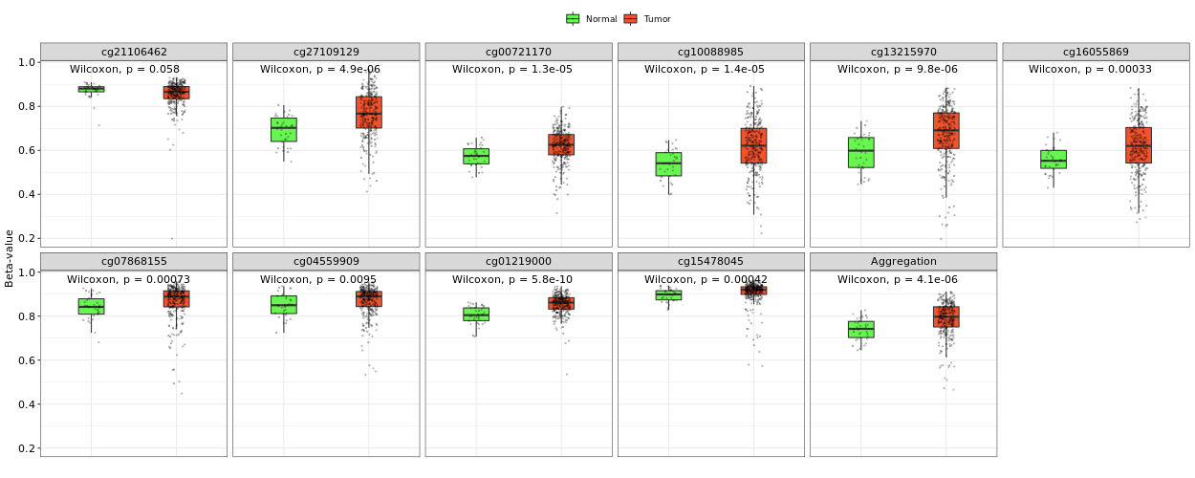
CXCL5

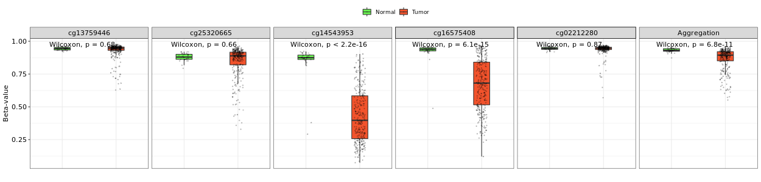
MMP1
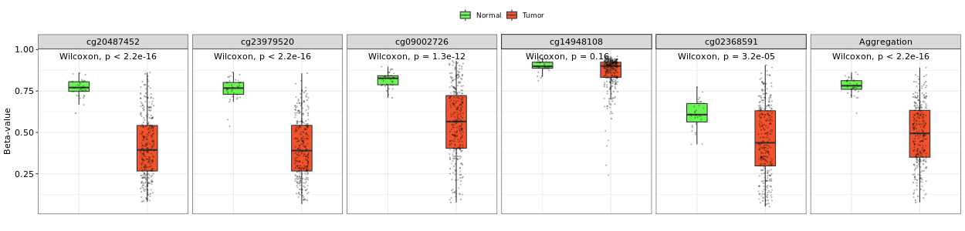
MMP12

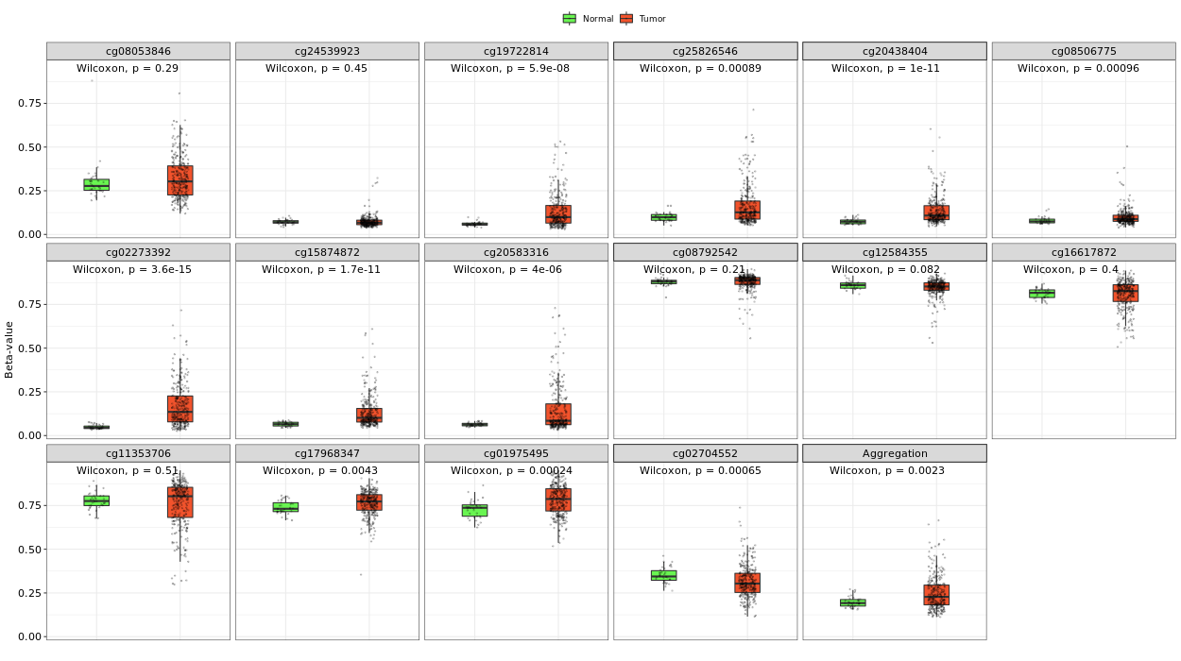
SERPINE1
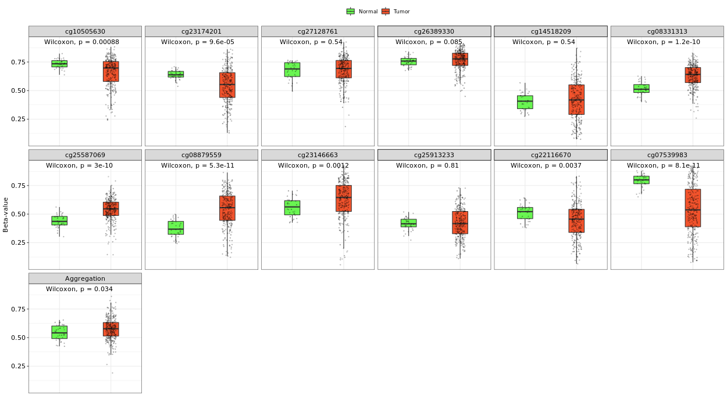
SPARC
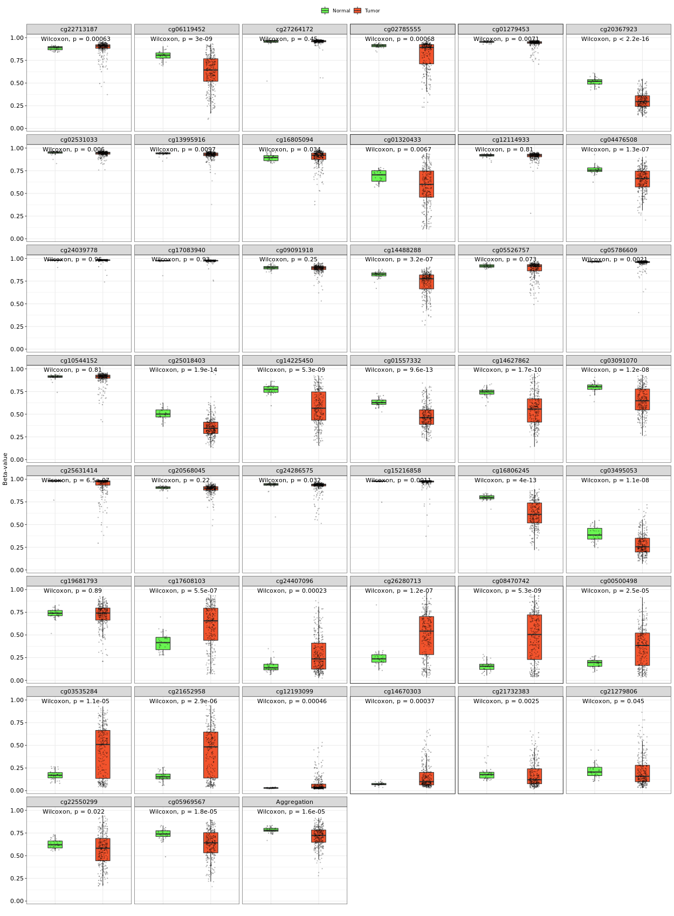
THBS2
Supplementary Figure-11
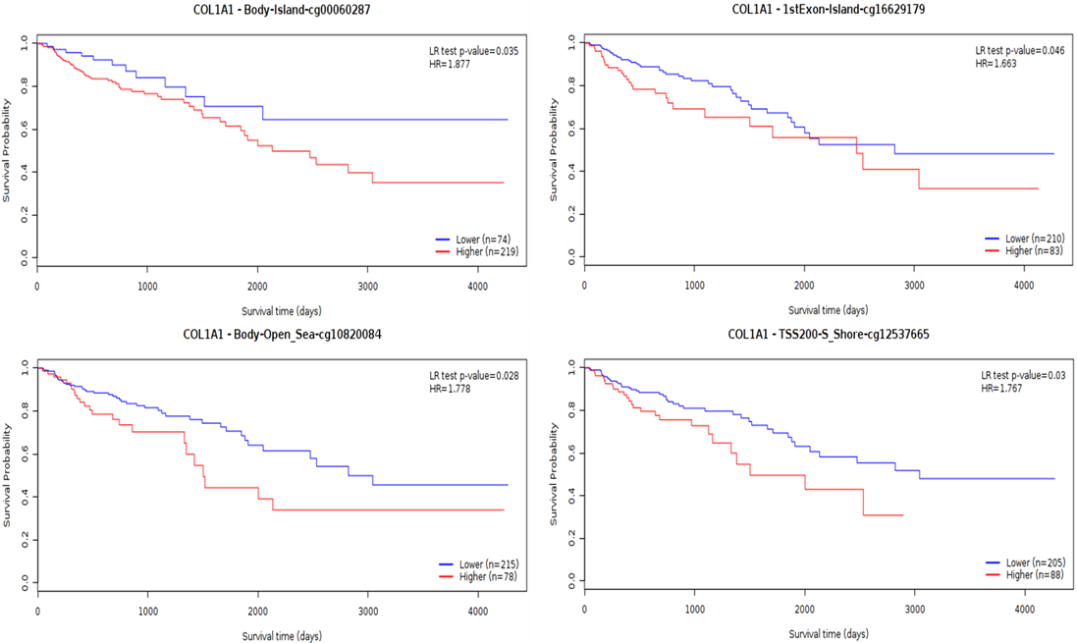
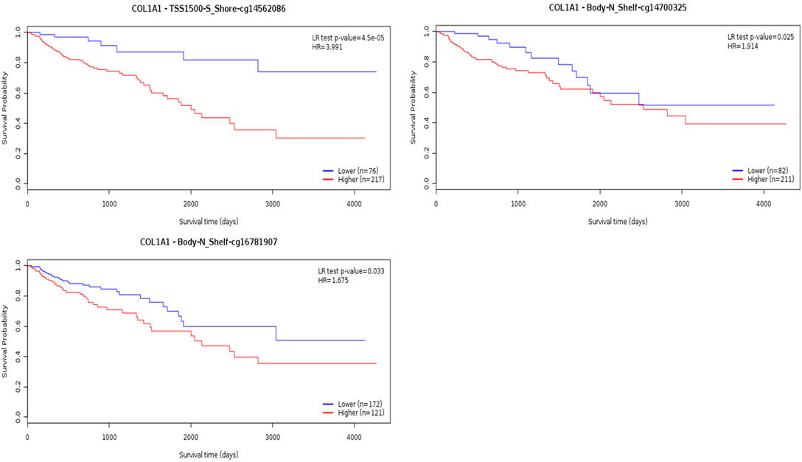
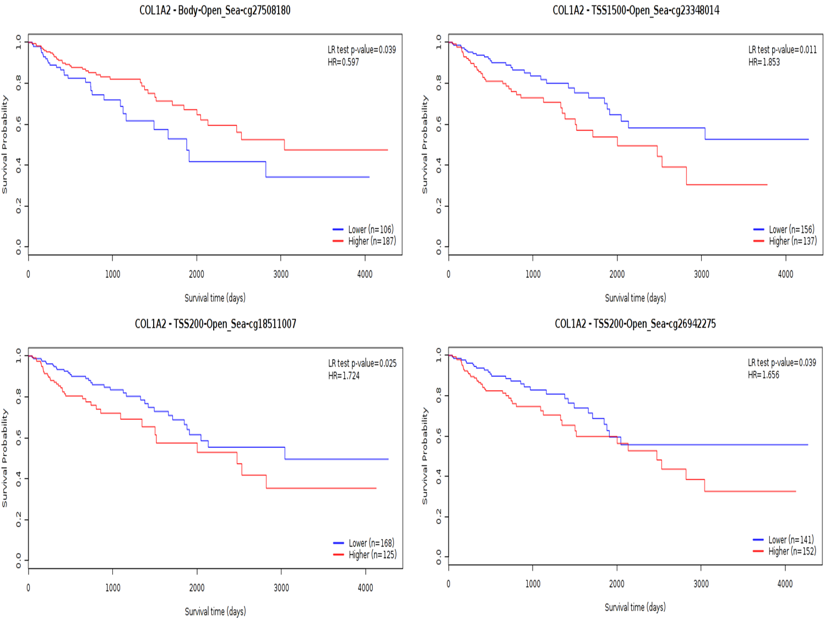
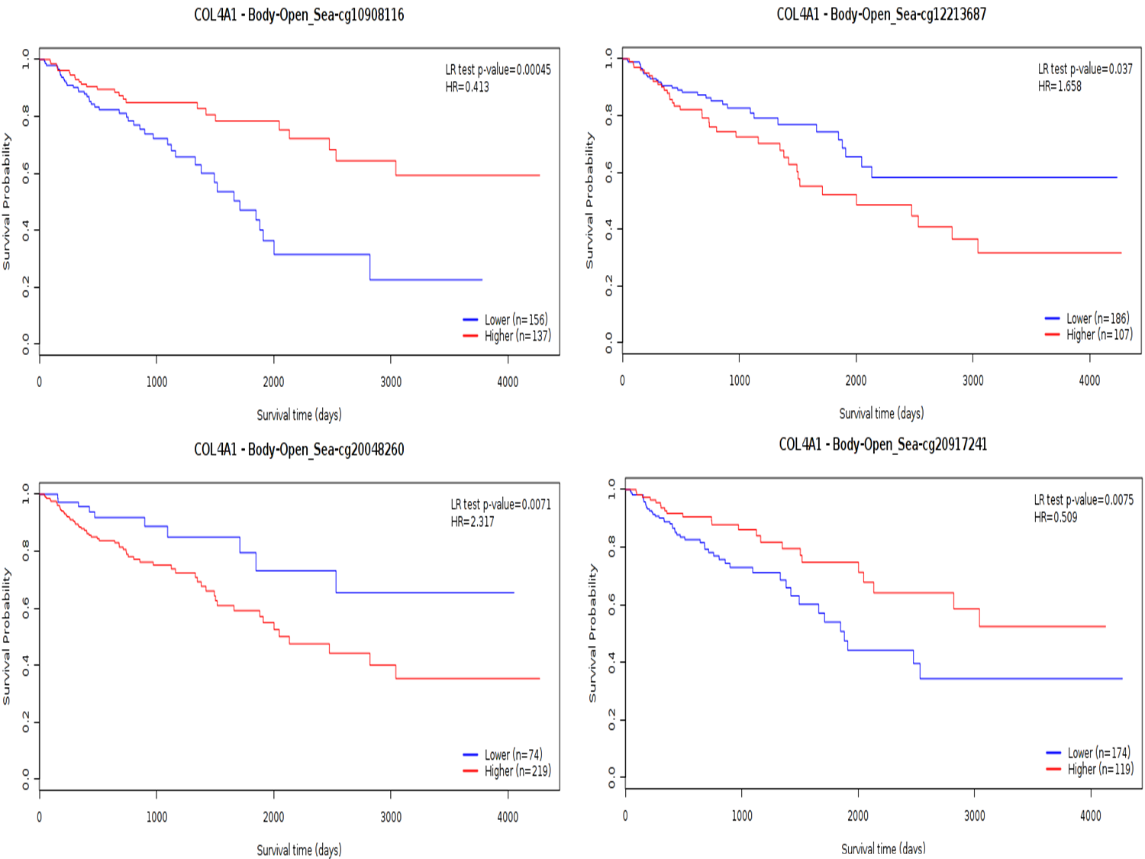
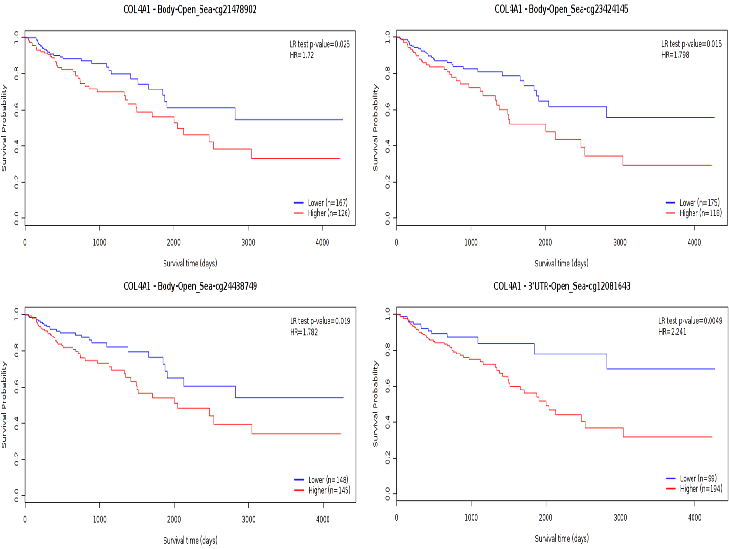
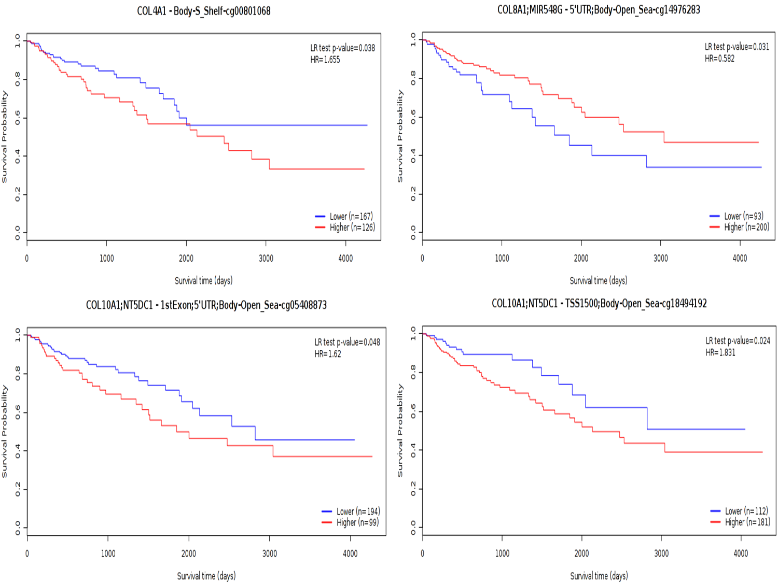
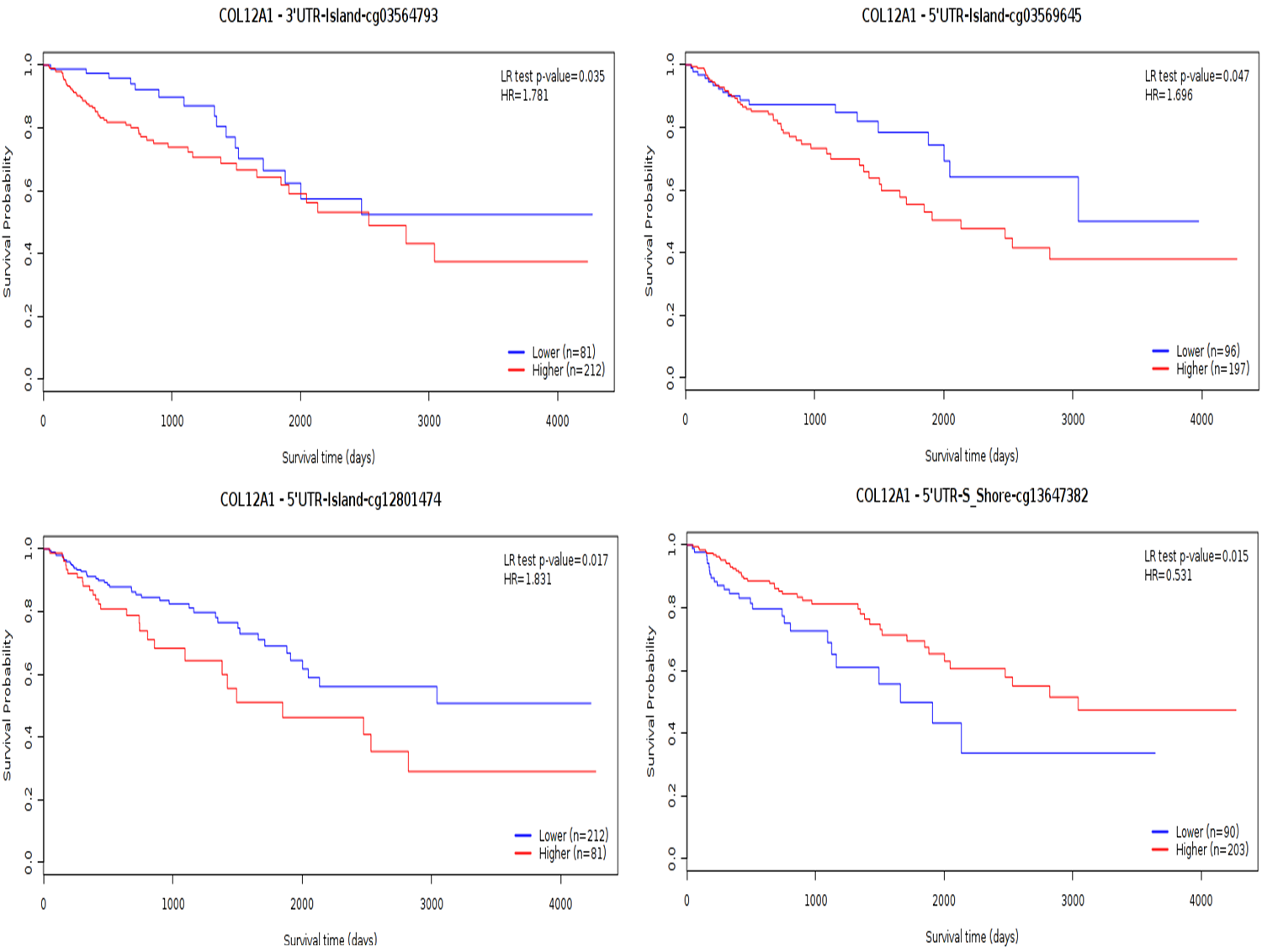
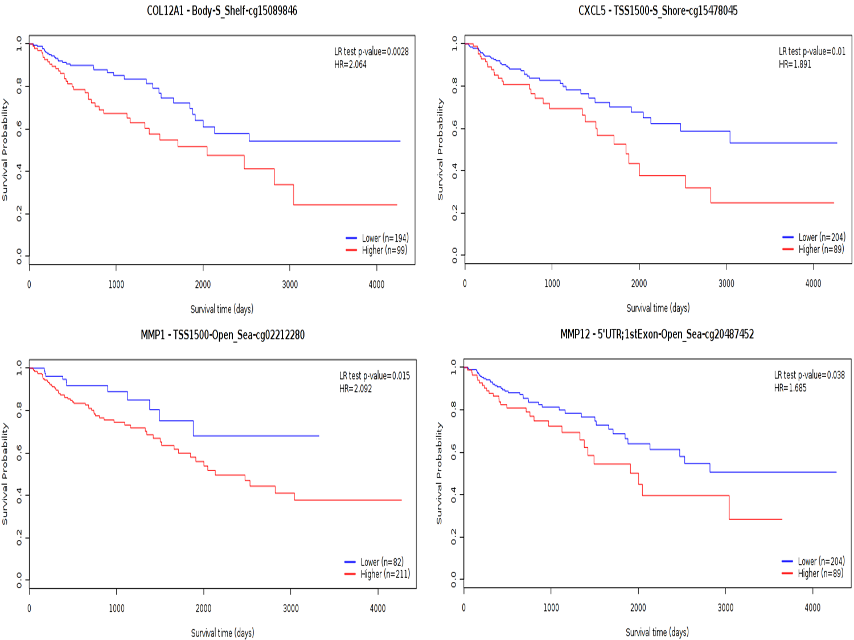
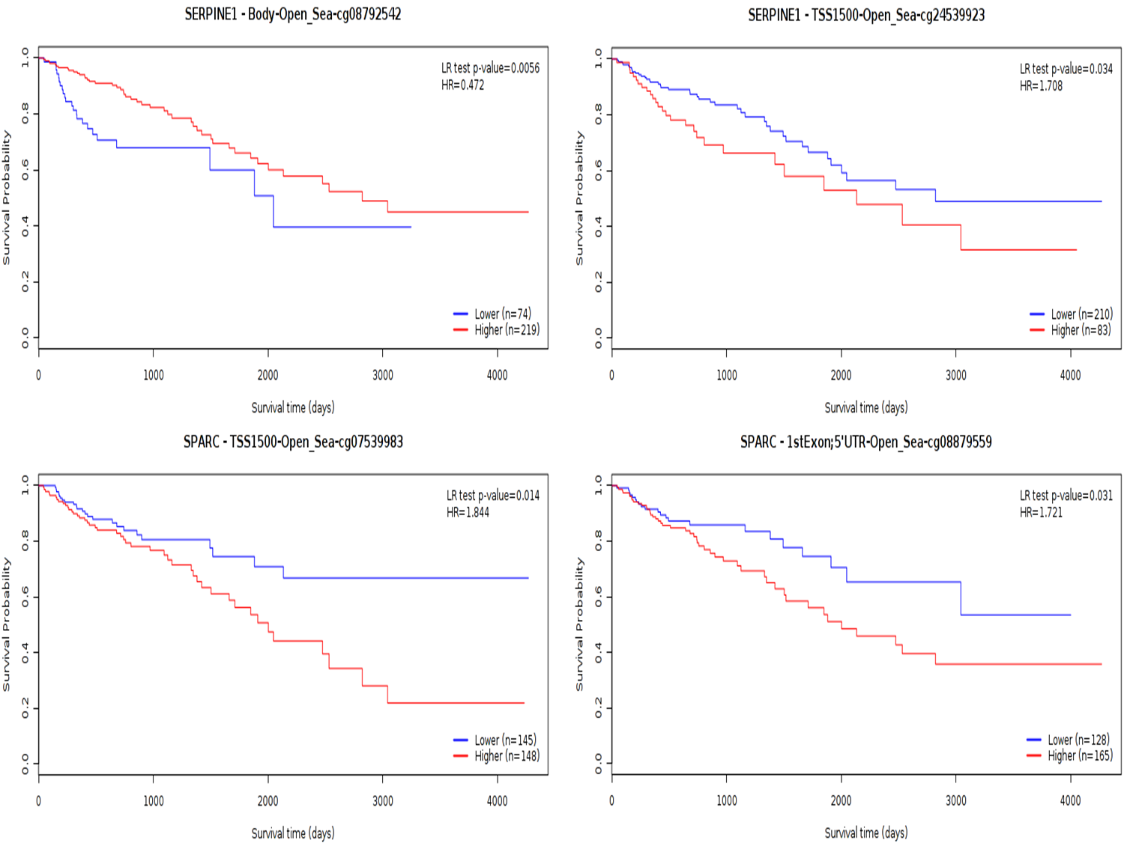
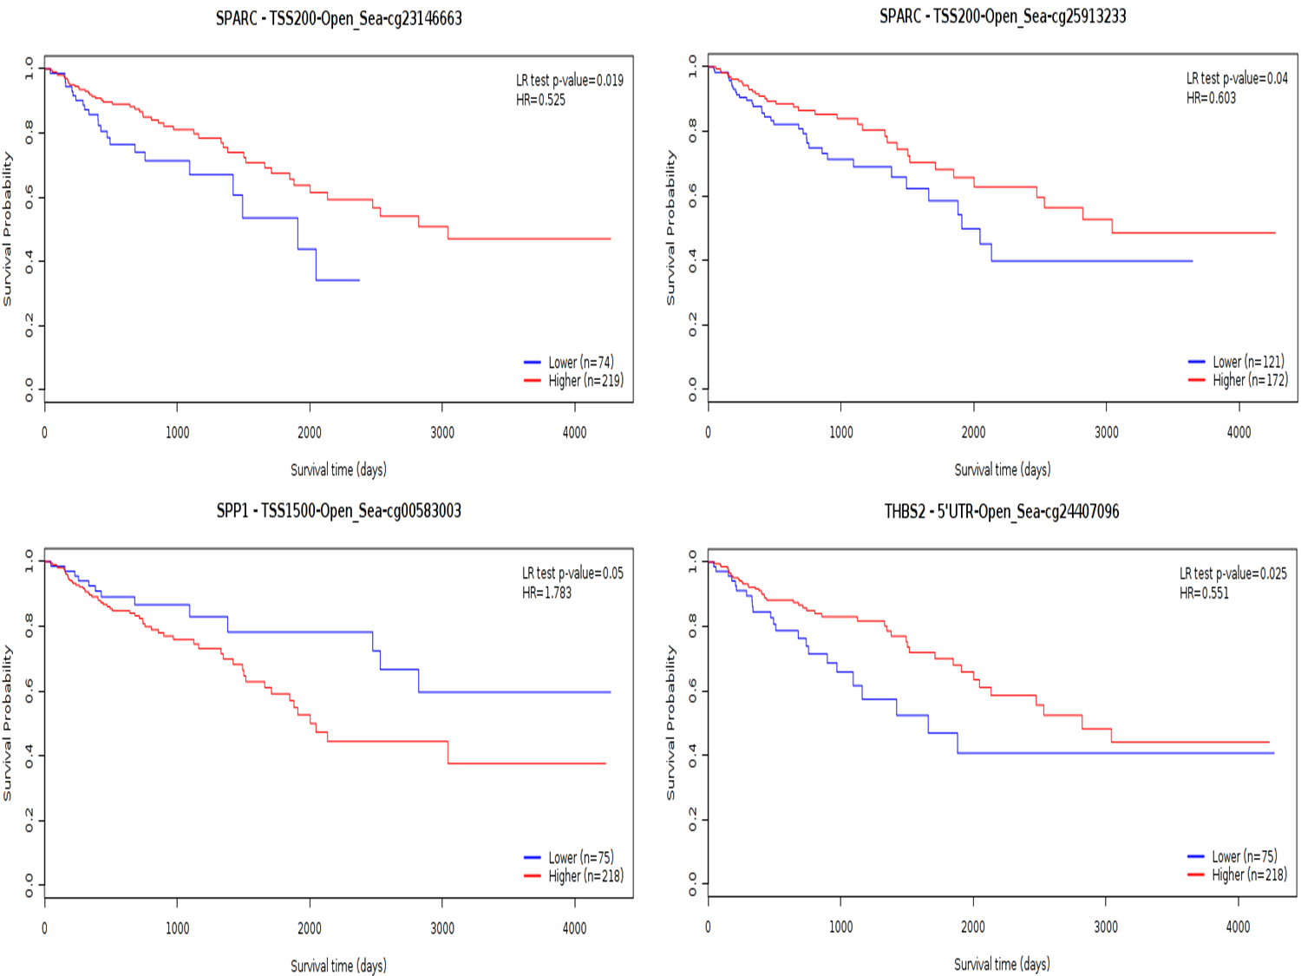
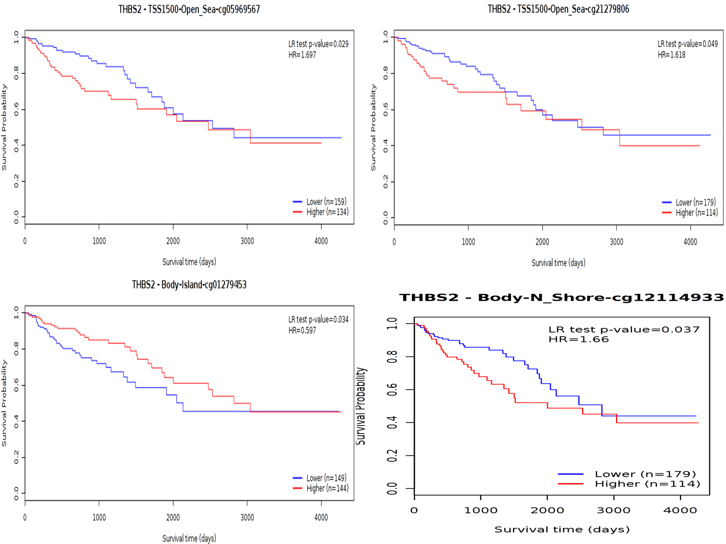
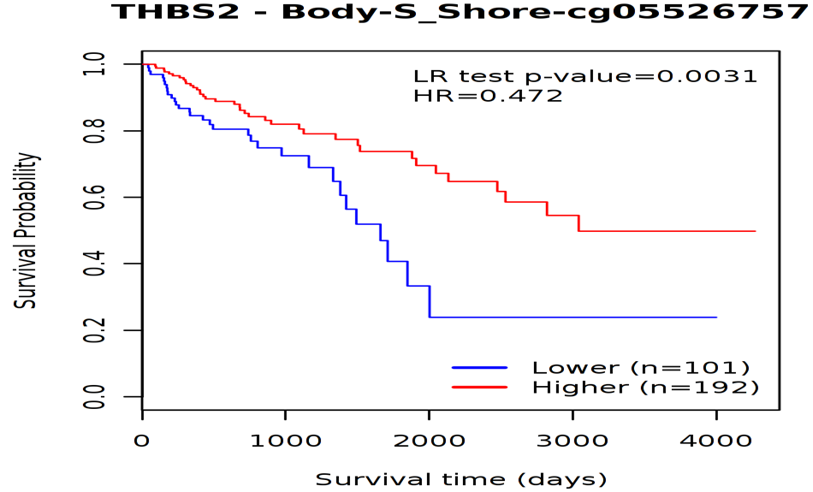
Supplementary Figure-12
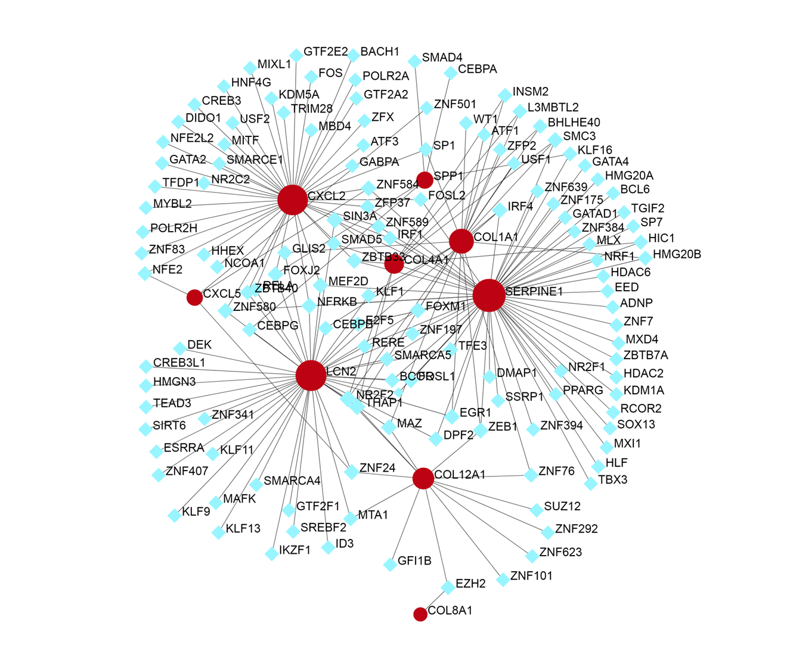

Supplementary Table-1
#Term | Database | ID | Input number | P-Value | Corrected P-Value | Input
Cytokine-cytokine receptor interaction | KEGG PATHWAY | hsa04060 | 8 | 5.48E-08 | 1.28E-06 | CXCL1, CXCL3, CXCL2, CXCL5, INHBA, CXCL11, GDF15, TNFRSF12A
IL-17 signaling pathway | KEGG PATHWAY | hsa04657 | 7 | 4.75E-10 | 3.33E-08 | CXCL1, CXCL3, CXCL2, CXCL5, LCN2, MMP3, MMP1
Protein digestion and absorption | KEGG PATHWAY | hsa04974 | 7 | 1.75E-08 | 6.14E-07 | COL10A1, COL11A1, COL1A2, COL4A1, COL1A1, COL12A1, COL8A1
Rheumatoid arthritis | KEGG PATHWAY | hsa05323 | 6 | 2.31E-05 | 0.000202532 | CXCL1, CXCL5, MMP3, MMP1, CXCL3, CXCL2
Amoebiasis | KEGG PATHWAY | hsa05146 | 6 | 2.72E-05 | 0.000211771 | CXCL1, COL1A2, COL4A1, COL1A1, CXCL2, CXCL3
Viral protein interaction with cytokine and cytokine receptor | KEGG PATHWAY | hsa04061 | 5 | 1.13E-06 | 1.97E-05 | CXCL11, CXCL1, CXCL3, CXCL2, CXCL5
TNF signaling pathway | KEGG PATHWAY | hsa04668 | 5 | 1.92E-06 | 2.69E-05 | CXCL1, CXCL3, CXCL2, CXCL5, MMP3
ECM-receptor interaction | KEGG PATHWAY | hsa04512 | 5 | 1.87E-05 | 0.000202532 | THBS2, COL1A2, COL4A1, COL1A1, SPP1
Chemokine signaling pathway | KEGG PATHWAY | hsa04062 | 5 | 2.31E-05 | 0.000202532 | CXCL11, CXCL1, CXCL3, CXCL2, CXCL5
Focal adhesion | KEGG PATHWAY | hsa04510 | 5 | 0.00043412 | 0.001999831 | THBS2, COL1A2, COL4A1, COL1A1, SPP1
Human papillomavirus infection | KEGG PATHWAY | hsa05165 | 5 | 0.002717965 | 0.009512878 | THBS2, COL1A2, COL4A1, COL1A1, SPP1
PI3K-Akt signaling pathway | KEGG PATHWAY | hsa04151 | 5 | 0.003482586 | 0.01160862 | THBS2, COL1A2, COL4A1, COL1A1, SPP1
AGE-RAGE signaling pathway in diabetic complications | KEGG PATHWAY | hsa04933 | 4 | 3.30E-05 | 0.0002313 | COL1A2, SERPINE1, COL4A1, COL1A1
Relaxin signaling pathway | KEGG PATHWAY | hsa04926 | 4 | 8.88E-05 | 0.000564777 | MMP1, COL1A2, COL4A1, COL1A1
Legionellosis | KEGG PATHWAY | hsa05134 | 3 | 0.00014267 | 0.000832244 | CXCL1, CXCL3, CXCL2
Epithelial cell signaling in Helicobacter pylori infection | KEGG PATHWAY | hsa05120 | 3 | 0.000282296 | 0.001520055 | CXCL1, CXCL3, CXCL2
PPAR signaling pathway | KEGG PATHWAY | hsa03320 | 3 | 0.000356274 | 0.001781372 | FABP6, SCD, MMP1
Salmonella infection | KEGG PATHWAY | hsa05132 | 3 | 0.000457104 | 0.001999831 | CXCL1, CXCL3, CXCL2
Cell adhesion molecules (CAMs) | KEGG PATHWAY | hsa04514 | 3 | 0.002232954 | 0.008683709 | CLDN1, CLDN2, CDH3
NOD-like receptor signaling pathway | KEGG PATHWAY | hsa04621 | 3 | 0.003862366 | 0.012289348 | CXCL1, CXCL3, CXCL2
Kaposi sarcoma-associated herpesvirus infection | KEGG PATHWAY | hsa05167 | 3 | 0.004357628 | 0.013262348 | CXCL1, CXCL3, CXCL2
Steroid biosynthesis | KEGG PATHWAY | hsa00100 | 2 | 0.000606084 | 0.002495639 | FAP, CEL
Fat digestion and absorption | KEGG PATHWAY | hsa04975 | 2 | 0.002542957 | 0.009368791 | FAP, CEL
Glycerolipid metabolism | KEGG PATHWAY | hsa00561 | 2 | 0.005378807 | 0.015688187 | FAP, CEL
p53 signaling pathway | KEGG PATHWAY | hsa04115 | 2 | 0.007348545 | 0.020575926 | SERPINB5, SERPINE1
Pancreatic secretion | KEGG PATHWAY | hsa04972 | 2 | 0.013084808 | 0.033923577 | FAP, CEL
Leukocyte transendothelial migration | KEGG PATHWAY | hsa04670 | 2 | 0.016764626 | 0.041911565 | CLDN1, CLDN2
Platelet activation | KEGG PATHWAY | hsa04611 | 2 | 0.020227365 | 0.048824673 | COL1A2, COL1A1
Hippo signaling pathway | KEGG PATHWAY | hsa04390 | 2 | 0.030045142 | 0.068643828 | SERPINE1, TEAD4
Hepatitis C | KEGG PATHWAY | hsa05160 | 2 | 0.030399409 | 0.068643828 | CLDN1, CLDN2
Tight junction | KEGG PATHWAY | hsa04530 | 2 | 0.035910124 | 0.078553397 | CLDN1, CLDN2
Transcriptional misregulation in cancer | KEGG PATHWAY | hsa05202 | 2 | 0.042177629 | 0.089467698 | ETV4, MMP3
Vitamin B6 metabolism | KEGG PATHWAY | hsa00750 | 1 | 0.012046525 | 0.032432951 | PSAT1
Biosynthesis of unsaturated fatty acids | KEGG PATHWAY | hsa01040 | 1 | 0.04733471 | 0.097453815 | SCD

Supplementary Table-2
#Term | Database | ID | Input number | P-Value | Corrected P-Value | Input
Metabolic pathways | KEGG PATHWAY | hsa01100 | 16 | 5.81E-07 | 2.07E-05 | HMGCS2, AKR1B10, UGT2A3, GCNT2, SELENBP1, CA2, DHRS9, CA7, CA4, PCK1, UGT2B17, ADH1C, ANPEP, HSD17B2, GBA3, HSD11B2
Neuroactive ligand-receptor interaction | KEGG PATHWAY | hsa04080 | 7 | 2.62E-05 | 0.000366921 | PYY, GCG, INSL5, SST, THRB, PTGDR, EDN3
Steroid hormone biosynthesis | KEGG PATHWAY | hsa00140 | 5 | 6.35E-07 | 2.07E-05 | DHRS11, HSD17B2, UGT2B17, HSD11B2, UGT2A3
Pancreatic secretion | KEGG PATHWAY | hsa04972 | 5 | 6.24E-06 | 0.000152946 | CA2, CLCA1, CLCA4, SLC26A3, SLC4A4
Proximal tubule bicarbonate reclamation | KEGG PATHWAY | hsa04964 | 4 | 6.08E-07 | 2.07E-05 | CA2, PCK1, SLC4A4, CA4
Mineral absorption | KEGG PATHWAY | hsa04978 | 4 | 1.29E-05 | 0.000253234 | MT1M, TRPM6, SLC26A3, MT1F
Retinol metabolism | KEGG PATHWAY | hsa00830 | 4 | 3.09E-05 | 0.000379057 | UGT2A3, UGT2B17, ADH1C, DHRS9
Bile secretion | KEGG PATHWAY | hsa04976 | 4 | 4.05E-05 | 0.000396617 | CA2, ABCG2, AQP8, SLC4A4
Drug metabolism - cytochrome P450 | KEGG PATHWAY | hsa00982 | 4 | 4.05E-05 | 0.000396617 | UGT2A3, UGT2B17, ADH1C, FMO5
Nitrogen metabolism | KEGG PATHWAY | hsa00910 | 3 | 1.66E-05 | 0.000270607 | CA2, CA7, CA4
Pentose and glucuronate interconversions | KEGG PATHWAY | hsa00040 | 3 | 0.000109504 | 0.000975582 | AKR1B10, UGT2B17, UGT2A3
Aldosterone-regulated sodium reabsorption | KEGG PATHWAY | hsa04960 | 3 | 0.000138488 | 0.001130987 | NR3C2, HSD11B2, SCNN1B
Renin secretion | KEGG PATHWAY | hsa04924 | 3 | 0.000789106 | 0.005948646 | EDN3, CLCA1, CLCA4
Metabolism of xenobiotics by cytochrome P450 | KEGG PATHWAY | hsa00980 | 3 | 0.00103321 | 0.007232472 | UGT2A3, UGT2B17, ADH1C
Drug metabolism - other enzymes | KEGG PATHWAY | hsa00983 | 3 | 0.001150859 | 0.007518943 | UGT2B17, UGT2A3, CES2
Chemical carcinogenesis | KEGG PATHWAY | hsa05204 | 3 | 0.001276636 | 0.007819394 | UGT2A3, UGT2B17, ADH1C
Leukocyte transendothelial migration | KEGG PATHWAY | hsa04670 | 3 | 0.003024051 | 0.016464278 | CLDN8, CLDN23, CXCL12
Tight junction | KEGG PATHWAY | hsa04530 | 3 | 0.009364598 | 0.041715028 | CLDN8, CLDN23, TUBAL3
Ascorbate and aldarate metabolism | KEGG PATHWAY | hsa00053 | 2 | 0.002386581 | 0.013757939 | UGT2B17, UGT2A3
Porphyrin and chlorophyll metabolism | KEGG PATHWAY | hsa00860 | 2 | 0.005427526 | 0.027994608 | UGT2B17, UGT2A3
ABC transporters | KEGG PATHWAY | hsa02010 | 2 | 0.006172089 | 0.030243236 | ABCG2, ABCA8
Intestinal immune network for IgA production | KEGG PATHWAY | hsa04672 | 2 | 0.007232906 | 0.033753561 | TNFRSF17, CXCL12

Supplementary Table-3
Enrichment FDR | No. of Genes | Pathway | URL | Genes
1.42E-11 | 7 | Protein digestion and absorption | http://www.genome.jp/kegg-bin/show_pathway?hsa04974 | COL11A1, COL1A1, COL12A1, COL10A1, COL8A1, COL1A2, COL4A1
6.62E-08 | 6 | ECM-receptor interaction | http://www.genome.jp/kegg-bin/show_pathway?hsa04512 | COL1A1, SPP1, COL1A2, SPARC, THBS2, COL4A1
2.73E-06 | 6 | Focal adhesion | http://www.genome.jp/kegg-bin/show_pathway?hsa04510 | COL1A1, SPP1, COL1A2, SPARC, THBS2, COL4A1
1.52E-05 | 6 | PI3K-Akt signaling pathway | http://www.genome.jp/kegg-bin/show_pathway?hsa04151 | COL1A1, SPP1, COL1A2, SPARC, THBS2, COL4A1
1.23E-05 | 5 | Human papillomavirus infection | http://www.genome.jp/kegg-bin/show_pathway?hsa05165 | COL1A1, SPP1, COL1A2, THBS2, COL4A1
4.51E-06 | 4 | IL-17 signaling pathway | http://www.genome.jp/kegg-bin/show_pathway?hsa04657 | CXCL2, LCN2, CXCL5, MMP1
4.51E-06 | 4 | AGE-RAGE signaling pathway in diabetic complications | http://www.genome.jp/kegg-bin/show_pathway?hsa04933 | SERPINE1, COL1A1, COL1A2, COL4A1
4.51E-06 | 4 | Amoebiasis | http://www.genome.jp/kegg-bin/show_pathway?hsa05146 | CXCL2, COL1A1, COL1A2, COL4A1
9.90E-06 | 4 | Relaxin signaling pathway | http://www.genome.jp/kegg-bin/show_pathway?hsa04926 | COL1A1, COL1A2, COL4A1, MMP1
0.000140599 | 3 | Rheumatoid arthritis | http://www.genome.jp/kegg-bin/show_pathway?hsa05323 | CXCL2, CXCL5, MMP1
0.008025979 | 2 | Viral protein interaction with cytokine and cytokine receptor | http://www.genome.jp/kegg-bin/show_pathway?hsa04061 | CXCL2, CXCL5
0.009377378 | 2 | TNF signaling pathway | http://www.genome.jp/kegg-bin/show_pathway?hsa04668 | CXCL2, CXCL5
0.010567576 | 2 | Platelet activation | http://www.genome.jp/kegg-bin/show_pathway?hsa04611 | COL1A1, COL1A2
0.012094266 | 2 | Apelin signaling pathway | http://www.genome.jp/kegg-bin/show_pathway?hsa04371 | SERPINE1, SPP1
0.021036932 | 2 | Chemokine signaling pathway | http://www.genome.jp/kegg-bin/show_pathway?hsa04062 | CXCL2, CXCL5
0.021036932 | 2 | Proteoglycans in cancer | http://www.genome.jp/kegg-bin/show_pathway?hsa05205 | COL1A1, COL1A2
0.021036932 | 2 | Diabetic cardiomyopathy | http://www.genome.jp/kegg-bin/show_pathway?hsa05415 | COL1A1, COL1A2
0.021986499 | 2 | Lipid and atherosclerosis | http://www.genome.jp/kegg-bin/show_pathway?hsa05417 | CXCL2, MMP1
0.038101096 | 2 | Cytokine-cytokine receptor interaction | http://www.genome.jp/kegg-bin/show_pathway?hsa04060 | CXCL2, CXCL5

