Supplementary Material

Estimating the risk of incident risk of SARS-CoV-2 infection among healthcare workers residing in Egyptian quarantine hospitals
Sofía Jijón^{1,2†} (PhD), Ahmad Al Shafie^{3†} (MSc), Essam Hassan⁴, EMAE-MESuRS working group on nosocomial SARS-CoV-2 modeling, Laura Temime^{1,2} (PhD), Kévin Jean^{1,2,4}* (PhD), Mohamed El-Kassas^{3*}(MD)
¹ Laboratoire Modélisation, épidémiologie et surveillance des risques sanitaires (MESuRS), Conservatoire national des Arts et Métiers, Paris, France
² Unité PACRI, Institut Pasteur, Conservatoire national des Arts et Métiers, Paris, France
³ Endemic Medicine Department, Faculty of Medicine, Helwan University, Cairo, Egypt
⁴ Tropical Medicine Department, Faculty of Medicine, Fayoum University, Fayoum, Egypt
⁵MRC Centre for Global Infectious Disease Analysis, Department of Infectious Disease Epidemiology, Imperial College London, United Kingdom

Supplementary figures

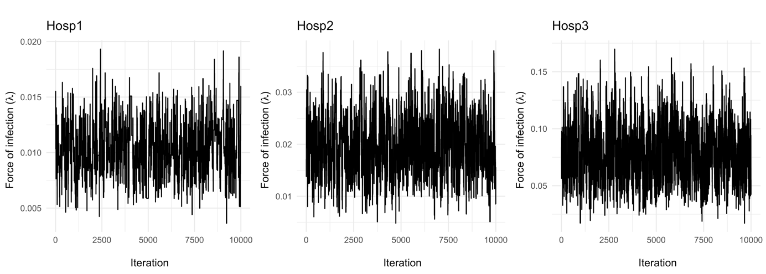
Figure S1 Markov Chain Monte-Carlo diagnostics
Trace plot of the posterior distribution for the force of infection ($λ$), for Hosp1–3. In 10,000 iterations, the sample space is explored many times and no high serial correlation is apparent in the chain.

