Supplementary Information

Are public good ecosystem services generated by on farm conservation of crop diversity valued by the general public?

Figure S1. Example of a choice set presented to respondents who were asked to choose Program 1, Program 2, or the Status Quo (see associated question below)
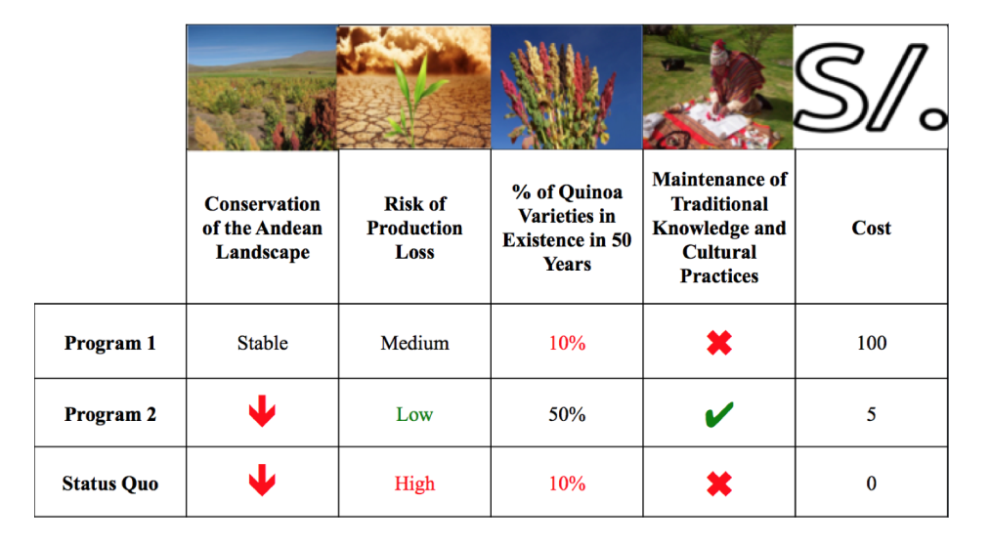
Associated question:
You will be shown several cards, each of which includes multiple conservation programs from which to choose. Each program has an associated cost that reflects the management costs.
These costs represent a one-time donation. For each card, select the program that you would support given the associated costs.
Please consider the following when choosing a program from each card:
- Bringing about good conservation outcomes costs money;
- Quinoa varieties are not the only crop that may require further funding;
- There are other good causes that you may wish to support;
- You may have limited income and need to consider this cost in light of your other expenses

Figure S2. Information framing to prime people’s perceptions prior to answering the choice experiment questions (translated from Spanish)
NATIONAL IDENTITY:
1. Peru is one of the most important centres of crop diversity and domestication in the world. This diversity has a value that goes beyond Peruvian borders. Agricultural biodiversity
is the basis of human survival and well-being – and through maintenance of biodiversity, Peruvians are protectors of the entire human race.
2. Quinoa originated in the mountains of Peru, and has been important to Andean cultures for over 5,000 years. For the Inca, one of the most powerful civilizations on the American
continent, quinoa was an important staple crop and was considered. They called it, the mother of all grains, or chisaya mama. The legend states that the Incan emperor would
ceremoniously plant the first quinoa seeds every year. It remains a prominent food source for their indigenous descendants, the Quechua and Aymara people.
3. Like many of the ancient grains, quinoa slipped into obscurity in 1532 with the arrival of the Spanish. Explorer Francisco Pizarro, in his resolve to destroy Incan culture, had
quinoa fields destroyed. Thanks to the diversity of quinoa species, some varieties were able to survive high in the mountains. This allowed for quinoas reintroduction to the
modern world. Now, we can benefit from the mother grain that our Incan predecessors left behind.
4. Maintaining traditional varieties of quinoa is important to maintain Peru’s culture. Biodivesity is a Peruvian cultural asset just like languages, archeology, or food.

FOOD SECURITY:
Currently, the global population relies on 15 crops for 90% of all calories. By 2050, the agricultural industry will need to support 9 billion individuals and increase food production by 70
percent according to the Food and Agricultural Organization. Food security can be defined as: “when all people, at all times, have physical and economic access to sufficient, safe, and
nutritious food to meet their dietary needs and food preferences for an active and healthy life

Table S1. RPL model results for both priming groups (FS: food security and NI: national identity) and the control group (no priming)
 | Model for NI group (N = 164) |  |  | Model FS for group (N = 165) |  |  | Model for control group (N = 162)
 | Coefficient | SE | SD | Coefficient | SE | SD | Coefficient | SE | SD
Risk of production loss: Low | 1.10*** | 0.22 | 1.52*** | 0.99*** | 0.18 | 1.10*** | 0.84*** | 0.19 | 1.22***
Risk of production loss: Medium | 1.19*** | 0.25 | 2.02*** | 0.99*** | 0.18 | 1.03*** | 1.07*** | 0.23 | 1.56***
Percentage of Quinoa varieties still existing in 50 years: 90% | 0.97*** | 0.22 | 1.83*** | 1.22*** | 0.20 | 1.59*** | 0.96*** | 0.21 | 1.70***
Percentage of Quinoa varieties still existing in 50 years: 50% | 0.64*** | 0.18 | 1.07*** | 1.00*** | 0.19 | 1.20*** | 0.53*** | 0.19 | 1.32***
Maintenance of Traditional Knowledge and Cultural Practices | 0.82*** | 0.19 | 1.73*** | 0.78*** | 0.16 | 1.31*** | 0.57*** | 0.16 | 1.25***
Conservation of the Andean Landscape: Increasing | 0.92*** | 0.21 | 1.17*** | 0.89*** | 0.19 | 1.26*** | 0.72*** | 0.21 | 1.46***
Conservation of the Andean Landscape: Stable | 1.06*** | 0.21 | 1.38*** | 0.93*** | 0.17 | 0.61*** | 0.73*** | 0.18 | 1.03***
One off donation | -0.03*** | 0.004 | 0.04*** | -0.04*** | 0.005 | 0.04*** | -0.04*** | 0.004 | 0.04***
SQ | -0.30 | 0.22 |  | -0.41** | 0.21 |  | -1.02** | 0.22
Loglikelihood | -1043.22 |  |  | -1044.61 |  |  | -998.14
Pseudo R² | 0.28 |  |  | 0.28 |  |  | 0.30
RPL = Random Parameter Logit

