Supporting Information
Sulfated Polyborate Catalyzed Enamines, Enaminones Synthesis via Activation of Methyl Ketones, Active Methylenes, and DMF-DMA: Application to Intermediate of Imatinib, Nilotinib
Priyanka V. Bandivadekar, Kanchan D. Gavali and Ganesh U. Chaturbhuj*
*Department of Pharmaceutical Sciences and Technology, Institute of Chemical Technology, Mumbai- 400019 India.
*Corresponding author. Tel.: +91-223-361-2212; fax: +91-222-414-5614; e-mail: gu.chaturbhuj@gmail.com
Table of Contents
Sr.No. | Description | Pg. No.
1.0 | Experimental | 2
1.1 | Material and methods | 2
1.2 | General procedures | 2-3
1.3 | Unexpected reaction of hydroxyl acetophenones with DMF-DMA | 3-4
2 | Spectral and physical data of synthesized compounds | 5-7
3 | Copies of ¹H NMR of synthesized compounds | 8-19
4 | References | 20

1. Experimental:
1.1. Materials and methods:
All reactions were carried out under the fuming hood. The melting points of products were recorded with Analab Thermo Cal apparatus in an open capillary tube and uncorrected. Infrared spectra were recorded on Bruker FTIR-attenuated total reflectance (ATR) Spectrometer, USA. Solvents and chemicals used were of LR grade, purchased from Avra Synthesis, Spectrochem, and SD fine chemicals, and used without purification. Starting material purity assessment and reaction monitoring were done by thin-layer chromatography (TLC) on Merck silica gel G F₂₅₄ plates. ¹H NMR spectra were recorded on MR400 Agilent Technology NMR spectrometer using CDCl₃ as a solvent. All the products are known compounds identified by ¹H NMR spectroscopy.
1.2 General Procedure for the synthesis of enaminone I:
To the mixture of acetophenone (0.5 g, 4.1 mmol), DMF-DMA (1.49 g, 12.4 mmol), was added sulfated polyborate (0.05 g, 10 wt%) and stirred in an oil bath preheated to 110 °C, monitored by TLC. Upon completion of the reaction, cooled to room temperature and evaporated to remove the unreacted DMF-DMA and methanol; the product was extracted by ethyl acetate (3 X 5 mL). The organic layer was dried over anhyd. sodium sulfate, condensed in a vacuum, and the solid obtained was recrystallized from hexanes: ethyl acetate (75:25). All the products were identified by ¹H NMR.
1.3 Gram Scale procedure for (E)-3-(dimethylamino)-1-(pyridin-3-yl)prop-2-en-1-one; intermediate for the synthesis of Imatinib and Nilotinib II: (Scheme 3)
To a mixture of 3-acetyl pyridine (10 g, 82 mmol) and DMF-DMA (29.4 g, 247 mmol), added boric acid (0.51 g, 10 mol%) without solvent in an oil bath preheated to 110 °C for 50 minutes. The reaction was monitored by TLC. On completion, the unreacted DMF-DMA and methanol formed were recovered by distillation. The traces of DMF-DMA were removed under vacuum for 30 minutes to produce a solid product. The product was extracted with ethyl acetate (3 X 20 mL), and the organic layer was dried over anhyd. sodium sulfate, evaporated under vacuum to obtain 13.76 g, 94.58% of crude solid. After recrystallization from hexane: ethyl acetate (40:20), obtained 11.65 g, 80%, 3o as orange-red solid, m.p. 70-73 °C.
Unexpected reaction of hydroxyl acetophenones with DMF-DMA:¹
Initially, 3g was prepared using 4’-methoxy acetophenone with complete conversion within 3h 40 min. However, the reaction of 4’-hydroxy acetophenone with DMF-DMA in the ratio of 1:6 initially resulted in multiple compound formations in the reaction mixture. It was observed that along with enaminone formation, DMF-DMA was a methylating hydroxy group of 4-hydroxy acetophenone, leading to the formation of (E)-3-(dimethylamino)-1-(4-methoxyphenyl)prop-2-en-1-one along with unreacted 4’-hydroxy acetophenone. The progress of the reaction was monitored in comparison with 4-hydroxy acetophenone as a substrate (P1), the reaction mixture of (E)-3-(dimethylamino)-1-(4'-methoxyphenyl)prop-2-en-1-one (3g) from 4-methoxy acetophenone (Pm) and reaction mixture of 4-hydroxy acetophenone (P). The figure 1 indicate that 4’-hydroxy acetophenone was converted into 4’-methoxy acetophenone, (E)-3-(dimethylamino)-1-(4-hydroxyphenyl)prop-2-en-1-one and (E)-3-(dimethylamino)-1-(4-methoxyphenyl)prop-2-en-1-one simultaneously. We continued the reaction till all the multiple compounds were finally converted to (E)-3-(dimethylamino)-1-(4-methoxyphenyl)prop-2-en-1-one within 4h 10 minutes. The product obtained was characterized by TLC and melting point compared with the literature. A similar result was observed in the reaction of 3’-hydroxy acetophenone.
Note: ¹H NMR of 3g from 4’-methoxy acetophenone included here. 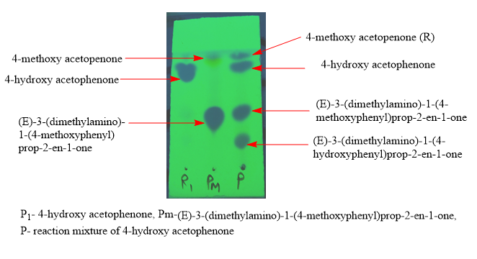
Figure 1: TLC comparison during a reaction of 4-hydroxy acetophenone with DMF-DMA.

2. Spectral and physical data of synthesized compounds
- (E)-3-(dimethylamino)-1-phenylprop-2-en-1-one² (Table 4, entry 1): Yellow crystals, 97% yield, m.p. 81-84 °C (lit.² 82-83 °C); ¹H NMR (400 MHz, CDCl₃) δ 7.89 (d, J = 6.6 Hz, 2H), 7.80 (d, J = 12.4 Hz, 1H), 7.42 (dt, J = 14.1, 6.8 Hz, 3H), 5.72 (d, J = 12.4 Hz, 1H), 3.13 (s, 3H), 2.93 (s, 3H).
- (E)-1-(4-chlorophenyl)-3-(dimethylamino)prop-2-en-1-one² (Table 4, entry 2): White crystals, 95% yield, m.p. 75-80 °C (lit.² 70-72 °C); ¹H NMR (400 MHz, CDCl₃) δ 7.82 (t, J = 11.0 Hz, 3H), 7.37 (d, J = 8.7 Hz, 2H), 5.66 (d, J = 12.4 Hz, 1H), 3.16 (s, 3H), 2.94 (s, 3H).
- (E)-1-(4-bromophenyl)-3-(dimethylamino)prop-2-en-1-one² (Table 4, entry 3): Yellow crystals, 82.63% Yield, m.p. 81-83 °C (lit.² 82-83 °C); ¹H NMR (400 MHz, CDCl₃) δ 7.77 (dd, J = 19.3, 10.4 Hz, 3H), 7.51 (d, J = 8.5 Hz, 2H), 5.63 (d, J = 12.3 Hz, 1H), 3.15 (s, 3H), 2.92 (s, 3H).
- (E)-3-(dimethylamino)-1-(4-fluorophenyl)prop-2-en-1-one³ (Table 4, entry 4): Yellow crystals. 88.65% yield, m.p. 80-83 °C (lit.³ 83-84 °C); ¹H NMR (400 MHz, CDCl₃) δ 7.96 – 7.84 (m, 2H), 7.78 (d, J = 12.3 Hz, 1H), 7.05 (t, J = 8.7 Hz, 2H), 5.65 (d, J = 12.3 Hz, 1H), 3.02 (d, J = 75.7 Hz, 6H).
- (E)-3-(dimethylamino)-1-(3-nitrophenyl)prop-2-en-1-one³ (Table 4, entry 5): Orange crystals. 84% yield, m.p. 145-148 °C (lit.³ 148-149 °C); ¹H NMR (400 MHz, CDCl₃) δ 8.70 (s, 1H), 8.28 (dd, J = 18.0, 8.4 Hz, 2H), 7.89 (d, J = 12.2 Hz, 1H), 7.60 (t, J = 7.9 Hz, 1H), 5.72 (d, J = 12.2 Hz, 1H), 3.10 (d, J = 87.3 Hz, 6H).
- (E)-3-(dimethylamino)-1-(p-tolyl)prop-2-en-1-one² (Table 4, entry 6): Yellow solid, 87.9% yield, m.p. 88-89 °C (lit.² 89-90 °C); ¹H NMR (400 MHz, CDCl₃) δ 7.79 (dd, J = 10.2, 6.2 Hz, 3H), 7.20 (d, J = 7.9 Hz, 2H), 5.71 (d, J = 12.4 Hz, 1H), 3.02 (d, J = 68.2 Hz, 6H), 2.38 (s, 3H).
- (E)-3-(dimethylamino)-1-(4-methoxyphenyl)prop-2-en-1-one³ (Table 4, entry 7): Yellow solid, 89.9% yield, m.p. 89-91 °C (lit.³ 90-91 °C); ¹H NMR (400 MHz, CDCl₃) δ 7.90 (d, J = 8.9 Hz, 2H), 7.78 (d, J = 12.4 Hz, 1H), 6.91 (d, J = 8.9 Hz, 2H), 5.70 (d, J = 17.2 Hz, 1H), 3.85 (s, 3H), 2.98 (s, 6H).
- (E)-3-(dimethylamino)-1-(4-methoxyphenyl)prop-2-en-1-one³ (Table 4, entry 8): Red-brown solid, 88.5% yield, m.p. 92-94 °C (lit.³ 90-91 °C).
- (E)-3-(dimethylamino)-1-(3-methoxyphenyl)prop-2-en-1-one² (Table 4, entry 9): Red-brown thick liquid. 82.9% yield; ¹H NMR (400 MHz, CDCl₃) δ 7.77 (d, J = 12.4 Hz, 1H), 7.43 (d, J = 2.4 Hz, 2H), 7.27 (d, J = 22.0 Hz, 2H), 6.97 (d, J = 11.6 Hz, 1H), 5.66 (d, J = 12.4 Hz, 1H), 3.82 (s, 3H), 2.99 (d, J = 85.9 Hz, 6H).
- (E)-3-(dimethylamino)-1-(naphthalen-1-yl)prop-2-en-1-one² (Table 4, entry 10): Yellow thick oil, 85.37% yield; ¹H NMR (400 MHz, CDCl₃) δ 8.22 (s, 1H), 7.81 (s, 2H), 7.60 – 7.35 (m, 5H), 5.49 (d, J = 12.7 Hz, 1H), 2.92 (d, J = 67.1 Hz, 6H).
- (E)-3-(dimethylamino)-1-(naphthalen-2-yl)prop-2-en-1-one² (Table 4, entry 11): Yellow solid, 98.22% yield, m.p. 106-109 °C (lit.² 107-109 °C); ¹H NMR (400 MHz, CDCl₃) δ 8.37 (s, 1H), 7.99 (d, J = 8.5 Hz, 1H), 7.92 (d, J = 8.8 Hz, 1H), 7.90 – 7.80 (m, 3H), 7.51 (d, J = 14.6 Hz, 2H), 5.86 (d, J = 12.3 Hz, 1H), 3.06 (d, J = 71.5 Hz, 6H).
- (E)-3-(dimethylamino)-1-(thiophen-2-yl)prop-2-en-1-one³ (Table 4, entry 12): Light brown solid, 98.85% yield. m.p. 116-118 °C (lit.³ 117-118 °C); ¹H NMR (400 MHz, CDCl₃) δ 7.77 (d, J = 12.3 Hz, 1H), 7.60 (d, J = 3.7 Hz, 1H), 7.45 (d, J = 5.0 Hz, 1H), 7.09 – 7.01 (m, 1H), 5.60 (d, J = 12.3 Hz, 1H), 3.00 (d, J = 76.1 Hz, 6H).
- (E)-1-(5-bromothiophen-2-yl)-3-(dimethylamino)prop-2-en-1-one⁶ (Table 4, entry 13): Light brown solid, 86.71% yield, m.p. 112 °C (lit.⁶ 114 °C); ¹H NMR (400 MHz, CDCl₃) δ 7.76 (d, J = 12.2 Hz, 1H), 7.35 (d, J = 3.9 Hz, 1H), 7.03 (d, J = 3.9 Hz, 1H), 5.50 (d, J = 12.3 Hz, 1H), 3.15 (s, 3H), 2.92 (s, 3H).
- (E)-3-(dimethylamino)-1-(furan-2-yl)prop-2-en-1-one³ (Table 4, entry 14): Yellow solid, 93.3% yield, m.p. 79-80 °C (lit.³ 80-81 °C); ¹H NMR (400 MHz, CDCl₃) δ 7.79 (d, J = 12.5 Hz, 1H), 7.47 (s, 1H), 7.06 (s, 1H), 6.46 (s, 1H), 5.67 (d, J = 12.5 Hz, 1H), 3.02 (d, J = 85.6 Hz, 6H).
- (E)-3-(dimethylamino)-1-(1H-pyrrol-2-yl)prop-2-en-1-one² (Table 4, entry 15): Light brown solid, 74.66% yield; m.p. 93-95 °C (lit.² 94 °C); ¹H NMR (400 MHz, CDCl₃) δ 9.85 (s, 1H), 7.73 (d, J = 12.5 Hz, 1H), 6.93 (td, J = 2.6, 1.4 Hz, 1H), 6.76 (dd, J = 3.6, 2.4, 1.3 Hz, 1H), 6.23 (dt, J = 3.6, 2.5 Hz, 1H), 5.57 (d, J = 12.5 Hz, 1H), 2.99 (s, 6H).
- (E)-3-(dimethylamino)-1-(pyridin-3-yl)prop-2-en-1-one² (Table 4, entry 16): Yellow solid, 82.5% yield; m.p. 73-75 °C (lit.² 71-73 °C); ¹H NMR (400 MHz, CDCl₃) δ 9.06 (s, 1H), 8.65 (d, J = 4.8 Hz, 1H), 8.19 (dd, J = 7.9, 1.8 Hz, 1H), 7.84 (d, J = 12.2 Hz, 1H), 7.35 (dd, J = 7.9, 4.8 Hz, 1H), 5.67 (d, J = 12.3 Hz, 1H), 3.18 (s, 3H), 2.95 (s, 3H).
- (E)-3-(dimethylamino)-1-(pyridin-4-yl)prop-2-en-1-one² (Table 4, entry 17): Yellow red solid, 80.6% yield; m.p. 114-116 °C (lit.² 115-117 °C); ¹H NMR (400 MHz, CDCl₃) δ 8.68 (d, J = 6.0 Hz, 2H), 7.83 (d, J = 12.3 Hz, 1H), 7.67 (d, J = 6.0 Hz, 2H), 5.64 (d, J = 12.3 Hz, 1H), 3.18 (s, 3H), 2.94 (s, 3H).
- (1E,4E)-1-(dimethylamino)-5-phenylpenta-1,4-dien-3-one³ (Table 4, entry 18): Brown solid and after recrystallization with ethyl acetate: hexane (2:10) given yellow solid, 94% yield, m.p. 95-100 °C (lit.³ 99-100 °C); ¹H NMR (400 MHz, CDCl₃) δ 7.73 (d, J = 12.5 Hz, 1H), 7.52 (dd, J = 5.7, 2.1 Hz, 3H), 7.37 – 7.26 (m, 3H), 6.77 (d, J = 15.8 Hz, 1H), 5.25 (d, J = 12.5 Hz, 1H), 2.99 (d, J = 87.2 Hz, 6H).
- (E)-2-((dimethylamino)methylene)-2,3-dihydro-1H-inden-1-one⁵ (Table 4, entry 19): Light brown solid, 95.3% yield; m.p. 159-161 °C (lit.⁵ 159-161 °C); ¹H NMR (400 MHz, CDCl₃) δ 7.86 (d, J = 7.6 Hz, 1H), 7.55 (s, 1H), 7.47 (s, 2H), 7.41 (s, 1H), 3.90 (s, 2H), 3.19 (s, 6H).
- (E)-3-(dimethylamino)-2-phenylacrylonitrile⁷ (Table 4, entry 20): White solid, 95% yield, m.p.73-76 °C (lit.⁷ 73-75 °C); FTIR 2181 and 1616 cm⁻¹; ¹H NMR (400 MHz, CDCl₃) δ 7.32 – 7.25 (m, 4H), 7.12 (t, J = 8.4 Hz, 1H), 6.89 (s, 1H), 3.22 (s, 6H).
- ethyl (E)-2-cyano-3-(dimethylamino)acrylate⁹ (Table 4, entry 21): White solid, 90% yield, m.p. 72-74 °C (lit.¹⁰ 72 °C); FTIR 2196, 1689, 1615 cm⁻¹; ¹H NMR (400 MHz, CDCl₃) δ 7.68 (s, 1H), 4.24 (s, 2H), 3.38 (s, 3H), 3.20 (s, 3H), 1.32 (s, 3H).
- ethyl (E)-2-((dimethylamino)methylene)-3-oxobutanoate⁸ (Table 4, entry 22): Orange liquid, 90% yield, ¹H NMR (400 MHz, CDCl₃) δ 7.68 (s, 1H), 4.23 (q, J = 7.1 Hz, 2H), 3.04 (s, 6H), 2.33 (s, 3H), 1.32 (t, J = 7.1 Hz, 3H).
- diethyl 2-((dimethylamino)methylene)malonate⁸ (Table 4, entry 23): colorless liquid, yield 95%, ¹H NMR (400 MHz, CDCl₃) δ 7.48 (s, 1H), 4.19 (dd, J = 29.8, 7.0 Hz, 4H), 2.97 (d, J = 16.3 Hz, 6H), 1.35 – 1.20 (m, 6H).; residual solvent impurities 8.00 (s, 0.5H), (CH, DMF), 2.95 and 2.87 (s, 1H), (CH_{3,} DMF).

¹H NMR spectra of synthesized compounds:
- (E)-3-(dimethylamino)-1-phenylprop-2-en-1-one
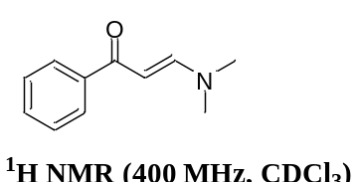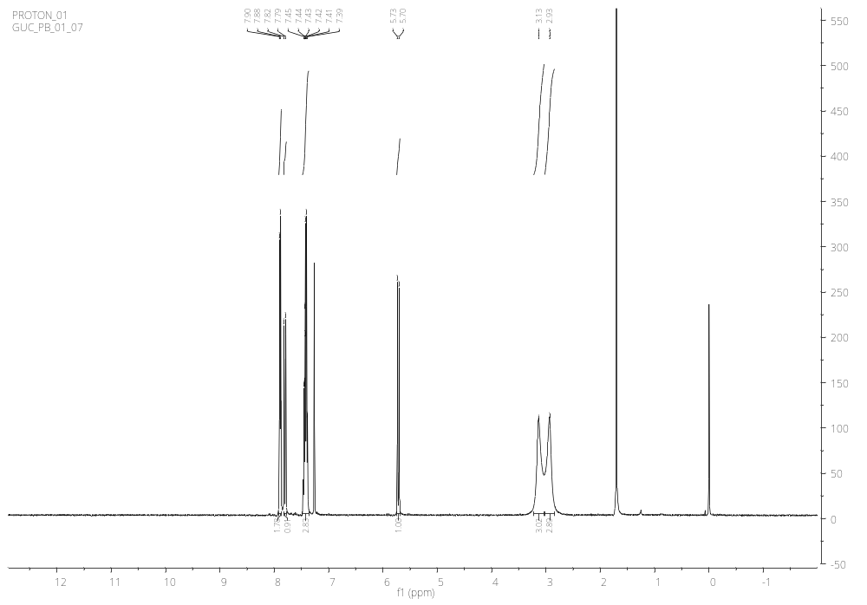
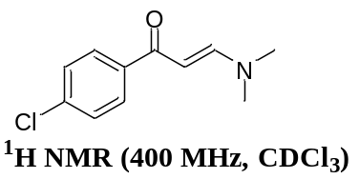2.(E)-1-(4-chlorophenyl)-3-(dimethylamino)prop-2-en-1-one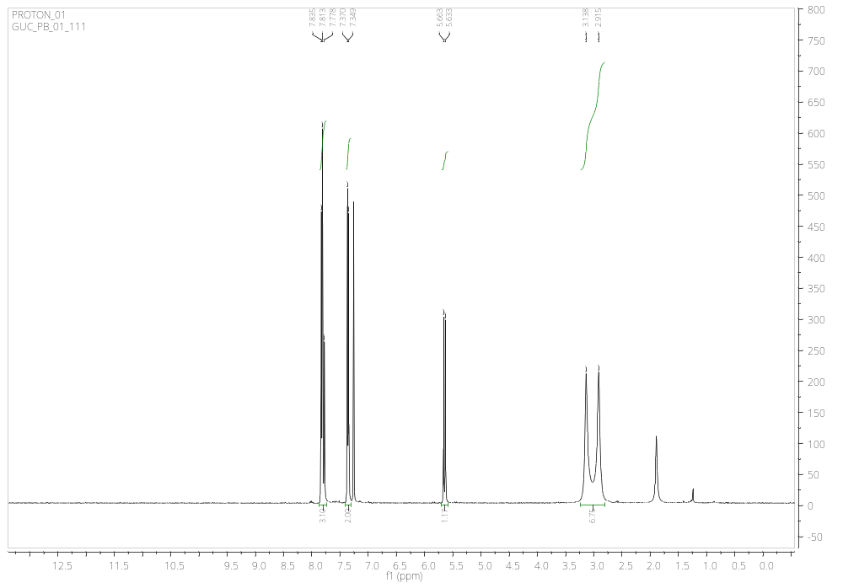
3. (E)-1-(4-bromophenyl)-3-(dimethylamino)prop-2-en-1-one
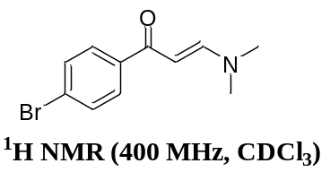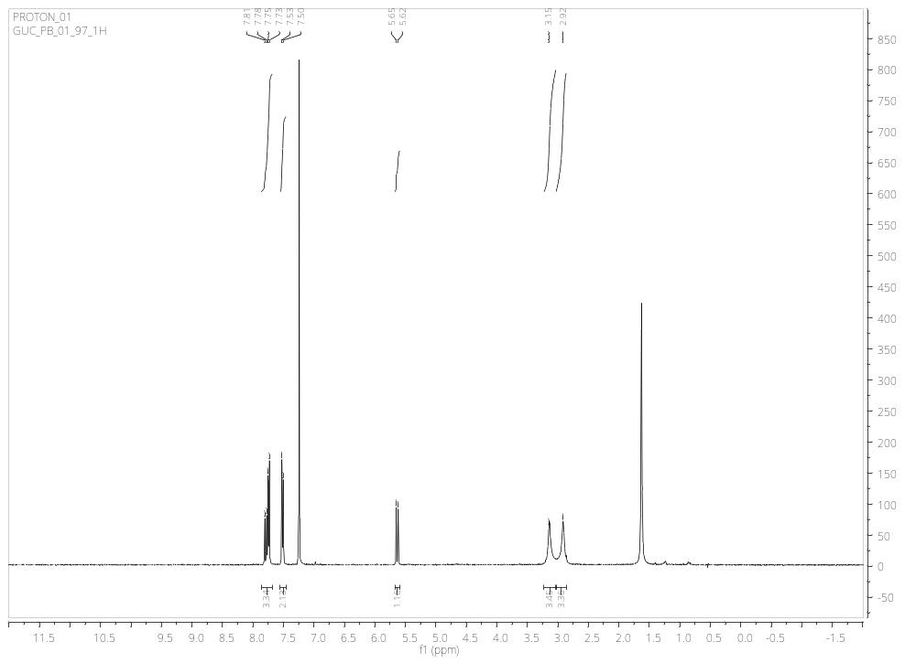
4.(E)-3-(dimethylamino)-1-(4-fluorophenyl)prop-2-en-1-one
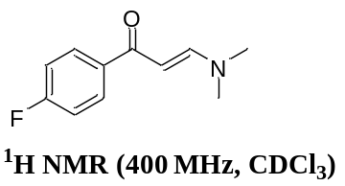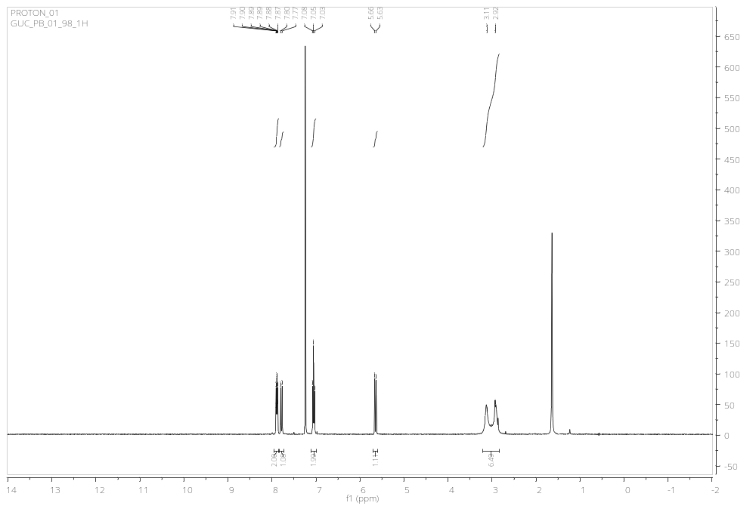
5.(E)-3-(dimethylamino)-1-(3-nitrophenyl)prop-2-en-1-one
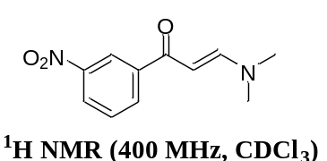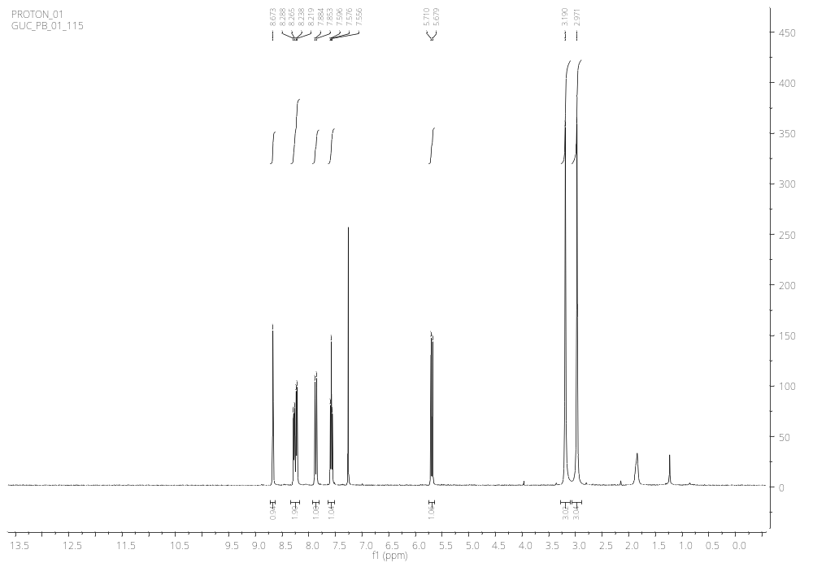
6. (E)-3-(dimethylamino)-1-(p-tolyl)prop-2-en-1-one
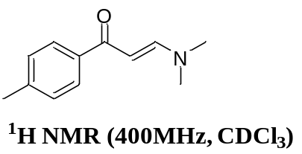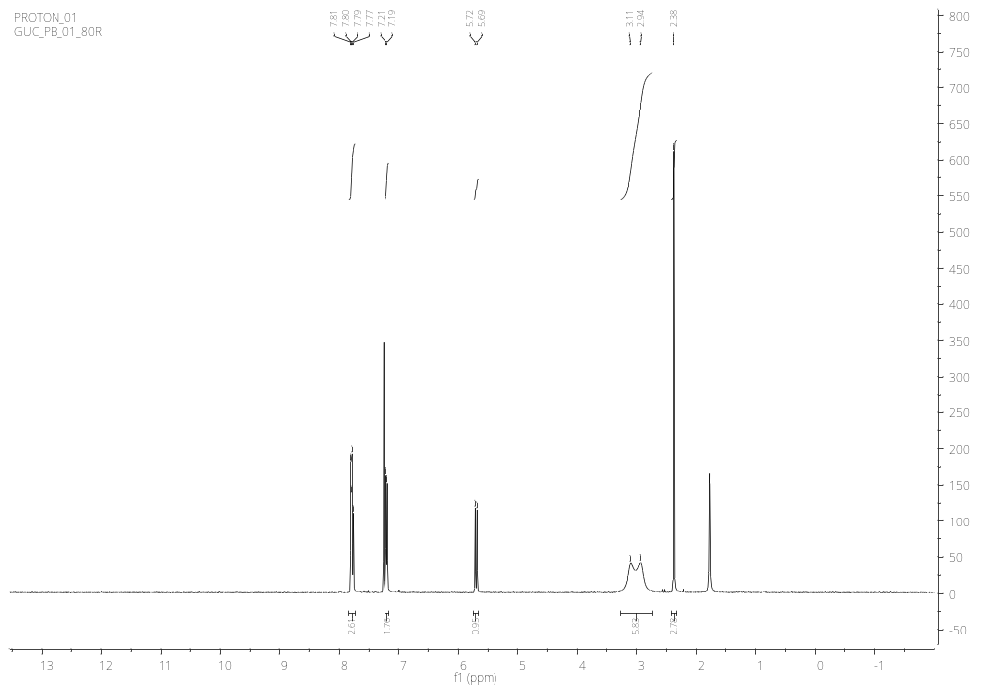
7. (E)-3-(dimethylamino)-1-(4-methoxyphenyl)prop-2-en-1-one
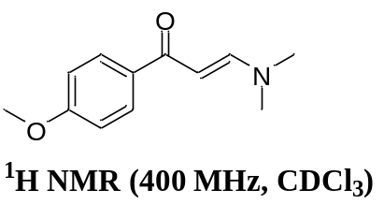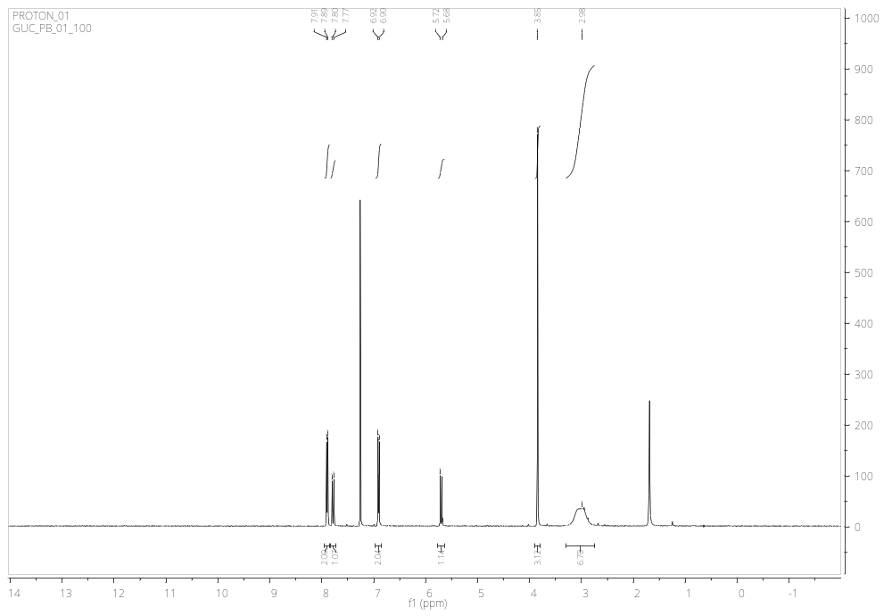
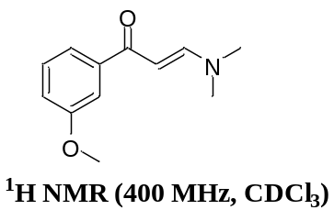9.(E)-3-(dimethylamino)-1-(3-methoxyphenyl)prop-2-en-1-one
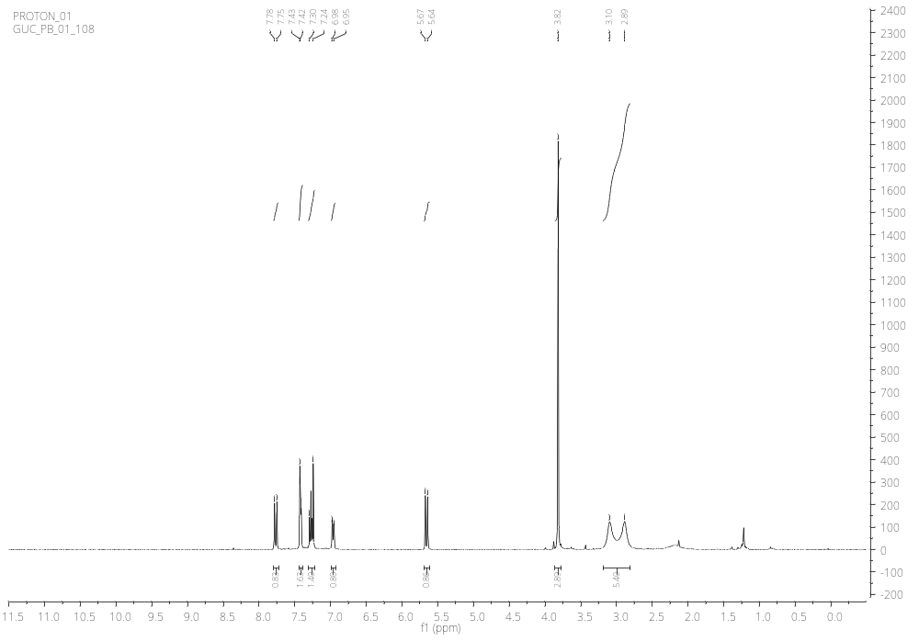
10. (E)-3-(dimethylamino)-1-(naphthalen-1-yl)prop-2-en-1-one
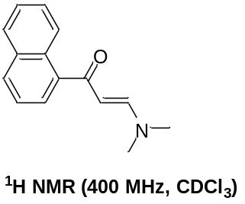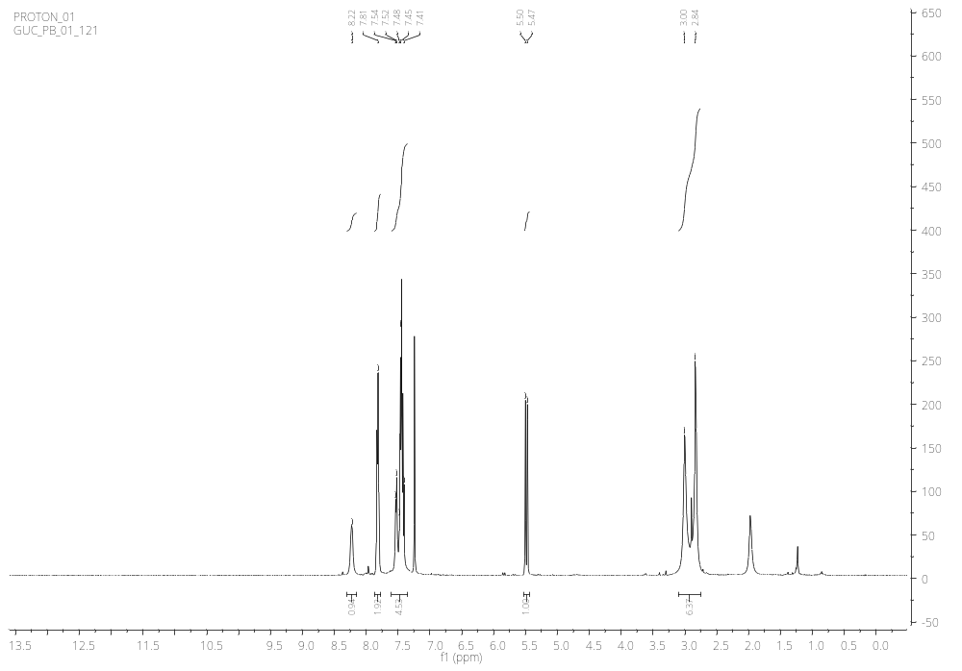
11. (E)-3-(dimethylamino)-1-(naphthalen-2-yl)prop-2-en-1-one
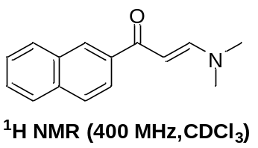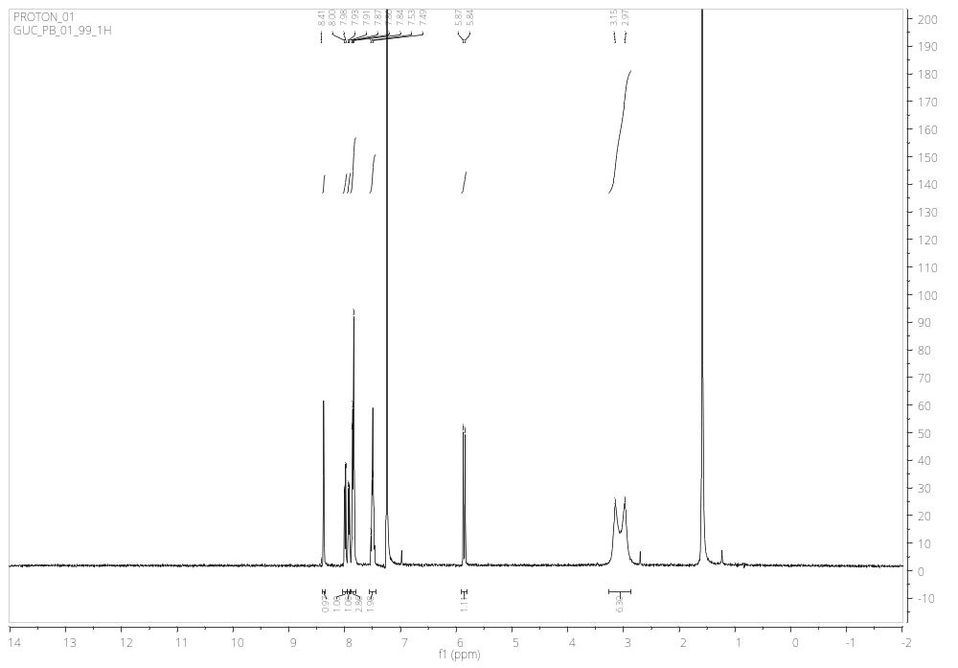
12. (E)-3-(dimethylamino)-1-(thiophen-2-yl)prop-2-en-1-one
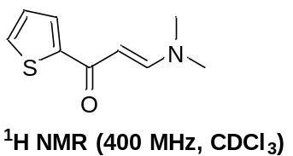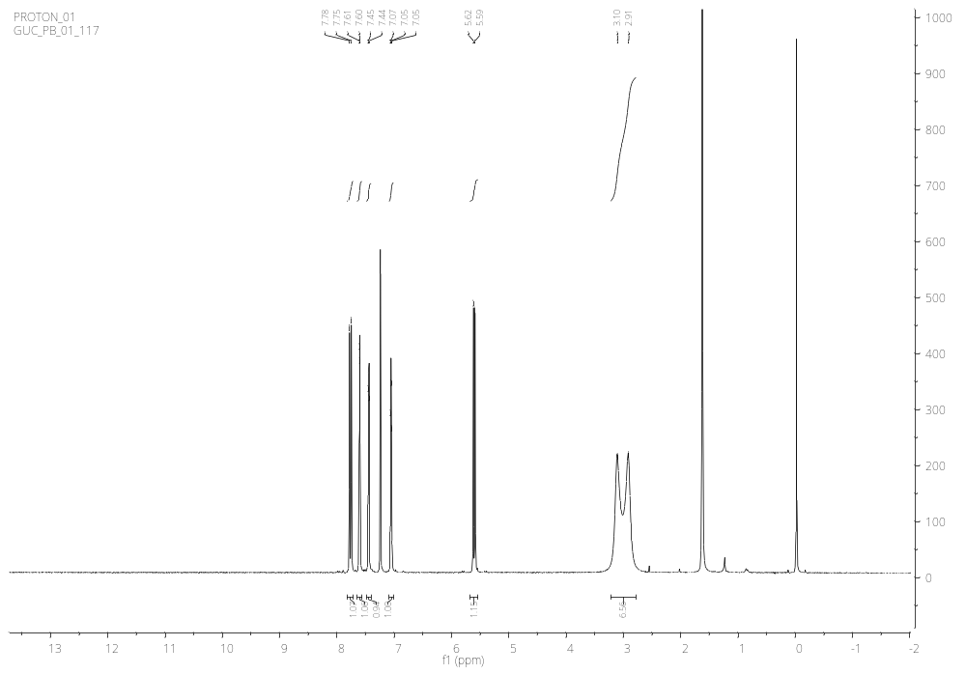
13.(E)-1-(5-bromothiophen-2-yl)-3-(dimethylamino)prop-2-en-1-one
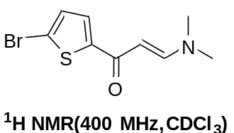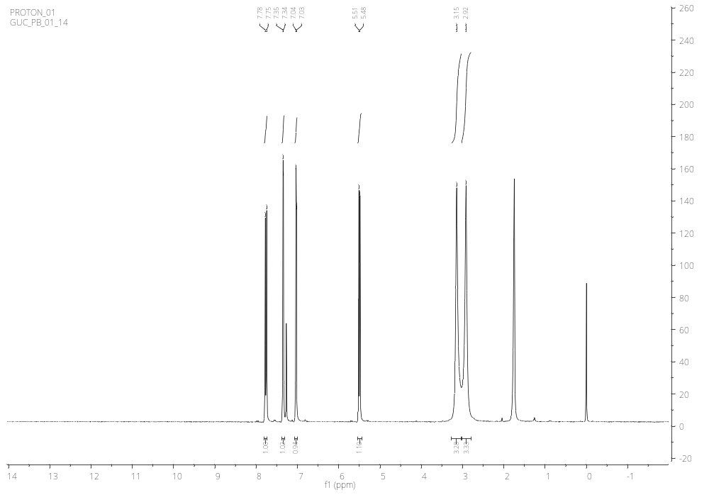
14. (E)-3-(dimethylamino)-1-(furan-2-yl)prop-2-en-1-one
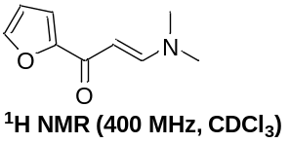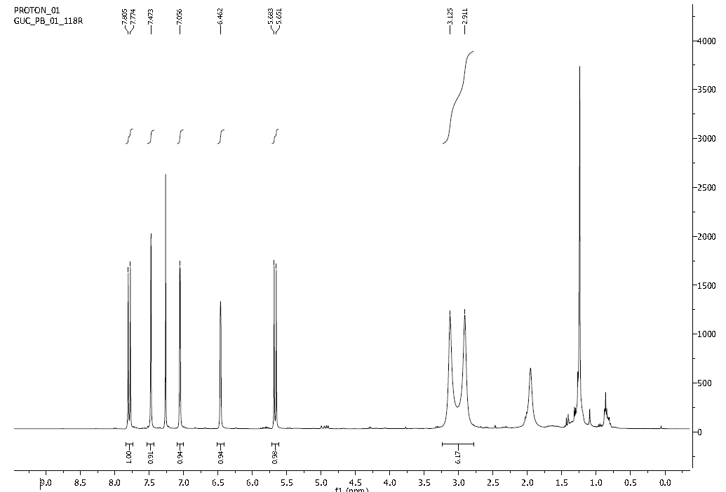
15. (E)-3-(dimethylamino)-1-(1H-pyrrol-2-yl)prop-2-en-1-one
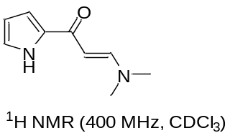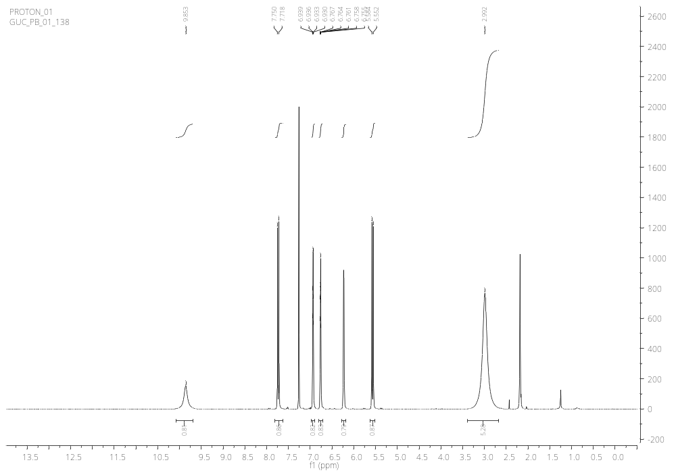
16. (E)-3-(dimethylamino)-1-(pyridin-3-yl)prop-2-en-1-one
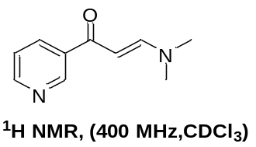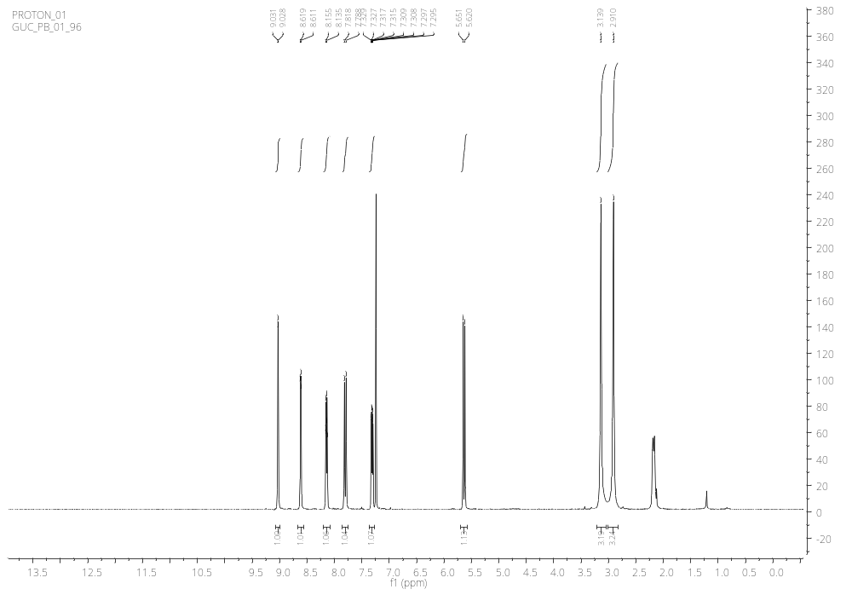
17.(E)-3-(dimethylamino)-1-(pyridin-4-yl)prop-2-en-1-one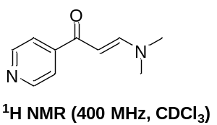O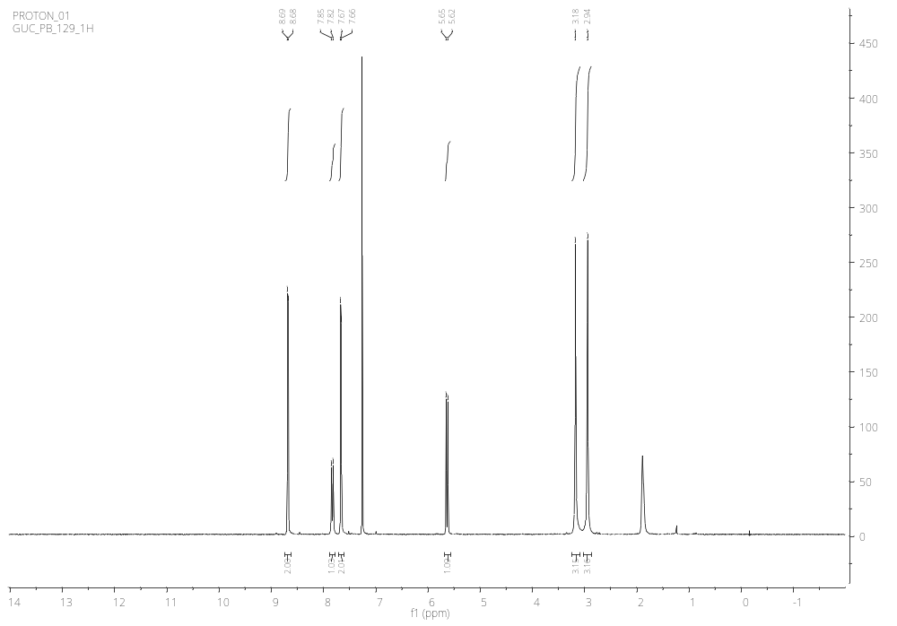
18. (1E,4E)-1-(dimethylamino)-5-phenylpenta-1,4-dien-3-one
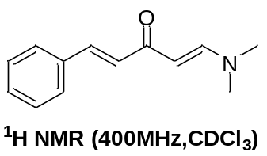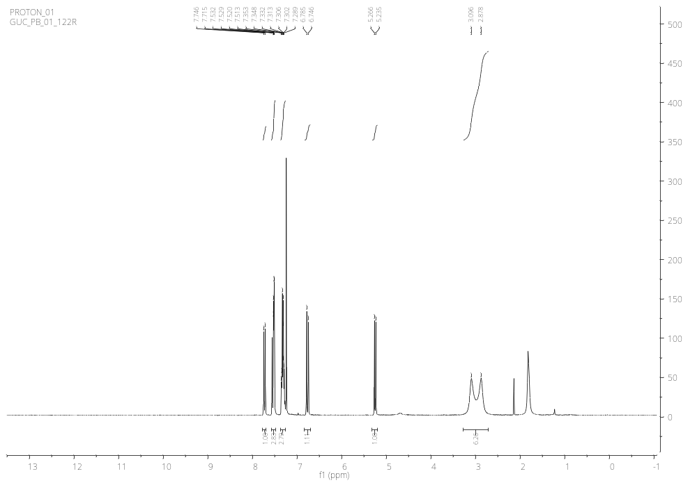
19. (E)-2-((dimethylamino)methylene)-2,3-dihydro-1H-inden-1-one
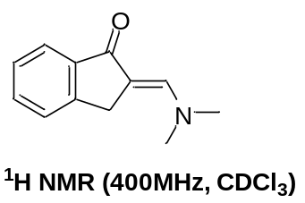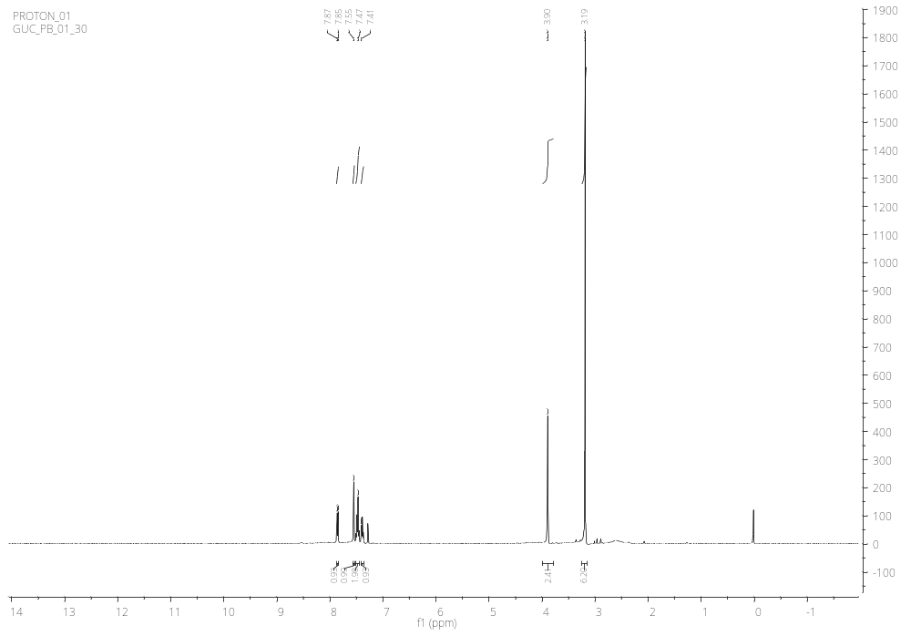
20.(E)-3-(dimethylamino)-2-phenylacrylonitrile 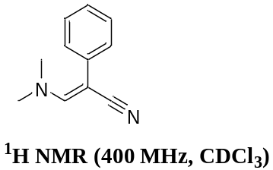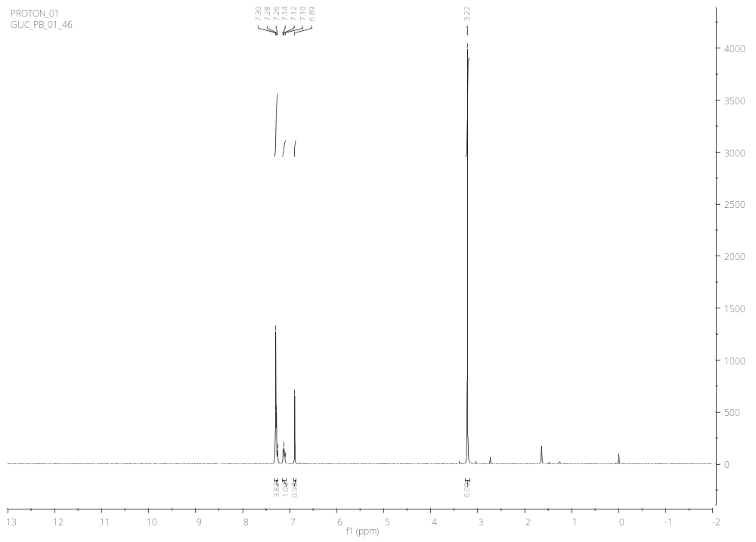
FTIR of (E)-3-(dimethylamino)-2-phenylacrylonitrile
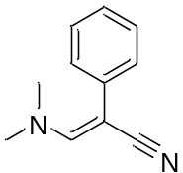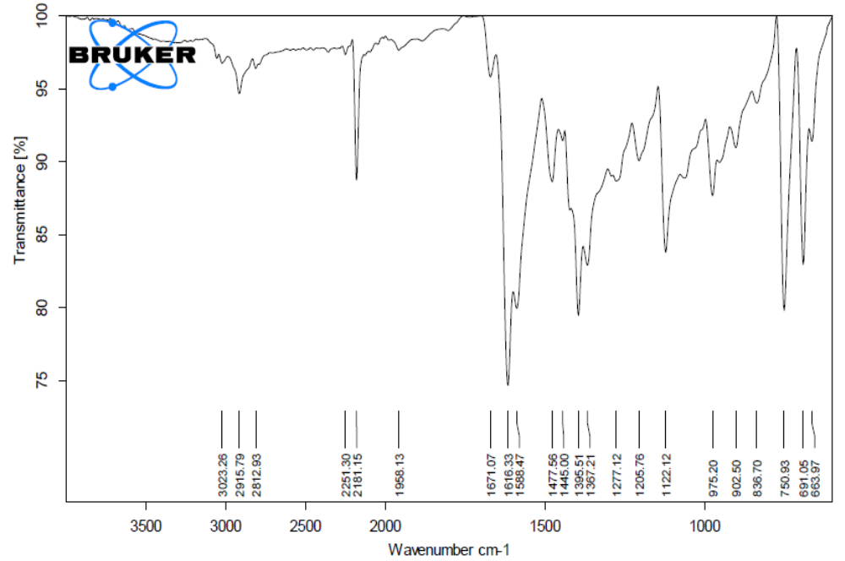
21. Ethyl (E)-2-cyano-3-(dimethylamino)acrylate
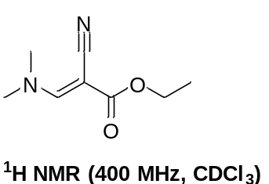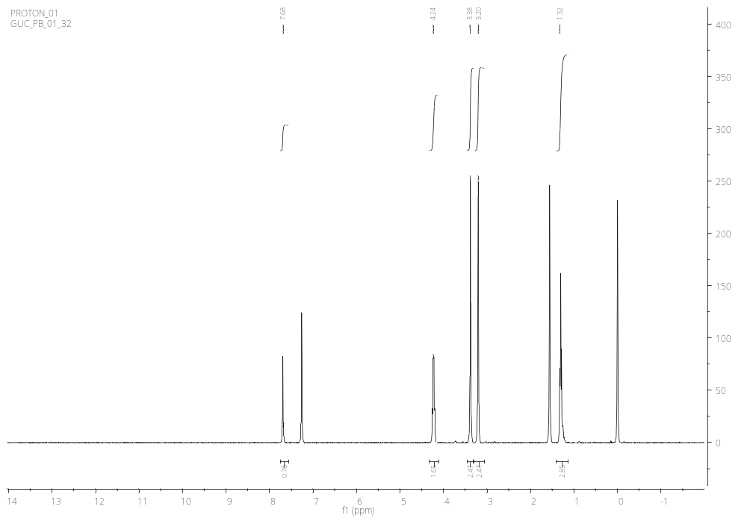
FTIR of ethyl (E)-2-cyano-3-(dimethylamino)acrylate
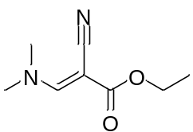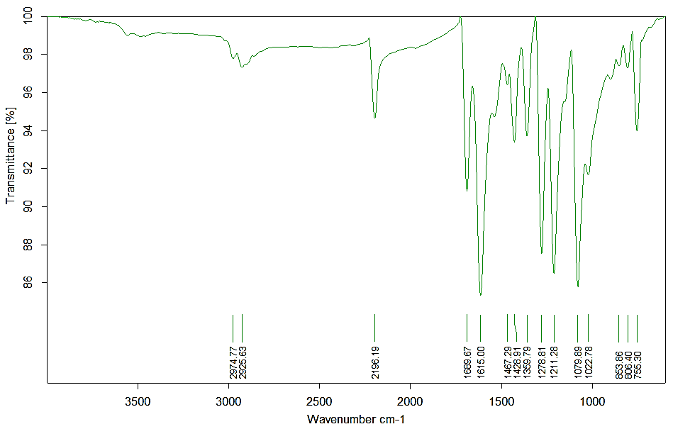
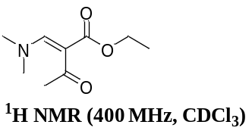22. Ethyl (E)-2-((dimethylamino)methylene)-3-oxobutanoate
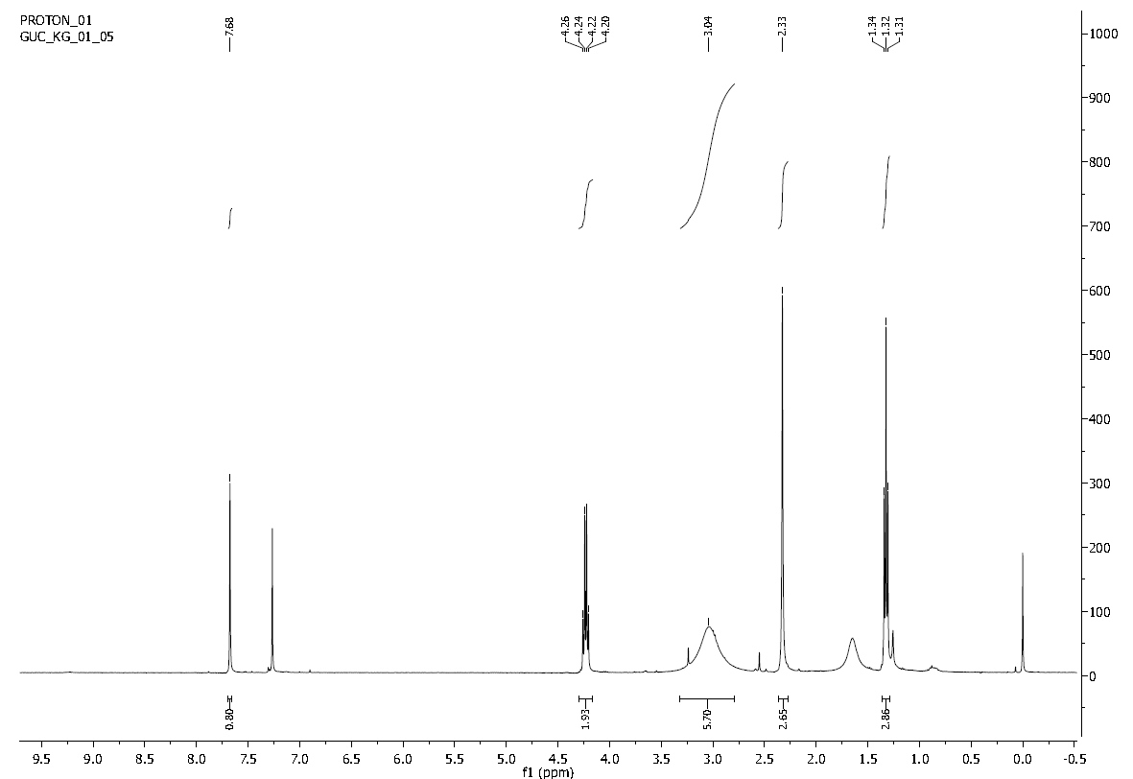
23. Diethyl 2-((dimethylamino)methylene)malonate
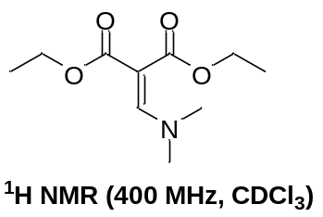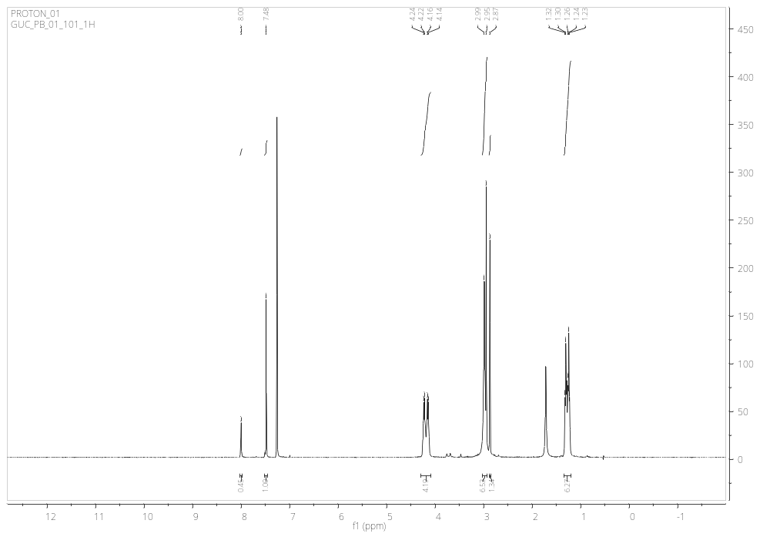
CH₃, DMF
CH, DMF
- References:
- Belov, P.; Campanella, V. L.; Smith, A. W.; Priefer, R. Tetrahedron Lett. 2011, 52, 2776-2779.
- Kumar, D.; Kommi, D. N.; Chopra, P.; Ansari, M.I.; Chakraborti, A.K. Eur. J. Org. Chem. 2012, 32, 6407-6413.
- Zhang, Ni. M.; Liang, J., X.; Jiang, Y.; Loh, T. P. Chem. Comm. 2017, 53, 12286-12289.
- Zeng, X.X.; Zheng, R.L.; Zhou, T.; He, H.Y.; Liu, J.Y.; Zheng, Y.; Tong, A.P.; Xiang, M.L.; Song, X.R.; Yang, S.Y.; Yu, L.T. Chem. Lett. 2010, 20, 6282-6285.
- Philip D. H.; Geroge M. M. 1972, United States Patent.
- RamaRao, R. J.; Rao, A. K. S.; Sreenivas, N.; Kumar, B. S.; Murthy, Y. L. N. J. Korean Chem. Soc. 2011, 55, 243-250.
- Gupton, J.T.; Crawford, E.; Mahoney, M.; Clark, E.; Curry, W.; Lane, A.; Shimozono, A.; Moore-Stoll, V.; Elofson, K.; Juekun, W.; Newton, M. Tetrahedron 2018, 74, 7408-7420.
- Gupton, J. T.; Lizzi, M. J.; Polk, D. Synth. Commun. 1982, 12, 939-946.
- Misra, A.; Dwivedi, J.; Shukla, S.; Kishore, D.; Sharma, S. J. Heterocycl. Chem. 2020, 57, 1545-1558.

