Table

Table: 4. Sulfated polyborate catalyzed synthesis of enamines and enaminonesª
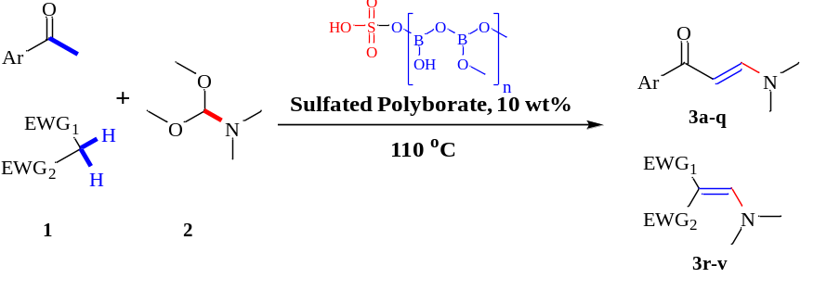
Entry | Ketones/Active Methylene | Product | Time | Yield (%)
 | 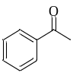 | 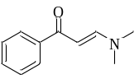 | 1 h 20 min. | 97^{b,c}
 | 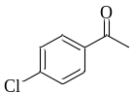 | 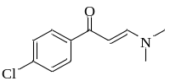 | 2 h. | 95^{b}
 | 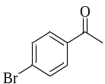 | 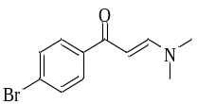 | 1 h 40 min. | 82.63^{b}
 | 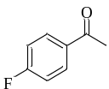 | 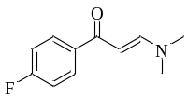 | 1 h 55 min. | 88.65^{b}
 | 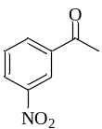 | 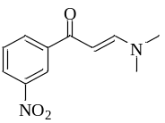 | 26 min. | 84^{b,c}
 | 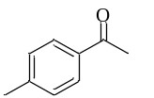 | 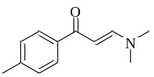 | 45 min. | 88^{b,c}
 | 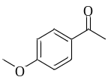 | 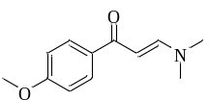 | 3 h. 40 min. | 90^{b,c,e}
 | 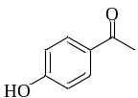 |  | 4 h. 40 min. | 88.5^{b,c,f}
 | 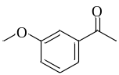 | 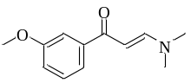 | 2 h. | 83^{b,c,g}
 | 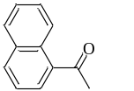 | 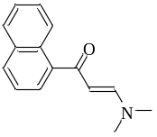 | 3 h. | 98^{b,c}
 | 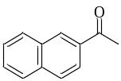 | 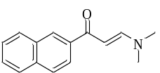 | 1 h. | 85.4^{b,d}
 | 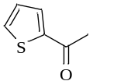 | 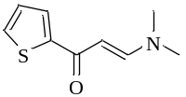 | 1 h. 27 min. | 98.85^{b,c}
 | 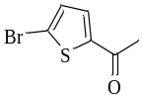 | 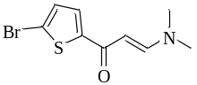 | 40 min. | 86.7^{b}
 | 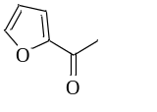 | 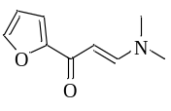 | 40 min. | 93.3^{b,c}
 | 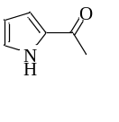 | 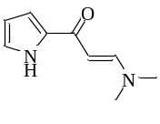 | 1 h | 74.66^{b}
 | 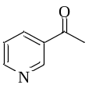 | 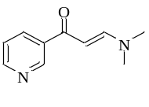 | 40 min. | 82.5^{b}
 | 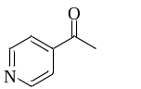 | 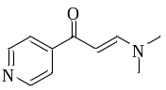 | 14 min. | 80.6^{b,c}
 | 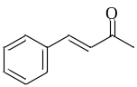 | 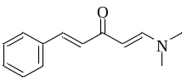 | 1 h 35 min. | 94%^{b,d}
 | 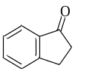 | 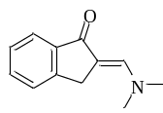 | 10 min. | 95.3^{b}
 | 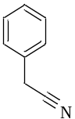 | 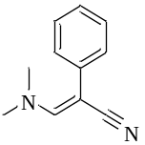 | 16 min. | 95.22^{b}
 | 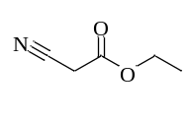 | 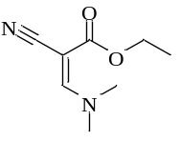 | 16 min. | 90%^{b,d}
 | 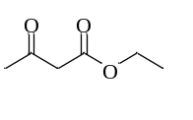 | 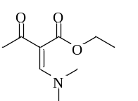 | 10 min. | 90%^{b,d}
 | 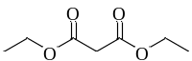 | 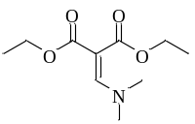 | 60 min. | 95%^{b,d}
ªReaction condition: ketone/active methylene (4 mmol), DMF-DMA (12 mmol), sulfated polyborate (10 wt%), 110 °C; ^{b}Isolation by extraction with chloroform; ^{c}Purification with hexanes: ethyl acetate; ^{d}Purification with toluene; ^{e}from 4’-methoxy acetophenone; ^{f}from 4’-hydroxy acetophenone; ^{g}from 3’-hydroxy acetophenone.

