Supplementary Material for
Impact of HIV infection and integrase strand transfer inhibitors-based treatment on the gut virome
Pablo Villoslada-Blanco¹, Patricia Pérez-Matute^{1§}, María Íñiguez¹, Emma Recio-Fernández ¹, Daan Jansen², Lander De Coninck², Lila Close², Pilar Blanco-Navarrete³, Luis Metola⁴, Valvanera Ibarra⁴, Jorge Alba⁴, Jelle Matthijnssens² and José A. Oteo^{1,4}.
¹Infectous Diseases, Microbiota and Metabolism Unit. Infectious Diseases Department, Center for Biomedical Research of La Rioja (CIBIR), Logroño, La Rioja, Spain.
²KU Leuven, Department of Microbiology, Immunology and Transplantation, Rega Institute, Laboratory of Viral Metagenomics, Leuven, Belgium.
³Centro de Salud Siete Infantes de Lara, Logroño, La Rioja, Spain.
⁴Infectious Diseases Department. Hospital Universitario San Pedro, Logroño, La Rioja, Spain.

§Corresponding author: Patricia Pérez-Matute
Infectious Diseases, Microbiota and Metabolism Unit. Infectious Diseases Department, Center for Biomedical Research of La Rioja (CIBIR), Logroño, La Rioja, Spain.
C/Piqueras 98
CIBIR building, third floor
26006 Logroño (La Rioja)
cpperez@riojasalud.es

Supplementary Table 1
Supplementary Table 2
Supplementary Table 3
Supplementary Figure 1
Supplementary Figure 2
Supplementary Table 1. INSTIs-based treatments used in HIV-infected patients.
INSTI | Backbone | Number of patients
Dolutegravir | Abacavir and lamivudine | 10/15 (66.67%)
Dolutegravir | Lamivudine | 2/15 (13.33%)
Bictegravir | Emtricitabine and tenofovir alafenamide | 3/15 (20.00%)
HIV (human immunodeficiency virus infection), INSTI (integrase strand transfer inhibitor).

Supplementary Table 2. Predicted lysogenic-specific genes and their functions.
Lysogenic-specific genes | Function
Integrase | Integrase
INTEGRASE | Integrase
Phage_integrase_family_protein | Integrase
SITE_SPECIFIC_RECOMBINASE_XERD | Integrase
Excisionase_from_transposon_Tn916 | Excisionase
DNA_binding_domain,_excisionase_family | Excisionase
Repressor_protein_CI | Repressor
P22_AR_repressor_domain_protein | Repressor
REPRESSOR_PROTEIN | Repressor
Cro/C1-type_HTH_DNA-binding_domain | Repressor
Phage_regulatory_protein_Rha_(Phage_pRha) | Repressor
Uncharacterized_ATPase,_putative_transposase | Transposase
MU TRANSPOSASE | Transposase
PROPHAGE_LAMBDALM01_ANTIGEN | Prophage domain
Mu-like_prophage_DNA_circulation_protein | Prophage domain
Mu-like_prophage_I_protein | Prophage domain
ParB protein | Lysogenic recombination
CHROMOSOME_PARTITIONING_PROTEIN_PARB | Lysogenic recombination

 | Control | Naive | INSTIs-treated | p value
Number of patients | 26 | 15 | 15 | -
Gender (men) | 9/26 (34.62%) | 13/15 (86.67%) ** | 12/15 (80.00%) ** | 0.002
Age (years) | 43.58±2.31 | 33.87±2.85 * | 43.67±3.39 | 0.033
BMI (kg/m²) | 24.30±0.69 | 23.23±1.05 | 23.51±0.85 | 0.616
Waist circumference (cm) | 85.35±2.55 | 83.83±2.86 | 85.13±2.15 | 0.916
Systolic blood pressure (mmHg) | 120.58±2.76 | 135.67±5.67 * | 129.73±6.02 | 0.050
Diastolic blood pressure (mmHg) | 72.19±1.94 | 81.87±3.31 * | 77.80±3.24 | 0.035
Alcohol active | 3/26 (11.54%) | 0/15 (0.00%) | 1/15 (6.67%) | 0.578
Smoking active | 3/26 (11.54%) | 7/15 (46.67%) * | 10/15 (66.67%) *** | 0.001
Basal CD4 (cells/µl) | - | 464.07±76.46 | 850.53±101.68 | 0.006
Nadir CD4 (cells/ µl) | - | 464.07±76.46 | 526.53 ± 56.30 | 0.517
CD4/CD8 ratio | - | 0.53±0.13 | 0.84±0.10 | 0.027
Mode of transmission | - | HS: 6/15 (40.00%) | HS: 7/15 (46.67%) | 0.716
Mode of transmission | - | MSM: 9/15 (60.00%) | MSM: 7/15 (46.67%) | 0.716
Mode of transmission | - | Parenteral: 0/15 (0.00%) | Parenteral: 1/15 (6.66%) | 0.716
AIDS | - | 1/15 (6.67%) | 0/15 (0.00%) | 1
Coinfection with virus C | - | 0/15 (0.00%) | 2/15 (13.33%) | 0.483
Coinfection with virus B | - | 0/15 (0.00%) | 0/15 (0.00%) | 1
Supplementary Table 3. Characteristics of healthy uninfected controls and HIV-infected patients (naive and under INSTIs).
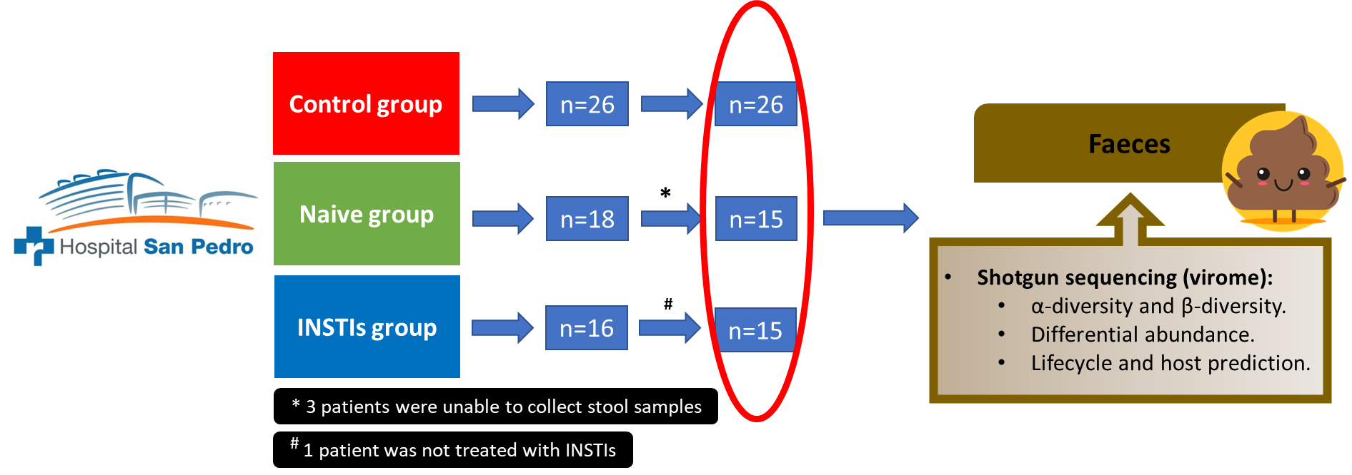
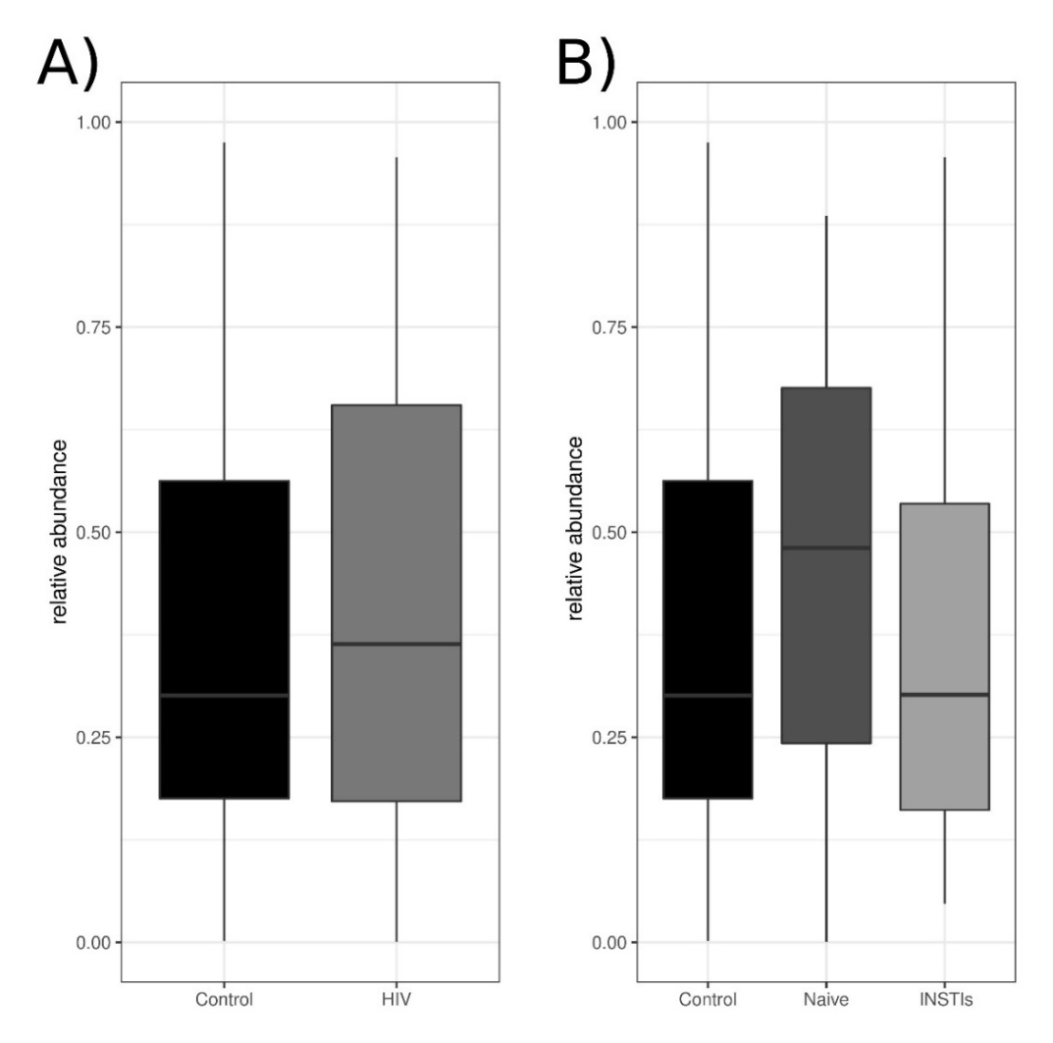
Qualitative variables are represented in percentage while quantitative variables are represented as mean ± standard error mean. P value refers to the comparation between two (naive vs. ART) or three (control vs. naive vs. ART) groups, as appropriate. Statistically significant p values are in bold. Asterisks indicate statistically significant differences with respect to control group (*p<0.05, **p<0.01 and ***p<0.001). AIDS (acquired immunodeficiency syndrome), BMI (body mass index), HS (heterosexual), INSTIs (integrase strand transfer inhibitors-based treatment), MSM (men who have sex with men).
Supplementary Figure 1. Flowchart of patient recruitment. INSTIs (integrase strand transfer inhibitors-based treatment).
Supplementary Figure 2. Relative abundance of the lysogenic phages belonging to Caudoviricetes class comparing control group vs. HIV-infected patients (A) and control group vs. naive patients vs. INSTIs-treated patients (B). HIV (human immunodeficiency virus), INSTIs (integrase strand transfer inhibitors-based treatment).

