Supplementary data
Supplementary Table 1. HADS/KDQOL scores between treatment groups
 | HD  (n=50) | PD  (n=50) | CM  (n=50) | CM stage 5  (n=31)
HADS anxiety score | 7.16 ± 3.95 | 4.56 ± 3.66 | 4.56 ± 3.98 | 5.38 ± 3.78
HADS depression score | 6.12 ± 4.24 | 4.70 ± 3.43 | 4.38 ± 4.60 | 4.77 ± 4.31
Composite physical score | 63.24 ± 9.64 | 57.26 ± 10.98 | 66.19 ± 7.73 | 64.95 ± 8.37
Physical functioning | 48.70 ± 11.59 | 50.0 ± 9.04 | 51.50 ± 10.31 | 51.45 ± 10.10
Role-physical | 60.0 ± 35.36 | 56.0 ± 35.56 | 82.50 ± 26.85 | 79.03 ± 29.65
Pain | 86.05 ± 16.69 | 76.90 ± 24.26 | 85.80 ± 17.03 | 84.03 ± 17.23
Composite mental score | 53.56 ± 9.27 | 48.56 ± 6.55 | 50.70 ± 7.59 | 51.15 ± 7.49
Emotional well-being | 40.40 ± 10.04 | 55.0 ± 9.85 | 54.60 ± 7.48 | 55.32 ± 7.85
Role-emotional | 46.67 ± 32.30 | 34.67 ± 32.27 | 32.0 ± 27.73 | 36.56 ± 27.70
Social functioning | 59.25 ± 17.8 | 49.75 ± 18.98 | 55.75 ± 14.77 | 53.63 ± 15.54

Supplementary data: HADS anxiety and depression scores

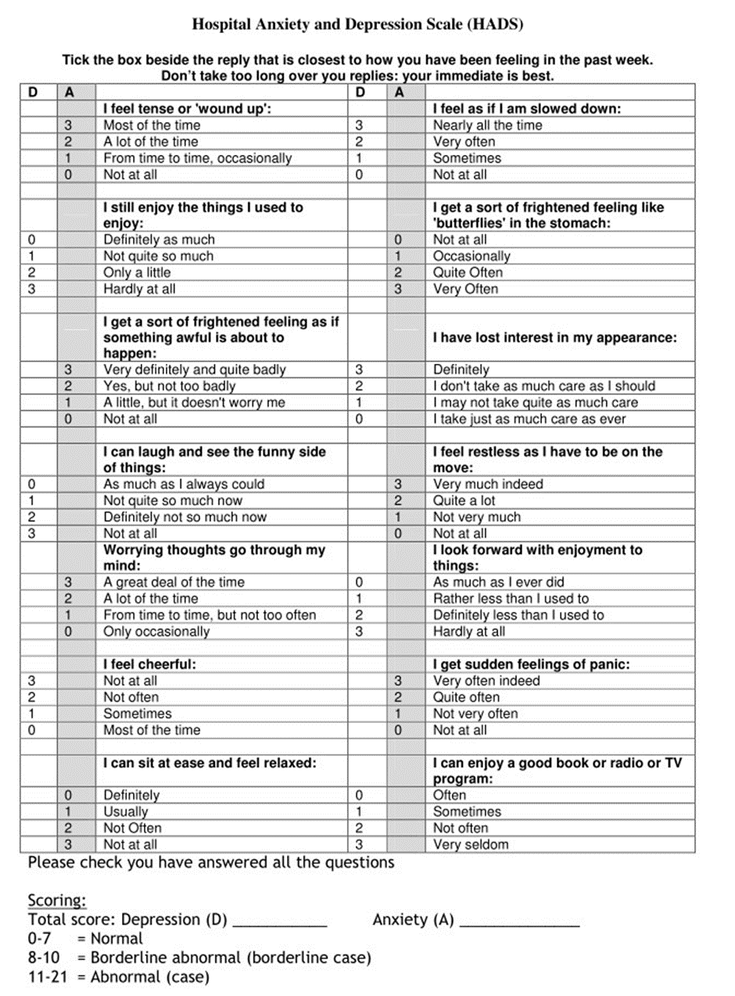

Supplementary data: KDQOL-36 survey

