Supporting Information

An Investigation into the Structural, Electronic, and Non-Linear Optical Properties in C_{N} (N=20, 24, 26, 28, 30, 32, 34, 36, and 38) Fullerene Cages

K. Soyarslan¹, B. Ortatepe¹, B. Yurduguzel², M. T. Güllüoğlu³ and Y. Erdogdu^{1*}

¹Department of Physics, Faculty of Science, Gazi University, 06500 Teknikokullar, Ankara, Turkey
²Programme of Electric and Energy, Kaman Technical Vocational School of Higher Education, Ahi Evran University, 40040, Kirsehir, Turkey
³Department of Electric and Electronic Engineering, Faculty of Engineering, Harran University, Sanliurfa, Turkey

*Corresponding author.
E-mail address: yerdogdu@gazi.edu.tr (Y. Erdogdu)

Table S1. Optimized energy, charge, multiplicity and symmetry of the C20 fullerene cage
 | Symm. | P/H | Charge | Multi. | Opt. Energy (a.u.) | Rel. Ener.  (k. cal/mol) | Geometry
1 | D₂ | 12/0 | -1 | Doublet (2) | -761.66873178 | 0.000 | 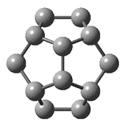
 |  |  |  | Quartet (4) | -761.66455267 | 2.622
1 | D₂ | 12/0 | 0 | Singlet (1) | -761.59274170 | 0.000
 |  |  |  | Triplet (3) | -761.58969760 | 1.910
1 | D₂ | 12/0 | 1 | Doublet (2) | -761.33639729 | 0.000
 |  |  |  | Quartet (4) | -761.26045833 | 47.652

Table S2. Optimized energy, charge, multiplicity and symmetry of the C24 fullerene cage
 | Symm. | P/H | Charge | Multi. | Opt. Energy (a.u.) | Rel. Ener.  (k. cal/mol)
1 | D₆ | 12/2 | -1 | Doublet (2) | -914.117687330 | 0.000 | 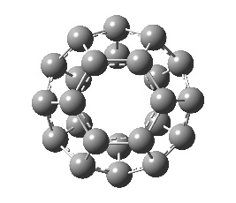
 |  |  |  | Quartet (4) | -914.095364460 | 14.008
1 | D₆ | 12/2 | 0 | Singlet (1) | -914.016223017 | 0.000
 |  |  |  | Triplet (3) | -914.009088174 | 4.477
1 | D₆ | 12/2 | +1 | Doublet (2) | -913.732812184 | 3.244
 |  |  |  | Quartet (4) | -913.737981349 | 0.000
 |  |  |  | Sextet (6) | -913.720383069 | 11.043

Table S3. Optimized energy, multiplicity and symmetry of the C26 fullerene cage
 | Symm. | P/H | Charge | Multi. | Opt. Energy (a.u.) | Rel. Ener.  (k. cal/mol)
1 | D_{3h} | 12/3 | -1 | Doublet (2) | -990.34751324 | 12.64 | 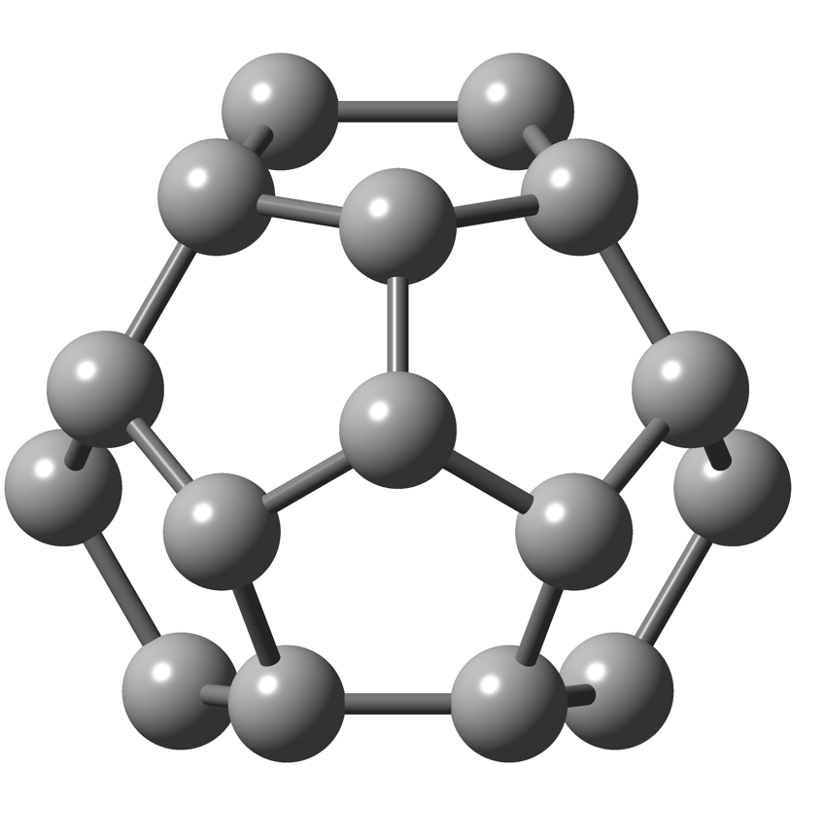
 |  |  |  | Quartet (4) | -990.36767126 | 0.000
 |  |  |  | Sextet (6) | -990.31978879 | 30.04
1 | D_{3h} | 12/3 | 0 | Singlet (1) | -990.22775763 | 20.88
 |  |  |  | Triplet (3) | -990.23847751 | 14.15
 |  |  |  | Quintet (5) | -990.26103602 | 0.000
 |  |  |  | Septet (7) | -990.214870013 | 28.97
1 | D_{3h} | 12/3 | +1 | Doublet (2) | -989.96104259 | 19.08
 |  |  |  | Quartet (4) | -989.97396762 | 10.97
 |  |  |  | Sextet (6) | -989.99145726 | 0.000
 |  |  |  | Octet (8) | -989.92919267 | 39.07

Table S4. Optimized energy, multiplicity and symmetry of the C28 fullerene cage
 | Symm. | P/H | Charge | Multi. | Opt. Energy (a.u.) | Rel. Ener.  (k. cal/mol) | Geometry
1 | D₂ | 12/4 | -1 | Doublet (2) | -1066.61371802 | 0.000 | 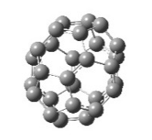
 |  |  |  | Quartet (4) | -1066.56763002 | 28.92
1 | D₂ | 12/4 | 0 | Singlet (1) | -1066.49407671 | 0.000
 |  |  |  | Triplet (3) | -1066.48517587 | 5.585
1 | D₂ | 12/4 | +1 | Doublet (2) | -1066.21361706 | 0.000
 |  |  |  | Quartet (4) | -1066.20488704 | 5.478
2- | T_{d} | 12/4 | -1 | Doublet (2) | -1066.62648336 | 11.50 | 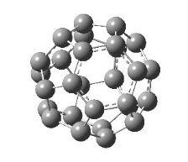
 |  |  |  | Quartet (4) | -1066.64480935 | 0.000
 |  |  |  | Sextet (6) | -1066.57795655 | 41.95
2- | T_{d} | 12/4 | 0 | Singlet (1) | -1066.50408346 | 21.86
 |  |  |  | Triplet (3) | -1066.51690226 | 13.82
 |  |  |  | Quintet (5) | -1066.53892935 | 0.000
 |  |  |  | Septet (7) | -1066.43942701 | 62.43
2- | T_{d} | 12/4 | +1 | Doublet (2) | -1066.23327072 | 8.493
 |  |  |  | Quartet (4) | -1066.24680463 | 0.000
 |  |  |  | Sextet (6) | -1066.24157373 | 3.282

Table S5. Optimized energy, multiplicity and symmetry of the C30 fullerene cage
 | Symm. | P/H | Charge | Multi. | Opt. Energy (a.u.) | Rel. Ener.  (k. cal/mol) | Geometry
1 | D_{5h} | 12/5 | -1 | Doublet (2) | -1142.78997183 | 0.000 | 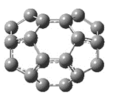
 |  |  |  | Quartet (4) | -1142.78733949 | 1.652
1 | D_{5h} | 12/5 | 0 | Singlet (1) | -1142.68662099 | 0.000
 |  |  |  | Triplet (3)” | -1142.68338898 | 2.028
1 | D_{5h} | 12/5 | +1 | Doublet (2) | -1142.42978072 | 0.000
 |  |  |  | Quartet (4) | -1142.40357980 | 16.44
2 | C_{2v} | 12/5 | -1 | Doublet (2) | -1142.86772010 | 0.000 | 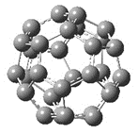
 |  |  |  | Quartet (4) | -1142.83982842 | 17.50
2 | C_{2v} | 12/5 | 0 | Singlet (1) | -1142.76714208 | 0.000
 |  |  |  | Triplet (3) | -1142.74033678 | 16.82
2 | C_{2v} | 12/5 | +1 | Doublet (2) | -1142.48175205 | 0.000
 |  |  |  | Quartet (4) | -1142.45602872 | 16.14
3 | C_{2v} | 12/5 | -1 | Doublet (2) | -1142.90170966 | 0.000 | 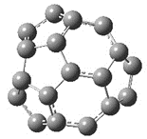
 |  |  |  | Quartet (4) | -1142.86665052 | 22.00
3 | C_{2v} | 12/5 | 0 | Singlet (1) | -1142.77329993 | 1.423
 |  |  |  | Triplet (3) | -1142.77556826 | 0.000
 |  |  |  | Quintet (5) | -1142.73456302 | 25.73
3 | C_{2v} | 12/5 | +1 | Doublet (2) | -1142.49658278 | 0.000
 |  |  |  | Quartet (4) | -1142.48698280 | 6.024

Table S6. Optimized energy, multiplicity and symmetry of the C32 fullerene cage
 | Symm. | P/H | Charge | Multi. | Opt. Energy (a.u.) | Rel. Ener.  (k. cal/mol) | Geometry
1 | C₂ | 12/6 | -1 | Doublet (2) | -1219.08433028 | 0.000 | 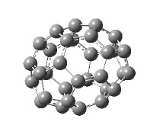
 |  |  |  | Quartet (4) | -1219.07827134 | 3.802
1 | C₂ | 12/6 | 0 | Singlet (1) | -1218.97653261 | 0.000
 |  |  |  | Triplet (3) | -1218.97517418 | 0.852
1 | C₂ | 12/6 | +1 | Doublet (2) | -1218.71726794 | 0.000
 |  |  |  | Quartet (4) | -1218.68828371 | 18.18
2 | D₂ | 12/6 | -1 | Doublet (2) | -1219.05993514 | 0.000 | 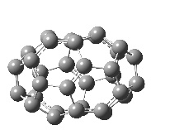
 |  |  |  | Quartet (4) | -1219.04491956 | 9.422
2 | D₂ | 12/6 | 0 | Singlet (1) | -1218.95901242 | 0.000
 |  |  |  | Triplet (3) | -1218.95071300 | 5.208
2 | D₂ | 12/6 | +1 | Doublet (2) | -1218.69594891 | 0.000
 |  |  |  | Quartet (4) | -1218.66507947 | 19.37
3 | D_{3d} | 12/6 | -1 | Doublet (2) | -1219.05276807 | 0.000 | 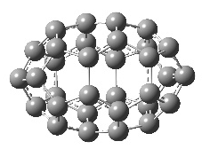
 |  |  |  | Quartet (4) | -1219.04889752 | 2.429
3 | D_{3d} | 12/6 | 0 | Singlet (1) | -1218.94522008 | 0.000
 |  |  |  | Triplet (3) | -1218.93837565 | 4.295
3 | D_{3d} | 12/6 | +1 | Doublet (2) | -1218.68441781 | 0.000
 |  |  |  | Quartet (4) | -1218.65787494 | 16.65
4 | C₂ | 12/6 | -1 | Doublet (2) | -1219.12744119 | 0.000 | 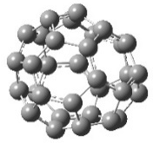
 |  |  |  | Quartet (4) | -1219.09503162 | 20.33
4 | C₂ | 12/6 | 0 | Singlet (1) | -1219.02251592 | 0.000
 |  |  |  | Triplet (3) | -1219.00146252 | 13.21
4 | C₂ | 12/6 | +1 | Doublet (2) | -1218.74578313 | 0.000
 |  |  |  | Quartet (4) | -1218.71681096 | 18.18
5 | D_{3h} | 12/6 | -1 | Doublet (2) | -1219.02835019 | 0.000 | 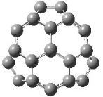
 |  |  |  | Quartet (4) | -1218.99567738 | 20.50
5 | D_{3h} | 12/6 | 0 | Singlet (1) | -1218.93884942 | 0.000
 |  |  |  | Triplet (3) | -1218.89209592 | 29.33
5 | D_{3h} | 12/6 | +1 | Doublet (2) | -1218.65609040 | 0.000
 |  |  |  | Quartet (4) | -1218.62677574 | 18.39
6 | D₃ | 12/6 | -1 | Doublet (2) | -1219.16518266 | 0.000
 |  |  |  | Quartet (4) | -1219.10423510 | 38.24
6 | D₃ | 12/6 | 0 | Singlet (1) | -1219.06353687 | 0.000
 |  |  |  | Triplet (3) | -1219.01991849 | 27.37
6 | D₃ | 12/6 | +1 | Doublet (2) | -1218.76939309 | 0.000
 |  |  |  | Quartet (4) | -1218.72831882 | 25.77

Table S7. Optimized energy, multiplicity and symmetry of the C34 fullerene cage
 | Symm. | P/H | Charge | Multi. | Opt. Energy (a.u.) | Rel. Ener.  (k. cal/mol) |  | Geometry
1 | C₂ | 12/7 | -1 | Doublet (2) | -1295.26317654 | 0.000 |  | 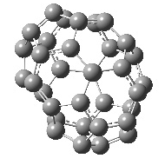
 |  |  |  | Quartet (4) | -1295.25263333 | 6.616
1 | C₂ | 12/7 | 0 | Singlet (1) | -1295.15244632 | 0. 000
 |  |  |  | Triplet (3) | -1295.14537342 | 4.438
1 | C₂ | 12/7 | +1 | Doublet (2) | -1294.88870999 | 0.000
 |  |  |  | Quartet (4) | -1294.88459276 | 2.584
2 | C_{s} | 12/7 | -1 | Doublet (2) | -1295.34358001 | 0.000 |  | 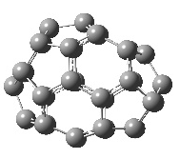
 |  |  |  | Quartet (4) | -1295.33931547 | 2.676
2 | C_{s} | 12/7 | 0 | Singlet (1) | -1295.21709231 | 4.956
 |  |  |  | Triplet (3) | -1295.22499074 | 0.000
 |  |  |  | Quintet (5) | -1295.22289551 | 1.315
2 | C_{s} | 12/7 | +1 | Doublet (2) | -1294.95826980 | 7.474
 |  |  |  | Quartet (4) | -1294.97018078 | 0.000
 |  |  |  | Sextet (6) | -1294.93313045 | 23.24
3 | C_{s} | 12/7 | -1 | Doublet (2) | -1295.33572233 | 0.000 |  | 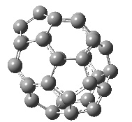
 |  |  |  | Quartet (4) | -1295.31562528 | 12.61
3 | C_{s} | 12/7 | 0 | Singlet (1) | -1295.22354998 | 0.000
 |  |  |  | Triplet (3) | -1295.22147101 | 1.305
3 | C_{s} | 12/7 | +1 | Doublet (2) | -1294.96501613 | 0.000
 |  |  |  | Quartet (4) | -1294.93524096 | 18.68
4 | C₂ | 12/7 | -1 | Doublet (2) | -1295.35512283 | 0.000 |  | 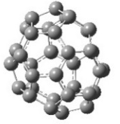
 |  |  |  | Quartet (4) | -1295.33867809 | 10.31
4 | C₂ | 12/7 | 0 | Singlet (1) | -1295.24849989 | 0.000
 |  |  |  | Triplet (3) | -1295.23782771 | 6.697
4 | C₂ | 12/7 | +1 | Doublet (2) | -1294.98245467 | 0.000
 |  |  |  | Quartet (4) | -1294.96396884 | 11.60
5 | C₂ | 12/7 | -1 | Doublet (2) | -1295.37425385 | 0.000 | 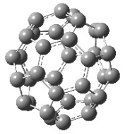
 |  |  |  | Quartet (4) | -1295.36423778 | 6.285
5 | C₂ | 12/7 | 0 | Singlet (1) | -1295.25734143 | 8.113
 |  |  |  | Triplet (3) | -1295.27027046 | 0.000
 |  |  |  | Quintet (5) | -1295.22843301 | 26.25
5 | C₂ | 12/7 | +1 | Doublet (2) | -1295.00596497 | 0.000
 |  |  |  | Quartet (4) | -1294.98313270 | 14.32
6 | C_{3v} | 12/7 | -1 | Doublet (2) | -1295.33159628 | 0.000 | 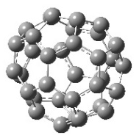
 |  |  |  | Quartet (4) | -1295.32747151 | 2.588
6 | C_{3v} | 12/7 | 0 | Singlet (1) | -1295.21726312 | 2.375
 |  |  |  | Triplet (3) | -1295.22104828 | 0.000
 |  |  |  | Quintet (5) | -1295.18492272 | 22.66
6 | C_{3v} | 12/7 | +1 | Doublet (2) | -1294.96297733 | 0.000
 |  |  |  | Quartet (4) | -1294.93224286 | 19.28

Table S8. Optimized energy, multiplicity and symmetry of the C36 fullerene cage
 | Symm. | P/H | Charge | Multi. | Opt. Energy (a.u.) | Rel. Ener.  (k. cal/mol) | Geometry
1 | C₂ | 12/8 | -1 | Doublet (2) | -1371.50226748 | 0.000 | 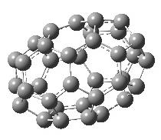
 |  |  |  | Quartet (4) | -1371.49487652 | 4.638
1 | C₂ | 12/8 | 0 | Singlet (1) | -1371.37921052 | 3.302
 |  |  |  | Triplet (3) | -1371.38447219 | 0.000
 |  |  |  | Quartet (4) | -1371.37693594 | 4.729
1 | C₂ | 12/8 | +1 | Doublet (2) | -1371.11859922 | 4.102
 |  |  |  | Quintet (5) | -1371.12513618 | 0.000
 |  |  |  | Sextet (6) | -1371.10451275 | 12.94
2 | D₂ | 12/8 | -1 | Doublet (2) | -1371.44874083 | 0.000 | 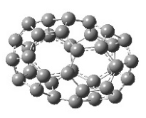
 |  |  |  | Quartet (4) | -1371.42811728 | 12.94
2 | D₂ | 12/8 | 0 | Singlet (1) | -1371.34322711 | 0.000
 |  |  |  | Triplet (3) | -1371.33167320 | 7.250
2 | D₂ | 12/8 | +1 | Doublet (2) | -1371.08315179 | 0.000
 |  |  |  | Quintet (5) | -1371.05389722 | 18.35
3 | C₁ | 12/8 | -1 | Doublet (2) | -1371.54303060 | 0.000 | 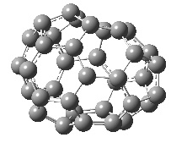
 |  |  |  | Quartet (4) | -1371.53802337 | 3.142
3 | C₁ | 12/8 | 0 | Singlet (1) | -1371.42372598 | 0.755
 |  |  |  | Triplet (3) | -1371.42492853 | 0.000
 |  |  |  | Quartet (4) | -1371.41346696 | 7.192
3 | C₁ | 12/8 | +1 | Doublet (2) | -1371.16507121 | 0.000
 |  |  |  | Quintet (5) | -1371.15874222 | 3.972
4 | C_{s} | 12/8 | -1 | Doublet (2) | -1371.51590814 | 0.000 | 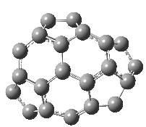
 |  |  |  | Quartet (4) | -1371.49570673 | 12.67
4 | C_{s} | 12/8 | 0 | Singlet (1) | -1371.39495343 | 1.562
 |  |  |  | Triplet (3) | -1371.39744268 | 0.000
 |  |  |  | Quartet (4) | -1371.37509289 | 14.02
4 | C_{s} | 12/8 | +1 | Doublet (2) | -1371.12875885 | 3.442
 |  |  |  | Quintet (5) | -1371.13424460 | 0.000
 |  |  |  | Sextet (6) | -1371.10458482 | 18.61
5 | D₂ | 12/8 | -1 | Doublet (2) | -1371.48612304 | 0.000 | 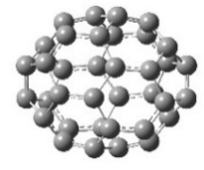
 |  |  |  | Quartet (4) | -1371.45620964 | 18.77
5 | D₂ | 12/8 | 0 | Singlet (1) | -1371.37450366 | 0.000
 |  |  |  | Triplet (3) | -1371.36282390 | 7.329
5 | D₂ | 12/8 | +1 | Doublet (2) | -1371.10702614 | 0.000
 |  |  |  | Quintet (5) | -1371.08497140 | 13.84
6 | D_{2d} | 12/8 | -1 | Doublet (2) | -1371.57042980 | 0.000 | 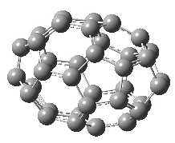
 |  |  |  | Quartet (4) | -1371.56267249 | 4.868
6 | D_{2d} | 12/8 | 0 | Singlet (1) | -1371.46801640 | 0.000
 |  |  |  | Triplet (3) | -1371.45425193 | 8.637
6 | D_{2d} | 12/8 | +1 | Doublet (2) | -1371.20680805 | 0.000
 |  |  |  | Quintet (5) | -1371.18075775 | 16.34

Table S8 (cont.). Optimized energy, multiplicity and symmetry of the C36 fullerene cage
 | Symm. |  | P/H |  |  | Charge |  | Multi. |  | Opt. Energy (a.u.) |  | Rel. Ener.  (k. cal/mol) |  |  | Geometry
7 |  | C₁ |  | 12/8 |  |  | -1 |  | Doublet (2) |  | -1371.57760790 |  |  | 0.000 |  | 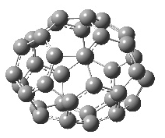
 |  |  |  |  |  |  |  |  | Quartet (4) |  | -1371.55553841 |  |  | 13.84
 |  |  |  |  |  |  | 0 |  | Singlet (1) |  | -1371.45943847 |  |  | 0.362
 |  |  |  |  |  |  |  |  | Triplet (3) |  | -1371.46001463 |  |  | 0.000
 |  |  |  |  |  |  |  |  | Quartet (4) |  | -1371.43228920 |  |  | 17.39
 |  |  |  |  |  |  | +1 |  | Doublet (2) |  | -1371.19845555 |  |  | 0.000
 |  |  |  |  |  |  |  |  | Quintet (5) |  | -1371.19382641 |  |  | 2.905
8 |  | C_{s} |  | 12/8 |  |  | -1 |  | Doublet (2) |  | -1371.59409724 |  |  | 0.000 |  | 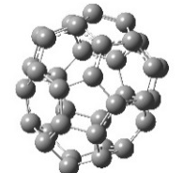
 |  |  |  |  |  |  |  |  | Quartet (4) |  | -1371.57483121 |  |  | 12.09
 |  |  |  |  |  |  | 0 |  | Singlet (1) |  | -1371.48007237 |  |  | 0.000
 |  |  |  |  |  |  |  |  | Triplet (3) |  | -1371.46928588 |  |  | 6.769
 |  |  |  |  |  |  | +1 |  | Doublet (2) |  | -1371.21436488 |  |  | 0.000
 |  |  |  |  |  |  |  |  | Quintet (5) |  | -1371.20339699 |  |  | 6.882
9 |  | C_{2v} |  | 12/8 |  |  | -1 |  | Doublet (2) |  | -1371.61493839 |  |  | 0.000 |  | 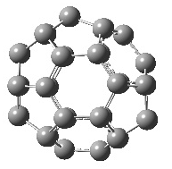
 |  |  |  |  |  |  |  |  | Quartet (4) |  | -1371.60015262 |  |  | 9.278
 |  |  |  |  |  |  | 0 |  | Singlet (1) |  | -1371.50756305 |  |  | 0.000
 |  |  |  |  |  |  |  |  | Triplet (3) |  | -1371.50339270 |  |  | 2.617
 |  |  |  |  |  |  | +1 |  | Doublet (2) |  | -1371.24830478 |  |  | 0.000
 |  |  |  |  |  |  |  |  | Quintet (5) |  | -1371.24024800 |  |  | 5.056
10 |  | C₂ |  | 12/8 |  |  | -1 |  | Doublet (2) |  | -1371.55962597 |  |  | 0.000 |  | 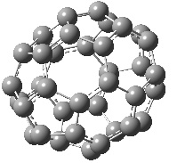
 |  |  |  |  |  |  |  |  | Quartet (4) |  | -1371.55317800 |  |  | 4.046
 |  |  |  |  |  |  | 0 |  | Singlet (1) |  | -1371.44211576 |  |  | 0.373
 |  |  |  |  |  |  |  |  | Triplet (3) |  | -1371.44270968 |  |  | 0.000
 |  |  |  |  |  |  |  |  | Quartet (4) |  | -1371.43068846 |  |  | 7.543
 |  |  |  |  |  |  | +1 |  | Doublet (2) |  | -1371.18396947 |  |  | 0.000
 |  |  |  |  |  |  |  |  | Quintet (5) |  | -1371.17784423 |  |  | 3.844
11 |  | C₂ |  |  | 12/8 |  | -1 |  | Doublet (2) |  | -1371.61471502 |  | 0.000 |  |  | 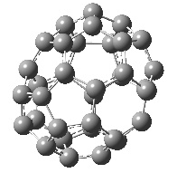
 |  |  |  |  |  |  |  |  | Quartet (4) |  | -1371.58669279 |  | 17.58
 |  |  |  |  |  |  | 0 |  | Singlet (1) |  | -1371.49799941 |  | 0.000
 |  |  |  |  |  |  |  |  | Triplet (3) |  | -1371.49627672 |  | 1.081
 |  |  |  |  |  |  | +1 |  | Doublet (2) |  | -1371.23523838 |  | 0.000
 |  |  |  |  |  |  |  |  | Quintet (5) |  | -1371.22932153 |  | 3.713
12 |  | C₂ |  |  | 12/8 |  | -1 |  | Doublet (2) |  | -1371.62122176 |  | 0.000 |  |  | 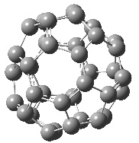
 |  |  |  |  |  |  |  |  | Quartet (4) |  | -1371.59869851 |  | 14.13
 |  |  |  |  |  |  | 0 |  | Singlet (1) |  | -1371.50827452 |  | 0.000
 |  |  |  |  |  |  |  |  | Triplet (3) |  | -1371.50696255 |  | 0.823
 |  |  |  |  |  |  | +1 |  | Doublet (2) |  | -1371.24961710 |  | 0.000
 |  |  |  |  |  |  |  |  | Quintet (5) |  | -1371.23968410 |  | 6.233

Table S8 (cont.). Optimized energy, multiplicity and symmetry of the C36 fullerene cage

 | Symm. |  | P/H |  | Charge |  | Multi. |  | Opt. Energy (a.u.) |  | Rel. Ener.  (k. cal/mol) |  | Geometry
13 |  | D_{3h} |  | 12/8 |  | -1 |  | Doublet (2) |  | -1371.57416643 |  | 0.000 |  | 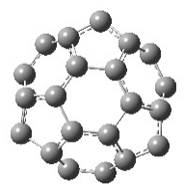
 |  |  |  |  |  |  |  | Quartet (4) |  | -1371.54661194 |  | 17.29
 |  |  |  |  |  | 0 |  | Singlet (1) |  | -1371.45426904 |  | 0.000
 |  |  |  |  |  |  |  | Triplet (3) |  | -1371.44987918 |  | 2.755
 |  |  |  |  |  | +1 |  | Doublet (2) |  | -1371.18967959 |  | 0.000
 |  |  |  |  |  |  |  | Quintet (5) |  | -1371.18622995 |  | 2.165
14 |  | D_{2d} |  | 12/8 |  | -1 |  | Doublet (2) |  | -1371.61579884 |  | 3.574 |  | 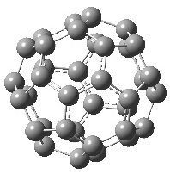
 |  |  |  |  |  |  |  | Quartet (4) |  | -1371.62149511 |  | 0.000
 |  |  |  |  |  |  |  | Sextet (6) |  | -1371.59444617 |  | 16.97
 |  |  |  |  |  | 0 |  | Singlet (1) |  | -1371.50211233 |  | 8.794
 |  |  |  |  |  |  |  | Triplet (3) |  | -1371.51612630 |  | 0.000
 |  |  |  |  |  |  |  | Quartet (4) |  | -1371.49275653 |  | 14.66
 |  |  |  |  |  | +1 |  | Doublet (2) |  | -1371.25946386 |  | 0.000
 |  |  |  |  |  |  |  | Quintet (5) |  | -1371.24624250 |  | 8.297
15 |  | D_{6h} |  | 12/8 |  | -1 |  | Doublet (2) |  | -1371.62912672 |  | 0.000 |  | 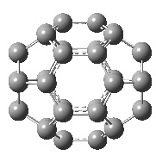
 |  |  |  |  |  |  |  | Quartet (4) |  | -1371.61463525 |  | 9.094
 |  |  |  |  |  | 0 |  | Singlet (1) |  | -1371.51474954 |  | 2.664
 |  |  |  |  |  |  |  | Triplet (3) |  | -1371.51899435 |  | 0.000
 |  |  |  |  |  |  |  | Quartet (4) |  | -1371.48784602 |  | 19.54
 |  |  |  |  |  | +1 |  | Doublet (2) |  | -1371.25962754 |  | 0.000
 |  |  |  |  |  |  |  | Quintet (5) |  | -1371.24649496 |  | 8.241

Table S9. Optimized energy, multiplicity and symmetry of the C38 fullerene cage

 | Symm. | P/H | Charge | Multi. | Opt. Energy (a.u.) | Rel. Ener.  (k. cal/mol) | Geometry
1 | C₂ | 12/9 | -1 | Doublet (2) | -1447.72498557 | 0.000 | 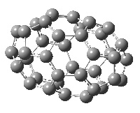
 |  |  |  | Quartet (4) | -1447.70406439 | 13.12
1 | C₂ | 12/9 | 0 | Singlet (1) | -1447.60233477 | 0.000
 |  |  |  | Triplet (3) | -1447.59856881 | 2.363
1 | C₂ | 12/9 | +1 | Doublet (2) | -1447.33427578 | 0.000
 |  |  |  | Quartet (4) | -1447.33401782 | 0.162
2 | D_{3h} | 12/9 | -1 | Doublet (2) | -1447.68213906 | 0.000 | 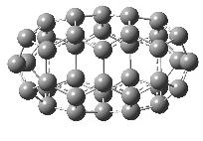
 |  |  |  | Quartet (4) | -1447.64726440 | 21.88
2 | D_{3h} | 12/9 | 0 | Singlet (1) | -1447.55635956 | 0.000
 |  |  |  | Triplet (3) | -1447.55499448 | 0.857
2 | D_{3h} | 12/9 | +1 | Doublet (2) | -1447.28956779 | 3.324
 |  |  |  | Quartet (4) | -1447.29486485 | 0.000
 |  |  |  | Sextet (6) | -1447.27065326 | 15.19
3 | C₁ | 12/9 | -1 | Doublet (2) | -1447.78889547 | 0.000 | 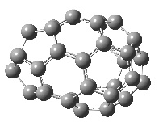
 |  |  |  | Quartet (4) | -1447.77249551 | 10.29
3 | C₁ | 12/9 | 0 | Singlet (1) | -1447.66551219 | 0.000
 |  |  |  | Triplet (3) | -1447.66400765 | 0.944
3 | C₁ | 12/9 | +1 | Doublet (2) | -1447.40145323 | 0.000
 |  |  |  | Quartet (4) | -1447.39795218 | 2.197
4 | C₁ | 12/9 | -1 | Doublet (2) | -1447.75466813 | 0.000 | 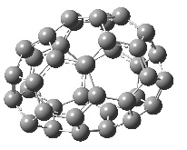
 |  |  |  | Quartet (4) | -1447.73075753 | 15.00
4 | C₁ | 12/9 | 0 | Singlet (1) | -1447.64226581 | 0.000
 |  |  |  | Triplet (3) | -1447.62952521 | 7.995
4 | C₁ | 12/9 | +1 | Doublet (2) | -1447.37255333 | 0.000
 |  |  |  | Quartet (4) | -1447.35854702 | 8.789
5 | C₁ | 12/9 | -1 | Doublet (2) | -1447.81793607 | 0.000 | 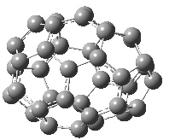
 |  |  |  | Quartet (4) | -1447.80081562 | 10.74
5 | C₁ | 12/9 | 0 | Singlet (1) | -1447.69988597 | 0.000
 |  |  |  | Triplet (3) | -1447.69583425 | 2.542
5 | C₁ | 12/9 | +1 | Doublet (2) | -1447.43841593 | 0.000
 |  |  |  | Quartet (4) | -1447.42593054 | 7.835
6 | C₂ | 12/9 | -1 | Doublet (2) | -1447.78788532 | 0.000 | 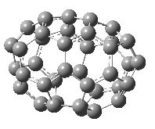
 |  |  |  | Quartet (4) | -1447.76264726 | 15.83
6 | C₂ | 12/9 | 0 | Singlet (1) | -1447.67916336 | 0.000
 |  |  |  | Triplet (3) | -1447.66621957 | 8.122
6 | C₂ | 12/9 | +1 | Doublet (2) | -1447.41498417 | 0.000
 |  |  |  | Quartet (4) | -1447.39177139 | 14.56

Table S9 (count.). Optimized energy, multiplicity and symmetry of the C38 fullerene cage

 | Symm. | P/H | Charge | Multi. | Opt. Energy (a.u.) | Rel. Ener.  (k. cal/mol) | Geometry
7 | C₁ | 12/9 | -1 | Doublet (2) | -1447.77494744 | 0.000 | 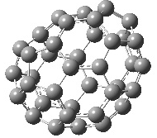
 |  |  |  | Quartet (4) | -1447.75528753 | 12.33
7 | C₁ | 12/9 | 0 | Singlet (1) | -1447.65557812 | 0.076
 |  |  |  | Triplet (3) | -1447.65569935 | 0.000
 |  |  |  | Quintet (5) | -1447.62515359 | 19.16
7 | C₁ | 12/9 | +1 | Doublet (2) | -1447.39659684 | 0.000
 |  |  |  | Quartet (4) | -1447.38403590 | 7.882
8 | C₁ | 12/9 | -1 | Doublet (2) | -1447.82218034 | 0.000 | 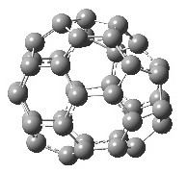
 |  |  |  | Quartet (4) | -1447.80307767 | 11.98
8 | C₁ | 12/9 | 0 | Singlet (1) | -1447.70520579 | 0.000
 |  |  |  | Triplet (3) | -1447.69784565 | 4.619
8 | C₁ | 12/9 | +1 | Doublet (2) | -1447.44041023 | 0.000
 |  |  |  | Quartet (4) | -1447.43388474 | 4.095
9 | D₃ | 12/9 | -1 | Doublet (2) | -1447.75769177 | 0.000 | 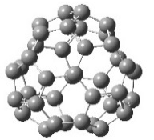
 |  |  |  | Quartet (4) | -1447.74195111 | 9.877
9 | D₃ | 12/9 | 0 | Singlet (1) | -1447.65284576 | 0.000
 |  |  |  | Triplet (3) | -1447.63547393 | 10.90
9 | D₃ | 12/9 | +1 | Doublet (2) | -1447.38997682 | 0.000
 |  |  |  | Quartet (4) | -1447.37145100 | 11.62
10 | C₂ | 12/9 | -1 | Doublet (2) | -1447.84860119 | 0.000 | 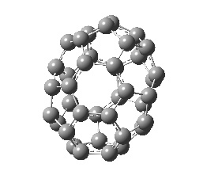
 |  |  |  | Quartet (4) | -1447.82169370 | 16.88
10 | C₂ | 12/9 | 0 | Singlet (1) | -1447.72167745 | 4.374
 |  |  |  | Triplet (3) | -1447.72864739 | 0.000
 |  |  |  | Quintet (5) | -1447.69510289 | 21.05
10 | C₂ | 12/9 | +1 | Doublet (2) | -1447.45720241 | 1.181
 |  |  |  | Quartet (4) | -1447.45908481 | 0.000
 |  |  |  | Sextet (6) | -1447.42121136 | 23.76
11 | C₁ | 12/9 | -1 | Doublet (2) | -1447.80836738 | 0.000 | 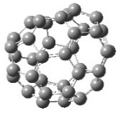
 |  |  |  | Quartet (4) | -1447.79922647 | 5.736
11 | C₁ | 12/9 | 0 | Singlet (1) | -1447.69256101 | 0.000
 |  |  |  | Triplet (3) | -1447.68866502 | 2.445
11 | C₁ | 12/9 | +1 | Doublet (2) | -1447.43185300 | 0.000
 |  |  |  | Quartet (4) | -1447.42062465 | 7.046
12 | C_{2v} | 12/9 | -1 | Doublet (2) | -1447.76523612 | 0.000 | 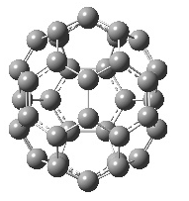
 |  |  |  | Quartet (4) | -1447.72045764 | 28.09
12 | C_{2v} | 12/9 | 0 | Singlet (1) | -1447.60459198 | 13.64
 |  |  |  | Triplet (3) | -1447.62634092 | 0.000
 |  |  |  | Quintet (5) | -1447.60155015 | 15.55
12 | C_{2v} | 12/9 | +1 | Doublet (2) | -1447.36055673 | 4.074
 |  |  |  | Quartet (4) | -1447.36704937 | 0.000
 |  |  |  | Sextet (6) | -1447.33830890 | 18.03

 | Symm. | P/H | Charge | Multi. | Opt. Energy (a.u.) | Rel. Ener.  (k. cal/mol) | Geometry
13 | C₂ | 12/9 | -1 | Doublet (2) | -1447.85367097 | 0.000 | 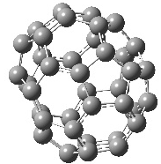
 |  |  |  | Quartet (4) | -1447.83317481 | 12.86
13 | C₂ | 12/9 | 0 | Singlet (1) | -1447.73590378 | 0.000
 |  |  |  | Triplet (3) | -1447.73114799 | 2.984
13 | C₂ | 12/9 | +1 | Doublet (2) | -1447.47066494 | 0.000
 |  |  |  | Quartet (4) | -1447.46006009 | 6.655
14 | C₁ | 12/9 | -1 | Doublet (2) | -1447.84269474 | 0.000 | 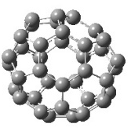
 |  |  |  | Quartet (4) | -1447.82495770 | 11.13
14 | C₁ | 12/9 | 0 | Singlet (1) | -1447.72322978 | 0.000
 |  |  |  | Triplet (3) | -1447.72198896 | 0.779
14 | C₁ | 12/9 | +1 | Doublet (2) | -1447.46401717 | 0.000
 |  |  |  | Quartet (4) | -1447.45884494 | 3.246
15 | C_{2v} | 12/9 | -1 | Doublet (2) | -1447.80483141 | 0.000 | 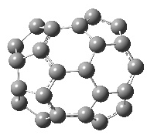
 |  |  |  | Quartet (4) | -1447.80313218 | 1.066
15 | C_{2v} | 12/9 | 0 | Singlet (1) | -1447.67562348 | 6.126
 |  |  |  | Triplet (3) | -1447.68538558 | 0.000
 |  |  |  | Quintet (5) | -1447.67905982 | 3.969
15 | C_{2v} | 12/9 | +1 | Doublet (2) | -1447.42014746 | 1.115
 |  |  |  | Quartet (4) | -1447.42192377 | 0.000
 |  |  |  | Sextet (6) | -1447.40807349 | 8.691
16 | C_{3v} | 12/9 | -1 | Doublet (2) | -1447.83962989 | 0.000 | 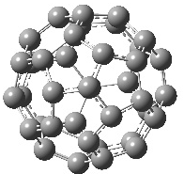
 |  |  |  | Quartet (4) | -1447.81609741 | 14.76
16 | C_{3v} | 12/9 | 0 | Singlet (1) | -1447.70717454 | 10.83
 |  |  |  | Triplet (3) | -1447.72444084 | 0.000
 |  |  |  | Quintet (5) | -1447.69466815 | 18.68
16 | C_{3v} | 12/9 | +1 | Doublet (2) | -1447.45401618 | 4.662
 |  |  |  | Quartet (4) | -1447.46144532 | 0.000
 |  |  |  | Sextet (6) | -1447.43547389 | 16.29
17 | C₂ | 12/9 | -1 | Doublet (2) | -1447.86856339 | 0.000 | 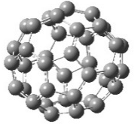
 |  |  |  | Quartet (4) | -1447.84479775 | 14.91
17 | C₂ | 12/9 | 0 | Singlet (1) | -1447.76583967 | 0.000
 |  |  |  | Triplet (3) | -1447.74670360 | 12.00
17 | C₂ | 12/9 | +1 | Doublet (2) | -1447.50273440 | 0.000
 |  |  |  | Quartet (4) | -1447.47589880 | 16.84
Table S9 (count.). Optimized energy, multiplicity and symmetry of the C38 fullerene cage

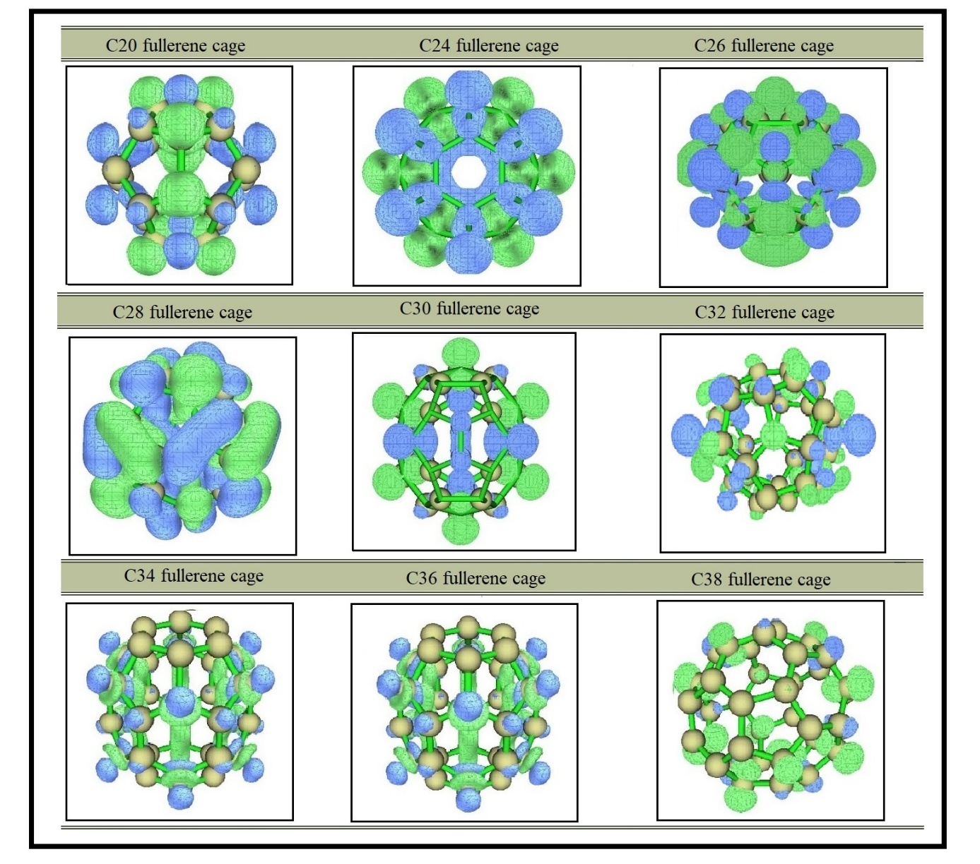
Figure S1 Fukui plots of C_{N} (N=20, 24, 26, 28, 30, 32, 34, 36, and 38) Fullerene Cages

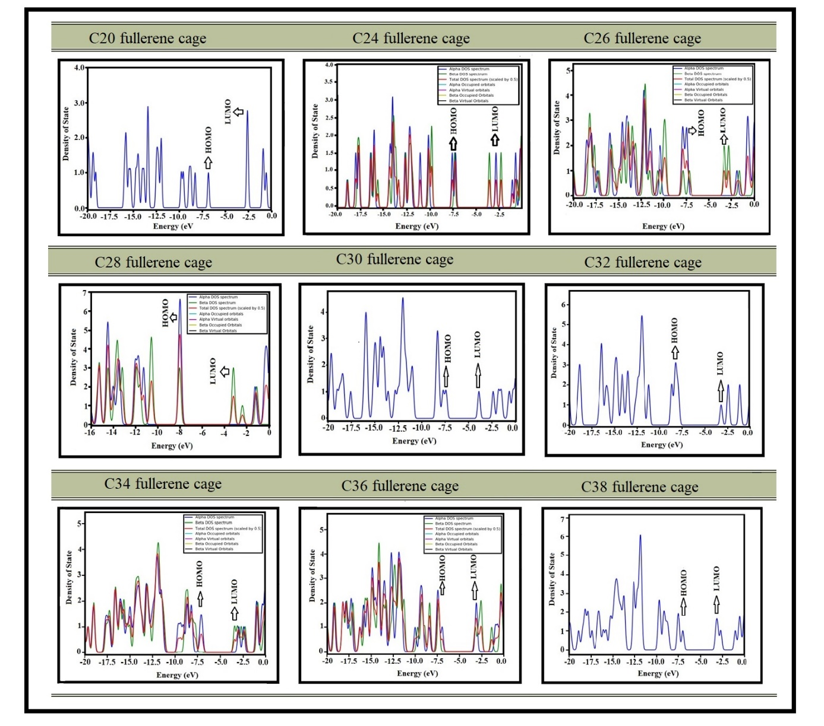
Figure S2 Density of state plots of C_{N} (N=20, 24, 26, 28, 30, 32, 34, 36, and 38) Fullerene Cages

