Supplementary Materials

Short-term head-out whole-body cold-water immersion facilitates positive affect and increases interaction between large-scale brain networks
A.Yankouskaya, R. Williamson, C. Stacey, J. Totman, H. Massey

Figure S1. Means heart rate (A) and tidal volume (the amount of air that moves in or out of the lungs with each respiratory cycle, B) 60 sec prior CWI (PRE-CWI), CWI (start of cold-water immersion). The X-axes represents time of CWI. Error bars represent SEM at each time point. Dashed green lines showed means of the baseline measurements
Table S1. Results of Wilcoxon’s signed rank test on individual items of PANAS. W is defined as the smaller of W+ (sum of the positive ranks) and W- (sum of the negative ranks). BF₁₀ - the Bayes factor in favour of H1 over H0
Measures | W | z | p | BF₁₀
[Pre – Post] | W | z | p
Interested | 43.00 | -0.59 | 0.55 | 0.26
Active | 18.00 | -3.25 | <.001 | 79.51
Afraid | 48.00 | 2.09 | 0.04 | 1.73
Alert | 32.00 | -3.21 | .001 | 83.24
Ashamed | 10.00 | 1.83 | .09 | 0.44
Attentive | 8.00 | -4.06 | <.001 | 1155.12
Determined | 31.00 | -1.91 | .05 | 1.44
Distressed | 99.00 | 2.92 | .002 | 22.84
Enthusiastic | 28.00 | -2.50 | .009 | 5.42
Exited | 37.00 | -1.85 | .05 | 0.99
Guilty | 28.00 | 2.37 | .02 | 1.35
Hostile | 34.50 | 1.42 | .16 | 0.35
Inspired | 6.00 | -3.69 | <.001 | 445.06
Irritable | 84.00 | 2.69 | .007 | 4.55
Jittery | 117.00 | 2.56 | .009 | 9.95
Nervous | 406.00 | 4.62 | <.001 | 26282.93
Proud | 5.00 | -3.51 | <.001 | 1151.66
Scared | 41.00 | 2.19 | .03 | 1.19
Strong | 64.50 | -2.44 | .01 | 7.08
Upset | 45.00 | 2.67 | .006 | 3.87

Table S2. The results of Network Based Statistic analysis with varied ‘height’ thresholds for contrast [Post-CWI>Pre-CWI] (p-value for each component was FWE corrected). NS denotes that a component did not survive the FWE correction
Height threshold  (p< ) | Connections comprising a component | Component statistics
Height threshold  (p< ) | Connections comprising a component | mass | size | p-FWE  value
.05 - .02 | NS
.01 - .006 | DMN.MPFC->SN.ACC  DMN.MPFC->SN.RPFC(L)  FP.PCC(R)->Vis.Lat(R)  FP.PCC(R)->DAN.IPS(R)  DMN.PCC ->Vis.Lat (R)  DMN.MPFC->DMN.LP (L)  DMN.PCC->LP (R)  DMN.MPFC->SN.Ains (L) | 357 | 1 | .003
.005 - .002 | DMN.MPFC->SN.ACC  DMN.MPFC->SN.RPFC(L)  FP.PCC(R)->Vis.Lat(R)  FP.PCC(R)->DAN.IPS(R)  DMN.PCC ->Vis.Lat (R)  DMN.MPFC->DMN.LP (L)  DMN.PCC->LP (R)  DMN.MPFC->SN.Ains (L) | 168.06  165.30 | 2 | .013 - .001
.001 -.0004 | DMN.MPFC->SN.ACC  DMN.MPFC->SN.RPFC(L)  FP.PCC(R)->Vis.Lat(R)  FP.PCC(R)->DAN.IPS(R)  DMN.MPFC->DMN.LP (L)  DMN.MPFC->SN.Ains (L) | 165.30  126.78 | 2 | < .001 - .001
.0005 - .00001 | DMN.MPFC->SN.ACC  DMN.MPFC->SN.RPFC(L)  FP.PCC(R)->Vis.Lat(R)  FP.PCC(R)->DAN.IPS(R)  DMN.MPFC->DMN.LP (L) | 126.78  151.22 | 2 | < .001
.0000009 | FP.PCC(R)->Vis.Lat(R)  FP.PCC(R)->DAN.IPS(R) | 64.23 | 1 | .03
.0000005 | NS

Table S3. The results of Network Based Statistic analysis with varied ‘height’ thresholds for contrast [Post-CWI>Pre-CWI]*Changes in Positive Affect (p-value for each component was FWE corrected). NS denotes that a component did not survive the FWE correction
Height threshold  (p< ) | Connections comprising a component | Component statistics
Height threshold  (p< ) | Connections comprising a component | mass | size | p-FWE  value
.05 - .004 | NS
.003 - .00002 | DMN.MPFC->SN.ACC  DMN.MPFC->SN.RPFC(L)  FP.PCC(R)->Vis.Lat(R)  FP.PCC(R)->DAN.IPS(R) | 102.86  96.62 | 2  2 | .019 - .00002  0.03-0.0004
.00001 - .00007 | DMN.MPFC->SN.ACC  FP.PCC(R)->Vis.Lat(R)  FP.PCC(R)->DAN.IPS(R) | 86.11  96.62 | 1  2 | .006 -.004
.00006 - .000002 | FP.PCC(R)->DAN.IPS(R) | 46.90 | 1 | .004 - .04
.000001 | NS

Table S4. The results of Network Based Statistic analysis with varied ‘height’ thresholds for contrast [Post-CWI>Pre-CWI]*Changes in Negative Affect (p-value for each component was FWE corrected). NS denotes that a component did not survive the FWE correction
Height threshold  (p< ) | Connections comprising a component | Component statistics
Height threshold  (p< ) | Connections comprising a component | mass | size | p-FWE  value
.05 - .03 | Vis. Lat (R)  Vis. Lat (L)  Vis. Med  DAN.IPS (R)  DAN.IPS (L)  DAN.FEF (L)  SM.Superior  SN.RPFC (R)  SN.ACC  SN.AIns (R)  SN.AIns (L)  SN.SMG (L)  Language.IFG (R)  Language.pSTS (R)  Language.pSTS (L)  Language.IFG (L)  FP.LPFC (R)  FP.PPC (L)  FP.LPFC (L)  DMN.MPFC  DMN.PCC  DMN.LP (R)  DMN.LP (L) | 594.50 | 68 | .02
.02 | FP.LPFC (R)  DMN.MPFC  DMN.PCC  DMN.LP (R)  DMN.LP (L)  DAN.IPS (R)  DAN.IPS (L)  DAN.FEF (L)  SM.Superior  Language.IFG (R)  SN.SMG (L)  SN.Ains (L)  SN.AIns (R) | 387.72 | 30 | .016
.01-.001 | DMN.MPFC  DMN.PCC | 154.50 | 2 | .003
.0009-.0001 | FP.PCC(R)->DAN.IPS(R) | 46.90 | 1 | .004 - .04
.000001 | NS

Figure S2. Large scale brain networks derived from CONN’s atlas (Whitfield-Gabrieli & Nieto-Castanon, 2012)

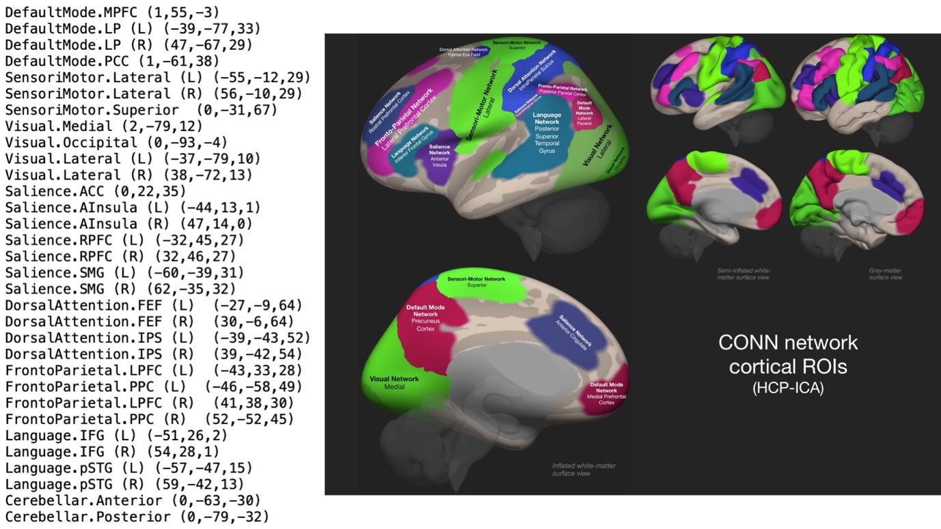
References
Whitfield-Gabrieli, S., & Nieto-Castanon, A. (2012). Conn: A functional connectivity toolbox for correlated and anticorrelated brain networks. Brain connectivity, 2(3), 125-141.

