Table S1: Associations of Mets and its components with categorized DMFT
Dependent variables | Simple poisson regression |  |  |  | Multiple poisson regression
Dependent variables | Categorized DMFT | n | IR (95% CI) | P.value | Adjusted IR (95%CI) | p.valueª
Sum of the components of metabolic syndrome | DMFT≤ 6 | 269 | 1 | - | 1 | -
Sum of the components of metabolic syndrome | 6 < DMFT≤ 15 | 869 | 1.02 (0.97-1.08) | 0.285 | 0.99 (0.94-1.05) | 0.894
Sum of the components of metabolic syndrome | DMFT> 15 | 2055 | 0.98 (0.93-1.03) | 0.600 | 0.93 (0.88-0.98) | 0.008
Raised TG level | DMFT≤ 6 | 267 | 1 | - | 1 | -
Raised TG level | 6 < DMFT≤ 15 | 872 | 1.02 (0.89-1.17) | 0.745 | 1.00 (0.87-1.15) | 0.975
Raised TG level | DMFT> 15 | 1871 | 0.91 (0.80-1.03) | 0.167 | 0.87 (0.76-0.99) | 0.045
Reduced HDL cholesterol | DMFT≤ 6 | 398 | 1 | - | 1 | -
Reduced HDL cholesterol | 6 < DMFT≤ 15 | 1329 | 1.04 (0.93-1.16) | 0.444 | 1.05 (0.94-1.18) | 0.345
Reduced HDL cholesterol | DMFT> 15 | 3038 | 0.99 (0.89-1.10) | 0.912 | 1.98 (0.97-1.21) | 0.127
Central obesity | DMFT≤ 6 | 715 | 1 | - | 1 | -
Central obesity | 6 < DMFT≤ 15 | 2272 | 0.99 (0.91-1.08) | 0.920 | 0.96 (0.88-1.05) | 0.433
Central obesity | DMFT> 15 | 4815 | 0.87 (0.81-0.95) | 0.001 | 0.89 (0.82-0.96) | 0.004
Raised fasting blood sugar | DMFT≤ 6 | 226 | 1 | - | 1 | -
Raised fasting blood sugar | 6 < DMFT≤ 15 | 762 | 1.05 (0.91-1.22) | 0.471 | 1.09 (0.94-1.26) | 0.244
Raised fasting blood sugar | DMFT> 15 | 1968 | 1.13 (0.98-1.30) | 0.071 | 1.15 (1.00-1.32) | 0.039
Raised blood pressure | DMFT≤ 6 | 109 | 1 | - | 1 | -
Raised blood pressure | 6 < DMFT≤ 15 | 405 | 1.16 (0.94-1.43) | 0.160 | 1.13 (0.91-1.39) | 0.255
Raised blood pressure | DMFT> 15 | 1290 | 1.54 (1.26-1.87) | <0.001 | 1.34 (1.10-1.63) | <0.001
Cardiovascular disease | DMFT≤ 6 | 42 | 1 | - | 1 | -
Cardiovascular disease | 6 < DMFT≤ 15 | 194 | 1.44 (1.03-2.01) | 0.030 | 1.25 (0.89-1.74) | 0.190
Cardiovascular disease | DMFT> 15 | 802 | 2.48 (1.82-3.39) | <0.001 | 1.42 (1.04-1.95) | 0.027
Non-alcoholic fatty liver disease | DMFT≤ 6 | 123 | 1 | - | 1 | -
Non-alcoholic fatty liver disease | 6 < DMFT≤ 15 | 357 | 0.90 (0.74-1.11) | 0.362 | 0.80 (0.65-0.98) | 0.036
Non-alcoholic fatty liver disease | DMFT> 15 | 799 | 0.84 (0.70-1.02) | 0.086 | 0.77 (0.63-0.95) | 0.014
a: Adjusted for Age, gender, marital status, ethnicity, place of residence, job, frequency of brushing, flossing, using mouthwash, smoking, alcohol consumption, drug use, cardiovascular disease, and non-alcoholic fatty liver disease.

Table S2: Associations of Mets and its components with DMFT
Dependent variables | Simple poisson regression |  | Multiple poisson regression
Dependent variables | IR (95% CI) | P.value | Adjusted IR (95%CI) | p.value^{b}
Sum of the components of metabolic syndrome | 0.99 (0.99-1.00) | 0.001 | 0.99 (0.99-1.00) | <0.001
Raised TG level | 0.99 (0.99-1.00) | 0.006 | 0.99 (0.98-1.00) | 0.001
Reduced HDL cholesterol | 0.99 (0.99-1.00) | 0.037 | 1.00 (0.99-1.01) | 0.209
Central obesity | 0.99 (0.98-1.00) | <0.001 | 0.99 (0.99-1.00) | <0.001
Raised fasting blood sugar | 1.00 (1.00-1.01) | 0.003 | 0.99 (0.99-1.00) | 0.013
Raised blood pressure | 1.00 (1.01-1.02) | <0.001 | 1.00 (0.99-1.01) | 0.579
Cardiovascular disease | 1.03 (1.03-1.04) | <0.001 | 1.01 (1.00-1.02) | 0.006
Non-alcoholic fatty liver disease | 0.99 (0.98-1.00) | 0.001 | 0.99 (0.98-1.00) | 0.010
b: Adjusted for Age, gender, marital status, ethnicity, place of residence, job, frequency of brushing, flossing, using mouthwash, smoking, alcohol consumption, drug use, cardiovascular disease, and non-alcoholic fatty liver disease.
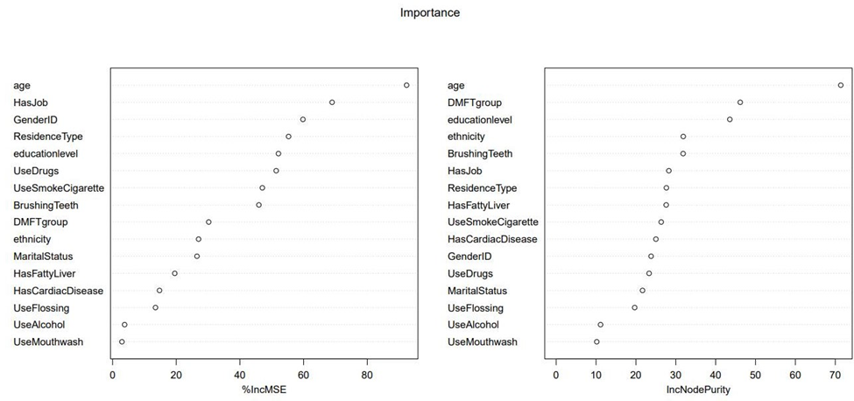
FigureS1: Random forest for Raised fasting blood sugar or previously diagnosed type 2 diabetes by covariates.
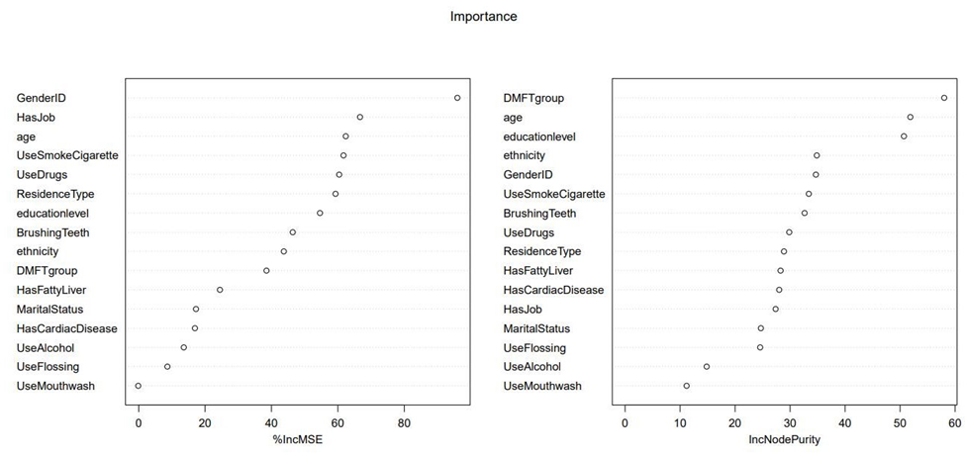
FigureS2: Random forest for reduced HDL cholesterol level or related specific treatment by covariates.
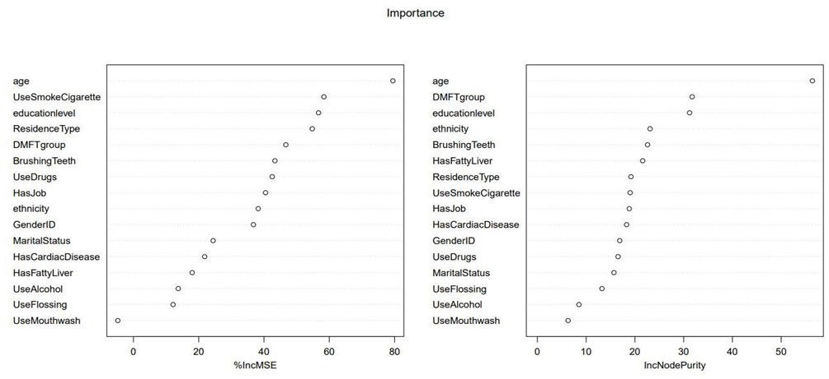
FigureS3: Random forest for high blood pressure or treatment of previously diagnosed hypertension by covariates.

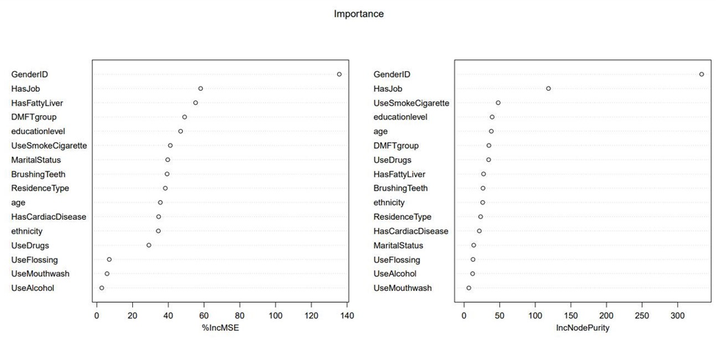
FigureS4: Random forest for central adiposity by covariates.

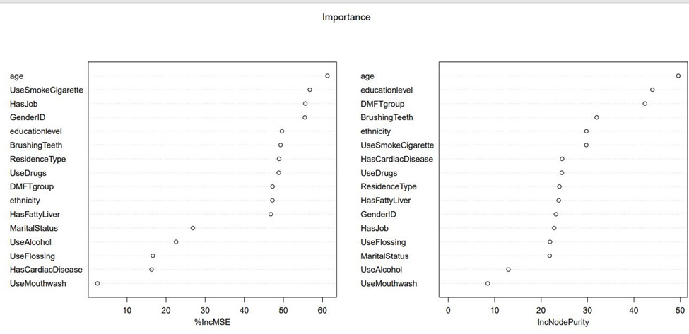
FigureS5: Random forest for raised triglycerides level or related specific treatment by covariates.

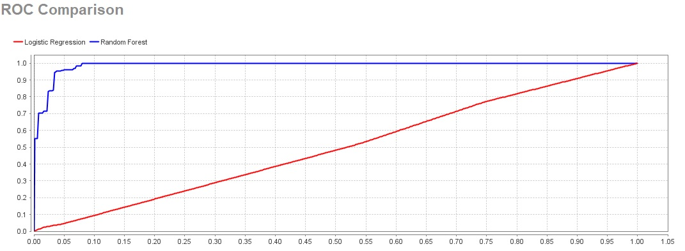
FigureS6: logistic regression and Random Forest performances for metabolic syndrome by covariates.

