Polarity switching from p- to n-type in a single thermoelectric donor-acceptor copolymer by p-type doping

Jing Wang¹, Yizhuo Wang¹, Qing Li¹, Zhanchao Li¹, Liqing Xu¹, Kuncai Li¹, Hong Wang^{1,2}*

¹Frontier Institute of Science and Technology, Xi’an Jiaotong University, Xi’an, 710054, China
²State Key Laboratory of Multiphase Flow in Power Engineering, Xi’an Jiaotong University, Xi’an, 710054, China

E-mail: hong.wang@xjtu.edu.cn

Materials
DPPTTT (poly (2,5-bis(2-octyldodecyl)-3,6-di(thiophen-2-yl)diketopyrrolo [3,4-c]pyrrole-1,4-dione-alt-thieno[3,2-b]thiophen)) (Mw=22.47 kDa) from Derthon Optoelectronic Materials Science Technology Co LTD; P3HT(Poly(3-hexylthiophene-2,5-diyl)) (Mw=85000 KDa) purchased from 1-material. Ferric chloride from Macklin, Nitromethane was purchased from Damao Chemical Reagent Factory, Iron sulfate hydrate, Iron nitrate nonahydrate from Aladdin industrial corporation, 2,3,5,6-Tetrafluoro-7,7,8,8-tetracyanoquinodimethane, Iron p-toluenesulfanate and 1.2-dichloriobenzene were purchased from Energy Chemical, All chemicals were used as received. CN6-CP synthesized according to the reference¹.
Film preparation
DPPTTT films doped with 10 wt. % to 84 wt. % FeCl₃ was prepared by blend-cast doping and sequential doping process, P3HT films doped with 10 wt. % to 84 wt. % FeCl₃ was prepared by blend-cast doping as a comparison.
Blend-cast doping: The semiconductors DPPTTT and P3HT were dissolved in O-dichlorobenzene with a concentration of 0.05 wt. %. Dopants with 10 wt. % to 84 wt. % was added to the solutions. After being stirred for 15 minutes, the mixture solution was dropped into the glass substrates which were cleaned consecutively by ultrasonication with a detergent solution, acetone, and isopropyl alcohol, and then dried and treated with plasma for 5 min. The films were dried at three different humidity (at glovebox with H₂O< 0.2 ppm and O₂<0.02 ppm, and a humidity of 15 % and 65 % respectively).
Sequential doping: The semiconductors DPPTTT was also doped by sequential doping, with polymer dissolved in O-dichlorobenzene with a concentration of 0.05 wt. %, the pristine DPPTTT solution was being drop-casted in glass substrates, after being fully dissolved, and dried at room temperature with humidity of 15 %, and immersed in a dopant solution with 84 wt. % ferric chloride (FeCl₃) in nitromethane of a series of periods.
Instrumentation
Thermoelectric properties
Electrical conductivity and Seebeck coefficient of samples were measured at NETZSCH SBA 458, in the atmosphere of nitrogen. A minimum of three to five measurements was obtained for an average value. The film thickness was measured at XP-2.

UV-Vis absorption spectroscopy
An analytic PE Lambda 950 plus at a scan rate of 20 nm s⁻¹ was used to record UV-vis absorption spectra of thin polymer films prepared by spin-casting on glass slides with a spin speed of 2000 rpm, 30 s. All of the samples were prepared in a glovebox then the samples were placed on a sealed cuvette to prevent being oxidized.

Atomic force microscope (AFM)
AFM images of the DPPTTT films of pristine and doped by 21 wt. %, 84 wt. % FeCl₃ were obtained in tapping mode using a Veeco/Digital Instruments Nanoscope III. The films were spin-coated on glass substrates and used for this purpose.

Kelvin probe
The contact potential difference of DPPTTT doped with 21 wt. % FeCl₃ and doped with 84 wt. % FeCl₃ was measured at Bruker Dimension ICON.

Scanning electron microscope (SEM)
SEM images were measured at su-8010, samples were prepared by drop-casting in glass substrates.

Ultra-violet photoelectron spectroscopy (UPS) and X-ray photoelectron spectroscopy (XPS)
UPS and XPS spectrums were measured at Thermo Fisher. Samples of DPPTTT and P3HT were prepared onto ITO glass via a spin-coating method. The He I (21.2 eV) emission line was employed as a UV source. The helium pressure in the analysis chamber during analysis was about 4.0×10⁻⁸ Torr.

Cyclic voltammetry (CV)
Cyclic voltammetry was performed on a CHI660E Instruments in a classic three-electrode cell, with a glassy carbon working electrode, a platinum disc counter electrode, and a silver wire was used as a pseudo-reference electrode. Film measurements were carried out in a 0.1 M tetra-N-butylammonium hexafluorophosphate in acetonitrile. Polymer films were dropped cast on the glassy carbon working electrode from O-dichlorobenzene solutions. The scanning rate was 50 mV/s. Ferrocene/ferrocenium (Fc/Fc⁺) redox pair was used as the internal standard.
P-N junction and the responses of the transient and steady-state current of the organic diode were measured in CHI660E Instruments in a glovebox, with working electrode hold on one side, a counter electrode and reference electrode hold on the other side of the sample, and measured with the mode of cyclic voltammetry and current-time respectively.

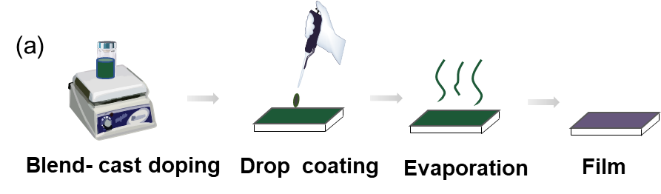
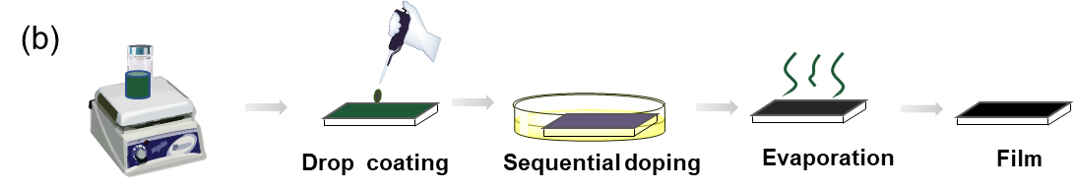
Figure S1. the scheme of DPPTTT solution doped by blend-cast method (a) and sequential doping method (b).

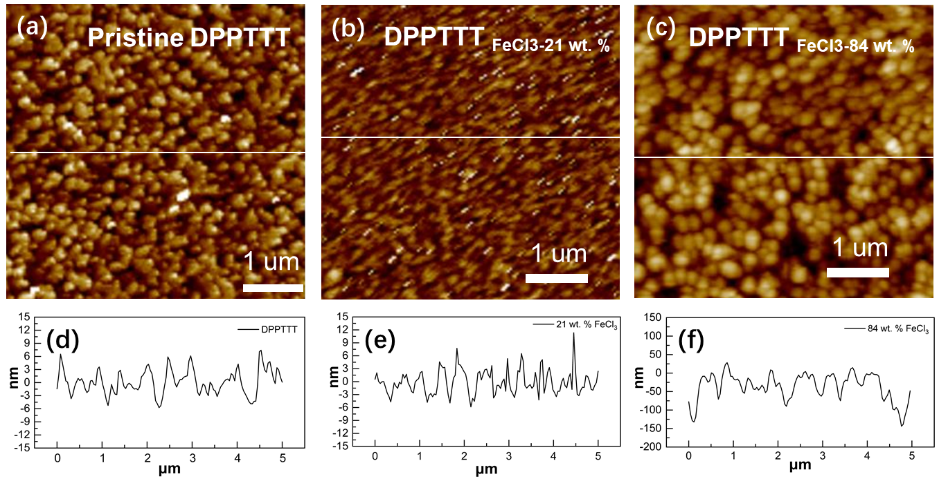
Figure S2. AFM images (a-c) and profile (d-f) of pristine DPPTTT and DPPTTT doped by 21 wt. % and 84 wt. % FeCl₃.

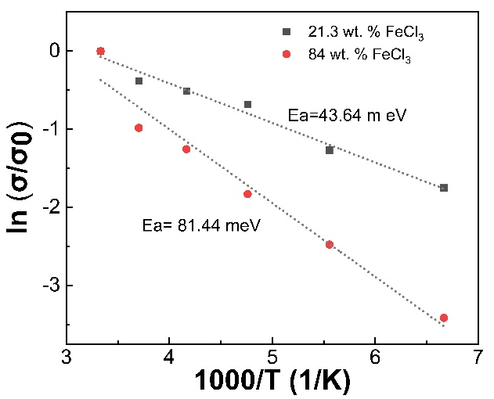
Figure S3. ln(σ/σ₀) as a function of temperature in the range of 150 K – 300 K.

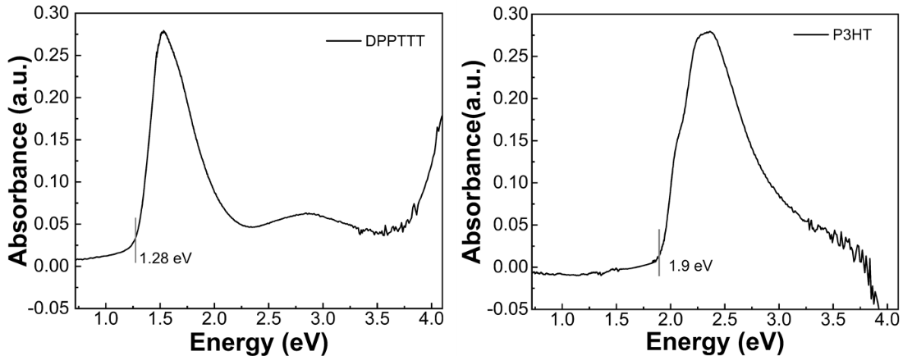
Figure S4. UV-vis-NIR spectra of pristine DPPTTT and pristine P3HT films.

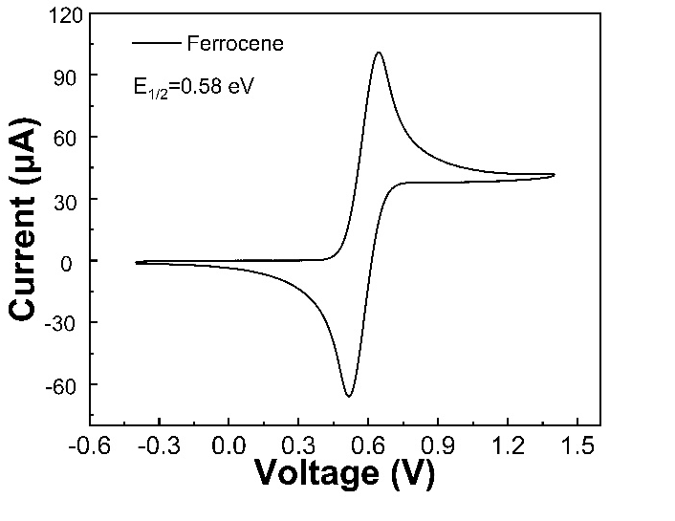
Figure S5. Cyclic voltammogram spectra of ferrocene.

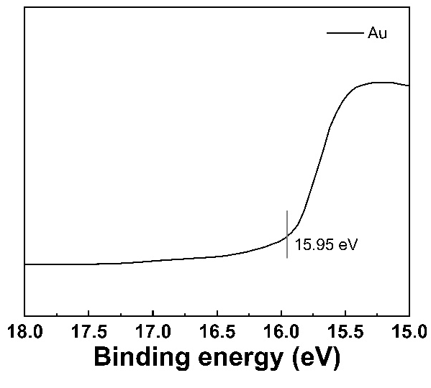
Figure S6 UPS spectra of fresh Au.

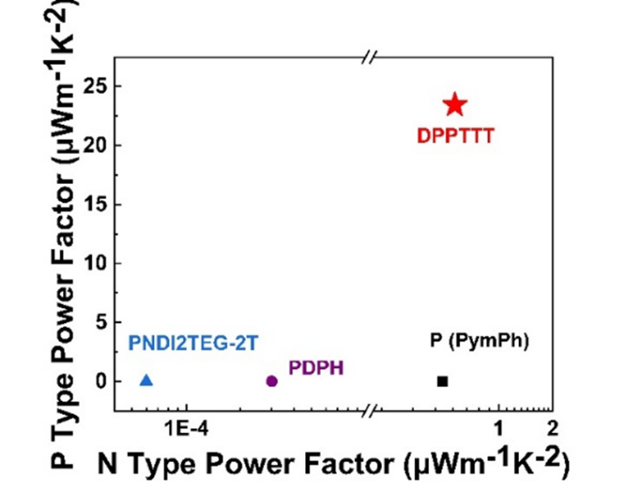
Figure S7. The comparison of thermoelectric properties of ambipolar D-A copolymers

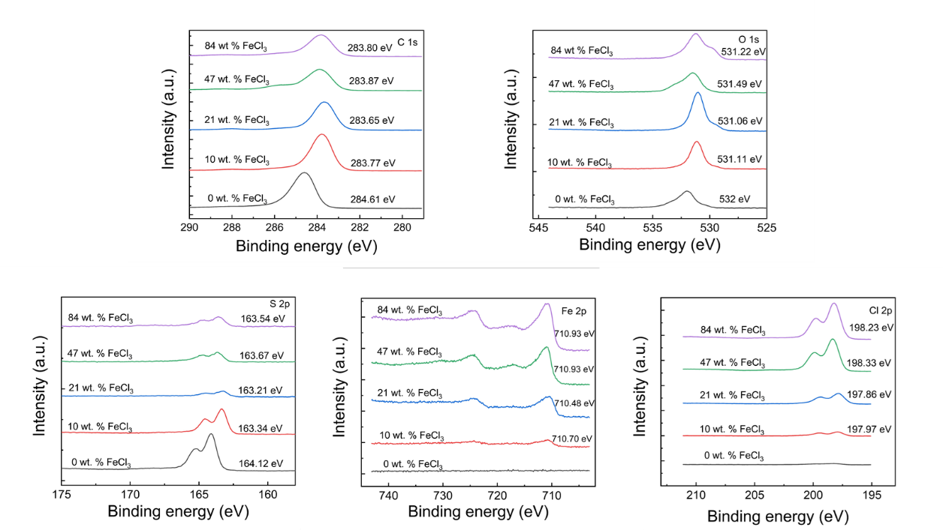
Figure S8. XPS spectra of C 1s, N 1s, O 1s, S 2p, Fe 2p, and Cl 2p of DPPTTT and DPPTTT doped by 10 wt. %, 21 wt. % FeCl3, 47 wt. %, 84 wt. % FeCl3.

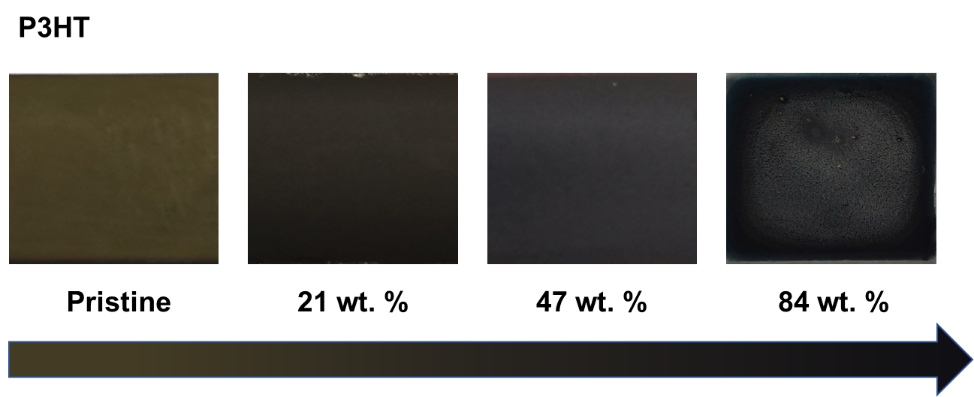
Figure S9 The color of P3HT change as a function of FeCl₃ concentration.

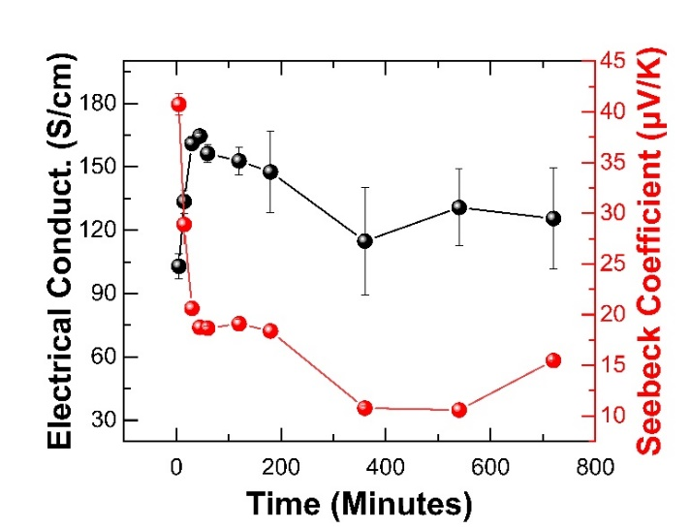
Figure S10. The thermoelectrical properties of DPPTTT dipped in 84 wt. % FeCl₃ solution for different time.

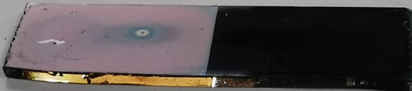
Figure S11. The image of p-n junction prepared by DPPTTT doped by 21 wt. % FeCl3 and 84 wt. % FeCl3.

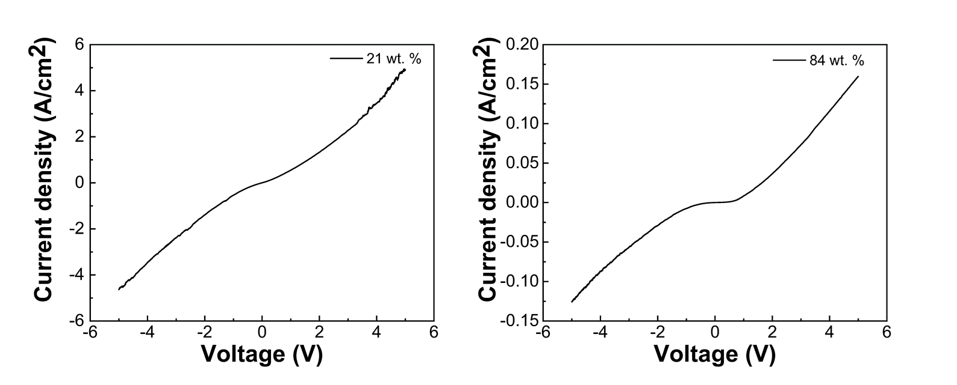
Figure S12. Current density versus bias voltage for DPPTTT doped with 21 wt. % and with 84 wt. % FeCl₃.

Table S1, Thermoelectric properties of P-type solution-processable D-A polymer
Materials |  | Electrical conductivity (S/cm) | Seebeck coefficient (μV/K) | Power factor (μWm⁻¹K⁻²) | Year
Unipolar | PDPPse-12 | ~997 | / | 364 (55 ºC) | 2019²
Unipolar | PIDF-BT | 634.3 | 32.5 | 67.2 | 2020³
Unipolar | PIDF-BT | 610 | / | / | 2020⁴
Unipolar | PIDF-BT | >210 | / | 35 | 2020⁵
Unipolar | PCPDTSBT-OC | 205.9 | 28.8 | 49.8 | 2020⁶
Unipolar | P(DTPTBT) | 155 | 14.82 | 3.4 | 2020⁷
Ambipolar | DPPTTT | 130.56 | 79.14 | 22.43 | This work
Unipolar | PPDT2FBT-OC | 125.1 | 66.0 | 112.01 | 2020⁶
Unipolar | PDPP-ene | ~101 | / | 10 | 2020⁸
Unipolar | PDPP-4T-EDOT | ~99.2 | ~174.2 | ~298.2 | 2020⁹
Unipolar | EHT6-20DPP | 93.28 | / | 56.73 | 2021¹⁰
Unipolar | PDPP(6-DO)2TT | 70 | / | / | 2016¹
Unipolar | PDPP3T | 62 | 45 | 25 | 2014¹¹
Unipolar | PDPP3T | 55 | 226 | 276 | 2017¹²
Unipolar | PIID810-TT | 42.8 | 87.2 | 37.8 | 2020¹³
Unipolar | PSBTBT | 21 | 24 | 3.5 (320K) | 2014¹¹
Unipolar | PDPP(2-OD)2TT | 12 | / | / | 2016¹
Unipolar | PCDTFBT | 8.73 | 213 | 31.5 | 2019¹⁴
Unipolar | PCDTPT | 5.13 | 211 | 21.8 | 2019¹⁴
Unipolar | PDPP-4T | 4 | / | / | 2018¹⁵
Unipolar | PCPDTSBT | 2.13 | ~190.53 | 7.73 | 2018¹⁶
Unipolar | C8TBT | 2.11 | 335 | 13.11 (90 ºC) | 2017¹⁷
Unipolar | PDPP(6-DO)TT | 2 | / | / | 2017¹⁸
Unipolar | PBDTDTBTF-3 | 1.52 | 60.83 | 1.12 (70 ºC） | 2018¹⁹
Unipolar | P(DTCTBT) | 0.87 | 43.43 | 0.16 | 2020⁷
Unipolar | PDPP-T-TT-T | 0.5 | / | / | 2018¹⁵
Unipolar | PCQ | 0.3 | ~600 | ~10 | 2018²⁰
Unipolar | PCPDTBT | 0.24 | ~427.03 | 4.41 | 2018¹⁶
Unipolar | CPE-C3-Na | 0.22 | ~195 | 0.84 | 2014²¹
Ambipolar | PDPH | 0.001 | 80 | 0.0007 | 2018²²
Ambipolar | PNDI2TEG-2Tz | 0.0007 | 60.3 | 0.0002 | 2018²³

Table S2
Thermoelectric properties of N-type solution processable D-A polymer.
Materials |  | Electrical conductivity (S/cm) | Seebeck coefficient (μV/K) | Power factor (μWm⁻¹K⁻²) | Year
Unipolar | TBDOPV-T | 65 | -130 | 106 | 2020²⁴
Ambipolar | DPPTTT | 14.22 | -20.25 | 0.66 | This work
Unipolar | P(PzDPP-CT2) | 8.4 | / | 57.3 | 2019²⁵
Unipolar | A-DCV-DPPTT | ~ 3.1 | ~ −568 | ~95 | 2017²⁶
Unipolar | TBDOPV-2T | 2.3 | -325 | 7.8 | 2020²⁴
Unipolar | PNDIHexEG-2Tz | 1.9 | ~ -163 | 5.1 | 2020²⁷
Unipolar | PNDI2TEG-2Tz | ~ 1.8 | ~ −159 | ~ 4.6 | 2018²³
Unipolar | PNDIC82TEG-2Tz | ~ 1.6 | ~ −326 | ~ 16.5 | 2020²⁷
Unipolar | PNDI2TEG-2Tz | 1.36 | ~ −167 | ~ 3.8 | 2020²⁷
Unipolar | PDPF | 1.30 | −235 | 4.65 | 2018²²
Unipolar | P(BTP-DPP) | 0.45 | / | / | 2017²⁸
Unipolar | P(TDPP-CT2) | 0.39 | / | 9.3 | 2019²⁵
Unipolar | p(gNDI-gT2) | 0.3 | −93 | 0.4 | 2018²⁹
Unipolar | TEG-N2200 | 0.17 | −153 | 0.4 | 2018³⁰
Unipolar | Q-DCM-DPPTT | ~ 0.11 | ~ −383 | ~ 1.7 | 2017²⁶
Unipolar | P(NDIOD-T2) | 0.008 | −850 | 0.6 | 2014³¹
Unipolar | P(NDIOD-T2) | 0.007 | -670 | 0.06 | 2019³²
Unipolar | 2s-trans-PNDIT2 | 0.006 | ~ −90 | 0.05 | 2018³³
Unipolar | P(NDIOD-T2) | 0.004 | –770 | 0.2 | 2014³¹
Unipolar | P(NDIOD-T2) | 0.003 | / | 0.013 | 2016³⁴
Unipolar | P(NDIOD-T2) | 0.003 | / | 0.012 | 2018³⁵
Unipolar | P(NDIOD-T2) | 0.002 | -950 | 0.18 | 2017³⁶
Unipolar | PNDIT2 | 0.001 | / | 0.01 | 2018³³
Unipolar | P(NDIOD-T2) | 0.001 | −354.0 | ~ 0.013 | 2020³⁷
Ambipolar | PNDI2TEG-2T | 0.0002 | ~ −50 | 0.00007 | 2018²³
Ambipolar | PDPH | 0.0002 | ~ −100 | 0.0001 | 2018²²

References:

1. Karpov Y, Erdmann T, Raguzin I, Al-Hussein M, Binner M, Lappan U, et al. High Conductivity in Molecularly p-Doped Diketopyrrolopyrrole-Based Polymer: The Impact of a High Dopant Strength and Good Structural Order. Advanced Materials 2016, 28(28): 6003-+.

2. Ding J, Liu Z, Zhao W, Jin W, Xiang L, Wang Z, et al. Selenium-Substituted Diketopyrrolopyrrole Polymer for High-Performance p-Type Organic Thermoelectric Materials. Angewandte Chemie-International Edition 2019, 58(52): 18994-18999.

3. Yoon SE, Kang Y, Jeon GG, Jeon D, Lee SY, Ko S-J, et al. Exploring Wholly Doped Conjugated Polymer Films Based on Hybrid Doping: Strategic Approach for Optimizing Electrical Conductivity and Related Thermoelectric Properties. Advanced Functional Materials 2020, 30(42).

4. Yoon SE, Park J, Kwon JE, Lee SY, Han JM, Go CY, et al. Improvement of Electrical Conductivity in Conjugated Polymers through Cascade Doping with Small‐Molecular Dopants. Advanced Materials 2020, 32(49): 2005129.

5. Yoon SE, Kang Y, Noh SY, Park J, Lee SY, Park J, et al. High Efficiency Doping of Conjugated Polymer for Investigation of Intercorrelation of Thermoelectric Effects with Electrical and Morphological Properties. Acs Applied Materials & Interfaces 2020, 12(1): 1151-1158.

6. Lee Y, Park J, Son J, Woo HY, Kwak E. Degenerately Doped Semi-Crystalline Polymers for High Performance Thermoelectrics. Advanced Functional Materials 2020.

7. Zhou H, Gao C, Liu T, Pan C, Wang L. Enhancement of the thermoelectric performance for DTC-based polymer via N-octyl substitution. Journal of Materials Chemistry C 2020, 8(21): 7096-7103.

8. Hofmann AI, Kroon R, Zokaei S, Jarsvall E, Malacrida C, Ludwigs S, et al. Chemical Doping of Conjugated Polymers with the Strong Oxidant Magic Blue. Advanced Electronic Materials 2020, 6(8).

9. Liu Z, Hu Y, Li P, Wen J, He J, Gao X. Enhancement of the thermoelectric performance of DPP based polymers by introducing one 3,4-ethylenedioxythiophene electron-rich building block. Journal of Materials Chemistry C 2020, 8(31): 10859-10867.

10. Kim NY, Lee TS, Oh JG, Lee K, Kim JY, An TK, et al. Enhanced doping efficiency and thermoelectric performance of diketopyrrolopyrrole-based conjugated polymers with extended thiophene donors. Journal of Materials Chemistry C 2020.

11. Zhang Q, Sun Y, Xu W, Zhu D. What To Expect from Conducting Polymers on the Playground of Thermoelectricity: Lessons Learned from Four High-Mobility Polymeric Semiconductors. Macromolecules 2014, 47(2): 609-615.

12. Jung IH, Hong CT, Lee U-H, Kang YH, Jang K-S, Cho SY. High Thermoelectric Power Factor of a Diketopyrrolopyrrole-Based Low Bandgap Polymer via Finely Tuned Doping Engineering. Scientific Reports 2017, 7.

13. Yoon SE, Shin SJ, Lee SY, Jeon GG, Kang H, Seo H, et al. Strategic Side-Chain Engineering Approach for Optimizing Thermoelectric Properties of Isoindigo-Based Conjugated Polymers. Acs Applied Polymer Materials 2020, 2(7): 2729-2735.

14. Suh EH, Jeong YJ, Oh JG, Lee K, Jung J, Kang YS, et al. Doping of donor-acceptor polymers with long side chains via solution mixing for advancing thermoelectric properties. Nano Energy 2019, 58: 585-595.

15. Liang Z, Zhang Y, Souri M, Luo X, Boehm AM, Li R, et al. Influence of dopant size and electron affinity on the electrical conductivity and thermoelectric properties of a series of conjugated polymers. Journal of Materials Chemistry A 2018, 6(34): 16495-16505.

16. Lee J, Kim J, Nguyen TL, Kim M, Park J, Lee Y, et al. A planar cyclopentadithiophene–benzothiadiazole-based copolymer with Sp2-hybridized bis (alkylsulfanyl) methylene substituents for organic thermoelectric devices. Macromolecules 2018, 51(9): 3360-3368.

17. Wang L, Pan C, Liang A, Zhou X, Zhou W, Wan T, et al. The effect of the backbone structure on the thermoelectric properties of donor-acceptor conjugated polymers. Polymer Chemistry 2017, 8(32): 4644-4650.

18. Karpov Y, Erdmann T, Stamm M, Lappan U, Guskova O, Malanin M, et al. Molecular Doping of a High Mobility Diketopyrrolopyrrole- Dithienylthieno 3,2-b thiophene Donor-Acceptor Copolymer with F6TCNNQ. Macromolecules 2017, 50(3): 914-926.

19. Wang L, Pan C, Chen Z, Zhou X, Gao C, Wang L. A study of the thermoelectric properties of benzo 1,2-b:4,5-b dithiophene-based donor-acceptor conjugated polymers. Polymer Chemistry 2018, 9(35): 4440-4447.

20. Joo Y, Huang L, Eedugurala N, London AE, Kumar A, Wong BM, et al. Thermoelectric Performance of an Open-Shell Donor-Acceptor Conjugated Polymer Doped with a Radical-Containing Small Molecule. Macromolecules 2018, 51(10): 3886-3894.

21. Mai C-K, Schlitz RA, Su GM, Spitzer D, Wang X, Fronk SL, et al. Side-Chain Effects on the Conductivity, Morphology, and Thermoelectric Properties of Self-Doped Narrow-Band-Gap Conjugated Polyelectrolytes. Journal of the American Chemical Society 2014, 136(39): 13478-13481.

22. Yang C-Y, Jin W-L, Wang J, Ding Y-F, Nong S, Shi K, et al. Enhancing the n-Type Conductivity and Thermoelectric Performance of Donor-Acceptor Copolymers through Donor Engineering. Advanced Materials 2018, 30(43).

23. Liu J, Ye G, van der Zee B, Dong J, Qiu X, Liu Y, et al. N-Type Organic Thermoelectrics of Donor-Acceptor Copolymers: Improved Power Factor by Molecular Tailoring of the Density of States. Advanced Materials 2018, 30(44).

24. Lu Y, Yu Z-D, Un H-I, Yao Z-F, You H-Y, Jin W, et al. Persistent Conjugated Backbone and Disordered Lamellar Packing Impart Polymers with Efficient n-Doping and High Conductivities. Advanced Materials 2020.

25. Yan X, Xiong M, Li J-T, Zhang S, Ahmad Z, Lu Y, et al. Pyrazine-Flanked Diketopyrrolopyrrole (DPP): A New Polymer Building Block for High-Performance n-Type Organic Thermoelectrics. Journal of the American Chemical Society 2019, 141(51): 20215-20221.

26. Huang D, Yao H, Cui Y, Zou Y, Zhang F, Wang C, et al. Conjugated-Backbone Effect of Organic Small Molecules for n-Type Thermoelectric Materials with ZT over 0.2. Journal of the American Chemical Society 2017, 139(37): 13013-13023.

27. Liu J, Ye G, Potgieser HGO, Koopmans M, Sami S, Nugraha MI, et al. Amphipathic Side Chain of a Conjugated Polymer Optimizes Dopant Location toward Efficient N-Type Organic Thermoelectrics. Advanced Materials 2020.

28. Perry EE, Chiu C-Y, Moudgil K, Schlitz RA, Takacs CJ, O'Hara KA, et al. High Conductivity in a Nonplanar n-Doped Ambipolar Semiconducting Polymer. Chemistry of Materials 2017, 29(22): 9742-9750.

29. Kiefer D, Giovannitti A, Sun H, Biskup T, Hofmann A, Koopmans M, et al. Enhanced n-Doping Efficiency of a Naphthalenediimide-Based Copolymer through Polar Side Chains for Organic Thermoelectrics. Acs Energy Letters 2018, 3(2): 278-285.

30. Liu J, Qiu L, Alessandri R, Qiu X, Portale G, Dong J, et al. Enhancing Molecular n-Type Doping of Donor-Acceptor Copolymers by Tailoring Side Chains. Advanced Materials 2018, 30(7).

31. Schlitz RA, Brunetti FG, Glaudell AM, Miller PL, Brady MA, Takacs CJ, et al. Solubility-Limited Extrinsic n-Type Doping of a High Electron Mobility Polymer for Thermoelectric Applications. Advanced Materials 2014, 26(18): 2825-2830.

32. Liu J, Shi Y, Dong J, Nugraha MI, Qiu X, Su M, et al. Overcoming Coulomb Interaction Improves Free-Charge Generation and Thermoelectric Properties for n-Doped Conjugated Polymers. Acs Energy Letters 2019, 4(7): 1556-1564.

33. Nava D, Shin Y, Massetti M, Jiao X, Biskup T, Jagadeesh MS, et al. Drastic Improvement of Air Stability in an n-Type Doped Naphthalene-Diimide Polymer by Thionation. Acs Applied Energy Materials 2018, 1(9): 4626-4634.

34. Wang S, Sun H, Ail U, Vagin M, Persson POA, Andreasen JW, et al. Thermoelectric Properties of Solution-Processed n-Doped Ladder-Type Conducting Polymers. Advanced Materials 2016, 28(48): 10764-+.

35. Wang S, Sun H, Erdmann T, Wang G, Fazzi D, Lappan U, et al. A Chemically Doped Naphthalenediimide-Bithiazole Polymer for n-Type Organic Thermoelectrics. Advanced Materials 2018, 30(31).

36. Madan D, Zhao X, Ireland RM, Xiao D, Katz HE. Conductivity and power factor enhancement of n-type semiconducting polymers using sodium silica gel dopant. Apl Materials 2017, 5(8).

37. Dong C, Meng B, Liu J, Wang L. B <- N Unit Enables n-Doping of Conjugated Polymers for Thermoelectric Application. Acs Applied Materials & Interfaces 2020, 12(9): 10428-10433.

