Supplements

Supplement 1. Negative (A) and positive (B) control for RIG-I and EFTUD2 staining (C: negative; D: positive control).
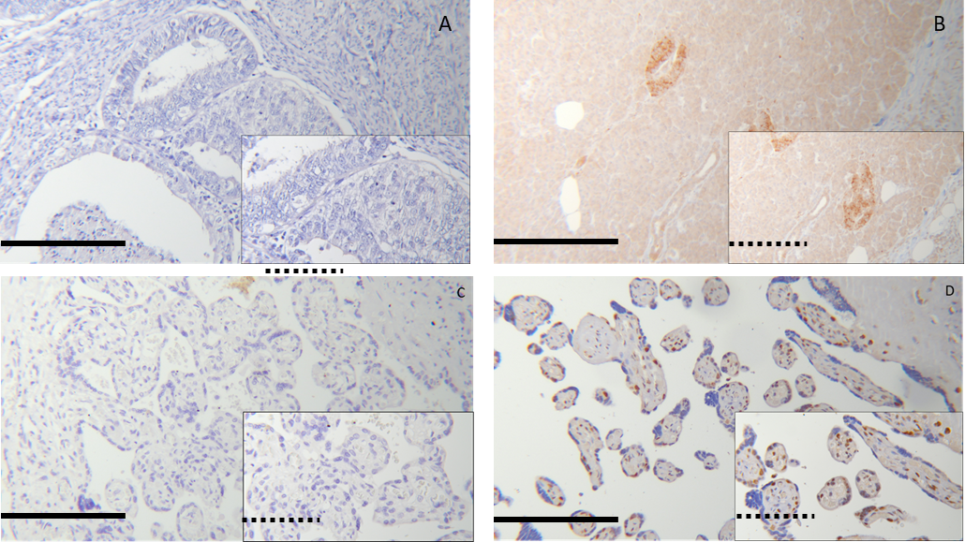
Magnification: big pictures *25, small pictures *100. = 200µm; =100µm
Supplement 2. RIG-I expression in correlation to clinicopathological variables.
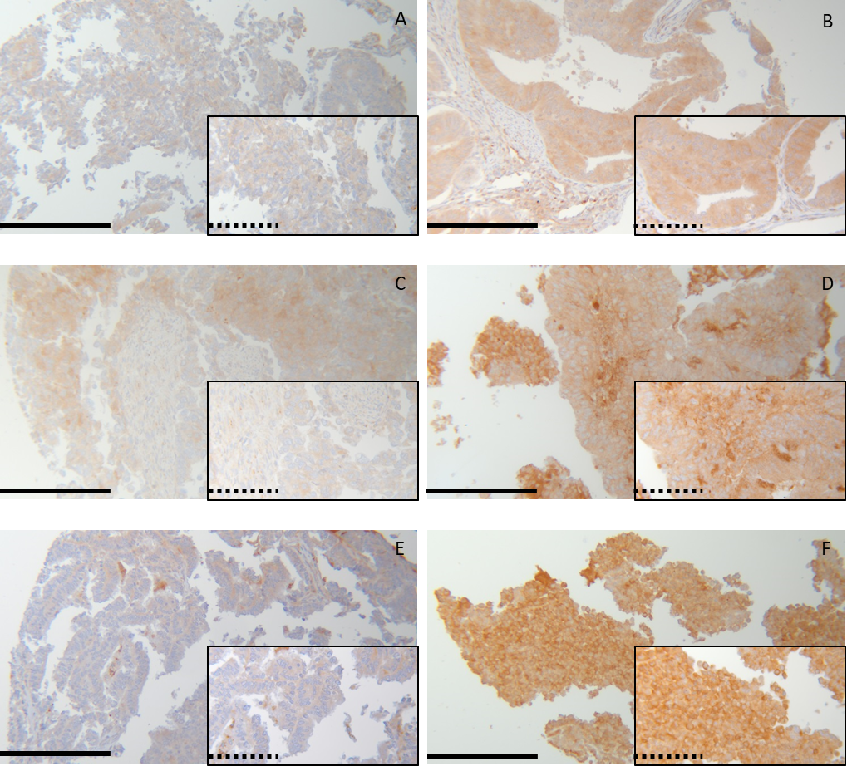
RIG-I Expression and clinicopathological variables. RIG-I expression is significant lower in FIGO I (A) compared to FIGO IV (B). Regarding pT stages, RIG-I expression is lower in pT1 (C) compared to higher pT stages (D). Low graded ECs have significant less RIG-I expression (E) than high graded samples (G3; F). Magnification: bg pictures *25, small pictures *100. = 200µm; =100µm

Supplement 3. Distribution of patient groups in survival analyses regarding RIG-I.
 | Total number | Number of events | Censored
OS
IRS ≤4 | 47 | 21 | 26
IRS >4 | 175 | 109 | 66
PFS
IRS ≤4 | 47 | 4 | 43
IRS >4 | 175 | 41 | 134

Supplement 4. Distribution of patient groups in survival analyses regarding EFTUD2.
 | Total number | Number of events | Censored
OS
IRS ≤8 | 172 | 96 | 76
IRS >8 | 56 | 36 | 20
PFS
IRS ≤8 | 172 | 28 | 144
IRS >8 | 56 | 19 | 37

