Supplemental Fig. 1 Characterization of the epithelial phenotypes of retroperitoneal bronchogenic cyst. A: Hematoxylin and eosin (H&E) section showing the wall of the cystic lesion. The ciliated epithelium is shown in the magnification of the red square. Smooth muscle was confirmed by α-smooth muscle actin staining, as shown in the magnification of the light blue square. B–G: The ciliated epithelium was assessed for CK7 (B), CK20 (C), thyroid transcription factor 1 (TTF-1: D), p40 (E), napsin A (F), and surfactant protein A (SP-A: G) by immunohistochemical (IHC) analyses. Scale bars in A–G: 20 μm.

Supplemental Fig. 2 Bronchogenic cyst in the skin. A: Polyp-like lesion on the chest (red arrow). B: H&E section showing cystic lesions (asterisks), with seromucous glands in the magnification of the black square. C: Anatomopathological features for the diagnosis of bronchogenic cyst. Seromucous glands (red arrowhead) and cartilage (red arrow) were detected near the ciliated epithelium (black arrowhead). D–G: Ciliated epithelium (D: H&E) was assessed for CK7 (E), TTF-1 (F), and p40 by IHC analyses (G). Red arrowhead in D: goblet cell. Scale bar in B: 500 μm, C: 50 μm, and D–G: 20 μm.

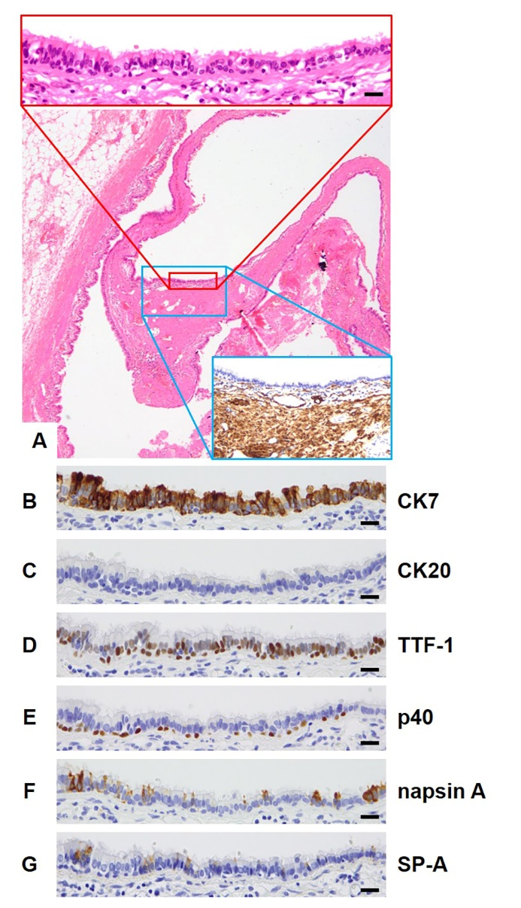

Supplemental Fig. 1 Characterization of the epithelial phenotypes of retroperitoneal bronchogenic cyst. A: Hematoxylin and eosin (H&E) section showing the wall of the cystic lesion. The ciliated epithelium is shown in the magnification of the red square. Smooth muscle was confirmed by α-smooth muscle actin staining, as shown in the magnification of the light blue square. B–G: The ciliated epithelium was assessed for CK7 (B), CK20 (C), thyroid transcription factor 1 (TTF-1: D), p40 (E), napsin A (F), and surfactant protein A (SP-A: G) by immunohistochemical (IHC) analyses. Scale bars in A–G: 20 μm.

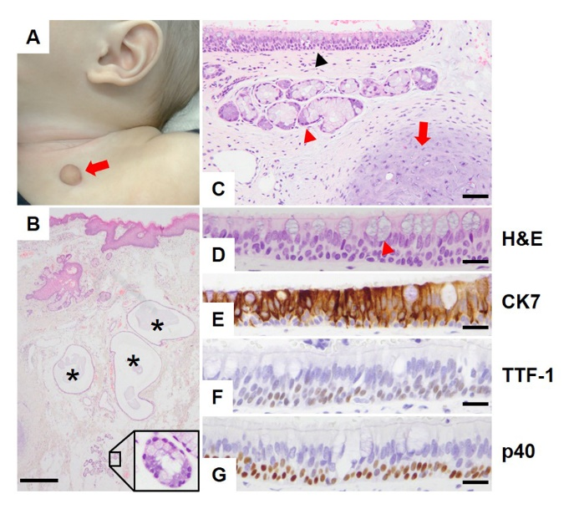

Supplemental Fig. 2 Bronchogenic cyst in the skin. A: Polyp-like lesion on the chest (red arrow). B: H&E section showing cystic lesions (asterisks), with seromucous glands in the magnification of the black square. C: Anatomopathological features for the diagnosis of bronchogenic cyst. Seromucous glands (red arrowhead) and cartilage (red arrow) near the ciliated epithelium (black arrowhead) were detected. D–G: Ciliated epithelium (D: H&E) was assessed for CK7 (E), TTF-1 (F), and p40 (G) by IHC analyses. Red arrowhead in D: goblet cell. Scale bar in B: 500 μm, C: 50 μm, and D–G: 20 μm.

