Supplementary Information for
Directly Batch-Manufacturing of Flexible Sensors for Soft Manipulator Based on Graphene-Nanosheets Film
Xi Zhang*, Wenhao Huang, Chaoyang Lv, Ruifeng Zeng, Yu Zhang, Jichen Zhang, Bo Wen, Dongfeng Diao*
Institute of Nanosurface Science and Engineering, School of Mechatronics and Control Engineering, Shenzhen University, Shenzhen, 518060, China
E-mail: zh0005xi@szu.edu.cn, dfdiao@szu.edu.cn

The PDF file includes:
Methods
Figs. S1 to S2
Tables S1
Video S1

Supplementary Methods
S1 Preparation of F-GNEC films under pattern mask
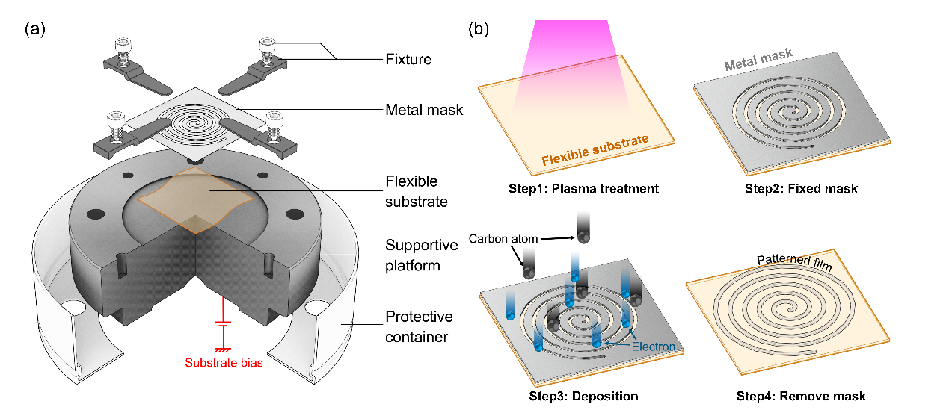
Figure. S1. Schematic diagram of the working process of the rigid mask.
With the help of metal mask, the magnetically controlled sputtering of ECR in this work can manufacture patterned films. Figure S1 (a) is a schematic diagram of the metal mask loading structure, and the substrate bias is applied to the support platform to induce electrons to bombard the substrate. Figure S1 (b) shows the working process of the rigid mask. During the preparation of the patterned film in this work, the deposition parameters are the same as the above. After the plasma is generated by microwave and magnetic resonance, the flexible substrate is plasma cleaned, and then selectively deposited on the substrate with the help of the mask. After removing the mask, the patterned film is obtained. Because the temperature during the preparation process is low, and the ultra-thin metal mask version with a thickness of less than 50 μm will not be warped by the bombardment of the charged particles, the mask and the substrate can be tightly fit, which effectively improves the accuracy and the reliability of pattern processing.

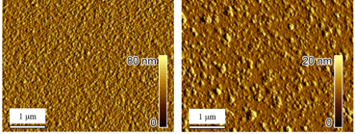
Figure S2. Testing the surface roughness of GNEC film under AFM
S2 Batch Preparation of F-GNEC films combined with UV lithorgraphy
First, the substrate is glued, and after the substrate is adsorbed on the suction cup, the speed of the gluer is set to 4000r/min, and the glued time is 1 minute. After the homogenization was completed, the substrate was placed on a heating plate, heated at 100° C for 1 minute, and dried. After drying, the substrate and the reticle were installed, the parameters were adjusted, the distance between the reticle and the substrate was 1 micrometer, and the exposure time was 3 seconds. After exposure, the substrate is soaked in developing solution for 1 minute, that is, developing. After developing, soak in deionized water for 1 minute. The lithography is over.
Place the photoetched substrate in the ECR equipment cavity to adjust the relevant parameters for carbon plating. After the end, use acetone to wash off the photoresist. The photoresist washing process can use a shaker to obtain a better washing effect. After washing, precise patterned carbon film devices can be obtained.

S3 Principle of ECR plasma manufacturing
In the sputtering process, the substrate temperature comes from the interaction between charged particles and carbon films. The charged particles, which are acting on the carbon film, mainly obtain energy in the sheath between the plasma bulk and the substrate, instead of obtaining energy from the plasma bulk, which is generally considered. It is extremely important to study the energy distribution of charged particles on the substrate surface. Theoretically, the mass conservation equations of electrons and ions can be expressed by the drift-diffusion model in the plasma source chamber. P_{ECR} is the energy provided by the external microwave source to the plasma, which has the following form:
$P_{ECR} = c{[1-{(\frac{r}{R_{0}})}^{2}]}^{2}{[1+({\frac{B-B_{0}}{ΔB})}^{2}]}^{-1}$ (1)
B is the magnetic induction intensity of space. Coefficient c is determined by the following formula:
$P_{W} = \iiint_{V}{P_{ECR}dv}$ (2)
P_{W} is the input power of the microwave source. Therefore, the energy distribution and drift velocity of charged particles in ECR cavity can be controlled by the input power of microwave source and magnetic field strength of the coil.
Figure 2(c) shows that when V_{sub} increases from 30 V to 150 V, φ_{Total} does not change much, but the average electron energy follows the following formula:
$\overline{E}e= e×(V_{sub}-V_{P})$ (3)
V_{P} represents the plasma potential of the plasma, and previous studies have shown that V_{P} is about 10V.
Based on the above statistical results, patterned samples were manufactured using PET, PDMS substrates in this work, as shown in Figure 3(d). Through precisely controlling the parameters, all kinds of substrates can withstand the preparation process. Annular interdigitated patterns, spiral patterns and radial serpentine patterns manufactured by ultra-thin PDMS substrates can be applied to complex surfaces with excellent conformability ability. The parameters of the successful samples manufactured from the above types of substrates are shown in Table S1.
Table.S1. Sample name, substrate material, magnetic field pattern, induced particles, substrate applied bias and microwave power.
serial number | substrate material | confinement magnetic field B_{sub}(G) | substrate bias(V) | microwave power(W) | Target bias（V）
1 | PI | 400 | 0 | 200 | 500
2 | PI | 600 | +40 | 200 | 500
3 | PI | 800 | +80 | 200 | 500
4 | PI | 800 | +40 | 300 | 500
5 | PI | 800 | +40 | 400 | 500
6 | PI | 800 | -40 | 200 | 500
7 | PET | 200 | +40 | 400 | 500
8 | PET | 400 | +40 | 300 | 500
9 | PET | 400 | +20 | 300 | 500
10 | PDMS | 300 | 0 | 200 | 500
11 | PDMS | 300 | +20 | 300 | 500

