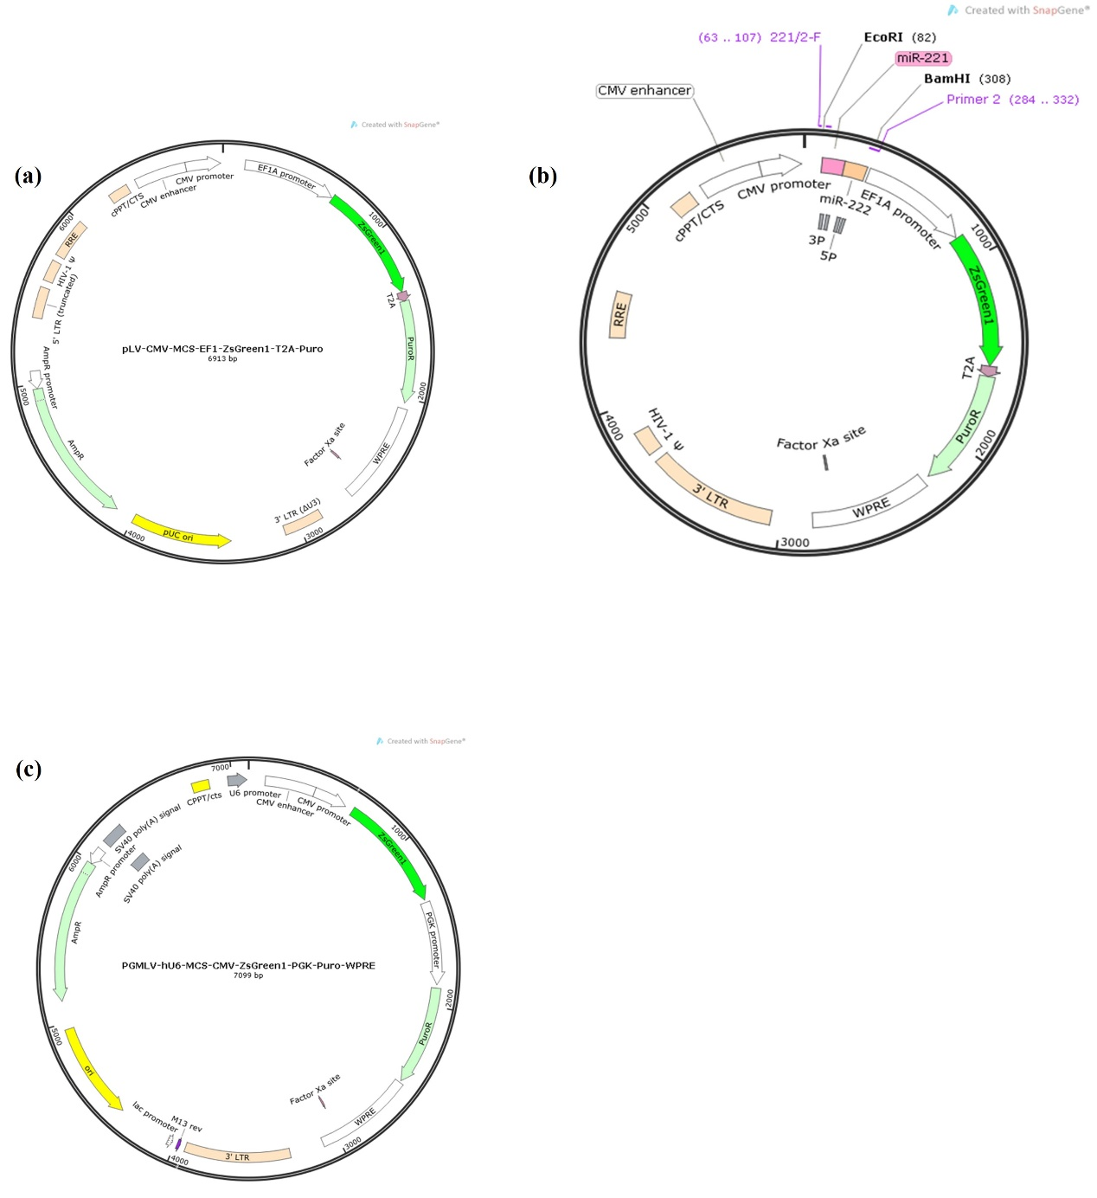
Fig. S1 The map of vector. (a) the vector of negative control of overexpression; (b) the vector of miR-221/222 overexpression; (c) the vector of negative control of shRNA, miR-221shRNA and miR-222 shRNA (The vector of them is same)

