FigureS1 Analysis of relative densities of different types of background immune cells by immunostaining with subgroup associated markers in CHL patients.
Note:Picture A-E subsequently shew the representative high power fields with high-density for CD4 (marking T-helper cells), FOXP3(marking T-reg cells), CD8 (marking cytotoxic T-cells) , CD163(marking macrophages) and PD1 positive T helper cells from relative CHL patients.
S1A

S1B
S 1C

S1D
S1E
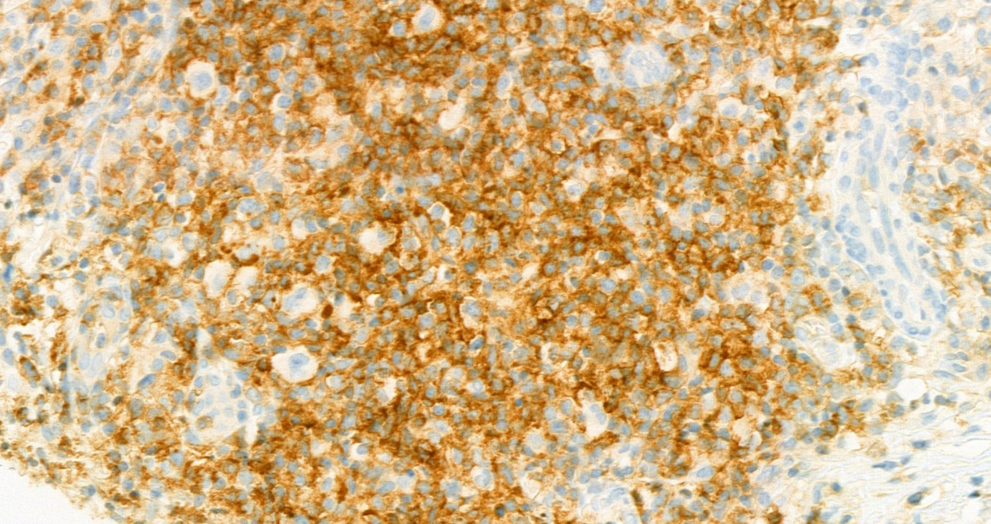

Figure S2 Comparison between PD-L1 expression on HRS cells detected with 9A11 clone Abs and the IHC Sore for the densities of different subgroups of immune cells in TME

Fig S3 Comparison between the PD-L1 expression on HRS cells (2A) and on background IC cells(2B) clinicopathological parameters (sex, age, B symptoms, stage, pathology, EBER et al) and the detected by IHC with 9A11 clone Abs
S3A
S3B
Figure S4 Survival Analysis for the impact of CD163 immune scores and PD-L1 expression scored by IC on event free survival(EFS) with antibody clone 9A11 (Note: cut off value >25 for PDL1 expression on IC， named “high-IC” or “low-IC” )
S4A
S4B

