Supporting information
Natural floating Fe films: microbial interactions and function within Fe cycling bacteria in wetlands
Leheng Dong ^{a, b#}, Manjia Chen ^{b#}, Chengshuai Liu ^{c}, Yahui Lv ^{b}, Qinkai Lei ^{b}, Yujuan Fang ^{b}, Xugang Wang ª, Hui Tong ^{b,*}
ª College of Agriculture / Tree Peony, Henan University of Science and Technology, Luoyang, 471023, China
^{b} National-Regional Joint Engineering Research Center for Soil Pollution Control and Remediation in South China, Guangdong Key Laboratory of Integrated Agro-environmental Pollution Control and Management, Guangdong Institute of Eco-environmental Science and Technology, Guangdong Academy of Sciences, Guangzhou, 510650, China
^{c} State Key Laboratory of Environmental Geochemistry, Institute of Geochemistry, Chinese Academy of Sciences, Guiyang, 550081, China

# These authors contributed equally to the work.

* Corresponding author: Hui Tong (huitong@soil.gd.cn)

Fig. S1 The three sampling locations at lake wetlands in Guangdong province, China.
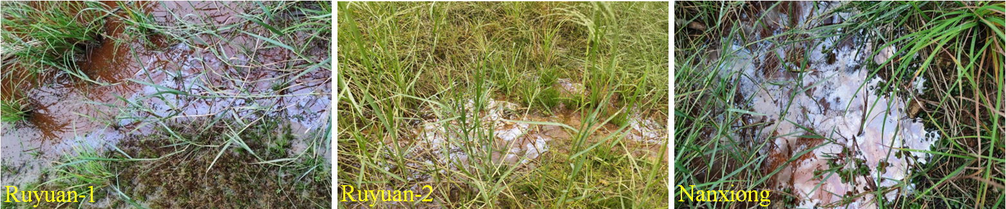

Fig. S2 PCA compares microbial composition to four samples from the floatin iron films (A1, A2, and A3) and associated water(B1, B2, and B3), sediment (C1, C2, and C3), and rhizosphere (D1, D2, and D3).
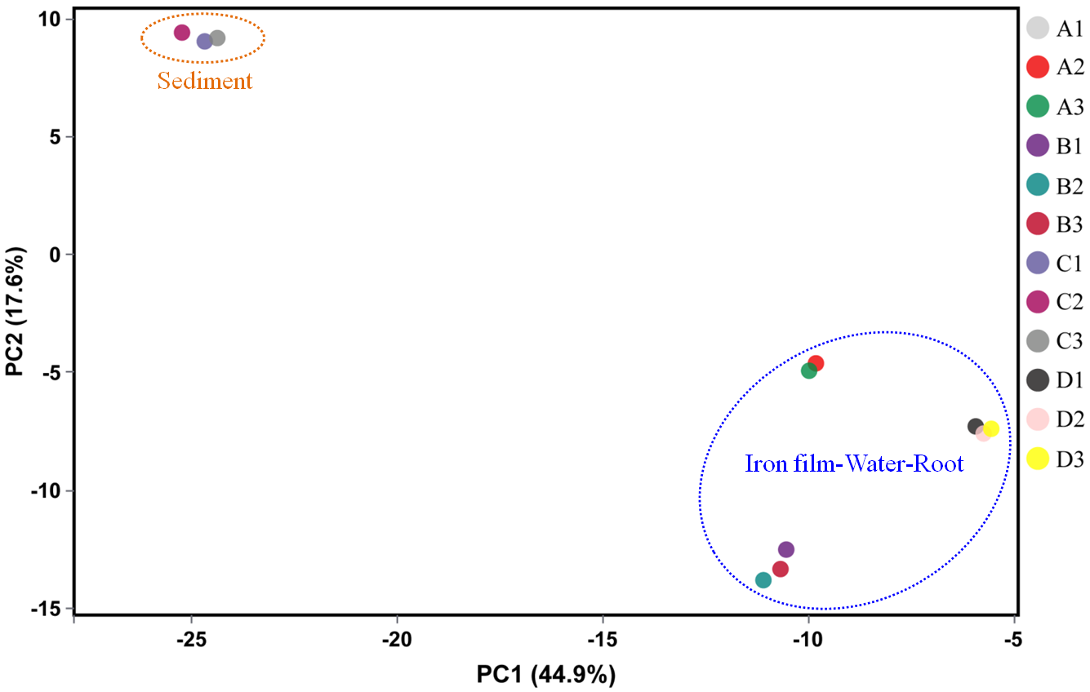

Fig. S3 LEfSe measurements identify differentially abundant bacteria between the floating iron films and water samples at genus-level taxa.
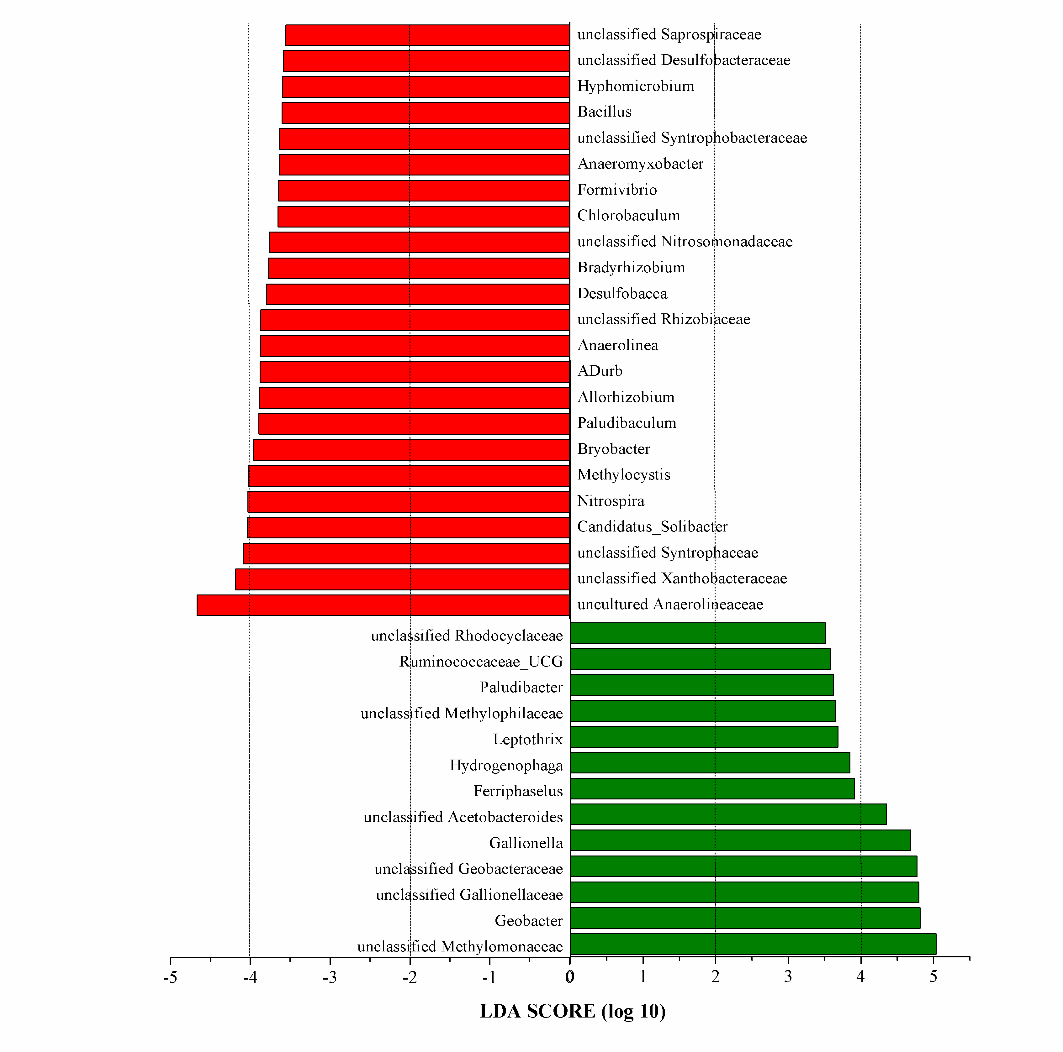

Table S1 Parameters of associated water by field- and laboratory-measurement
 | Value
 | Site 1 | Site 2 | Site 3
Temp (ºC) | 20.5 | 20.7 | 20.4
pH | 6.31 | 6.28 | 7.01
Eh (mV) | 237 | 223 | 318
Oxygen (mg L⁻¹)  (water body) | 6.59 | 5.96 | 6.28
Oxygen (mg L⁻¹)  (below the surface of iron flims) | 0.4 | 0.1 | 0.8
Dissolved Fe(II) (μm) | 11.2 | 11.5 | 12.6
Dissolve Fe(III) (μm) | 119.6 | 46.9 | 351.1
Extracted Fe(II) (mM kg⁻¹) | 108.1 | 87.1 | 94.5
Extracted Fe(III) (mM kg⁻¹) | 15.2 | 6.5 | 11.4

Table S2 Mössbauer spectral parameters derived from fitting samples in Figure 1
Temperature | Component | C.S.(m m/s) | Q.S. (m m/s) | Field(B)
278K | FeOOH | 0.34000 | 0.74577 | -
13K | FeOOH | 0.46000 | -0.05000 | 47.03048

