Supplemental S2
Definitions of COVID-19 diagnosis and diabetes:
Diagnosis of COVID-19 was defined as the patient having a positive result on the nasopharyngeal and oropharyngeal swabs for SARS-CoV-2 by reverse transcriptase polymerase chain reaction (RT-PCR) according to the WHO interim guidance¹.
According to the criteria of the 2022 guidelines of the American Diabetes Association, Diabetes was defined by fasting plasma glucose (FPG) ≥7.0 mmol/L or random blood glucose ≥11.0 mmol/L or glycosylated haemoglobin A1c (HbA1c) ≥6.5% at admission or the patient with a previous diagnosis of diabetes, or anti-diabetic medication use².

Supplemental Table S3
Collected predictors correlated with prognosis of COVID-19 with diabetes within 24 hours on admission.
Variable | Category | Description
Age, years | C | Continuous variable
Alanine aminotrans ferase, U/L | C | Continuous variable, within 24 hours on admission
Albumin, g/l | C | Continuous variable, within 24 hours on admission
Aspartate aminotrans ferase, U/L | C | Continuous variable, within 24 hours on admission
Beta-blocker | B | Routine treatment before admission
BMI, kg/m2 | C | Continuous variable
C reactive protein, mg/L | C | Continuous variable, within 24 hours on admission
Cough | B | Presenting Cough
Creatinine, mg/dl | C | Continuous variable, within 24 hours on admission
Diabetes treatment | Cat. | Routine treatments of diabetes before admission include no treatment, only diet, oral hypoglycemic drugs, insulin, and oral hypoglycemic drugs & insulin
Diabetic courses, years | Cat. | Diabetic courses include ≤5, 6-10, 11-15, >15; the new case denied diabetes and did not take hypoglycemic drugs before admission
Diarrhea | B | Presenting Diarrhea
Dyspnea | B | Presenting Dyspnea
Fasting plasma glucose, mmol/L | C | Continuous variable, within 24 hours on admission
Fever | B | Presenting Fever
Gender | B | Female, male
Glomerular filtration rate, mL/min/1.73 m2 | C | Continuous variable, within 24 hours on admission
Glycated hemoglobin, % | C | Continuous variable, within 24 hours on admission
Glycated hemoglobin, % | C | Less than 7% indicates well glucose control; greater than 7% indicates poor glucose control
Lactate dehydrogenase, U/L | C | Continuous variable, within 24 hours on admission
Loss of consciousness | B | Presenting Loss of consciousness
Lymphocyte, % | C | Continuous variable, within 24 hours on admission
Neutrophil / Lymphocyte ratio | C | Continuous variable, within 24 hours on admission
Neutrophil, % | C | Continuous variable, within 24 hours on admission
O2 Saturation, % | C | Vital signs on admission
Original comorbidities | D | Comorbidity events of hypertension, cardiovasculardisease, crebrovascular diseases, chronickidney disease, Chronic respiratory disease before admission
Platelet count, 109/L | C | Continuous variable, within 24 hours on admission
Potassium, mEq/L | C | Continuous variable, within 24 hours on admission
Pulse rate, beats/min | C | Vital signs on admission
Statin | B | Routine treatment before admission
C= continuously B=binary D=discretely Cat.=categorical

Supplemental Table S4
The description of missing data and sensitivity comparative analysis between original and complete data.

 | Missing data  (n=96) | Original data  (n=127) | Complete data  (n=31) | P  value
Demographic and clinical characteristics
Age, years | 0 | 66.4±12.5 | 68.1±11.1 | 0.448
Gender | 0 |  |  | 0.733
Female |  | 56 (44.1%) | 12 (38.7%)
Male |  | 71 (55.9%) | 19 (61.3%)
Diabetic courses, years | 15(15%) |  |  | 0.129
New case |  | 7 (5.51%) | 2 (6.45%)
≤5 |  | 19 (15.0%) | 8 (25.8%)
6-10 |  | 36 (28.3%) | 10 (32.3%)
11-15 |  | 21 (16.5%) | 2 (6.45%)
>15 |  | 29 (22.8%) | 9 (29.0%)
BMI | 0 | 26.7 (25.0-30.4) | 26.8 (24.6-29.3) | 0.565
Original comorbidities
Hypertension | 0 | 68 (53.5%) | 19 (61.3%) | 0.565
Cardiovasculardisease | 0 | 39 (30.7%) | 8 (25.8%) | 0.752
Crebrovascular diseases | 0 | 16 (12.6%) | 3 (9.68%) | 1
Chronickidney disease | 0 | 16 (12.6%) | 3 (9.68%) | 1
Chronic respiratory disease | 0 | 4 (3.15%) | 0 (0.00%) | 1
Signs and Symptoms on admission
Cough | 0 | 89 (70.1%) | 22 (71.0%) | 1
Fever | 0 | 53 (41.7%) | 15 (48.4%) | 0.639
Loss of consciousness | 0 | 11 (8.66%) | 5 (16.1%) | 0.315
Dyspnea | 0 | 83 (65.4%) | 17 (54.8%) | 0.378
Diarrhea | 0 | 11 (8.66%) | 3 (9.68%) | 1
Vital signs on admission
Pulse rate, beats/min | 9(9%） | 86.0 (80.0-94.8) | 86.0 (80.0-93.5) | 0.58
O2 Saturation, % | 9(9%） | 90.0 (85.0-92.0) | 90.0 (87.0-92.0) | 0.611
Laboratory findings on admission
Fasting plasma glucose, mmol/L | 24(25%） | 10.0 (8.00-14.0) | 11.0 (8.00-15.0) | 0.845
Glycated hemoglobin, % | 11(11%） | 8.70 (7.47-10.5) | 8.70 (7.25-9.50) | 0.681
Neutrophil, % | 5(5%） | 74.4 (64.2-82.8) | 75.0 (66.2-83.8) | 0.957
Lymphocyte, % | 5(5%） | 18.3 (10.7-28.6) | 17.5 (6.70-26.7) | 0.598
Platelet count, 109/L | 3(3%） | 189 (143-252) | 188 (154-236) | 0.943
C reactive protein, mg/L | 7(7%） | 50.6 (27.0-75.0) | 70.4 (33.0-96.6) | 0.061
Albumin, g/l | 28(29%） | 39 .0(35.0-41.0) | 40.0 (37.0-41.0) | 0.583
Lactate dehydrogenase, U/L | 46(48%） | 354 (230-559) | 300 (202-462) | 0.189
Alanine aminotrans ferase, U/L | 30(31%） | 26.0 (20.0-35.0) | 25.0 (20.5-30.0) | 0.513
Aspartate aminotrans ferase, U/L | 29(30%） | 31.5 (25.0-44.0) | 30.0 (22.0-36.0) | 0.229
Glomerular filtration rate, mL/min/1.73 m2 | 16(17%） |  |  | 0.923
>90 |  | 5 (4.50%) | 1 (3.23%)
60-90 |  | 35 (31.5%) | 12 (38.7%)
30-60 |  | 48 (43.2%) | 12 (38.7%)
≤30 |  | 23 (20.7%) | 6 (19.4%)
Potassium, mEq/L | 3(3%） | 4.30 (3.90-4.62) | 4.30 (3.90-4.85) | 0.975
Routine treatment before admission
Diabetes treatment | 0 |  |  | 0.287
No treatment |  | 11 (8.66%) | 3 (9.68%)
Only diet |  | 11 (8.66%) | 4 (12.9%)
Oral hypoglycemic drugs |  | 66 (52.0%) | 20 (64.5%)
Insulin |  | 11 (8.66%) | 2 (6.45%)
Oral hypoglycemic drugs and insulin |  | 28 (22.0%) | 2 (6.45%)
Statin | 0 | 43 (33.9%) | 9 (29.0%) | 0.765
Beta-blocker | 0 | 14 (11.0%) | 0 (0.00%) | 0.08
Outcome (nonsurvivor) | 0 | 29 (22.8%) | 6 (19.4%) | 0.859

Supplemental Table S5
Sensitivity comparative analysis between pre-imputation and post-imputation.
 | Original data | Imputation 1 | Imputation 2 | Imputation 3 | Imputation 4 | Imputation 5 | p value
Pulse rate, beats/min | 86.0 (80.0-94.8) | 86.0 (80.0-95.0) | 86.0 (80.0-93.5) | 86.0 (80.0-95.0) | 86.0 (80.0-94.5) | 88.8 (13.5) | 0.996
O2 Saturation, % | 90.0 (85.0-92.0) | 90.0 (85.0-92.0) | 90.0 (85.0-92.0) | 90.0 (85.0-92.0) | 90.0 (85.0-92.5) | 90.0 (85.0-93.0) | 0.998
Fasting plasma glucose, mmol/L | 10.0 (8.00-14.0) | 10.1 (7.47-13.8) | 10.1 (7.47-13.8) | 10.2 (7.97-13.9) | 10.2 (8.06-13.9) | 10.2 (7.78-14.5) | 0.968
Glycated hemoglobin, % | 8.70 (7.47-10.5) | 8.70 (7.65-10.2) | 8.80 (7.55-10.5) | 8.70 (7.65-10.3) | 8.80 (7.55-10.6) | 8.70 (7.55-10.5) | 0.995
Neutrophil, % | 74.4 (64.2-82.8) | 74.0 (64.5-83.0) | 74.0 (63.5-83.0) | 74.0 (64.5-82.5) | 75.0 (63.5-84.0) | 74.0 (64.4-82.7) | 1
Lymphocyte, % | 18.3 (10.7-28.6) | 18.0 (10.5-28.5) | 18.0 (11.0-28.5) | 18.0 (11.0-27.5) | 18.0 (10.0-28.5) | 17.6 (10.8-28.4) | 1
Platelet count, 109/L | 189 (143-252) | 189 (143-254) | 189 (145-254) | 186 (140-250) | 188 (143-250) | 190 (145-253) | 0.998
C reactive protein, mg/L | 50.6 (27.0-75.0) | 50.8 (27.5-75.0) | 50.8 (27.5-76.0) | 50.5 (26.5-74.0) | 49.7 (26.5-74.0) | 51.0 (27.5-75.0) | 0.997
Albumin, g/l | 39.0 (35.0-41.0) | 40.0 (40.0-40.0) | 40.0 (40.0-40.0) | 40.0 (40.0-40.0) | 40.0 (40.0-40.0) | 39.0 (35.0-41.0) | 0.997
Lactate dehydrogenase, U/L | 354 (230-559) | 374 (256-570) | 365 (256-558) | 350 (230-558) | 350 (247-544) | 365 (250-570) | 0.92
Alanine aminotrans ferase, U/L | 26.0 (20.0-35.0) | 26.0 (21.0-37.5) | 26.0 (20.0-37.0) | 27.0 (20.0-38.0) | 27.0 (20.0-37.5) | 25.0 (19.5-37.0) | 0.989
Aspartate aminotrans ferase, U/L | 31.5 (25.0-44.0) | 33.0 (25.0-47.5) | 32.0 (24.0-45.0) | 31.0 (25.0-45.0) | 33.0 (25.0-45.0) | 31.0 (25.0-45.0) | 0.961
Glomerular filtration rate, mL/min/1.73 m2 |  |  |  |  |  |  | 0.050
>90 | 5 (4.50%) | 5 (3.94%) | 5 (3.94%) | 5 (3.94%) | 5 (3.94%) | 5 (3.94%)
60-90 | 35 (31.5%) | 41 (32.3%) | 42 (33.1%) | 41 (32.3%) | 38 (29.9%) | 40 (31.5%)
30-60 | 48 (43.2%) | 58 (45.7%) | 55 (43.3%) | 57 (44.9%) | 60 (47.2%) | 59 (46.5%)
≤30 | 23 (20.7%) | 23 (18.1%) | 25 (19.7%) | 24 (18.9%) | 24 (18.9%) | 23 (18.1%)
Potassium, mEq/L | 4.30 (3.90-4.62) | 4.30 (3.90-4.60) | 4.30 (3.90-4.60) | 4.30 (3.90-4.65) | 4.30 (3.90-4.65) | 4.30 (3.90-4.60) | 1

Supplemental Figure S6. Texture feature selection using the least absolute shrinkage and selection operator (LASSO) binary logistic regression model.
(A)
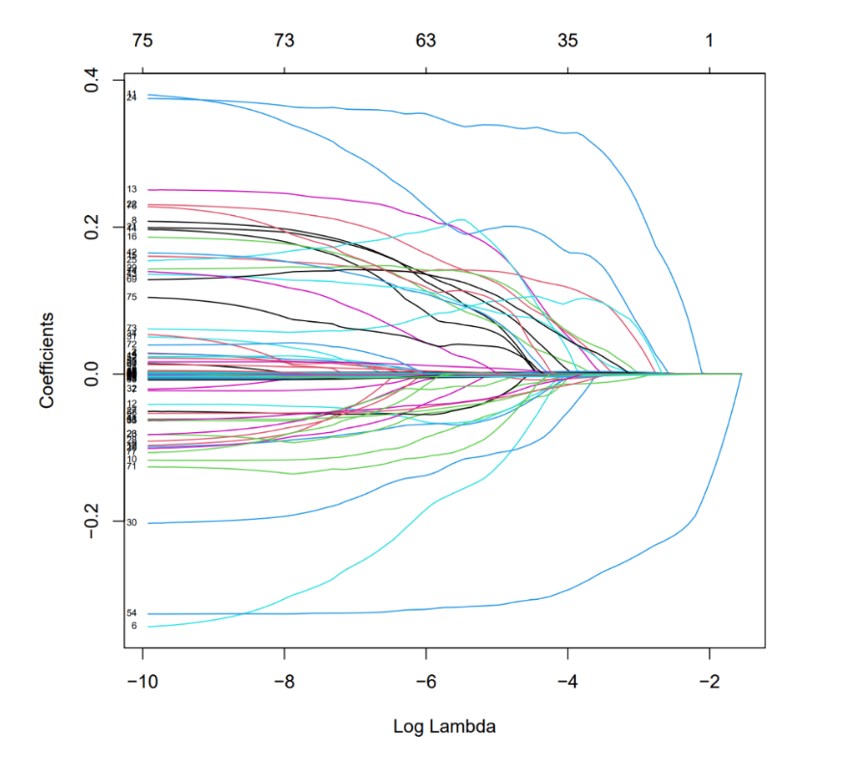
(B)
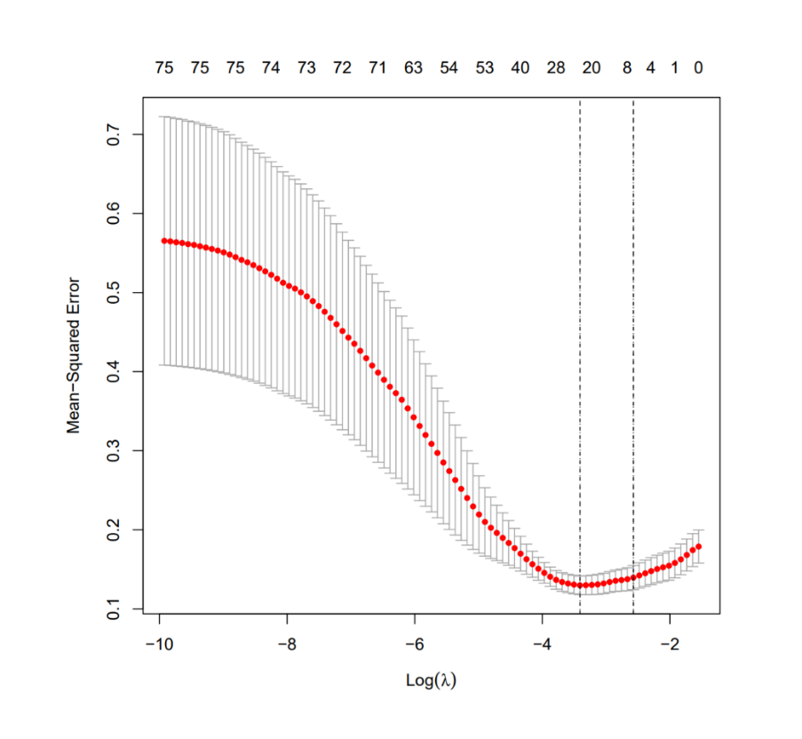

Note: (A) Tuning parameter (λ) selection in the LASSO model used 10-fold cross-validation via minimum criteria. The area under the receiver operating characteristic (AUC) curve was plotted versus log(λ). Dotted vertical lines were drawn at the optimal values by using the minimum criteria and the λ standard error of the minimum criteria (the 1-SE criteria). (B) LASSO coefficient profiles of the 79 texture features. A coefficient profile plot was produced against the log (λ) sequence. Vertical line was drawn at the value selected using 10-fold cross-validation, where optimal l resulted in 23 non-zero coefficients.
Supplemental Figure S7
Calibration curves for the nomogram.
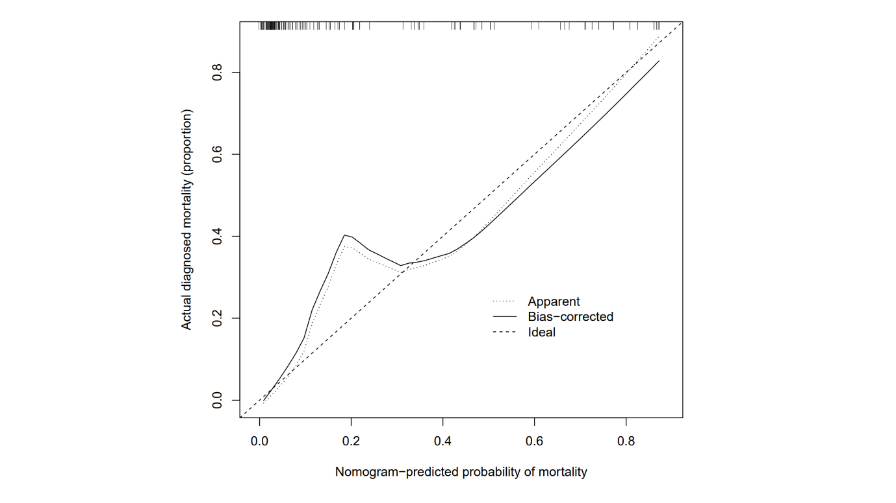
Note: Calibration method with bootstrapping was used to illustrate the association between actual COVID-19 mortality and predicted COVID-19 mortality. Calibration plots show the apparent (actual), bias-corrected (adjusted), and ideal (100% agreement) curves with bootstrapping samples. Bootstrapping involved 1000 repetitions. Nomogram-predicted probability of COVID-19 mortality is plotted on the x-axis; the observed probability of COVID-19 mortality is plotted on the y-axis.
Supplemental Table S8
Table3. C-statistics of different groups under model sensitivity analysis.
Models of subtypes | C-statistic (95% CI) | p value
Model A: Gender
Female | 0.950 (0.903-0.997) | <0.001
Male | 0.860 (0.750-0.970) | <0.001
Model B: Age, years
≤65 | 0.939 (0.867-1.000) | <0.001
>65 | 0.911 (0.842-0.979) | <0.001
Model C: Fasting plasma glucose, mmol/L
≤10 | 0.925 (0.837-1.000) | <0.001
>10 | 0.915 (0.840-0.99) | <0.001
Model D: Glycated hemoglobin, %
≤7 | 0.912 (0.797-1.00) | 0.003
>7 | 0.903 (0.838-0.969) | <0.001

References
1. Organization WH. Clinical management of severe acute respiratory infection when novel coronavirus (‎‎‎‎‎ 2019-nCoV)‎‎‎‎‎ infection is suspected: interim guidance, 28 January 2020. World Health Organization;2020.
2. Association AD. Standards of Medical Care in Diabetes—2022 Abridged for Primary Care Providers. Clinical Diabetes. 2022;40(1):10-38.

