Supplementary Materials for

Single-Cell Transcriptomic and Chromatin Accessibility Atlas of Peripheral Blood Mononuclear Cells Reveal the Immune Cell Heterogeneity of Pigs

Hairui Fan^{1†}, Chao Xu^{1†}, Cui Du², Haifei Wang¹, Yejun Wang³, Bin Zhao⁴, Chao Chen⁵, Shaobin Shang², Shenglong Wu¹, Ming-an Sun^{2*}, Wenbin Bao^{1*}

*Corresponding author. Email: Wenbin Bao, wbbao@yzu.edu.cn; Ming-an Sun, mingansun@yzu.edu.cn.

This file includes:

Figs. S1 to S11
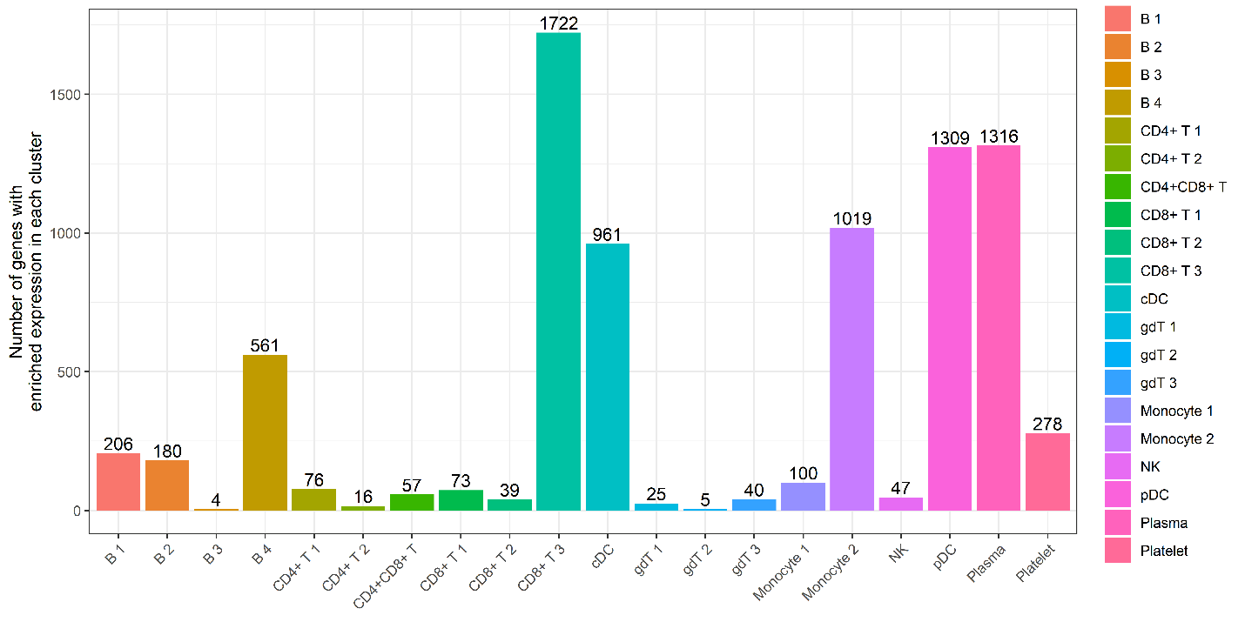

Figure S1. Number of genes with enriched expression in each cell cluster
This barplot shows the number of genes with significantly enriched expression in each cell cluster. The gene numbers are indicated on the top of each bar.
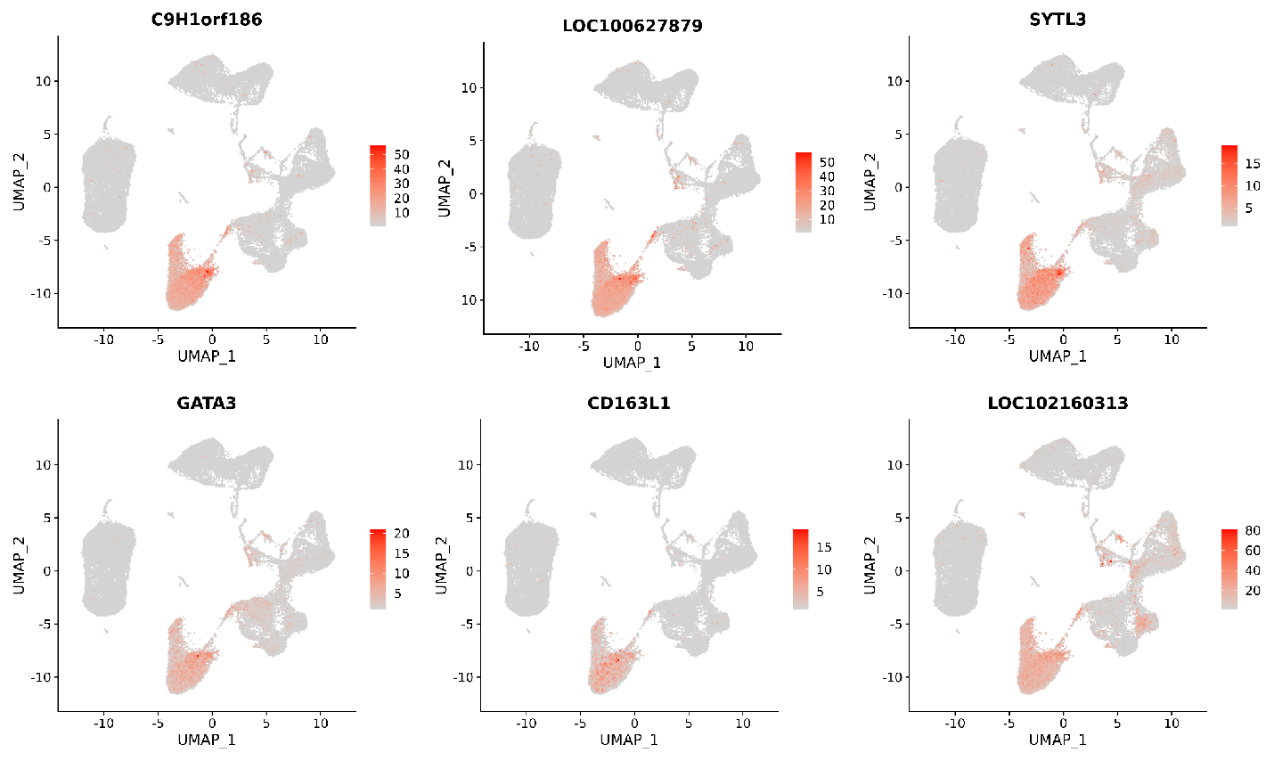

Figure S2. Expression patterns of representative genes with enriched expression in γδ T lymphocytes
This figure shows the expression of C9H1orf186, LOC100627879, SYTL3, GATA3, CD163L1 and LOC102160313 is restrained to a distinct subset of in γδ T lymphocytes.
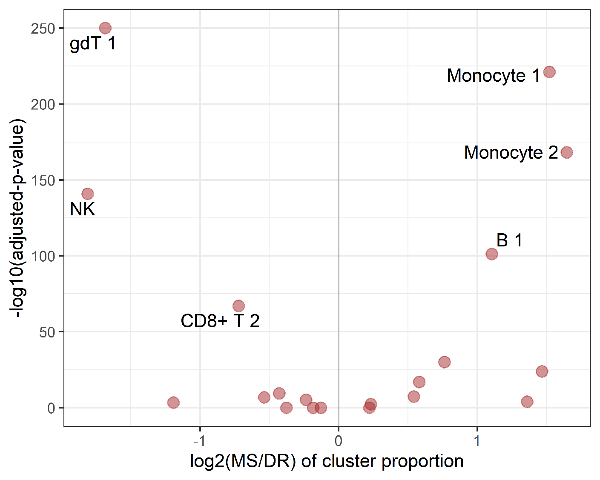

Figure S3. Variation of the proportions of each cell cluster in PBMCs of Duroc and Meishan pigs
This figure shows the proportion differences of each cell cluster between the PBMCs of Duroc and Meishan pigs. The x-axis indicates the log2fold of the proportion between Meishan and Duroc pigs, and y-axis indicates the –log10(adjusted-p-value). The cluster annotations for several most variable cell clusters are labelled.

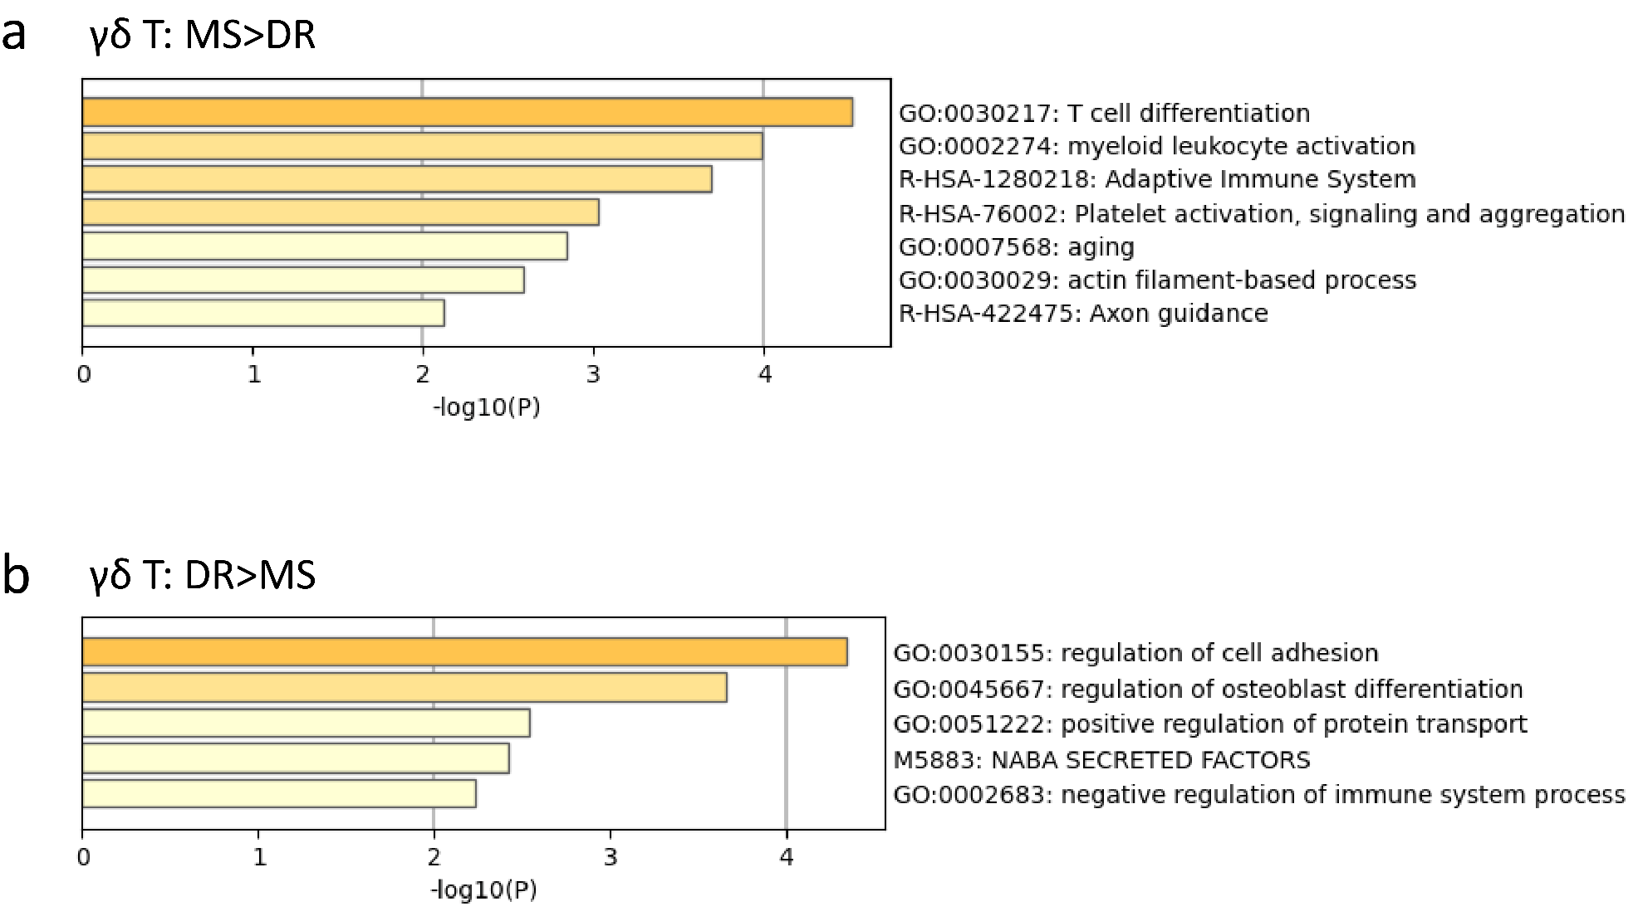

Figure S4. GO enrichment results for the DEGs of γδ T lymphocytes between Duroc and Meishan pigs
This figure shows the GO enrichment results for the genes overexpressed in the γδ T lymphocytes of Meishan (a) and Duroc (b) pigs, respectively. DR, Duroc pigs; MS, Meishan pigs.
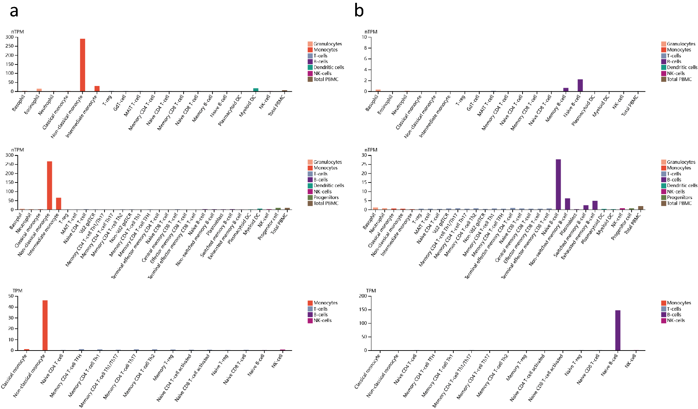

Figure S5. Expression of CKB and LIX1 in the immune cells of human based on Human Protein Atlas data
This figure shows the expression of CKB (a) and LIX1 (b) in different types of human immune cells based on Human Protein Atlas database.

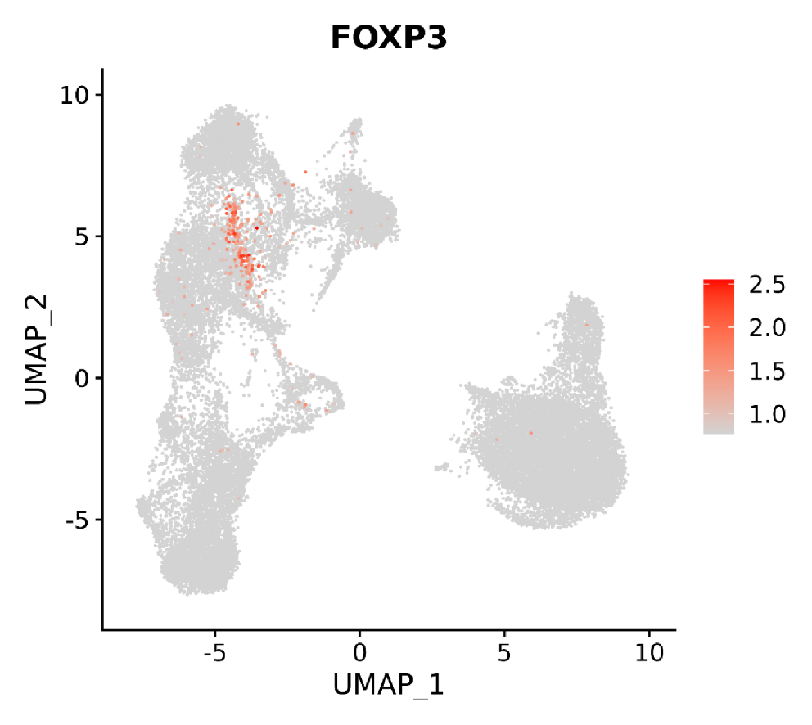

Figure S6. Expression pattern of FoxP3 in T lymphocytes based on re-clustering analysis
This figure shows the expression of FOXP3 is restrained to a distinct subset of T lymphocytes.

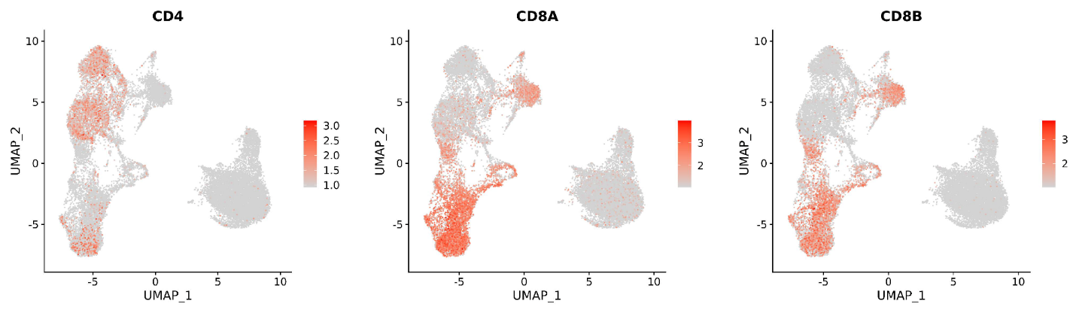

Figure S7. Distribution of CD4⁺CD8⁺ T lymphocytes based on re-clustering analysis
This figure shows the expression of CD4, CD8A and CD8B is restrained to a distinct subset of T lymphocytes.

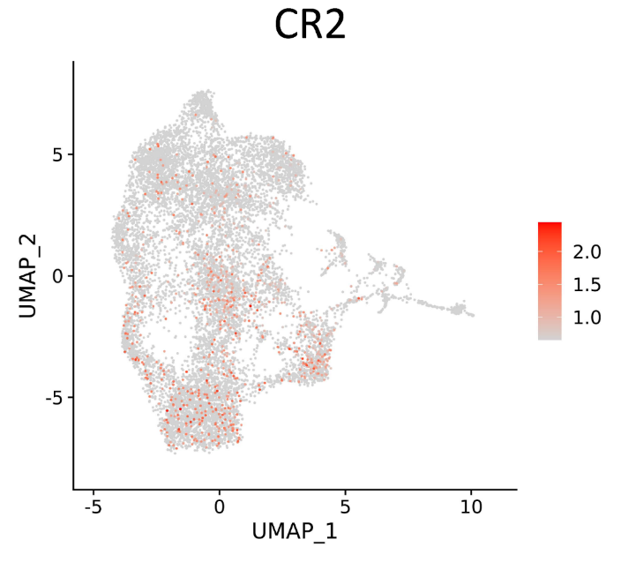

Figure S8. Expression pattern of CR2 in B lymphocytes based on re-clustering analysis
This figure shows the expression of CR2 is restrained to a distinct subset of T lymphocytes.

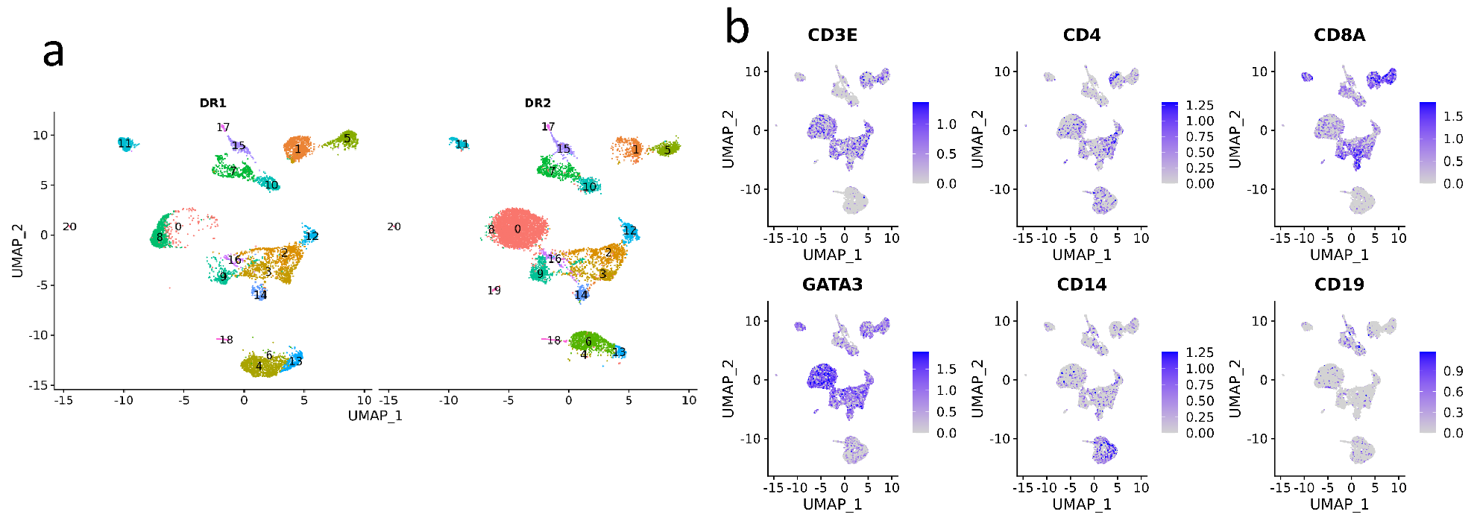

Figure S9. Clustering of PBMCs based on scATAC-seq data
UMAP visualization of PBMCs based on scATAC-seq data (a). Plots show the expression distribution of canonical immune cell markers (b).

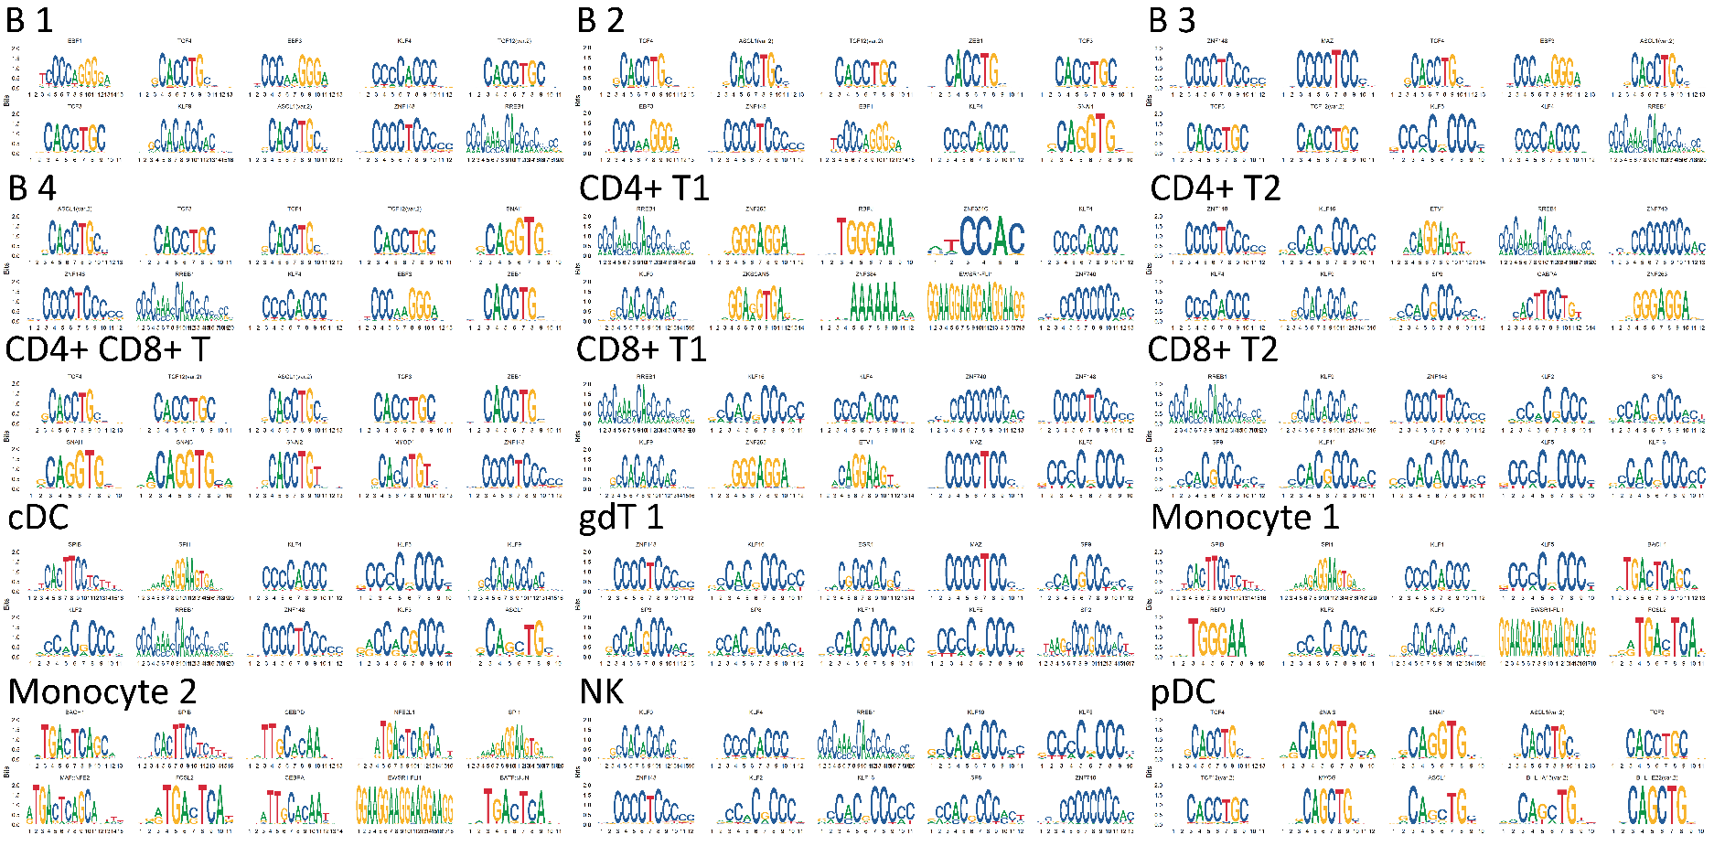

Figure S10. Clustering of PBMCs based on scATAC-seq data
This figure demonstrates the top 10 enriched motifs for each cell cluster based on scATAC-Seq data.

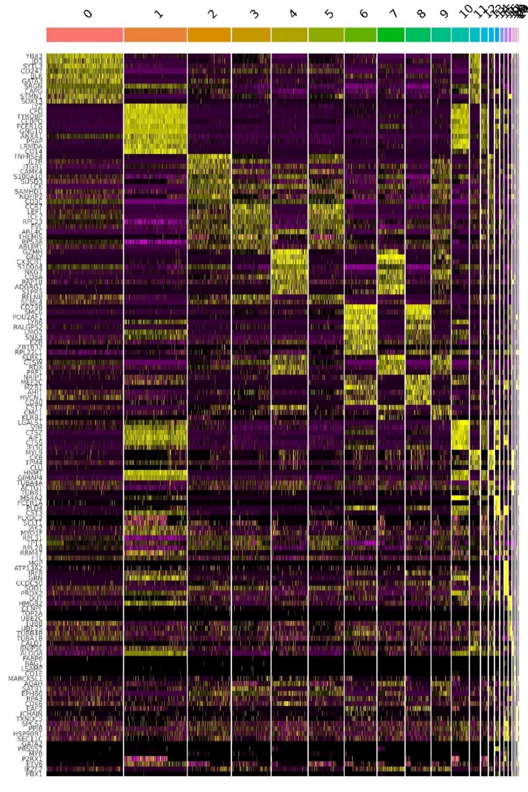

Figure S11. Heterogeneity of PBMCs by integration analysis of Porcine and Human scRNA-seq Datasets
Heatmap for the expression pattern of the top 10 genes with enriched expression in each cluster. Color indicates the normalized expression value.

