Supplementary material

Plant-based green fabrication of S-scheme CuO/CdO/bentonite heterojunction with enhanced photocatalytic performance for degradation of levofloxacin
Majid Mahjooreª, Moones Honarmand^{b,*}, Ahmad Aryafarª
ªDepartment of Mining Engineering, Faculty of Engineering, University of Birjand, Birjand, Iran
^{b}Department of Chemical Engineering, Birjand University of Technology, Birjand, Iran
*E-mail: honarmand@birjandut.ac.ir, honarmand.moones@yahoo.com,
Tel: +98 56 32391232; Fax: +98 56 32252025

Captions
Text S1 Materials and characterizations
Text S2 Preparation of Ferula extract
Fig. S1. N₂ adsorption–desorption isotherms of bentonite and CuO-CdO-BT
Fig. S2. (a) UV–vis DRS and (b) Tauc's plot for CuO NPs, CdO NPs and CuO-CdO-BT
Fig. S3. Zeta potential of CuO-CdO-BT at different pH values
Fig. S4. Recyclability test of the CuO-CdO-BT in the LVF photodegradation
Fig. S5. HPLC-MS spectra of intermediates from the degradation of LVF using CuO-CdO-BT after (a) 15 and (b) 30 min
Table S1. The surface structure characteristics of bentonite and CuO-CdO-BT

Text S1: Materials and characterizations
Levofloxacin antibiotic was supplied by Abidi pharmaceuticals company (Iran). Cadmium nitrate tetrahydrate Cd(NO₃)₂.4H₂O and Copper sulfate pentahydrate (CuSO₄.5H₂O) with chemical purity of 99% were purchased from ACROS and Sigma-Alderich Companies, respectively. The pH of solutions was measured by Metrohm pH meter (Switzerland).The crystalline phase of samples was analyzed by X-ray Diffraction (Philips X’pert diffractometer type PW 1800 goniometer, Cu Kα = 1.5406 A˚). Field-emission scanning electron microscopy (FE-SEM) by means of a TESCAN microscope (FE-SEM, Mira 3-XMU) equipped with energy dispersive X-ray (EDX) microanalysis was utilized to study morphology and surface structure of the samples. Using a Shimadzu spectrophotometer (UV-2550 model), the UV-Vis diffuse reflectance spectroscopy (DRS) of the samples was measured. Belsorp-mini II analyzer was used to determinate the Brunauer–Emmett–Teller (BET) surface area, total pore volume, and mean pore diameter of samples. X-ray photoelectron spectroscopy (XPS) was utilized to identify surface elemental compositions and valence state of catalyst (K-Alpha XPS spectrometer, Thermo Scientific, USA). FT-NIR spectroscope (RAYLEIGH, WQF-510) was used to record the Fourier-transform infrared (FTIR) spectra of the samples. The generated intermediates of LVF photodegradation were identified by an HPLC-MS analysis (Quattro Micro API micromass Waters 2695) with an Atlantis T3-C18 3μ, 2.1 × 100 mm column. The surface electrical charge of biosynthesized nanocomposite was measured by determining the zeta potential (Malvern, Japan). The concentration of the LVF solutions were measured by using UV/Vis spectrophotometer (GENWAY, UK).
Text S2: Preparation of Ferula extract
Ferula plant was collected from mountainous areas in South Khorasan province, Iran. The collected fresh Ferula was washed multiple times with water. The treated Ferula was cut into small pieces and shadow dried for 14 days and then powdered using a mixer grinder. To prepare the Ferula extract, 10 g of dispersed plant powder in 200 ml of deionized water was refluxed for 30 minutes. After bringing back to laboratory temperature, the suspension was centrifuged at 10000 rpm for 10 minutes to remove suspended particles and then it was filtered using Whatman No. 1 filter paper to obtain Ferula aqueous extract.

Fig. S1. N₂ adsorption–desorption isotherms of bentonite and CuO-CdO-BT

Fig. S2. (a) UV–vis DRS and (b) Tauc's plot for CuO NPs, CdO Nps and CuO-CdO-BT

Fig. S3. Zeta potential of CuO-CdO-BT at different pH values

Fig. S4. Recyclability test of the CuO-CdO-BT in the LVF photodegradation

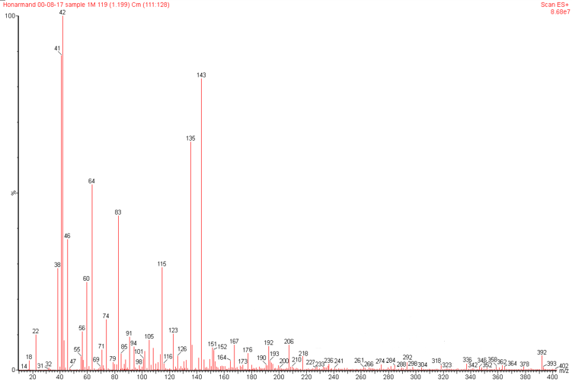
(a)
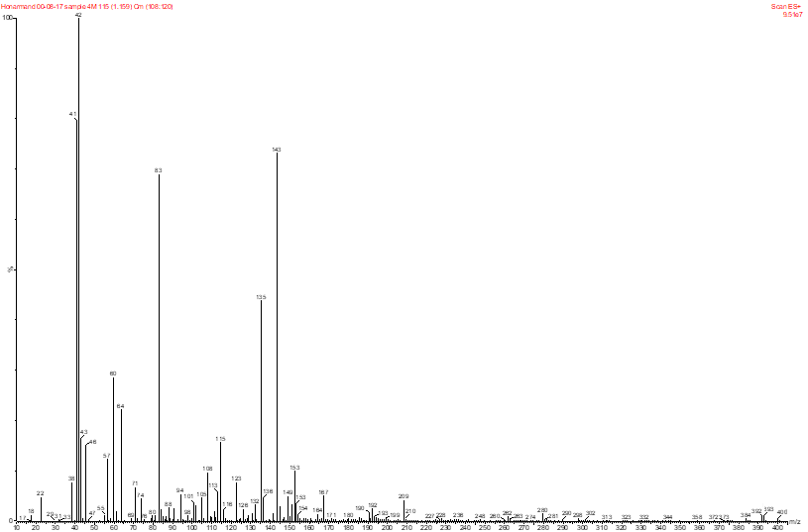
(b)
Fig. S5. HPLC-MS spectra of intermediates from the degradation of LVF using CuO-CdO-BT after (a) 15 and (b) 30 min

Table S1. The surface structure characteristics of bentonite and CuO-CdO-BT
Sample | BET surface area (m² g⁻¹) | Total pore volume (cm³ g⁻¹) | Mean pore diameter (nm)
Bentonite | 23.733 | 0.1049 | 17.682
CuO-CdO-BT | 45.875 | 0.2075 | 18.094

